MSc Motorsport Engineering
Mechanisms of Materials Failure
Assessment Title | Hydrogen Embrittlement
Module Number | ACEA7010
Lecturer | Dr Jeremiah McCallister
Date of Submission | 19/01/2025

University of Wales Trinity Saint David
School of Engineering
2024-2025

Abstract
This report explores the implications of hydrogen on material properties and its role in achieving net-zero energy policies. It begins by examining the origins of hydrogen in both natural and industrial contexts, including its production through electrolysis and steam reforming. A detailed analysis is provided on the structural changes caused by hydrogen absorption in metals during liquid and solid states, including lattice expansion, elastic strain, and phase transformations. Metallographic examination techniques, such as optical and electron microscopy, are discussed for detecting hydrogen-induced defects. The report further evaluates the effects of hydrogen absorption on ferrous metals, focusing on mechanical properties such as tensile strength, ductility, and fatigue resistance. Finally, it addresses the challenges of hydrogen in fabrication processes, particularly welding, where hydrogen-induced cracking and porosity pose significant risks. Mitigation strategies, including vacuum degassing, controlled cooling, and advanced alloys, are recommended to minimize hydrogen's adverse effects on metals. The findings underscore the importance of process optimization and material innovation to ensure the durability of metals in high-performance applications.

Contents Page
Table of Contents
Abstract 1
Contents Page 2
Table of Figures 3
Introduction 4
Origin of Hydrogen 6
Primordial Origins 6
Natural Occurrence on Earth 6
Geological Sources 6
Natural Hydrogen Emissions 6
Mantle Hydrogen 6
Industrial production 6
Hydrogen embrittlement 7
Interstitial Hydrogen absorption 7
Lattice Expansion 7
Elastic Strain 7
Hydride formation 8
Microstructural effects 9
Dislocation Interaction 9
Grain boundary Effects 9
Fatigue failure 10
Dissociation and diffusion 10
Contributing factors to hydrogen absorption 10
Hydrogen challenges in Welding 11
Conclusion 13
References 14

Table of Figures
Figure 1 - Gravimetric Vs Volumetric Energy Densities (Kobayashi, H. et al. 2019) 5

Introduction
The transition of the world to net-zero energy systems requires a shift from carbon-based fuels and reducing agents to sustainable alternatives such as hydrogen. Hydrogen has been touted as a game-changer for energy systems and will play a critical role in this transition because of its zero-emission characteristics. Hydrogen can be produced from renewable energy through electrolysis and acts as both a fuel and a reducing agent in industrial processes, including the extraction of metals. But atomic size, high reactivity, and interaction of hydrogen with materials make it very difficult to store, convey, and use in metallurgical applications.
Hydrogen embrittlement is a critical failure mode through the absorption of hydrogen into metals, resulting in reduced ductility, promotion of microcracking, and mechanical integrity compromise. Such a phenomenon is most profound in the processing, casting, and fabrication processes of ferrous metals. In welding, the complicating involvement of hydrogen-induced defects on quality assurance and structural performance includes porosity and delayed cracking.
The present work outlines the sources of hydrogen, the structural effect it has on metals, its effect on mechanical properties, the metallographic techniques of detection of defects due to hydrogen, and possible mitigation strategies that might alleviate its problems in industrial use.

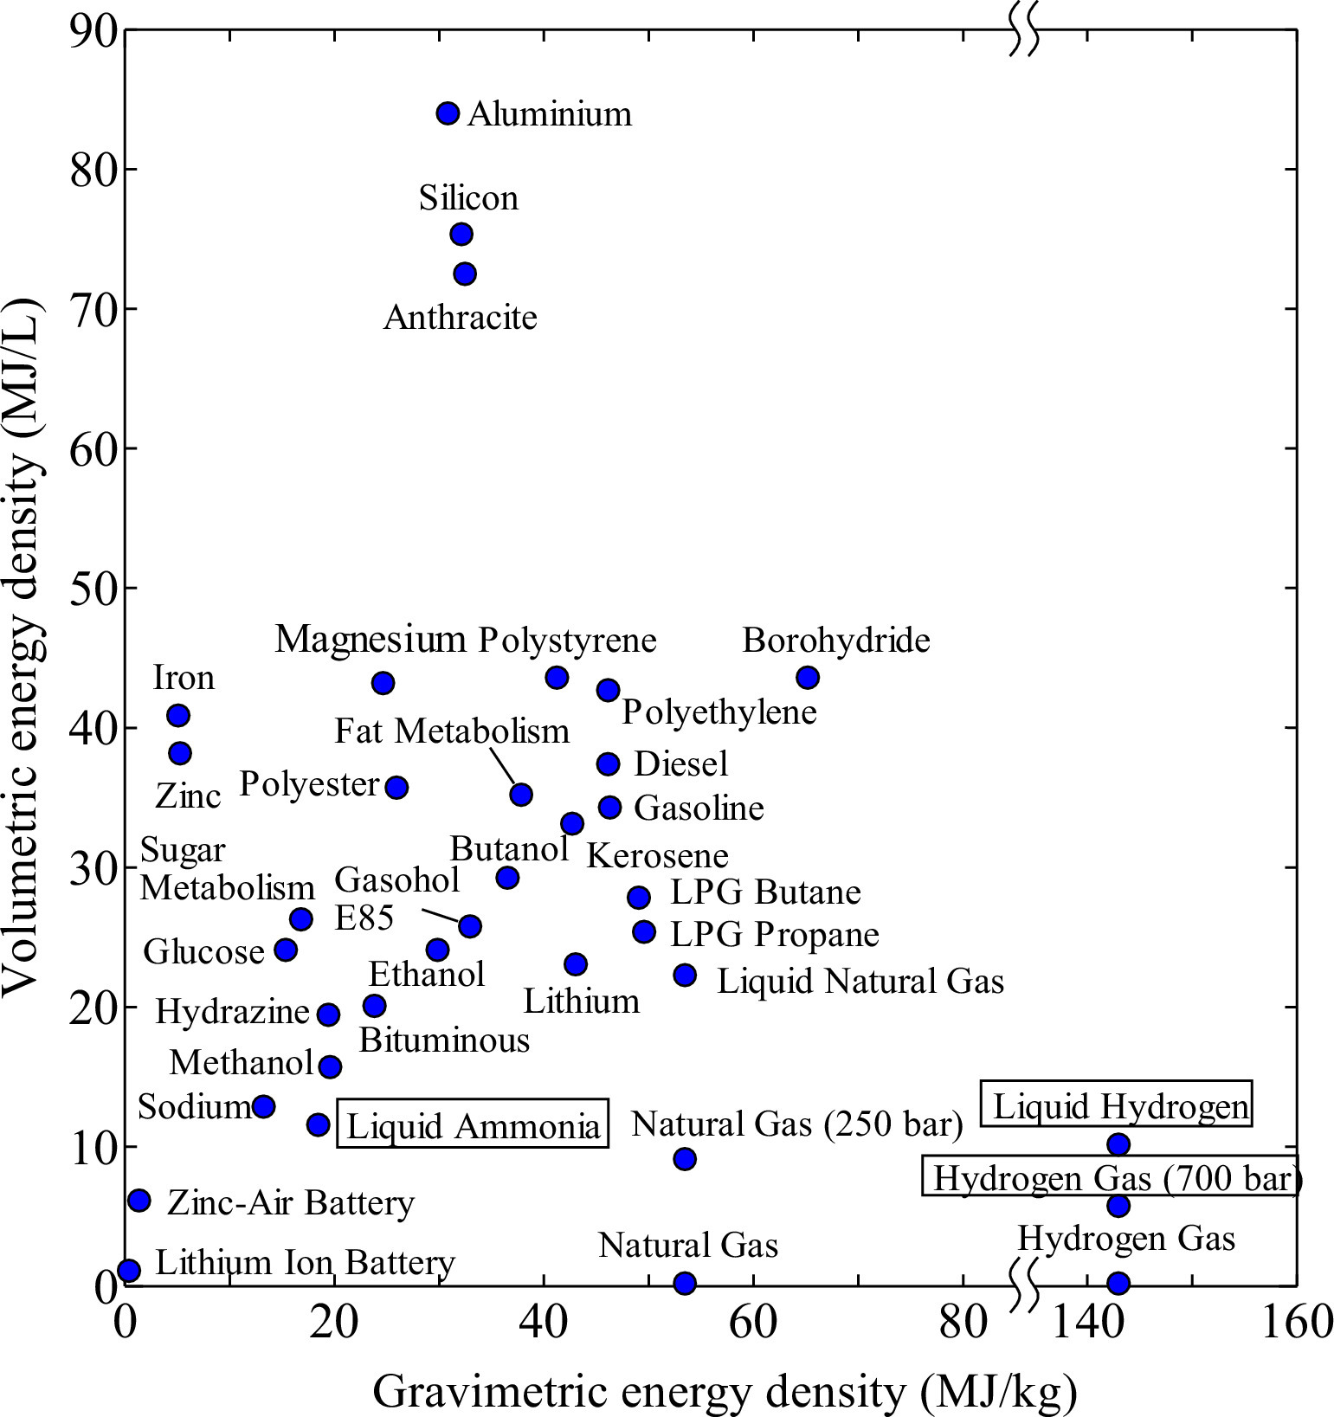
Figure 1 - Gravimetric Vs Volumetric Energy Densities (Kobayashi, H. et al. 2019)

Origin of Hydrogen
Hydrogen is hailed as a game-changer in global energy systems, offering a sustainable remdedy to climate change through its zero waste attributes, beneficial for both power energy generation and transportation. (Chang, S.H. and Rajuli, M.F 2024)

Primordial Origins
Hydrogen atoms formed approximately 379,000 years after the Big Bang, emerging from the hot, dense plasma of protons, electrons and photons that constituted the early universe.

Natural Occurrence on Earth
Hydrogen is rarely found in its diatomic form (H₂) due to its lightness and tendency to escape the atmosphere. Instead, it predominantly exists in combined forms such as water (H₂O) and hydrocarbons. Recent studies have highlighted several natural sources and production mechanisms of hydrogen. Due to hydrogen’s anatomical size and low molecular weight, it escapes the earth’s gravitational pull more easily than heavier gases, resulting in minimal presence in the atmosphere, ~0.00005% (0.5 parts per million, ppm). Hydrogen plays a role in the atmospheric chemistry, reacting with hydroxyl radicals (OH) and contributing to the balance of other trace gases. Although indirect, hydroxyl radicals play a role in methane (CH₄) oxidation, a process that generates hydrogen by forming formaldehyde and eventually water, releasing free hydrogen in the environment.

Geological Sources
Hydrogen can be generated through alteration of iron(II)-containing rocks, radiolysis of water, degassing of magma, and reactions involving water and reduced minerals. In geochemical processes, hydroxyl radicals may contribute to water-rock interactions that release hydrogen in geological formations.

Natural Hydrogen Emissions
Geologists have discovered numerous sources of naturally occurring hydrogen in various geologies worldwide.

Mantle Hydrogen
Recent discoveries suggest that the Earth’s mantle may contain significant quantities of natural hydrogen, indicating a larger presence than previously thought.

Industrial production
Most hydrogen used industrially is produced through methods such as steam reforming of natural gas and electrolysis of water.

Hydrogen embrittlement

Interstitial Hydrogen absorption
Hydrogen atoms dissolve into metals by taking up interstitial sites in the host crystal lattice. Due to their larger sizes of interstitial voids, BCC and FCC crystal structures can better accommodate hydrogen atoms than the HCP structure. For instance, BCC iron absorbs more hydrogen compared to FCC iron, specifically at high temperatures, which is attributed by Takahashi et al. (2017) to larger interstitial spaces in the former. However, this increased solubility is a two-edged sword, as it makes BCC metals more susceptible to hydrogen embrittlement, especially under tensile stress or cyclic loading.
In contrast, HCP structures, while less prone to hydrogen absorption due to their smaller interstitial spaces, can still experience significant degradation through hydride formation, as seen in titanium and zirconium alloys. Zirconium hydride (ZrH₂) forms when hydrogen occupies interstitial spaces, causing a phase change from HCP to FCC, drastically reducing ductility and increasing brittleness (Baskaran et al., 2015).

Lattice Expansion
The introduction of hydrogen atoms into the interstitial lattice causes lattice expansion, which generates internal stresses and distortion. For example, titanium hydrides cause a lattice parameter increase of approximately 0.1–0.2% per atomic percent hydrogen, leading to significant internal stresses (Schwartz et al., 2018)

Elastic Strain
Elastic strain generated by hydrogen absorption is directly proportional to the hydrogen concentration. Metals like nickel and palladium, which readily absorb hydrogen, exhibit significant elastic strain, leading to the accumulation of defects at grain boundaries. This phenomenon is particularly problematic for high-strength alloys, where localized strain can act as a precursor for hydrogen-assisted cracking (HAC) (Sofronis & Robertson, 2017).

Hydride formation
In the case of high hydrogen concentration, metals can form metal hydrides, which are a result of the chemical bonding between hydrogen atoms and metal atoms. The formation of such hydride is very often accompanied by pronounced structural changes in the metal: new crystal structure formations, changes in the lattice constants, and local symmetry changes. Such transformations have a marked effect on the mechanical properties, especially in ductility and fracture resistance. A typical example is the HCP-to-FCC or the tetragonal transformation of the structure in case of Ti due to formation of titanium hydrides (TiH₂), which affects its mechanical behavior drastically. The Schwartz et al. study documented this in their work that was published in 2018. Similarly, zirconium undergoes a phase transition from HCP to FCC when zirconium hydrides (ZrH₂) form, leading to a degradation in its material properties (Ramberg et al., 2020). This transformation indeed brings larger lattice constants, as hydrogen atoms occupy the interstitial space within the lattices and expand the unit cell dimensions. For example, the lattice constant of TiH₂ is around 15% larger than that of pure titanium and thus induces internal stresses in the material (Schwartz et al., 2018).
The hydride formation in metals reduces ductility, increases brittleness, and reduces the mobility of dislocations-those imperfections which are crucial for plastic deformation. Dislocations move along specific slip systems, which are crystallographic planes or directions where atomic layers can slide under stress. However, hydride phases often show distinct crystallographic structures with fewer or no active slip systems. For example, the tetragonal structure of ZrH₂ has only a few slip planes, which impairs ductility compared to the parent HCP zirconium, Ramberg et al. 2020. The hydride hence results in a loss of ductility and hence more brittle material that has high susceptibility to fracture, especially under high levels of stress.
Hydrogen-induced embrittlement becomes especially concerning at high hydrogen concentrations. Hydrogen-induced embrittlement is severe in titanium alloys, where fracture toughness decreases by 50% with an increase in hydrogen concentration above 100 ppm (Kim Y et al., 2017). For zirconium alloys, which are commonly used in nuclear reactors, hydride-induced embrittlement is a major failure mode, particularly when hydrogen concentrations exceed 500 ppm. In these cases, hydrides accumulate at grain boundaries, initiating cracking under tensile stress (Baskaran et al., 2015). The presence of hydrogen and hydrides thus severely compromises the material's integrity, making it more susceptible to catastrophic failure under mechanical loading.
Besides the formation of hydride, hydrogen solubility in metals is also governed by the Sievert's law, according to which in metals, the concentration of hydrogen, C is directly proportional to the square root of the partial pressure of hydrogen, P in the surrounding provided by the relation, $C=k\sqrt{P}$. A relatively large amount of hydrogen at elevated temperature can dissolve in molten iron, which, when the molten iron starts cooling down exceeds the limit of its solubility, thereby resulting in a situation known as supersaturation. This is the solution to this problem. At the solid-phase, hydrogen concentration exceeds the metal's capacity for retaining it, and hydrogen atoms combine into molecular hydrogen gas, this results in gas bubbles or porosity, (Tayeb et al., 2016) The mechanical properties of metals, such as ultimate tensile strength, fatigue limiters, and ductility are degraded severely by these kinds of porosity created due to hydrogen absorption like pinholes, blowholes or micropores. (Tanaka et al., 2017). Hydrogen concentrations above 200 ppm in steel can lead to sudden losses of tensile strength and fatigue resistance with an increased risk of sudden failure. (Tanaka et al., 2017.)
Effects other than porosity and the formation of metal hydrides can occur due to hydrogen absorption. The most evident effect of hydrogen absorption is lattice expansion, in which hydrogen atoms occupy the interstitial spaces of the metal lattice, causing internal stresses and distortions within the host metal. These stresses are directly proportional to the concentration of hydrogen within the material, with the lattice expansion capable of even inducing phase transformation in some metals. For example, in titanium alloys, hydrogen absorption can cause a phase change from the α phase (solid solution) to the β phase (hydride phase), further contributing to a reduction in ductility and toughness (Liu et al., 2020). Hydrogen can build up at grain boundaries in steel alloys, facilitating intergranular cracking and hydrogen-induced cracking, HIC, which significantly reduces the fatigue life of the material. According to Koch et al. (2019), vacuum degassing, argon purging, and controlled cooling are some of the different methods applied to prevent hydrogen-induced defects. Vacuum degassing by itself can remove up to 90% of hydrogen from molten iron, thus minimizing the chances of hydrogen-induced porosity. According to Tanaka et al. (2017), controlled cooling rates provide the opportunity for hydrogen to diffuse from the metal during solidification and avoid supersaturation. Shielding gases in welding and casting further reduce hydrogen absorption by keeping the molten metal free from contamination. The various treatments discussed here have generally been associated, in most cases, with loss in some aspects of production efficiency, cost, and material performance. For example, hydrogen content reduction by vacuum degassing or argon purging is extremely time-consuming and costly, although highly essential in quality assurance of the materials to be used for high-strength applications where material failure is unacceptable (Tayeb et al., 2016).

Microstructural effects

Dislocation Interaction
Hydrogen atoms interact with dislocations leading to pinning or multiplication. Excessive hydrogen absorption can create voids or cracks, especially along grain boundaries, causing embrittlement.

Grain boundary Effects
Hydrogen preferentially segregates to grain boundaries, reducing cohesion and making them weaker. Weak grain boundaries make the material more susceptible to crack initiation and propagation, which leads to intergranular fractures, where cracks propagate along grain boundaries rather than though the grains themselves. Grain boundaries play a critical role in transferring load across grains, therefore weak boundaries reduce overall material strength.

Fatigue failure
Grain boundaries often act as sites of stress concentration, weaker boundaries are more likely to nucleate cracks under cyclic loading. The presence of weak grain boundaries accelerates crack growth, reducing the material’s fatigue life.

Dissociation and diffusion
Hydrogen molecules (H₂) dissociate into atomic hydrogen (H) on the surface of liquid metal, facilitated by high temperatures. The atomic hydrogen diffuses into molten metal due to its solubility in the liquid state, depending on temperature and pressure.
$H_{2}↔2H$ (at metal surface)

Contributing factors to hydrogen absorption
Liquid iron at elevated temperatures dissolves appreciable amounts of hydrogen, its solubility increasing with temperature in accordance with Sievert's Law: the solubility of a gas in a metal is proportional to the square root of its partial pressure. This allows molten iron to pick up hydrogen during processing. As the molten iron cools, the solubility of hydrogen decreases sharply in the solid, supersaturation occurring because of insufficient diffusion of hydrogen atoms out of the lattice.
Supersaturation forces the excess hydrogen atoms to clump together as molecular hydrogen gas bubbles, producing porosity. These defects may appear as pinholes, blowholes, or micropores and lead to a reduction in tensile strength, fatigue resistance, ductility, and toughness. Porosity is particularly harmful in high-strength applications such as aerospace components, where defects can initiate catastrophic failure.
The degree of supersaturation depends not only on the kinetics of hydrogen diffusion but also on the rate of cooling. Thus, the quicker the rate of cooling, the more hydrogen becomes trapped in the solidifying matrix, whereas, with slower cooling, some diffusion out of the metal can take place. Impurities such as sulphur and phosphorus encourage porosity by restricting the mobility of hydrogen, whereas alloying elements, for example, carbon, influence the solubility and diffusivity of hydrogen.
Present mitigation strategies include vacuum degassing and argon purging; these are effective in reducing the hydrogen content of molten iron. Up to 90% hydrogen can be removed by vacuum degassing. Minimizing hydrogen absorption, with controlled cooling rates and shielding improvements during melting and casting, further adds to this. These measures have associated trade-offs with costs and production efficiency versus defect mitigation. Addition of elements such as niobium, vanadium, or molybdenum improves hydrogen resistance owing to either the stabilization of the lattice structure and/or the alteration of the hydrogen diffusion paths. ZIRLO a niobium-stabilized zirconium alloy-finds wide application in modern nuclear reactors because it shows excellent resistance to hydride formation. (Baskaran et al., 2015).
Porosity increases the production cost owing to rework and rejection rates; hence, foundries incur huge loss in the manufacture of defective castings. Such challenges call for advanced controls for the processes, further understanding of the dynamics in solidification, and use of innovative techniques to mitigate hydrogen absorption. Such processes need optimization to result in reliable and economically viable metal components.

Hydrogen challenges in Welding
Such welding is an important fabrication process, finding application in many industries-most prominently in construction, automotive, aerospace, and energy sectors. Much as welding is also versatile and fast, being a means through which pieces of metal are joined together, hydrogen-induced cracking remains a nightmare that threatens the long-term integrity and performance in several welded structures. The mechanical properties, such as tensile strength, ductility, and fatigue resistance, can be seriously deteriorated by such defects as porosity, hydrogen-induced cracking, and hydrogen embrittlement caused by hydrogen absorption during welding. In most cases, hydrogen-induced cracking is a critical problem developed under the concurrent action of several factors: residual stresses, crack-susceptible microstructure, and absorbed hydrogen.
Hydrogen-induced cracking may appear hours or days after welding and hence is difficult to detect during the process. Such delayed cracking behaviour creates a challenge in QA for the welding industries, as the cracks may appear much later, sometimes resulting in catastrophic failure of the parts (Koch et al., 2019). The problem is increased by residual stresses from welding. Besides that, these, along with the embrittling effects of hydrogen, will promote both initiation and propagation. Residual stresses arise from thermal gradients experienced during welding that result in uneven expansion and contraction of the material, creating a tensile stress field in the welded region. Generally, cold cracking in high-strength steels occurs under conditions of high tensile stresses, which, together with a brittle microstructure induced by hydrogen, promote fracture. Often, cracks appear at grain boundaries but also can form directly within the weld metal. Given the consequences it has on structural strength and safety, the chances of this should be considered at the stage of welding while preparing structures and means should be taken to minimize its possibilities.
While traditional gas welding is a practical and rather inexpensive solution for general applications, by its nature, it has some limitations regarding hydrogen absorption control and weld integrity.
Laser welding with inert gas gives the best results regarding the least occurrence of hydrogen-induced defects because of its precision control, inert shielding, and localized heat input. With increasing demands for high-strength, defect-free welds, especially in aerospace and automotive industries, laser welding is gaining favour despite its higher initial cost. For applications that are less critical, however, gas welding remains a viable alternative.

Criteria | Optical Microscope | Electron Microscope
Resolution | Lower resolution (typically ~0.2–0.5 µm). | High resolution (up to ~0.1 nm for TEM).
Defect Types Detected | Surface cracks, larger voids, or hydride precipitates visible at micro-scale. | Nanoscale voids, dislocations, and hydrides. Ideal for detecting early-stage hydrogen damage.
Hydride Analysis | Limited ability to differentiate hydrides or phases. Requires chemical etching for contrast. | Clear visualization of hydrides and phase changes. Can differentiate hydride phases like TiH₂ or ZrH₂ via diffraction patterns (TEM) or elemental mapping (SEM-EDS).
Stress/Strain indicators | Limited; indirect detection through crack patterns or microstructural deformation. | Can observe lattice distortions and strain using electron diffraction or high-resolution imaging.
Sample preparation | Minimal; polished surface is sufficient. | Requires complex preparation (thin sections for TEM, conductive coatings for SEM).
Cost and Accessibility | Low-cost and widely available. | High cost; requires specialized equipment and expertise.
Use Case For hydrogen-absorbed metals | Suitable for initial defect assessment, identifying larger hydrogen-related voids and surface hydrides. | Ideal for detailed analysis of hydrogen-induced nanostructural changes, such as dislocations, nano-hydrides, and phase transformations.
Time for analysis | Short; quick overview of defects. | Longer, detailed nanoscale investigation.
Key limitations | Cannot detect nanoscale defects or lattice distortions. | High equipment and operational costs, plus time-intensive analysis.

Conclusion
In conclusion, the absorption of hydrogen into metals during processing and fabrication can lead to severe material degradation, including reduced strength, ductility, and fatigue resistance. The formation of porosity due to supersaturation, phase transformations caused by hydride formation, and lattice distortions resulting from hydrogen absorption all contribute to embrittlement. Understanding and controlling hydrogen interactions with metals through advanced metallurgical techniques, such as vacuum degassing, controlled cooling, and shielding, is essential to minimising these defects and ensuring the durability and integrity of materials used in high-performance applications.

References
Baskaran, R., et al. (2015). Zirconium alloys and hydrogen absorption in nuclear reactors: Implications for material integrity. Journal of Nuclear Materials, 463, 329-337.
Campari, A. et al. (2023) ‘A review on hydrogen embrittlement and risk-based inspection of Hydrogen Technologies’, International Journal of Hydrogen Energy, 48(90), pp. 35316–35346. doi:10.1016/j.ijhydene.2023.05.293.
Chang, S.H. and Rajuli, M.F. (2024) ‘An overview of pure hydrogen production via electrolysis and hydrolysis’, International Journal of Hydrogen Energy, 84, pp. 521–538. doi:10.1016/j.ijhydene.2024.08.245.
Kim, J., & Park, S. (2017). Hydride-induced embrittlement in titanium alloys. Journal of Materials Research, 32(10), 1457–1465.
Kim, Y., et al. (2017). Hydrogen embrittlement in titanium alloys: A review of mechanisms and mitigation strategies. Journal of Materials Science & Technology, 33(12), 1751-1760.
Kobayashi, H. et al. (2019) ‘Science and Technology of Ammonia Combustion’, Proceedings of the Combustion Institute, 37(1), 109–133. doi:10.1016/j.proci.2018.09.029.
Koch, C., et al. (2019). Hydrogen-induced cracking in steel alloys and its impact on fatigue resistance. International Journal of Fatigue, 121, 20-29.
Liu, J., et al. (2020). Hydrogen embrittlement and phase transformations in titanium alloys. Metallurgical and Materials Transactions A, 51(4), 1292-1301.
Ramberg, E., et al. (2020). Hydride effects in zirconium alloys for nuclear applications. Nuclear Engineering and Design, 367, 110746.
Ramberg, R., et al. (2020). The effect of hydride formation on the mechanical properties of zirconium alloys. Acta Materialia, 182, 127-136.
Schwartz, C. P., et al. (2018). Phase transformations and lattice changes in titanium hydrides. Metallurgical Transactions A, 49(3), 655–664.
Schwartz, R., et al. (2018). Hydrogen absorption and hydride formation in titanium alloys: Effects on mechanical properties. Journal of Materials Science, 53(24), 16589-16598.
Sofronis, P., & Robertson, I. M. (2017). Hydrogen effects on dislocation activity in metals. Acta Materialia, 122, 77–85.

Tayeb, A., et al. (2016). Hydrogen-induced porosity in cast iron and its mitigation strategies. Journal of Materials Engineering and Performance, 25(6), 2305-2314.
Tanaka, M., et al. (2017). Effects of hydrogen on the mechanical properties of steel and its mitigation. Journal of the Japan Institute of Metals and Materials, 81(1), 22-31.

