
A Critical Analysis of the HR Practices at FEI Foods and How They Influence Engagement
Research Proposal
Amy Collins: 1703573
2019
Table of Contents
1. Introduction 3
1.1 FEI Foods Ltd 3
1.2 Background and Literature Review 3
1.3 Rationale 4
1.4 Aims and Objectives 5
2. Research Design and Methodology 5
2.1 Paradigm 7
2.2 Sampling 7
2.3 Data Analysis and Collection 7
2.3.1 Quantitative Analysis 7
2.3.3 Collection Method 8
2.4 Limitations 8
2.5 Ethical Risks 8
3. Resources and Planning 9
3.1 Resources 9
3.2 Timescale 9
3.3 Gantt Chart 10
4. References 12

Table of Figures
Figure 1: The Research Onion (Saunders et al., 2009) 6
Figure 2: Gantt Chart 11

1. Introduction

The purpose of this dissertation is to critically analyse the HR practices that are currently being carried out at FEI Foods. It will also provide an evaluation on how they influence engagement to their workforce. Employee engagement is critical to all businesses as it enables staff to feel motivated and results in them wanting to help move the company in the right direction (Sunil, 2019).

1.1 FEI Foods Ltd

FEI Foods Ltd is a large microwavable rice and snack pots manufacturer based in Swansea. They currently produce and supply some of the markets leading supermarkets and food retailers in Europe and the UK (FEI Foods, 2019).

1.2 Background and Literature Review
There are various ways in which engagement can be defined, however for the purpose of this study the researcher will discuss both work engagement and employee engagement. Work engagement can be described as the relationship someone has with their job, whereas employee engagement can be similar but it also includes the person’s relationship with the organisation (Truss et al., 2013).
Employee engagement can be linked with a series of outcomes that benefit an organisation. For example, improved performance, profitability and employee retention (Sharma et al., 2019). This means that it is vital for all organisations to ensure they are encouraging employee engagement to attempt to keep their workforce satisfied and improve the business overall. It has been claimed that employees that are engaged at work have higher customer satisfaction rankings on average as well as contributing towards an improved organisational performance (Engage for Success, 2012). The results of employee engagement are suggested to be an exact match for what many businesses are looking for in an employee. For example, they are more likely to be productive, healthier and more likely to stay at that job, as well as being less likely to take any day’s absence (Buchanan, 2004). It has been argued that “happy and satisfied employees of an organization play a major role in achieving organizational objective” and, with this being the case, it is vital for organisations to turn their focus more on the essential elements of their business to ensure they are satisfied and therefore make them more productive to meet the objectives of the organisation (Pradhan et al., 2017). Engage for Success (2019) argues that there is no straight forward approach in relation to successful employee engagement, therefore after comprehensive research conducted by David MacLeod he has established four enablers to aid organisations in their attempt to improve their employee engagement. The four enablers are strategic narrative, engaging managers, employee voice and integrity (Engage for Success, 2019). In relation to this research study on FEI Foods, the researcher will only be discussing engaging managers and employee voice as part of their dissertation.

1.3 Rationale
The current staff turnover rate at FEI Foods is at approximately 70%. This
may be related to the amount they are paying their staff as well as the effectiveness of the practices they have that encourages engagement. The researcher will assess the various factors that drive employee engagement within a workforce, including the importance for competitive wages. There is a lack of academic literature that discusses the relationship between HR practices, employee engagement and job satisfaction (Pradhan et al., 2017) Due to this being the case, the researcher is carrying out this study.

1.4 Aims and Objectives

The aim of this dissertation is to critically analyse the HR practices that are in place at FEI Foods and how they influence engagement to their workforce. The objectives for this study can be seen below:

1. To critically analyse previous academic literature on HR practices and how they influence workforce engagement. This will be used to inform the importance of engagement to employee retention.

2. To carry out primary research through a questionnaire to establish if the HR practices that are currently in place at FEI Foods influence engagement levels of the staff.

3. To evaluate both primary and secondary data gathered to establish whether the workforce at FEI Foods are engaged.

4. To provide recommendations to FEI Foods on how to improve their employee engagement.

2. Research Design and Methodology

Saunders et al. (2009:5) defines research itself as “something that people undertake in order to find out things in a systematic way, thereby increasing their knowledge”. In the most effective way possible, research is conducted for the purpose of ensuring that any statements made by the researcher is made based on data and not made with biases (Salkind, 2012).
There are a variety of research methods for the researcher to choose from and will need to make sure that the method selected is the most appropriate for this research study. Below is an image showing the variety of routes that the researcher can take during this study and is presented within the Research Onion (Saunders, et al., 2009).
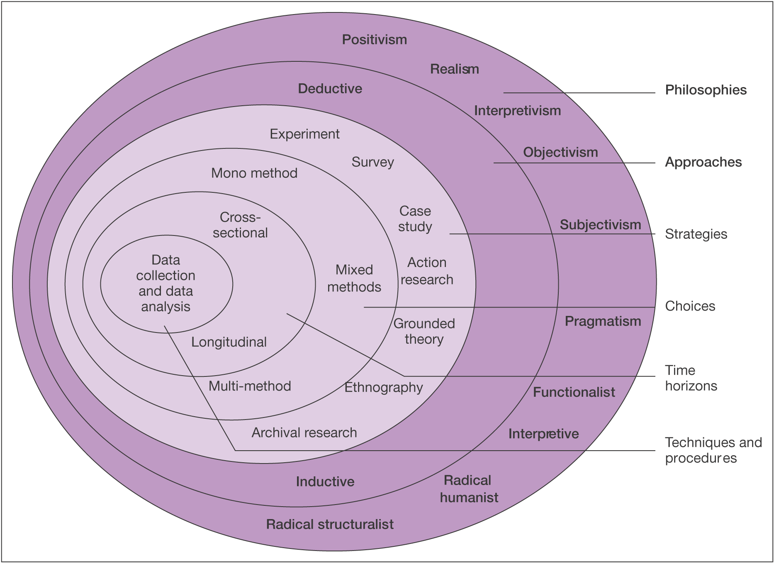
Figure 1: The Research Onion (Saunders et al., 2009)
The first aspect of the research onion is the data collection and data analysis. A cross sectional approach will be undertaken by the researcher as the type of research will be carried out at a particular time. This will be using a mono method approach as the researcher will be conducting a survey as it will provide a larger amount of responses and data that can be closely analysed compared to qualitative research. Moving onto the strategic layer of the research onion, the researcher has acknowledged the use of an inductive and pragmatist approach to the research study.

2.1 Paradigm

In regards to this research study, the researcher has identified that the philosophy used will be positivism. Closed questions from the questionnaire will be analysed with an inductive approach as the data is clearly laid out. There are various purposes to using this type of approach. For example, an inductive approach can be used to “establish clear links between the evaluation or research objectives and the summary findings derived from the raw data” (Thomas, 2006). However, open questions will be analysed with a deductive approach as it is qualitative research.

2.2 Sampling

For the purpose of this research study, convenience sampling will be used to conduct the research and gather data. This type of sampling is known as non- probability sampling and can be defined as “neither purposeful nor strategic”. It allows the researcher to fast and conveniently collect data (Patton, 1987). The researcher has chosen to select the employees that work in the factory at FEI Foods as the sample of responses. This is because it will provide the best sample possible to align with the research title and obtain a larger number of responses compared to other sampling methods for this research study.

2.3 Data Analysis and Collection

2.3.1 Quantitative Analysis

Quantitative data is data that appears in numbers (Collis & Hussey, 2009). Quantitative data will be gathered for this research study as the researcher will be using a positivist philosophy.
To analyse the results from the questionnaire, the researcher will use statistical analysis software (in this case, SPSS). This will be used to evaluate the data in the search to find trends and correlation between HR practices and the engagement among the employees at FEI Foods.

2.3.3 Collection Method

This primary research will be conducted through a questionnaire that will be created using Google Forms. The questionnaire will be issued to the shift managers at FEI Foods in order for them to be handed to the staff. This method of research is relevant to the study as it allows the researcher to gather a greater number of responses and will be beneficial when looking for trends in employee engagement. The questionnaire will be proof read by colleagues to ensure that it is appropriate for its audience.

2.4 Limitations

In relation to this study, one limitation that might occur is the timeframe being too constrained with regards to carrying out the primary research. Due to the limited timeframe possibly being an issue, the researcher will have to adapt and schedule the Gantt chart to guarantee improved time management (See 3.2 & 3.3)

2.5 Ethical Risks

During this study, the ethical risks are limited as none of the respondents will be classed as vulnerable citizens – the researcher will also ensure that anybody taking part does so by their own will, and is over the age of 18. Respondents will be informed exactly how their data will be utilised, with all answers given to be anonymised to support confidentiality. All responses from the questionnaire will be stored securely in a locked drawer as well as on a password protected file on a personal computer after analysis.

3. Resources and Planning

To ensure this research study is completed successfully, it is important to plan out the research before beginning. Many of the resources that will be used within this research study will be utilised solely for the purpose of gaining an enhanced understanding of the topic being discussed.

3.1 Resources

The resources that will be used to complete this critical analysis will be primary and secondary data. The primary data will be the data received from the questionnaire completed by the factory workers at FEI Foods. The university’s computer hardware and software will also be used in order to fully evaluate the data collected. The secondary data aspect consists of a variety of sources such as physical text books, journals, online articles and the university’s own online resources. These will all be used to extend the researcher’s knowledge of the topic and will all feature in the literature review.

3.2 Timescale

To ensure the researcher is organised and has all tasks mapped out alongside their due dates, a Gantt chart will be used. A Gantt chart can be used to clearly illustrate a series of tasks or activities that relate to a particular project (Saunders, et al., 2009). The next section will provide a clear illustration of the remaining tasks and activities the researcher is required to carry out to ensure the deadline is met by May 13th 2020.

3.3 Gantt Chart

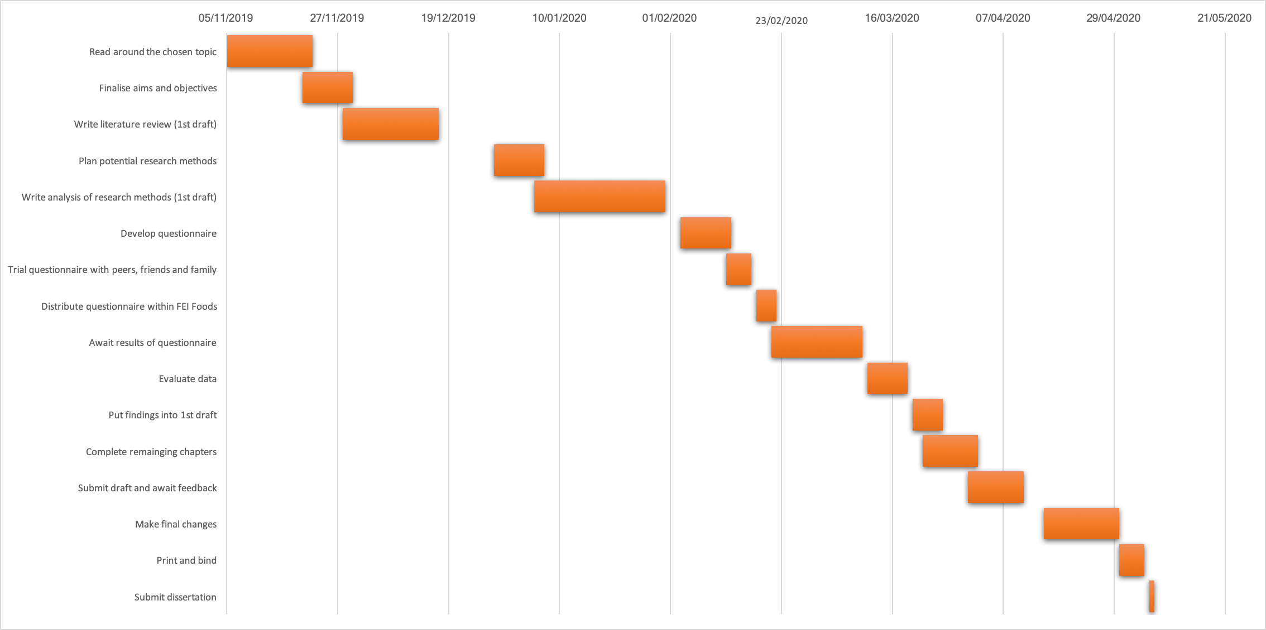
Figure 2: Gantt Chart

4. References

Buchanan, L. (2004) “The things they do for love.” Harvard Business Review, 82(12), pp. 19-20
Collis, J. & Hussey, R. (2009) “Business Research: A Practical Guide for Undergraduate and Post Graduate Students” Basingstoke: Macmillan Publishers Limited

Engage for Success. (2012) “Nailing the Evidence” Available at: https://engageforsuccess.org/nailing-the-evidence (Accessed: 12 Nov. 2019)

Engage for Success. (2019) “The Four Enablers” Available at: https://engageforsuccess.org/the-four-enablers (Accessed: 17 Nov. 2019)

FEI Foods. (2019) “Microwaveable Pouches: Packed full of flavour & convenience” Available at: https://feifoods.co.uk/ (Accessed: 18 Oct. 2019)
Patton, M. (1987) “How to Use Qualitative Methods in Evaluation” California: Sage Publications.
Pradhan, R., Dash, S. and Jena, L. (2017) “Do HR Practices Influence Job Satisfaction? Examining the Mediating Role of Employee Engagement in Indian Public Sector Undertakings.” Global Business Review, 20(1), pp.119-132.
Salkind, N. (2012) “100 Questions (and Answers) About Research Methods” California: Sage Publications.

Saunders, M., Lewis, P. & Thornhill, A. (2009) “Research Methods for Business Students” London: Pearson Education.
Sharma, N., Chaudhary, N. & Singh, V. (2019) “Management Techniques for Employee Engagement in Contemporary Organizations” Pennsylvania: IGI Global.

Sunil, P. (2019) “Why Employee Engagement is so Important and What to do about it” Available at: https://www.humanresourcesonline.net/why-employee-engagement-is-so-important-and-what-to-do-about-it/ (Accessed: 18 Oct. 2019)
Thomas, D. (2006) “A General Inductive Approach for Analyzing Qualitative Evaluation Data”. American Journal of Evaluation, 27(2), pp.237-246.
Truss, C., Alfes, K., Delbridge, R., Shantz, A. & Soane, E. (2013) “Employee Engagement in Theory and Practice” Oxfordshire: Routledge.

