16 October 2022
Certificate of Higher Education Skills for the work place
Effective team work and communication
Student name: | Boyd R. Malcolm
Student id | 2128536
Module code: | BMSW4002_BIRM
Lecturer: | Dr. Hafiz Rahmani

Assignment title: Report on Effective Teamworking for Business Success



Table of Content
Introduction page:3
Main Body
Group formation page 4
Role and function of groups page:5
Benefits of teamwork page 6
Communications solutions page 7
Summary and My Take A Way page:8
Wheelan Model Page:9
Figure 1-: Belbin's Team Roles page:9
Références page 10

Introduction
The process of forming and developing a team into an effective team is critical, as is
organizational management.
The importance of teams in organisations stems from the fact that all organisations rely on teams to complete critical tasks (pina, Martinez, and Martinez,2018).
Most teams, however, have found it difficult to develop effective teams. In most cases,
teams fail or become ineffective due to negative factors that make success impossible.
Furthermore, the case study demonstrates that the team lacked an established
communication channels, and some members are more concerned with their personal
benefits than the team's collective success. The goal of this report is to provide direction to the team leader in order to maximise effectiveness. The Wheelan model and the Belbin team rules will be the primary models on which this report will concentrate.

Lets us start by getting the main idea of a group formation. As explained by Tuckerman's (1965), this is where a group meets for the first time, they try to figure out each other. everyone is unsure of what to expect, they test each other's boundaries while trying to feel safe enough to express themselves, at this stage they should reach a point where there is some conflict due to strength and personalities starting to be revealed
Following the chaos, subset groups are formed within the main group. People begin to trust key members, this is where they should begin to share, their thoughts and ideas on how to complete their tasks as quickly as possible so they have more free time to socialize. They also begin to feel at ease and bonding begins.
The next step in this process is getting things done; they already know each other's strengths and weaknesses, and they use their own strengths to help each other progress. The ultimate goal is to complete the task at hand, in a timely manner; each person knows their role and function and feels the need to improve daily to get that feeling of job satisfaction.
Tuckman was updated by Wheelan(2016) by shortening a step and making a few changes. The methodology emphasizes the chosen leader taking control of any situation that may arise; the concept is that rather than giving people too many choices or options, they should rely solely on the leader, for guidance and direction until they are confident enough to branch out on their own. This is a more maternal approach that takes less time to settle. As the leader, you will intervene to resolve major issues and conflicts and direct them toward the task at hand.
So, Tom, for the task you're attempting to complete, the Wheelan model is the best way to form your team. You will be a dominant leadership figure, guiding your project while allowing your team to go through the necessary processing stages, and you would intervene to solve any conflicts and coax them along until they reached the bounded stage where they would be less dependent on you. The fact is that you need a very strong team because the project is divided between three different cities, so good communication skills are required. According to Pearce (2007), if a person is in a managerial position, they should never allow the failures of their team members/employees to undermine their self-confidence. Instead, discuss with them what went wrong and why. Determine and then attempt to correct the root causes of failure, such as by providing additional training or equipment. Instil confidence in your team/employees and encourage them to try again.
When a team is performing well, each team member usually has distinct responsibilities. Equally important, you'll notice that every role required to achieve the team's goal is being played fully and well.
According to by the mind tool content team, accessed (15 Oct 2022) For many years, Dr. Meredith Belbin Studied teamwork and famously observed that people in teams tend to assume different "team roles." He defined a team role as "a natural tendency to behave, contribute, and interact with others in a specific way," and he identified nine such team roles that underpin team success. Belbin's Team Roles - Leadership Training from MindTools.com
Shapers are people who push the team to be better. They are dynamic and usually extroverted people who enjoy stimulating others, challenging norms, and figuring out the best ways to solve problems. Implementers are those who make things happen. They translate the team's ideas and concepts into actionable steps and plans. Completer-Finishers are those who ensure that projects are completed completely. They ensure that no errors or omissions have occurred, and they pay close attention to the smallest of details. action -oriented roles
Coordinators, also known as "chairpersons," are the people who take on the traditional team-leader role. They direct the team toward what they perceive to be the goals. Team Workers are individuals who provide assistance and ensure that members of their team work effectively together. These individuals serve as team negotiators and are adaptable, diplomatic, and perceptive. Resource Investigators are creative and inquisitive. They investigate available options, make contacts, and negotiate for team resources. They are enthusiastic team members who identify and collaborate with external stakeholders to help the team achieve its goal. People oriented roles
The Plant is an innovative thinker who comes up with new ideas and approaches. They thrive on praise, but criticism is especially difficult for them. Monitor-Evaluators excel at analyzing and evaluating ideas generated by others (often Plants). These individuals are astute and objective. Specialists are people who have specialized knowledge that is required to complete a task. thought oriented roles
Tom I would recommend that you use the people-oriented roles because they will best suit the purpose of the task that you are attempting to complete; this is where you can fully utilize Mihaela and Spencer. You could also choose from the other qualities to assign each team member a specific task and function; for example, Mihaela and Spencer would be monitor-evaluators and resource investigators, so as the leader, you should try to find a role that fits them; this is not a quick fix, so you could try them in different roles until they fit. The significance of collaboration (as proven by science)

According to research, collaborative problem-solving produces better results. If they have the backing of a team, people are more likely to take calculated risks that lead to innovation. Working as part of a team promotes personal development, increases job satisfaction, and reduces stress. benefits of teams - Search (bing.com)
The benefits of a team that works well together will lead to The benefits of teamwork (as proven by science) - Work Life by Atlassian
The general understanding A group that functions at a higher level is more productive, which increases productivity and makes it easier to share workloads. Team members rely on one another, so more guidance and idea exchange encourages innovation and different perspectives, which leads to better ideas for doing a task.
Boosted motivation When a task is completed as a result of the power of teamwork, they have a greater sense of accomplishment because someone cared enough to help them. This improves self-worth and self-esteem, as well as morale and camaraderie.
Personnel in groups improves coordination and communication which increases job satisfaction. For a team to work, it must be diverse, digital, dispersed, and dynamic.
Doctor Patrick Laughlin suggested that by forming a group of three to five people they should excel at complex problem-solving. When a team works well together, each member knows the ins and outs of their process, so when encouraged to work together, each member has a larger pool of knowledge to draw from, and working together can make the process easier. If this actually occurs, it will benefit the company.
According to the same article, healthy competition among peers in a group motivates them to try harder and do better, and a good team creates a happier work environment, which ultimately reduces stress.

Be open and truthful. Maintain a clear and simple message. Inspire and engage, not just inform. Put punctuality first. Maintain consistency.
5 Internal Business Communication Best Practices | Grammarly Business
People value honesty and openness because it fosters trust. Being "in the know" about what's going on in your organisation also encourages active engagement rather than silent observation, which increases employee engagement. This is especially true in written communication, where it is all too easy to lose that crucial human touch. While complete transparency may not always be possible, communicating openly and honestly will produce better results. Sharing company health and milestone updates. Delivering both bad and good news. Accepting (and correcting) a lack of knowledge about a specific issue or topic, and encouraging team members to do the same.
Clearness and straightforwardness are essential for managing expectations and achieving desired results. Internal and external, this means greater efficiency and fewer misunderstandings. Breaking down complex ideas and procedures into specific steps and controllable chunks. Including images, videos, and metaphors to help explain abstract or difficult concepts. Using a proofreading tool or a digital writing assistant that can assess the clarity and conciseness of written communication in real-time and provide suggestions for improvement.
Simply telling someone the facts is not enough to educate them; you must also show them why your message is important. Connecting the dots in this manner is what will ultimately elicit the desired response and inspire them to act. They might even become more proactive. Engagement is essential for growth, and motivating employees to be more engaged by identifying and adopting a distinct tone and personality to be used both internally and externally. Use a virtual tone detector to ensure that written communications match your company's preferred voice and tone.
More than efficiency is at stake when it comes to responding quickly to comments, questions, or requests. It demonstrates how much you appreciate and respects the other person's time and patience. Even if it takes time to find the necessary information to answer a question, being prompt in informing the other person that you will get back to them later is preferable to leaving them in the dark. Using a messaging platform that allows you to set up autoresponders for simple responses. putting in place a writing assistant tool that can integrate with communication, instantly analyze messages, and suggest changes before sending them
Consistency in information and presentation is essential for creating a unified identity and avoiding unnecessary confusion and frustration. Provide opportunities for regular training to review guidelines and ensure company-wide compliance. Use a writing assistant tool with a style guide feature that allows team members to quickly and easily check draughts against your company's internal guidelines. To effectively implement these best practices, you'll need a strategy that is tailored to your company's needs.
Tom from the points mentions above you would automatically solve, your communication and commitment issues.

To summarise
After conducting this research, Tom, the Wheelan model is the best way to form your team for the task you're attempting to complete. When a team is successful, each team member usually has distinct responsibilities. You'll also notice that every role necessary to achieve the team's goal is being played fully and well. Tom I would recommend that you use Belvin's people-oriented roles because they will best suit the purpose of the task that you are attempting to complete. Be open and honest. Maintain a simple and clear message. Not just inform, but also inspire and engage. Prioritize punctuality. Keep your consistency. Collaborative problem-solving produces better results when communicating. People are more likely to take calculated risks that lead to innovation if they have the support of a team. Working as part of a team fosters personal growth, increases job satisfaction, and reduces stress.

My Take away.
Most of the ideas discussed will also be implemented by me, as it teaches me about things I previously took for granted. I never took the time to learn about team formation, the importance of effective communication, or its impact. The role and function of each member It has already begun to have an impact on my life, especially at work, where I am now confident in reorganising my team for greater efficiency.

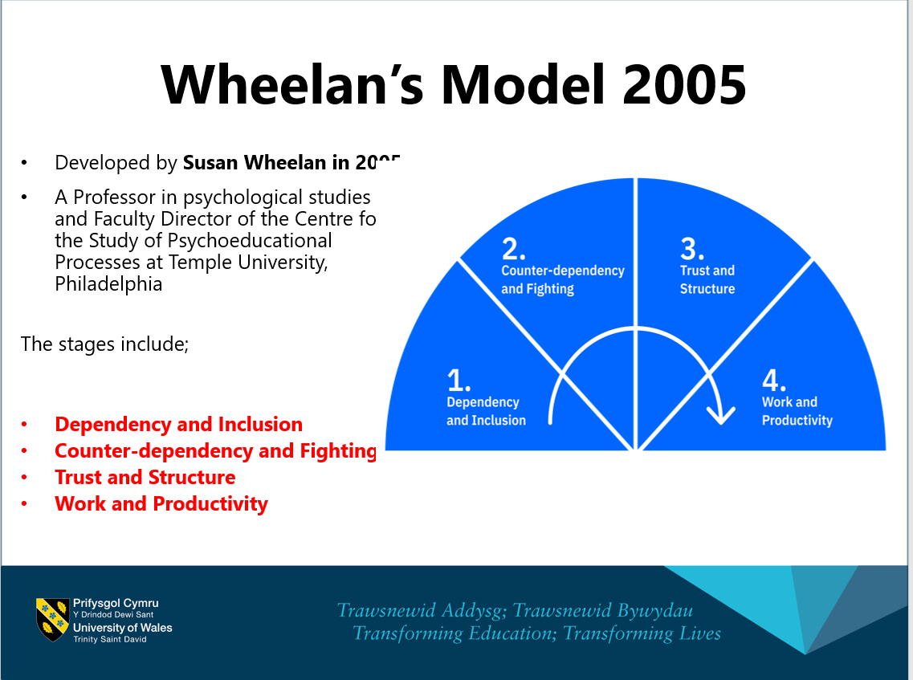
Week 2 slide 22- Effective team work and communication
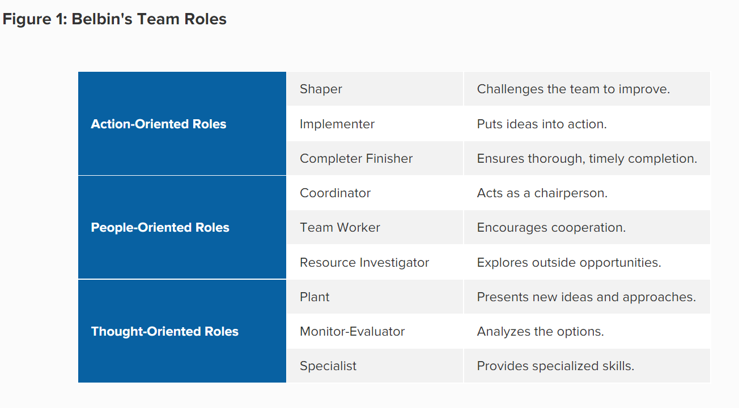Belbin's Team Roles - Leadership Training from MindTools.com

References

5 Internal Business Communication Best Practices | Grammarly Business

Belbin, M., (2010), Team Roles at Work, eBook Collection (EBSCOhost), Routledge

Belbin's Team Roles - Leadership Training from MindTools.com

https://www.atlassian.com/blog/author/trcmddltn

The benefits of teamwork (as proven by science) - Work Life by Atlassian

Pasleau, P., (2017), Tuckman Model: Understanding the stages of team formation, [video], Available at: https://www.youtube.com/watch?v=2QbXc6E08H4 (Accessed: 19 June 2020).

PEARCE, C.,:2007. Ten steps to staff motivation. Nursing Management (through 2013), 13(9), pp. 21

Pina, M.I.D., Martinez, A.M.R. and Martinez, L.G., 2018. Teams in organizations: a reviewon team effectiveness. Team Performance Management:An International Journal.

Wheelan, S.A., (2016), Creating Effective Teams, 5th edn, London: SAGE

