

Innovative Service Plan
Table of Contents
1. Introduction 3
2.1 The innovative service proposition: 3
2.2 E-commerce 8
2.3 Marketing 10
3. Summary 12
References 14

1. Introduction
In this report, a proper innovative service plan regarding a newer business venture will be proposed regarding travel guidance providing business Xploraholic. Concerning this context, ideas regarding the development of a newer mobile application will be developed. Which appropriate ideas will be included in this report which will support in designing a user-friendly application for different kinds of travellers which will be included in this particular report.

2.1 The innovative service proposition:
The tourism industry is near about 1.16 trillion British Pounds (Statista, 2022). Innovative businesses in this sector can be proven highly profitable as well as they can acquire huge customers within a short time. For that reason, this study has thrown light on an innovative business venture, “Xploraholic”. Xploraholic is all about a mobile application that will guide people who love to travel and explore the world. It is a software service-based company that will guide customers in order to select the travel destination according to their budget, book tickets and other transportation for ensuring the journey of the customers. Moreover, customers can book their hotel rooms through the Xploraholic mobile app. Moreover, the app will provide a virtual tour assistant to make the customers informed about the details of the spot they will visit (Cook, 2016). In addition, the 24x7 customer support service of this app will also help customers in any problematic situation. Based on the services of Xploraholic it can be said that the business idea will sell a complete travel solution to the customers. In present time there is no mobile application that provides a complete solution regarding the trip. Its personalised suggestions make it unique
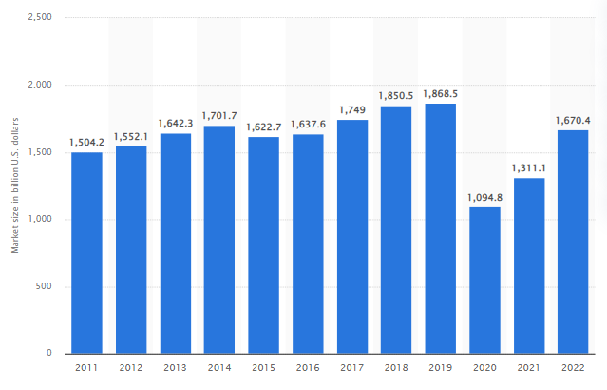
Figure 1: Market size of tourism industry
The service that Xploraholic is going to provide has several traits that make it innovative. Currently in order to travel to any place customers must go through different applications for performing different tasks like flight ticket booking, hotel room booking and so on. Xploraholic is an innovative mobile application in which customers can perform all these tasks. Another innovative aspect of this service is its AI and chatbot system (Gamble, 2022). The mobile application of Xploraholic will be available in Google Play for android users and AppStore for iOS users. The application will earn money from the end of consumers as well as the agencies connected with this app. When the customers will buy any travel package a certain percentage of the profit will be received by Xploraholic. Moreover, hotels and other agencies will ensure their partnership with Xploraholic with subscription fees.
Unique selling point
Xploraholic which is a travel guide providing software has planned on providing their targeted customers belonging from the age groups belonging from 16 to 65 yrs. of age present in different markets. The unique selling point of this travel guidance providing software is that it will help the customers in attaining adequate knowledge regarding any travel destination following their stipulated budgeting options (Haaker et al 2021). This unique travelling application will help its customers by providing virtual travel assistance through the integration of AI Technology within the mobile application (Wang et al 2019).
Other than that, it will provide travelling guidance to the travels in terms of locations and other facilities for further enhancing their travelling experience. Moreover, one of the most unique selling points of this application is the providence of personalised destination suggestion to the varied travellers in accordance with their budget (Jeong & Shin, 2020). All these different unique selling points will help this mobile application in becoming much more acceptable amongst the buyers and is also quite innovative in nature.
Moreover, this mobile application will also support assisting the travellers in getting guidance regarding the food, and logging facilities that are necessary information regarding the travel destination. Moreover, the application will help the travellers in booking their train or flight tickets for visiting the location (Linton & Kwortnik, 2019). Furthermore, the mobile application will also support travellers in attaining local guidance concerning a certain destination. Thus, all these facilities will surely prove to be a unique selling point for this application amongst its intended customers (Carayannis, Samara & Bakouros, 2015).
As a part of the open innovation technique the travel guidance application will also include a reviewing section for their customers and other app users who can easily click on the links that will be provided inside the app and can also provide their feedbacks regarding the app and its different services in accordance with their level of satisfaction with the application. All these different kinds of facilities are not being provided by the main competitors of this application such as Skyscanner and Expedia and this will surely be the unique selling point of this mobile application designed for Xploraholic.
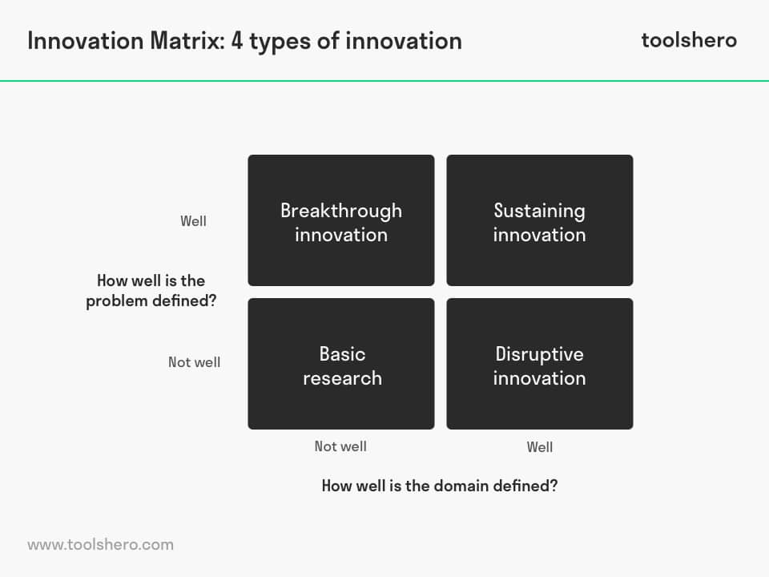
Figure: Innovation Matrix
For this business, the sustaining innovation is the most appropriate innovation matrix which has been adopted for the business. As this innovative style is quite like a breakthrough innovation as is addresses the travelling issues of the travellers in a well-defined manner. Its difference lies in the fact that the travelling sector is already well-defined which implies that the organisations is aware of the correct approach taken for arriving at its desired results (Brunswicker & Van de Vrande, 2014).
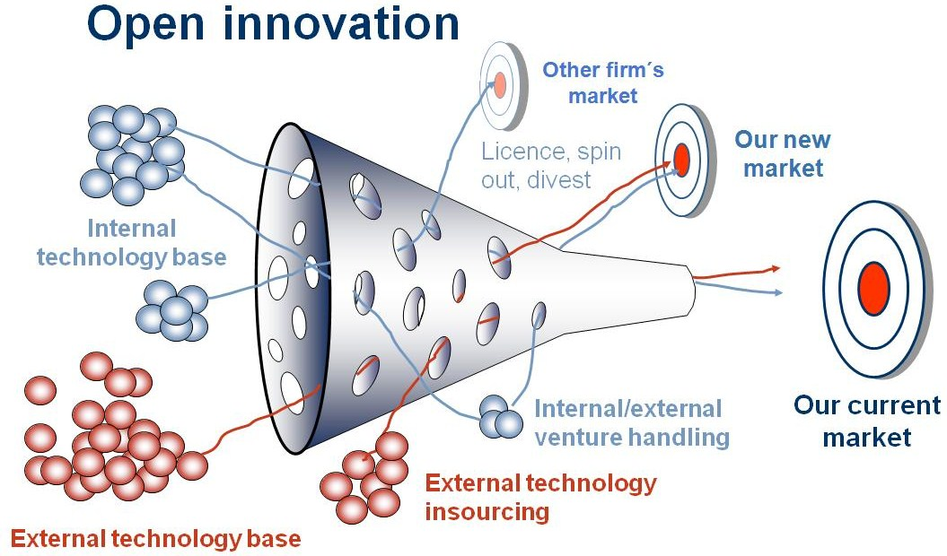 Figure: Open innovation model
As per the Schumpeterian views of innovation, it suggests that the product which is highly innovative has the potentiality to drive more consumer base than those products which has less pricing. Hence Xploraholic falls under the theory suggested by Schumpeter’s theory as it highly innovative and less focused upon pricing factors.
Customer requirements
After the end of the Covid-19 pandemic times, there has been a drastic transformation within the customer requirements that previously they use to have with the travelling businesses. After downloading this application, the intended customers will be able to gather necessary information regarding any travel destination such as the covid-19 travelling guidelines, and the costs of food and lodging-related expenses (Liew et al 2019). Along with that, they will also be enabled enough in gathering information regarding the famous attraction spots which are present within the area which the visitors can easily visit and in turn can attain a greater travelling experience for themselves (Shaheen et al 2020).
SWOT Analysis
Strengths | Weaknesses
- Due to the ease of usage of the mobile application the buyers or the customers of this application will be become able enough in effectively fining all the necessary information regarding any travel related queries that that they have regarding any travelling location. This application is mainly designed for alluring larger number of people towards the business (Singer, 2006).  - The customers can effectively buy this app either from the app store for iOS users and the play store for the android user. As it a cost-effective application which can largely use their users in getting effective travelling guidance. | - These types of applications are dependent on the availability of internet. The places where the internet is not available the app will not be able to function there. Hence the decrease in the customer base.  - Continuous changes in the customer behaviour changes are one of the major weaknesses that the application faces. As there are many similar applications already providing similar kinds of facilities creating major setback for this application (Shakibaei et al 2021).
Opportunities | Threats
- Can target many people at a single point in time.  - There are present several applications that use for hotel and ticket booking but the trend that makes it different from the others is its virtual travel assistant. It provided travel suggestions as well as guidance to the customers. For that reason, it has a huge opportunity in order to attract customers.  - The tourism industry is worth approximately 1.6 trillion British pounds and it is expanding with time (Statista, 2022). It is a great opportunity for Xploraholic in order to experience high profitability. | - Other similar Such as Skyscanner and Experia kinds of mobile applications are already available in the online market and are already being used by varied customers  - Make my trip, Expedia other application or websites which gives similar services are threat for that the organisation. Because those applications are quite popular nowadays, other local travel agents provide service at low cost hence, people can get more attracted towards them. (Sharma, Sharma & Chaudhary, 2020). Hence, it can be said that popular application and local travel agents are threat for the application.

Although there are certain famous competitors such as MakeMyTrip, RedBus and much more who can provide major competition to this mobile application. OYO (On Your Own) specialises in providing lodging and food facilities to the people with it they usually book hotel rooms for themselves for staying purposes while travelling to any location (Jia & Rua, 2020). MakeMyTrip helps its customers in booking flights for any destination. RedBus allows their intended customers in booking bus tickets for themselves and for which all these travelling businesses have designed applications for it through which their intended customers can for travel bookings in accordance with their budget and expense limitations (Shaheen et al 2020).
Xploraholic will be working as a one-stop application for their customers. Through this, its intended customer groups can easily do hotel bookings, and ticket bookings and can get guided information regarding any travelling location which they will be planning on visiting alone or with their family (Peake, Kerr & Sullivan, 2018). Moreover, this application will also sort out the travel destinations and accommodation, food and ticket booking facilities following their customer’s travelling budget ranging which will surely help in providing added competitive advantage to this new business venture in the long run (Liew et al 2019). All these added advantages will in turn help in providing an additional value of money to their targeted customer groups. Other than providing food, lodging, flights tickets, booking and other facilities the application will also be providing personalised travelling destination suggestions to their customers which is not done by its other competitors such as Skyscanner and Expedia which will prove to be the innovative factor of this mobile application (Al-Hakim, 2016).

2.2 E-Business
The mobile application will be prepared with the help of SaaS. With the help of SaaS, the new company will be able to build a better application. The app will provide an all-around service to the customers like it will book the tickets as per the budget of the customer. It will also suggest the destinations, book the hotels, and other local help. It will provide a map of the place and will also provide detailed information about the place. All these features can be installed with the help of the SaaS software. As stated by Memon et al (2020), it has been said that all-around information about travel destinations helps travellers and is used frequently by travellers (Memon et al. 2020).
The app Xploraholic will be available to people and travellers in the Google Play Store and Apple Store. Travelers and tourists can buy it from the Google Play Store and from the Apple Store. The customers will be attracted by the help of attractive content and photographs of destinations. Good content will surely bring more people to the app. The creative content will help to increase awareness about the app, and it will also help to reach potential customers. In the opinion of Schneiderman, (2000). it has been found that tempting photographs are very useful in attracting customers. With the help of attractive content, people are also attracted, and the revenue can be increased in this way.
The business idea will be a very innovative idea as it will provide complete guidance to the travellers. The app will provide all kinds of guidance to the travellers who will go to a destination. It will show recommendations about the different tourist attractions in the destinations. It will provide a complete guide to the travellers. The travellers will not need any human advice for visiting a particular destination. The app will ask about the personal details of the traveller and according to tit e budget the app will recommend the destinations, hotels, restaurants, and medium of transportation. In simple words, it is a complete guide for a traveller. The business will be a very innovative idea as the competitors like Expedia and other apps do not have these features. The business Xploraholic is providing many more added benefits to the customers and generating value for money.
Financing
Xploraholic will get the money from angel investors. Angel investors are the personnel who provide business ventures money instead of equity. Taking small loans from financial institutions sometimes creates business risk; hence, the company will choose Angel investors for receiving money (Herck Giaquinto & Bortoluzzo, 2020).
Table for Cost:
Purpose | Cost
Licensing | £40,000
Human Resource | £15, 000
App developers | £20, 000
App designers | £15, 000
For store permission | £40,000
Advertisement in digital media | £10,000
Offline Advertisement | £10,000
Other Equipment | £20,000

Equipment and Supplies- For making any effective software for this newer business venture the app developer will be needing one of the basic native mobile application development equipment such as X-code, Android Studio, App Code, and so on (Wu et al 2021). And for running one or more of these specified apps developing equipment the app developers will be required to have a proper set-up with the setting of scope, through proper user or market research, utilisation of UX wireframe, designing of the prototype first, effective UI designing with animation, software developing and much more (Wang, Cai & Zhao,2020).
Staff- With the joint efforts of all these varied groups of individuals will surely support the business in developing a robust, impactful and user-friendly application for the intended customers of the Xploraholic and will also provide them with added competitive upper hand in the highly competitive travelling guidance providing industry (Zhang, Guo &Su, 2021).
Using of Payment Services- Through Xploraholic’s mobile application the customers will be able to purchase all the innovative services which are being designed for them for their convenience while travelling to any location for any necessary or recreational purposes. either through online payment systems such as UPI (Unified Payments Interface) payments, Net Banking facilities or card payments (Naruetharadhol et al 2022).
For safeguarding the payment details of the different users of the application user’s proper awareness of PCI (Payment Card industry)-DSS (Decision Support System) issues such as online fraud or identity thefts will also be kept in mind while designing the mobile application (Mohd.Satar, Dastane & Ma’arif, 2019). Proper PCI Awareness training providing basic knowledge regarding the PCI DSS will be given to the individuals working for the Xploraholic which will help them in meeting the compliance needs and safety of the mobile application users and handlers (Zhu et al 2019).

2.3 Marketing
Innovative social-media marketing strategy
Here to craft, the finest promotional strategy for the Xploraholic innovative marketing strategies will be adopted. It has been seen in the research that business ventures opt for pioneering marketing methods for multiple reasons such as to enhance the success of the business (Trott, 2008). To recognise future markets also to introduce a brand-new product or service in the market (Lee et al., 2019). Xploraholic will provide all types of travel guides to its subscribers. Xploraholic provides all the travel assistance all together that has not been yet provided by any other organisation before hence, the business idea of Xploraholic is unique. Hence, the company will utilise an interactive social media marketing strategy as an innovative endorsement method.
It has been found from a report by Statista (2022) that the number of social media users world there is approximately 4.26 billion also it has been projected in the same report that the number will increase to 6 billion. As social media has become a popular activity all over the world most business institution has started using that technology. On average one digital media user spend approximately 144minutue each day on social media platforms like Facebook, Instagram and YouTube (Dixon, 2022).
SEO Marketing
SEO is an abbreviation of Search engine optimisation. Paid SEO marketing permits businesses to place their advertisements at the top of the search engine. It has been found in a report that 60% of marketers opined that the best quality leads came to them from SEO-engaged consumers (Muthoni,2022). Ranking the search engine pages like Google is essential because only through it one application like Xploraholic can be seen by the consumers. Placing an advertisement on the front page on one side gives the business more exposure to the consumers and makes it the most trustworthy application.
Target Consumers
Way to target consumers
As per the opinion of Ortt & van der Duin (2008). market segmentation is important for businesses as it can assist one organisation in understanding its consumers in a better way and the marketing method becomes suitable. On the other hand, Wood et al., (2021) said that market segmentation permits corporations in gaining knowledge about their consumers through which business venture can customise their offers for their potential consumers. The targeted consumers of Xploraholic will be 18 to 60 aged persons who are also tech-savvy. Becker, Spann & Barrot (2020) stated that a clear message can increase the interest of potential clients in opting for a service.
Customer Journey Mapping
Mapping the journey of the consumers' guarantees that one organisation is not misplacing any chance to communicate with their consumers. The procedure also aids leaders of the business organisation in finding general consumer pain points also businesses became capable to deliver personalised consumer experience (Sinclair et al., 2018). To create the consumer journey mapping Xploraholic first will create their buyer persona then the business will map out the journey which will enclose Awareness, Consideration, Purchase, service and loyalty.

Figure: Consumer Journey Mapping
The above image explains that for awareness, the company will use online advertisements and digital billboards and take the consideration of search engine optimisation. The consumers will consider social media; reviews from the previous purchases also will read about the application from blogs. Interested consumers became able to purchase the service of the application from downloading the app from app stores. Consumer retention depends on quality of service; hence the service will be provided through chat and call and when the consumers gain satisfaction, they will become loyal consumers. To increase the consumer loyalty the app will arrange loyalty programmes like they app authority will provide gift-coins after each time visit to the application also for referrals, which a consumer can use in booking flights.
Pre-launch/launch promotion:
Pre-launch marketing indicates the occasion which occurs before the official launch of a service or product. The supremacy of word–of–mouth marketing is huge for the pre-launch occasion the Xploraholic will collaborate with the influencers. In social media influencers have a loyal fan base hence, that collaboration will provide the business venture with the most excellent result in reaching out to potential consumers (Lakmal, Hettiarachchi & Anuranga, 2019).

3. Summary
From the above, it has been recognised that the Xploraholic will provide all the travel faculties to their potential clients. The tourism industry all over the world is huge and now the modern generation wants all services in one place. The ease of use will attract the consumers more. For marketing purposes, the company will use social media marketing and that will provide them with many benefits.
`

References
Ahmad, S. Z., Bakar, A. R. A., & Ahmad, N. (2018). Social media adoption and its impact on firm performance: the case of the UAE. International Journal of Entrepreneurial Behavior & Research.
Becker, J. U., Spann, M., &Barrot, C. (2020). Impact of proactive postsales service and cross-selling activities on customer churn and service calls. Journal of Service Research, 23(1), 53-69.
Gamble, A. (2020). Artificial intelligence and mobile apps for mental healthcare: a social informatics perspective. Aslib Journal of Information Management, 72(4), 509-523.
Haaker, T., Ly, P. T. M., Nguyen-Thanh, N., & Nguyen, H. T. H. (2021). Business model innovation through the application of the Internet-of-Things: A comparative analysis. Journal of Business Research, 126, 126-136.
HerckGiaquinto, L., &Bortoluzzo, A. B. (2020). Angel investors, seed-stage investors and founders influence on FinTech funding: An emerging market context. Macroeconomics and Finance in Emerging Market Economies, 13(3), 276-294.
Jia, L., &Ruan, L. (2020). Going global: Comparing Chinese mobile applications' data and user privacy governance at home and abroad. Internet policy review, 9(3), 1-22.
Lakmal, K. G. P., Hettiarachchi, H. A. H., &Anuranga, B. K. H. D. (2019). How brands opt social media influencers for influencer marketing on Instagram: A study on Sri Lankan beauty & personal care brands. Sri Lanka Journal of Marketing, 5(2), 135-158.
Lee, J., Suh, T., Roy, D., & Baucus, M. (2019). Emerging technology and business model innovation: The case of artificial intelligence. Journal of Open Innovation: Technology, Market, and Complexity, 5(3), 44.
Liew, M. S., Zhang, J., See, J., & Ong, Y. L. (2019). Usability challenges for health and wellness mobile apps: mixed-methods study among mHealth experts and consumers. JMIR mHealth and uHealth, 7(1), e12160.
Liew, M. S., Zhang, J., See, J., & Ong, Y. L. (2019). Usability challenges for health and wellness mobile apps: mixed-methods study among mHealth experts and consumers. JMIR mHealth and uHealth, 7(1), e12160.
Linton, H., &Kwortnik, R. J. (2019). Mobile usage in travel: bridging the supplier-user gap. International Journal of Contemporary Hospitality Management.
Memon, I., Shaikh, R. A., Hasan, M. K., Hassan, R., Haq, A. U., &Zainol, K. A. (2020). Protect mobile travelers information in sensitive region based on fuzzy logic in IoT technology. Security and Communication Networks, 2020.
MohdSatar, N. S., Dastane, O., &Ma’arif, M. Y. (2019). Customer value proposition for E-Commerce: A case study approach. International Journal of Advanced Computer Science and Applications (IJACSA), 10(2), 454-458.
Muthoni, J. (2022) Council post: 10 key benefits of SEO for your business, Forbes. Forbes Magazine. Available at: https://www.forbes.com/sites/forbesagencycouncil/2021/06/14/10-key-benefits-of-seo-for-your-business/ (Accessed: October 19, 2022).
Naruetharadhol, P., Wongsaichia, S., Zhang, S., Phonthanukitithaworn, C., &Ketkaew, C. (2022). Understanding Consumer Buying Intention of E-Commerce Airfares Based on Multivariate Demographic Segmentation: A Multigroup Structural Equation Modeling Approach. Sustainability, 14(15), 8997.
Peake, J. M., Kerr, G., & Sullivan, J. P. (2018). A critical review of consumer wearables, mobile applications, and equipment for providing biofeedback, monitoring stress, and sleep in physically active populations. Frontiers in physiology, 9, 743.
Published by S. Dixon (2022) Number of worldwide social network users 2027, Statista. Available at: https://www.statista.com/statistics/278414/number-of-worldwide-social-network-users/ (Accessed: October 19, 2022).
Shaheen, S., Cohen, A., Chan, N., & Bansal, A. (2020). Sharing strategies: carsharing, shared micromobility (bikesharing and scooter sharing), transportation network companies, microtransit, and other innovative mobility modes. In Transportation, land use, and environmental planning (pp. 237-262). Elsevier.
Sharma, A., Sharma, S., & Chaudhary, M. (2020). Are small travel agencies ready for digital marketing? Views of travel agency managers. Tourism Management, 79, 104078.
Sinclair, M., Sheldrick, L., Moreno, M., & Dewberry, E. (2018). Consumer intervention mapping—A tool for designing future product strategies within circular product service systems. Sustainability, 10(6), 2088.
Statista. (2022). Global tourism sector market size 2022. [online] Available at: https://www.statista.com/statistics/1220218/tourism-industry-market-size-global/#:~:text=In%202021%2C%20the%20market%20size [Accessed 19 Oct. 2022].
Thimmesch, A. B. (2018). Consuming the Benefits of Copyright: Multijurisdictional Sales Tax Complexity. Ky. LJ, 107, 685.
Wang, Q., Cai, R., & Zhao, M. (2020). E-commerce brand marketing based on FPGA and machine learning. Microprocessors and Microsystems, 103446.
Wood, B., Williams, O., Nagarajan, V., & Sacks, G. (2021). Market strategies used by processed food manufacturers to increase and consolidate their power: a systematic review and document analysis. Globalization and health, 17(1), 1-23.
WordPress.com. 2022. WordPress.com: Fast, Secure Managed WordPress Hosting. [online] Available at: <https://wordpress.com/> [Accessed 19 October 2022].
Wu, J. S., Ye, S., Zheng, C. J., & Law, R. (2021). Revisiting customer loyalty toward mobile e-commerce in the hospitality industry: does brand viscosity matter?. International Journal of Contemporary Hospitality Management.
Zhang, H., Guo, T., & Su, X. (2021). Application of big data technology in the impact of tourism E-commerce on tourism planning. Complexity, 2021.
Zhu, G., Wu, Z., Wang, Y., Cao, S., & Cao, J. (2019). Online purchase decisions for tourism e-commerce. Electronic Commerce Research and Applications, 38, 100887.
Wang, J., Liu-Lastres, B., Ritchie, B. W., & Mills, D. J. (2019). Travellers' self-protections against health risks: An application of the full Protection Motivation Theory. Annals of Tourism Research, 78, 102743.
Jeong, M., & Shin, H. H. (2020). Tourists’ experiences with smart tourism technology at smart destinations and their behavior intentions. Journal of Travel Research, 59(8), 1464-1477.
Brunswicker, S., & Van de Vrande, V. (2014). Exploring open innovation in small and medium-sized enterprises. New frontiers in open innovation, 1, 135-156.
Shakibaei, S., De Jong, G. C., Alpkökin, P., & Rashidi, T. H. (2021). Impact of the COVID-19 pandemic on travel behavior in Istanbul: A panel data analysis. Sustainable cities and society, 65, 102619.
Al-Hakim, L. (Ed.). (2016). Handbook of research on driving competitive advantage through sustainable, lean, and disruptive innovation. IGI Global.
Cook, P. J. (2016). Leading innovation, creativity and enterprise. Industrial and Commercial Training.
Carayannis, E. G., Samara, E. T., &Bakouros, Y. L. (2015). Innovation and Entrepreneurship||[electronic resource].
Shneiderman, B. (2000). Creating creativity: user interfaces for supporting innovation. ACM Transactions on Computer-Human Interaction (TOCHI), 7(1), 114-138.
Ortt, J. R., & van der Duin, P. A. (2008). The evolution of innovation management towards contextual innovation. European journal of innovation management.
Singer, A. E. (2006). Business strategy and poverty alleviation. Journal of Business Ethics, 66(2), 225-231.
Figure: Innovation Matrix
(Source: https://ca.indeed.com/career-advice/career-development/what-is-innovation-matrix#:~:text=An%20innovation%20matrix%20is%20a,most%20promising%20approach%20for%20growth.)
(Source: https://www.consultingmix.it/en/open-innovation-whats-your-innovation-strategy/)

