MARKETING MANAGEMENT – ASSESSMENT 1

Name – Reemabahen Patel
Student Id – 2212569
Subject – Marketing Management
Lacterer – Tushara Balendran
Date – 09/01/2023

Table of Contents
1. Introduction: Marketing management 3
2. Background: Sainsbury's 4
3. Marketing strategies to meet stakeholder’s expectation 4
4. Marketing mix and theory based strategies 13
5. Conclusion 15
Reference List 16

1. Introduction: Marketing management
“Marketing management is the process of planning and executing the conception, pricing, promotion, and distribution of ideas, goods, and services to create exchanges that satisfy individual and organizational objectives” (Rahmayati, 2021). The goal of marketing management is to identify, anticipate, and satisfy customer needs profitably. It involves analyzing marketing opportunities, selecting target markets, developing and implementing marketing strategies, and evaluating and controlling marketing performance.

Figure 1: Marketing management
(Source: Developed by Author)
Touchpoints are important as they are the points of contact between the customer and the company. They can be used to provide a personalized customer experience and to build relationships with customers. However, it is important to focus on the customer’s end-to-end journey, as this is the overall experience that the customer has with the company. The end-to-end journey should be seamless, with each step in the process providing clarity, convenience, and value to the customer. Companies should focus on creating a smooth journey for the customer, from initial contact to post-purchase support (Engelvuori, 2021). This means that touchpoints should be used as part of the overall customer experience, rather than as the focus of the customer experience. Companies should look to create a holistic view of the customer journey, taking into account all of the touchpoints and interactions that the customer has with the company. This will enable the company to provide a consistent and positive experience throughout the journey.

2. Background: Sainsbury’s
Sainsbury’s is expected to remain a major player in the U.K. grocery market in 2022. The retailer has been adapting to the changing landscape of the sector by investing in digital capabilities and expanding its non-food offering. It has also been increasing its focus on convenience and online shopping and has been expanding its delivery and click-and-collect services. Given its strong brand recognition, growing presence in convenience, and focus on digital, Sainsbury’s is likely to remain a strong competitor in the U.K. grocery market in 2022 and beyond (Newing et al. 2020). According to estimates from analysts, Sainsbury’s is expected to have a revenue of around £28.6 billion in 2022 (Russell et al. 2022). Its profits are expected to be around £609 million for the same period. Sainsbury’s is also expected to have an estimated 16.5% of the country’s (U.K.) grocery market share in 2022.
Sainsbury’s current marketing strategies focus heavily on digital marketing and customer loyalty. They use a variety of channels, such as social media, email, and mobile apps, to reach their customers. They also use targeted promotions and discounts to incentivize customers to shop with them.
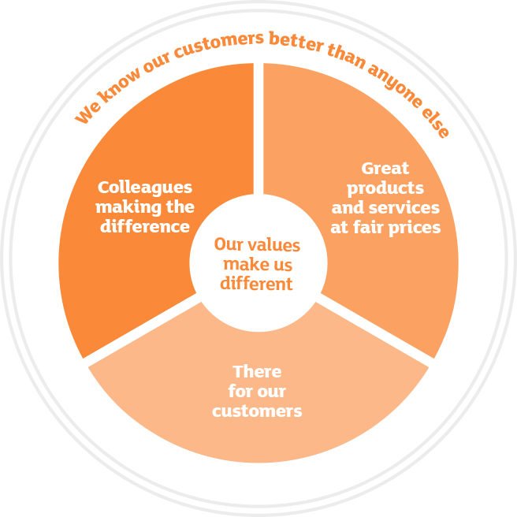
Figure 2: Sainsbury’s business values
(Source: sainsburys.co.uk, 2022)

3. Marketing strategies to meet stakeholders’ expectation
Marketing Management at Sainsbury’s is focused on driving profitable growth by creating value for customers, both in terms of price and quality. This requires an understanding of customers’ needs and preferences, as well as an effective strategy to meet those needs. The marketing team at Sainsbury’s has several core responsibilities, including:
- Developing a strategic marketing plan to identify target customer segments and opportunities, define key messages, and create relevant campaigns.
- Analyzing customer data and market trends to gain insights into customer needs and behaviors.
- Developing and executing creative campaigns to engage with customers, build brand loyalty, and drive sales.
- Evaluating the effectiveness of marketing efforts and making recommendations for improvement.
- Working with suppliers, partners, and other stakeholders to ensure that Sainsbury’s meets its strategic objectives.
- Managing budgets, timelines, and resources to ensure that marketing activities are completed on time and within budget.
- Monitoring competitor activities and understanding the competitive landscape.
- Developing and maintaining relationships with media outlets to ensure that Sainsbury’s products and services are promoted effectively.
In order to create innovative marketing strategies for raising awareness of the brand, Sainsbury’s can use a variety of tactics (Bocken et al. 2020). Firstly, they can focus on leveraging their existing customer base by using targeted online and offline campaigns to engage existing customers and reach new audiences. This could include using social media, email campaigns, and advertising in print or on television. They could also focus on creating content that is relevant to their customer base and is likely to be shared or discussed. This could include creating videos, blog posts, or even offering competitions or discounts to encourage engagement.
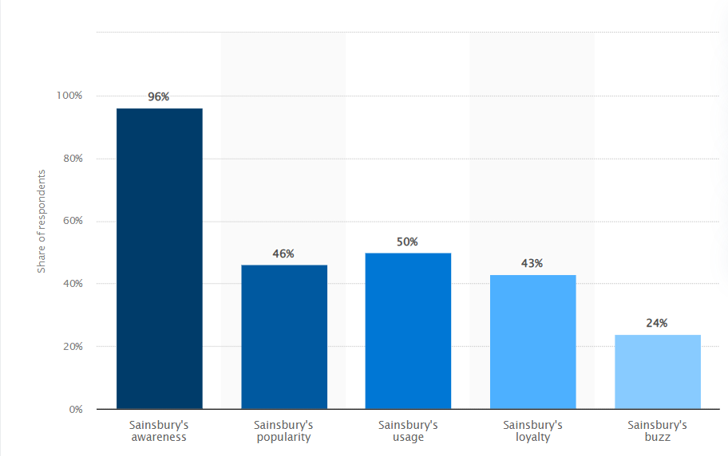
Figure 3: Sainsbury’s brand awareness
(Source: statista.com, 2021)
In order to manage and evaluate the customer journey, Sainsbury’s could use customer feedback surveys and analytics to gain insights into the customer experience. This could allow them to identify areas that need improvement and create strategies to address them. They could also look at customer behaviour patterns and analyse how customers interact with their brand, website, and products (Guthrie et al. 2021). This could help them target their marketing strategies more effectively. Additionally, Sainsbury’s could also use customer segmentation to identify target audiences more accurately and create more tailored marketing strategies.
By leveraging their existing customers and using customer feedback, Sainsbury’s can create innovative marketing strategies and manage and evaluate the customer journey (Li et al., 2023). This would further help in gaining a far-reaching understanding of their target audience and creating strategies that are more tailored to their needs. In addition, they can also create content that is engaging and relevant to their customers, as well as analyse customer behaviour patterns to ensure their marketing efforts are effective.
The customer’s end-to-end journey should be at the heart of Sainsbury’s marketing strategy. This means understanding how customers interact with the brand through the various touchpoints and developing a strategy to ensure that each interaction is optimized to deliver the best possible customer experience. This could involve refining the customer experience through digital channels, such as the website, app, and social media accounts; investing in physical experiences, such as in-store events and experiences, and ensuring that customer service teams are well-trained and equipped to handle customer inquiries (Hughes and Vafeas, 2019). Additionally, Sainsbury’s should ensure that customer feedback is being regularly gathered and analyzed to identify ways to improve the customer’s journey. This could be done through surveys, focus groups, and other research methods. By understanding the customer’s end-to-end journey, Sainsbury’s can ensure that each interaction with the brand delivers a positive experience, ultimately increasing customer loyalty and driving sales.
An innovative customer journey strategy recommendation for Sainsbury’s is to create a personalized shopping experience. This could involve using customer data to tailor their products and services to the individual customer, such as providing custom recommendations and discounts. Additionally, they could offer a rewards program that rewards customers for their loyalty and engagement. They could also use AI-powered chatbots to provide customers with a more efficient and personalized shopping experience (Patel and Trivedi, 2020).
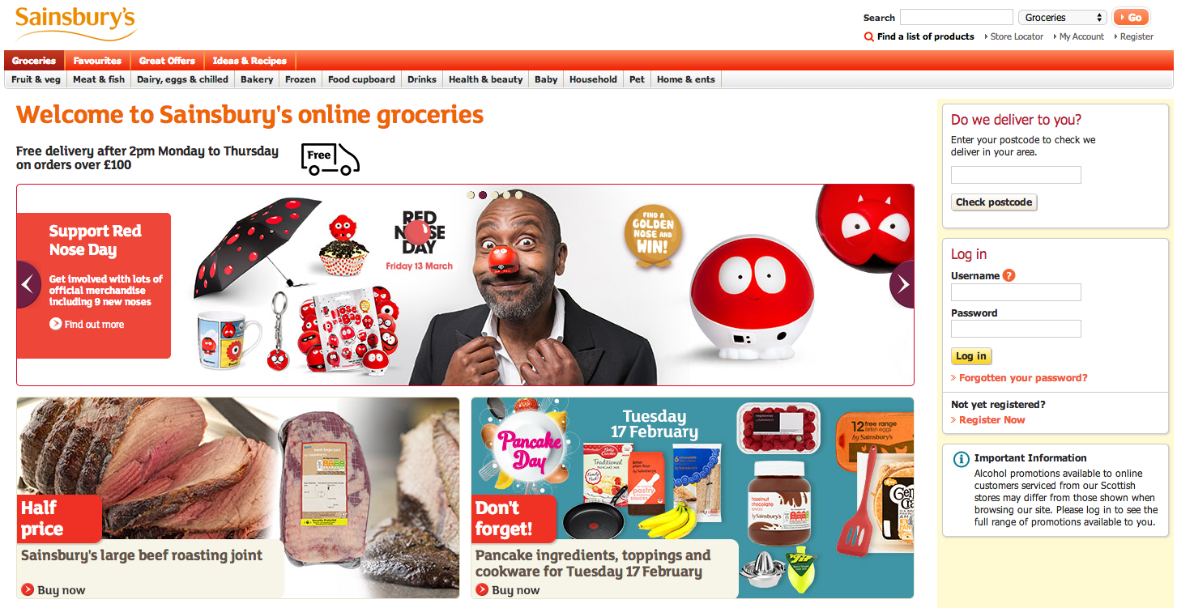
Figure 4: Sainsbury’s website (front page)
(Source: sainsburys.co.uk, 2022)
Finally, they could use location-based marketing to promote their products and services in the areas where their customers are located.
- Increase Visibility: Increase Sainsbury’s visibility and presence across multiple communication channels, such as T.V. commercials, radio spots, print media, and digital campaigns. Utilize creative and engaging content to draw attention to the brand and create brand awareness (Bunten et al. 2022).
- Engage with Customers: Develop an interactive and engaging customer journey strategy. This can include creating social media accounts and hosting regular giveaways and competitions. Additionally, create a mobile app for customers to access discounts, browse products and services, and receive personalized offers.
- Utilize Loyalty Programs: Utilize loyalty programs, such as loyalty cards, to reward customers for their continued patronage. This will help to create a sense of loyalty and trust with customers.
- Focus on Customer Service: Focus on providing excellent customer service. This can include providing knowledgeable and helpful customer service representatives, quick response times, and resolving complaints quickly (Bunten et al. 2022).
- Invest in Digital Solutions: Invest in digital solutions, such as chatbots, voice search, and AI-powered chat services to provide customers with personalized experiences.
- Analyze Customer Data: Utilize customer data to gain insights into customer preferences and behaviour. This will allow Sainsbury’s to personalize customer experiences, tailor offers to the customers’ needs, and drive loyalty.
- Maximize Online Presence: Maximize Sainsbury’s online presence with an optimized website, SEO, and online advertising. This will help to ensure customers can easily find the brand and engage with its products and services.
- Monitor and Measure Results: Monitor and measure the customer journey strategy on a regular basis to ensure that it is meeting the needs of customers and helping to drive the desired results (Bunten et al. 2022).
Sainsbury’s faces stiff competition from the likes of Tesco and Asda in the country. In order to remain competitive and increase brand awareness, Sainsbury’s needs to focus on marketing strategies that will help them stand out from the crowd. Here are some of the key strategies that Sainsbury’s could use to increase brand awareness:
- Social Media Engagement: Social media is increasingly becoming an important tool for businesses to engage with their customers and build relationships. Sainsbury’s should focus on creating engaging content for their social media channels and use them as a platform to promote their products and services.
- Public Relations: Sainsbury’s should focus on building relationships with the media and use public relations to increase brand awareness. This could involve issuing press releases, attending press conferences, and engaging in other activities that will get the company’s name out there.
- Sponsorships: Sainsbury’s should look into sponsoring events and organizations that are related to their business (Dixon et al. 2019). This could involve sponsoring a local sports team, a charity event, or a music festival. This will give the company more exposure and help them increase brand awareness.
- Digital Advertising: Sainsbury’s should also look into using digital advertising platforms such as Google Ads, Facebook Ads, and Twitter Ads to reach a wider audience. Digital advertising is more cost-effective than traditional advertising and can be targeted to reach the right audience.
- Content Marketing: Content marketing is an effective way to reach potential customers and showcase the company’s products and services. Sainsbury’s should focus on creating content that is informative and engaging, and share it across their social media channels as well as on their website.
These are just some of the strategies that Sainsbury’s could use to increase brand awareness and remain competitive in the U.K. grocery market. Implementing these strategies will help the company reach a wider audience and build a better reputation.
Sainsbury stakeholder analysis
Stakeholders of Sainsbury are those who have an interest or an influence on the company’s operations and decisions (Newborne, 2022). This includes customers, suppliers, employees, shareholders, the government, and the local community.
Customers: Customers are the primary stakeholders of Sainsbury, as they are the ones who directly purchase goods and services from the company. They are also the ones who influence the company’s sales and profits, as well as its reputation. Therefore, Sainsbury needs to ensure that its customers are satisfied with the products and services they receive.
Suppliers: Suppliers provide the goods and services that Sainsbury purchases in order to provide to its customers. Without them, the company would not be able to meet the needs of its customers. As such, Sainsbury needs to ensure that it has a good relationship with its suppliers in order to ensure a steady supply of goods and services.
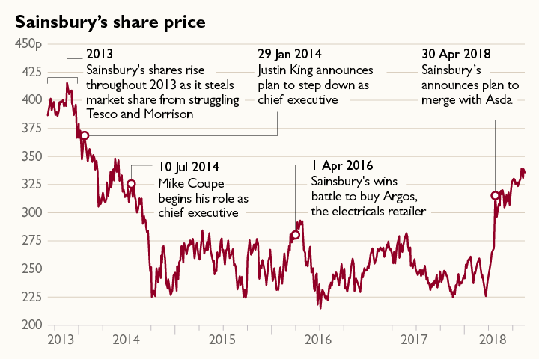
Figure 5: Sainsbury share prices over the years
(Source: thetimes.co.uk, 2021)
Employees: Employees are another important stakeholder group for Sainsbury. They are the ones who provide the day-to-day operations of the company and are the ones who interact with customers. Therefore, it is important for Sainsbury to ensure that its employees are well-trained and motivated to provide excellent customer service.
Shareholders: Shareholders are the owners of the company, and they have a vested interest in its success. They benefit from any dividends or profits made by the company. Therefore, Sainsbury needs to ensure that it is making decisions that are beneficial for the shareholders.
Government: The government is another important stakeholder for Sainsbury, as it sets the rules and regulations for the company to follow. These regulations can have an effect on the company’s operations, and therefore, it is important for Sainsbury to stay compliant to the regulations.
Local Community: The local community is also an important stakeholder for Sainsbury, as it can have a direct impact on the company’s reputation. Sainsbury needs to ensure that it is providing value to the local community, as well as making sure that it is not causing any harm to the environment.
Sainsbury stakeholder expectations
- Quality Products: Sainsbury’s stakeholders expect the company to provide high quality, safe and nutritious food products.
- Transparency: Stakeholders expect Sainsbury’s to be transparent and accountable in all of their business activities.
- Financial Returns: Stakeholders expect Sainsbury’s to generate a return on their investment.
- Responsible Business Practices: Sainsbury’s stakeholders expect the company to operate in a way that is socially and environmentally responsible.
- Employee Satisfaction: Stakeholders expect Sainsbury’s to provide a working environment that is safe, fair and equitable.
- Customer Satisfaction: Stakeholders expect Sainsbury’s to provide quality customer service and to meet customer needs.
- Innovation: Sainsbury’s stakeholders expect the company to pursue innovative approaches to its products and services.
Sainsbury’s marketing strategy to meet stakeholder expectations
Increase Brand Awareness: Leverage digital and traditional marketing channels to increase brand awareness and reach new customers (Pandey et al. 2020). This includes investing in online advertising, using social media channels to engage with customers and developing a strong presence at events and trade shows.
Focus on Quality and Value: Focus on providing quality products and services that meet customer needs and expectations. Invest in research and development to ensure that new products and services are innovative, meet customer needs and are competitively priced.
Improve Customer Engagement: Develop strategies to improve customer engagement by understanding and responding to customer feedback. This includes developing loyalty programs and providing a streamlined customer experience both online and in-store.
Enhance Online Presence: Enhance Sainsbury’s online presence by investing in e-commerce solutions, improving content marketing, and optimizing website design.
Increase Corporate Social Responsibility: Increase corporate social responsibility efforts by supporting local communities and engaging in sustainability initiatives. This can help to build a positive reputation for the company and create loyalty among customers.
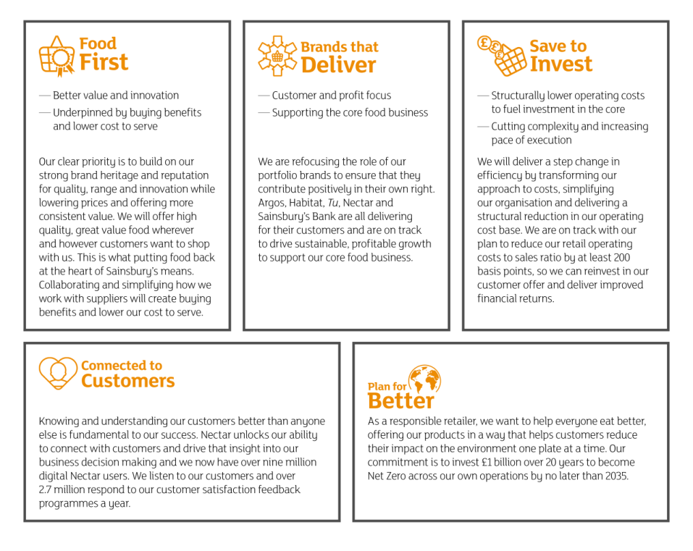
Figure 6: Corporate Social Responsibilities of Sainsbury
(Source: sainsburys.co.uk, 2022)
Sainsbury’s marketing strategy focuses on providing its customers with a seamless shopping experience. The aim is to provide customers with an end-to-end journey that is tailored to their individual needs and preferences. This involves creating an engaging, personalised experience by leveraging data and insights to identify and target customers, engaging with them through various channels, delivering a consistent and relevant message across the customer’s journey, and providing an efficient and effortless checkout process (Campbell et al. 2020). Sainsbury’s also aims to build customer loyalty and trust by delivering a reliable, secure, and satisfying experience. Additionally, Sainsbury’s employs a variety of digital marketing strategies, such as email marketing, social media campaigns, and mobile app development, to reach and engage customers.
Sainsbury’s marketing strategy recommended solutions of the customer’s end-to-end journey,’
1. Comprehensive Customer Understanding:
To provide an end-to-end customer journey, Sainsbury should first gain a comprehensive understanding of their customers. This includes learning about their needs, wants, and preferences, as well as their behaviour and motivations. Sainsbury should use data and analytics to gain insights into their customers and develop targeted strategies that meet their needs.
2. Personalization:
Sainsbury should also focus on personalizing the customer journey.
This includes providing tailored offers and experiences that are relevant to each individual customer. Sainsbury should use data-driven insights to create personalized experiences and offers that are tailored to each customer’s specific needs.
3. Seamless Experience:
Sainsbury should strive to provide a seamless, integrated experience across all touchpoints. This includes providing a consistent experience across web, mobile, and in-store. Sainsbury should also ensure that customers can easily switch between channels without having to repeat information.
4. Omni-Channel:
Sainsbury should also focus on providing an omnichannel experience. This means providing a unified experience across all channels, including online, mobile, and in-store. Sainsbury should ensure that customers can start an interaction on one channel and continue it on another without having to repeat information.
5. Automation:
Sainsbury should also focus on automating parts of the customer journey. This includes automating routine tasks such as order processing, account updates, and customer service requests. Automating these processes will help to reduce costs and improve efficiency.
6. Measurement and Feedback:
Finally, Sainsbury should measure and analyse customer feedback. This will help Sainsbury to identify areas for improvement and ensure that they are meeting customer expectations. Customer feedback should be collected and analysed regularly to ensure that Sainsbury is providing the best possible customer journey.

4. Marketing mix and theory based strategies
Sainsbury’s customer relationship theory is based on the idea that customers need to be treated as individuals and that their needs should be met in order to build customer loyalty and relationships. This theory is based on customer service, communication, trust and building relationships over time. Sainsbury’s customer service focuses on making sure customers have a positive experience each time they shop and that they feel heard and valued (Rawson et al. 2022). Their communication strategy is designed to provide timely, relevant and helpful information to customers to meet their needs. Sainsbury’s also works to build customer loyalty through rewards and loyalty programs. Finally, Sainsbury’s also puts an emphasis on building relationships with customers by providing personalized customer service, listening to customer feedback, and offering exclusive offers.
Sainsbury marketing mix
Product | Sainsbury’s offers a wide range of products and services, including food and drink, clothing, health and beauty, homeware, toys and entertainment, electricals, financial services, and more (Piecyk et al. 2021). Sainsbury’s also offers its own brand products, ranging from groceries to homeware.
Price | Sainsbury’s offers competitive pricing, as well as seasonal promotions and discounts. Sainsbury’s also offers loyalty schemes, such as its Nectar card, which rewards customers with points for shopping.
Place | Sainsbury’s has a large network of stores across the U.K., including supermarkets, convenience stores, and petrol stations. Sainsbury’s also offers online shopping and delivery services.
Promotion | Sainsbury’s uses a range of promotional activities, including television and radio advertising, online campaigns, press and magazine advertising, direct mail, and in-store promotions. Sainsbury’s also uses social media platforms to promote its products and services.
People | Sainsbury’s employs a large number of staff across its stores and corporate offices. The company has a strong focus on customer service, and its staff are trained to ensure customers have a pleasant shopping experience.

Figure 6: The 4P’s of Marketing Mix
(Source: Developed by author)
4.1 Sainsbury Differentiation Strategy
Sainsbury’s has adopted a differentiation strategy to differentiate itself from its competitors and create a unique brand identity. The supermarket chain has invested heavily in its own brand products, range of fresh produce, and customer service. It has also focused on creating a unique shopping experience for customers by introducing exclusive product lines, creating loyalty programs, and developing innovative digital experiences. Additionally, Sainsbury’s has adopted a variety of sustainability initiatives, such as reducing food waste, transitioning to renewable energy sources, and supporting local businesses. These strategies have helped Sainsbury’s to establish itself as a unique and desirable brand in the market, which has allowed it to differentiate itself from its competitors (Nastasoiu and Vandenbosch, 2019). In addition, Sainsbury’s has committed to helping its customers save money and reduce their environmental footprint. This includes offering a range of green initiatives such as recycling, offering energy-efficient products, and encouraging shoppers to purchase reusable bags. Sainsbury’s also provides resources for customers to learn about the benefits of sustainable practices, and to make informed decisions when selecting products.
4.2 Sainsbury’s STP
Sainsbury’s STP (Segmentation, Targeting, Positioning) strategy is focused on targeting a wide range of customers, from families to professionals and from young people to older people.
Segmentation | Sainsbury’s segments customers into different demographic and lifestyle segments. Depending on the type of customer, Sainsbury’s will tailor its marketing and product offerings to meet their needs and wants.
Targeting | Sainsbury’s targets customers based on the customer segments they have identified (Davies et al. 2019). This includes targeting customers who are looking for value, convenience, quality, and those who are environmentally conscious.
Positioning | Sainsbury’s position itself as a high-quality retailer offering a wide range of products and services that meet the needs of its customers. Sainsbury’s also positions itself as a responsible company that cares about the environment and its customers.

5. Conclusion
It can be stated from the above discussion that Sainsbury’s has a great opportunity to capitalize on the ever-growing popularity of social media and digital advertising in order to maximize its reach and engagement with its customer base. With the right strategies and tactics in place, Sainsbury’s can build a strong presence on social media, increase its reach and visibility, and drive more sales. Additionally, Sainsbury’s should also focus on leveraging digital advertising to gain more customers and to strengthen its brand. By taking advantage of the latest digital advertising trends and technologies, Sainsbury’s can reach even more potential customers, generate more leads, and increase its sales. With these tactics in place, Sainsbury’s can ensure that it remains competitive and continues to successfully grow its business. Therefore, it can be concluded that the mentioned business organization can increase customer satisfaction with the help of social media marketing and digital advertising strategy.

References
Bocken, N., Morales, L.S. and Lehner, M., 2020. Sufficiency business strategies in the food industry—The case of Oatly. Sustainability, 12(3), p.824.
Bunten, A., Shute, B., Golding, S.E., Charlton, C., Porter, L., Willis, Z., Gold, N., Saei, A., Tempest, B., Sritharan, N. and Arambepola, R., 2022. Encouraging healthier grocery purchases online: A randomised controlled trial and lessons learned. Nutrition Bulletin.
Campbell, C., Sands, S., Ferraro, C., Tsao, H.Y.J. and Mavrommatis, A., 2020. From data to action: How marketers can leverage A.I. Business Horizons, 63(2), pp.227-243.
Davies, A., Dolega, L. and Arribas-Bel, D., 2019. Buy online collect in-store: exploring grocery click&collect using a national case study. International Journal of Retail & Distribution Management.
Dixon, H., Lee, A. and Scully, M., 2019. Sports sponsorship as a cause of obesity. Current obesity reports, 8(4), pp.480-494.
Engelvuori, K., 2021. Effect of post purchase actions towards customer experience in a multichannel SaaS environment.
Guthrie, C., Fosso-Wamba, S. and Arnaud, J.B., 2021. Online consumer resilience during a pandemic: An exploratory study of e-commerce behavior before, during and after a COVID-19 lockdown. Journal of Retailing and Consumer Services, 61, p.102570.
Hughes, T. and Vafeas, M., 2019. Marketing agency/client service-for-service provision in an age of digital transformation. Journal of Business-to-Business Marketing, 26(3-4), pp.265-280.
Jones, P. and Comfort, D., 2018. Storytelling and corporate social responsibility reporting: A case study of leading U.K. retailers. European Journal of Sustainable Development Research, 2(4), pp.1-11.
Li, X., Xu, M., Zeng, W., Tse, Y.K. and Chan, H.K., 2023. Exploring customer concerns on service quality under the COVID-19 crisis: A social media analytics study from the retail industry. Journal of Retailing and Consumer Services, 70, p.103157.
Nastasoiu, A. and Vandenbosch, M., 2019. Competing with loyalty: How to design successful customer loyalty reward programs. Business Horizons, 62(2), pp.207-214.
Newborne, P., 2022. Crossed wires: public regulation and private action for water stewardship and sustainable farming. Water International, 47(7), pp.1169-1186.
Newing, A., Hood, N. and Sterland, I., 2020. Planning support systems for retail location planning. In Handbook of Planning Support Science. Edward Elgar Publishing.
Pandey, N., Nayal, P. and Rathore, A.S., 2020. Digital marketing for B2B organizations: structured literature review and future research directions. Journal of Business & Industrial Marketing.
Patel, N. and Trivedi, S., 2020. Leveraging Predictive Modeling, Machine Learning Personalization, NLP Customer Support, and A.I. Chatbots to Increase Customer Loyalty. Empirical Quests for Management Essences, 3(3), pp.1-24.
Piecyk, M., Allen, J., Woodburn, A. and Cao, M., 2021. Online Shopping and Last-Mile Deliveries: Briefing Report.
Rahmayati, R., 2021. Competition Strategy In The Islamic Banking Industry: An Empirical Review. International Journal Of Business, Economics, And Social Development, 2(2), pp.65-71.
Rawson, H., Rigby, K., Ockerby, C. and Forbes, H., 2022. Older people’s experiences of community engagement in aged care: A qualitative study. Collegian.
Russell, D., Onorato, N., Stern, A., Vergez, S., Oberlink, M., Luebke, M., Feldman, P.H., McDonald, M.V. and Sterling, M.R., 2022. A Qualitative Study of Home Health Aides’ Perspectives towards COVID-19 Vaccination. Journal of Applied Gerontology, p.07334648221130677.
statista.com, 2021. Available at: https://www.statista.com/forecasts/1335715/sainsbury-s-grocery-stores-brand-profile-in-the-uk[Accessed on: 23.12.2022]

sainsburys.co.uk, 2022. Available at: https://www.about.sainsburys.co.uk/about-us/our-business-strategy [Accessed on: 23.12.2022]
thetimes.co.uk, 2021. Available at: https://www.thetimes.co.uk/article/for-sainsburys-shareholders-at-least-the-price-is-right-6dflld387 [Accessed on: 23.12.2022]

