Mathew Jones
2317425@student.uwtsd.ac.uk
Research and case scenario in Data Security and Compliance

L5 - Data Security and Compliance (FT - ACCA5034)
Contents
Task 1 - Research in Data Security and Compliance 3
Abstract 3
Introduction to Physical Security 3
Physical Access controls 3
Physical structures and manpower 4
Fire Safety and Security 4
Heating, Ventilation, and Air Conditioning 5
Electrical distribution 6
Water systems 6
Mobile and Portable devices 6
Considerations for organisations 7
Conclusion 7
Task 2 – Case scenario 8
Introduction 8
My Approach 8
Organisation structure 8
Policies and Procedures 9
Compliance: Laws and Ethics 10
Governance and Strategic Planning for Security 11
Risk Management 12
Contingencies planning 12
Protection mechanisms 13
Conclusion 14

RESEARCH, AND CASE SCENARIO IN
DATA SECURITY AND COMPLIANCE
Mathew Jones
Student University of Wales Trinity St David, Swansea, Wales
1909160@student.uwtsd.ac.uk

Task 1 - Research in Data Security and Compliance

Abstract - This paper will examine how critical physical security is for an organisation to remain secure from external threats, it will also explore best practices for employees, and highlighting that some organisations will not have the top of line security due to funds but showing there are ways you can still mitigate risks. Additionally, this paper will be covering aspects such as floods, fires and how an organisation to reduce the likelihood of one happening but also if one were to happen how to combat it. Understanding and addressing these risks are critical to having a successful organisation and a key component of this is creating a resilient system that not only safeguard their digital assets but also their physical assets

Introduction to Physical Security
Physical security is protecting against threats such as unauthorised access like espionage, theft, criminal damage, natural disaster, fires, floods and even internal threats from individuals such as disgruntled employees. The way in which achieve this goal by putting in place strategies, mechanisms, and safeguards that protect electrical systems and infrastructure from these threats. Physical security is an essential part of an organisations overall security strategy as not being able to protect against these threats can affects the organisations’ ability to operate effectively, system down time, loss of data, data centres and hardware can get damaged, tampered with or even stolen. Physical security does not only mean protecting IT systems but also extends to the safety of employees and any visitors on the organisations grounds.

Physical Access controls
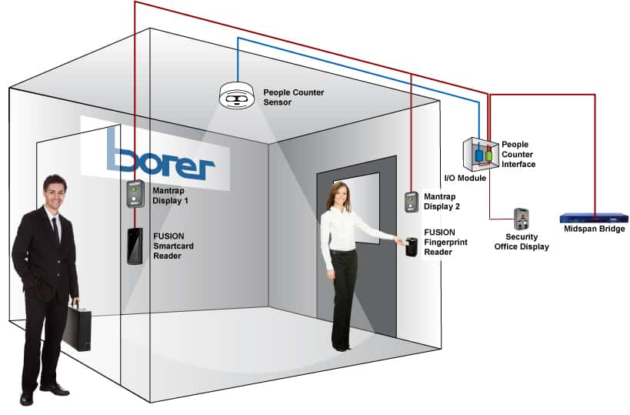
Preventing unauthorised access is critical in ensuring an organisation remains secure and one method preventing unauthorised access is physical access controls also known as PACS. They can be used to allow certain staff members to access certain rooms based on their role in the company. [1]
There are many ways to implement this technology such as keycards which is a simple and easy method to allow access but will require two forms of authentication. The reason for this is keycards are easy to clone, steal, modify and are unable to verify who the individual is so having ID is essential. Keycards also have the advantage of being able to quickly change access for new hires, removing whom you’ve laid off/fired and employees who have transferred to another department.
Another form of keycard could be the use of the employees mobile phone as phones are more often than not with the employee and usually have security on it such as passwords or biometric scanners. [2] The final method to discuss in regards to PACS is biometrics such as iris scanners, facial and fingerprints. Biometrics are considered more secure and individuals you use them would agree but many have privacy concerns regarding them. [3]
These are all good methods in preventing unauthorised access, but hostile entities could tailgate behind an authorised employee. Tailgating is when an unauthorised individual follows someone with access to a room or area that need authorisation. [4]
One method of combating this is using turnstiles or mantraps which only allows one individual to enter at a time. A mantrap is small room/ enclosure where an individual will walk in, they will not be able to exit until access has been authorised.

Fig 1. Example of mantrap [5]

Physical structures and manpower
There are many different physical security controls and organisation can implement but it depends a lot on the location as if it is in the middle of a busy centre you would not erect a large fencing/wall perimeter. Additionally it also depends on the size of the organisation as it can be costly so there are many things to consider.
Constructing walls/fencing would advantageous for a large data centre such as google as well as gate manned 24/7 to control whom comes in and out. Having security guards and dogs would also be required to walk the wall/fence perimeter as well as having security guards in vehicles. The advantages of having a security guards on sight is they can react to each situation immediately but can be costly and tend to get bored/distracted. Security guards are also key as they have better senses such as hearing, smelling and can be used in dangerous situations to mitigate an individual losing their life.
Having external lights will allow security to patrol the perimeter at night but will also deter potential threats from attempting as well. Security guards should also patrol regularly but at unpredictable times so attackers don’t get used to their patrol pattern. Installing surveillance cameras around the perimeter and inside the organisation would instrumental as you could have one security guard in a control monitoring them all and radioing in any updates or potential threats to those patrolling. Staff members are also to be security aware and trained to understand the potential threats such as leaving windows wide open or not locking doors. [6]
Testing the physical security could be also be a method to find any weak spots in security from a security guard not paying attention to a faulty access point, the organisation can gain lots of important information about their security and could potentially prevent a real life scenario from happening. Documenting and evaluating the information is also important to keep a record to see if the organisation is improving or not. Hardware are also to be inspected and catalogued to ensure staff members are not stealing things such as memory drives or laptops.

Fire Safety and Security
Fires are the most serious threat to the safety of human life as they account for the most injuries, deaths and property damage. There are 3 requirements for a fire to take place and they are heat, fuel and oxygen. It is essential to put measures in place to prevent, detect and respond to any fires that occur. To do this you can install fire alarms to detect smoke/heat and having a fire suppression system. Doing regular fire tests and drills is critical to ensure the system is function but also employees know where to be and where to go if a real fire were to happen.


Fig 2. Fire triangle [7]

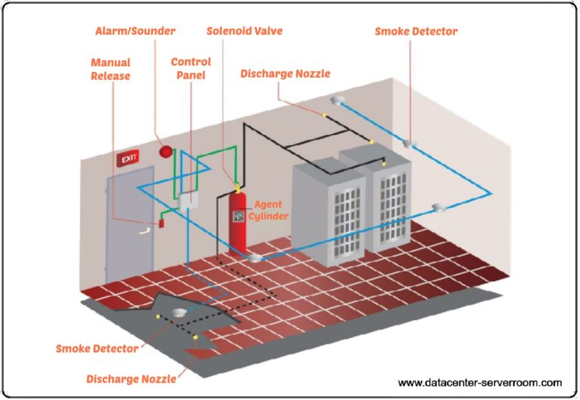
There are many types of fire suppression systems but the most common used in IT companies are gas suppression systems. The benefits of using a gas suppression system are that can automatically combat fires and does not use water so will save money from damaging equipment in rooms such as server rooms. These systems should be linked to smoke detection systems so that it operates automatically. If an issue arises and it does not go off automatically then you are able to manual discharge the system from a control panel, additionally there should be C02 fire extinguishers around any electrical device as other extinguishers will damage them. [8]

Fig 3. Fire suppression system [9]
There are multiple types of these systems but here are a few examples. Novec 1230 is used to protect the most at risks areas and is used where Halon 1301 was previously used. Halon 1301 is no longer used due to its effects on the ozone layer. Novec 1230 is a non-conductive, near odourless and colourless gas. Inert gases (IG55, IG541(INERGEN)) work by reducing the oxygen contents of a room from a usual 21% to below 15%. This means the fire can no longer sustain itself thus extinguishing it. [10]

Heating, Ventilation, and Air Conditioning
Heating, ventilation and air conditioning also known as HVAC is a critical part of maintaining the correct temperature, filtration, humidity, and static levels. These four can have a major impact on electronics throughout an organisation. The desired temperature for server room environments is 19 to 21 degrees Celsius but 18 to 27 degrees Celsius is acceptable. Falling below 10 and above 35 can damage components and increase the risk of a fire. [11] Filtrations are not really required for modern day office spaces but if it were a sensitive environment like a component’s assembly area or chip fabricator, filtration would be required. [12]
Humidity is another aspect that needs to be considered as high humidity creates condensation issues which can short circuit electrical equipment. Low humidity may increase static electricity in the area which can damage microchips from as serious as catastrophic failure to latent failures which takes a while for the damage to occur. Either way the chips will have to be replaced. The ideal humidity levels in a computing area are 40 to 60 percent and this can be achieved using humidification or dehumidification systems. [13]

Electrical distribution
During power outages organisations become more vulnerable to cybersecurity threats and data breaches due to not being able to detect if an attack is happening. A method of addressing this problem would be cloud storage and having a backup power generator. Additionally, an organisation may install solar panel to generate renewable energy and storing them with batteries. These can be quite expensive but can be critical in a crisis scenario. [14] Power outages also affect other systems in organisations such as security systems, firefighting systems and general operations of the businesses so having a secondary power source is essential in maintaining security integrity.

Water systems
Something that may be overlooked is water systems travelling around the building but it is an essential part of the building as it may supply fire suppression systems where there are no electrical devices, air conditioning systems, cooling electrical devices and general toiletry needs. Managing the system pressure is key as too low and it won’t function but too high and there is a high risk of flooding or leaks

Mobile and Portable devices
Mobile computing systems are devices such as laptops, tablets and smartphones and require a higher level of security as they will have valuable information stored on them and some may also have access to the organisations network. Individuals with these systems are known to allow devices to remember usernames and passwords which is a security threat as if someone were to steal it then they will have access to the system and company secrets. [15] Employees must be educated not to do this and to be aware of their surroundings when working especially in public areas as someone could be looking over their shoulder.
Some organisations will need to use laptops especially now as working from home is becoming increasingly common so having something like CompuTrace is a perfect software tool. It allows the organisation to monitor employees if they download or use something that is unauthorised, software policies can be enforced easier, devices are able to be frozen and message left on the screen to notify the employee of something such as the laptop requires servicing, able to retrieve and delete files remotely and if stolen the device has GPS where a theft recovery team will take over to find the device and inform law enforcement. This assists organisations massively has they have total control of their devices and if they were to be stolen then can be located and found without the organisation doing anything excepting notifying it has been lost or stolen. [16]

Considerations for organisations
Organisations have a lot to think about when it comes to physical security, access control, HVACs, fire safety and much more so being able to outsource these issues to other companies with better experience can be advantageous although an organisation can form a team called facilities management. The advantage of doing it within the organisation is having total control, being able to set your own policies and procedures, the ability to change course based on specific challenges, get feedback directly from employees and having a long term strategy and goal for the organisation. The disadvantages are it is more costly and resource intensive as you will have to hire, train and maintain a team to this as well as having limited knowledge initially and it may increase employees workload.

The advantages of outsourcing are the cost saving aspect, having a security company with expertise, you the organisation can focus on purely on your business, having more up to date technologies, innovations and finally the company you outsource to usually takes responsibility for complying with safety and regulatory requirements reducing the risk and liabilities for the organisation. The disadvantage is relying on the organisation as if they fail to meet the quality standards it could impact the organisations reputation, operation effectiveness and customer satisfaction, there would also be limited influence on daily operations and the overall strategy. Additionally, outsourcing could become more costly long term as there could be additional charges for additional services. [17]

Conclusion
To conclude Physical security plays a critical role in securing an organisation by using methods such as physical access points, physical structures, manpower and surveillance. It is also essential to pay close attention fire prevention, water systems, HVACs and electrical distribution as the play a major role in not just the running of an organisation but also the safety of employees and could potentially save company assets from damage. Using all of these methods shown an organisation will be able to ensure the safety and security of its employees and company.

Task 2 – Case scenario

Introduction
This assignment will show a method of setting up a new information security unit for threat intelligence and consultancy company known as CyStresSolution or CSS for short. The assignment will also go over the design for a security framework taking into account the organisation’s structure and policies currently in place as well as any improvements that can be implemented.

My Approach
When creating an information security unit or ISU it is critical that there main goal is to ensure the security of the organisations data, systems, prevent any security attacks or if one were to happen mitigate it’s effects, prevent unauthorised access and comply with regulations.

Organisation structure
The organisation structure for the new ISU would be a medium sized company, although CyStresSolution is fast growing it seems to have room to grow so they ISU must reflect that. Additionally, they will be using a top-down approach as upper management will be issuing new policies, procedures, aims and future goals for the team. The top-approach will make the implementation faster and there will be greater clarity on what the goal is. [18]

At the head of the organisation will be the CEO or Chief Executive officer, they will ensure that IT departments are following CSS policies, procedures and goals. Below the CEO will the CIO or chief information officer who is responsible for advising the CEO on general strategy and operation of the IT department in the company. They may also have responsibilities in the implementation of system upgrades, managing funds, introducing improvements into the department using new technology and generally leading the IT team. [19]

Next in line would be the CISO or chief information security officer. They are in charge of cyber security as well as the physical security of the organisation. The physical security aspects includes a multitude of things such as risk management, privacy, safety compliance, creating a disaster recovery plan and many much more. Additionally, they are to develop policies and procedures, comply with regulations and budget management. [20]
Finding a CISO can be quite the task and even more difficult is retaining the CISO when you gave them due to the high stress nature of the position the average tenure of a CISO is only 18 to 26 months. CSS could hire a vCISO or virtual CISO as they already have expertise in the field and having a permanent CISO would be more costly. [21]

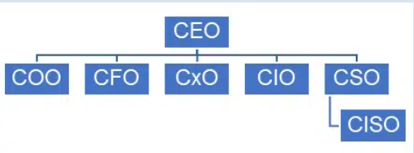
Fig 4. Organisation structure [22]

Under the CISO will be different departments such as program management, security operations centre, security engineering/ asset security and emergency operation and incident management. All of these team will report to CISO and will have a variety of roles from updating access controls to updating polices and many more. [23]

Policies and Procedures
CSS specialise in threat intelligence, consulting and cloud-based solutions so having policies and procedures that reflect there business in essential. Having cloud based solutions means the organisation will require online security as well as physical security for there data centre. There data centre will require an access control policy to prevent unauthorised access as well as to restrict access to those employees who do not require access. This could include certain rooms or on a computer where an employee does not require access to a certain piece of information such as employee information or and valuable organisation secrets.[24]

There will be sensitive information being dealt with as well so CSS having a security policy would be important, as well as what would be activities would be prohibited on IT systems, what data is public, confidential, restricted and setting the standards for password such as how complex they should be, how often you should change them and if they should be saved on the device. For CSS password should be changed on a regular basis as well as not saved on devices as if someone were to gain access then they would instantly have access and finally they should never be written down anywhere as this is a security risk. Training on all of these policies is critical so that all staff members are up to standards. [25]

CSS will also need an incident response protocol as it is critical the organisation is able to respond to any hostile cyberattacks. There are five steps to creating an incident response plan and they are:

- Protecting critical components of the network and data against any serious damage by replicating and storing data into remote locations. Determine the most important data and system as business networks are large and complex, so you are able to back them up but make sure you remember their location. Following these action will ensure the recovery of CSSs network is quick and efficient
- The next step is identifying any weaknesses in the network and addressing them. If there is a single point of failure it could expose the network when an attack happens. These weaknesses could be in the network, hardware, software and even the staff roles. A method of mitigating the effects of these is by have redundancies so if something were to fail there is still another, having failover software features and having a second employee who is able to respond to the incident. Implementing these steps will reduce the damage and disruption to CSSs network and businesses.

- In some instances working remotely may be advantageous as in the case of a security breach or natural disaster as locations and certain processes may be inaccessible. This puts a risk to employee safety so working from home may be the best method for not only safety but to limit SSCs downtime. The organisation should put in place things such as virtual private networks or VPNs and secure web gateways for employees so they are able to communicate with one another safely to combat the threat.

- Actually, create a formal incident response plan but ensuring all employees understand their roles and responsibilities. Here is a list of what the incident response plan should include:

- Roles and responsibilities for all involved in the response team.
- A business continuity plan.
- Information regarding what tools is required, technologies and if any physical resources are needed.
- A list of key networks and data recovery processes
- The ability to communicate, both internally and externally.

- Finally you must ensure staff members are trained up and understand the response plan as it is critical that all staff members in the organisation understand there role if a real life incident were to happen. Employees should be trained up on it regularly to ensure they don’t become rusty, this includes non IT employees as just having a basic knowledge of basic security and reduce the chances of a breach. [26]
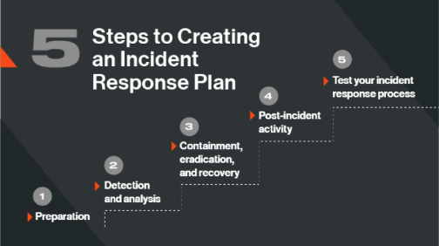
Fig. 5 steps to creating an incident response plan [27]

Compliance: Laws and Ethics
CSS must comply with regulatory standards and framework so it is essential that the ISU implement these into the organisations policies especially as CSS deals with customer data. This means CSS must comply with data protection laws such as General Data Protection Regulation (GDPR) or data protection act of 2018.
The Data protection Act of 2018 was implemented after the UK left the European Union and states how users data should be used by organisations and government bodies. Users have the right to stop or restrict the processing of their data, request there data be deleted, have access to their personal data, be notified of how the users data is being used and have the ability to update incorrect data. [28]

To comply with the European Union you must also follow the GDPR but it is very similar to the data protection act of 2018. There are some key differences such as child consent for data processing is 16 in the EU but 13 in the UK and date subject rights can be waived if and organisation has legitimate reason to process scientific, historical and statistical data. [29]

To comply with GDPR a good start would be appointing a data protection officer as they will have overall responsibility how data is being processed within CSS and educating staff on legislation, internal process and policies. Additionally, another method is doing regular audit checks on data CSS currently have. CSS will need to know:
- What data is being collected?
- Why is that date being collected?
- How is that date being collected
- How is the date being used?
- Where is the date being stored?
- Who has access to the data?
- How protected is the data?
- How long is the data being stored for?
CSS will have to ensure that all the questions are in line with GDPR requirements before accessing the European market. [30]

Governance and Strategic Planning for Security
ISU must ensure that SCC’ security procedures are compatible with their business objectives as well as regulatory requirements whilst ensuring security is up to standards. There must be policies set in place to guide decision making and individual who can make for decisions are the CISO or chief information officer. They can ensure SCC is following laws such GDPR and the date protection Act of 2018 as well meeting industry standards such as IS0 27001. CISO also identifies any risks to security and attempts mitigate those risks to ensure the safety of the organisation
The information security governance goal is to “protect the confidentiality, integrity, and availability (CIA) of date” [31] and this should be the goal of the CISO. Having confidentiality restricts sensitive information to those who are unauthorised creating a sense of trust. Integrity is ensuring data is accurate and complete and availability means the resources and information are available to authorised individuals when required. These principles will with assist the CISO in creating and enforcing there security measures and policies. [32]
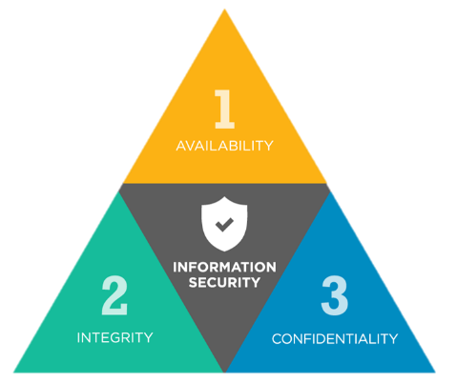

Fig 6. C.I.A Triad [33]

Risk Management
When dealing with risk management the first step is to identify any potential risks that CSS may have. ISU will have to identify all potential asset risks such servers, network router, laptops and many other electrical devices. ISU will also need to check for any potential vulnerabilities such as data not having a backup, employees using weak password, encryptions not being used and no firewalls. These are critical to the security of CSS and must be dealt with if found. Identifying potential threats will be key for ISU to ensure that hostile entities are unable to access the organisation physically or infiltrate the organisations systems digitally.
This is due to the risk of theft or damage to hardware, viruses and loss of data. The second step is to analyse what ISU found and to evaluate what the potentially impact of it happening and what are the chances of it. These will be known as risk assessment and they will show SCC where there resources should go to mitigate the most likely and damaging risk to the organisation. Risk assessments should be updated only a regular basis as threats are constantly changing.
The third step is known as treatment where ISU will put in procedures and other security measure to safeguard SCC. ISU could introduce access control protocols, increasing number of security guards, back up data on the cloud and training employees to become more aware when it comes to security such as using strong passwords. Additionally, sometimes organisations will have to accept some risks will need to be accepted which means if something cost more to rectify than the actual impact of the threat occurring then sometimes there is an acceptable risk to take.
The fourth step is to communicate to CSS’ stakeholders the cost of rectifying or the potential cost of not rectifying these risks. This will important as you will need justify to them why implementing these new security measure or assets will make the organisation safer and is it worth the cost. Additionally, if an attack were to happen stakeholders are to be informed as what is the current situation and how severe it is.

Step five is that risk management is a never ending process where there are always new breach being identify and technology is constantly improving so CSS’ risk management will have to show those changes by monitoring security on a regular basis for any vulnerabilities and looking out for any new ways to potentially improve security in a cost-effective method. [34]

Contingencies planning
A contingency plan is what an organisation standard operating procedure (SOPs) when a cyberattack occurs. Employees and security teams should use it to assist them in dealing with this threat. The aim is combat the cyberattack and recover as quickly as possible so limit downtime. [35]
There are seven steps in creating a contingency plan and with the assistance of NIST SP 800-34 Rev. Vol 1, SSC can integrate them into the organisations policies and procedures.

- Create a policy statement which will lay the foundation of SCCs contingency plan, what are the organisations objects are, what is the aim and to identify to staff members what their role is.
- Identify using Business Impact Analysis (BIA) the potential impacts of any disruptions, what systems are essential and what components are critical for running of the business. Knowing these facts will assist SCC in recovering faster.
- Put in place preventive control measures to reduce downtime and potentially save money on future incidents. You must first identify the vulnerabilities and risk first to be able to put in the control measures.
- Create a strategy that can recover critical systems in fast and efficient manner using the BIA. This should lead to negligible downtime and data loss.
- Develop a plan that offers guidance and specific procedures based on the security impact level. Additionally, you will need to know what data requires recovering and step by step plan on how to restore IT system and general operations of SCC.
- Regular test, training and exercises are critical in ensuring your plan is effective as it helps identify any short falls, assists employees in being prepared, and ensures the organisation is prepared for a real life incident.
- Finally you must ensure that there are regular reviews and updates to the plan as new threats are constantly evolving and techniques/technologies are constantly improving. If any is to be changed you must update the plan and ensure all your employees are aware of the change. [36]
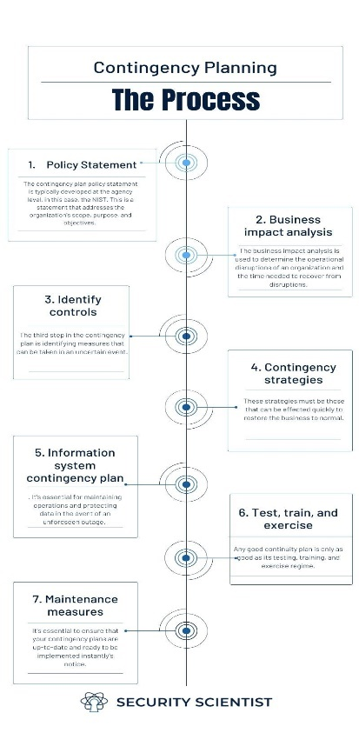

Fig 7. Contingency planning [37]

Protection mechanisms
ISU must put in place protection mechanisms into SCC’ security system as they are one of if the not the most important factor in securing an organisation. This include things such as alarm systems, surveillance, biometrics and identity cards. These are known as physical control and it would be in ISU best interest in using these technologies in the security of SCC. There are also Technical controls which are used of the networks security such as firewalls, encryption, and access controls. All of these protection mechanisms are key in securing SCC as an organisation and implementation must take place rapidly. [38]

Conclusion
To conclude ISU has a critical task in ensuring CSS is protecting clients and employees from dangerous of external threats as well as protecting viable data from hackers wanting to gain access. Implement well though out procedures and plans are critical for the success of SCC and with assistance with ISU that should be possible.

[1] Avigilon team. "Physical Access Control System (PACS): Components + Examples." Avigilon. https://www.avigilon.com/blog/physical-access-control (accessed Dec 9).
[2] D. Gibbons. "What are the different types of physical access control systems?" Acesecurity. https://www.acesecurity.co.uk/blog/what-are-the-different-types-of-physical-access-control-systems (accessed Dec 8).
[3] S. Gupta, M. Kacimi and B. Crispo, "Step & turn—A novel bimodal behavioral biometric-based user verification scheme for physical access control," Comput.Secur., vol. 118, pp.102722, 2022. doi: 10.1016/j.cose.2022.102722.
[4] Proofpoint team. "Tailgating attacks." Proofpoint. https://www.proofpoint.com/uk/threat-reference/tailgating-attacks-cybersecurity (accessed Dec 9).
[5] Borer team. "Two Door Interlock / Mantrap." Borer. https://www.borer.co.uk/access-control-solutions/two-door-interlock/ (accessed Dec 9).
[6] ProtectUK team. "Physical security." ProtectUK. https://www.protectuk.police.uk/advice-and-guidance/risk/physical-security (accessed Dec 9).
[7] Fire action team. "The Fire Triangle Explained." Fire action. https://fireaction.co.uk/news/fire-triangle-explained/ (accessed Dec 9).
[8] Churches Fire & Security Team, "Gas Fire Suppression Systems", Churches Fire & Security, https://www.churchesfire.com/fire-safety/gas-suppression/ (accessed Dec 9, 2024).
[9] Datacenter-server room team, "FM200 fire suppression for Data center design in Dubai, UAE. HFC-227ea gaseous fire supression clean agent." 2016-08-28T12:10:56+0000 2016-08-28T12:10:56+0000. Accessed: Dec 9, 2024, [Online]. Available: https://datacenter-serverroom.com/fm200-fire-suppression-data-center-design
[10] Marlowe Fire & Security Team, "Gas Fire Suppression", Marlowe Fire & Security, https://marlowefireandsecurity.com/solutions/fire-suppression-systems/gas-fire-suppression/ (accessed Dec 9, 2024).
[11] Cool-Tec Team. "What Is The Correct Temperature For A Server Room? | Cool-Tec." Cool-Tec Air Conditioning, Refrigeration and Ventilation. https://cool-tec.co.uk/blog/correct-temperature-for-server-rooms/ (accessed Dec 9).
[12][13][17] M. E. Whitman and H. J. Mattord,Principles of information security, Boston, MA: Cengage, 2022.
[14] James Longley. "Risks Power Outages Pose to Cyber Security." utilitybidder. https://www.utilitybidder.co.uk/compare-business-energy/risks-power-outages-pose-to-cyber-security/ (accessed Dec 10).
[15] Dell Team. "Computrace Complete - absolute-computrace-security.pdf." Dell. https://i.dell.com/sites/content/business/solutions/brochures/en/Documents/absolute-computrace-security.pdf (accessed Dec 10).
[16] B. Choudhary. "Field Service Management Software." field circle. https://www.fieldcircle.com/articles/in-house-vs-outsourcing-facility-management/ (accessed Dec 11).
[18] Team Asana. "Top-down approach vs bottom-up approach: What's the difference?" Asana. https://asana.com/resources/top-down-approach (accessed Dec 11).
[19] Digital guardian Team. "The Role of a Chief Information Security Officer in Today s Information." Digital guardian. https://www.digitalguardian.com/blog/role-chief-information-security-officer-todays-information-landscape (accessed Dec 12).
[20] Field Effect Team. "What is a virtual CISO (vCISO)?" https://fieldeffect.com/blog/what-is-a-virtual-ciso (accessed Dec 11).
[21] W. Schwab, "The CISO Organization and its Place in the Corporate Hierarchy -", Sitsi pacanalyst, https://sitsi.pacanalyst.com/the-ciso-organization-and-its-place-in-the-corporate-hierarchy/ (accessed Dec 11, 2024).
[22] satoricyber. "Access Control Policies: Definitions & Types." https://satoricyber.com/access-control/access-control-policies-definitions-types/. https://satoricyber.com/access-control/access-control-policies-definitions-types/ (accessed Dec 12).
[23] "What is a Security Policy? Definition, Elements, and Examples." Varonis. https://www.varonis.com/blog/what-is-a-security-policy (accessed Dec 12).
[24] Cisco Team. "What Is an Incident Response Plan for IT?" Cisco. https://www.cisco.com/c/en/us/products/security/incident-response-plan.html (accessed Dec 12).
[25] S. Pagnotta. "What is an Incident Response Plan? Know the 5 Basic Steps." Bitsight. https://www.bitsight.com/blog/5-steps-creating-incident-response-plan (accessed Dec 12).
[26][27] Gov Team. "The Data Protection Act." Gov. https://www.gov.uk/data-protection (accessed Dec 12).
[28] IT Governance Team. "The UK Data Protection Act 2018 and UK GDPR." IT Governance. https://itgovernance.co.uk/dpa-2018 (accessed Dec 12).
[32] British assessment Team. "How to comply with GDPR." British assessment. https://www.british-assessment.co.uk/insights/how-to-comply-with-gdpr/ (accessed Dec 12).
[33] Christie Rae. "Governance of Information Security - ISMS.online." ISMS. https://www.isms.online/glossary/governance-of-information-security/ (accessed Dec 12).
[33] L. Irwin. "What Is the CIA Triad and Why Is It Important?" It Governance. https://www.itgovernance.co.uk/blog/what-is-the-cia-triad-and-why-is-it-important (accessed Dec 12).
[34][35] Sapphire Team, "What Is Information Security Risk Management? - Sapphire.net", Sapphire, https://www.sapphire.net/blogs-press-releases/information-security-risk-management/ (accessed Dec 12, 2024).
[36] Z. Amos. "Do You Have a Cybersecurity Contingency Plan?" ISA. https://gca.isa.org/blog/do-you-have-a-cybersecurity-contingency-plan (accessed Dec 12).
[37] Trio Team, "7 Steps to Create a Robust IT Contingency Plan", Trio Blog, https://www.trio.so/blog/it-contingency-plan/ (accessed Dec 12, 2024).
[38] Security scientist Team. "NIST 800-34: Don't Be a Sitting Duck - 7 Steps to Contingency Planning." Security scientist. https://www.securityscientist.net/blog/nist-contingency-planning-guide/ (accessed Dec 12).
[33] Olayenikan Michael. "Common Protection Mechanisms." Linkedin. https://www.linkedin.com/pulse/common-protection-mechanisms-olayenikan-michael (accessed Dec 12).

