

University of Wales

Trinity Saint David

Network Security for a BYOD Solution

Internet Technology and Security

Ryan Lee Morgan

Software Engineering
1706559
Dr Carlene Campbell

Hand-in Date

3rd January 2019

Table of Contents

Abstract |  |  |  |  | 3
1.0 | Introduction |  |  |  | 4
 | 1.1 | Hyper-Fort Ltd |  |  | 4
 | 1.2 | BYOD Networks |  |  | 4
 | 1.3 | Security Threats |  |  | 4
2.0 | Risk Assessment |  |  |  | 4-6
 | 2.1 | Network Applications and Service Risks |  |  | 4
 | 2.2 | Information and Data Risks |  |  | 5
 | 2.3 | Risk Analysis |  |  | 5-6
3.0 | Policy Scope |  |  |  | 6
 | 3.1 | Availability |  |  | 6
 | 3.2 | Integrity |  |  | 6
 | 3.3 | Confidentiality |  |  | 6
 | 3.4 | Legislation |  |  | 6
4.0 | Key Responsibilities |  |  |  | 6-7
 | 4.1 | Responsibilities of the Organisation |  |  | 6
 | 4.2 | Responsibilities of the User |  |  | 7
5.0 | Policy |  |  |  | 7-8
 | 5.1 | Network Access Control |  |  | 7
 | 5.2 | Correct Usage of Passwords |  |  | 7
 | 5.3 | Portable Devices and Remote Networking |  |  | 7
 | 5.4 | Network Monitoring |  |  | 8
 | 5.5 | Internet and Email Use |  |  | 8
 | 5.6 | Malicious Software and Viruses |  |  | 8
 | 5.7 | Employee Leaving Procedure |  |  | 8
 | 5.8 | Disposal of Devices and Media |  |  | 8
 | 5.9 | Security Threats |  |  | 8
6.0 | Implementation |  |  |  | 9-11
 | 6.1 | Access Control and Administration |  |  | 9
 | 6.2 | Wireless Configuration |  |  | 9-10
 | 6.3 | Network Monitoring |  |  | 10
 | 6.4 | Remote Cloud and Secure Environments |  |  | 10
 | 6.5 | Firewall Placement |  |  | 10
 | 6.6 | Disaster Recovery Systems |  |  | 10-11
7.0 | Conclusion |  |  |  | 11
Bibliography |  |  |  |  | 12-13
Appendix |  |  |  |  | 14-24

Abstract

- Introduction

Hyper-Fort Ltd is an established company, that is currently looking to expand their existing systems to meet growing demands of both employee, and guests, wishing to utilise their own personal device for work use. Users should be able to access and share network resources from anywhere, while ensuring the integrity of their data remains intact. With network security being the focus of attention, a policy will be produced outlining key security measures, while a working topology will also be produced to demonstrate the network structure required for a BYOD network.

1.1 BYOD Networks

The term BYOD, or bring your own device is one that is being implemented in networks around the world. Growing popularity for smart devices such as laptops, phones and wearables, see companies taking advantage of this existing technology, to improve the productivity and speed of work, by providing employees with the resources to work anywhere, at any time ^{[1]}.

1.2 Security Threats

Utilising this type of network can deliver many benefits in a big organisation. However, the security risks can be greater, by allowing employees to store confidential company data on their own personal device, the company is entrusting the individual to manage the security of that devise effectively, by ensuring adequate password protection is set up in case of loss or theft, and that no other unauthorised individual can gain access.

An increase in mobile devices being connected, can cause a strain on the networks bandwidth particularly when considering video conferencing. This could potentially lead to network downtime causing disruption. Other security risks can include cyber-attacks, inappropriate use of mobile applications and lack of policy informing user behaiour ^{[2]}.

2.0 Risk Assessment

The adaption of Hyper-Forts systems to allow local access to personal devices, and secure information sharing via a remote cloud, carries with it several potential risk factors that need addressing to ensure a secure network is maintained.

2.1 Network Applications and Service Risks

The user can be a substantial risk factor to consider, when looking at a networks from a security perspective. Staff require training on how to be more vigilant when using the provided network services ^{[3]}. Each user on the organisations network will require a different level of security privileges, allowing administrators to easily suspend or delete a user who is no longer authorised to access those services or where there is inappropriate usage.

Other areas of concern include applications, internet, and email usage. Providing staff with email can be a valuable asset for communication and completing a range of work-related tasks. However, the service could also be used to share sensitive information ^{[4]}, or can be an access point for malware, viruses, and other cyber-criminal activity.

2.2 Information and Data Risks

Users accessing services through their own devices, will require extra levels of security, such as antivirus software. We must also consider the issue of multitenancy, where the users existing data and applications, should be kept separate from that of the organisations ^{[5]}.

A cloud service will be required to provide users remote access to files, folders, and applications stored on the organisation’s servers. Sharing data incurs the risk of data leakage ^{[6]}, where a user could gain access to information they may not be authorised to see.

By providing users with the ability to work and use services remotely, the organisation risks individuals downloading, replicating and potentially changing that data. The network will need to incorporate security measures to prevent this.

2.3 Risk Analysis

Regular risk analysis is an important task to undertake, in order to maintain a secure network environment. There are numerous ways in which a network can be stress tested to ensure its performance ^{[7]}, including;

- filling a server with spam email messages.
- affecting a system with viruses or other malware.
- hacking into a machine and utilise its resources to spread spam messages.

While stress testing determines how a system holds up under attack, it is also important to understand one of the other many threats that could occur, especially in a BYOD system. One simple approach to assess these other threats can be observed by using a “step-by-step approach to determine the likelihood of threat occurrence and to prioritise implementation” ^{[8]}.

[See Appendix: Fig 2]

→ Impact → | → Likelihood →
→ Impact → |  | High | Medium | Low
→ Impact → | High | An unencrypted device connected to the network sharing data | Unauthorised user gains access to sensitive data whilst using the service | An unauthorised user gains access due to a weak password
→ Impact → | Medium | A personal device has been stolen whilst using public transport | Sensitive data has been shared using email to a known receipt | No audit trail for monitoring staff usage and performance
→ Impact → | Low | An employee has been dismissed but can still access services | A device connected to the service is using out dated antivirus software | A user opens a suspicious email from an unknown source

The analysis determines the main risks in a BYOD structure and shows that a secure cloud server will need to be implemented. An application could also be used to support secure logins, while allowing a separate secure environment for sensitive corporate data.
The second priority is network monitoring, providing an auditing system for staff usage, and facilities to scan both incoming and outgoing email messages. User privileges should also be reviewed to ensure that sensitive data cannot be viewed, downloaded, edited or redistributed by any unauthorised individual. Lastly is creating awareness amongst users to ensure they understand the implications of an insecure device, and what they can do to protect themselves and the organisation.

3.0 Policy Scope

As mentioned previously any network needs to be supported by an effective user policy. For the purpose of a BYOD system the policy show below will apply to all employee’s, guests and contracted third parties of Hyper-Fort Ltd. It applies to all forms of information including that which is stored on both company and personal devices, databases and is transmitted across networks. The aim of the policy is to make employees aware of potential cyber risks, promote adherence and provide guidance on important security measures.

3.1 Availability

Network downtime or loss of data, can cause long delays in getting important information to the end user. It is the responsibility of the organisation to ensure adequate recovery plans are put in place, and data is stored in a manner that is secure.

3.2 Integrity

The data held within the network must remain accurate, for the time that information is held there, and precautions should be put in place to ensure that the data remains unchanged. Precautions should include access control, authentication for a trustworthy environment while using personal devices and a system that ensures information and services that are being exchanged remain secure ^{[9]}.

3.3 Confidentiality

Hyper-Fort stores a range of information, including computerised records of customers, employees and business associates. Both Hyper-Fort and users sharing personal data, have a responsibility to ensure the information is not accessible to anyone, without proper authentication.

3.4 Legislation

The Data Protection Act 2018 is the United Kingdoms General Data Protection Regulation. The purpose of the legislation is to protect personal information stored by organisations, and to ensure that the data is both being used correctly and stored in a manner that is secure ^{[10]}.

4.0 Key Responsibilities

  - Responsibilities of the Organisation

- To provide adequate training and awareness to ensure the contents of this policy are adhered to.
- To conduct risk assessments for information security and make improvements to reduce those risks.
- To take appropriate action and conduct proper investigations for each reported incident.

  - Responsibilities of the User

- It is the sole responsibility of all employees to ensure that there are no security breaches as a result of their own actions.
- Employees should operate a clear desk, clear screen policy. This means that sensitive data should be locked away when not in use.
- Users should report any security threat or incident to the appropriate manager.

5.0 Policy

[See Appendix: Fig 1]

5.1 Network Access Control

Access to Hyper-Forts resources will be controlled by usernames and passwords. Network administrators will ensure the appropriate security levels are given to users. Audit trails can be used in applications that store personal information ^{[11]}. Users can manage their accounts via a company intranet or contacting the network administrators directly.

5.2 Correct Usage of Passwords

Strong passwords are essential to both individuals and organisations because they are the first line of defence in protection against cyber threats ^{[12]}. The general guidelines for creating a strong effective password includes;

- Should contain eight or more characters.
- Use a combination of lower, and uppercase letters, numbers and symbols.
- Should not include any easily discoverable information.
- Passwords should be changed regularly.
- Users should not share or keep hand written passwords.
- Users are instructed never reuse an old password.

5.3 Portable Devices and Remote Networking

It is the sole responsibility of all employees to ensure the safety of both their devices, and the information stored on it. Personal devices that are infected, and are connected to the network, either wired or via wi-fi, can migrate the malware over to the organisation’s network ^{[5]}. Antivirus software can help prevent against this by performing regular scans on the device, and other precautionary measures should include;

- Ensuring the device is properly password protected and the screen locked, when left unattended.
- Being extra cautious when using transportation or in any other public location, ensure the device is locked away in a secure carry case when not in use.
- Reporting loss or theft immediately to the police and relevant manager.

5.4 Network Monitoring

Hyper-Fort reserves the right to monitor the employee’s use of the network, including all network resources, applications, internet and email usage. The reasons for monitoring include;

- Ensuring that Hyper-Forts policies are adhered to.
- Early detection and prevention of security threats.
- Maintenance of effective operations.

5.5 Internet and Email Use

To avoid inappropriate or illegal internet and email use that creates risk to the organisation, employees are advised to use the organisation’s internet, to assist in their day to day work duties only ^{[13]}. Incoming and outgoing emails are also monitored, outgoing messages are scanned for sensitive information and are restricted from being sent to remote destinations, while incoming mail is scanned for spam and viruses ^{[4]}.

5.6 Malicious Software and Viruses

To protect both the employee and organisation from threats such as malicious software and viruses, the following precautions must be adhered to;

- Ensuring an updated antivirus software is installed on the device and is set up to complete regular scans.
- Employees are advised not to open any suspicious emails or download applications from an untrusted source.
- Ensuring all installed software is properly licenced.

5.7 Employee Leaving Procedure

When an employee is dismissed, resigns, or retires it is important to restrict or remove their access rights from the network. Any devices provided by the organisation should be returned and company software used to access the organisations network, must be wiped from any personal devices.

5.8 Disposal of Devices and Media

Any equipment or media that has been used to store sensitive data must be professionally destroyed. Formatting the media will not be enough because the data can be recovered using specialist software. Instead the media should be destroyed in a manner where the data cannot be recovered ^{[14]}.

5.9 Security Incidents

All incidents and security breaches should be reported to a line manager. If a user suspects their device contains a virus or other malicious software, it should be reported immediately to the network administrators. Where necessary, security breaches will be reported to the appropriate bodies and may result in disciplinary or criminal actions being pursued against the user.

6.0 Implementation

Understanding the flow of data is key when designing and implementing a new or upgraded network system. This helps to provides solutions for the key requirements and services that will need to be configured. The data flow diagram or DFD below shows the authorisation of a user and the process the data goes through to authorise the user for access.
A data flow diagram can be expanded or broken down into different levels for further insight into the subprocesses and datastores of a network structure;

6.1 Access Control and Administration

User access controls provide network administers with the tools to effectively manage the organisation’s services. By developing a role-based access system, administrators can set privileges depending on the level of authorisation held by that particular user. This type of control helps minimise the potential risks of data leakage ^{[6]} and ensures where employment is terminated access can easily revoked.

The role of the administrator should include managing the day-to-day activities of the service whilst conducting regular stress testing and risk assessments, to ensure the networks can withstand attacks from the continuously changing methods of cyber criminals.

6.2 Wireless Configuration

The infrastructure will require a number of wireless access points, located in key areas around the site, to ensure good network coverage is achieved. Ensuring a secure level of encryption is vital when handling sensitive data. WEP (Wired Equivalent Privacy) uses a strong level of encryption but is vulnerable because it can be easily exploited by hackers. WPA (Wi-Fi Protected Access) provides a solution to WEP by encrypting the data based on the users password, and integrity checking monitors for data interception ^{[15]}.

WPA2 - PSK Authentication is achieved using a pre-shared key then converts this to a PMK (Pairwise Master Key) used to encrypt the data.

WPA2 - RADIUS Authentication is achieved using an employee’s username and password, a random PMK is given to encrypt the data.

The pre-shared key method ensures good levels of security, but will always encrypt data using the same pairwise master key. Implementing a RADIUS server on the network provides a random PMK for each user on the system, ^{[16]} giving an extra level of security.

6.3 Network Monitoring

Millions of emails pass through networks each day. To minimise the number of spam messages being received, the system can scan messages, and discard any emails containing unsafe content. The same technology can be utilised to detect sensitive data in a message, and restrict it from leaving the server ^{[4]}, while auditing systems alert the administrator of the user in question.

Auditing systems allow tracking of user behaviour, the process provides an extra level of security when handling sensitive data. Smarter systems can be trained to detect such behaviour. Scanning SQL statements and existing audit logs for feature selection, the system constructs detection patterns, then monitors the network for abnormal activity ^{[17]}.

6.4 Remote Cloud and Secure Environments

There are a number of models to consider when implementing a cloud service. For a large organisation, with a number of employees, the more appropriate model, Infrastructure as a Service (IaaS), provides the organisation with the tools required to deliver resources to employees. This model enables the organisation to keep control over operating systems, deployed applications and network configurations ^{[18]}.

Deploying applications to personal device users can assist with containing corporate data in a separate, secure environment from that of the users. Applications should include an email client for secure email messaging, a web browser for company intranet, and a file directory for accessing data. However, developing applications of this type have both time and cost constraints and as a result third party providers such as MobileIron are often asked to provide “risk-based policies to prevent unauthorised users, endpoints, apps, or services from connecting to enterprise cloud services” ^{[19]}.

6.5 Firewall Placement

The firewall should be placed at the point where the private network meets the outside internet, so that all network traffic passes through it. Each packet of data contains fields of information such as source and destination ^{[20]}. To operate, a firewall requires rules, which allows data to be mapped and handled correctly. The rules are called policies and should be configured carefully to avoid handling conflicts.

6.6 Disaster Recovery Systems

Users of the organisation’s network requiring valuable information stored, should be able to gain timely access to the company resources. A disaster recovery plan can be used to prevent service downtime.
The implementation of RAID storage systems will ensure data continuity in the event of a disaster by reconstructing the data from the remaining functioning drives. Backups of other data and applications should be automatic and run regularly.

Redundancy control provides network resilience in the event of hardware failure. The technique involves duplicating packets of data and transmitting them over multiple paths in a network ^{[21]}. The redundancy controller establishes itself within the network, continuing to monitor paths and replace if required.

7.0 Conclusion

Hyper-Fort is an already established company looking to implement a secure structure for Bring Your Own Device services. Utilising existing hardware and resources, we must compare a multitude of security techniques, and provide an in-depth analysis of the most appropriate and secure methods. Risk analysis was completed to determine the most common risk factors for a BYOD service, using a method of prioritisation, the analysis showed that human factors and cloud services present the majority of risk in an organisation’s network.

Implementing a simpler approach by adding items such as service monitoring, network access control and generating policy awareness, provides an adequate solution to the human risk factors. By providing a secure Wi-Fi encryption method and correctly configured firewall additionally protects incoming and outgoing traffic.

Cloud services models differ slightly, but mainly outline the level of knowledge, customisation and configuration required by the organisation. A large enterprise company would be more suited to the Infrastructure as a Service model because it allows the most control over network security options.

Bibliography

[1] S. Tanimoto, S. Yamada, M. Iwashita, T. Kobayashi, H. Sato, and A. Kanai, “Risk assessment of BYOD: Bring your own device,” in 2016 IEEE 5th Global Conference on Consumer Electronics, 2016, pp. 1–4.

[2] K. AlHarthy and W. Shawkat, “Implement network security control solutions in BYOD environment,” in 2013 IEEE International Conference on Control System, Computing and Engineering, 2013, pp. 7–11.

[3] R. E. Smith, “The Challenge of Community,” in Elementary Information Security, 2nd ed., Minnesota: Jones & Bartlett Learning, 2015, p. 555.

[4] P. S. Rompas and R. S. Perdana, “Securing Confidential Documents in Local Network Using an Email Filtering Technique,” in 2018 International Workshop on Big Data and Information Security (IWBIS), 2018, pp. 137–141.

[5] K. W. Miller, J. Voas, and G. F. Hurlburt, “BYOD: Security and Privacy Considerations,” IT Prof., vol. 14, no. 5, pp. 53–55, Sep. 2012.

[6] N. Mahakalkar and V. Sahare, “Implementation of re-encryption based security mechanism to authenticate shared access in cloud computing,” in 2017 International Conference on Trends in Electronics and Informatics (ICEI), 2017, pp. 547–550.

[7] M. Rouse, “Stress Testing,” WhatIs.com, 2007. [Online]. Available: https://searchsoftwarequality.techtarget.com/definition/stress-testing. [Accessed: 17-Nov-2018].

[8] “Security Risk Analysis for Meaningful Use, MIPS/MACRA and HIPAA,” EHR 2.0, 2018. [Online]. Available: https://ehr20.com/services/security-risk-analysis-for-mips-meaningful-use/. [Accessed: 18-Nov-2018].

[9] S. Patnaik, Cyber-Physical Systems for Next-Generation Networks. India: IGI Global, 2018.

[10] “Data protection,” Gov.UK, 2018. [Online]. Available: https://www.gov.uk/data-protection. [Accessed: 15-Nov-2018].

[11] “What Is Network Access Control?,” Cisco, 2018. [Online]. Available: https://www.cisco.com/c/en/us/products/security/what-is-network-access-control-nac.html. [Accessed: 05-Nov-2018].

[12] “How to choose a secure password,” Norton Symantec Corporation, 2018. [Online]. Available: https://us.norton.com/internetsecurity-how-to-how-to-choose-a-secure-password.html. [Accessed: 18-Nov-2018].

[13] “Employee Internet Usage Policy,” Workable, 2018. [Online]. Available: https://resources.workable.com/internet-usage-policy. [Accessed: 18-Nov-2018].

[14] “Hard Drive Destruction Services,” Shredit, 2018. [Online]. Available: https://www.shredit.co.uk/en-gb/secure-shredding-services/hard-drive-destruction. [Accessed: 19-Nov-2018].

[15] J. Parsons and D. Oja, New Perspectives on Computer Concepts, 11th ed. Cengage Learning, 2008.

[16] T. Radivilova and H. A. Hassan, “Test for penetration in Wi-Fi network: Attacks on WPA2-PSK and WPA2-enterprise,” in 2017 International Conference on Information and Telecommunication Technologies and Radio Electronics (UkrMiCo), 2017, pp. 1–4.

[17] Y. Li, T. Zhang, Y. Y. Ma, and C. Zhou, “Anomaly Detection of User Behavior for Database Security Audit Based on OCSVM,” in 2016 3rd International Conference on Information Science and Control Engineering (ICISCE), 2016, p. 214.

[18] D. Zissis and D. Lekkas, “Addressing cloud computing security issues,” Futur. Gener. Comput. Syst., vol. 28, no. 3, pp. 583–592, Mar. 2012.

[19] “MobileIron Access,” MobileIron.com, 2018. [Online]. Available: https://www.mobileiron.com/en/cloud-security/MobileIron-Access. [Accessed: 19-Nov-2018].

[20] A. X. Liu and M. G. Gouda, “Firewall Policy Queries,” IEEE Trans. Parallel Distrib. Syst., vol. 20, no. 6, p. 766, Jun. 2009.

[21] D. Comer, R. H. Karandikar, and A. Rastegarnia, “Redundancy Control using software defined networking,” in 2016 13th IEEE Annual Consumer Communications & Networking Conference (CCNC), 2016, p. 638.

Appendix

Fig 1 – Network Security Policy, Health and Social Care Information Centre
Obtained from place of work, ABMU NHS Trust
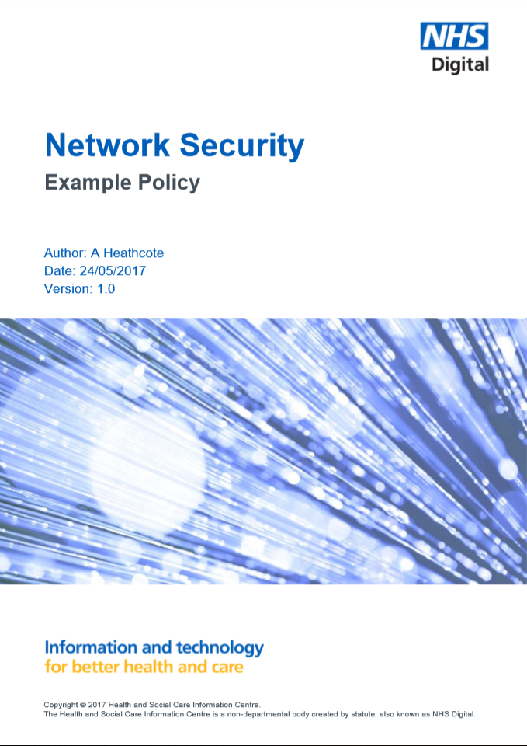
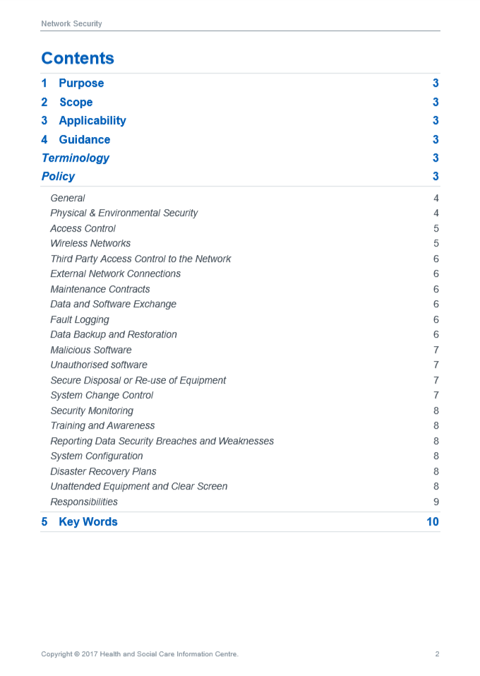

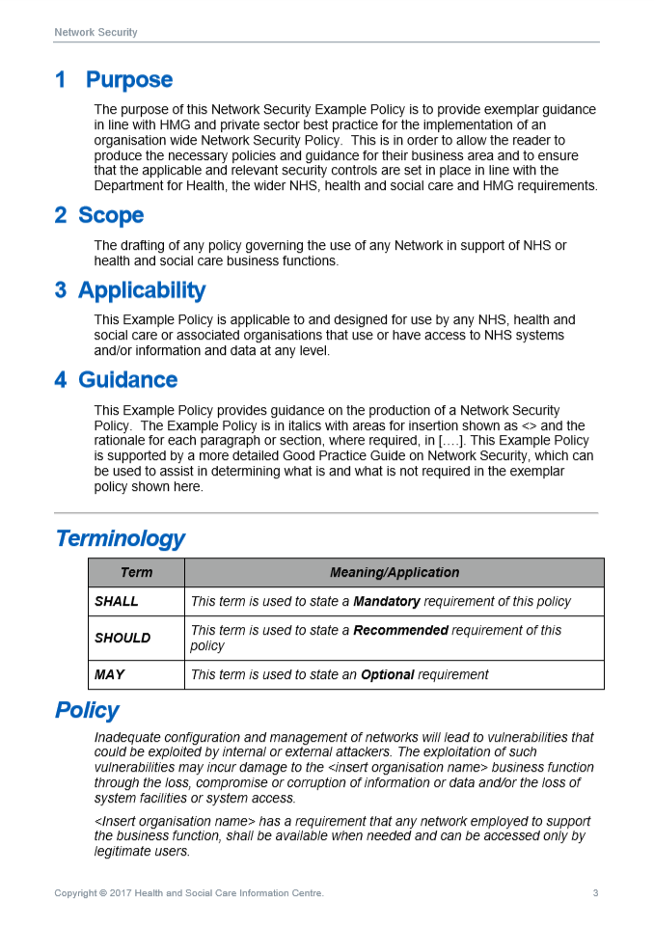
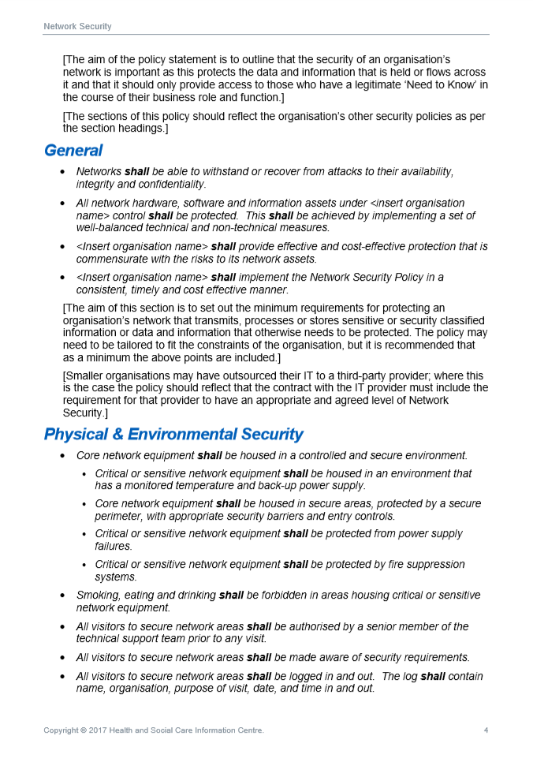

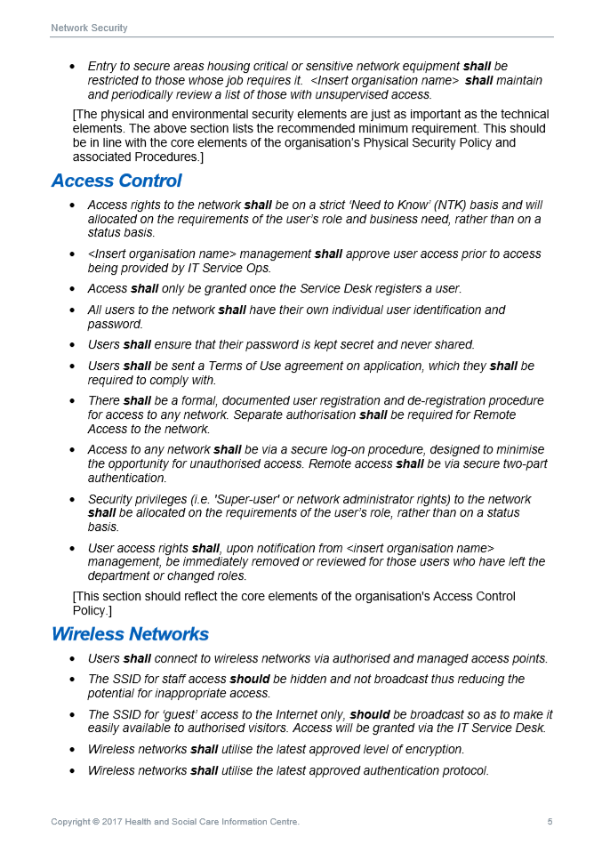

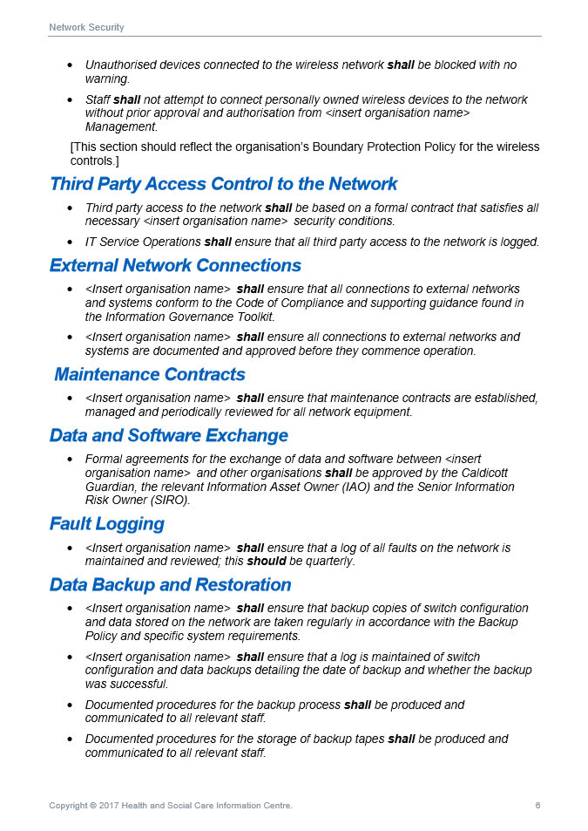

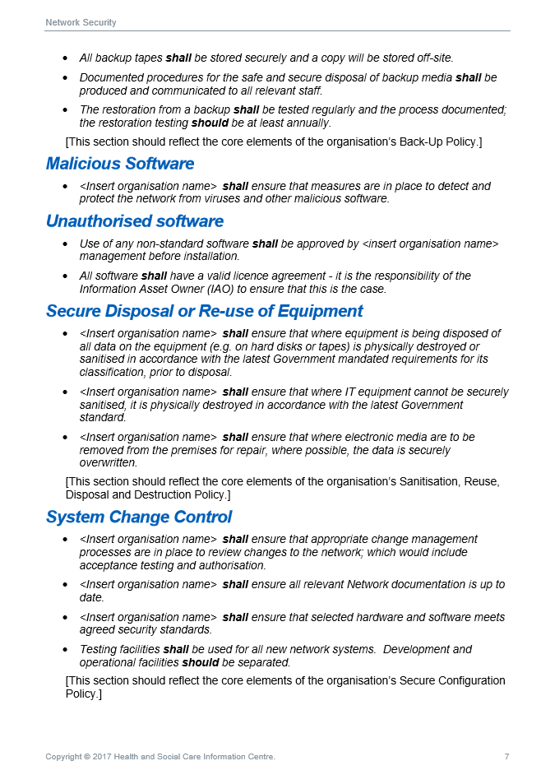

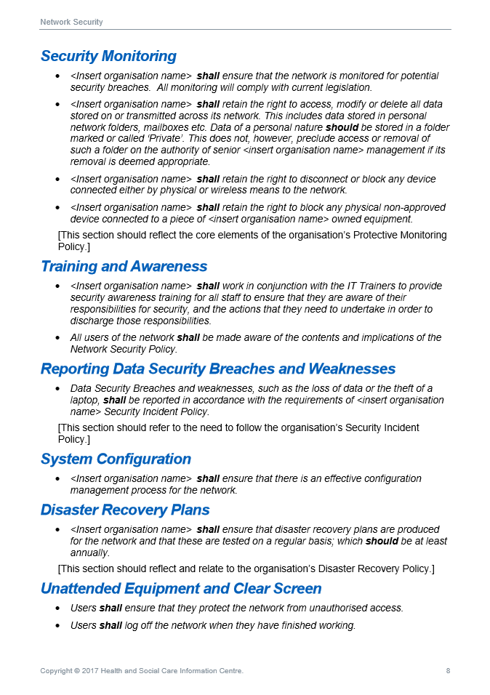

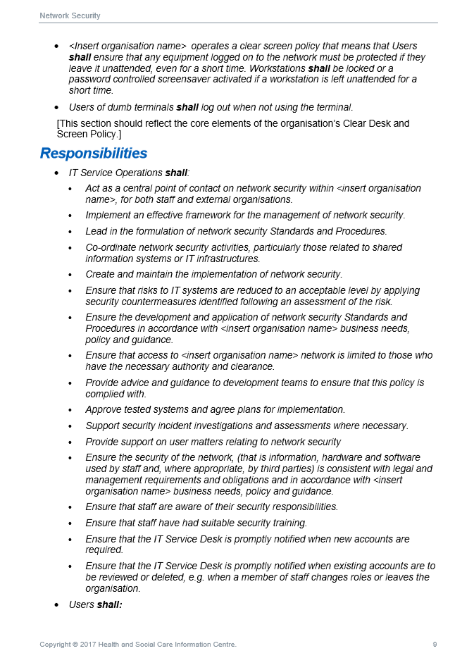

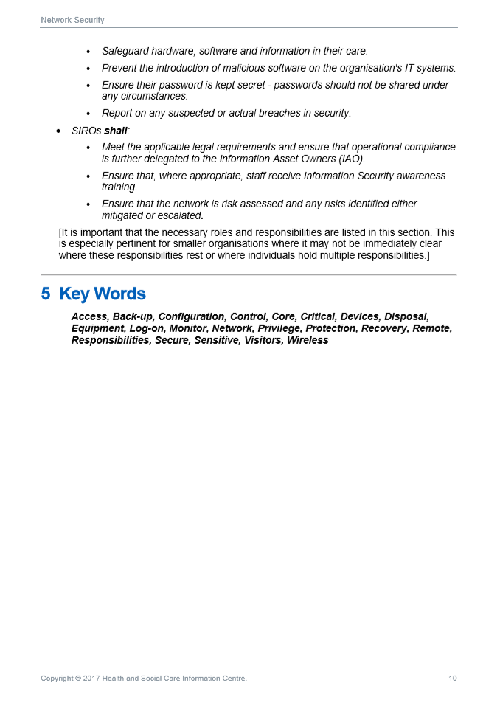

Fig 2 – Sample Risk Analysis Template, EHR 2.0
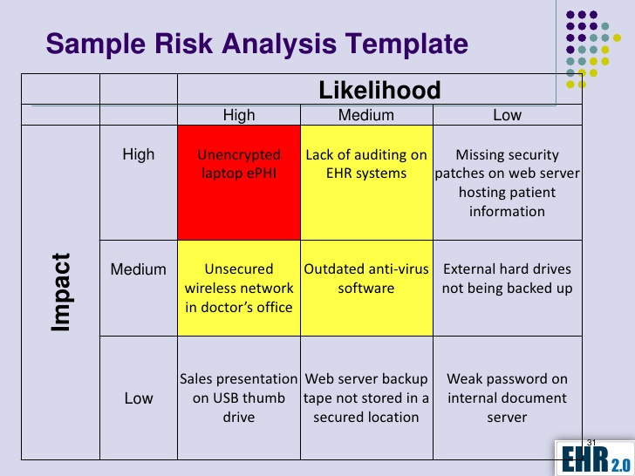
https://ehr20.com/services/security-risk-analysis-for-mips-meaningful-use/

