
Applied Computing Wales Institute of Science and Art (WISA)

Networks and Cybersecurity Essentials (ACCA4024)

Home Work 3: Straight Through and Crossover Cables

Submission Deadline: On or before 06/11/2020 23.59 Hrs.
Submission Via Moodle Link.



n.kaliyamurthy@uwtsd.ac.uk 1

Objectives
- Understand cabling standards for use in LAN cabling environments.

Background/ Scenario
The TIA/EIA has specified unshielded twisted pair (UTP) cabling standards for use in LAN cabling environments. TIA/EIA 568-A and 568-B stipulates the commercial cabling standards for LAN installations; these are the standards most commonly used in LAN cabling for organizations and they determine which color wire is used on each pin.
With a crossover cable, the second and third pairs on the RJ-45 connector at one end of the cable are reversed at the other end, which reverses the send and receive pairs. The cable pinouts are the 568-A standard on one end and the 568-B standard on the other end. Crossover cables are normally used to connect hubs to hubs or switches to switches, but they can also be used to directly connect two hosts to create a simple network.
Note: With modern networking devices, a straight-through cable can often be used even when connecting like devices because of their autosensing feature. With autosensing, the interfaces detect whether the send and receive circuit pairs are correctly connected. If they are not, the interfaces reverse one end of the connection. Autosensing also alters the speed of the interfaces to match the slowest one. For example, if connecting a Gigabit Ethernet (1000 Mb/s) router interface to a Fast Ethernet (100 Mb/s) switch interface, the connection uses Fast Ethernet.
The Cisco 2960 switch has autosensing turned on, by default; therefore, connecting two 2960 switches together works with either a crossover or a straight-through cable. With some older switches, this is not the case and a crossover cable must be used.
In addition, the Cisco 1941 router Gigabit Ethernet interfaces are autosensing and a straight- through cable may be used to connect a PC directly to the router interface (bypassing the switch). With some older routers, this is not the case and a crossover cable must be used.
When directly connecting two hosts, it is generally advisable to use a crossover cable.

Task 1: Analyze diagrams and tables for the TIA/EIA 568-A and TIA/EIA 568-B standard Ethernet cable.
The following table and diagrams display the color scheme and pinouts, as well as the function of the four pairs of wires used for the 568-A standard.
Note: In LAN installations using 100Base-T (100 Mb/s), only two pairs out of the four are used.
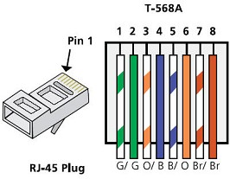
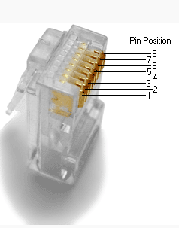
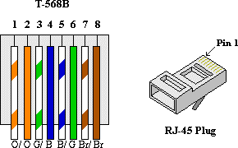

Record your reflection
- What are these TIA/EIA Standards? How do 568 A differs from 568 B? Are there any other answers are below the questions. _ _ _
_ _ _ _
_ _ _ _

- What is a Straight through Cable and Cross over Cable? Which cable should be selected during a simple network installation (Topology includes Routers, Switches and End Devices)? (100 – 300 Words). You shall use Tables, Diagrams to clarify.
Answers are below the questions. _ _ _ _
_ _ _ _
_ _ _ _
_ _ _ _
_ _ _ _
_ _ _ .

- TIE/EIA use commercial cabling standards, which states how to; manage, build and design a cabling system. The only difference between a 568 A and a 568 B is that the orange and green cables are interchanged, if both standards are used on the end of a single cable it can create a crossover cable rather than a straight through cable which only uses one of the two methods. There are some other forms of cabling standards to my knowledge such as: Generic Telecommunications Cabling for Customer Premises, Commercial Building Telecommunications Cabling Standard, Balanced Twisted-Pair Telecommunication Cabling and Components Standard, Optical Fiber Cabling And Components Standard, Broadband Coaxial Cabling and Components Standard.

- A straight through cable is a type of cable where both ends of the cable use the same wiring standard (T568A or T568B) and is often used in LANS (local area networks) to connect a computer to a router or other form of device used in creating a network. A crossover cable is a type of cable that use a different wiring standard at each end of the cable. A crossover cable connects two similar devices together such as two pcs or two hubs. In a simple network installation I believe a straight through cable would be better due to cisco packet tracer and the image of my work from lab 3, which shows the two end devices using straight through cables connecting to the switch which enables the devices to communicate, however if the network was more complex and PC-A and PC-C need to be connected I’d then advise using a crossover, but there is no need for one in a simple network such as one below (pg4).



