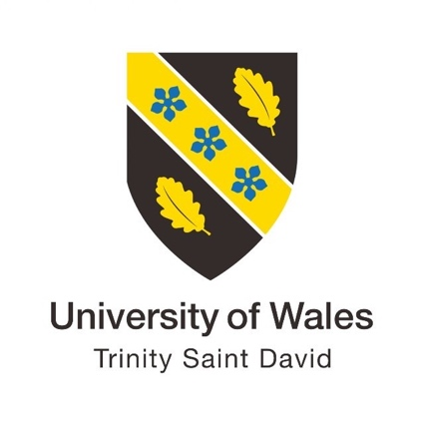

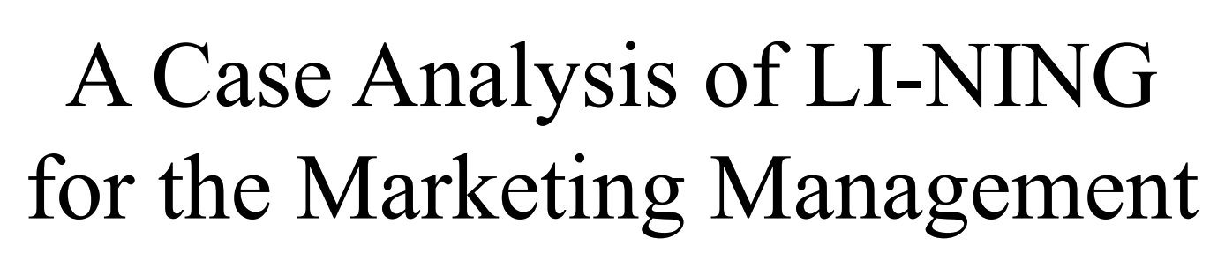

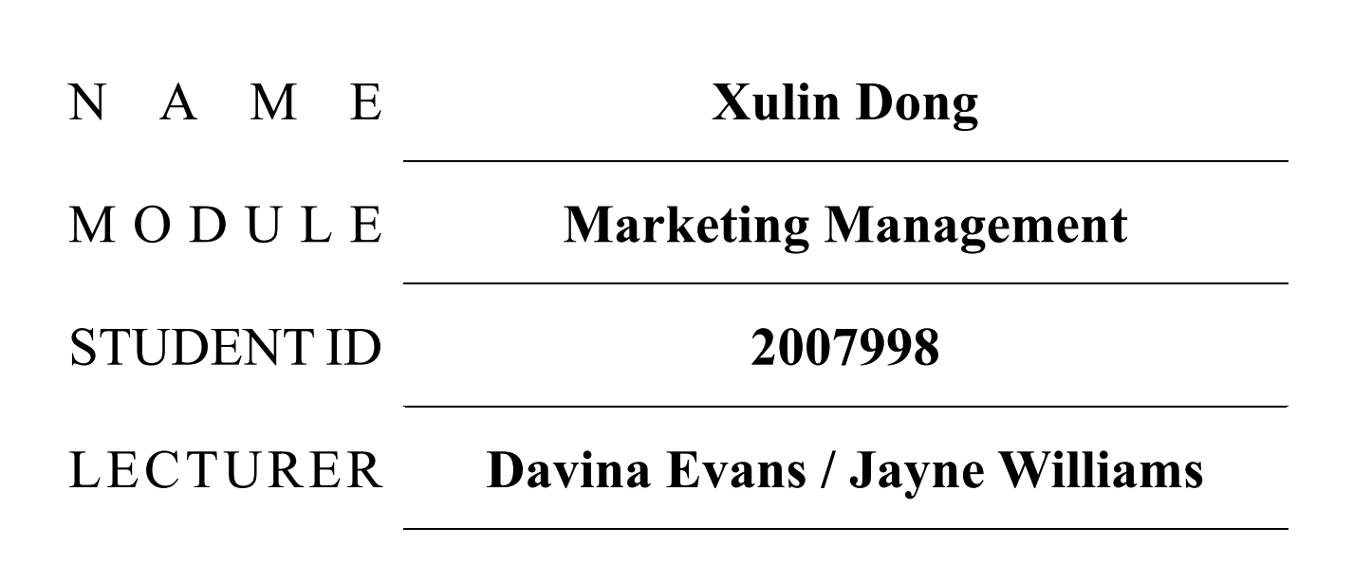

June 2021

Contents
Contents I
1.0 Executive Summary 1
2.0 Situation Analysis 1
2.1 Information from presentation 1
2.2 SWOT Analysis 2
2.3 Porter's Five Forces Model 5
2.4 TOWS Matrix 7
3.0 Marketing Objectives 9
4.0 Marketing Strategies 9
4.1 Segment Expansion 10
4.2 Brand Expansion 10
5.0 Tactics 11
6.0 Actions 13
7.0 Control 15
7.1 Annual Plan Control 15
7.2 Profitability Control 15
7.3 Efficiency Control 16
References 17

1.0 Executive Summary

The purpose of this marketing plan is to develop and launch a new customer care program and enhance the entire customer journey with valuable creative activities that will help LI-NING provide its market dominance, awareness, and sustainability for future growth through this marketing strategy (BrandGuide, 2019). The marketing plan will follow the SOSTAC (Situation analysis, Objectives, Strategy, Tactics, Actions and Control) framework. LI-NING, the company featured in this report, is a sports fashion brand from China, whose founder is an Olympic gold medalist in gymnastics and has a high social profile, while LI-NING's sub-brand China LI-NING is currently gaining significant attention around the world.

2.0 Situation Analysis

2.1 Information from presentation

As an essential part of an organisation's allocation of marketing opportunities, the marketing audit is an important strategic control process and evaluation stage (ZHANG, 2015). The marketing audit is part of a fundamental marketing planning process and it is important that the marketing audit is an independent examination of the marketing performance of the company in particular with the objective of identifying problems and marketing opportunities and proposing measures to improve the situation (Brownell, 2018).
The financial results show that for the full year 2020, LI-NING Group's revenue rose 4.2% to RMB14.457 billion and net profit rose 13.3% to $1.698 billion, with a gross margin of 49.1% unchanged from the previous year. with 4.2% revenue growth and 13.3% net profit growth, the epidemic did put a hard brake on LI-NING's rise (Doyle, 2020). After all, at this time last year, LI-NING gave an all too bright report card - a 32% jump in revenue, a 110% jump in net profit and a 98.6% jump in operating profit for 2019. In fact, from HK$6.59 at the start of 2018 to HK$53.25 by the end of 2020, LI-NING's share price has soared 700% in three years. In the past 2020, LI-NING's market capitalisation has even doubled and has surpassed HK$100 billion (GAO, 2020).
LI-NING has its own online shop and has a large number of fans and customers on Taobao (a well-known shopping platform in China), providing customers with a convenient and varied purchasing process, further increasing customer satisfaction (Zhang, 2021).

2.2 SWOT Analysis

SWOT analysis is a method of strategic planning that helps organizations identify the areas of weakness and strengths. (Dauda, 2019).

Strengths

Founded in 1990, LI-NING started earlier than other domestic sports brands and took the lead in occupying a large domestic market. And with the 2008 Olympic Games, it has greatly increased its brand awareness and is arguably a household name in China (Grant, 2019). In 2010, LI-NING opened its first overseas physical shop in Portland, USA, creating a precedent for domestic sports brands (Hu, 2014).
Innovation has always been an integral part of every company and LI-NING has always been committed to developing innovative new products (ZHANG, 2011). Whether it's the early incorporation of traditional Chinese heroes, ancient characters, folklore and opera face into sneakers, or the recent promotion of the "China LI-NING" series, the effort to incorporate Chinese elements into products is something LI-NING has continued to do to this day (LI, 2013). LI-NING is making a distinctive sports brand that belongs only to China, an advantage not seen in any other domestic sports brand.

Weaknesses

LI-NING's most serious issue in the development process is that its brand positioning has not been clear enough. LI-NING, as the first domestic sports brand to land in the NBA, has been signing NBA stars, which shows that LI-NING wants to take the high-end positioning route, although it has adopted the strategy of developing multiple brands together, subdividing its products into running, basketball, badminton, comprehensive training and sports life, so that the target customer group is broader, but LI-NING has not been able to define whether to take the popular fashion market or the professional sports market. LI-NING has not been able to define whether it should go into the mass fashion market or the professional sports market (Li, 2015). The other competing companies in the country have a clear positioning of their products, which puts LI-NING at a disadvantage in the competition (Zi-xin, 2012).

Opportunities

Currently, China has been experiencing a wave of sports, and the branding of sportswear in second and third-tier cities is a driving force behind LI-NING's rise. In terms of market share, LI-NING's trendy brand has gained popularity since New York Fashion Week, and the 'China LI-NING' brand has gained a large market share worldwide. At the same time, LI-NING China's product innovation has captured the hearts of the 'post-90s' youth (LI, 2010).
In addition, China is currently organising large scale sporting events, which requires event sponsorship, giving LI-NING a better opportunity to expand its reach.

Threats

As a mass consumer product, there are not many technical barriers, but in the minds of most consumers, foreign brands are still considered to be superior to domestic brands, and this consumer mindset exists not only in sports products but in almost every field. In terms of competition in the industry, LI-NING still has a gap with Adidas and Nike in the high-end products, while in the mid-range products, LI-NING's competitors are not to be underestimated, with domestic sports brands such as Anta, 361 and Pique also occupying a large part of the market.
Online sales have had a huge impact on the physical sector. The rapid development of e-commerce platforms in the internet era has resulted in more and more consumers preferring to buy goods from e-commerce platforms, which often offer great discounts without the need for high shop expenses, giving consumers the impression that physical shops offer a serious price premium. However, this represents a huge blow to physical shops, and LI-NING's massive expansion of physical shops has not been very effective (Liang, 2015).

2.3 Porter's Five Forces Model

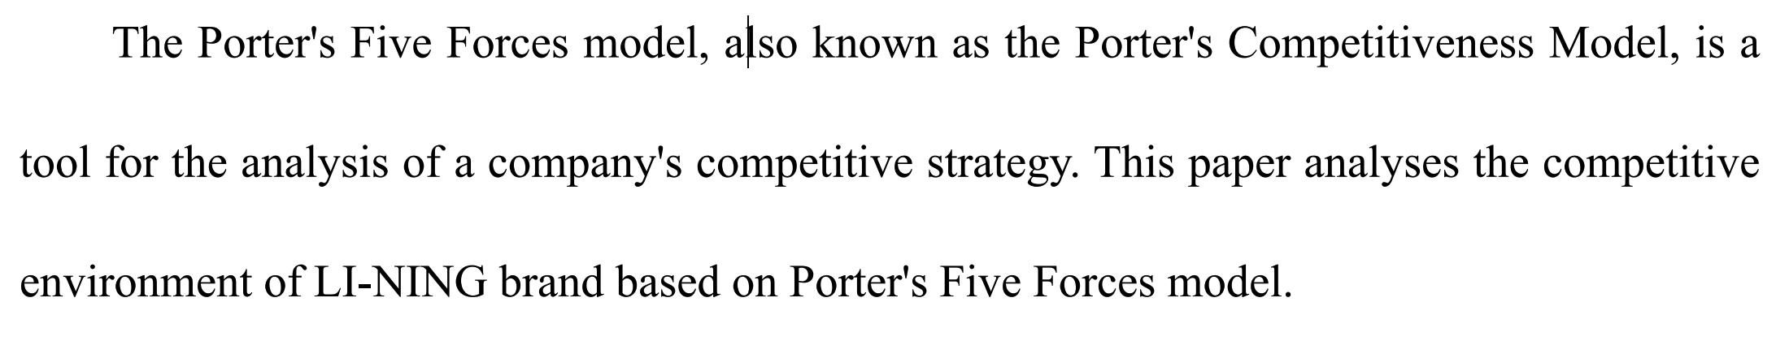

Competitiveness of competitors
Competition in the sporting goods industry is fierce, and LI-NING has to face not only well-known international brands such as Nike and Adidas but also major domestic brands represented by Anta and PEAK, of which Anta surpassed LI-NING's position as the top domestic sales performer in 2012 (Liu, 2005). From the analysis of the domestic market, Anta and other domestic sportswear brands have a lower brand positioning than Li-Ning in the domestic market and sales are more stable.

The ability of potential competitors
The high-end market for sports goods has a high barrier to entry, which has always been dominated by international brands. The fact that LI-NING has not been able to fully enter the high-end market for so many years shows that it is not sensible to blindly pursue the high-end route (Mao, 2018). As a company with a history of nearly 30 years, LI-NING has many established advantages over these challengers:
1. As the first sports brand in China, Li-NING has a high degree of recognition among consumers. Its products have various advantages such as being able to provide quality products at a competitive price.
2. Long-term development of new technologies enabled LI-NING to develop products that are not available to other competitors. (Meuer, 2015);
3. LI-NING has thousands of shops across the country and has its flagship shops in Taobao and JD, so its online and offline channel advantages are not comparable to those of its potential competitors.

Substitutability of alternatives
The high-end market for sports equipment mainly focuses on the professionalism of sports, and the products have a high technological content (Ning, 2015). However, at the lower end of the market, on the one hand, manufacturers do not differentiate in detail by function, and on the other hand, because consumers do not require high functionality and do not need to specialise too much in their needs, which leads to a high degree of substitutability of goods at the lower end of the market (ZHANG, 2009). LI-NING has adjusted its product strategy by making specialised categories, launching basketball, running, badminton and other related categories respectively, which has greatly reduced the substitutability of its products.

Bargaining power of the buyer
The high-end markets have greater bargaining power when compared to the low-end. This is because the value of the product is more important to consumers than the price (Ning, 2015). As a top domestic company of LI-NING and buyers are buying a standardised product with standardised pricing, both for distributors and for consumers in shops, which creates trust in the brand's price, so the bargaining power of buyers is not a threat to LI-NING.

2.4 TOWS Matrix

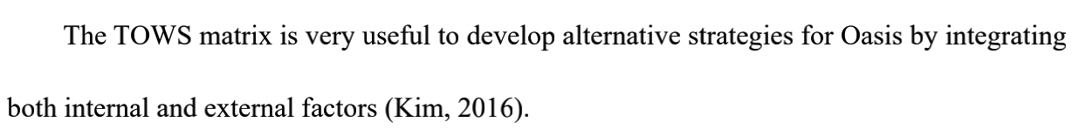
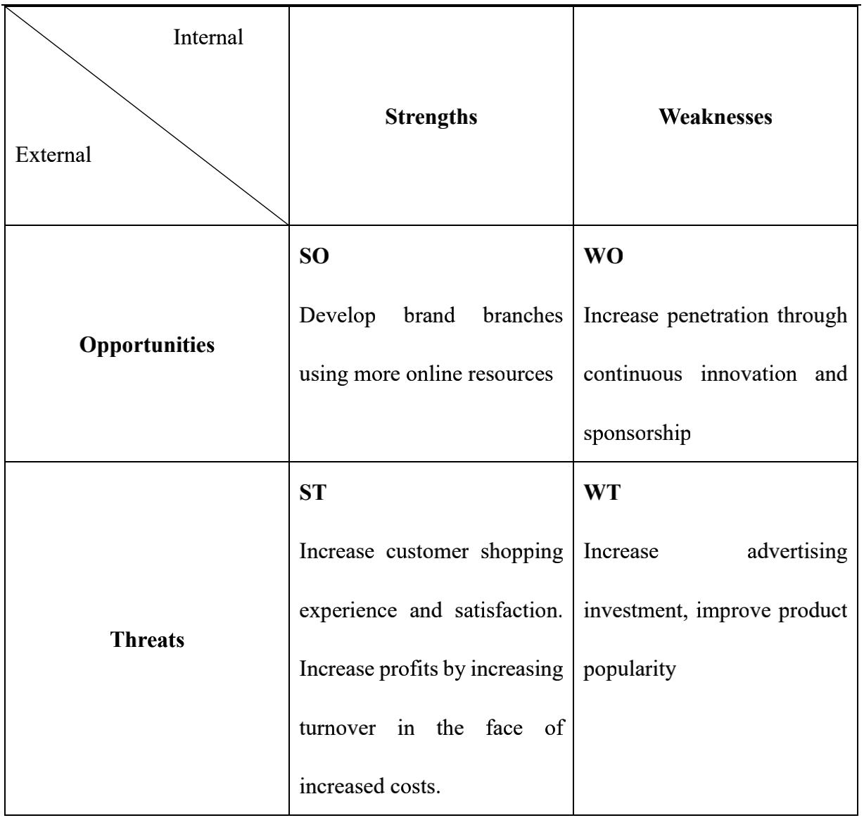

LI-NING must enter the premium market by creating sub-branches and invest heavily in the advertising level to increase its awareness and national recognition and to provide improved customer care and bring in new customers, while continuing to maintain its existing client base. John A Goodman stated that the success of an organisation depends on how it serves its customers.

3.0 Marketing Objectives

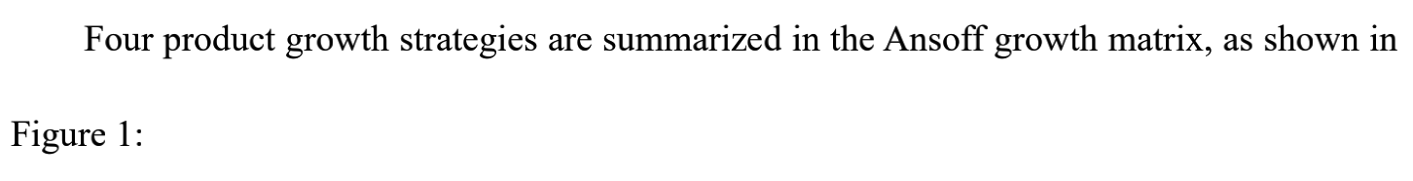
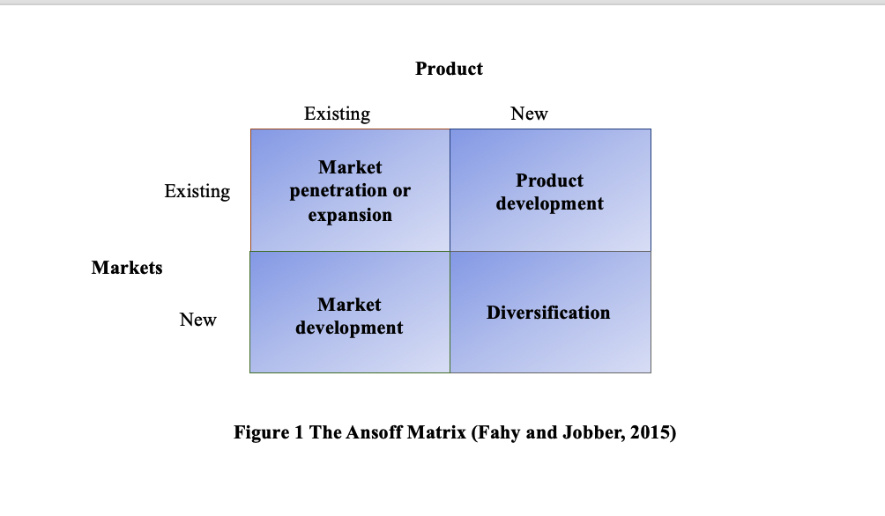
- 29% increase in sales by the end of 2021
- Launch more branded branches by the end of 2021
- Increase customer satisfaction to 90% by the end of 2021
- Complete a 25% increase in daily active users in the brand's flagship shops by the end of 2021

4.0 Marketing Strategies

Marketing strategy is about market focus and how to choose the right plan for the company in the target market. The analysis shows that LI-NING is still in the growth phase of market expansion and should continue to develop more expansion strategies and brand expansion plans in the growth phase of the market to face the increasingly tough competition in the domestic and international arena (Ning, 2002).

4.1 Segment Expansion

LI-NING's target market is large and covers a wide range of sectors, with its main targets being the sports crowd and fashionable brands, and after sponsoring the Chinese national badminton and basketball teams, it's high-quality sports equipment The image of LI-NING can bring a sustained impact in the sports sector and largely help it to gain a firm foothold in the sports sector (Ning, 2012). Meanwhile, LI-NING is now actively participating in fashion week events, using its existing fashion resources and marketing strategies to help it gain more support and buying power in the fashion sector.

4.2 Brand Expansion

The introduction of new products and the creation of sub-brands and trendy branches is not only the whole of the brand expansion strategy but also the additional value-added services that are important support for the brand expansion and that can provide great value to the customer (Yue, 2019). LI-NING initially started as a sports brand, marketed as a sports equipment and apparel manufacturing brand. However, as the market position changed and the environment became more and more intense, LI-NING began to gradually dabble in the market circle and gained a good response, with its ping brand, shopping APP, online and offline lottery purchase mode and offline physical shops covering the whole country, which can provide customers with a good shopping life experience in line with the brand and provide a good shopping experience (Pratap, 2018).

5.0 Tactics

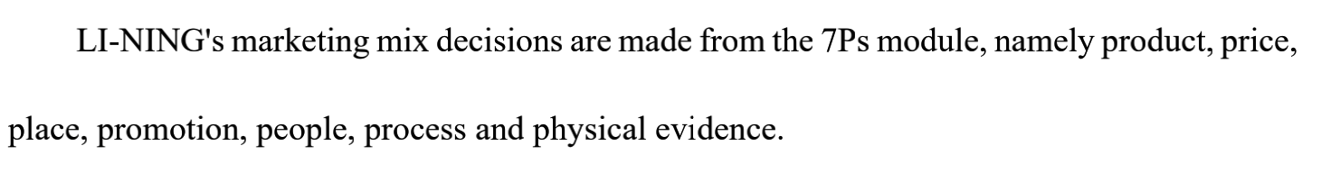

Product
Today's consumer market is dominated by a younger generation of consumers, with changing aesthetics and the arrival of foreign brands leaving traditional brands facing the dilemma of transformation or closure. In terms of product positioning, LI-NING has changed its previous vague product positioning and has defined five core sports products, with basketball, running and badminton as its core sports products, while venturing into high-end sports and outdoor, table tennis and yoga and fitness (Qinghua, 2010).
Nowadays the consumers’ needs and market environment are varied, so the company launched sports products to suit different categories of sports attributes. The first is a strategy of professional and functional products, while the second is a strategy of sports and leisure products for the general public. The strategy is to enhance the accessibility of the products to the general public and to re-open the market to the general consumer in a more grounded way (YAN, 2014).

Place
As of 3of May 2021, the number of LI-NING points of sale totalled 6,052, 397 fewer than at the end of last year (with a net decrease of 224 and 252 in the first and second quarters respectively), but a net increase of 79 points of sale in the third quarter compared to the second quarter, with the number of shops returning to net growth for the first time this year (Shengguang, 2009). This illustrates that against the backdrop of the epidemic, the number of LI-NING shops is still growing at a rate that is not significantly affected by the epidemic. At the same time, according to the map display and logo, the locations of Li-Ning shops are mostly in busy areas, which indicates that Li-Ning is thinking through the choice of shop locations, which is beneficial to the marketing development of LI-NING.

People
In 2019, Lijie Chen and his team were appointed to the LI-NING design team, a move that even changed the fortunes of LI-NING, whose designs were immediately sought after by the majority of young people in China and even the world (Xiawen, 2019). Design is extremely important to a fashion company, so acquiring qualified and renowned designers will improve the quality of the design of LI-NING products (Sun, 2020). The staff in the offline shops should be well trained, as they are the ones who come into direct contact with the customers and are the ones who have the first impression of LI-NING.

Promotion
LI-NING uses a policy of sharing offline offers and online promotions to ensure that users get the best value for money and do not choose other shops because of price. It guarantees the timeliness and distinctiveness of its offers. The promotions are also unique in that they vary from week to week and are updated to give customers a wider selection of discounted items (TANG, 2019).

6.0 Actions

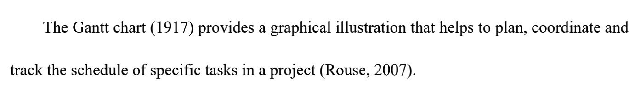
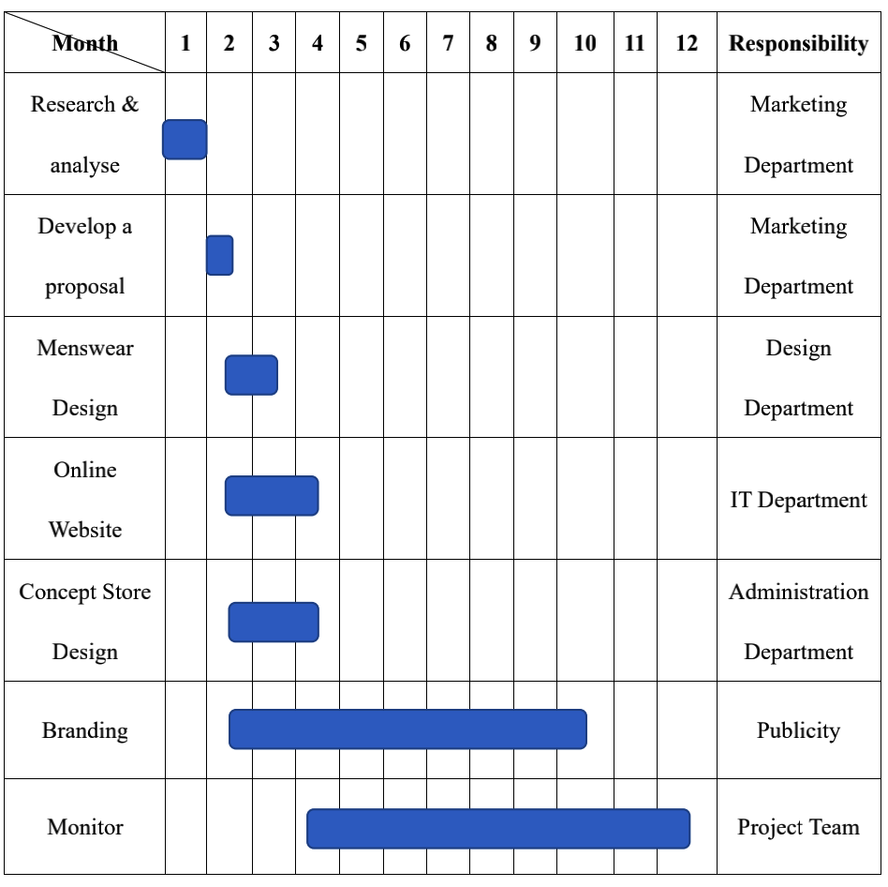
First, the marketing department needs to develop a marketing plan and analyze the current situation of LI-NING. The design department needs to create the menswear products and the online platform (Xiao-kun, 2009). The administration department is responsible for contacting design companies to renovate LI-NING offline shops (Tu, 2017). Regarding the enhancement of the LI-NING brand image, the publicity department is responsible for this. In terms of monitoring, the project team has to constantly check the whole process of the marketing plan. The above actions will help increase LI-NING's sales.

7.0 Control

A good marketing control system helps marketers measure and evaluate the results of their marketing strategies. (Law, 2009). Kotler (1997) identifies four main areas associated with the control of marketing activities: annual planning, profitability, efficiency and strategy (Drummond et al., 2008). Three of these approaches will be carried out in the control process.

7.1 Annual Plan Control

LI-NING collects and analyses the sales of different products and sales channels from different products and sales methods and uses this information to compare them with existing targets (Xiaocong, 2016). Through these analyses, LI-NING can know how well these targets are being met and, by analysing customer service online shopping behaviour and customer feedback, the percentage of customer satisfaction could be understood by LI-NING and how customer service can be improved.

7.2 Profitability Control

Using analysis to examine the products and the profitability of the concept shops, LI-NING can decide either to help expand, reduce or eliminate the product offering. In addition, LI-NING can decide whether to break up distribution channels or continue to segment the product range depending on profitability.

7.3 Efficiency Control

Efficiency is about getting the best value from marketing assets (Drummond et al. 2008), and LI-NING should regularly stage what it gains and what it acquires from marketing activities such as advertising, promotion and sales to ensure that efficiency of all efforts is guaranteed.

References
BrandGuide (2019) LI-NING Clothing SWOT Analysis, Competitors & USP. Available at: https://www.mbaskool.com/brandguide/lifestyle-and-retail/3764-oasis-clothing.html
Brownell, S., 2015. Why 1984 Medalist LI-NING Lit the Flame at the Beijing 2008 Olympics: The Contribution of the Los Angeles Olympics to China's Market Reforms. The International Journal of the History of Sport, 32(1), pp.128-143.
Doyle, C. (2011) 'marketing strategy. A Dictionary of Marketing. 3rd Ed. New York: Oxford University Press, pp.128.
GAO, M. and KONG, P., 2013. On the Development History of Li-Ning Sporting Goods Corporation in Badminton Industry. The Guide of Science & Education, p.05.
Goodman, J.A. (2009) Strategic customer service managing the customer experience to increase positive word of mouth, build loyalty, and maximize profits, New York: AMACOM, pp.1.
Grant, M. (2019) Strength, Weakness, Opportunity, and Threat (SWOT) Analysis. Available at: https://www.investopedia.com/terms/s/swot.asp
Hu, J., 2014. Sportswear branding in China: a comparative case study of LI-NING and Adidas.
Kim, N. (2016) Local Sport Development Strategy through Sport Development Model and TOWs Matrix. International Information Institute (Tokyo). Information, 19(4), pp.1210.
LI, N. and WANG, H.S., 2013. Relationship among Sports Medias [J]. Journal of Sports Adult Education, 1.
Li, N., 2015, March. Research on the Innovation and Applications on Sports Equipment. In 2015 International Conference on Education Technology, Management and Humanities Science (ETMHS 2015) (pp. 288-291). Atlantis Press.
LI, N., WANG, X. and QU, X., 2010. The Structural Status of the Sports Industry and the Related Policy [J]. Journal of Gansu Lianhe University (Natural Science Edition), 6.
Liang, J.I.A.N.G., 2015. Comparative Study of Brand Building Between Domestic and Overseas Sports Goods from the View of Cultural Innovation Theories——Based on Nike and LI-NING. Journal of Hebei Institute of Physical Education, p.06.
Liu, Y.L., 2005. A Case Study Of LI-NING Company Limited (Doctoral dissertation, Multimedia University).
Mao, L.L. and Zhang, J., 2018. Branding through sponsorship-linked marketing: A case of Chinese sports apparel and equipment brand “LI-NING”. In Digital marketing and consumer engagement: Concepts, methodologies, tools, and applications (pp. 191-214). IGI Global.
Meuer, J., DiVito, L., Krug, B. and Yue, T., 2010. A Grand Entrance? LI-NING’s Emergence as a Global, Chinese Brand.
Ning, L., 2015. Branding through Sponsorship-Linked Marketing: A Case of Chinese Sports Apparel. Emerging Trends and Innovation in Sports Marketing and Management in Asia, p.44.
Ning, L., Jun, L., Teng, L. and Fuguo, C., 2013. Confucian culture influence Chinese sports culture. Contemporary Sports Technology, 16, p.094.
Ning, L., Jun, L., Teng, L. and Fuguo, C., 2013. Confucian culture influence on Chinese sports culture. Contemporary Sports Technology, 16, p.094.
Ning, L.I., 2002. Present condition of development and Policy selection of China's Sports Industry [J]. Journal of Nanjing Institute of Physical Education (Social Science), 6.
Ning, L.I., 2012. A research on mass sports development trends in China——A comparative analysis based on the results of 3 mass sports surveys nationwide [J]. Journal of Physical Education, 1.
Pratap, A. (2018) PESTEL/PESTLE Analysis of the Fashion Retail Industry. Available at: https://notesmatic.com/2017/09/pestelpestle-analysis-of-the-fashion-retail- industry
Qinghua, W.A.N.G., 2010. The Analysis of Li-Ning Sports' Olympic Marketing Strategy [J]. Hubei Sports Science, 6.
Shengguang, W.U., 2009. An Investigation and Analyzation on" LI-NING Cup" National Youth Gymnastic Competition in 2007. Sport Science and Technology, p.01.
Sun, J.M., Yang, H.T., Wang, Y. and Ge, T.J., 2014. Application of multi-media technology on the sports website in China—a case study on LI-NING. In Computer, Intelligent Computing and Education Technology (pp. 722-725). CRC Press.
TANG, Y.C. and WU, S., 2011. Research On Network Running Club——Taking LI-NING iRUN Running Club as Example [J]. Journal of Hebei Institute of Physical Education, 1.
Tu, J., 2014. LI-NING: Make the Change. In Case Studies in Asian Management (pp. 55-66).
Xiaocong, L. and Xiaoli, F., 2016. Research On Business Model Innovation Of Sports Goods Enterprises In The Internet Era——Analysis Of The Development Dilemma Of LI-NING Company. Journal of Anhui Sports Science, p.05.
Xiao-kun, Y.A.N.G., 2009. Study on Competitive Trend and Strategy of Sports Brand in China-Empirical Analysis Based on the Development of LI-NING Company. Journal of Jilin Province Economic Management Cadre College, p.06.
Xiawen, Y., 1989. Kinematical Analysis on LI-NING's Handspring Sideways Stretched Sideward Somersault with 1 3/4 Turn in Horse Vaulting [J]. China Sport Science and Technology, 12.
YAN, Y.C., DOU, Y.J., WANG, H. and WANG, M.J., 2014. SWOT Analysis on LI-NING Sports Brand——Based on Consumer's Cognition and Behavior of the Generation after 90s of 223 College Students. Bulletin of Sport Science & Technology, p.12.
Yue, G., Selamat, M.H. and XiaDi, L., 2019. Current Management Situation of renowned Sporting equipment enterprises in China--Take LI-NING Sports Goods Co., Ltd. as an example. International Journal of Business and Management, 3(6), pp.08-15.
ZHANG, L., TONG, Y. and GAO, X., 2009. Case Study on Core Competence and Competitive Strategy in China's Enterprises in the Perspective of Resource——Based on Case of LI-NING Sports Goods Co., Ltd.[J]. Science of Science and Management of S. & T, 11.
ZHANG, P.G. and ZHOU, Q.D., 2011. The General Effect of the Listed Company Public Offering on the Domestics Sports Enterprises——A Case Study of LI-NING Company [J]. Journal of Beijing Sport University, 1.
Zhang, X., Marketing Plan for Li-Ning Product Expansion in UK.
Zhang, Y., Li, N., Sun, J. and Su, Q., 2013. Effects of combined traditional Chinese exercises on blood pressure and arterial function of adult female hypertensive patients. Research in Sports Medicine, 21(1), pp.98-109.
ZHANG, Y., SUN, J. and LI, N., 2015. Analysis of Sports Activities and Extracurricular Activity Survey On Primary and Secondary School Students in Sichuan Province——Taking Chengdu, Zigong and Dazhou as an example. Sichuan Sports Science, p.02.
Zi-xin, S.H.E.N., 2012. The New Exploration of the Upgrade Path of China's Traditional Industrial Enterprises: Take LI-NING Sports Brand as an Example. Journal of Shijiazhuang University of Economics, p.03.

