Student Name: Cristian Pintilei
Student Number: 2126371

Table of Contents
Part 1: Coffee Consumption and Effects 2024 3
Introduction 3
(a) 3
What is the mean value for coffee consumption (in cups) per day? 3
What is the median value for coffee consumption (in cups) per day? 4
What is the mode of coffee consumption (in cups) per day? 4
What is the standard deviation for effects on the human body (based on a health index score)? 5
Which one of the two variables has a larger variance? 5
Which one of the two variables has a larger standard deviation? 6
Can you interpret the last three outcomes? 6
(b) 7
Using MS Excel you need to demonstrate how you can present the data in your report with the use of any one of Excel functions such as: IF, PIVOT TABLES, CHARTS AND GRAPHS. 7
(c) 8
Find out what is the correlation between coffee consumption and the health index score. 8
Produce a scatterplot of the two variables. Use coffee consumption on the horizontal axis and effects on the human body (health index score) on the vertical axis and comment on the graph. 9
Conclusion 10
Part 2: 11
Discuss the advantages and disadvantages of using SPSS, Excel or Tableau using relevant practical examples. 11
Explain the meaning and importance of the Data Mining Cycle with examples. 12
Reference 13

Part 1: Coffee Consumption and Effects 2024

Introduction
Daily coffee consumption can have positive and negative effects on human health. On the positive side, coffee contains antioxidants that can improve brain function and reduce the risk of conditions like Alzheimer's and Parkinson's diseases. Moderate coffee intake may also increase energy, enhance mood, lower the risk of Alzheimer's disease, reduce cardiovascular disease risk, and improve thyroid function. However, excessive coffee consumption can lead to negative outcomes such as increased anxiety, potential bone health issues, pregnancy complications, and caffeine dependency with withdrawal symptoms. Moderate coffee intake, typically 3 to 4 cups per day, is generally considered safe and beneficial, but individual tolerance varies (Lauren Manaker, 2023). As part of a research project called "Coffee_Consumption_and_Effects_2024," a detailed dataset has been compiled to explore this topic. As a data analyst intern, my task is to analyse this dataset using Microsoft Excel and SPSS software to understand the relationship between coffee consumption and health effects. The dataset includes information on daily coffee intake and health index scores, and our goal is to uncover insights that could guide future dietary recommendations and deepen our understanding of coffee's impact on health. Through statistical analysis and visualisation using Excel and SPSS, we aim to contribute valuable insights to the ongoing discussion on coffee consumption and health.

(a)

What is the mean value for coffee consumption (in cups) per day?
Answer:
The mean is a way to find the average or most common value in a group of numbers. It is used in mathematics and statistics to show where most numbers in a set are. There are different ways to find the mean, but two common ones are the arithmetic mean and the geometric mean. The arithmetic mean adds up all the numbers and divides by how many there are. The geometric mean finds the nth root of the product of all the numbers. In finance, the arithmetic mean can sometimes give an inflated average because it does not account for things like volatility and compounding. The geometric mean is often used in finance because it does account for these factors and gives a more accurate average (Tyreman, 2011).
Mean value for coffee consumption (in cups) per day: This is the average number of cups of coffee consumed per day across all individuals in the data set. It is calculated by adding up all the values for coffee consumption and dividing by the total number of individuals.
Formula: Sum Total of Coffee Consumption per Day/ Total Number of Person
= 145/40
= 3.625 Cups
Table. 1
The mean coffee consumption per day of 3.625 cups indicates the average amount of coffee consumed by individuals in the dataset. Essentially, if the total coffee consumption were distributed equally among all individuals, each person would consume approximately 3.625 cups daily. This value serves as a measure of central tendency, offering insight into the typical coffee consumption level within the group.

What is the median value for coffee consumption (in cups) per day?
Answer:
The median represents the midpoint in a dataset, where half of the data points are smaller and half are larger. To determine the median, arrange the data points in ascending order. If there is an odd number of data points, the median is the middle value. If the number of data points is even, the median is the average of the two middle values (Statista Canada, 2021).
Table. 2
The median value for coffee consumption (in cups) per day, which is 3.5, represents the mid-point when all individuals' coffee consumption values are arranged in ascending order. Essentially, it signifies that half of the individuals consume more than 3.5 cups of coffee per day, while the other half consumes less than 3.5 cups. This calculation accounts for cases where there is an even number of values, in which the median is determined by averaging the two middle values. Therefore, the median serves as a balanced indicator of coffee consumption habits within the dataset.

What is the mode of coffee consumption (in cups) per day?
Answer:
The mode in statistics is the value that appears most frequently in a dataset. It may be the only mode, more than one mode, or no mode at all. For data with a normal distribution, the mode, mean, and median are the same. Mode is particularly useful for categorical data where an average median value cannot be calculated (Singh, 2006).
Table. 3
The mode of coffee consumption, with a value of 2 cups per day, signifies that among the individuals surveyed, the most frequently occurring number of cups of coffee consumed daily is 2. This finding suggests that a notable portion of the group tends to consume this amount of coffee regularly. Recognising the mode provides insight into the prevalent level of coffee intake within the population, revealing a common trend in the data.

What is the standard deviation for effects on the human body (based on a health index score)?
Answer:
The standard deviation measures how spread out the data points are from the average value. It calculates the deviation of each data point from the mean, showing how much they vary from the average. Standard deviation helps in understanding the variation in the data and how far individual data points are from the average (Friedman, 2015).
Table. 4
The standard deviation for effects on the human body, based on a health index score, is 13.41236991. It indicates the amount of variation or dispersion in the health index scores among the individuals in the data set. A higher standard deviation suggests that the health index scores are more spread out from the average, meaning there is greater variability in the health status among the individuals. Conversely, a lower standard deviation would indicate that the health index scores are closer to the mean, suggesting less variability and a more consistent health status among the individuals. Therefore, in this case, the standard deviation value of 13.41236991 implies a moderate level of variability in the health index scores among the individuals surveyed.

Which one of the two variables has a larger variance?
Answer:
Variance measures how spread out the data is. It is found by averaging the squared differences from the mean. A higher variance means the data is more spread out from the mean, while a lower variance means it is closer to the mean (Mahalle et al., 2021).
Table. 5
The variance for effects on the human body, based on a health index score, is 179.8916667, which is larger than the variance for coffee consumption, which is 4.342948718. This indicates that the variability in the health index scores among the individuals is greater than the variability in their coffee consumption habits. A higher variance reflects a wider range of health index scores among the individuals in the data set compared to their coffee consumption patterns.

Which one of the two variables has a larger standard deviation?
Answer:
Standard deviation is a measure that shows how spread out the values in a dataset are compared to the average. It is calculated by finding the square root of the variance, which involves looking at how much each data point differs from the mean. If the data points are far from the mean, the deviation within the dataset is higher, resulting in a larger standard deviation. This means that when the data is more spread out, the standard deviation is higher (Friedman, 2015).
Table. 6
The standard deviation for the effects on the human body, based on a health index score, is larger with a value of 13.41236991, indicating greater variability in health statuses among the individuals. This means that the health index scores are more widely dispersed from the average, reflecting a broader range of health conditions within the surveyed population. Conversely, the standard deviation for coffee consumption is smaller at 2.08397426, suggesting less variability in the amount of coffee consumed by the individuals. This implies a more consistent level of coffee intake across the group.

Can you interpret the last three outcomes?
Answer:
The standard deviation for effects on the human body, based on a health index score, is 13.41236991. This indicates a moderate level of variability in health index scores among the individuals surveyed. A higher standard deviation suggests greater dispersion from the average, reflecting a wider range of health statuses. Conversely, the variance for health index scores, at 179.8916667, is larger than that for coffee consumption, indicating greater variability in health index scores compared to coffee consumption habits. Similarly, the larger standard deviation for health index scores (13.41236991) compared to coffee consumption (2.08397426) implies greater variability in health statuses among individuals, with a more consistent level of coffee intake across the group. These findings highlight the varying degrees of dispersion and consistency in health index scores and coffee consumption patterns among the surveyed individuals.

(b)

Using MS Excel you need to demonstrate how you can present the data in your report with the use of any one of Excel functions such as: IF, PIVOT TABLES, CHARTS AND GRAPHS.
Answer:
In the picture below, the consumption strategy was determined using the Excel IF function to categorise individuals based on their daily coffee consumption. The formula "=IF(B2<=3, "Low", IF(B2<=6, "Moderate", "High"))" assigns a consumption category to each person based on the number of cups of coffee they drink per day. If a person consumes 3 or fewer cups, they are classified as "Low" consumption. If they consume between 4 and 6 cups, they are classified as "Moderate." Those who consume 7 or more cups are categorised as "High" consumption. This categorisation helps to analyse and understand the coffee consumption habits of individuals in the dataset.

Table. 7

(c)

Find out what is the correlation between coffee consumption and the health index score.
Answer:
Correlation is a statistical tool used to measure how two variables change together linearly, without indicating causation. The sample correlation coefficient, denoted as "r," quantifies the strength of this relationship and is also tested for statistical significance. However, correlation analysis has its limitations. It cannot consider the influence of other variables beyond the two being studied, and it does not provide insights into cause and effect. Additionally, correlation is not suitable for describing relationships that follow a curved or non-linear pattern (Roy, 2021).
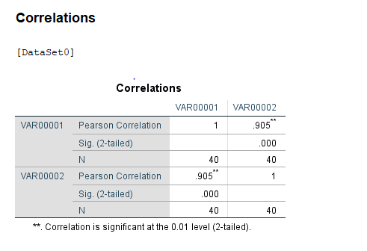
Picture. 1
The correlation coefficient between the Health Index Score and Coffee Consumption (Cups/Day) is 0.905085559. This high positive correlation suggests a strong relationship between the two variables. As the correlation coefficient is close to +1, it indicates that as Coffee Consumption increases, the Health Index Score also tends to increase. In other words, there is a positive association between the amount of coffee consumed per day and the overall health index score. This suggests that individuals who consume more cups of coffee per day tend to have higher health index scores, while those who consume fewer cups of coffee per day tend to have lower health index scores.

Produce a scatterplot of the two variables. Use coffee consumption on the horizontal axis and effects on the human body (health index score) on the vertical axis and comment on the graph.
Answer:
A scatter plot is a graph that displays the relationship between two variables in a dataset. It shows data points on a two-dimensional plane, with one variable plotted on the X-axis and the other on the Y-axis. Scatter plots, also known as scatter graphs or scatter diagrams, are used to visualise numerical data pairs and demonstrate their connection. They are helpful in situations where we have paired numerical data or when there are multiple values of the dependent variable for a unique value of an independent variable. Scatter plots are commonly used to understand relationships between variables, such as identifying potential causes of problems or determining if two related products occur together due to the same cause.
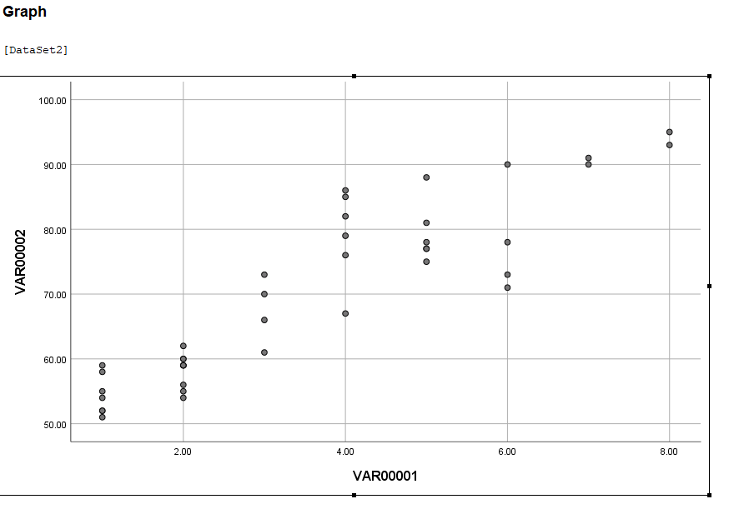
Picture. 2
The scatter plot based on the given data will display points scattered across the graph without a discernible pattern initially. A general trend is anticipated where higher Coffee Consumption corresponds to higher Health Index Scores, indicating a positive correlation between the two variables. However, variability in the data points may be observed due to individual differences, lifestyle choices, and other factors influencing health, resulting in some points deviating above or below the expected trend line.

Conclusion
The analysis of coffee consumption and its effects on the human body reveals important insights. The mean coffee consumption per day of 3.625 cups indicates a typical level of intake among the individuals surveyed. The strong positive correlation coefficient of 0.905085559 suggests that as coffee consumption increases, health index scores tend to rise, indicating a potential association between higher coffee intake and better health outcomes. Additionally, the scatter plot illustrates a scattered distribution of data points, with a general trend of higher coffee consumption corresponding to higher health index scores. These findings contribute to our understanding of the relationship between coffee consumption and health effects, informing future dietary recommendations and research efforts.

Part 2:

Discuss the advantages and disadvantages of using SPSS, Excel or Tableau using relevant practical examples.
Answer:
SPSS stands for Statistical Package in the field of Social Sciences.
Advantages:
Statistical Analysis: SPSS is tailored for analysis of statistical data, making it well-suited for analysts as well as researchers requiring to perform intricate statistical tests (Cronk, 2017).
Data Visualisation: SPSS provides a range of graphical as well as charting choices to represent correlations, data distributions as well as trends (Yockey, 2016).
Data-Management: This software also offers strong data management features that enable users to effectively manipulate, clean, as well as organise large datasets (Cronk, 2017).
Disadvantages:
Complex: SPSS has a lengthy learning process, making it challenging for beginners who might require a lot of instruction to fully utilise its capabilities (Yockey, 2016).
Limited Graphical Options: SPSS provides limited graphical customisation options in comparison to tools such as Tableau (Cronk, 2017).
Practical Application: A research team studying how socioeconomic factors affect educational achievement might utilise SPSS using regression analysis as well as to illustrate the connections between variables (Yockey, 2016).
Excel:
Advantages:
Ubiquitous: Excel has become widely easily accessible and commonly known, making it suitable for simple reporting as well as analysis of information (Guerrero, Guerrero and Rauscher, 2019).
Versatility: It provides a diverse array of functions beyond the analysis of data, including budgeting, scheduling of project management as well as accounting.
Integration: Excel seamlessly interacts with various other Microsoft Office software, enabling easy data import/export as well as collaboration (Salkind and Frey, 2021).
Disadvantages:
Deal with Limited Datasets: Excel's ability is restricted when dealing with extensive datasets as well as intricate analyses, resulting in decreased speed and possible errors (Salkind and Frey, 2021).
Lack of Specialised Performance: Excel offers comprehensive statistical tools in comparison to specialised software such as SPSS (Guerrero, Guerrero and Rauscher, 2019).
Practical Application: The owner of small business could utilise Excel for monitoring sales data, generating financial reports, as well as overseeing inventory (Salkind and Frey, 2021).

Tableau:
Advantages:
Dynamic Data-Visualisation: Tableau provides interactive as well as dynamic visualisations that enable users to examine information throughout real-time and discover insights rapidly (Hwang and Yoon, 2021).
Appealing Data-Visualisation: The intuitive dragging and dropping interface of this tool facilitates the creation of appealing dashboards as well as reports for users who are not technical.
Large Data-Set Management: Tableau is capable of efficiently managing large amounts of data as well as can be scaled to accommodate organisations of any size (Hwang and Yoon, 2021).
Disadvantages:
Costly: Tableau might be costly, particularly for enterprise-level implementations or advanced functionalities (Loth, 2019).
Easy Utilisation: Although Tableau is easy to use, becoming proficient in advanced features might demand further training as well as strong experience.
Practical Application: The marketing department could utilise Tableau to develop interactive dashboards for analysing customer segmentation as well as purchasing behaviour, enabling them to delve into particular consumer demographics as well as preferences (Loth, 2019).
Each tool possesses unique advantages and disadvantages, and the selection is contingent upon the particular needs, technical proficiency, and financial limitations of the individual or organisation. SPSS is favoured for complex statistical analysis, Excel for generic data management as well as analysis, and Tableau in interactive data visualisation as well as exploration (Hwang and Yoon, 2021; Salkind and Frey, 2021; Yockey, 2016).

Explain the meaning and importance of the Data Mining Cycle with examples.
Answer:
The process of data mining is associated with the extraction of useful and meaningful information from large amounts of accumulated data, more often, from a set of connected data sets or data warehouses. Knowledge discovery in databases (KDD) remains the complete process by which information is extracted and data mining is only one of the multiple steps of the KDD process. This step uses powerful analytical, mathematical and statistical tools and techniques to identify relationships, patterns and trends from large data sets and facilitate planning and informed decision-making. The most commonly used method for the development of data mining projects is CRISP-DM; nevertheless, its widespread adoption is restricted as it only suggests what to do instead of how to do it; also, the emergence of multiple other competitive methodologies such as sample explore, modify, model, asses (SEMMA) method (Mariscal, Marban and Fernandez, 2010). Multiple other mathematical techniques are used for data mining such as regression analysis that facilitates predicting numbers on the basis of historic patterns anticipated to happen in future. Likewise, the clustering approach emphasises grouping data based on their similarities instead of pre-defined assumptions (King, 2015).
The virtuous data mining cycle as proposed by Linoff and Berry (2011) involves four key stages including data transformation, acting on information, measuring the results and finally identifying opportunities for business and developing informed decisions based on valuable data.
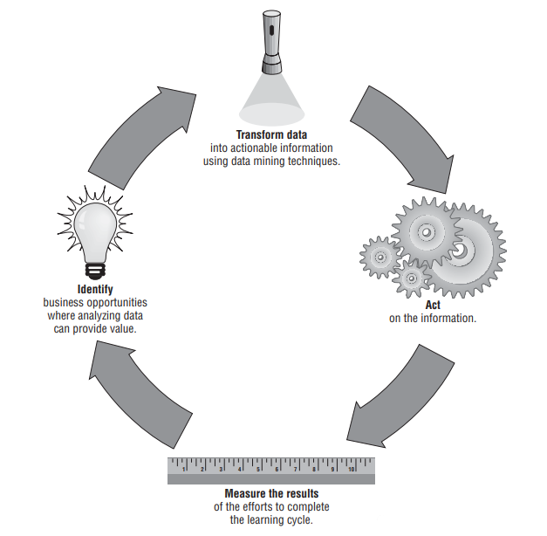
Figure: Data Mining Cycle
Source: (Linoff and Berry, 2011)
The importance of the data mining cycle is that its systematic approach to extracting valuable data from remote sensors, social media and other websites helps in the development of detailed reports on market activities and product movement. It provides tools and techniques for the purpose of exploiting big data to its fullest and eventually performing actionable intelligence. The data mining cycle is also important as it has the ability to determine intriguing and complex patterns and relationships from unrelated information pieces. As information often comes in discrete categories, it was earlier challenging to analyse the whole. Nevertheless, at the same time, there might exist some relationship or interconnectedness between external factors such as economic factors or demographics and the company’s product performance. Thus, as most business managers engage in determining the number of sales as per specific territory, region or product line, they often struggle to get exact information about the changing external situations. Consequently, their analysis often results in finding “what happened” and not “why it happened”. However, the data mining cycle facilitates resolving such problems by determining the correlation existing between external factors. Although correlation does not guarantee causation, the trends identified from the data mining process provide valuable indicators for business managers that guide their production, channel and product decisions (Linoff and Berry, 2011).
For example, companies engaged in the development and distribution of food products can use data mining techniques for analysing patterns of purchase using a combination of demographic and economic data and in turn, improve its ability to better target the company’s products. The company’s marketing managers can also conduct cross-checking of repair records and user feedback for the purpose of determining opportunities for product improvement.

Reference
Cronk, B.C. 2017. How to use SPSS®: A step-by-step guide to analysis and interpretation. Routledge.
Friedman, A. 2015. Statistics for Library and Information Services: A Primer for Using Open Source R Software for Accessibility and Visualization. United States: Rowman & Littlefield Publishers.
Guerrero, H., Guerrero, R. and Rauscher, 2019. Excel data analysis. Springer International Publishing.
Hwang, J. and Yoon, Y. 2021. Data Analytics and Visualization in Quality Analysis Using Tableau. CRC Press.
King, R.S., 2015. Cluster analysis and data mining: An introduction. New York: Mercury Learning and Information.
Lauren Manaker, M.S. 2023. What Happens to Your Body When You Drink Coffee Every Day. [Online]. Available at: https://www.eatingwell.com/article/8069479/is-coffee-good-for-you/#:~:text=Excessive%20caffeine%20intake%20is%20linked,sleep%20disorders%20and%20poor%20appetite. [Accessed on: 04 March 2024].
Linoff, G.S. and Berry, M.J., 2011. Data mining techniques: for marketing, sales, and customer relationship management. John Wiley & Sons.
Linoff, G.S. and Berry, M.J., 2011. Data mining techniques: for marketing, sales, and customer relationship management. New York: John Wiley & Sons.
Loth, A., 2019. Visual analytics with Tableau. John Wiley & Sons.
Mahalle, P.N., Shinde, G.R., Pise, P.D. and Deshmukh, J.Y. 2021. Foundations of Data Science for Engineering Problem Solving. Singapore: Springer Nature Singapore.
Mariscal, G., Marban, O. and Fernandez, C., 2010. A survey of data mining and knowledge discovery process models and methodologies. The Knowledge Engineering Review, 25(2), pp.137-166.
Mukhiya, S.K. and Ahmed, U. 2020. Hands-On Exploratory Data Analysis with Python: Perform EDA Techniques to Understand, Summarize, and Investigate Your Data. United Kingdom: Packt Publishing.
Roy, J.P. 2021. Arihant CBSE Economics Term 2 Class 11 for 2022 Exam (Cover Theory and MCQs). India: Arihant Publication India Limited.
Salkind, N.J. and Frey, B.B. 2021. Statistics for people who (think they) hate statistics: Using Microsoft Excel. Sage publications.
Singh, Y.K. 2006. Fundamental of Research Methodology and Statistics. India: New Age International (P) Limited.
Statista Canada. 2021. Measures of Central Tendency. [Online]. Available at: https://www150.statcan.gc.ca/n1/edu/power-pouvoir/ch11/median-mediane/5214872-eng.htm [Accessed on: 04 March 2024].
Tyreman, C.J. 2011. How to Pass the QTS Numeracy and Literacy Skills Tests: Essential Practice for the Qualified Teacher Status Skills Tests. United Kingdom: Kogan Page.
Yockey, R.D. 2016. SPSS demystified: a simple guide and reference. Routledge.

