12/20/2024
Assessment 2
Practical and Professional Development of the Proposed Project

Module NaMe: Changemakers, Creativity and Value creation
Module Code: ACCA 5033
Student NAME: Adiam mokonen
Student ID: 2422051
Lecturer: Fahad ahmed
Trinity saint david University of Wales (London Campus)

Table of Contents
Introduction: 2
Main Body 2
Task 1 2
Project Management 2
Project Management & Planning: 2
Project Design: 2
Task 2 2
Enterprise & Innovation 3
Enterprise: 3
Innovation: 3
Task 3 3
Project Reflection 3
Project Progress diary: 3
Skills: 4
Positive Social Impact (PSI): 4
Conclusion 4
Reference 4
Appendices 4

Introduction:
This assignment is based on developing a smart system to support drug addiction prevention and recovery using modern technology. Drug addiction is a serious problem that affects many individuals and can have negative impacts on health and daily life. Many existing systems mainly focus on recovery, but they do not provide enough support for early detection and prevention. Because of this, there is a need for a more advanced solution that can monitor behavior and provide support at an early stage.
The main idea of this project is to use artificial intelligence and digital technologies to create a system that can track user behavior, analyses data, and provide personalized feedback. The system is designed as a mobile and web application so that it can be easily accessed by users. This assignment will explore project management, system development, innovation, and reflection related to the project. It will also analyses how technology can be used to improve healthcare services and support individuals more effectively.

Main Body
Task 1
Project Management and Planning
This project is focused on developing a smart system that supports drug addiction prevention and recovery using modern technology. The main purpose of the project is to design a system that can observe user behavior identify early warning signs of addiction and provide ongoing support. Many existing applications mainly concentrate on helping users during recovery but they do not focus enough on prevention. This project aims to improve that by offering both early detection and recovery support [1].
The scope of the project includes building a mobile and web based application that allows users to enter information such as their habits mood and daily activities. This information will be analyzed to understand behavior patterns and identify possible risks related to addiction. Based on the analysis the system will provide personalized feedback suggestions and alerts to guide users. Another important feature of the system is an emergency alert function which can inform a trusted person if risky behavior is detected. This feature increases user safety and provides additional support [2].
The proposed solution is to use intelligent technology combined with behavior tracking to create a more advanced system than current applications. By analyzing user data the system can recognize patterns and detect early signs before the problem becomes serious. This makes the system more effective because it focuses on prevention as well as recovery.
Several technologies are required to develop this project. These include artificial intelligence data processing tools cloud storage and mobile application development platforms. Artificial intelligence will help in analyzing user data and identifying patterns. Data processing tools will organize and manage the collected information. Cloud storage will be used to store user data safely and allow access across devices. Mobile development platforms will be used to design and build the application interface [3].
To manage the project effectively a clear timeline is required. The project will be divided into different stages including planning design development testing and evaluation. In the planning stage the main idea and system requirements will be identified. During the design stage diagrams such as flowcharts and wireframes will be prepared. The development stage will focus on building the system. Testing will be carried out to ensure that the system works correctly and meets user needs. Finally the evaluation stage will be used to assess the performance of the system and identify improvements. A Gantt chart will be used to organize these stages and track the progress of the project.
There are also some limitations and challenges that need to be considered. These include time constraints technical difficulties and privacy issues. Since the system collects sensitive data it is important to ensure that user information is protected. Another challenge is user engagement because the system depends on users regularly entering their data [4].
For the development process the agile method is the most suitable approach. Agile allows the project to be developed in smaller stages which makes it easier to manage and update. It also allows feedback to be included during development which helps improve the system. Compared to other methods agile is more flexible and better suited for this type of project.
Project Design
The design stage is important because it shows how the system will function and how users will interact with it. A flowchart will be used to explain the process of the system. It will show the steps starting from user input to data processing and final output. This helps make the system easier to understand.
A wireframe will also be created to show the layout of the application. It will include different screens such as login dashboard behavior tracking and alert pages. The wireframe helps in planning the structure of the system and ensures that the application is user friendly.
Gantt chart
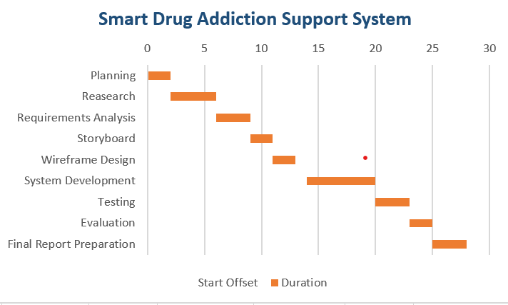
The Gantt chart shows the project timeline and the different stages involved in the development process. It includes tasks such as planning, design, development, testing, and evaluation. This helps in organizing the work and ensuring the project is completed on time.
Storyboard
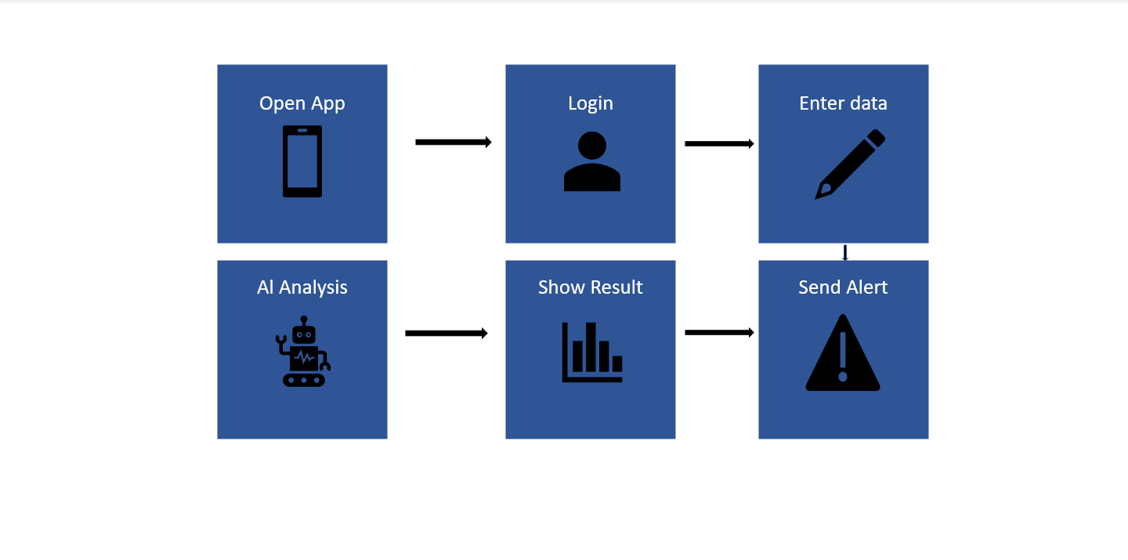
The storyboard shows the step by step interaction between the user and the system. It explains how the user opens the application, enters data, and receives feedback or alerts. This helps in understanding how the system will work from the user perspective.
Wireframe
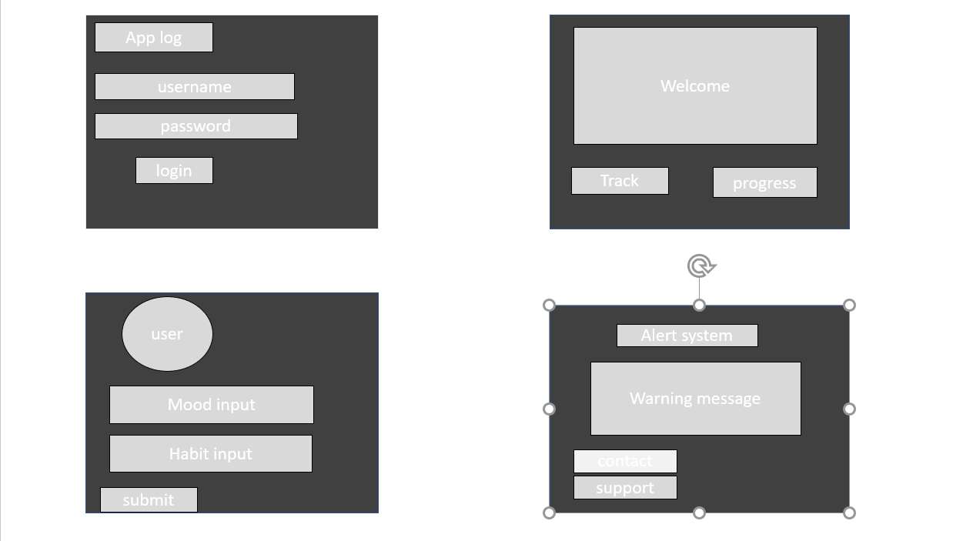

The wireframe shows the basic structure and layout of the system screens. It includes the login screen, dashboard, behavior tracking page, and alert system. The design focuses on how users will interact with the application by entering their data and receiving feedback. This helps to visualize the system before full development.

Task 2 Innovation
This project focuses on developing a smart system to support drug addiction prevention and recovery by using modern technologies. The system uses artificial intelligence to monitor user behavior and provide support based on collected data. If this system is implemented within a large organization such as a healthcare provider, it is important to consider how it will be developed, deployed, maintained, and improved over time [5].
To develop this system, an agile method can be used. This approach allows the system to be built step by step, making it easier to manage and update. Each stage can be tested before moving forward, which helps reduce errors and improve performance. Agile also allows feedback from users and professionals to be included, which helps in creating a system that meets real user needs [6].
The system will use several technologies. Artificial intelligence will analyses user behavior and identify patterns that may show addiction risks. Data processing tools will help manage large amounts of information. Cloud storage will be used to store user data securely and allow access from different devices [7]. Mobile and web development tools will be used to create an easy to use interface for users.
When deploying the system in a large organization, it is important to ensure that it can work with existing systems. The application should be compatible with healthcare platforms so that data can be shared easily. Before full implementation, testing must be carried out to ensure the system works correctly. Training may also be needed for staff so they can use the system effectively.
Maintenance is also important for this system. Regular updates are needed to fix errors and improve performance. Data security must be monitored to protect sensitive user information. Continuous monitoring ensures that the system remains reliable and effective over time.
The system can also be improved in the future by collecting user feedback and analyzing system performance. New features can be added based on user needs and technological changes. This helps ensure that the system continues to provide useful support.
To understand external and internal factors that may affect this type of system, a PEST and SWOT analysis can be used [8]. An example of a large technology company is Google.
PEST Analysis of Google
Factor | Description
Political | Government regulations and data protection laws must be followed when handling user information
Economic | The cost of developing and maintaining technology systems and the effect of global economic changes
Social | User trust and concerns about privacy when using digital services
Technological | Use of advanced technologies such as artificial intelligence and cloud computing
SWOT Analysis of Google
Strengths | Weakness
Strong brand reputation | Privacy concerns
Advanced technology and innovation | High dependence on advertising
Opportunities | Threats
Growth in artificial intelligence and new services | Strong competition from other technology companies
Expansion into new markets | Government regulations and legal restrictions
Legal and ethical considerations are very important for this type of system. The system must follow data protection laws to ensure that user information is safe. Users must give permission before their data is collected and they should understand how it will be used. Ethical issues include protecting user privacy and ensuring that artificial intelligence systems provide fair and unbiased results [9]. These considerations help ensure that the system is safe, reliable, and trustworthy.

Task 3
Project Reflection
During this project, I have gained a better understanding of how to plan and manage a system from the early idea stage to a more developed concept. At the beginning, my focus was on identifying a real-life problem related to drug addiction and thinking about how technology could be used to solve it. I then worked on organizing the project into clear stages such as planning, design, development, and evaluation. Creating a timeline and using a Gantt chart helped me manage my time more effectively and understand how each stage of the project is connected [10].
Throughout the project, I realized that developing a good idea requires continuous improvement. My initial idea was quite basic, but after doing research and analyzing existing systems, I was able to refine it and make it more focused. This process helped me understand the importance of research and how it supports better decision making. If I had the opportunity to complete this project again, I would spend more time at the beginning exploring different solutions and comparing them. I would also plan my time more carefully to avoid working under pressure close to the deadline.
Another important learning experience from this project was understanding the challenges involved in developing a system. I had to think about different factors such as user needs, system features, and possible risks. This helped me improve my ability to think critically and consider different solutions. Managing the project also required me to stay organized and follow a clear plan, which improved my overall approach to completing assignments.
Skills
During this project, I have developed several useful skills that will help me in my future studies and career [11]:
- Improved research skills by using academic sources and analyzing information related to addiction and technology
- Better planning and organization skills by creating a timeline and managing tasks step by step
- Increased understanding of how artificial intelligence and digital systems can be used in healthcare
- Stronger problem-solving skills by identifying issues and thinking about possible solutions
- Improved communication skills by presenting my ideas clearly in written form
In the future, I would like to continue developing more technical skills such as programming and system design. This will help me turn my ideas into real applications. I also want to improve my ability to work with data and understand how systems can analyses user behavior more effectively. These skills will be important if I continue working on similar projects at a higher level.
Positive Social Impact
This project has the potential to create a positive impact on society by supporting individuals who are dealing with drug addiction. The system is designed to detect early signs of risky behavior and provide guidance before the situation becomes more serious. This can help reduce the negative effects of addiction and support individuals in making better decisions about their health and lifestyle.
The project can also benefit healthcare organizations by providing useful information about user behavior. This data can help professionals understand patterns and improve the support they offer to patients. In addition, the system can raise awareness about the importance of using technology to solve real world problems, especially in the healthcare sector.

Conclusion
In conclusion, this assignment has explained the development of a smart system for drug addiction prevention and recovery. It has covered different aspects such as project management, system design, and the use of innovative technologies. The project highlights how artificial intelligence and data analysis can be used to monitor user behavior and provide support in a more effective way.
The assignment also explored external and internal factors that may affect the system through PEST and SWOT analysis, along with important legal and ethical considerations. In addition, the reflection section showed the skills and knowledge gained during the project and how they can be applied in the future.
Overall, this project demonstrates how modern technology can be used to address real world problems and improve healthcare services. It also shows the importance of planning, design, and continuous improvement when developing a system that aims to support individuals and society.

Reference
[1] A. T. McLellan, D. C. Lewis, C. P. O’Brien, and H. D. Kleber, “Drug dependence, a chronic medical illness: Implications for treatment, insurance, and outcomes evaluation,” JAMA, vol. 284, pp. 1689–1695, 2000.
[2] L. T. Marsch, “Digital health interventions for behavioral and substance use disorders,” Neuropsychopharmacology, vol. 37, pp. 276–277, 2012.
[3] J. Jiang, L. Shi, and Y. Wang, “Artificial intelligence in healthcare: Past, present and future,” Stroke and Vascular Neurology, vol. 2, pp. 230–243, 2017.
[4] S. Giorgi et al., “Evaluating generative AI responses to substance use questions,” Psychiatry Research, vol. 333, 2024.
[5] E. Topol, Deep Medicine: How Artificial Intelligence Can Make Healthcare Human Again, Basic Books, 2019.
[6] R. S. Pressman and B. R. Maxim, Software Engineering: A Practitioner’s Approach, 8th ed., McGraw-Hill, 2019.
[7] J. W. Rittinghouse and J. F. Ransome, Cloud Computing: Implementation, Management, and Security, CRC Press, 2017.
[8] F. R. David and F. R. David, Strategic Management: Concepts and Cases, 16th ed., Pearson, 2017.
[9] T. L. Beauchamp and J. F. Childress, Principles of Biomedical Ethics, Oxford University Press, 2019.
[10] J. W. Creswell and J. D. Creswell, Research Design: Qualitative, Quantitative, and Mixed Methods Approaches, 5th ed., Sage, 2018.
[11] Y. S. Park, L. Konge, and A. R. Artino Jr., “The positivism paradigm of research,” Academic Medicine, vol. 95, no. 5, pp. 690–694, 2020.

