Electrical Power

Design a renewable off-grid wind/solar power supply system for rural isolated area.

By Alex Kazemi
Gower College Swansea (UWTSD)

Abstract
The aim of this report is to design a renewable energy system that can power a village completely off grid. The report will feature the design, construct, and maintain processes of the energy system. The system will then be cost compared to the current energy market. I will carry out the following in order to compile the report;
- Calculate the cost of the electricity supply by the National Grid Electric Power for a period of 10 years, assume fixed electricity tariff at year end of 2021 (before the Ukraine war).

- Justify your chosen a Wind Energy Power System to generate electrical power to the village.

- Design a wind power system.
- Wind machines property and number.
- Wind viability survey.
- Turbine.
- Inverter
- Battery property and number.

- Calculate the cost of the small off-grid wind system.
- Capital cost of the hardware of the system
- Maintenance cost, assume the cost of the spare components of the wind system per year is 3% of the hardware cost, and the power system need two part time maintenance technicians.

- If the provider pays the cost of the renewable wind energy system. Calculate an appropriate tariff (regular fixed monthly fee) must pay per cottage in order the payback period for this project is 10 Years. Assume 0% interest rate on the capital.

- Discuss the comparison of the cost of electricity tariff generated by National Grid power and your off-grid wind system after cost recovery.

- Discuss the environmental impact.

Table of Contents
Title page 1
Abstract 2
Table of contents 3
Introduction 4-5
Theory, design and general principles 6-29
Discussion 30-31
Conclusions 32
References 33-34

Introduction
The reliance of the European Union and, indirectly, the United Kingdom on Russian natural gas supplies has increased over the last decade. Since the start of the war in Ukraine, Russia has suspended the supplies of the natural gas that continental Europe and the UK used for years to run factories, generate electricity and heat homes. Accordingly, the price of natural gas is nearly 5 times what it was two years ago, putting governments worldwide under enormous pressure. Rising energy prices are accelerating the cost-of-living crisis; increasing food and energy poverty; and increasing social unrest. The current global energy crisis and the impacts of environmental/ climate change accelerate the transition towards cleaner renewable and cheaper energy sources than fossil fuels.
In the United Kingdom there are many rural small villages that suffer from:
- Poor or insufficient electrical power supply due to technical and environmental problems in connecting these villages with the high voltage grid.

- Current worldwide energy price crisis.
The daily average use of energy demands in these villages is low and varies in the range of 8–10 kWh per household. Some of these villages are in regions with high winds that enable the use of wind turbines, while other villages are in regions with high solar potential that allow the use of Photovoltaic (PV) generators for electrification purposes.
A rural village in the south of the town of Colwyn Bay (Llanrwst valley) in north Wales suffers from a shortage of electrical power supply. The local village council decided to look at harvesting the potential energy resources in the area to generate reliable and adequate electrical power that can supply the village with electricity 24 hours a day for a whole year. There are 120 small cottages, 8 community services building (two schools, a police station, a hospital, sport centre and two worship houses), plus 80 street and traffic lights. The average rate of energy consumption is about 10kWh per day per cottage, 100kWh per day per school, 250kWh per day for the hospital, 40kWh per day for the sport centre, 120kWh per day for the police station, 40kWh per week per worship building, and 2kWh per day per street and traffic lights.

As an Electrical and Electronic Engineering specialist, the local council asks you to design a small off-grid of Renewable Wind Energy System (Task-A)/ Renewable Solar Energy System (Task-B). The designed electrical power system must provide self-sufficient electrical power based on the natural potential energy resources available in the geographical site of the village.

Theory and design
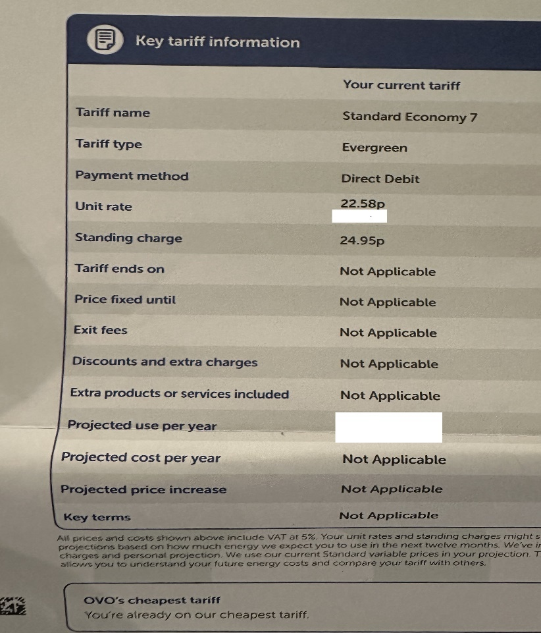
1.

[Ovo Energy, 2021]
Energy demand Calculation
Daily
120 cottages x 10kWh per cottage = 1200kWh total
2 schools x 100kWh per school = 200kWh total
1 hospital x 250kWh = 250kWh total
1 sports centre x 40kWh = 40kWh total
1 police station x 120kWh = 120kWh total
2 worship houses x 40kWh per building per week = 80kWh per week
80/7 = 11.43kWh per day
80 street/traffic lights x 2kWh per light = 160kWh total
Total = 1200 + 200 + 250 + 40 + 120 + 11.43 + 160
Total = 1981.43kWh per day
Unit rate 22.58p per kWh
£447.41 per day
Monthly
Total = 723221.95kWh per year / 12
Total = 60268.50kWh per month
Unit rate 22.58p per kWh
£13,608.63 per month
Standing charge 24.95p per day (Not considered for this month as number of days fluctuates).
Yearly
Total = 1981.43kWh per day x 365
Total = 723221.95kWh per year
723.22MWh
Unit rate 22.58p per kWh
£163,303.52 per year
Standing charge 24.95p per day x 365 = £91.07
£163,394.59 per year
10 Yearly
Total = 723221.95kWh per year x 10
Total = 7232219.50kWh per 10 years
7232.22MWh
Unit rate 22.58p per kWh
£1,633,035 per 10 years
Annual standing charge £91.07 x 10 = £910.70
£1,633,945.70 per 10 years

2. Justify type of energy system used to power village.
Solar
A solar power energy system works by converting energy from the sun into power. The energy is generated in two forms being heat and electricity. These will be generated across the country from residential properties to large solar farms. The carbon footprint is small and most of the materials used in solar energy are recycled, thus causing the footprint to continue to shrink.
The panels are made from semiconductor material, usually silicon, installed in a metal panel frame encased in glass. As this is exposed to the sunlight (photons), electrons are released producing an electric charge. The photovoltaic charge creates DC current which is converted to AC current through an inverter. This allows us to use the electricity in everyday activity. An off-grid system would have battery storage as it is not connected to the electricity network. During the day, the solar panel charges the battery. At night, the inverter is used by using the battery power when the sun is not available.
Whilst energy can be created on cloudy days, the location, size and quality of solar equipment as well as the amount of direct sunlight are vital to the total energy generated.
(National Grid, 2024)
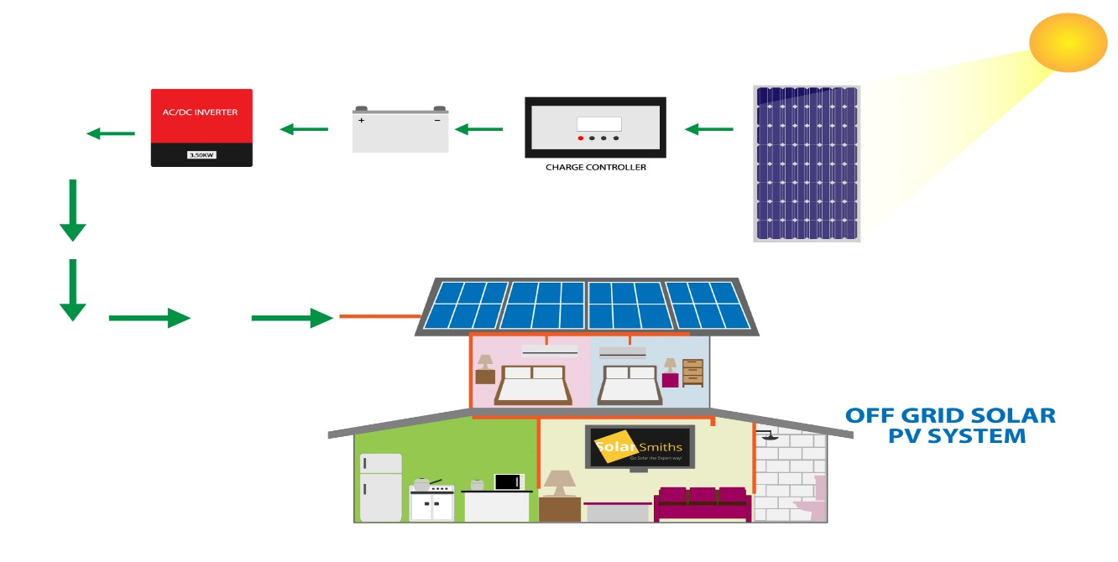

(SolarSmiths, 2024)
Solar irradiance is a useful method to determine the number of solar panels required in an installation. It is key to know exactly how much sun the potential location is receiving. There are two main ways to measure solar irradiance. One is Global Horizontal Irradiation (GHI) and the other is Direct Normal Irradiation (DNI).
GHI is the preferred method for solar panels as it includes both direct and diffuse irradiation. Direct irradiation is sunlight that hits the surface direct, whereas diffuse irradiation is sunlight scattered by the atmosphere. GHI is measured at the surface horizontally to the ground, which is where its name comes from.
DNI measures the sunlight that hits a surface directly perpendicularly to the sun. The only way to measure this is by tracking the sun, which most solar installations don’t do.
As you can see from the solar resource map below, the Llanrwst Valley would not be an ideal location for a solar energy power system. This tends to favour the warmer climates in the southern hemisphere. Unfortunately, the United Kingdom does not have a similar climate to the southern hemisphere.
The yearly total on the GHI map is 803kWh/m² per year and the village demand required for the year is 723.22MWh.
732220kWh / 803kWh/m² = 900.65m²

This means an area of 900.65m² of solar panels would be required to be exposed to this irradiation to supply the demand for the village. This is an extremely large area to install a solar farm compared to the area required to install a wind turbine.

(Footprinthero, 2019)
Wind
A wind turbine houses a set of blades, a box that’s beside them known as a nacelle and a shaft. As there is wind movement, this causes the blades to spin which creates a kinetic energy. These rotating blades make the shaft in the nacelle turn. A generator in the nacelle will then convert the kinetic energy to electrical energy.
Wind turbines from 7mph (3.1m/s) and 56mph (25m/s). Wind turbine efficiency is predominantly maximised at 18mph (8.05m/s) and then will reach the maximum output at 27mph (12m/s). Wind farms will be in areas where they will be subject to the most amount of wind. This will allow them to maximise energy creation. Onshore wind farms are usually located in fields or rural areas where obstacles such as buildings don’t interrupt the air flow.
(National Grid, 2024)
Like solar, wind energy systems store the energy through the means of battery and use the inverter to change from DC current to AC current to use everyday AC appliances.
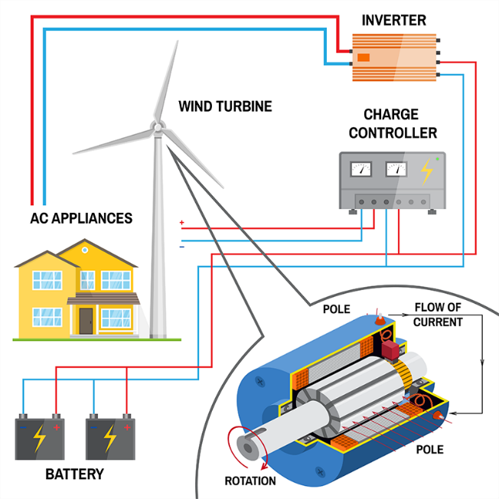

(Kinetecoinc, 2024)

Month | Mean monthly wind speed at 10m (knots) | knots to m/s | Mean monthly wind speed at 10m (m/s)
January | 15.52 | 0.51444444 | 7.984177709
February | 15.06 | 0.51444444 | 7.747533266
March | 13.61 | 0.51444444 | 7.001588828
April | 11.41 | 0.51444444 | 5.86981106
May | 11.43 | 0.51444444 | 5.880099949
June | 10.97 | 0.51444444 | 5.643455507
July | 10.89 | 0.51444444 | 5.602299952
August | 10.77 | 0.51444444 | 5.540566619
September | 11.08 | 0.51444444 | 5.700044395
October | 12.92 | 0.51444444 | 6.646622165
November | 13.42 | 0.51444444 | 6.903844385
December | 14.9 | 0.51444444 | 7.665222156
Annual | 12.66 | 0.51444444 | 6.51286661
(Met Office, 2020)
The table above shows the mean average wind speed at 10m taken from Capel Curig (Conwy) climate station, which is approximately 7 miles away. The wind speed is higher during the colder, winter months as compared to lower wind speed during the warmer, summer months. There could be a basis for maximum storage during this winter months when the wind speed is higher. Therefore, acting as a form of backup during the summer months where less electricity will be generated due to lower wind speeds.
My choice for energy system is the wind energy system. The location in Llanrwst Valley is better suited to wind energy than solar due to the climate. Also, rural areas are far more suited to wind with the lack of obstacles impacting the amount of wind the system would be subjected to. Whilst solar energy produces less noise pollution and provides a more predictable energy output, wind energy for this location is far more favourable. Wind energy can be harnessed at night whereas solar can’t. Wind energy is a more efficient power source, and it releases less CO2 into the atmosphere. To give an example, a solar panel procures 70g of CO2/1kWh and a wind turbine produces 4.64g of CO2/1kWh. Finally, wind power consumes less and produces more energy in comparison to solar panels. An efficient solar panel will only convert 22% of energy from sunlight into electrical energy. A wind turbine can cover up to 60% into electrical energy.
(Regenpower, 2024)

- 3. Ø Wind machines property and number.
- Ø Wind viability survey.
- Ø Turbine.
- Ø Inverter.
- Ø Battery property and number.
Below is a breakdown of the components within a wind turbine.
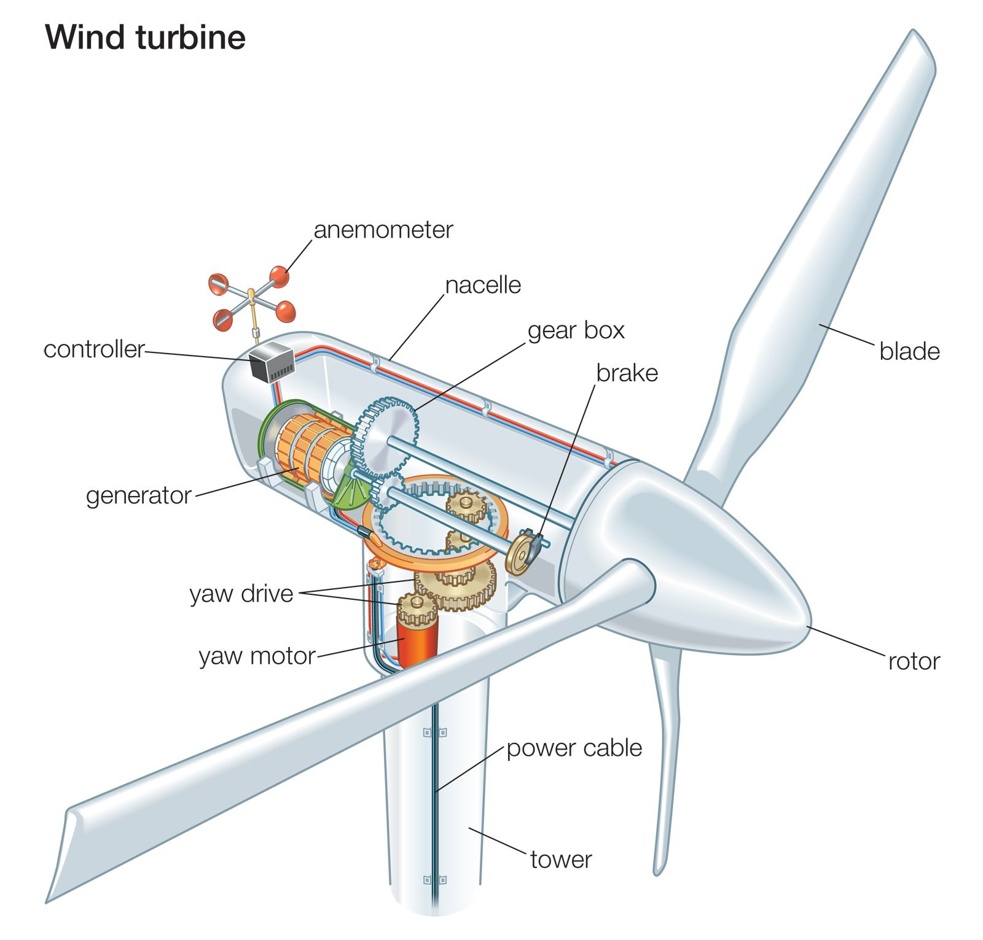

Blades
The blade design is important for capturing the maximum energy from fast and strong winds. The three options available are mono, twin and triple blade. As the wind encounters the blades, the shaft rotates, and this allows the generator to produce electricity. A three-blade turbine has a much smoother power output. They have a rigid hub and sometimes these blades will be cross linked for greater stability.
Hub
This is the central part of the rotor wheel. The blades are connected to the hub, and it also houses the pith angle control mechanism.
Nacelle
The Nacelle houses the yawning mechanism, hydraulic system, generator and gearbox.
Rotor
The rotor is designed aerodynamically to spin the blades at high speed by capturing the maximum surface area of wind. The blades are normally manufactured to be durable, lightweight, and using a corrosion-resistant material. The preferred choice are reinforced plastic and composites of fiberglass.
Gearbox
The gearbox amplifies the speed of the rotor to the desired generator speed rate. The rotor and gearbox are connected via the shaft, which is connected to the generator.
Generator
The nacelle is the enclosure that houses the gearbox and generator, providing protection to the components in the process. Medium demand usually has a synchronous generator to power remote areas and villages. Grid connected systems with large turbines use an induction generator that satisfies the output requirements.
Brakes
The brakes are used as a stopping mechanism when power generation is not required. There are hydraulic disc brakes which are fitted to the gearboxes shaft.
Tail vane
The tail vane maintains the proper rotor pointing and gains the maximum wind energy.
Tower
The rotor and nacelle are supported by the tower. Modern turbine generators are installed on tubular towers usually constructed of concrete and steel as the tower is much larger than the diameter of the rotor.
Yaw system
Within the yaw system, the yaw drive rotates the nacelle on the turbine to keep them facing the direction of the wind. The yaw motor is the powering component for the yaw drive. Downwind turbines don’t require the yaw drive as the wind blows the rotor away.
Batteries
Batteries are used in an off-grid system where the energy produced by the wind turbine is then stored in the batteries. When there is no wind or the wind turbine is not in service, the batteries can be used to power the required demand.
Charge controller
The charge controller is an electronic device which controls the amount of power sent to the battery bank from the wind turbine. It limits how fast the turbine spins when the batteries are fully charged or in adverse weather conditions. It also stops the turbine from overcharging the batteries.
Inverter
The inverter converts the DC power generated from the wind turbine/batteries into a smoother form of AC power, which is used to power everyday appliances. Without the inverter, there would be too much of a raw and fluctuating supply which everyday appliances can’t operate at their optimum rate.
(Electronic Clinic, 2024)

Wind viability survey section?
The wind profile calculator below shows the wind speeds in relation to the height above the ground. For this calculation, the average wind speed of 6.51m/s and a roughness length of 0.4m were used. The description of roughness length is stated below as towns, villages, agricultural land with many or high hedges, forests, and very rough and uneven terrain.
At 10m the wind speed is 6.51m/s, at 20m the wind speed is 7.91m/s and at 30m the wind speed is 8.73m/s.

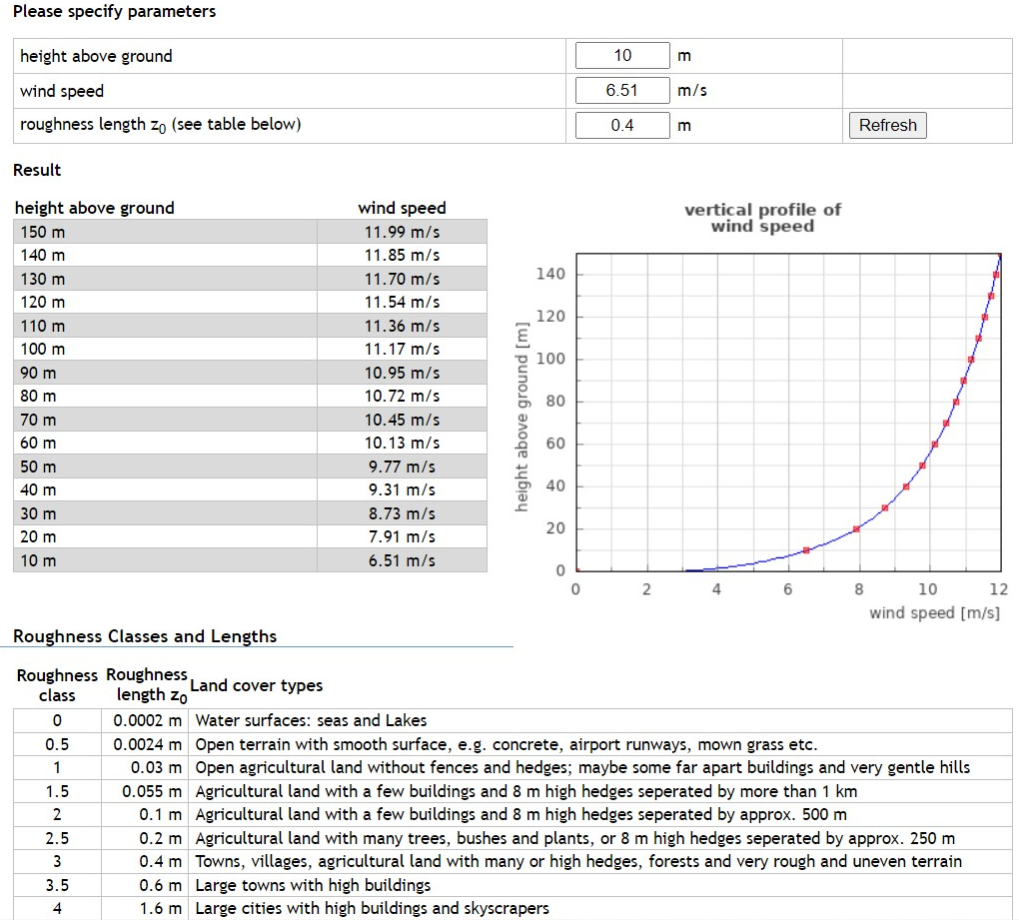

(Wind-data, 2024)

Wind turbine comparison
Manufacturer | Northern Power Systems | Norvento
Model | 100C-21 | nED 100
Rated power | 100kW | 100kW
Rotor diameter | 20.7m | 22m
Blade type | 3 blade upwind | 3 blade upwind
Blade material | N/A | Fiberglass-epoxy composite
Weight | 6500kg (Nacelle and rotor) | N/A
Overspeed protection | Dynamic generator brake and multiple  hydraulic callipers | Blade feathering, brake chopper (electronic power converter fed) and 2 hydraulic callipers
Generator | Permanent magnet | Multi-pole permanent magnet
Rated wind speed | 15m/s | 10m/s
Cut in wind speed | 3m/s | 3m/s
Cut out wind speed | 25m/s | 20m/s
Max wind gust speed | 59.5m/s | 59.5m/s
Tower | 22m tubular steel | 24.5m tubular steel
Estimated annual energy production | 369MWh per year at 8m/s | 435MWh per year at 8m/s
Overall cost | £402,000 | £441,000
O&M cost | £9,000 | £8,000
Design life | 20 years | 20 years

(Northern Power Systems and Norvento, 2024)
(Renewables First, 2024)
Turbine choice
Both turbines are rated at the same power and are similar in terms of their characteristics There isn’t a huge amount of difference in terms of rotor diameter and tower size. Both turbines have the same design lifetime and similar wind speeds and overspeed protections. Whilst the Northern Power System has a cheaper overall cost, the Norvento has a larger estimated annual energy production. The rated wind speed of the Norvento is also better suited to the wind speed at the tower heights, therefore being more efficient than the Norther Power System.
Annual energy for village = 723.22MWh
Number of turbines required = Annual energy/estimated annual energy production
Number of turbines required = 732.22MWh/435MWh
Number of turbines required = 1.68
Therefore, the installation requires two wind turbines. Also, by having two wind turbines, this allows for the maintenance and breakdown of one turbine. If one turbine is out of service, this can be repaired/maintained whilst the other turbine is still generating power. With only one turbine that was big enough to deal with the demand, should the turbine require maintenance/repairs, you are left with solely battery backup.

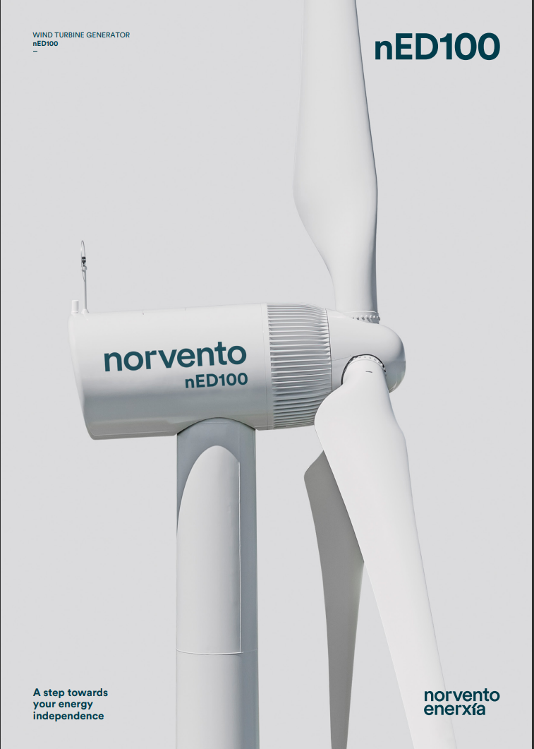
Norvento
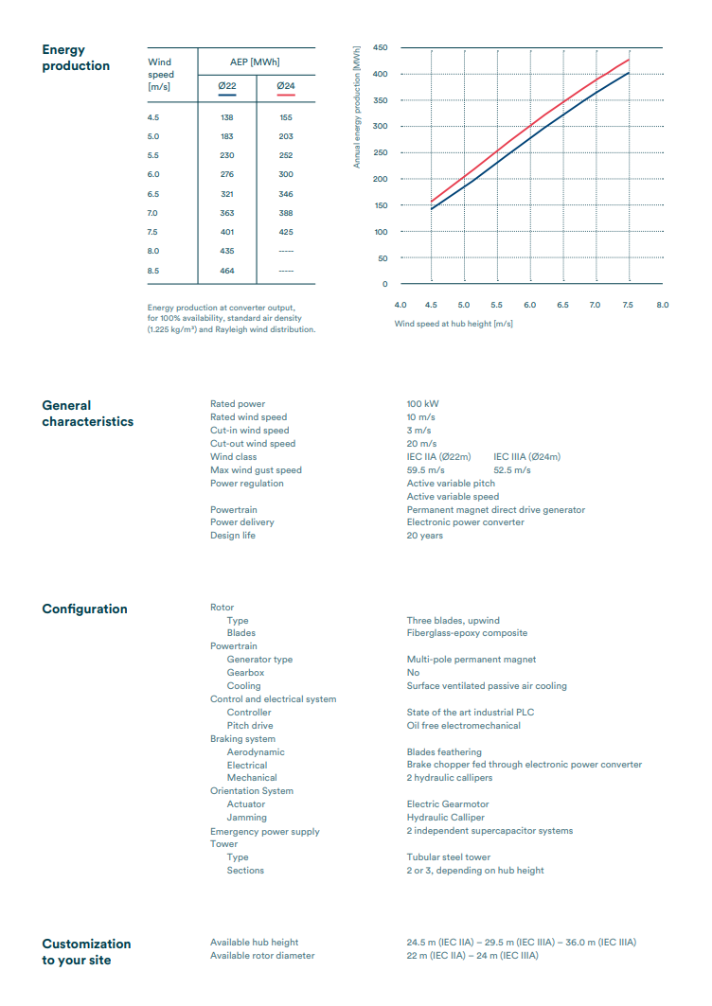

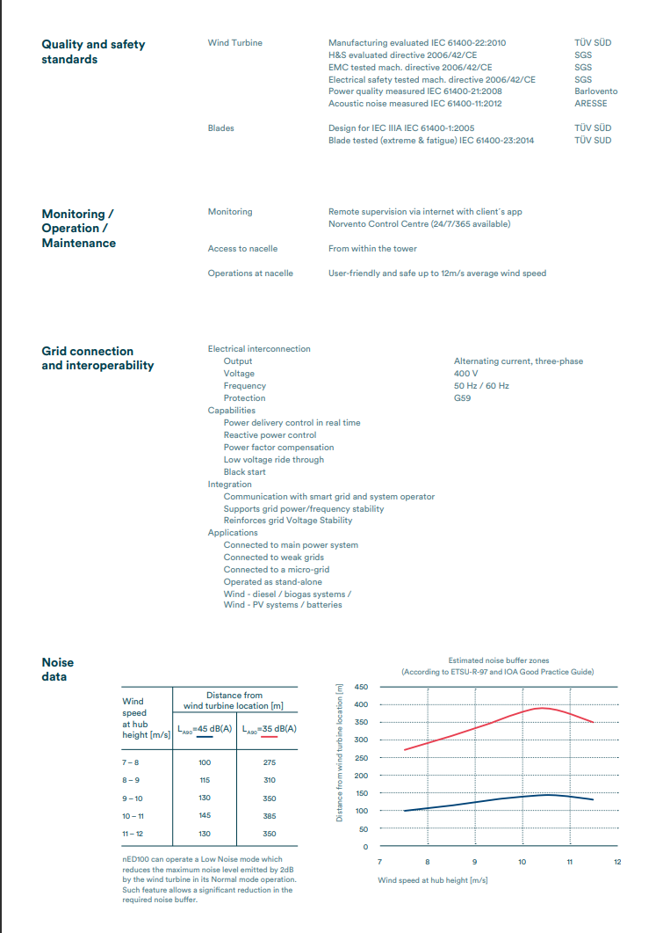

Northern Power Systems
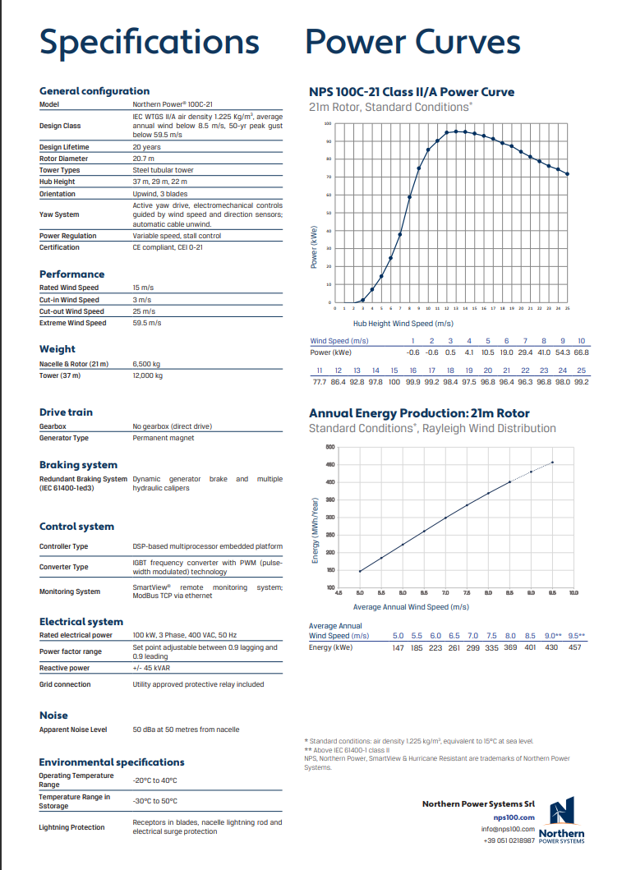

Batteries
The battery bank will be used to store the energy produced by the wind power system. The design is so that the batteries will be able to store the demand of the village for one day. In the event of catastrophic failure and both wind turbines not in operation, the village will still be supplied power for 24 hours. This will also allow for any maintenance or repairs to be carried out whether they are planned or as a result of failure.
The options for a battery bank for a wind energy system are 12V, 24V and 48V. Due to the size of the system, 48V is the preferred choice.
The battery bank system can be connected in either series or parallel. If you were to connect in series, 4x12V batteries the voltage is added together but the Ah stays the same. The example below shows 3x12V batteries in series.
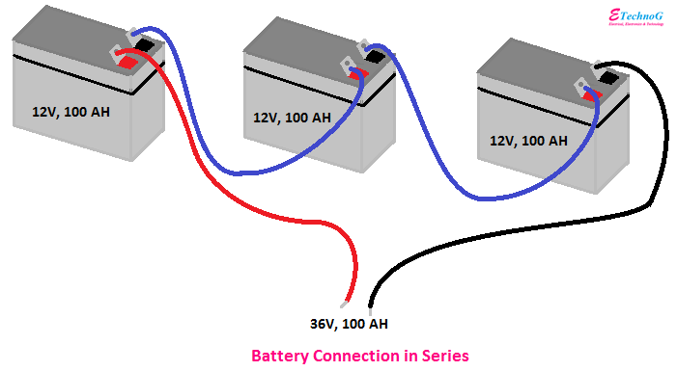

If you were to connect 4x12V batteries in parallel, the voltage stays the same, but you add the Ah together. The example below shows 3x12V batteries in series.
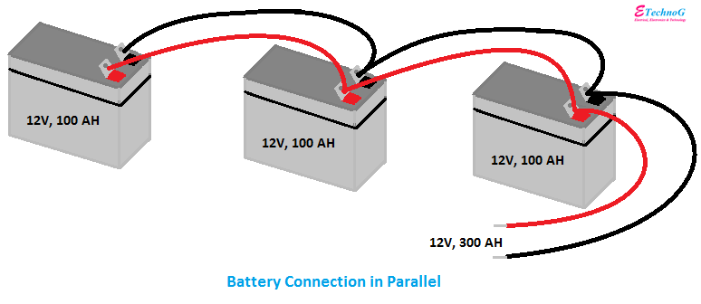
(E Techno G, 2024)
No battery system has maximum efficiency. Energy is always lost during charging, discharging and storage. The typical efficiency in a battery is around 80%. Lithium-ion batteries are normally over 95% efficient and new lead acid batteries are between 80%-90% efficient.
(Wind & Sun, 2024)
How many batteries are required for the system?
Demand to power village = 1981.43kWh per day.
One day battery backup required to account for maintenance or shutdown.
Ah capacity = 1981430Wh (one day) / 48V x 0.8 (efficiency).
Ah capacity required = 51599.74AH.
Required Ah / battery Ah = number of battery strings.
51599.74Ah / 200Ah = 258 battery strings.
51599.74Ah / 100Ah = 516 battery strings.
Each answer multiplied by 4 as connected in series (48V).
258 battery strings x 4 = 1032 batteries at 200Ah.
516 battery strings x 4 = 2064 batteries at 100Ah.
For this I will be choosing 200Ah batteries due to the volume of batteries required. 1032 batteries is a large amount of batteries, therefore by doubling the battery capacity, it is possible to halve the number of batteries needed in the system.
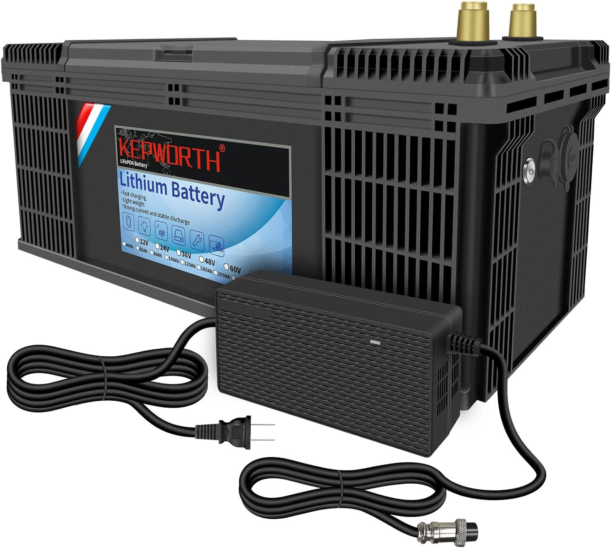

£649 per battery on amazon
1032 batteries at £649 each = £669,768.
(Amazon, 2024)

Capacity | 100Ah/200Ah
Battery Material | Lithium Iron Phosphate(LiFePO4) battery
Nominal voltage | 12.8V
Rated voltage | 12V
Max Protection Voltage | 14.6V
End Voltage | 10V
Instantaneous discharge current | ≥200A
Continuous discharge current | ≥100A
Size | 332*176*220mm/352*174*190mm/525*230*220mm
Weight | 11KG 22KG
Certificate | CE ROHS MSDS UN38.3
Upgrade Parts/Accessories | Grade A
Voltage Protection Board(BMS) | Yes
Cycles Life | 4000 Cycles-100% 6000 Cycles-70%
Max Charge Current | 1C
Working temperature | -20 ~ 60 ℃
Charge temperature | 0-45℃
Warranty | 3years
(Kepworth, 2024)
These batteries 90-95% efficient and don’t require changing for 10-15 years. Also I’ve accounted for an efficiency rate in my calculations at 80%. As these batteries are more efficient, there will be some spare batteries should any fail.
(Off Grid Power Geek, 2024)
Inverter Charger
Inverter efficiency is the total Direct Current that is converted into Alternating current. Due to different factors, this is never 100%. Like batteries, there will always be losses because of the conversion process. A figure of 85%-95% is a widely accepted rate of efficiency from an inverter, therefore you should oversize your inverter in comparison to your demand. For this calculation, we’ll assume the least efficient figure is used. This will allow us for worst case scenario energy loss. One reason an inverter loses energy because of heat. The other reason is due to the internal system such as safety protection, cooling, digital screen etc. The inverter is still using energy even when there is no outgoing load, also known as standby power.
(Watt A Lot, 2024)
Demand to power village = 1981.43kWh per day.
Inverter size = Demand x efficiency factor
Inverter size = 1981.43kWh x 1.15
Inverter size required = 2278.65kWh / 24h = 94.94kW
Inverter size 15kVA = 12kW
94.94kW/12kW = 7.91 inverters
System requires 8 inverters connected in series at £5778.86 = £46,230.80
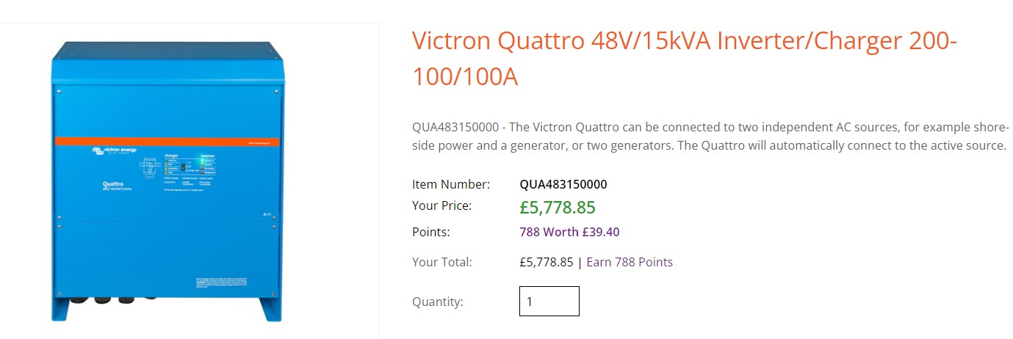

Converter

(Sunshine Solar, 2024)

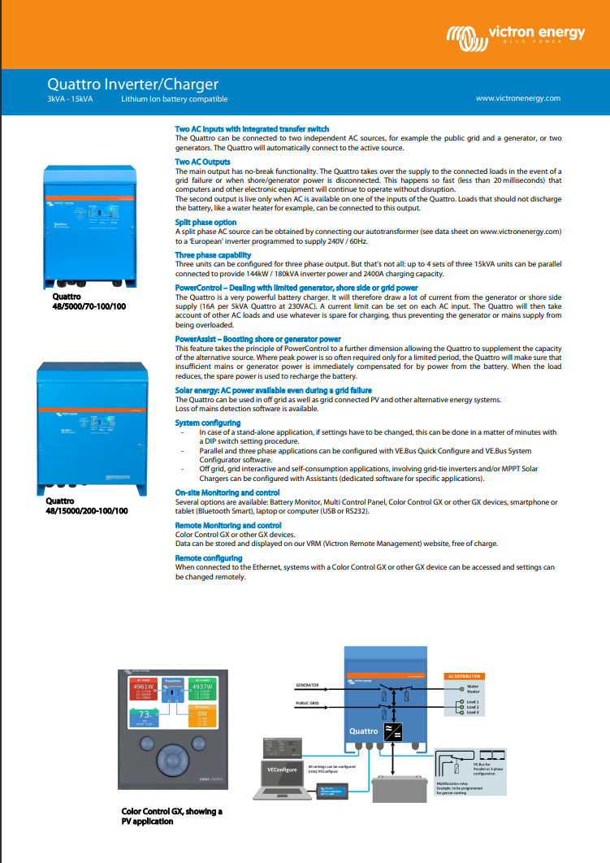

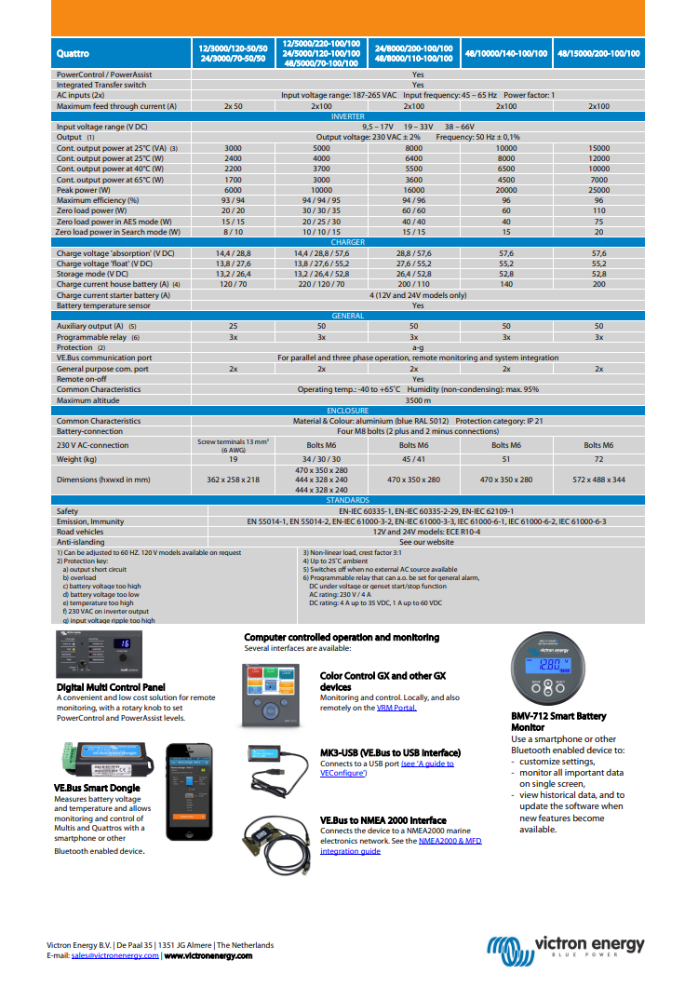

(Sunshine Solar, 2024)
4. Calculate the total cost of the wind system.
- Calculate the capital cost of the system – how much to buy all equipment and set up (everything quoted in part 3).
- Maintenance cost, spare components (assume 3% of equipment costs every year for 10 years) and the system needs two part time maintenance technicians.
Capital cost of system
Equipment | Cost
Turbines | £882,000
Batteries | £669,768
Inverters | £46,230.80
Total | £1,597,998.80

Maintenance costs
Annual maintenance | Cost per year
O&M | £8,000
Spares @ 3% equipment total | £47,939.96
Staff | £36,000
Total | £91,940
10-year total | £919,400

The average salary for a wind turbine technician is approximately £36,000 in the UK. Two part time staff at £18,000 each per year totals £36,000.



(Glassdoor, 2024)
Total cost over 10 years = £1,597,998.80 + £919,400
Total cost over 10 years = £2,517,398.90

- If the provider pays the cost of the renewable wind energy system. Calculate an appropriate tariff (regular fixed monthly fee) must pay per cottage in order the payback period for this project is 10 Years. Assume 0% interest rate on the capital.

Total cost over 10 years = £2,517,398.90 / 120 months
Total price per month = £20,978.32 / 120 cottages
Each cottage payment per month = £174.82

Discussion
- Discuss the comparison of the cost of electricity tariff generated by National Grid power and your off-grid wind system after cost recovery.
Compare costs of how much to install wind system and costs to power the system after recovering total costs.
Off grid costs
Annual maintenance costs / 120 cottages = Annual off grid cost per cottage
£91,940 / 120 cottages = £716.67 per year
£716.67 / 12 months = £63.85 per month per cottage
Current on grid costs
£163,394.59 per year / 120 cottages = £1,361.62 per year
£1,361.62 / 12 months = £113.47 per month per cottage
Price comparison after recovery
Each cottage would be £49.62 better off each month once the wind turbine system costs have been recovered as opposed to the current OVO tariff being supplied off the grid.
- Discuss the environment impact.
There are pros and cons to wind energy but, with the progressing and advancing nature of modern times, there are more benefits than faults.
Negatives
The biggest impact wind energy has on the environment for the wrong reason is to the environment. This can be directly to certain organisms within the environment or to the habit of the animals and nature around it.
Firstly, there is a major risk of death to birds and bats from direct collisions and the effects of the pressure from the moving parts. Prior to the wind turbines being erected, there is also the factor of construction works disturbing wildlife in their natural habitat. This can also lead to displacement of said animals within this environment. A number of these animals such as bats, dormice, and hedgehogs to name a few, are classed as endangered species. Their habitats must be protected regardless of the positive impact wind energy can bring.
Wind projects also produce noise pollution and are aesthetically unpleasant. This has a further impact on the environment as well as people living within the vicinity.
(TRVST, 2024)
Positives
Whilst there are negative factors of wind energy, the majority are of a positive nature. First and foremost, wind energy is a form of renewable energy. This alone will reduce our carbon footprint and reduce the rapid rate at which global warming is increasing. Unlike non-renewable energy, we will always have access to renewable energy. There will never be a time where wind energy will no longer exist. Unfortunately, the same can not be said for non-renewable energy such as oil and gas. As some point, in the not-so-distant future, these fuel supplies will fail to exist. With the recent war in Russia/Ukraine, fuel prices have risen astronomically and countries providing these supplies can potentially dictate the price and quantity of energy each country receives. By being sustainable, we don’t have to rely on other countries to provide us with an energy supply.
Wind energy boosts the economy by providing more jobs and training people up within the industry. With the ever-increasing number of wind farms being installed in the UK, we can become one of the leading forces in the wind energy world.
Although wind energy is initially an expensive system to install, after repayment is complete, energy costs are far cheaper. There is also the option of being connected to the grid. Areas with this setup would be able to sell excess energy back to the grid making the overall costs cheaper again.

Conclusion
To conclude the report, the best option for the village located in the Llanrwst Valley is a wind energy system. The environmental and climate factors greatly favour a wind energy system as opposed to a solar energy system. The area simply doesn’t get enough sunlight to warrant a solar system. Although the upfront costs are far more substantial, once the repayment has been made for wind energy system, the village will only gain greatly. The annual difference after the repayment will be £71,454.59 in favour of renewable system. This windfall can be invested back into the wind system infrastructure or even into the local economy and environment. In the future, energy prices are only going to increase far quicker than the costs of maintaining the system. Conflict around the world won’t dictate the driving costs of energy in this village. Furthermore, the reduction in carbon footprint and use of non-renewable energy, will only improve the environment and our future.

References
- Ovo Energy [Previous bill 2021]
- https://www.nationalgrid.com/stories/energy-explained/how-does-solar-power-work [Accessed 18th January 2024]
- https://www.solarsmiths.com/blog/knowledge/introduction-to-solar-power-system/ [Accessed 18th January 2024]
- https://footprinthero.com/solar-irradiance-calculator [Accessed 19th January 2024]
- https://www.metoffice.gov.uk/research/climate/maps-and-data/uk-climate-averages/gcmnn3630 [Accessed 4th December 2023]
- https://wind-data.ch/tools/profile.php?lng=en [Accessed 5th December 2023]
- https://www.nationalgrid.com/stories/energy-explained/how-does-wind-turbine-work [Accessed 20th January 2024]
- https://kinetecoinc.com/wp-content/uploads/2017/01/wind-turbine-diagram_AS_142772450.png [Accessed 20th January 2024]
- https://regenpower.com/which-renewable-energy-is-better-wind-or-solar/#:~:text=The%20wind%20is%20a%20more,energy%20compared%20to%20solar%20panels [Accessed 20th January 2024]
- https://www.electroniclinic.com/wind-energy-wind-power-plant-wind-turbine-working/ [Accessed 21st January 2024]
- https://www.pytech-demo.it/nps100/wp-content/uploads/2022/10/brochure-NPS-100C-21_ed2020_light_ENG-1.pdf [Accessed 21st January 2024]
- https://www.norvento.com/wp-content/uploads/2023/01/I1218-24-39-03-04-V01_04-nED-ENG_OnLine.pdf [Accessed 21st January 2024]
- https://renewablesfirst.co.uk/renewable-energy-technologies/windpower/windpower-learning-centre/wind-turbine-performance-finances/ [Accessed 22nd January 2024]
- https://www.windandsun.co.uk/blogs/articles/battery-lifetime-efficiency-and-care#:~:text=No%20battery%20is%20100%25%20efficient.%20Energy%20is%20lost,the%20battery%2C%20only%2080kWh%20can%20be%20taken%20out. [Accessed 22nd January 2024]
- https://www.etechnog.com/2021/05/battery-connection-diagram-in-series.html [Accessed 22nd January 2024]
- https://www.amazon.co.uk/KEPWORTH-Lithium-Batteries-Rechargeable-Phosphate/dp/B0BNTBC6PH?th=1 [ Accessed 22nd January 2024]
- https://offgridpowergeek.co.uk/best-200ah-lithium-battery-uk-12v-lifepo4/ [ Accessed 22nd January 2024]
- https://www.kepworth.com/product/12v-lifepo4-battery-100ah-200ah-lithium-iron-phosphate-cell-built-in-bms-6000-cycles-for-golf-cart-outdoor-camping-solar-storage/ [Accessed 22nd January 2024]
- https://wattalot.com/inverter-efficiency [Accessed 24th January 2024]
- https://www.sunshinesolar.co.uk/Item/QUA483150000 [Accessed 24th January 2024]
- https://www.sunshinesolar.co.uk/media/ecom/prodpdf/Datasheet-Quattro-3kVA-15kVA-EN.pdf [Accessed 24th January 2024]
- https://www.glassdoor.co.uk/Salaries/wind-turbine-technician-salary-SRCH_KO0,23.htm [Accessed 25th January 2024]
- https://www.trvst.world/renewable-energy/environmental-impact-of-wind-energy/ [Accessed 25th January 2024]

