TITLE- DIGITAL SKILLS AND RESEARCH METHODS
NAME :Jaroslava Bastlova
STUDENT NUMBER 2119565
MODULE CODE BMSW4003-BIRM

LECTURER’S NAME

Table of Contents
SLIDE 1: INTRODUCTION 3
SLIDE 2: RESEARCH QUESTION 4
SLIDE 3: RELEVANT READINGS 5
SLIDE 4: CONT. 6
SLIDE 5: CONT. 7
SLIDE 6: ETHICAL CONSIDERATIONS 9
SLIDE 7: RESEARCH METHOD 10
SLIDE 8: CONT. 11
SLIDE 9: RESEARCH TIMELINE 12
SLIDE 10: RESEARCH HYPOTHESES 13
SLIDE 11: EXPECTED OUTCOMES 14
SLIDE 12: CONCLUSION 15
SLIDE 13: REFERENCE LIST 16

SLIDE 1: INTRODUCTION
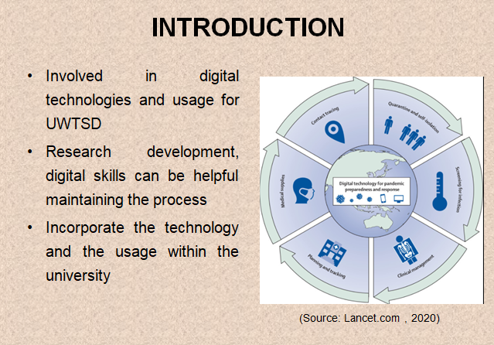
SN: The research proposal has been majorly involved in digital technologies and usage for UWTSD. In order to have methodological research development, digital skills can be helpful maintaining the process. Therefore, the proposal majorly involves the research study over the university's staff and students to incorporate the technology and the usage within the university.

SLIDE 2: RESEARCH QUESTION
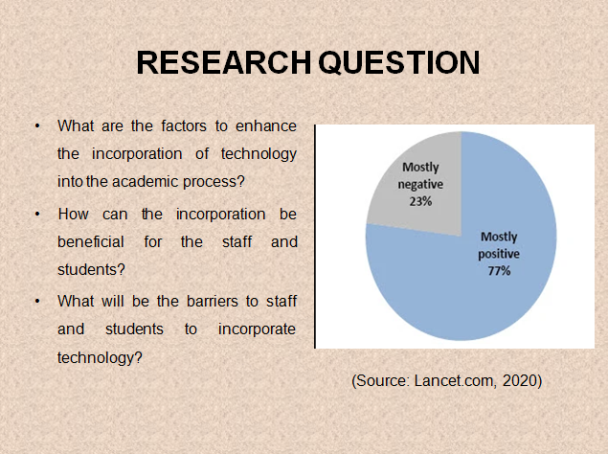
SN: The research questions are:
What are the factors to enhance the incorporation of technology into the academic process?
How can the incorporation be beneficial for the staff and students?
What will be the barriers to staff and students to incorporate technology?

SLIDE 3: RELEVANT READINGS
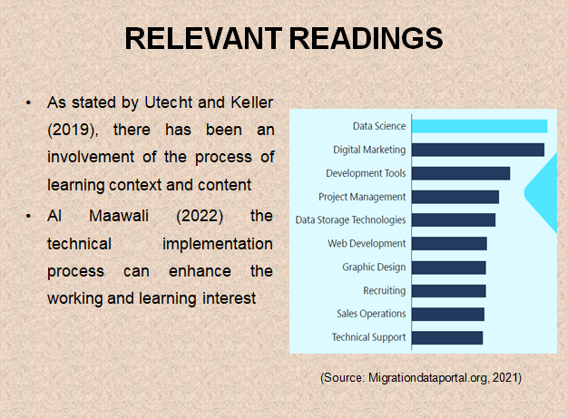
SN: Learning the practical approaches involves a better subjective analysis with the approach towards the new involvement. As stated by Utecht and Keller (2019), there has been an involvement of the process of learning context and content towards the development. On the other hand, Corbett and Spinello (2020) have involved the qualitative processing approach to technological interventions.
Therefore can be highly processed and developed with the connectivism learning theory approaches. Additional Al Maawali (2022) the technical implementation process can enhance the working and learning interest among the population of the academic members. Therefore, the technical implementations and the subjective knowledge along the process need a better archive growth among the process.

SLIDE 4: CONT.
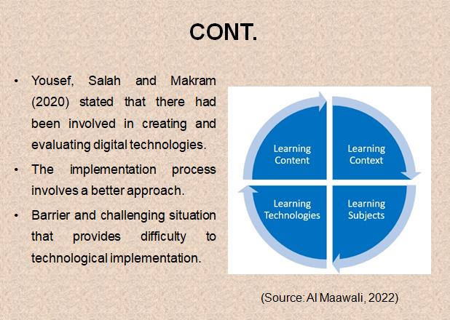
SN: The Blooms’ learning theory approach involves a better development and process towards the learning involvement. Yousef, Salah and Makram (2020) stated that there had been involved in creating and evaluating digital technologies and the academic process. The implementation process involves a better approach towards the development of different fields. On the contrary, Smith et al. (2021) has also been developed as a concept of differentiation with learning technologies. Therefore, the contribution of the learning objectives is to be involved within the academic members as per the choices.As suggested by Troussas, Krouska and Sgouropoulou (2020), the involvement of the technologies for the staff and students have been found to be difficult to understand. Therefore, the prices majorly follow with the training and learning samples to be provided. On the other hand, Csizmadia, Standl and Waite (2019) explained and described the hesitation among the staff to learn a new technological system. Therefore, these all can be a barrier and challenging situation that provides difficulty to technological implementation. Thus, the process majorly follows with the involvement of the opportunities among the certified process involved within.

SLIDE 5: CONT.
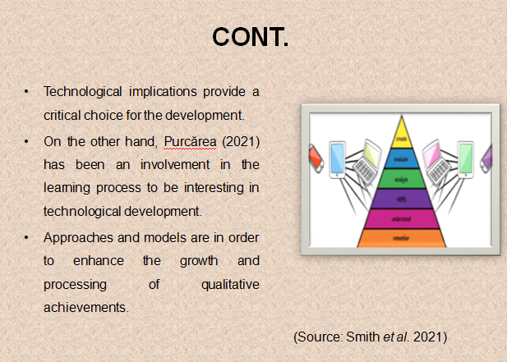
SN: Technological implications provide a critical choice for the development of the existing learning skills. As suggested by Singh and Nair (2021), there has been the involvement of technological implications and creative thinking improvement. The improvement towards the learning and working progress are to be identified. On the other hand, Purcărea (2021) has been an involvement in the learning process to be interesting in technological development.
The academic institutes have digital technologies to provide notes and lectures. Ng (2022) discussed that this could be developed as a preferably improved condition towards the learning and training process. Thus, it has been a great opportunity to develop and improve the effective generalise process. Csizmadia, Standl and Waite (2019) explained that there had been a differentiation between the genders to be successfully using the technologies in the study process.
In the UK, it has been found that boys are noir experts to develop technological implementing skills and knowledge. As stated by Smith et al. (2021), this can be effective and processed with the majority incorporation among the status of the members. Therefore, the academic purposes are to develop the techniques to learn the theoretical approaches. Approaches and models are in order to enhance the growth and processing of qualitative achievements. Thus, the technologies and their improvement within the academic resources are in need for a better achievable growth within the systematic process.

SLIDE 6: ETHICAL CONSIDERATIONS
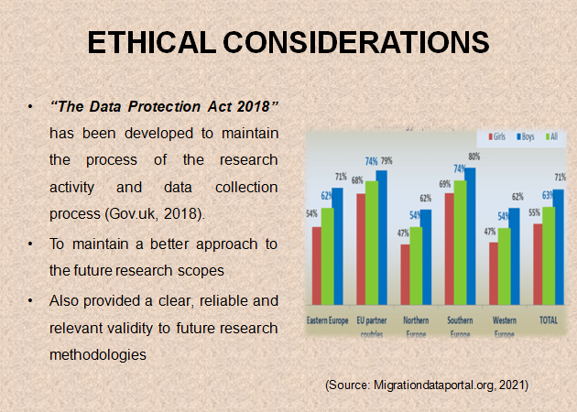
SN: The primary research process is majorly involved with the human approach and collection of personal data and information. Thus, there has been a need for protection to proceed with the research process. This is known as maintaining the data collection process with ethical considerations. In the UK, the legislative actions are to be involved for the research activities to be taken apart. “The Data Protection Act 2018” has been developed to maintain the process of the research activity and data collection process (Gov.uk, 2018). This is to maintain a better approach to the future research scopes and significance to other studies. On the other hand, it also provided a clear, reliable and relevant validity to future research methodologies and studies.

SLIDE 7: RESEARCH METHOD
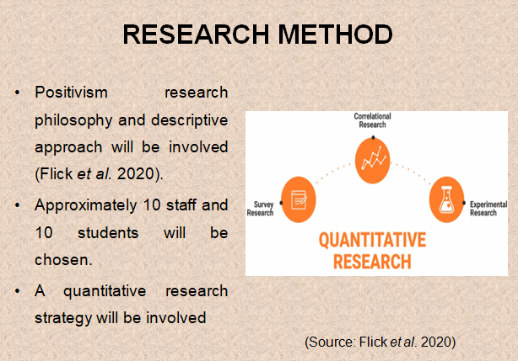
SN: The research method that has been developed for this research study topic will be the primary research method. The research philosophy and approach are to be defined and support the research method with the supporting theories. Therefore, positivism research philosophy and descriptive approach will be involved (Flick et al. 2020). On the other hand, the research design as a deductive design will support the research method as a quantitative strategy inclusion. The research strategy will be developed to define the process of data collection. Saunders (2021) stated that a quantitative research strategy will be involved with the current research study topic. There will be a data collection process involving a questionnaire to be developed.

SLIDE 8: CONT.
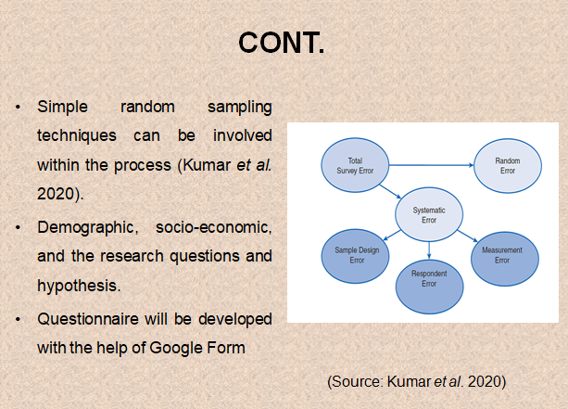
SN: The survey will be conducted in UWTSD among staff and students. Approximately 10 staff and 10 students will be chosen with sampling technique. Simple random sampling techniques can be involved within the process (Kumar et al. 2020). The questions will be related to demographic, socio-economic, and the research questions and hypothesis. The questionnaire will be developed with the help of Google Form and can be surveyed with the distribution of the web link distribution process. The data collection process will be developed as the topic suggests the incorporation of the technology and their impression over the staff and students.

SLIDE 9: RESEARCH TIMELINE
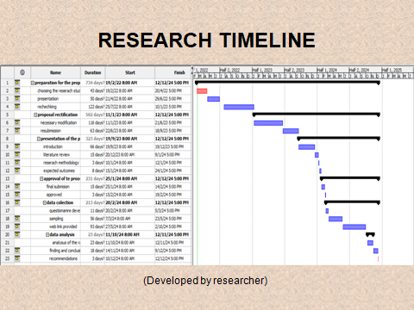
SN: The research will be conducted after the proposal of the research is approved and accepted by the professors. Therefore, the questionnaire will be developed and will take at least 1 month. The questionnaire development will be followed by sampling the population from the university staff and students. The data collection will be done to be expected within 2 to 3 months. Therefore, the data analysis of the raw primary information will be analysed. The data analysis will be done within 2 months to be expected.

SLIDE 10: RESEARCH HYPOTHESES
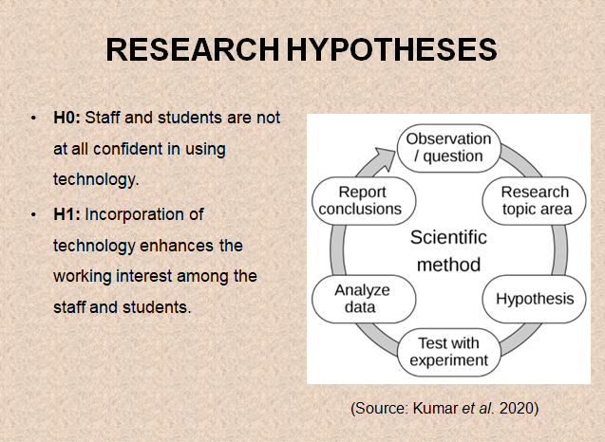
SN: Null hypothesis (H0): Staff and students are not at all confident in using technology.
Alternative hypothesis (H1): Incorporation of technology enhances the working interest among the staff and students.

SLIDE 11: EXPECTED OUTCOMES
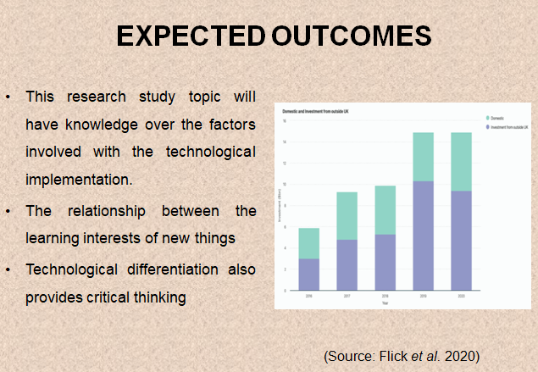
SN: The expected outcomes of this research study topic will have knowledge over the factors involved with the technological implementation. The relationship between the learning interests of new things among the academic professionals will be developed. The technological differentiation also provides critical thinking and an overview of the development.

SLIDE 12: CONCLUSION
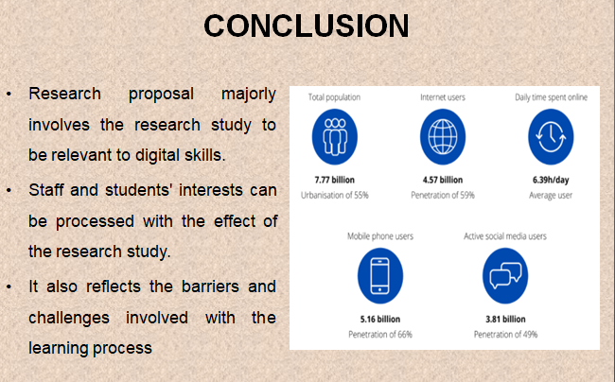
SN: Hence, it can be concluded that the research proposal majorly involves the research study to be relevant to digital skills and theory development. The development of the staff and students' interests can be processed with the effect of the research study. Thus, it also reflects the barriers and challenges involved with the learning process of digitalisation technologies among the student and staff members of UWTSD.

SLIDE 13: REFERENCE LIST


