2203307, ECEY4001, 3047 words
A handbook to support transitions within young children’s lives
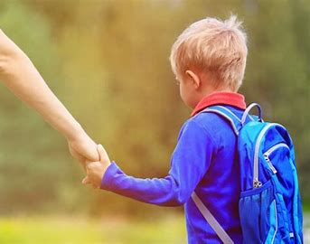

(Source: Educomics, 2019)

Focusing on 2 – 3 years

Contents page Page No.

- Introduction to transitions 3
- Role of the adult 4
- The needs of the child 6
- Partnership working 8
- Play 10
- Interventions 11
- Environment 13
- Proposed outcomes 15
- Reference list 16

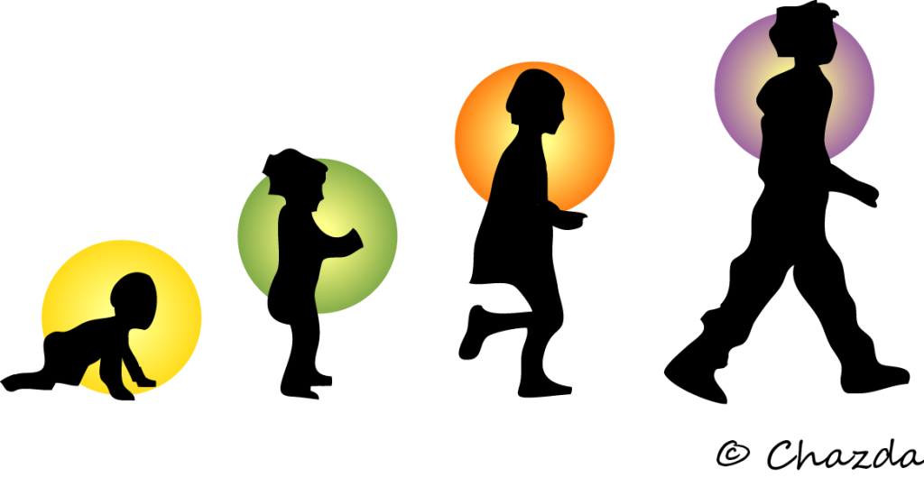
(Source: Krista, 2017)

Introduction to transitions

A transition is “is a period of change, from one significant stage or experience, to another” (Clarke, V, no date).
Children, as they grow and develop, will go through different transition experiences, which will affect all children differently. For example, a child between the age of 2 – 3 years will go through many transitions within these years. For example, most children this age will start to potty train (transition from nappies to the toilet), start school, attend a day-care or if already attending day-care, they will move rooms (from baby room to the toddler room).
These transitions can be big or small, predicted, or unpredicted, but will have a different impact to every child, as each child is an individual. There are 3 different types of transitions. Firstly, Horizontal transitions are changes that happen throughout a day. This type of transition may include changing activities (from playing with trains to playing with playdough). A second type of transition is Vertical transition. Open Learn Create (no date) describes Vertical transitions as events that do not occur day – to – day, such as moving from Reception to Year one in primary school. The last type of transition is education – associated. This is more significant and mostly happens outside of an education setting but will also impact the developing child. These changes may include parental divorce, or a new sibling being welcomed to the family.

The Role of the Adult

When a child makes a transition to a new school or day care, it is important for the practitioner to help the child to develop new relationships and attachments. “Transitions to childcare are typically about building relationships among children, parents, and childcare educators” (Schärer, J, 2018).
Practitioners should work with the parents/carers of the children to help develop smooth transitions. According to Essex County Council (no date) they believe that practitioners should gather knowledge from parents and additional services (if required) to be able to meet each individual child’s needs. After this is achieved, practitioners will be able to acknowledge every child’s individual needs and interests to help the child settle.
John Bowlby theory understood that attachment/relationships between a child and their caregiver positively impacted the child’s social development and relationships until the end of life. He placed an importance on children having a ‘mother figure’ and without this, children would be under emotionally developed. He developed a theory that children had to go through several stages of attachment, where eventually the child would be happy to leave the ‘mother figure’ for a few hours, as they would develop attachments with others as well as the ‘mother figure’. Schärer, 2018 suggests that practitioners need to develop relationships with the child and develop some knowledge on the child’s behaviours and signs to be able to develop a secure relationship.
To support transitions, practitioners will play the role of a key worker, which is when a practitioner is assigned a key child. A keyworker is role typically includes spending time with the child to develop a relationship that is positive and being the primary caregiver for that child. A key workers responsibilities are to role model positive behaviour, observing and assessing the child’s needs, providing emotional support, supporting the child’s families. Keyworkers will also be responsible for communicating with agencies involved with the child and follow up reviews and plans.
The Educator UK, 2017 says that practitioners and parents/carers should work together during a transition and should see a transition being a process instead of an event. When working together, the practitioner should ensure communication with the parents of the child is key and ensuring information they provide is introducing and understandable, also being happy to answer questions or concerns the parents/carers may have. Working together, it is important to reflect on the child’s progress on settling into the day care and any adjustments that might be needed to create a happier experience for the child.
During a transitions, it is important for practitioners be aware of different ethnic groups and diversity and be respectful of those different groups. Practitioners should ensure to be approachable and all-inclusive by understanding additional needs of the child/children and respecting cultures, ethnic and religious communities. Welsh Government, 2017 says that we should be mindful of children with additional needs as children with additional needs can find transitions/changes hard and potentially require further and adaptable support to tailor their need, which is supported through partnership working. Also, taking into consideration the needs of families that are from cultural, ethnical, and religious groups.
Vygotsky sociocultural theory looks at the interaction that a person has with society. Cherry (2022) writes that throughout this interaction, parents/carers and teachers heavily influence a child’s development.
Vygotsky also developed the Zone of Proximal development, looking at what children can and cannot do without help, while suggesting they need a ‘more knowledgeable other’. This person is more skilled and has a wider understanding. Cherry, (2022) refers to practitioners/teachers doing this by creating tasks that include teamwork and putting a less knowledgeable child with a more skilled child, for the less knowledgeable child to impersonate and to watch the more skilled child. Also, allowing the child to socialise with other children.

The Needs of the Child
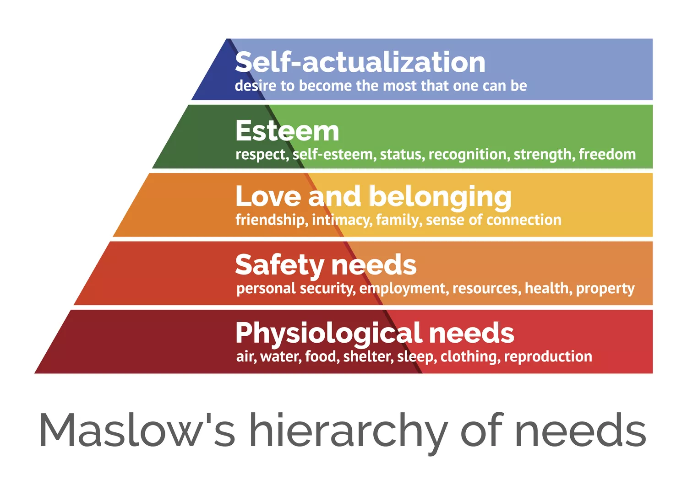
Maslow’s Hierarchy of Needs implies that we need our basic needs met first, and after they are met then we can focus on our higher level of needs. “Maslow believed that people have an inborn desire to be self-actualized, that is, to be all they can be” (Cherry, K, 2022). Maslow believed to reach this, a child’s fundamental needs, need to be met. Maslow developed five levels of his hierarchy, including Physiological needs, Safety needs, Love and belonging, Esteems and Self-actualisation. Once, the lowest ranking needs are satisfied, then we can draw our attention to the next level of the hierarchy.
(Source: ThoughtCo., 2020)
Although, these basic needs (Physiological) are not always met. Carlson (2020) suggests that if these are not met, it can damage a child psychologically and emotionally. For example, if the child home becomes unsecure, it can result in the child expressing behaviours that are unacceptable.
Moving to a new setting or starting at a setting can cause children anxiety and worry that their needs will not be met. Birth to 5 Matters (no date) acknowledges that a child transitioning from a familiar environment such as home, to an unfamiliar environment, for instance a new setting, can cause worry to the child about having their needs met. Whereas other children may manage the new setting/new environment well as they are more likely resilient than others.
Children need to express themselves when going through a transition as they will be experiencing new emotions that they may not have before or do not often and the overall experience can be overwhelming. To support a child during this time practitioners could carry out activities, including reading the children age-appropriate stories on transitions and how they can make us feel to prepare them for other transitions in life, or circle time, discussing emotions and how they make us feel. The Educator UK (2017), suggest that setting up an area for children to role play with puppets or dolls to assist the children to demonstrate these emotions. Also, creative arts and crafts to release those emotions.
Carrying out observations of the children in natural environments allows practitioners to recognise a child’s interests, changes in their behaviours and how they have developed holistically. Doherty, J. and Hugh, M. (2009) believes that practitioners prefer to observe a child in their home, in the outdoors and inside of the day care. Observations are important as they can tell us if a child feels safe, feel their needs are being met, how they bond with others, how they explore different environments and their understanding of the world around them.

Partnership working

Partnership working is when agencies come together to support a child’s needs. Early Years Matter (no date) says that this can include social services, health teams, education and parents/carers to help support a every child’s needs.
When working in partnership, it will help us to:
- Recognise a child’s needs.
- Provide help from suitable agencies.
- Help children to carry on and improve their development to lead a fulling life.
- Increase child’s mental health, for example self-confidence, self-esteem.

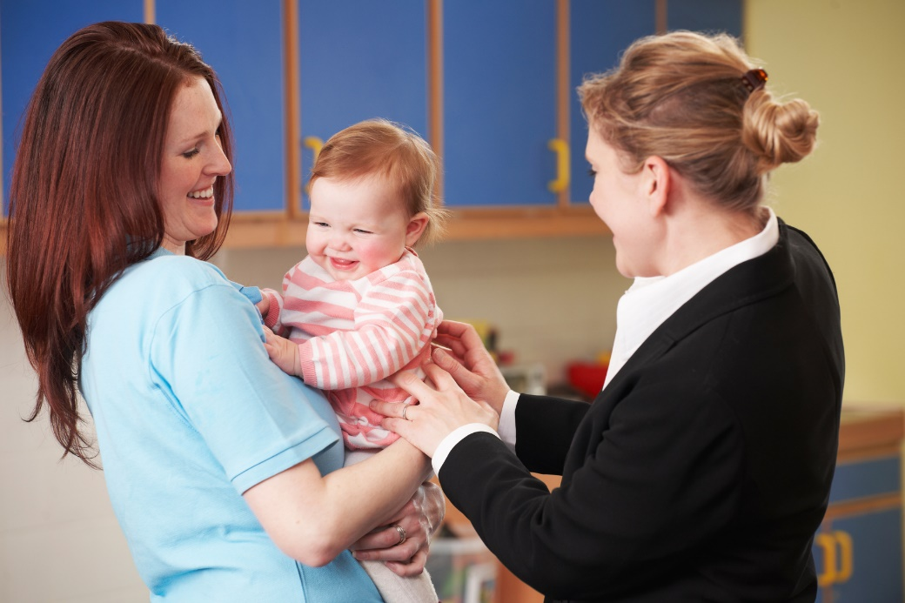
(Source: Kelly, 2016)

Partnership working is well organised meaning there is an increased possibility for people to be heard and to give a holistic view of the need’s children and their families. Communication is enhanced as views are taken into consideration. Croner-i (2020) believes that working in partnership is important to make sure the needs of the child are recognised, met, and observed during childhood.
Within partnership working it is necessary to include parents/carers and children (where appropriate) and making sure that the needs of the child are at the heart of decision making. Communication with parents is vital, for example keeping them up to date with observations and assessments carried out, and what agencies and professionals are involved with their child (with parental consent). Hopps, K. (2022) believes that developing the relationships between parents and carers helps to often provide communication that is two-way, and families will feel more involved and valued within the transition process, which would allow the parents to become confident when putting forward their views and contribute to the arrangement for the child.
The United Nations Convention on the Rights of the Child, article 3 states that “The best interests of the child must be top priority in all decisions and actions that affect children” (UNICEF, no date). Also, relating to this article 5 states an emphasises on respecting families’ rights and that families play the main role in assisting children to develop into adults.

Play during a transition

The Welsh Government (no date) emphasises the importance of when children walking into new environments, we should be mindful of the child’s backgrounds and past experiences. Developing a room that focuses on the child’s voice being heard and listened to and meeting their needs, supporting, and upholding their rights, and providing an environment that focuses on the children’s interests. When a child walks into a new childcare setting, see favourite toys or activities they enjoy can provide comfort.
Children have a right to play. Children are born with a demand to play. It supports children holistically (social, intellectual, cognitive, emotional, and physical development), while also providing children with an understanding of the world around us, and creates a sense of self-worth and self-esteem, promoting confidence and will develop the child’s independence, which is important during a transition.
The UNCRC, Article 31, states that “every child has the right to rest, relax, play and to take part in cultural and creative activities” (unicef, no date).
Susan Issac’s theory on play is that she believed nurseries and schools should be seen as an addition to the child’s home. Twinkl (no date) explains her theory by saying that the nursery environment should mirror “the warmth and caring elements of the family home “and create experiences/opportunities that the child may not have at their home. We can provide these opportunities by providing materials that are fascinating to children and that promote self-expression, discovery, social interaction, emotional development, and child-led play.
Play allows practitioners and parents to do more than observe the development of the child but to assess the mature levels of the child as well. Robinson, M. (2008) points out that children must play to develop imitation, which impacts how children and adults will behaviour. Role play can enable children to develop imitation by copying actions that adults carry out, supporting Bandura’s theory on children copying actions carried out by adults. Role play will also contribute to a child’s awareness of other’s feelings as well as their own, communication skills will thrive and help them to develop different likes and dislikes
Interventions during transitions

‘All about me’ booklet
An all about me booklet, can also be called ‘get to know me’ questionnaires. This booklet asks parents and carers a variety of questions including the child’s likes and dislikes, favourite foods, family life and routines, child’s preferred name, and favourite toys. Albrecht, K. and Fiechtner, J. (2015) think that this strategy is inviting to both children and parents and can develop good communication skills with the parents and carers of the children.
Comfort toys
A transitional object can provide a child with comfort. For example, the feeling of uncertainty when being away from the main carer for a few hours at first can be overwhelming. D.W.Winniecott came up with a theory on transitional objects (such as blanks, dolls, toys) that a child has a connection to. He understood that the comfort toy can provide the child with a sense of protection and safety in a new environment, replacing the main caregiver.
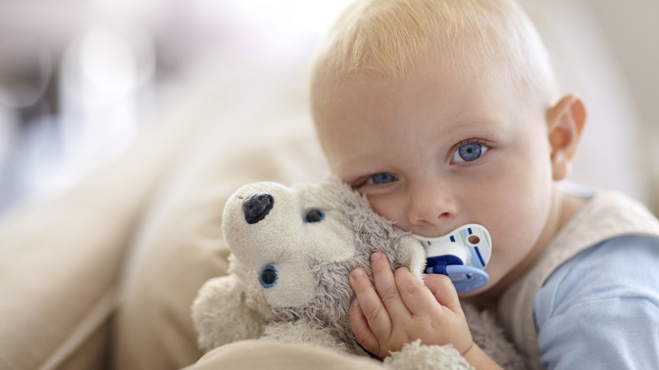
(Source: Lake, K, 2022)
Visits
It is important for children to attend their new setting with a familiar adult. A familiar adult provides comfort and will feel more comfort when attending the new environment on the first day, as it will have become a familiar surroundings. Although, this strategy can make children even more unsettled as may expect the familiar adult to attend with them when starting.

Circle time
Helen (no date) describes circle time by practitioners using it to create a place that is safe for children to learn and sit together. Involving children at circle time can enable a child to develop relationships and friends with other children at their new setting. It can also provide the child a feeling of acceptance. Circle time can also help develop routines and can help children to provide structure to their day.
Story books on transitions and emotions
Reading children books on the topic of transitions and emotions, can help you to explain transitions and feelings more easily. It can enable children to cope with transitions more smoothly and can help them to express those unknown or unusual feelings more appropriately. Books such as the colour monster focuses on feeling and emotions and how those emotions may make us feel.
Examples of story books based on transition:
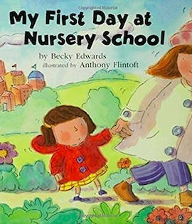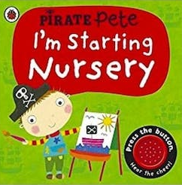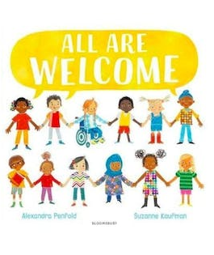
(Source: Simoni, C, 2021)

The Environment

When moving from a familiar environment that has a familiar face, to an environment without one, it can be overwhelming. Welsh Government (no date) says that practitioners within a setting should build an environment that is welcoming, accessible for all, accepting, and promoting diversity and equality. Patel, A. (no date) expresses the importance of children feeling a sense of safety within the new setting and a sense of home and stability. This is so they can purse their development and have that feeling of belonging.
Urie Bronfenbrenner developed an ecological theory focusing on the environment surrounding the child. According to Doherty, J. and Hughes, M. (2014) describes Bronfenbrenner’s theory as “a much richer description of environmental influences”.

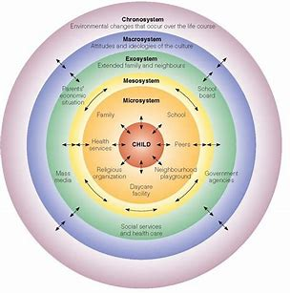
(Source: Guy-Evans, O, 2020)

He developed 5 systems, including the Microsystem, Mesosystem, Exosystem, Macrosystem and the Chronosystem. It starts firstly with the Microsystem, which is the child’s closest connections, which is the child’s families, their education and their community. The Mesosystem is the connections the child makes with the first system (microsystem). Next, the Exosystem focuses on relationships the child does not immediate contact with. For example, relationships that their parents form with others. Macrosystem is the religious belief or cultural community of the child. Finally, Chronosystem is developed later in life, for example experiencing the loss of a relative.
When a child is in a new environment it is important to ensure that the environment is suitable for the stage of development and age of every single child. Reybekill, N. and Beckett, L. (2008) believe that this will provide realistic expectations but will also help us to set out the appropriate materials/toys to help provide an environment that is suitable to meet the needs of each individual child.
To help the child to build on their learning at the start of their transition, we should provide opportunities which include decision making, promotes independence, autonomy, and the different styles of learning.
Piaget developed a theory on cognitive development. According to Exploring your mind (2022) they suggest that Piaget found that the “principles of logic begin to form inside us before the acquisition of language itself”. This is influenced by activities including sensory and motor and the functioning of the environment, more so an environment that focuses on social cultural environment.

Proposed Outcomes

Transitions must pursue the learning journey of a child and past events that the children have experienced need to be developed further.
A successful transition is essential to assist a child’s wellbeing and support as the needs of the child would have been met and support for families and children would receive. Lodge (2020) emphasises the importance of showing children their needs, feelings, and worries are heard. Successful transitions promote the resilience of a child and will create more positive transitions throughout life if carried out correctly.
It is important to remember that each child is an individual, meaning that they will develop at their own rate. Impacting how long a child will take to adjust to a transition. We can support this by allowing the child to explore and develop independently which will allow them to develop respect for others around them and the environment, and not adding that extra stress on a child by having massive expectations to succeed. This will help them to develop their social development.
Holmes, (2016) looks at how Montessori settings promote independence by promoting thinking and problem-solving skills. “Leading to their becoming happy, confident and resourceful little people” (Homes, E, 2016). This will also contribute to being able to adjust to different transitions.
Although, Rhondda Cynon Taf, (no date) says that staffs need to have a dedication to a child’s development and having professional manner to the children and parents/carers to develop a positive relationship and a positive transition process.

Reference list
Albrecht, K. and Fiechtner, J. (2015) Mindful transitions in childcare. Available at: Transitions in childcare | Supporting transitions | Community Playthings (Accessed:14 November 2022)
Birth to 5 Matters (no date) Transitions. Available at: Transitions – Birth To 5 Matters (Accessed: 16 November 2022)
Beckett, L. and Reybekill, N. (2008) Enabling environments: Transitions. Available at: Enabling Environments: Transitions | Nursery World (Accessed:16 November 2022)
Cherry, K. (2020) Child Development Theories and Examples. Available at: 7 of the Best-Known Theories of Child Development (verywellmind.com) (Accessed:13 November 2022)
Cherry, K. (2022) Lev Vygotsky’s Life and Theories. Available at: Vygotsky: Life, Theories, and Influence of Lev Vygotsky (verywellmind.com) (Accessed: 22 November 2022)
Clarke, V. (no date) Different Types of Transitions in Child Development. Available at: How to Help Your Preschooler Overcome Separation Anxiety (educomics.org) (Accessed: 11 November 2022)
Croner-I (2020) Partnership working to support children with additional needs. Available at: Partnership working to support children with additional needs | Croner-i (croneri.co.uk) (Accessed: 20 November 2022)
Carlson, J. (2020) The Basic Needs of Every Child. Available at: The Basic Needs of Every Child | HealthGuidance.org (Accessed: 17 November 2022)
Dunlop, A. and Fabian, H. (2006) Informing Transitions in the Early Years. UK: McGraw-Hill Education..
Doherty, J. and Hughes, M. (2009) Child development; theory and practice 0-11. Essex: Pearson Education Limited.
Early Years Matters (no date) Transitions. Available at: Transitions - Early Years Matters (Accessed: 10 November 2022)
Educomics (2019) First Day of School: Helping Your Child Deal with Separation Anxiety. Available at: How to Help Your Preschooler Overcome Separation Anxiety (educomics.org) (Accessed: 11 November 2022
Early Years Matters (no date) Working in Partnership. Available at: Working in Partnership - Early Years Matters (Accessed: 17 November 2022)
Exploring your mind (2020) Bronfenbrenner’s Ecological Systems Theory. Available at; Bronfenbrenner's Ecological Systems Theory - Exploring your mind (Accessed: 16 November 2022)
Exploring your mind (2022) Piaget And His Theory About Learning. Available at: Piaget And His Theory About Learning - Exploring your mind (Accessed: 22 November 2022)
Essex County Council (no date) Role of the adult. Available at: Role of the adult (essex.gov.uk) (Accessed: 13 November 2022)
Guy-Evans, O. (2020) Bronfenbrenner’s Ecological Systems Theory [Image]. Available at: Bronfenbrenner's Ecological Systems Theory (simplypsychology.org) (Accessed: 16 November 2022)
Gasper, M. (2009) Multi-agency Working in the Early Years. SAGE Publications Ltd.
GoodTherpay (2015) Donald Winnicott (1896-1971). Available at: Donald Winnicott Biography (goodtherapy.org) (Accessed: 21 November 2022)
Hopper, E. (2020) Maslow’s Hierarchy of Needs Explained. Available at: Maslow's Hierarchy of Needs Explained (thoughtco.com) (Accessed: 15 November 2022)
HCH (no date) Keyworker Guidance. Available at: Keyworker Guidance | Happy Children’s Homes (proceduresonline.com) (Accessed: 16 November 2022)
Helen. (no date) Circle Time: A guide for parents. Available at: Circle Time: A guide for parents - Kiddy Charts education (Accessed: 20 November 2022)
Hopper, E. (2020) Maslow’s Hierarchy of Needs Explained [Image]. Available at: Maslow's Hierarchy of Needs Explained (thoughtco.com) (Accessed: 15 November 2022)
Holmes, E. (2016) Trusting in transitions: getting it right in the early years. Available at: Trusting in transitions: getting it right in the early years | Optimus Education Blog (optimus-education.com) (Accessed: 27 November 2022)
Krista. (2017) Transitions – Puberty [Image] Available at: Transitions- Puberty | PYP Counselor Information (kis.ac.th) (Accessed: 28 November 2022)
Kelly. (2016) Parents on Universal Credit to receive childcare boost [image]. Available at: Parents On Universal Credit To Receive Childcare Boost - Early Years Careers (Accessed: 17 November 2022)
Robinson, M. (2008) Child development from birth to eight. Berkshire: Open University Press.
Lodge, L. (2020) The Importance of a Good Transition. Available at: The Importance of a Good Transition | OneEducation (Accessed: 27 November 2022)
Lake, K. (2022) Loveys: Blankies, bears, and other comfort objects for kids [Image]. Available at: What is a baby lovey? Comfort items for kids, explained. | BabyCenter (Accessed: 22 November 2022)
NSW Government (2022) Partnerships for transitions. Available at: Partnerships for transitions (nsw.gov.au) (Accessed: 28 November 2022)
Nolen, J. (no date) Bobo doll experiment. Available at: Bobo doll experiment | Description, Methodology, Results, & Facts | Britannica (Accessed: 3 December 2022)
Patel, A. (no date) Transitions in early years – Ideas for supporting children and families. Available at: Transitions in early years – Ideas for supporting children and families | A Unique Child | Teach Early Years (Accessed: 17 November 2022)
Penn, H. (2005) Understanding early childhood. Berkshire: Open University Press.
Pennstate Extension (no date) Why Observe Children? Available at: Why Observe Children? — Better Kid Care — Penn State Extension (psu.edu) (Accessed: 17 November 2022)
Queensland Government (2021) Moving to an early years setting. Available at: Moving to an early years setting (earlychildhood.qld.gov.au) (Accessed: 27 November 2022)
Rhondda Cynon Taf (no date) Transition information for Early Years. Available at: Transition information for Early Years | Rhondda Cynon Taf County Borough Council (rctcbc.gov.uk) (Accessed: 27 November 2022)
Schäre, J. (2018) ‘How educators define their role: building ‘professional’ relationships with children and parents during transition to childcare: a case study’, European Early Childhood Education Research Journal. 26 (2), PP. 246 – 257
Simoni, C. (2021) The best books about starting nursery. Available at: Enabling Environments: Transitions | Nursery World (Accessed: 22 November 2022)
The Educator UK. (2017) Managing Transitions in Early Years. Available at: Managing Transitions in Early Years – The Educator Magazine UK (the-educator.org) (Accessed: 11 November 2022)
The Edinburgh Counselling Service (2021) Winnicott and Transitional Objects. Available at: Winnicott and Transitional Objects (edinburghcounsellingservice.com) (Accessed: 21 November 2022)
Twinkl (no date) Susan Isaacs’ Theory. Available at: What is Susan Issacs' Theory? | Twinkl Teaching Wiki (Accessed: 23 November 2022)
The Educator UK (2017) Managing Transitions in Early Years. Available at: Managing Transitions in Early Years – The Educator Magazine UK (the-educator.org) (Accessed: 17 November 2022)
The Educator UK. (2017) Managing Transitions in Early Years. Available at: Managing Transitions in Early Years – The Educator Magazine UK (the-educator.org) (Accessed: 11 November 2022)
unicef (no date) The Convention on the Rights of the Child: The children’s version. Available at: The Convention on the Rights of the Child: The children’s version | UNICEF (Accessed: 23 November 2022)
unicef (no date) United Nations Convention on the Rights of the Child. Available at: United Nations Convention on the Rights of the Child (UNCRC) (unicef.org.au) (Accessed:13 November 2022)
Welsh Government (no date) A curriculum for funded non-maintained nursery settings. Available at: A curriculum for funded non-maintained nursery settings (gov.wales) (Accessed: 23 November 2022)
Welsh Government (2017) Flying Start – Annex. Available at: 141124-transition-guidance-en-v1.pdf (uwtsd.ac.uk) (Accessed: 14 November 2022)

