Connor Parry-Walters (P151238)

University of Wales Trinity Saint David
BREEAMPrinciples
BREEAM new construction assessment/energy assessment Juan A. Ferriz Papi


https://www.breeam.com/
http://www.passivehouse.com/
Table of Contents
Introduction 1
What is BREEAM ? 1
What is Passive House ? 3
BREEAM vs Passive House 4
References 5
Introduction
For this assignment we will be looking at both of the sustainable building codes of BREEAM and Passive House, we will look at what both of the methodology behind each and how they aim to be sustainable and look after the environment. We will look at what each of them entail in the process and what the benefits and disadvantages of each are and will compare them both directly and look at what is needed for to receive a certificate from each group.

What is BREEAM?
Breeam (Building research establishment environmental assessment method) is a sustainable methodology used in construction to set specific standards of a project using specification in the design, construction and operation stages. Breeam has now been going for over 25 years launched by the BRE (building research establishment) and being used in over 70 countries worldwide.
BREEAM is an assessment that looks at a range of categories such as
- Energy
- Land use and ecology
- Water
- Health and wellbeing
- Pollution
- Transport
- Materials
- Waste
- Management
(https://www.thenbs.com/knowledge/what-is-breeam)
These categories will be looked for the levels of sustainability against levels initially set, these categories will then be scored these scores will help the outcome levels. The Breeam rating can have 6 results of unclassified, pass, good, very good, excellent and outstanding. The ratings will be judged by an assessor who will be licenced and independent to the project, there are two stages to the assessment/certification with the first being involved in the design stage resulting in a interim certificate and the final assessment to be carried out when the project has been completed and a rating carried out and a certificate being awarded. When looking to obtain a BREEAM rating it is important to understand which scheme is being used, the schemes refer to the application and time of which the assessment can take place the schemes are as following

- BREEAM Communities (used in the planning stage)
- BREEAM New construction (used for design and construction)
- BREEAM Refurbishment (used when refurbishing and existing building)
- BREEAN In use (used when looking at an existing building)
When an appropriate scheme has been selected is it important to find an assessor, the assessor should be licensed by BREEAM and they will carry out the assessments. It is possible to achieve higher BREEAM scores by bringing in a BREEAM accredited professional to help with the project, for BREEAM in use there is a different assessor that will be used known as a BREEAM in-use auditor. The assessor should register the project being undertaken as soon as possible, it is possible for the client to register for the BREEAM in-use scheme or have the assessor carry out registration if the client wishes. The assessor will have carried out a pre-assessment with the client which will provide a rough guide on expected results from the assessment. When becoming certified it is possible for this to happen as early as a design stage which is recommended and the final stage (post construction). The assessor will submit the assessment to the BRE as evidence which will be checked for quality assurance and will be looked at by BRE global for certificate reasons, the BRE global will then issue a certificate to the appropriate stage weather design and post construction. The Process is different for BREEAM in use clients where they can register their project for assessment and the assessor will then put in for certification which will also be put through the quality assurance process and then be awarded by BRE global. BRE global will have assets and listed certified buildings on GreenBooklive which can be viewed by anyone using searches.
When a BREEAM certificate is being awarded there are different levels that can be awarded the levels are outstanding (over 85%), Excellent (over 70%), Very good (over 55%), Good (over 45%), Pass (over 35%) and unclassified is anything under 30%.Points are awarded in each category against the levels of standards and the point for each category are added up and a total mark is provide out of available points and stars are provided to each rating.
https://www.breeam.com/certification-training
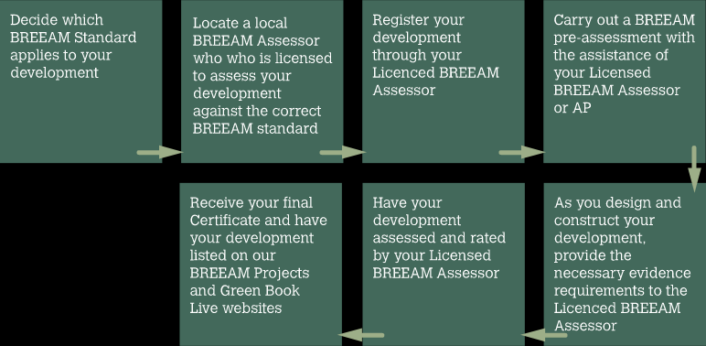

Passive house
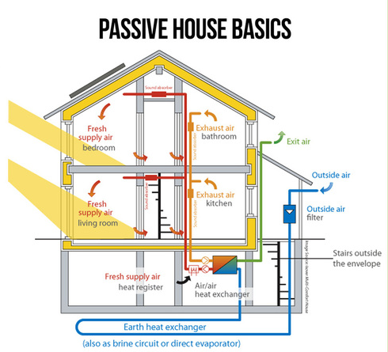
Passive house is a concept made in Germany in the 1990s as is seen to buy as one of the fastest growing energy performance standards, it has strict requirements that look at specific parts of the design, and it will focus itself on five main principles
- Continuous insulation – having insulation throughout the house means less heat loss and better heat gains
- Passive House standard windows and appropriate shading – having passive house standard windows will mean reduced heat loss through windows
- Continuous airtightness – this will reduce in the loss of heat from air leaks and will reduce moisture problems
- Ventilation unit – having ventilation will provide fresh air and improve air quality and should have a heat recover system so no heat is lost
http://www.egreengroup.com/passive-house.html
- No thermal bridges – this will greatly reduce the amount of heat loss though the house
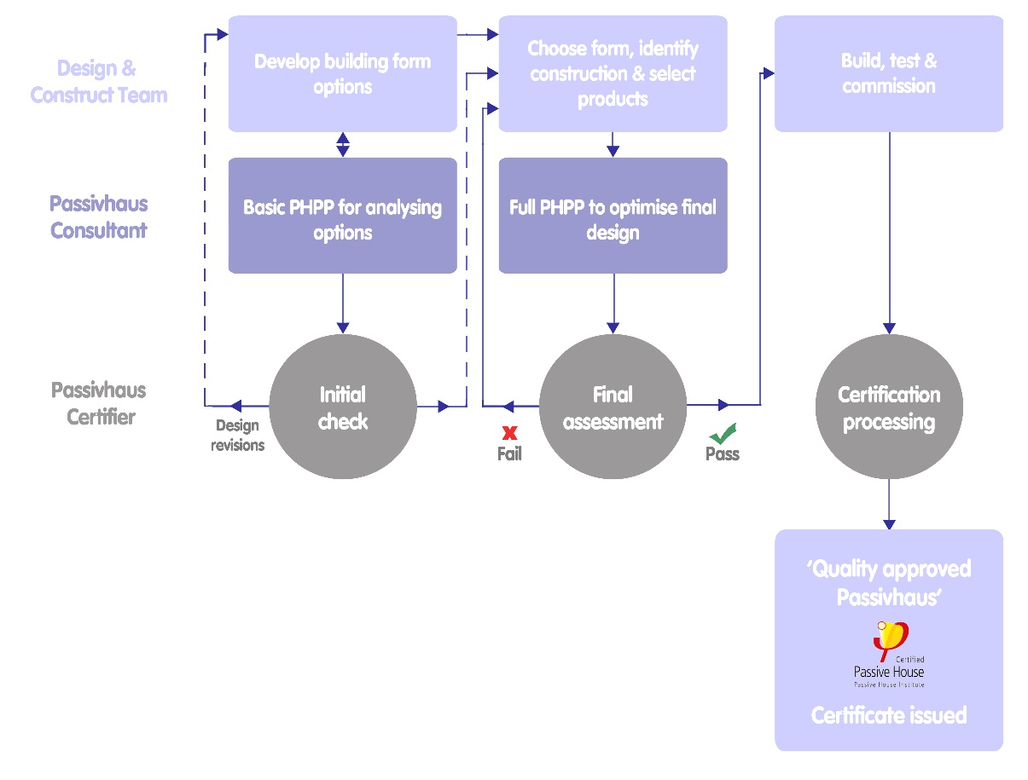
These principles will be applied to each project as each project is different they can be specific to each location. With the location of the project the climate of the area will affect the design with what materials are most durable/affordable and will stay in specification.
http://www.passivhaustrust.org.uk/certification.php
The orientation will also be a specific factor as is will be used to get the most of the sunlight and have the most thermal gain meaning less to no heating will be needed. Passive house is set out from the start and will look as the design stage and everything will be designed to be within the passive house standards, the PHI (PassivHaus Institute) have created software to help architects and designs to follow the correct standards with the use of software such as PHPP (Passive House Planning Package) and design PH which will work for current design software. This software packages can be used as evidence when becoming certified, the certification process begins at the design stage. By starting at the design stage you will be able to plan to meet the passive house standards from the start, once construction of the building is complete there will be a final assessment of the building if the building fails it will return to looking and the construction products and methods chosen and will be evaluated on PHPP, if the building passes the assessment it will continue to become tested such as for thermal loss and air leaks if the tests are successful it will then become certified and receive a passive house certificate,
BREEAM vs Passive House
BREEAM and Passive House have very similar sustainability aim they methodology behind each is slightly different with passive house being a much simpler process as it is based around energy consumption of the project where as BREEAM can become involved at any part of a buildings lifespan because of each of its schemes, this along with the vast area that BREEAM covers makes it a far more complex than passive house. While speaking to a BREEAM assessor he admitted to BREEAM becoming more complex as they are brought in at the wrong part of a projects construction meaning they are always behind on where they should be along the process, this factor could be cause by the complexity of BREEAM or that there are poor project management skills.
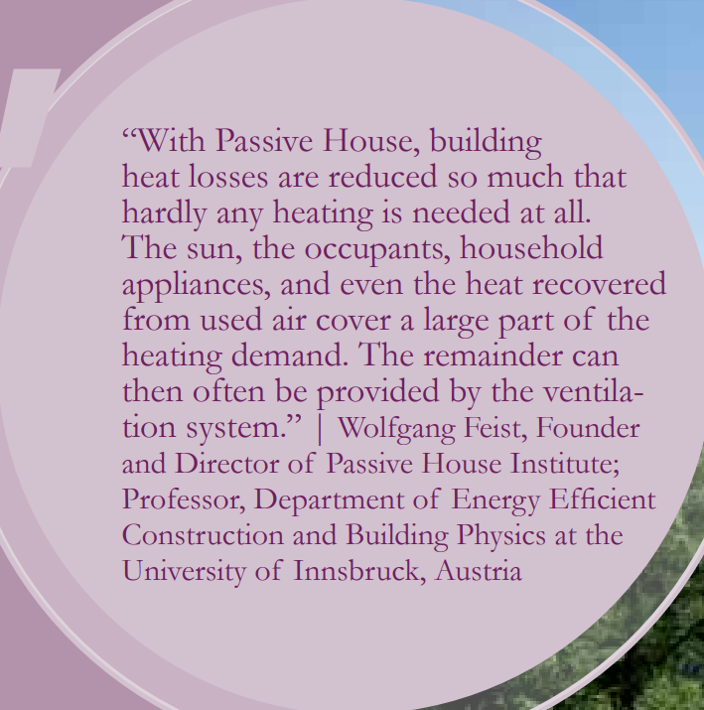
BREEAM is currently a more popular choice in the UK Construction industry with its growing numbers of users and is used by the government on all newly built or refurbished buildings in aim to promote sustainability as each building will obtain a BREEAM rating, comparing this to Passive House which was only set up in the 1990’s and has over 50,000 building worldwide (Passivehouse-international, 2017)
BREEAM and Passive house both look at the carbon emissions of the building but BREEAM does not have any focus on reducing carbon during the construction stage only when the building is in use. Both sustainable codes offer reduction of bills and carbon outputs when the building is in use with BREEAM on average saving 22.5% on energy bills (BREEAM, 2017). Passive house efficiency is down to the design of the building and its use, this results in energy savings of over 75% and a reduction of space heating of 90% (Passivehouse-international, 2017).

https://www.passivehouse-international.org/upload/download_complete_PH_Brochure.pdf
The cost of each of the codes can vary depending on size and complexity of each building/design, BREEAM can charge around £120 - £1850 to register for an assessment there is then additional costs of £505- £2120 to pay the certification fees. The assessor of BREEAM will charge £5000-£15000 depending on complexity and amount of involvement in the project (Willmott Dixon, 2017).In comparison Passive house costs around 1-3% of the total build cost (Cerezuela, 2017), however passive house can add a premium of 10-15 % to your house value.
Passive House and BREEAM Have good standards set and each have their own uses as BREEAM is well suited to larger clients like company’s/governments due to complexity and the style of building it suits which is larger buildings with more use e.g. schools, offices etc.. Passive house is easier to use but does not cover the broad area BREEAM offers with water and land use, it seems more suited to residential property that are simpler to design and will apple to the property owner due to the high reduction in heating costs and bills, it is also designed to be a comfortable for the occupant. Both BREEAM and Passive house are very good sustainability codes and the standards for these codes should always be going up to create a more sustainable environment in future this will prompt more buildings to follow these codes in future.

References
BRE. (2017, 10 10). Scoring and Rating BREEAM assessed buildings. Retrieved from breeam.com: http://www.breeam.com/BREEAM2011SchemeDocument/Content/03_ScoringRating/scoring.htm
BREEAM. (2017, 10 10). BREEAM 25 facts . Retrieved from BREEAM life cycle costs: http://www.breeam.com/breeam25/day_4.html#lifecyclecosts
Cerezuela, F. (2017). Passivhaus Certification on Residential Projects. Francisco Cerezuela.
egreengroup. (2017, 10 11). what is passive house. Retrieved from egreengroup.com: http://www.egreengroup.com/passive-house.html
Ferriz-Papi, J. A. (2017, 10 09). BREEAM Assessment . BREEAM Assessment Process.
John Holmes, G. H. (2003). The application of BREEAM in corporate real estate: A case study in the design of a city centre office development. Journal of corporate real estate.
McPartland, R. (2016, September 08). NBS - What is BREEAM ? Retrieved from NBS: https://www.thenbs.com/knowledge/what-is-breeam
Passivehouse-international. (2017, 10 10). Passive House International Broucher. Retrieved from Passivehouse-international: https://www.passivehouse-international.org/upload/download_complete_PH_Brochure.pdf
Passivhaus Trust. (2017, 10 10). Certification. Retrieved from Passivhaus Trust: http://www.passivhaustrust.org.uk/certification.php
The Passivhaus Standard. (2017, 10 10). Retrieved from Passivehaus.org: http://www.passivhaus.org.uk/standard.jsp?id=122
Willmott Dixon. (2017, 10 11). Willmott Dixon PDF. Retrieved from willmottdixon: https://www.willmottdixon.co.uk/asset/10430/download?1444054502

