NETWORK AND CYBERSECURITY ESSENTIALS  ACCA 4024 |  | Theresa Darzins  Student No. 1909721
Dr. Nitheesh Kaliyamurthy &  Dr. Carlene Campbell | LAB 3  Design a Simple Hybrid (Wired and Wireless) Network and Configure IP Address | 16 October 2020
START: WARM UP (Refresher) EXERCISE: SET UP A SWITCH AND TWO COMPUTERS AND ENSURE THEY CAN SPEAK TO EACH OTHER – Basic Instructions
- ADD DEVICES FIRST:
E.g. - choose 2 PC’s and a Switch (click and drag them onto page)

- ADD CONNECTIONS AFTER:
Click the orange zig zag on top row on the left then the one on the bottom row and then the one on the right (auto connection)
(menu; sub menu; sub submenu) ALWAYS USE THE AUTO OPTION

- Click on the PC or Switch and drag CONNECTOR to the one you want it to go to.

- Repeat Steps 2 and 3 for all other devices (each and every time)

- NAME YOUR DEVICES (Giving them different IP Addresses)
Click on the device and choose DESKTOP THEN IP Config

- Under IPv4 Enter the IP Address; 192.168.1.10 (you are naming your device) press return and the automatically generated other address comes up (greyed out)

- Now come out and do same for other device(s) - repeat step 5, using 192.168.1.11 and so forth

- TEST
Now Test that they can talk to each other click on the device;
- choose DESKTOP,
- Choose COMMAND PROMPT,
- TYPE IN IPCONFIG (return)
And if everything gone ok your devices ID will show (192.168.1.10)

At the command prompt c type in PING and other address 192.168.1.11 (return) and whole load of info comes up NB; THIS IS ONLY TO TEST FROM devices ending 10 and 11 (you have to repeat all above to show from 11 to 10 to finish test)

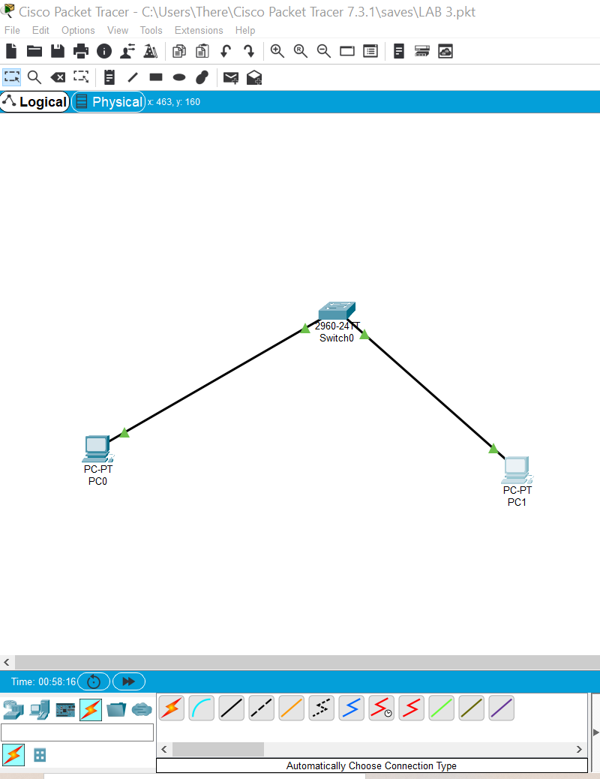
STAGE 1 – FROM 192.168.1.10 TO 192.168.1.1
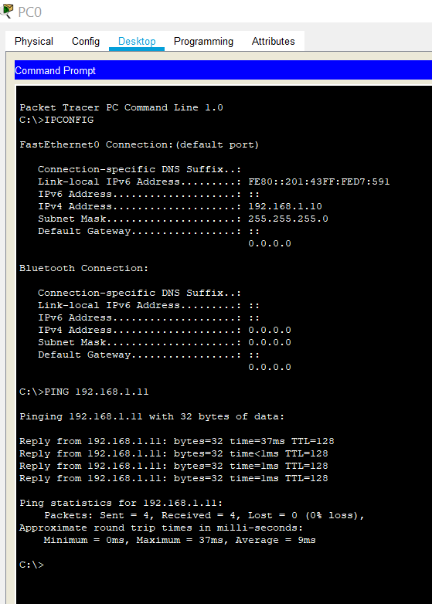

STAGE 2 (other way round); 192.168.1.11 to 192.168.1.10
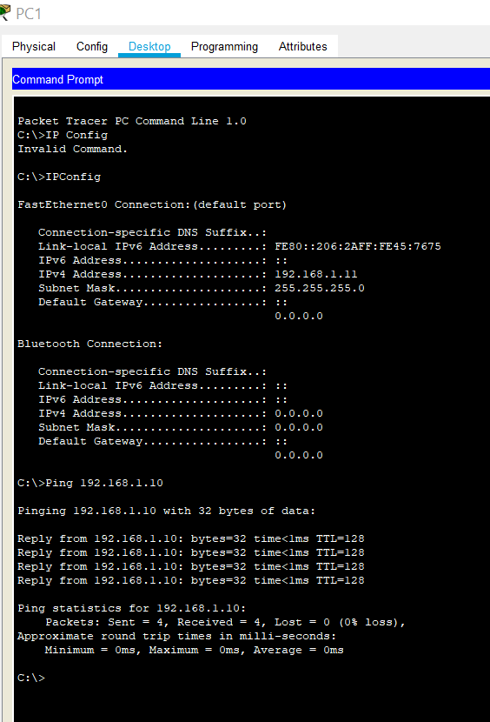

TASK 1:
CALCULATE THE IP ADDRESS OF THE HOSTS USING THE BELOW DETAILS
Mode |  | Which nos. active in the mode
Decimal | DEC | 0,1,2,3,4,5,6,7
Binary | BIN | 0,1
Hexadecimal | HEX | 0,1,2,3,4,5,6,7
Octal | OCT | 0,1,2,3,4,5,6,7

Question 1: Why are other nos. greyed out? Because outside of the scale. Binary is just noughts and ones.
Question 2: What happens to decimal no. 86 converted to binary (when BIN clicked)
Original conversion shows 86
When BIN clicked; shows 0101 0110 shows next to BIN
- but omits first 0 in Conversion so answer is 101 0110
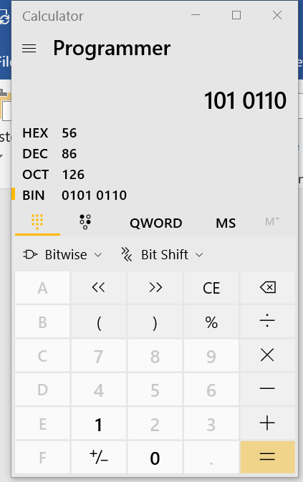
Question 3: Binary for no. 150
Answer is 1001 0110
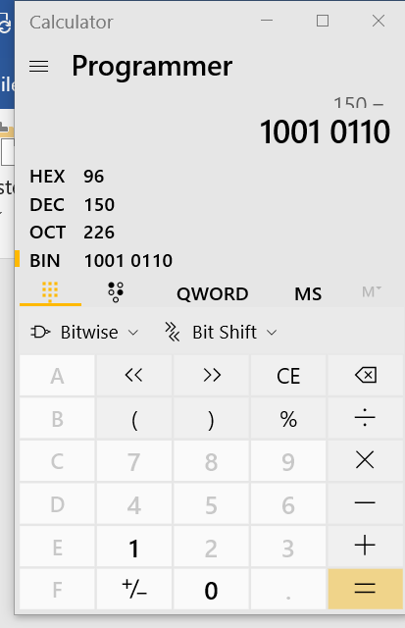

Question 4: Decimal for binary 1000 1010
Answer is 1000 1010
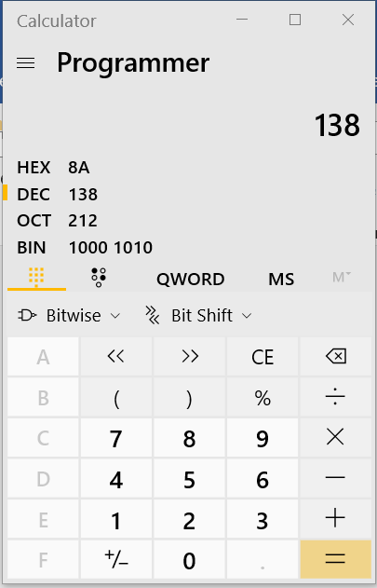
Question 5: Convert from Decimal to Binary
 | Decimal | Binary
1 | 52 | 011 0100 (missed off first 0)
2 | 78 | 100 1110 (missed off first 0)
3 | 129 | 1000 0001
4 | 242 | 1111 0010

Question 6: Convert Binary numbers to Decimal
 | Binary | Decimal
1 | 1100 0010 | 194
2 | 0011 1111 | 63
3 | 1011 0011 | 179
4 | 1011 1001 | 185

Question 7: Converting Host IP Addresses
 | HOST BINARY | HOST DECIMAL
1 | 11000000.10101000.00000001.00001010 | 192.168.1.10
2 | 11000000.10101000.00000001.00001011 | 192.168.1.11
No. 1 (It has four parts) – and No. 2 same except for last two digits
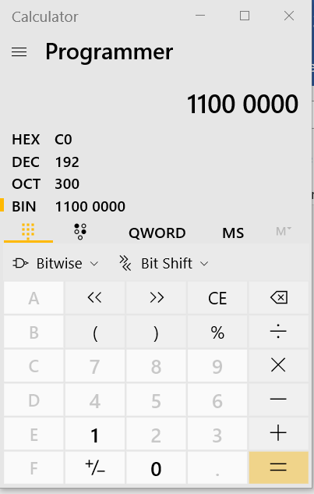
First part of the conversion (the first 8 binary digits) = 192.

Second Part; take the rest of the codes up to the dots in the same way; 168
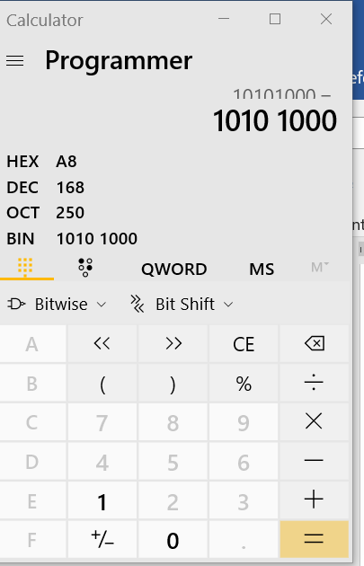

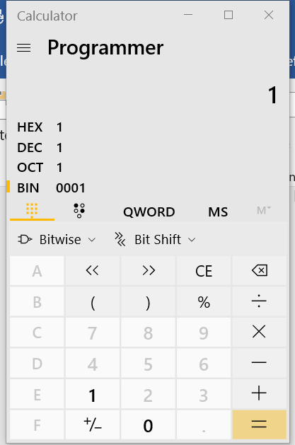
Third Part: Note here as code starts with all 0’s and only 1 at end next answer is just 1.

Last Part: in DEC its 10 so last two figures 10
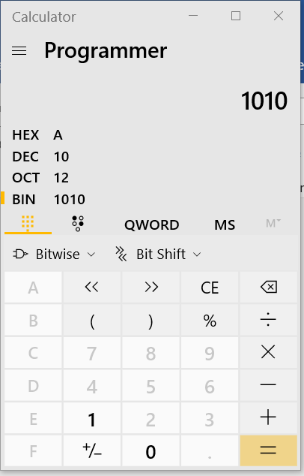

Question 8: Convert Host IP Subnet masks
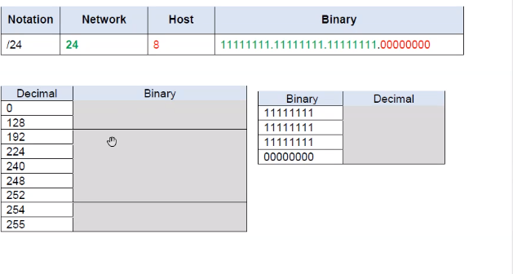

 | From Decimal | To Binary
1 | 0 | 0000 0000
2 | 128 | 1000 0000
3 | 192 | 1100 0000
4 | 224 | 1110 0000
5 | 240 | 1111 0000
6 | 248 | 1111 1000
7 | 252 | 1111 1100
8 | 254 | 1111 1110
9 | 255 | 1111 1111

 | From Binary | To Decimal
1 | 11111111 | 255
2 | 11111111 | 255
3 | 11111111 | 255
4 | 00000000 | 0

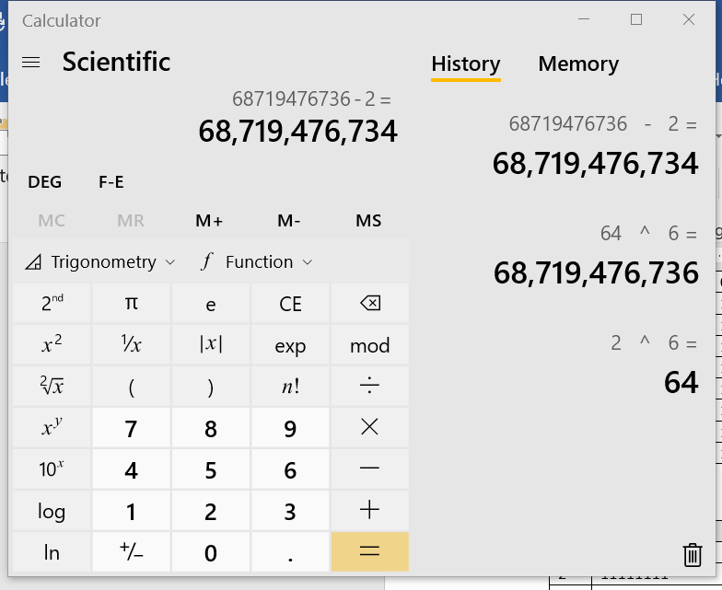
Question 9: Determine the number of Hosts

 | No. of Bits Used for Hosts | No. of Hosts
1 | 3 | =2³-2 = 8-2 = 6
2 | 8 | =2⁸-2 = 256-2 = 254
3 | 12 | =2¹² = 4096-2 = 4094
4 | 17 | =2¹⁷ = 131072-2 = 131070
HOW THE NO. OF HOSTS WORKED OUT FROM THE NO. OF BITS USED FOR HOSTS:
- Whatever the bits are become the Power
- Because its binary the base number is ALWAYS 2
- 2 X 2 = 4 X 2 = 8
- 8-2 (Take away 2 because the first is for network and last for the broadcast)

Question 10: Convert IP Addresses to Readable IP Addresses and Subnet Mask
 |  |  | IP Address |  |  |  | Subnet Mask
1 | PCA (O) | NIC | 1100 0000 | 1010 1000 | 0000 0001 | 0000 1010 | /24
2 | PCA(O) | NIC | 192 | 168 | 1 | 10 | 255.255.255.0
3 | PCB(1) | NIC | 1100 0000 | 1010 1000 | 0000 0001 | 0000 1011 | /24
4 | PCB(1) | NIC | 192 | 168 | 1 | 11 | 255.255.255.0

Question 11: Use the above IP Addresses
Is the Ping between PC-A and PC-B successful? - yes

TASK 2: Configure Wireless Router to the network with DHCP, basic security and remote access
- Add a laptop and a wireless router to your existing topology (WRT300 Wireless Router)

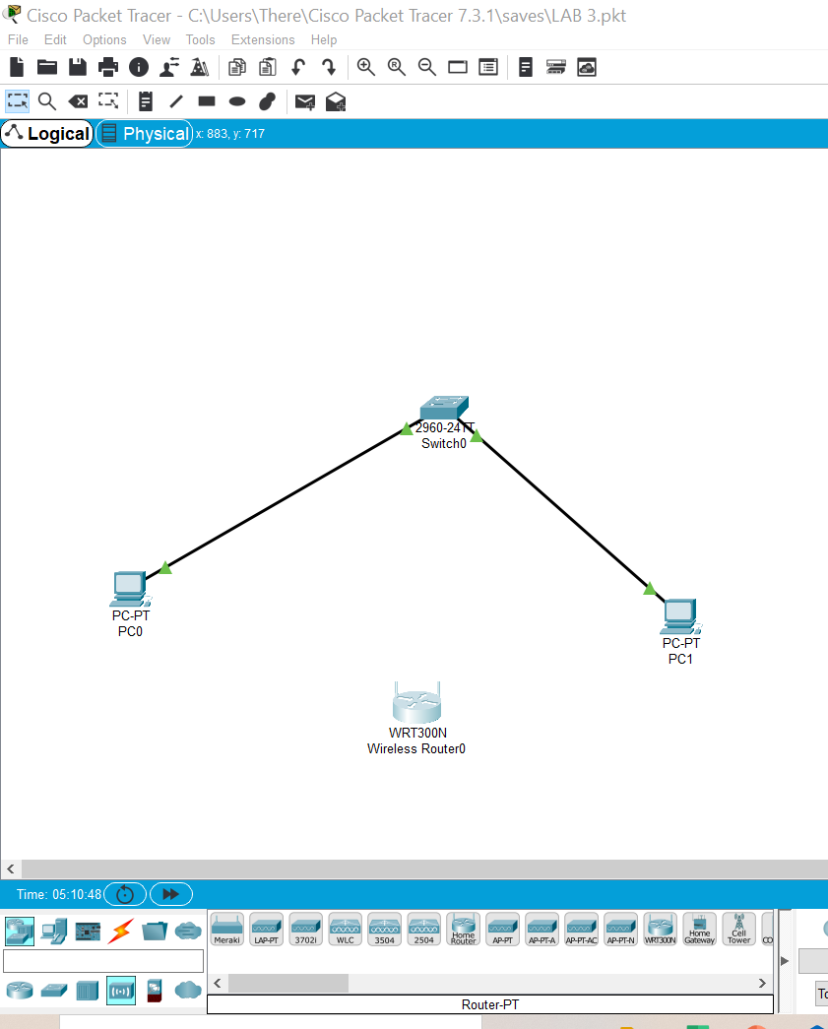
NOTE to self: ↑ is wireless router symbol (NOT the far left one)

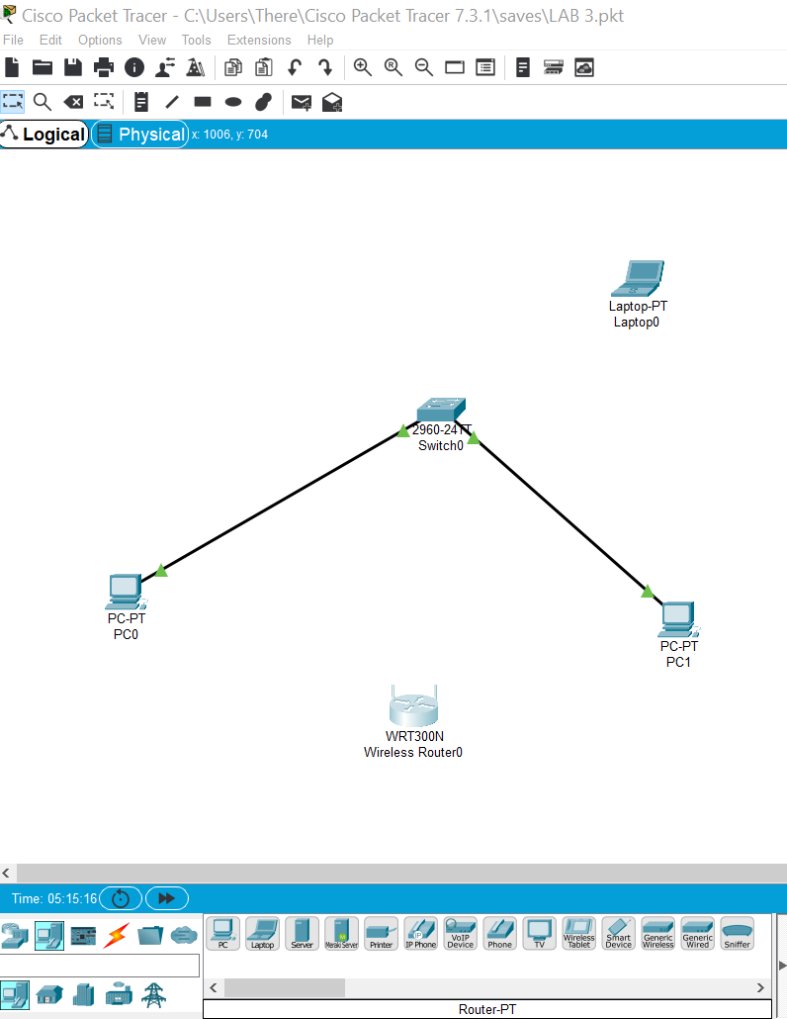

2. Changing the Router ID:
- Click on the router and choose GUI to change the IP address to 192.168.1.1 (ensuring save changes by scrolling down to bottom to SAVE)
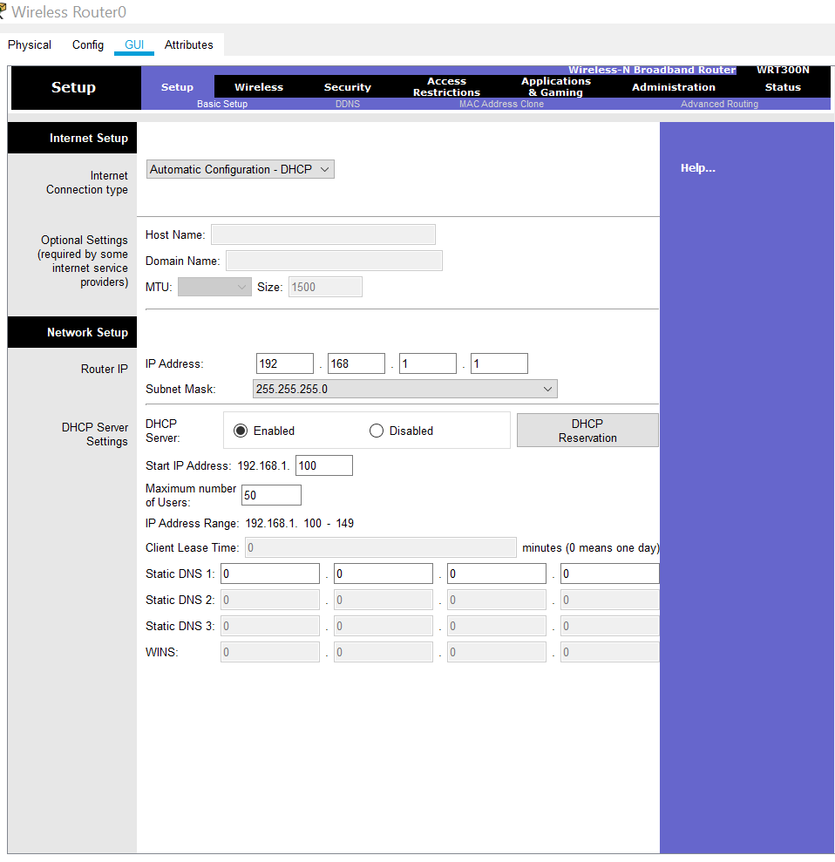

3. Select Wireless/Basic Wireless Settings (v small underneath) and change the name to My_ Class (SAVE)
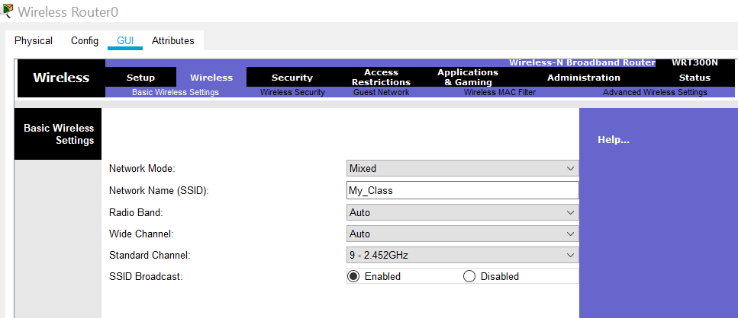
4. Now Select Wireless/Wireless Security (very tiny icon underneath) and change the security mode to:
A) Security mode to WPA2 Personal
B) the passphrase to cisco@123 (SAVE)
NB the Passphrase is the password you give to household/visitors to use internet but do NOT give other one (password 123) which is just for Administrator and NEVER make them the same as hackers could then easily take over your network.
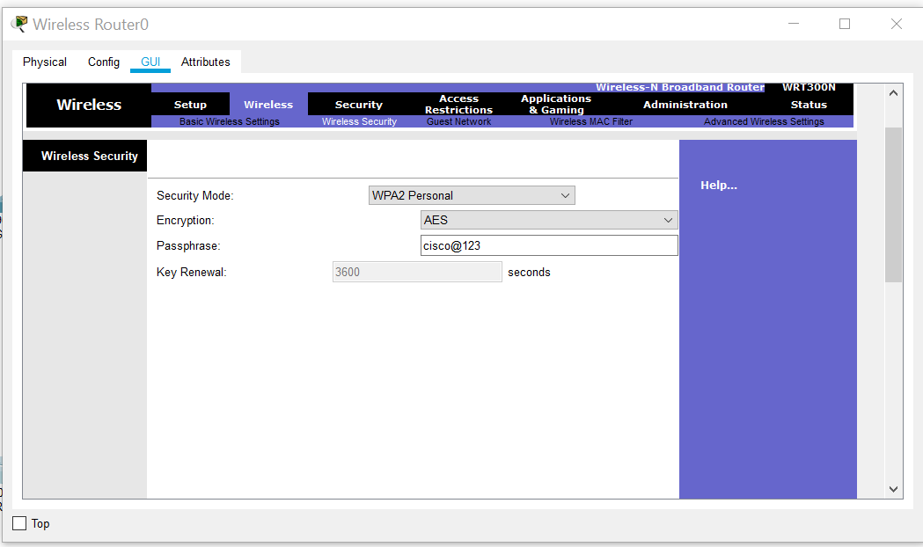

5. Select Administration/change router password to password123 and enable remote management (SAVE) and turn off router (go out of it)
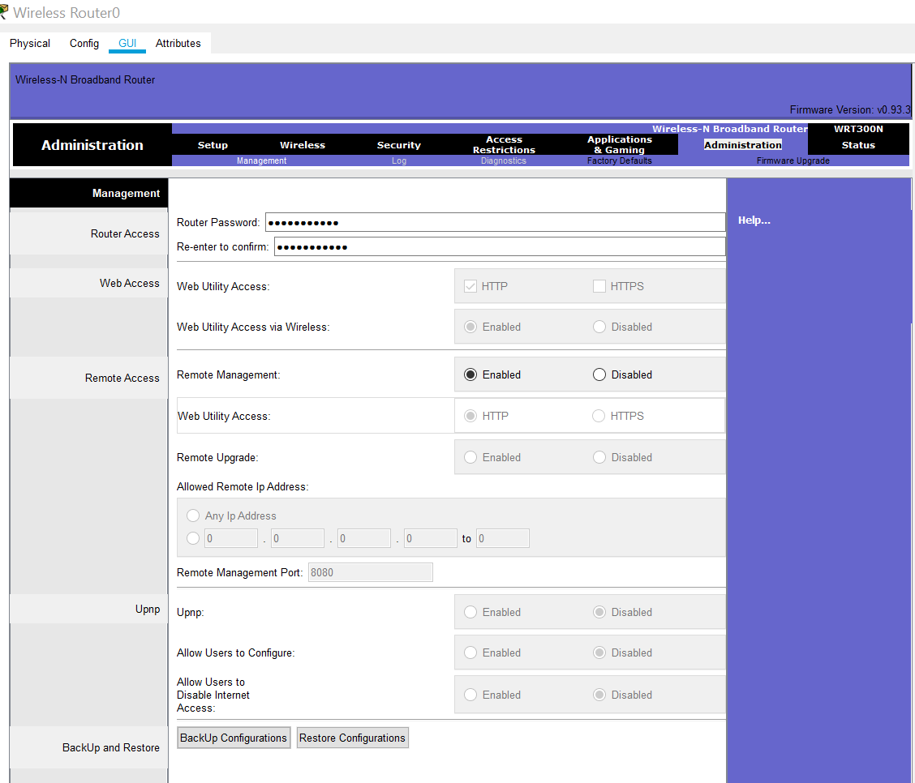

6. Now click on the laptop physical settings and turn off physical settings (button on side of it)
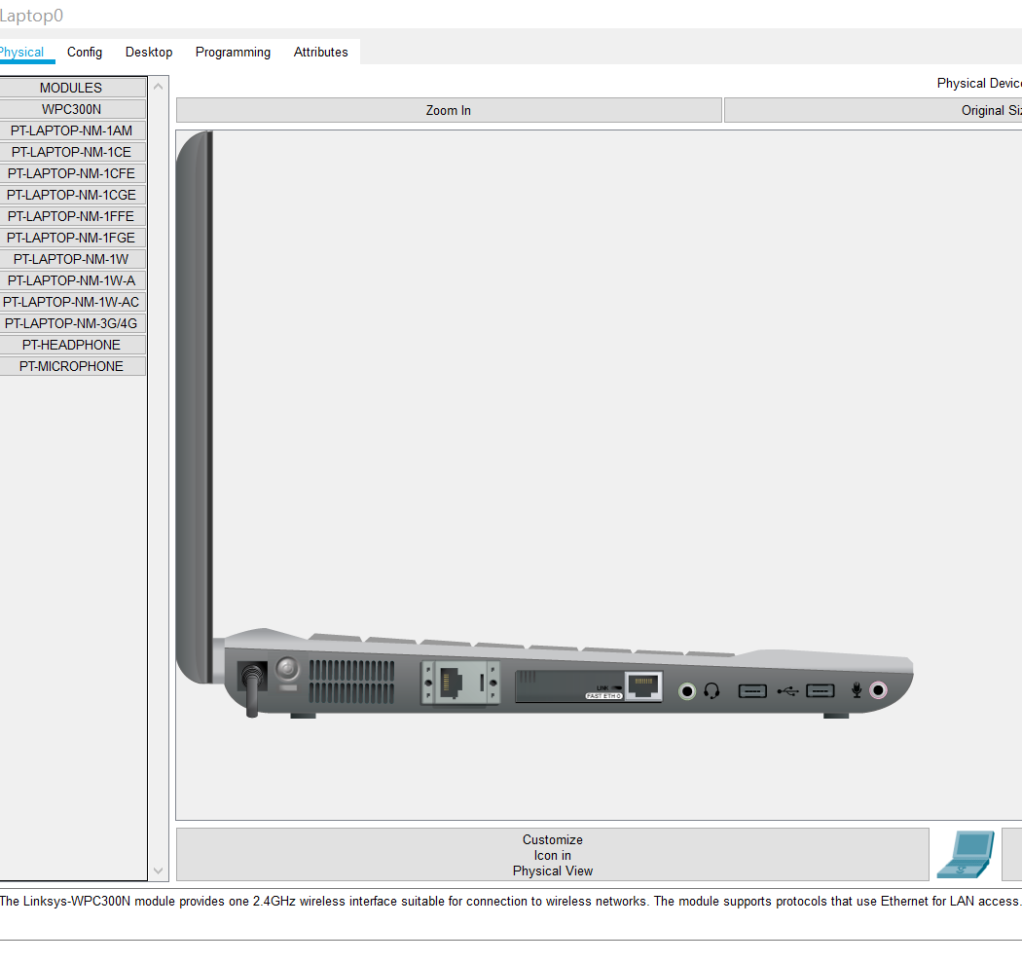

7. Now with the laptop OFF DRAG and remove the NIC and add WPC300N (wireless adapter/receiver)
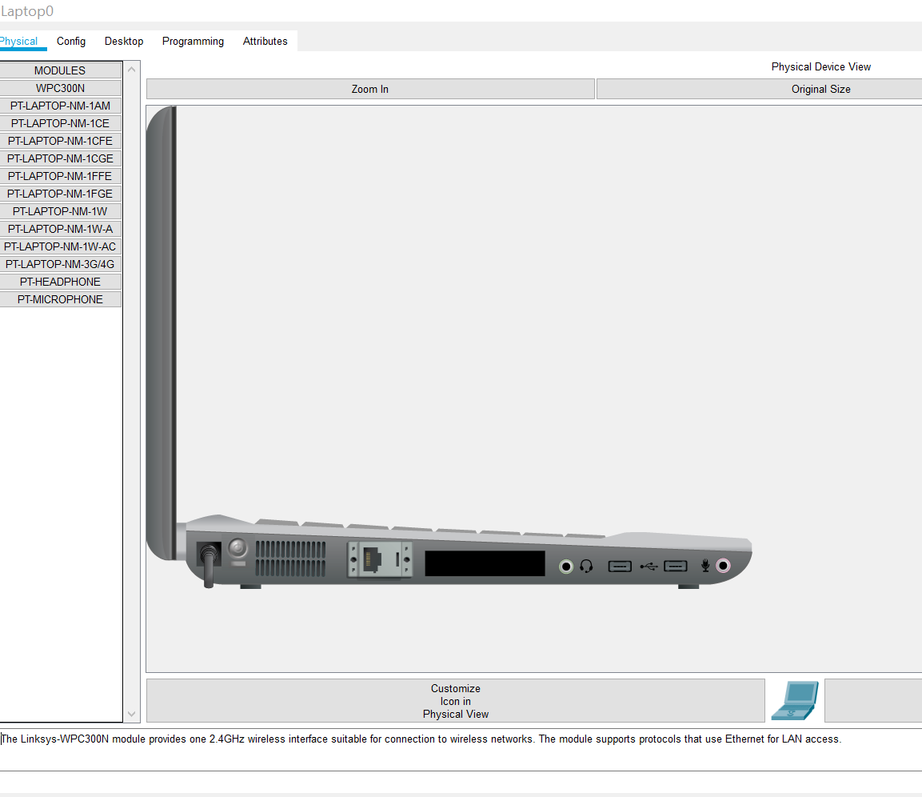
(see the hole has gone)
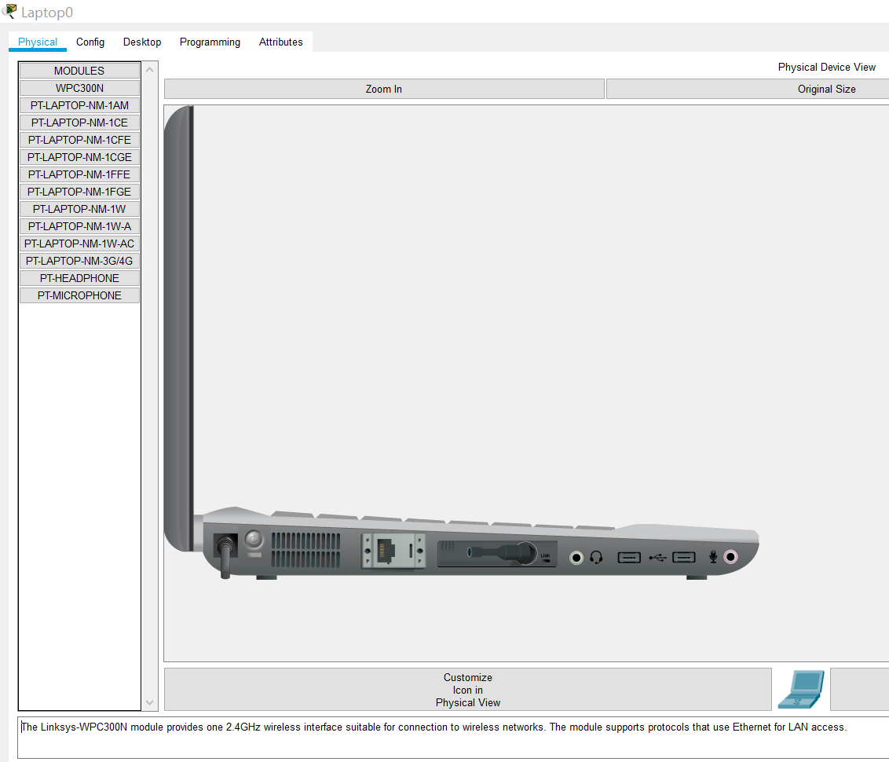

Dragged and dropped the WPC300N into the hole NOW TURN THE POWER BACK ON
- Go to Desktop on PC and choose Wireless Icon
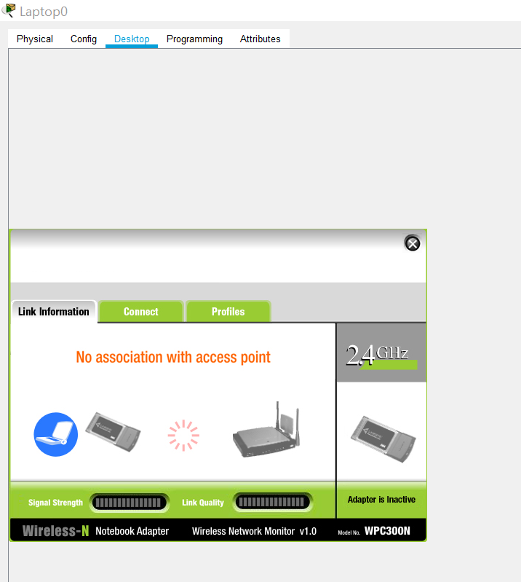

- Click connect
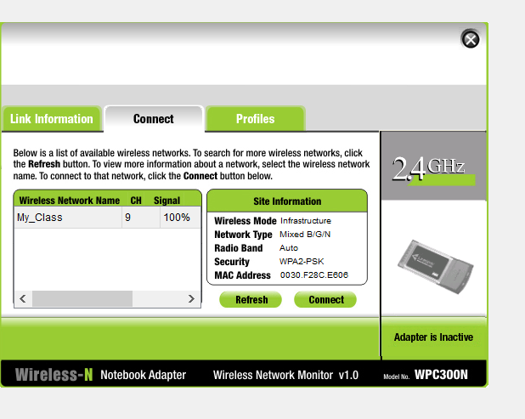
Click on My_Class then Connect (took two attempts! And so did Carlene)

- Enter passcode cisco@123 then connect
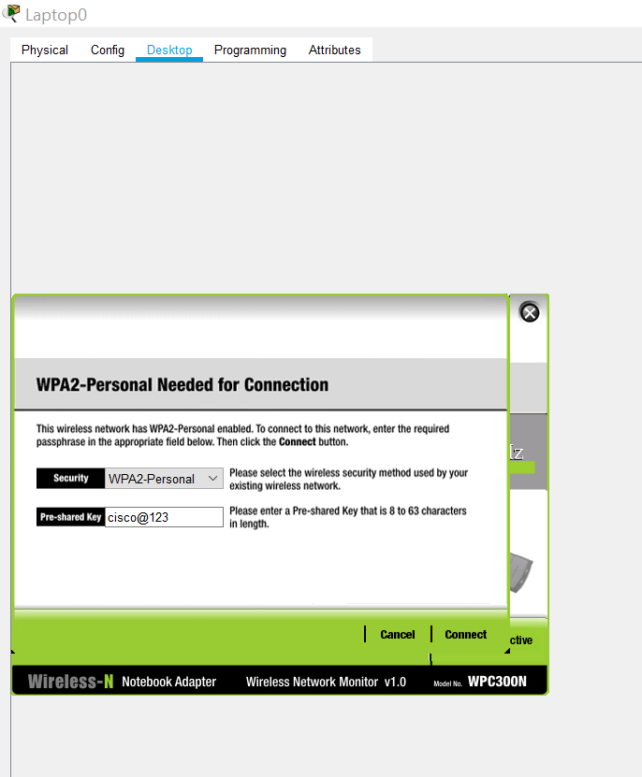

- Click on Link Information tab and this appears
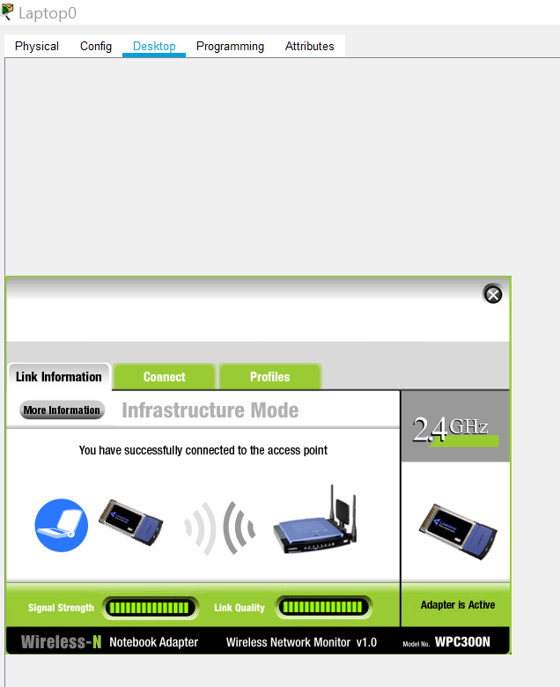

- After doing these steps you should see the IP address, Subnet mask and default gateway is configured using DHCP successfully.
- Click on the cross R/H side (CLOSE THE PREVIOUS SCREEN) to open up Desktop of PC and record the following from the laptop:

IP Address: 192.168.1.100
Subnet Mask 255.255.255.0
Default Gateway 192.168.1.1
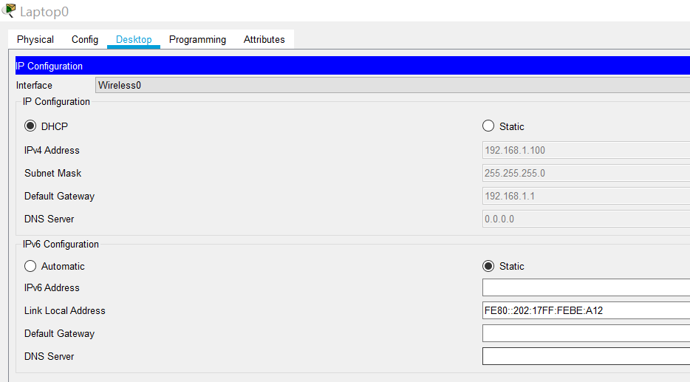

- NOTE: WPA2 Password is cisco@123 (NB this is for everybody to access your home network) and router password is password123 (this is the ADMIN password only you should know and the admin should always be different from the WPA2 one)

Ping Laptop to Wireless router

- from the laptop:
- IP Address: 192.168.100
- Subnet Mask 255.255.255.0
- Default Gateway 192.168.1.1

- PINGED from Laptop to router and successful:
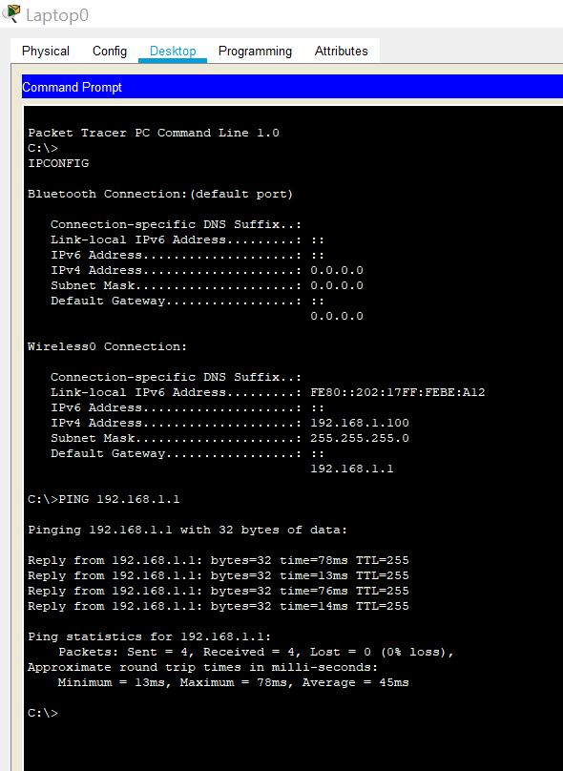

- Now Add the PC and connect wirelessly (different IP Addresses here)
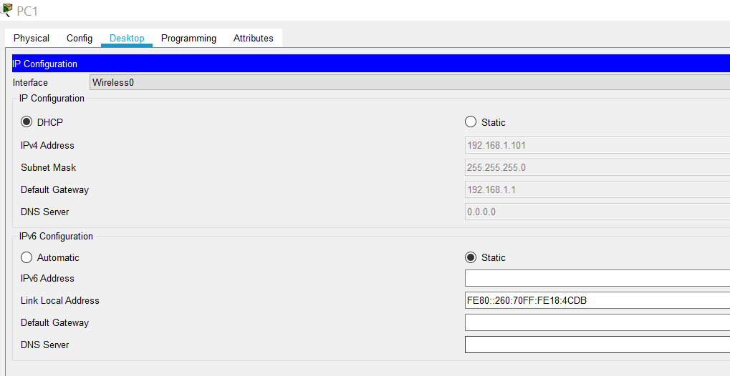

- Ping the (new wireless) desktop computer
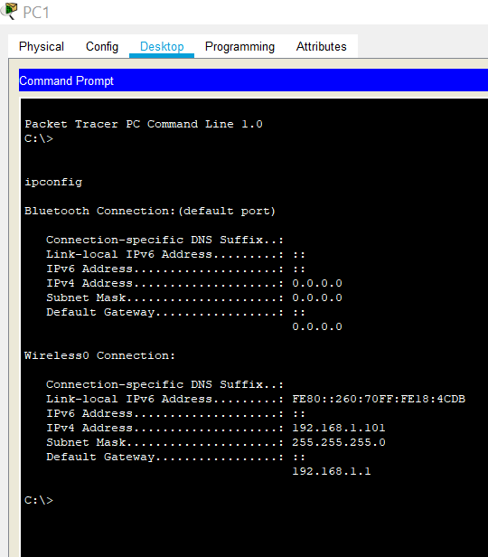
Shows the IP Address correctly (192.168.1.101) Subnet 255.255.255.0 and Default Gateway is 192.168.1.1

- Here is the final Topology
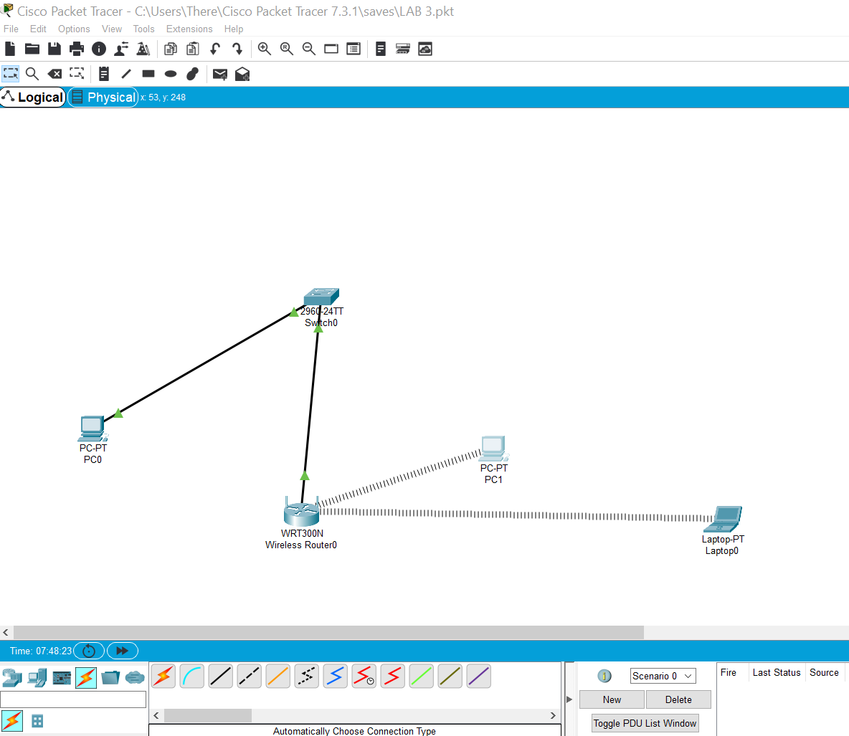

TASK 3: Observe the conversion of URL to an IP Address
- Go To ‘Type here ‘ (near window logo left hand side bottom screen) to search and type in COMMAND PROMPT GOOGLE.COM (return)
- For Google.com:
- Domain Name: Google.com
- IP Address: 172.217.169.78
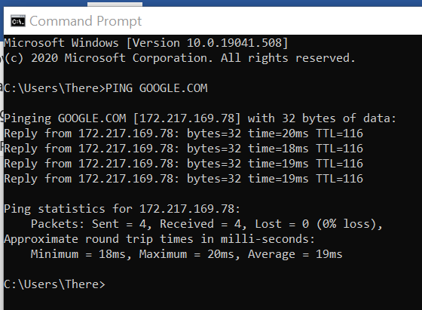
- Now type Cisco.com
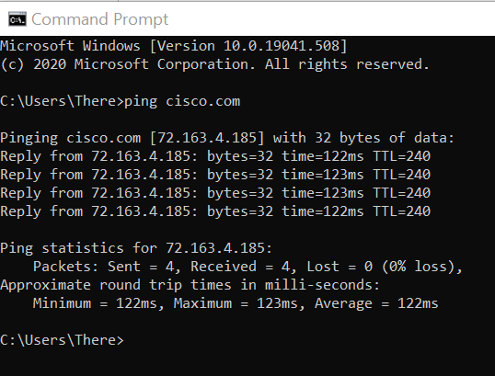
- For Cisco.com:
- Domain Name: Cisco.com
- IP Address: 172.217.169.78

- Nslookup
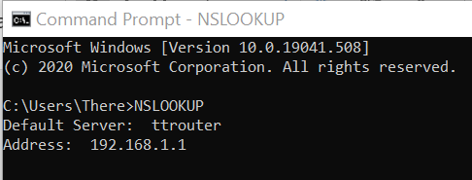
My Default Server: ttrouter
- Translated IP Address: 192.168.1.1
- It is an IPv4 address because it is 4 bytes long
- Same as the IP address with the Ping command? Yes
- By typing in nslookup the following info. Is revealed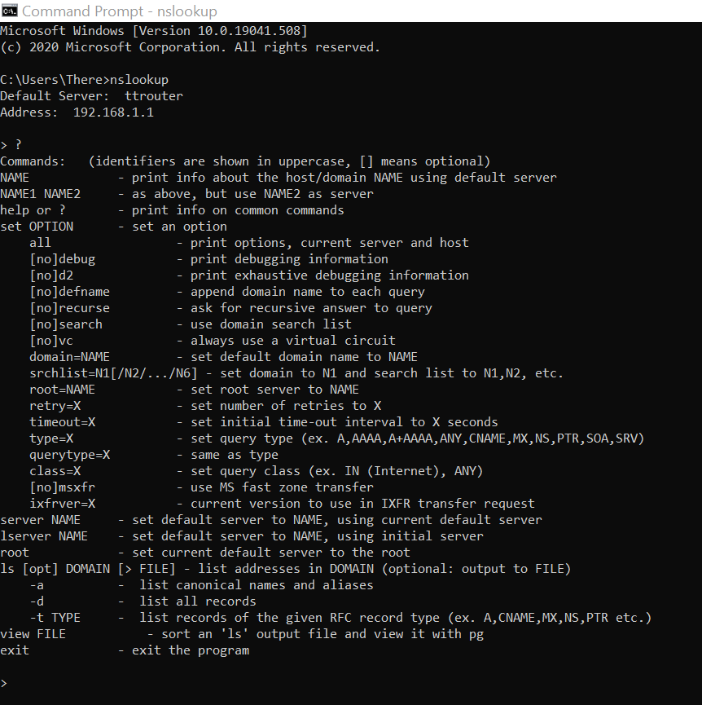

- REFLECTIONS
How is DNS useful to connect to a network service or to browse a website?

- DNS (Domain Name System) is like a phone book for the internet.

- It makes ‘human-readable’ names link to the IP Address allocated to the entities registered to that address.

- It acts as a central hub to provide a simple way to match name of the searched website to the numbers (address).

- Thanks to DNS you don’t have to keep a list of IP Addresses and can just type in the name of the company you wish to contact.

- Each device on the internet has a unique IP Address which consists of a string of numbers like 192.124.249.166. Domain names solve the problem of having to remember this long string of numbers and converts them into alphabetical list that makes it easier for people to search for things.

