

Business Plan
Student number : 2009477
Module Number: LCBB5001
Module Name: Entrepreneurship
Module Tutor: Vasilios Tavlaridis
Word count: 1830

Table of Contents
Introduction…………………………………………………………………………………………………3
SWOT Analyse……………………………………………………………………………………………..5
PESTEL Analyse…………………………………………………………………………………………….5
Target Market……………………………………………………………………………………………..7
Marketing Plan…………………………………………………………………………………………….9
Financial Plan……………………………………………………………………………………………...9
Cashflow Year 1…………………………………………………………………………………………..10
Reference List………………………………………………………………………………………………11

Logo of the Business


Introduction

An overview of your proposed business idea (Product/Service).

Party time is a children's party centre that will offer families in Cheltenham and the area organizing children's birthdays. The centre will have an indoor playroom with a special corner for children up to two years. And for the older ones there will be various games and entertainment. Parents will have special places where they can order snacks and drinks while watching the children play safely. Various entertainments such as: Sack skating, jumping on trampoline and bungee jumping will make children happy. For older children Party time will offer disco parties and laser shooting, as well as paintball shooting. In the list of offered services there will be parties with tricks, princess parties and karaoke stage. In each of the parties we can include games with parents and various competitions. What will make us different from our competitors is the fact that Party time will offer its customers to choose how long their party will last.

A brief explanation of the personal expertise and entrepreneurial skills

The owner is a parent of two children and has six years of experience in child care. He also has about fifteen years of experience in the field of services and customer service. He believes that the experience with children is the leading one in the business idea because he has experienced various difficulties in organizing such parties, as well as the desire to offer something different for the special day. The motivation for the business comes from the difficulties he has experienced in organizing his celebrations. The fact that you know the problems of your potential customers is an advantage for any business.
A brief discussion of the gap in the market
The niche that Party Time sees in the market is the opportunity to offer its customers the choice of whether their party will be outdoors or indoors according to the weather conditions. Most businesses in this field do not offer such a service. To gain a competitive advantage over our competitors, we will differentiate our products and services (Barney and Hesterly,2018) .This advantage and the wide choice of different party packages will make Party Time a market leader.
The location of your proposed business and it’s legal entity with a justification for both.
Based on the Business target market and the different market segmentations the area which the business will operate is Charlton Kings. Situated in the heart of the Cotswolds, the area is home to the picturesque Lineover woods; Charlton Kings Common and Leckhampton Hill, which are all considered areas of outstanding natural beauty. There are a variety of primary schools in the area, including Charlton Kings Junior School, and Charlton Kings Infant School, rated as ‘Outstanding’ by Ofsted and Glenfall Community Primary School, rated as ‘Good’ in its latest Ofsted inspection (www.andrewsonline.co.uk, n.d.).
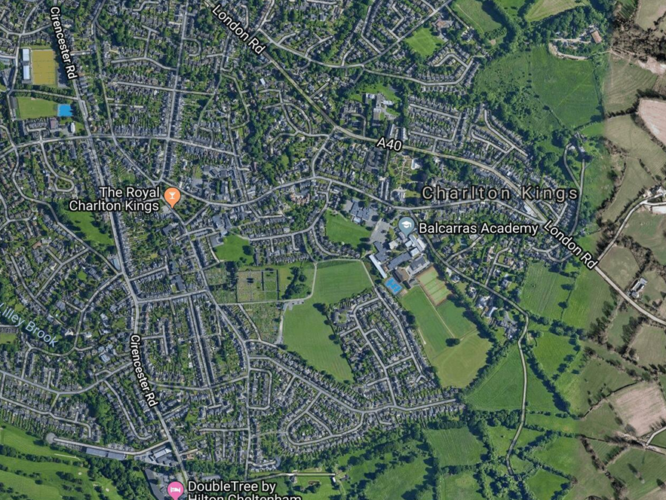(www.footballgroundmap.com, n.d.)

SWOT Analyse
Based on Swot analysis, businesses discover their strengths, weaknesses, opportunities and threats. This is the framework that shows the external and internal factors that can affect the business. Using both internal and external data, the approach can direct companies toward more strategic initiatives and away by those who have been or are projected to be less productive (Kenton, 2021).

S | W | O | T
Good Location  Many schools in the area  Own production of cakes  Good atmosphere  Qualified staff  Discount deals | New business in the market  Attracting customers  Advertising cost | Ability to book online  New services  Produce merchandise  Create connections with local schools | Lots of competition  Specific group of clients

PESTEL Analyse
Pestel is a very useful tool that is used by marketers to analyse the external marketing environment, these are the factors political, economic, socio-cultural, technological ecological, and legal. These analyses are very useful for any new business (Scarborough and Cornwall, 2019). If the business looks in detail at the PESTEL analysis, two very important and topical issues are affected by the political sector. Brexit is a fact and businesses need to adapt to this factor. Party Time is considering purchasing or cooperating with suppliers that are based in the UK. This will avoid charging higher fees and duties. On other side also Covid is a pandemic that is worldwide and directly or indirectly affects all businesses. The idea of Party Time is to adapt and offer its customers an online service. This type of service will be offered only in case of business closure.
Economically, the onset of high inflation implies a contraction in consumption and an increase in business costs. Party Time has a strategy to counter the contraction of consumption with various loyalty programs. Such as discount vouchers, discount cards and future discounts for recommendations, etc.
Based on statistics on the demographic map of the area, it can be seen that the target group of Party Time is a high percentage which is positive for business. The growing number of young families and good education are the basis of this target group.
Party Time sees a good opportunity in the well-developed technology in the area. The widespread use of innovation and social media is a good basis for good business advertising.
Weather and climate change directly or indirectly affect every business. This is where Party Time finds its gap. Party Time aims to protect nature from pollution by implementing separate collection of its waste and the use and implementation of environmentally friendly raw materials for its services (as far as applicable). For example the use of cardboard cups, plates, etc.
Party Time will have all the documents required by law, such as insurance, insurance and will meet all hygiene requirements.

POLITICAL
Brexit
- Possible supply problem
- Higher taxes and customs duties on import of goods
Covid
- Closing of the business at local and national level
- Reduction of customers due to fear and government restrictions

ECONOMICAL
High Inflation
- Shrinking consumption
- Raising the interest rates
- Higher rent
High average income for the potential customers

SOCIAL
Demographic map
- Growing numbers of young families
High level of education

TECHNOLOGICAL
- Technology
Higher level of innovations
Wide use of social media
Digital revolution

ENVIRONMENTAL
Weather
- Climate change
Sustainability
Recycling
Pollution
LEGAL
Health and safety laws and legislations
Product safety
Employment laws

Target Market
Good targeting is very important for any business. The clarity of the niche allows effective competition with larger competitors. When we focus on a specific market, we do not exclude potential customers who are not from our target, but allow the business to build the best possible marketing strategy.
The direct user of the services offered by the business are the children, but the real user of the service is the parents. This is the group between 20-64 years. This is because for the Party Time business, every family or future family is a potential customer. The target group of business clients are families with higher monthly income. Of course, the target does not exclude middle-income families.
Key findings from secondary research
According to Gloucestershire county council the resident population of Gloucestershire in 2019 was estimated to be 637,070 people of which:
• 22.4% were aged 0-19;
• 56.0% were aged 20-64;
• 21.6% were aged 65 and over
• at 24.6%, Gloucester has the highest proportion of children and young people (aged 0- 19) and exceeds the county and national figures.
• Gloucester has the highest proportion of people aged 20-64 (58.5%), exceeding the county and national figures.
• Cotswold, the Forest of Dean, Stroud and Tewkesbury all have a higher proportion of people aged 65+ when compared to the county and national figures. At 25.9% Cotswold has the largest proportion of people aged 65 and over (inform.gloucestershire.gov.uk, n.d.).

Gloucestershire population by broad age group, 2019

Gloucestershire average salary comparison
The average salary in ranging between £30.8k 8k in Cotswold and £38.0k in South Gloucestershire. The UK average salary was £38.6k in 2020. Gross average salary is calculated for full-time employees (Plumplot, n.d.). Employee has to be in the same job for over 12 months. The data collected is Tax Year Ending.

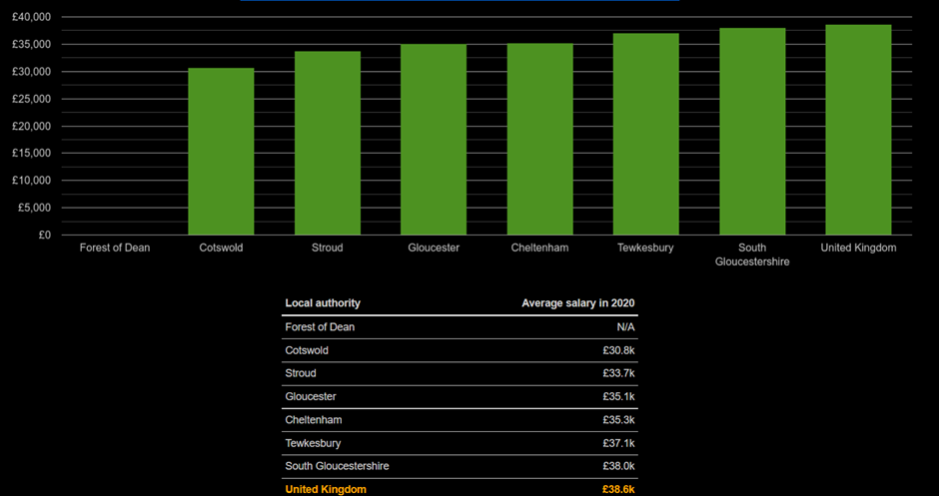
(Plumplot, n.d.)

Marketing plan
Marketing strategy is the overall strategy of the business and the way it will present its services to future customers, which will make them current. The purpose of the marketing strategy is to present the value of the business service (Fifield, 2016) . This is the business promise of quality without compromise. By presenting its marketing strategy, the business shows how the service will solve a problem or bring value to the consumer. In order for the marketing strategy to be well presented, we will use 4 Ps. ,product, price, place, and promotion.
Product
This is the services that Party Time will provide. Businesses need to meet existing demand or introduce new services that make consumers willing to take advantage of them. Party Time will offer many services that are already familiar to consumers, and some new to the market.
Price
This is the price that consumers pay for the services or product. Very often marketers link the real and perceived value of the service, taking into account the promotions of competitors and the cost of the service.
Sometimes the price of the service can be increased to create a feeling of a more luxurious service or product. The purpose of Party Time is to offer competitive prices and high quality.
Place
When a business chooses the place of importance, the users to whom it will provide its services should benefit from them. Charlton King area is surrounded by a wide variety of businesses and schools so it is identified as the best place for Party Time.
Promotion
The promotional strategy of the advertisement with which the service is promoted. Making contact with the client and the moment when we convince him that he needs the service that is offered and why they have to pay for it. Using social media, Party Time will introduce its customers to its services, as well as reviews of satisfied customers.
Financial plan
The financial plan is that part of the business plan which presents information about the financial condition of the company, expected expenses and income.Party Time choose at The government's Start Up Loan scheme.This scheme finances up to £ 25,000 for a period of five years, and has a fixed annual interest rate of 6% (Government Digital Service, 2017). It also has a grace period of 12 months. The advantage of this loan is the fixed interest rate, which is a guarantee that there will be no unpleasant surprises with an increase in the interest rate. Also, another advantage of this scheme is that it allows new businesses to benefit from helping to build their strategies. According to the calculations shown below at Party Time for five years, the amount to be returned is £ 28999.20. This means that the monthly installment is £ 483.32.

Cashflow Year 1

Reference List

Barney, J.B. and Hesterly, W.S. (2018). Strategic management and competitive advantage : concepts and cases. Harlow, England: Pearson.
Fifield, P. (2016). Marketing strategy. London: Routledge.
Government Digital Service (2017). Apply for a Start Up Loan for your business. [online] GOV.UK. Available at: https://www.gov.uk/apply-start-up-loan.
inform.gloucestershire.gov.uk. (n.d.). Population figures - Inform. [online] Available at: https://inform.gloucestershire.gov.uk/population/population-figures/ [Accessed 21 Oct. 2021].
Kenton, W. (2021). Strength, Weakness, Opportunity, and Threat (SWOT) Analysis. [online] Investopedia. Available at: https://www.investopedia.com/terms/s/swot.asp.
Plumplot (n.d.). Gloucestershire Average salary and unemployment rates in graphs and numbers. [online] www.plumplot.co.uk. Available at: https://www.plumplot.co.uk/Gloucestershire-salary-and-unemployment.html [Accessed 21 Oct. 2021].
Scarborough, N.M. and Cornwall, J.R. (2019). Essentials of entrepreneurship and small business management. New York, Ny Pearson Education.
www.andrewsonline.co.uk. (n.d.). Charlton Kings Area Guide | Andrews. [online] Available at: https://www.andrewsonline.co.uk/about/area-guides/charlton-kings [Accessed 21 Oct. 2021].

