1. Introduction
Sport participation is widely recognised as a critical contributor to physical health, psychological wellbeing, and social development. Regular physical activity is associated with a reduced risk of chronic illnesses such as cardiovascular disease, obesity, and type 2 diabetes, while also contributing to improved mental health outcomes, including lower levels of anxiety and depression (Biddle and Asare, 2011). Beyond individual benefits, sport plays a significant role in fostering social cohesion, enhancing communication skills, and promoting leadership and teamwork (Bailey et al., 2013). As a result, increasing participation in sport remains a key priority within public health and sport policy frameworks.
Despite these well-documented benefits, participation in sport remains unevenly distributed across populations, with gender representing one of the most persistent inequalities. In the United Kingdom, women and girls are consistently less likely than men to meet recommended physical activity levels (Sport England, 2023). This disparity is particularly concerning given the long-term health and social implications associated with inactivity. Importantly, the issue is not simply behavioural but reflects broader structural and cultural barriers embedded within sport systems.
One of the most critical challenges is the decline in participation during adolescence. Research consistently identifies this life stage as a key dropout period, particularly for girls (Eime et al., 2016). The transition from primary to secondary education often coincides with reduced confidence, increased self-consciousness, and heightened sensitivity to peer judgement. These factors are further exacerbated by body image concerns, which are particularly prevalent among adolescent girls (Slater and Tiggemann, 2011). As a result, many girls disengage from sport at a time when continued participation is crucial for long-term health and development.
In addition to psychological barriers, structural factors also contribute to disengagement. Traditional sport environments are frequently perceived as competitive, performance-oriented, and male-dominated (Coakley, 2017). While these environments may be suitable for individuals pursuing elite pathways, they can alienate those seeking recreational or social participation. Consequently, many girls and women feel excluded from mainstream sport provision.
Social and cultural norms further reinforce these challenges. Gender stereotypes, expectations around femininity, and limited representation of women in sport all contribute to a perception that sport is not a space where women belong (Women in Sport, 2022). These barriers are particularly pronounced in certain communities, where cultural expectations may further restrict participation.
In response to these issues, this business plan proposes the development of a Women’s Sport Camp. This initiative is designed as a structured, female-only programme aimed at addressing both psychological and structural barriers to participation. By providing a supportive, inclusive environment that prioritises enjoyment, confidence-building, and personal development, the camp seeks to encourage sustained engagement in sport.
From a sport management perspective, this initiative aligns with contemporary approaches that emphasise sport-for-development frameworks (Coalter, 2015). These frameworks recognise sport as a tool for achieving broader social outcomes, including improved health, social inclusion, and empowerment. Rather than focusing solely on performance, the Women’s Sport Camp adopts a holistic approach that prioritises participation and wellbeing.
Ultimately, this business plan aims to demonstrate that a targeted, inclusive sport programme can address existing gaps in provision while delivering both social impact and financial sustainability.

2. Business Concept and Strategic Objectives

2.1 Concept Overview
The Women’s Sport Camp will operate as a six-week seasonal programme, primarily delivered during the summer holiday period. This timeframe has been selected strategically to maximise accessibility, particularly for school-aged participants who have increased availability during this period. Additionally, the programme will be accessible to university students and working adults through flexible scheduling options.
Flexibility is a central feature of the business model. Participants will be able to choose between full programme enrolment and shorter-term packages, allowing individuals to engage based on their availability, financial capacity, and personal preferences. This approach is designed to reduce barriers to participation and increase overall accessibility.
The programme will offer a diverse range of activities, including team sports, individual fitness sessions, and personal development workshops. This variety is essential in catering to different skill levels, interests, and motivations. Research indicates that women are more likely to engage in physical activity when it is perceived as enjoyable, social, and non-competitive (Eime et al., 2013). Therefore, the camp will prioritise participation and enjoyment rather than performance outcomes.
A key distinguishing feature of the Women’s Sport Camp is its female-only environment. This is particularly important in addressing issues such as body image concerns, fear of judgement, and lack of confidence. Creating a safe and supportive space can significantly enhance participation and engagement, particularly among individuals who may feel uncomfortable in mixed-gender environments.
Furthermore, the inclusion of personal development workshops differentiates the programme from traditional sport provision. These workshops will focus on topics such as confidence-building, mental wellbeing, and goal-setting, providing participants with valuable skills that extend beyond sport.

2.2 Strategic Objectives
The strategic objectives of the Women’s Sport Camp are as follows:
- To increase female participation in sport among individuals aged 12 and above
- To reduce dropout rates during adolescence
- To enhance confidence, self-esteem, and mental wellbeing
- To provide accessible and inclusive sport opportunities
- To establish pathways for long-term engagement in physical activity
These objectives are aligned with national policy priorities, including the UK Physical Activity Guidelines (Department of Health and Social Care, 2019). Importantly, achieving these objectives requires a holistic approach that addresses both structural and psychological barriers. Market Analysis

3.1 Industry Context
The UK sport and physical activity sector has experienced steady growth in recent years, driven by increased awareness of health benefits and government investment. However, participation remains unevenly distributed, with significant disparities across gender, age, and socio-economic groups (Public Health England, 2021).
Women are disproportionately represented among inactive populations, particularly in lower-income communities. This highlights the need for targeted interventions that address both financial and social barriers. Furthermore, the long-term benefits of participation extend beyond health, with research indicating that engagement in sport can enhance employability, confidence, and social mobility.

3.2 Consumer Behaviour
Consumer behaviour trends reveal a shift away from traditional sport models. Key trends include:
- Declining participation among teenage girls
- Preference for non-competitive and social activities
- Growing demand for female-only environments
- Increased focus on wellbeing rather than performance
These trends reflect changing expectations, with participants seeking flexible, inclusive, and enjoyable experiences.

3.3 Target Market
The target market includes:
- Girls aged 12–18
- Young women aged 18–30
- Women returning to sport
- Older women seeking social engagement
Each segment has distinct needs, requiring tailored approaches to engagement and delivery.

3.4 Competitor Analysis
Existing competitors include sports clubs, gyms, and community programmes. However, many of these organisations prioritise performance and competition, limiting their appeal to broader audiences.
The Women’s Sport Camp addresses this gap by offering a participation-focused, inclusive alternative.
3.5 Promotional Material
This is the t-shirt for people to warm if they get warm during the sessions.
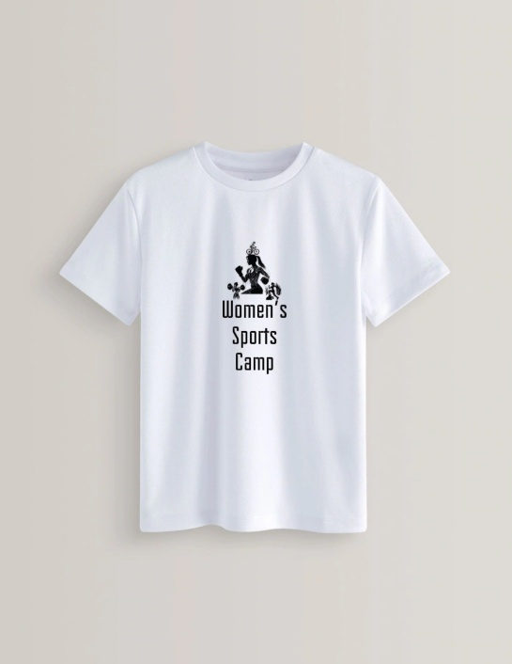
This is the jumper for if people get cold during the session.


This is the water bottles so people can stay hydrated.



This is the towel for if people need to wipe their heads if they sweat.
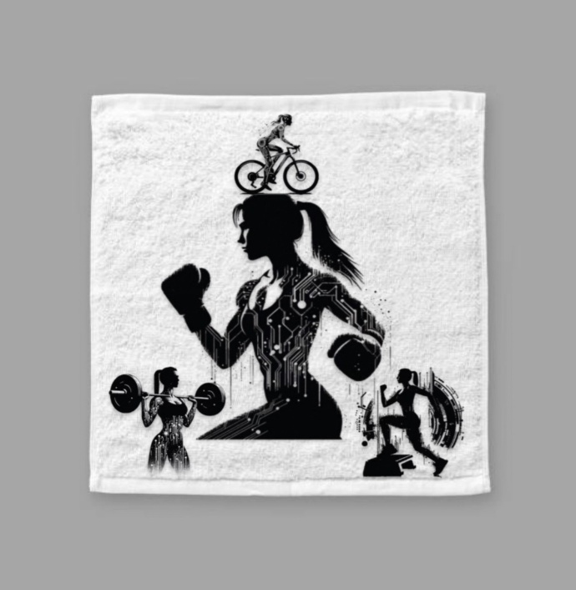

4. PESTLE Analysis
Political support for increasing physical activity is strong, particularly within the United Kingdom, where government strategies consistently emphasise reducing inactivity and promoting inclusivity in sport (Department of Health and Social Care, 2019). Initiatives led by organisations such as Sport England have reinforced the importance of engaging underrepresented groups, including women and girls. However, while policy alignment provides a favourable environment, reliance on public funding introduces uncertainty. Changes in government priorities or budget allocations may impact the availability of grants and financial support, making long-term planning more complex.
Economic conditions also play a significant role in shaping participation. The ongoing cost-of-living pressures in the UK may limit disposable income, reducing individuals’ ability to pay for recreational activities (Public Health England, 2021). This is particularly relevant for lower-income groups, who are already underrepresented in sport participation. Nevertheless, external funding opportunities, sponsorships, and tiered pricing strategies can help mitigate these barriers and improve accessibility.
Social factors are equally influential. While attitudes towards women in sport are gradually improving, persistent gender stereotypes and cultural expectations continue to affect participation (Women in Sport, 2022). Issues such as body image concerns, fear of judgement, and lack of confidence remain significant barriers, particularly among adolescent girls. Addressing these requires not only accessible programmes but also supportive and inclusive environments.
Technological developments provide valuable opportunities for marketing and engagement. Social media platforms, online booking systems, and digital communities enable cost-effective communication and outreach (Chaffey and Ellis-Chadwick, 2019). However, reliance on digital platforms may exclude individuals with limited access or digital literacy, highlighting the need for a balanced approach.
Legal considerations are critical, particularly in relation to safeguarding, health and safety, and data protection. Compliance with guidelines set by organisations such as the NSPCC is essential to ensure participant safety and organisational credibility. Finally, environmental factors, including unpredictable weather conditions, may disrupt outdoor activities. As a result, access to indoor facilities and contingency planning is necessary to ensure programme continuity and reliability.

5. SWOT Analysis
The Women’s Sport Camp demonstrates several key strengths, most notably its inclusive, female-only environment and strong emphasis on social impact. By prioritising confidence, wellbeing, and accessibility, the programme addresses clear gaps within traditional sport provision. This alignment with policy objectives, particularly those promoted by Sport England, further strengthens its relevance and potential for support.
However, weaknesses remain. The seasonal nature of the programme may limit continuity and long-term engagement, while initial brand recognition is likely to be low, requiring significant marketing efforts. Additionally, reliance on external facilities may reduce operational flexibility.
Opportunities are significant, including growing demand for inclusive sport programmes and potential partnerships with schools and community organisations. Access to grant funding also provides avenues for financial support.
Conversely, threats include competition from established providers and ongoing economic constraints, which may reduce participation rates and overall affordability for target groups.

6. Service Offering
The Women’s Sport Camp will deliver a comprehensive and diverse programme that integrates sports participation, structured fitness sessions, and personal development workshops, ensuring a holistic approach to engagement. Team sports such as football, netball, and basketball will provide opportunities for social interaction, teamwork, and skill development, while also fostering a sense of belonging among participants. These activities will be adapted to suit varying ability levels, ensuring accessibility for both beginners and more experienced individuals.
In addition to team-based activities, the programme will include fitness sessions focused on strength, cardiovascular endurance, and overall physical health. Activities such as circuit training, aerobics, and yoga will cater to participants who may prefer non-competitive forms of exercise. This aligns with participation trends identified by Sport England, which highlight a growing preference among women for flexible and wellbeing-focused activities.
A distinctive feature of the service offering is the inclusion of workshops addressing confidence, mental wellbeing, body image, and personal development. These sessions aim to tackle psychological barriers to participation and empower individuals beyond the physical aspects of sport. Collectively, this multi-dimensional approach ensures that the programme not only promotes physical activity but also supports long-term behavioural change and personal growth.

7. Marketing Strategy (Expanded)
A hybrid marketing strategy combining digital and traditional methods will be implemented to maximise reach, engagement, and inclusivity across diverse target groups. Digital marketing will play a central role, particularly in engaging younger audiences. Social media platforms such as Instagram, TikTok, and Facebook will be used to share promotional content, participant testimonials, and interactive posts that highlight the inclusive and supportive nature of the programme. These platforms enable targeted advertising, allowing the camp to reach specific demographics based on age, location, and interests. Additionally, a user-friendly website and online booking system will streamline registration and improve accessibility. Research by Dave Chaffey and Ellis-Chadwick (2019) highlights the effectiveness of digital channels in reaching and engaging modern consumers.
However, reliance solely on digital marketing may exclude certain groups, particularly older participants or those with limited digital access. Therefore, traditional marketing methods will complement online efforts. These will include partnerships with schools, community centres, and local organisations, as well as the distribution of posters and flyers in accessible locations. Word-of-mouth promotion and community engagement events will also play a key role in building trust and awareness.
Critically, the integration of both approaches ensures a more inclusive strategy, enabling the programme to reach a broader audience while maintaining cost-effectiveness and measurable impact.

8. Operations Plan
Qualified staff and rented facilities will ensure effective and professional programme delivery. The camp will employ experienced, appropriately certified female coaches who are not only skilled in their respective sports but also trained in inclusive coaching practices. This is essential to create a supportive and welcoming environment that caters to participants of varying abilities and confidence levels. In addition, designated safeguarding officers will be appointed to ensure the safety and wellbeing of all participants, in line with guidelines set by organisations such as the NSPCC. Administrative staff will also be required to manage registrations, communications, and day-to-day operations efficiently.
Facilities will be sourced through partnerships with local schools, leisure centres, and community venues. This approach reduces initial capital investment and allows access to pre-equipped, high-quality spaces. However, reliance on external facilities may limit scheduling flexibility and availability, particularly during peak periods. To mitigate this, advance booking and the identification of backup venues will be essential.
Overall, the operations plan focuses on balancing cost-efficiency with high-quality delivery, ensuring a safe, organised, and engaging experience for all participants.
- Financial Plan
Costs, revenue streams, and break-even analysis demonstrate viability, though dependent on participation.
The financial plan is structured around keeping initial costs manageable while ensuring the project can scale sustainably over time. Start-up costs primarily include materials, venue or platform fees, marketing, and any necessary equipment or software. Where possible, shared resources and partnerships are used to reduce upfront expenditure. Fixed costs are expected to remain relatively low, while variable costs will fluctuate depending on the number of participants and the scale of each event or activity.
Revenue streams are diversified to reduce financial risk. These include participation fees, ticket sales, sponsorships, and potential grants or community funding opportunities. Additional income may be generated through merchandise, optional add-on services, or tiered membership models that provide enhanced benefits to recurring participants. Sponsorship from local businesses or organisations also represents a key opportunity, particularly where the project aligns with community engagement or youth development goals.
A break-even analysis indicates that financial sustainability is achievable once a consistent level of participation is reached. Early-stage operations may run at a slight loss or minimal profit due to setup and promotional costs, but this is expected to stabilise as awareness grows and participant numbers increase. The break-even point is directly linked to attendance levels, making engagement and retention strategies critical to financial success.
Overall, while the model is financially viable on paper, its long-term success depends heavily on maintaining strong participation rates and building reliable community or stakeholder support.
- Implementation Timeline (Gantt Overview)
Phase | Timeline
Planning | Months 1–2
Marketing | Months 2–3
Recruitment | Months 3–4
Programme Delivery | Months 4–5
Evaluation | Month 6
The implementation timeline is designed as a structured, phased approach to ensure smooth delivery and effective project management. The planning phase (Months 1–2) focuses on defining objectives, securing resources, finalising logistics, and establishing partnerships where necessary. During this stage, risk assessments and operational frameworks are also developed to ensure the programme runs safely and efficiently.
The marketing phase overlaps slightly with planning (Months 2–3) to maximise outreach. This includes creating promotional materials, using social media channels, and engaging with local organisations or institutions to build awareness. Early marketing is essential to ensure sufficient interest before recruitment begins.
Recruitment (Months 3–4) involves registering participants, confirming eligibility (if applicable), and organising groups or schedules. This phase ensures that participant numbers are stable and that expectations are clearly communicated before delivery begins.
Programme Delivery (Months 4–5) is the core operational stage, where activities, sessions, or events are implemented according to the planned structure. Continuous monitoring is carried out to track engagement and address any issues in real time.
Finally, the Evaluation phase (Month 6) assesses outcomes against objectives, using feedback, performance data, and participant responses. This stage informs improvements for future iterations and determines overall success.

- Impact Assessment
Physical Health
Reduces risk of chronic illness (WHO, 2020). Regular participation in physical activity contributes to improved cardiovascular fitness, muscular strength, and flexibility. It also helps in maintaining a healthy body weight, reducing the likelihood of obesity and associated conditions such as type 2 diabetes and hypertension. Over time, consistent engagement in activity supports healthier lifestyle habits, including improved sleep patterns and energy regulation.
Mental Wellbeing
Improves confidence and reduces anxiety (Biddle and Asare, 2011). Physical activity is strongly linked to psychological benefits, including the release of endorphins which improve mood and reduce stress levels. Participation can also enhance self-esteem through skill development and goal achievement. Additionally, structured activity provides routine and a sense of purpose, which can help reduce symptoms of depression and social isolation.
Social Development
Enhances teamwork and leadership (Bailey et al., 2013). Group-based activities encourage communication, cooperation, and mutual support among participants. Individuals learn how to work effectively within teams, resolve conflicts, and take on leadership roles in structured environments. This contributes to improved social confidence and interpersonal skills that extend beyond the programme.
Beyond these core areas, there is also evidence of improved academic engagement and cognitive performance, as physical activity can enhance concentration, memory, and classroom behaviour. Collectively, these impacts demonstrate that participation delivers holistic benefits across physical, psychological, and social domains, supporting long-term wellbeing and personal development.

- Risk Management
Risk | Mitigation
Low participation | Strong marketing
Financial loss | Grants/funding
Safety concerns | Safeguarding policies
Facility issues | Backup venues
Effective risk management is essential to ensure the successful delivery and sustainability of the project. One of the primary risks identified is low participation. This could result from lack of awareness, competing commitments, or limited interest. To mitigate this, a strong and targeted marketing strategy will be implemented, including social media promotion, partnerships with schools or community organisations, and word-of-mouth engagement. Early recruitment and clear communication of benefits will also help improve uptake and retention.
Financial loss is another key risk, particularly in the early stages when setup costs may outweigh income. This will be managed through securing external funding such as grants, sponsorships, and community support schemes. Careful budgeting and ongoing financial monitoring will ensure that spending remains within planned limits, and contingency funds will be set aside where possible to cover unexpected costs.
Safety concerns must also be addressed, especially if the programme involves physical activity or group participation. This will be mitigated through strict safeguarding policies, risk assessments, and trained staff or supervisors. Clear emergency procedures and participant guidelines will be established to ensure a safe environment at all times.
Facility issues, such as unavailability of venues or equipment failure, present an operational risk. This will be managed by securing backup venues in advance and maintaining alternative arrangements for key resources. Flexibility in scheduling and pre-planned contingency options will help minimise disruption.
Additional risks include weather-related disruptions (if applicable), staff shortages, and logistical delays. These will be addressed through adaptable planning, cross-trained personnel, and clear communication channels. Overall, this structured approach ensures risks are identified early and managed effectively to maintain continuity and programme quality.

- Conclusion
The Women’s Sport Camp represents a strategically viable and socially impactful initiative within the sport management sector. While challenges exist, particularly regarding financial sustainability and participation rates, the strong alignment with public health objectives and market demand supports its feasibility.
Critically, success will depend on balancing social impact with financial viability, ensuring accessibility while maintaining operational sustainability. The programme responds to a clear and growing need to increase female participation in sport and physical activity, addressing long-standing inequalities in access, confidence, and representation. By providing a supportive and structured environment, the camp has the potential to encourage long-term engagement in physical activity, rather than short-term participation alone.
From a management perspective, the project demonstrates strong potential for scalability. If initial delivery is successful, the model could be expanded to additional locations, age groups, or seasonal programmes. This scalability increases its long-term value and strengthens the case for continued investment from sponsors, local authorities, or sporting organisations.
However, financial sustainability remains a key consideration. Ongoing success will depend on securing reliable funding streams, maintaining consistent participation levels, and carefully managing operational costs. Without these elements, even a socially valuable programme may struggle to continue in the long term. Therefore, strategic planning and regular evaluation will be essential in ensuring that objectives are met efficiently.
In addition, stakeholder engagement will play a significant role in the project’s success. Collaboration with schools, community groups, and sports organisations can enhance credibility, increase recruitment, and provide additional resources or expertise. Feedback mechanisms should also be embedded into the programme to ensure continuous improvement and responsiveness to participant needs.
Overall, the Women’s Sport Camp offers a strong balance of social impact and practical feasibility. With effective management, targeted marketing, and sustained support, it has the potential to make a meaningful contribution to both community wellbeing and the wider sport development landscape.

Reference List
Green, K. (2008).
HM Government (2020).
Hoye, R. et al. (2015) Sport Management.
House of Commons (2021).
Kirk, D. (2010).
Kremer, J. et al. (2012).
Malcolm, D. (2012).
NHS Digital (2022).
NSPCC (2021).
OECD (2019).
Public Health England (2021).
Rowe, N. (2015).
Shaw, S. & Frisby, W. (2006).
Slater, A. & Tiggemann, M. (2011).
Smith, A. (2008).
Sport England (2020).
Sport England (2023).
Sport Wales (2022).
Statista (2023).
UN Women (2020).
UNESCO (2015).
Weed, M. (2009).
Whitehead, M. (2010).
WHO (2020).
Women in Sport (2022).
Women’s Sport Trust (2021).
Youth Sport Trust (2021).
British Heart Foundation (2021).
Women’s Health Concern (2020).
World Bank (2020).
Here is the Harvard-style reference for that source:
Bailey, R. et al. (2013) Physical activity and educational achievement: a review of the evidence. International Journal of Behavioral Nutrition and Physical Activity, 10, p. 1.
Biddle, S.J.H. and Asare, M. (2011) ‘Physical activity and mental health’, British Journal of Sports Medicine, 45(11), pp. 886–895.
Chaffey, D. and Ellis-Chadwick, F. (2019) Digital marketing. 7th edn. Harlow: Pearson.
Coalter, F. (2015) Sport-for-development: What game are we playing? London: Routledge.
Coakley, J. (2017) Sports in society: Issues and controversies. 12th edn. New York: McGraw-Hill Education.
Department of Health and Social Care (2019) UK physical activity guidelines. London: Department of Health and Social Care.
Eime, R.M. et al. (2013) ‘A systematic review of the psychological and social benefits of participation in sport for children and adolescents: informing development of a conceptual model of health through sport’, BMC Public Health, 13, p. 813.
A full Harvard reference needs the specific report or webpage title, since Equality and Human Rights Commission published many items in 2019. Equality and Human Rights Commission (2019) Title of report. London: Equality and Human Rights Commission.
European Commission (2018) Title of document. Luxembourg: Publications Office of the European Union.
Foster, C. et al. (2005) ‘A new approach to monitoring exercise training’, Journal of Strength and Conditioning Research, 19(3), pp. 605–615.

