

International Market Entry Strategy and Marketing Mix of Chanel in France and Japan

Programme: | Master of Business Administration
Module: | International Marketing: Principles and Practices
Module Code: | LCMB7026
Assignment Title: | Assessment Component 1: Individual Report
Lecturer’s Name: | Tushara Balendran
Student Name: | Abu Siddik
Student ID: | 2504940
Word Count: | 5474

Acknowledgment
I affirm that I have not submitted any AI-generated content as my own work. I affirm that I own copies of my drafts, notes, and additional materials utilised prior to and subsequent to the employment of AI technologies, which I may be required to present as proof.

Table of Contents
Section 1: International Market Entry Strategy and Marketing Mix of Chanel in France and Japan 4
1. Introduction and Company Background 4
1.1 Introduction 4
1.2 Background of Chanel 4
2. Comparative Market Environment: France and Japan 5
2.1 Definition of PESTLE 5
2.2 Comparative PESTLE Analysis of France and Japan 6
2.3 Critical Comparison and Marketing Implications 8
3. Cultural Comparison Using Hofstede 9
3.1 Definition of Hofstede’s Cultural Dimensions 9
3.2 France and Japan: Key Cultural Differences 9
3.3 Implications for Chanel’s Marketing 10
3.4 Advantages and Disadvantages of Hofstede’s Model 11
4. Comparative STP Strategy 11
4.1 Definition of STP 11
4.2 Segmentation in France and Japan 12
4.3 Targeting Strategy 12
4.4 Positioning Strategy 13
4.5 STP Similarities and Differences Between France and Japan 14
5. Comparative International Marketing Mix: 7Ps 14
5.1 Definition of the 7Ps 14
5.2 Product 15
5.3 Price 16
5.4 Place 16
5.5 Promotion 18
5.6 People 18
5.7 Process 18
5.8 Physical Evidence 19
5.9 Critical Evaluation 19
6. Market Entry Strategy in Japan 20
6.1 Definition of Market Entry Strategy 20
6.2 Chanel’s Entry and Presence in Japan 20
6.3 Critical Evaluation of Entry Strategy 20
7. Ethical Issues in Chanel’s Marketing Mix 21
7.1 Definition of Ethical Marketing 21
7.2 Ethical marketing 22
7.3 Unethical marketing 22
7.4 Critical Judgement 22
8. Recommendations and Conclusion 23
8.1 Recommendations 23
Section 2: Reflection Using Gibbs’ Reflective Cycle 24
2.1 Description 24
2.2 Feelings 25
2.3 Evaluation 25
2.4 Analysis 25
2.5 Conclusion 26
2.6 Action Plan 26
References 28

Section 1: International Market Entry Strategy and Marketing Mix of Chanel in France and Japan

1. Introduction and Company Background

1.1 Introduction
This report makes a critical comparison between Chanel's marketing strategy internationally in France and Japan. The country of origin of the brand is France since Chanel originated in Paris, and the brand image is anchored in French luxury, couture and cultural images. The host country will be Japan because Chanel already enjoys a presence in the country, and Japanese luxury consumers have been reported to be very demanding on quality, service, accuracy and brand values.
This report analyses Chanel in terms of PESTLE analysis, Hofstede Cultural Dimensions, STP analysis, 7Ps marketing mix, market entry strategy and ethical marketing. The brand must contend with cultural translation, pricing attitudes, environmental issues, online communication and ethical issues as well. Finally, recommendations have been given, and a reflective account has been constructed based on Gibbs' model. Chanel is French, so it's legitimate in France, but in Japan this must be conveyed by arranging the communication, the quality of service and the sense of exclusiveness. This is indicative of the requirement for standardisation and adaptation in international marketing (Czinkota, 2023).

1.2 Background of Chanel
Gabrielle "Coco" Chanel was the first designer to produce a collection of Chanel, and in her official biography, she was described as the "pioneer" who "changed the face of the women's fashion with freedom, simplicity and a modern grace" (Chanel, 2026e). As a rule, the brand is credited as being founded in 1910, when Gabrielle Chanel opened her first millinery shop in Paris. Later, it evolved into a worldwide luxury brand that is linked to couture, perfume, beauty, watches, jewellery and accessories. The Chanel No.5, the quilted bag, the double-C and the camellia are some of the brand symbols.
Unlike many companies that have a concise mission statement, Chanel has no one-sentence mission statement. In terms of its mission, for this report, this means that it will look after creativity, craftsmanship, elegance and long-term desirability throughout the luxury spectrum. Their vision may be interpreted as the maintenance of global leadership and heritage in luxury, exclusivity and responsible luxury. This is supported by the fact that Chanel aims to be sustainable, which includes climate action and a just transition to a lower-carbon future (Chanel, 2026a).
Japan is chosen as the host country. Chanel K.K. is usually regarded as a direct subsidiary of Chanel in Japan, about 1980, although the period of its existence in the official Chanel sources is not quite determined. The strength of Chanel's business is reflected in their 2025 sales of US$19.3 billion (Chanel, 2026b). This highlights the concept presented by Kapferer and Bastien (2012) that luxury brands are based not only on mass growth, but also on rarity, symbolism and limited distribution.

2. Comparative Market Environment: France and Japan

2.1 Definition of PESTLE
PESTLE is a macro-environmental analysis of the forces affecting an organization, which means the Political, Economic, Social, Technological, Legal, and Environmental forces (Handranata and Kalila, 2025).
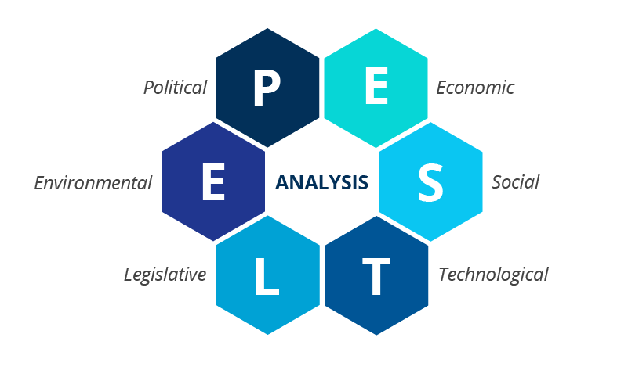
Figure 1: PESTLE Framework for Chanel Analysis (B2B International, 2025)

2.2 Comparative PESTLE Analysis of France and Japan
Political Factors:
Chanel has a favourable political climate in France as well as in Japan. Paris enhances Chanel's country-of-origin image, and France provides stability in the institutions and fosters the luxury industry in France. Political stability is also a strength in Japan, which helps to ensure long-term investment and operational continuity in the form of boutique investment. France, however, has actually more symbolic benefit as the brand is strongly associated with French fashion and luxury heritage (Czinkota, 2023).
Economic Factors:
France is a moderately favourable country, with high-income consumers and a high demand for luxury tourism supporting Chanel. However, demand for affordable products like fragrances and cosmetics could be dampened due to inflation and fiscal pressures, and a weakening of purchasing power (OECD, 2024a). The economy of Japan is also moderately favourable due to the restraint in aspirational luxury buyers' real income growth resulting from inflation and limited wage growth, as well as pressure on real income (OECD, 2024b). The most recent figures bear this out: Both are still big, but under different strain, luxury markets.
Table 1: Comparative Economic Indicators for France and Japan (2024–2025)
Indicator | France | Japan
GDP (2024) | US$3.16 trillion | US$4.03 trillion
Inflation (2025) | 0.9% | 3.2%
Chanel sales (2025) | US$19.3bn globally | US$19.3bn globally
Source: World Bank (2026a; 2026b), INSEE (2026), Statistics Bureau of Japan (2026) and Chanel (2026b).
Social Factors:
Both markets are conducive to the social interest, but for different reasons. Chanel is symbolic of Paris, craftsmanship, authenticity and fashion heritage, which are associated by French consumers (Xi et al., 2022). Precise, discreet messages, exquisite packaging and reliable post-sales service are important to Japanese customers. Chanel should therefore maintain its French identity while at the same time meeting the Japanese customers' needs (The Culture Factor Group, 2026). France: Favourable French consumers closely align with local cultural heritage, Parisian identity, and luxury craftsmanship, which naturally reinforces Chanel’s brand authority and organic market demand. Japan: Favourable High social emphasis on service precision, discreet luxury, elegant presentation, and social status creates a strong cultural alignment with Chanel’s premium positioning, though it requires tailored customer-care and retail experiences.
Cultural Factors:
Hofstede's model suggests that while France is more individualistic and indulgent, Japan is more masculine, uncertainty-avoiding, and long-term oriented; the greater details and comparison are given in Hofstede’s Cultural Dimensions.

3. Cultural Comparison Using Hofstede

Definition of Hofstede’s Cultural Dimensions
The cultural dimensions model by Hofstede assesses the cultures of nations based on many factors, such as power distance, individualism, masculinity, uncertainty avoidance, and long-term orientation. It assists international marketers to be aware of the impact cultural differences might have on consumer behavior, communication, status meanings and service expectations.

Figure 2: Hofstede Cultural-Dimension Comparison of France and Japan
Source: The Culture Factor Group (2026).

France and Japan: Key Cultural Differences
France scores higher on power distance (68–54), individualism (74–62) and indulgence (48–42), whereas Japan scores higher on masculinity (95–43), uncertainty avoidance (92–86) and long-term orientation (100–60).
The model developed by Hofstede might be useful in the case of the comparison of the markets of the developed economies of France and Japan since they have different cultural expectations. The Culture Factor Group is a source of data for comparing countries to determine differences between national cultures (The Culture Factor Group, 2026). France is a moderately individualistic and highly culture-proud country, whereby the importance of luxury consumption is on having their own tastes, style and identity. So, this might be one of the methods to connect Chanel with the French client who seeks to express himself, be stylish and personally sophisticated.
Japan is generally perceived as having a higher level of uncertainty avoidance, long-term orientation and harmony, respect and quality of social expectations. This is what Chanel goes through with its customer experience: it needs to reduce risks and create confidence. Product information, staff knowledge, the store ambiance, and the consistency of service come into play. However, Son, Ko and Lee (2025) state that luxury is perceived differently by prepared and unprepared buyers, and this is why mental accounting affects luxury consumers. As an illustration, in Japan, the service process must allow the customer to justify his/her high-end expenditure on Chanel in value, quality and meaning.
The same applies to the masculinity dimension. The luxury demand can be supported by the success-oriented mentality of Japan; luxury items could be a symbol of success and social status. This does not mean that Chanel can go on a status messaging offensive. A more advanced style can be more suitable for the Japanese audience (Eastman et al., 2018). In his research on the complexity of logos, Zhang (2025) has established that different generations perceive luxury and purchase intention differently when it comes to the visual symbols.

Implications for Chanel’s Marketing
The differences in culture influence the manner in which Chanel markets its products, deals with its services, designs its stores and deals with customers. Chanel can rely on the first-hand mentioning of the name of Paris, its art tradition, and influence in France. In Japan, the same symbols have to be interpreted in a more service-oriented and detail-oriented manner. Such as staff politeness, packaging, appointment systems and boutique atmosphere, luxury can be conveyed as much through these as it can be through advertising (Peishan and Yufei, 2021).
But Hofstede is not meant to be taken out of the box. It is easier to generalize to national culture and could overlook inter-generational, urban, gender and lifestyle differences within countries. Younger Japanese consumers might be more connected with the Internet and more global than older consumers. There is also a possibility that younger consumers in France may demand greater sustainability in their luxury than the older generation. According to this research, Suttharattanagul and Manotungvorapun (2026) found that social influence, brand image, and perceived quality had an impact on the intention of Gen Z to consume sustainably. Therefore, instead of a stereotype, Chanel needs to use Hofstede as a point of departure.

Advantages and Disadvantages of Hofstede’s Model
Hofstede's model offers a uniform way to evaluate France and Japan and a means of predicting the differences in communication, service, and risk perception (The Culture Factor Group, 2026). It can however be over generalising the entire population of a single nation, unable to account for generational and regional differences and view culture as more stable than it actually is. Therefore, it is not a good idea for Chanel to rely on the model as a sole reference point and ignoring the consumer research because not all customers will embrace the national cultural characteristics (McSweeney, 2002).
Technological Factors:
The country is favourable towards technology in both countries. France's digital and retail infrastructure facilitates online communications and appointments, as well as customised clienteling. Japan's state-of-the-art systems also provide private appointments and customised communications. But if the digital exposure and inappropriate use of influencers are too great, Chanel's exclusivity might be compromised, so digital communication should be selective and restricted (Handranata and Kalila, 2025).
Legal Factors:
The legal climate is favourable in France, as are the European consumer-protection, advertising, data-privacy, and intellectual-property laws, which all safeguard consumers and Chanel's brand assets. The other side of the coin is mostly favourable, with Japan also having laws that are mostly compliant with product, advertising and data-protection regulations, which heightens operating costs. Regulation increases customer confidence and helps to safeguard Chanel's brand against counterfeiting and brand misuse in both markets (Zhang et al., 2022).
Environmental Factors:
The environment is moderately favourable in both markets. France urges Chanel to cut down on emissions, improve packaging, and confirm sustainability claims (Chanel, 2026a). In Japan, source reduction is also a requirement of resource efficiency, responsible packaging is a requirement, and reliable environmental communication is a requirement. These requirements will cost the company more, but will help Chanel highlight its emphasis on quality and durability if the company doesn't fall into the trap of greenwashing (Li, Cavender and Lee, 2025).

2.3 Similarities and Differences
Political stability and advanced technology (and legal protection) are available in both countries, but France has more heritage legitimacy, while Japan demands more cultural and service adaptation. Both France and Japan are appealing, but have their own strengths and weaknesses, as suggested by the PESTLE comparison. Japan will give Chanel access to an advanced luxury market, as well as the chance to test to what degree the brand can adapt its service, communication and customer experience to conform to local expectations.
The key argument is: Chanel should not reach 100 percent standardisation. It ought to be the same name but ought to be done differently. In France, Chanel can emphasise the city of Paris, the history of couture and the legacy of Gabrielle Chanel. In Japan, it ought to concentrate on the sophisticated service, attentive packaging, product attention, accuracy and personalised exclusivity. This lends credence to the proposition that brand internationalization should encompass authenticity, as consumers have a better attitude towards brands when they grow internationally without diminishing their meaning (Zhang et al., 2022).

4. Comparative STP Strategy

4.1 Definition of STP
Segmentation is the act of breaking down the market into useful segments; targeting is the act of identifying which segments are the best; positioning is the act of defining the meaning that the brand will have on the market segments that are chosen (Kotler, Keller and Chernev, 2022).
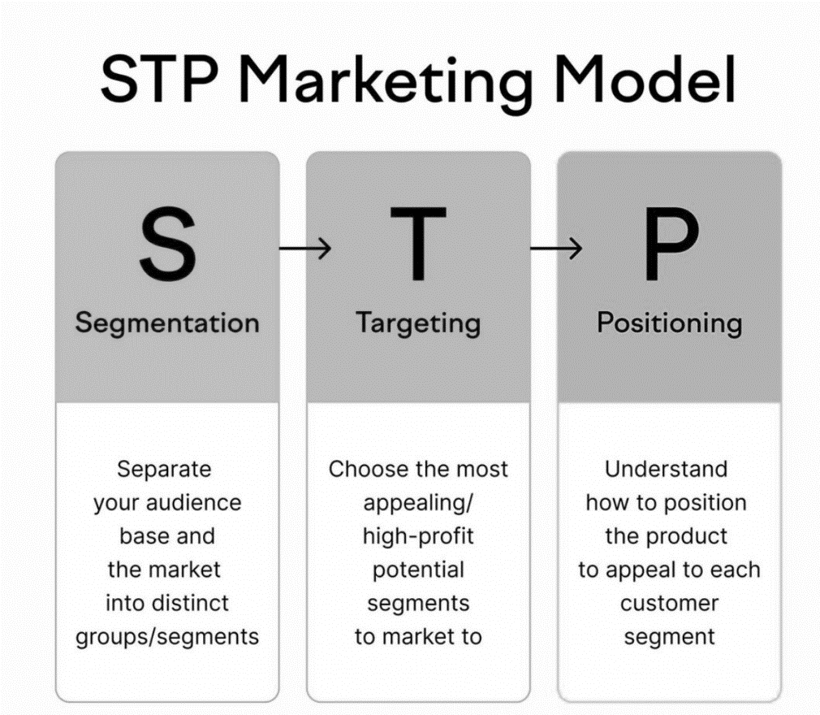
Figure 3: STP Strategy for Chanel in France and Japan (Etrend, 2026)

4.2 Segmentation in France and Japan
Demographic segmentation: Chanel caters for wealthy adults/mature consumers, professionals and high earners, as well as younger aspirational consumers interested in their beauty and fragrances.
Geographic segmentation: Chanel targets its top cities of France and Japan, namely Paris and Tokyo, and its high-end shopping areas.
Psychographic segmentation: It's people who appreciate prestige, identity, craftsmanship and a luxury lifestyle.
Psychographic segmentation: Chanel is mainly aimed at VALS consumers: Achievers who are dedicated to luxury and success, prestige, craftsmanship and self-expression.
Behavioural segmentation: Customers are grouped on the basis of their behaviour; for example, their loyalty level, how often they shop, occasions of shopping and what benefits they look for: quality, status orexclusivity (Kotler, Keller and Chernev, 2022).

4.3 Targeting Strategy
Chanel's targeting continues to be selective. It serves high-end consumers, international visitors, and heritage-savvy consumers in France, who identify with the brand, Paris, couture and authenticity. Japanese market is not a highly competitive market where one is only rich enough to target a market (Hennigs, Wiedmann and Klarmann, 2012). It must strive to appeal to the customer who values sophisticated service, quality control, sustainability and brand loyalty. In Japan, the value of green will promote brand trust, brand attitude and online interaction, and consequently, sustainability is gaining significance in targeting Chanel in Japan (Liu, Kim and Lee, 2025). Chanel is a parallel brand that offers differentiated targeting as it has separate fashion, beauty, fragrance, watch and accessory product lines, paired with concentrated targeting of affluent consumers who are looking for craftsmanship, exclusivity and prestige. Thus, Chanel advocates a segmentation of the product areas, along with a targeting of wealthy luxury shoppers.

4.4 Positioning Strategy
Chanel is a luxury brand, which is associated with timeless fashion, exclusiveness and cultural appeal. Its positioning is based on the French tradition, Gabrielle Chanel's heritage, craftsmanship, femininity and independence, and symbolic brand codes. It shows the luxury principle, which, according to Kapferer and Bastien (2012), is that rareness, distance and controlled desirability play a central role in the premium brand value. The image of Chanel in France is indissolubly connected with its origin and genuineness. It means fine service, cultural status and accuracy of products in the Japanese market. But, with younger consumers becoming more and more transparent and environmentally conscious, Chanel must be timeless, yet not timely (Yang, Su and Shion, 2023).
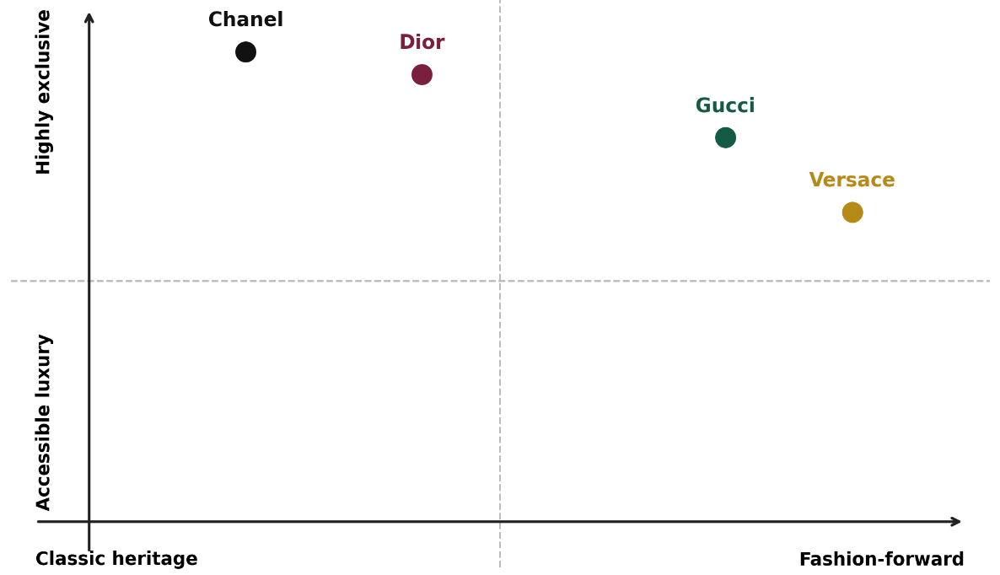
Figure 4: Perceptual Map of Chanel and Major Competitors in France
Source: Author-developed.

4.5 STP Similarities and Differences Between France and Japan
For both countries, Chanel's target customers are affluent, aspirational consumers and Chanel's positioning is based on quality, craftsmanship and exclusivity. Its Japanese execution de-emphasises the couture legitimacy and Parisian heritage, though, in favor of purchasing risk minimisation, personalised service, and discreet luxury, while its French STP highlights the former more.

5. Comparative International Marketing Mix: 7Ps

5.1 Definition of the 7Ps
Product, Price, Place, Promotion, People, Process and Physical Evidence are the 7Ps of the marketing mix. It's helpful for service and luxury brands, as it takes into account the customer experience of a brand as well as what is being sold. This long mix is particularly suitable in the context of luxury services (Kotler, Keller and Chernev, 2022).
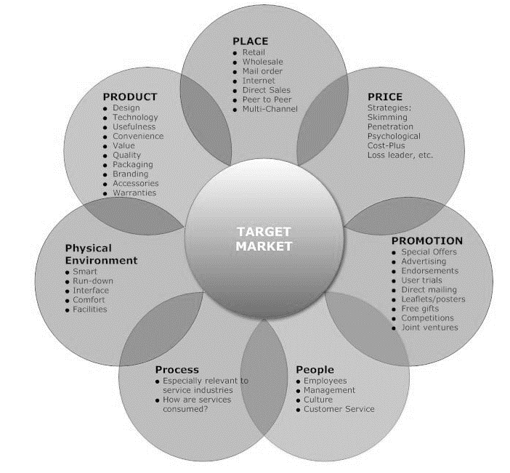
Figure 5: Marketing Mix 7Ps Framework for Chanel (ExportPlanning, 2021)

5.2 Product
Classic Flap bag sizes, materials, N°5 fragrance concentrations, lipstick shades, and seasonal colour variations are covered in product depth. Both markets are based on craftsmanship and controlled availability, which are complemented by recognisable brand codes within the design of the products. Product depth is created with size variations, material options, colours, seasonal variations, fragrance strength and beauty products. The product width is applicable to haute couture, ready-to-wear, leather goods, footwear, fragrance, beauty, watches, and jewellery. France should focus on couture origins and Parisian heritage, whereas Japan should have the same global lines with enhanced product explanation, presentation and after-sales service reliability. This regulated width makes it possible to meet different demands for luxury while maintaining the rareness and symbolism of the object (Kapferer and Bastien, 2012).
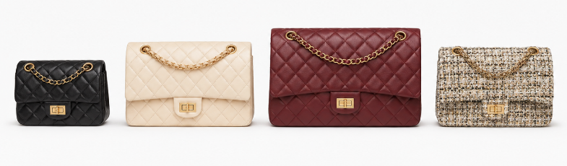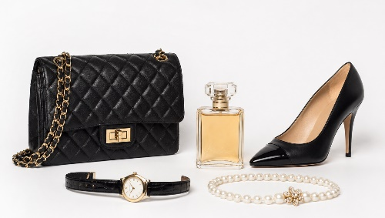
Figure 6: Examples of Chanel’s Product Depth and Product Width
Source: Chanel official website (2026).

5.3 Price
Chanel's premium pricing strategy tells people that they are rare, made by hand and that they are good and prestigious. Price is therefore not just a reflection of the manufacturing costs but also a reflection of the brand values. Differences between France and Japan may be caused by these macro factors such as exchange rate, inflation, taxation rates and import rules, as well as these micro factors such as distribution expenses, boutique expenses, demand, local purchasing power, and competition. Additional costs for importing, distribution and premium location may be added to Japanese prices. But Chanel will need to get these prices synonymous with quality and emotional value, as mental accounting shapes consumers' rationale for spending on luxury (Son, Ko and Lee, 2025).

5.4 Place
Selective distribution with directly controlled boutiques, beauty counters and precise luxury stores is used by Chanel. In France, the Parisian boutiques instill the brand's historical legitimacy. In Japan, premium real estate in large urban centers like Tokyo is available for visibility by the top consumption level. Restricted distribution helps to guarantee scarcity, ensure quality and price uniformity and minimise risk of dilution. The figure 7 illustrates the flow of products from producers to final consumers through direct and indirect channels (OpenStax, 2023).
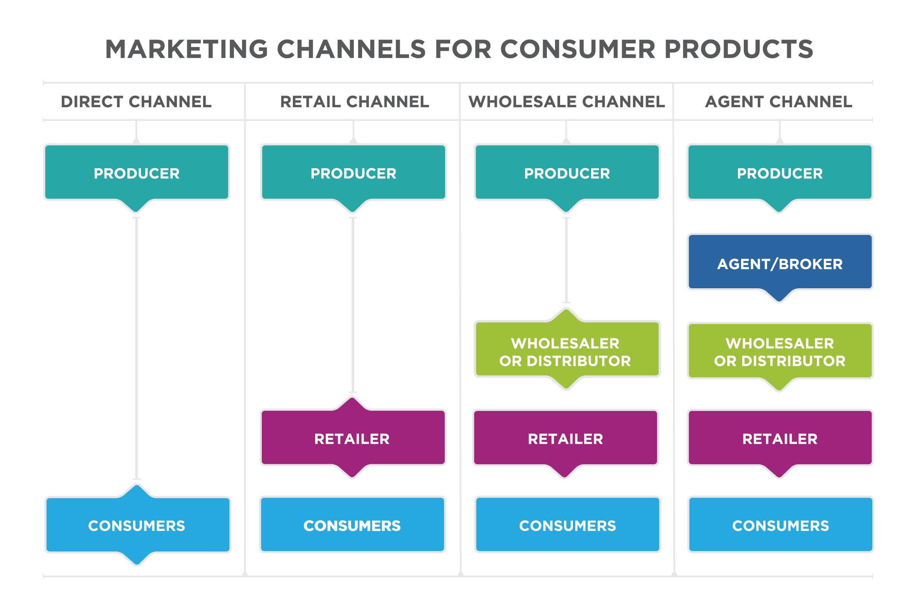
Figure 7: Direct and Indirect Distribution Channels Relevant to Chanel
Source: Adapted from OpenStax (2023).
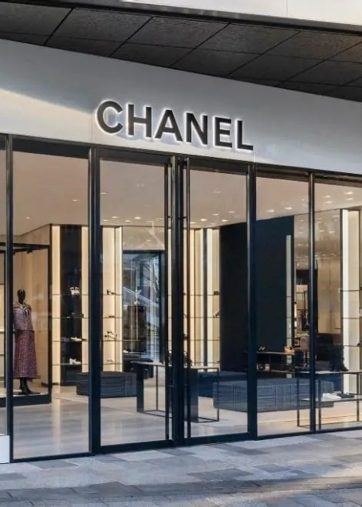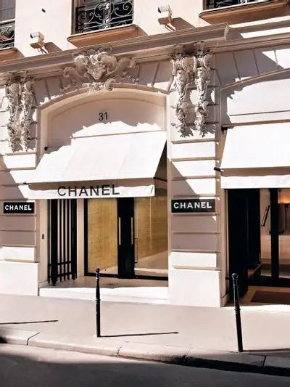
Figure 8: Chanel boutique in Paris and Chanel boutique in Tokyo
Source: Chanel official website (2026).

5.5 Promotion
The concept of integrated marketing communications (IMC) involves the synchronisation of paid, owned and interpersonal messages to ensure that every marketing contact delivers the same brand message (Kotler, Keller and Chernev, 2022).
French promotion can be the emphasis on Paris, on couture, on the legacy of Gabrielle Chanel, but Japanese communication must be refined in visual, cultural and service aspects. Excessive exposure can compromise Chanel's exclusivity, which they can leverage through fashion shows, private events, digital storytelling, and selected influencers. The selection of influencer parameters, such as credibility and brand fit, has a significant impact on purchase behaviour as well (Handranata and Kalila, 2025).

5.6 People
Staff members directly impact the luxury experience. The French adviser requires extensive knowledge of French heritage and fashion, and the Japanese adviser extensive knowledge of products, plus precision, politeness and detailed follow-up. Chanel said it employed 37,984 people globally at the end of 2025, but did not reveal the workforce size in France and Japan separately, making that also a poor guide to the number of employees (Chanel, 2026b). The critical strategic challenge is the same training to meet local expectations in services.

5.7 Process
Chanel's process includes the booking of appointments, consultations, payment, packaging, delivery, repair and follow-up. Customers in France can contact the company via telephone, email, WhatsApp or via a customer service form regarding the products, boutique, online orders or after-sales (Chanel, 2026c). Complaints in Japan are made via the local customer-care centre or the Chanel website online contact form and then referred to the relevant service team or boutique (Chanel, 2026d). The two systems can facilitate accountability, but in particular, it is necessary to clearly acknowledge and follow up on Japan's process.

5.8 Physical Evidence
Quality is physicalised through boutique architecture, lighting, displays, packaging, the double-C logo, and staff appearance. Design should be historical in France, and refined, orderly and sensitive to culture in Japan. The Chanel logo must be present without being overpowering, as logo design can impact luxury perception (Zhang, 2025).
Within these two stable, prosperous and technologically developed rich markets, French and Japanese buyers appreciate quality, craftsmanship and exclusivity. Chanel, however, is more legitimate under the "French" umbrella by its Parisians genealogy and fashion culture, while the "Japanese" side is more legitimate in the area of service precision, packaging, discreet communication and after sales care. While both markets have strong legal and sustainability requirements, their localisation needs are higher in Japan than in France, and positioning/communication in favour of heritage is more supported in France than in Japan.

5.9 Critical Evaluation
Table 2: Similarities and Differences in Chanel’s 7Ps in France and Japan
7Ps area | Similarities | Differences
Product and Price | Both markets use premium products, craftsmanship and prestige pricing. | France stresses couture heritage; Japan requires detailed presentation and value reassurance.
Place and Promotion | Both use selective distribution and controlled luxury communication. | France emphasises Parisian identity; Japan uses discreet, culturally adapted communication.
People and Process | Both require trained staff and exclusive customer service. | Japan requires greater precision, politeness, follow-up and service consistency.
Physical Evidence | Both use luxury boutiques, packaging and Chanel’s visual identity. | French design highlights heritage; Japanese design prioritises order, refinement and cultural sensitivity.
Source: Author-developed from the comparative 7Ps analysis.
Chanel's 7Ps are effective in ensuring protection of exclusivity, consistency and customer experience. But still, by maintaining high prices and limited access, they may lose the younger aspirational buyers. Sustainability communication also poses the risk of greenwashing; environmental claims should not just be presented as pictures or images, but as verifiable evidence (Li, Cavender and Lee, 2025).

6. Market Entry Strategy in Japan

6.1 Definition of Market Entry Strategy
Market entry strategy refers to a way in which a firm enters and operates in another market. It is possible to be in the business in a number of ways, such as exportation, licensing, franchising, joint ventures and direct investment, some of which involve more risk, control and resources than others.

6.2 Chanel’s Entry and Presence in Japan
Control luxury entry approach is the crux of Chanel's Japan strategy. Chanel's market presence is not dictated by mass distribution, but rather through boutiques, beauty distribution and by local control of organizations. Until about 1980, Chanel K.K. is typically associated with Chanel's direct Japanese presence. While the official Chanel references here do not specify exactly when the brand started to reach Japan, there is no doubt about the brand's presence in the country.
The access walkway is in the luxury logic of Chanel. For luxury brands, it's essential that they have control over the price, place, attitude of the personnel, process of service and availability of the product. Uncontrolled distribution may cause a loss of rarity and raise the grey market risk for Chanel. The local demand, coordination, market and market control across the borders (Czinkota, 2023) should be considered in international marketing decisions. It is therefore a regionalization vs brand protection spectacle, which is the Japanese version of Chanel.

6.3 Critical Evaluation of Entry Strategy
Chanel's high-control entry into Japan is its uniformity, its primary virtue. It can enable Chanel to safeguard brand codes, educate employees, oversee customer experience and keep up high prices. It also provides Chanel with the chance to learn from the Japanese customers who are also demanding and detail-oriented. The learning in this can improve the delivery of services globally (Peishan and Yufei, 2021).
This plan also has its flaws, however. Direct control is costly. High resources are needed for boutique investment, staff training, premium location and local compliance. It can also slow down expansion as Chanel may not be able to expand as quickly as retail network brands. With the Baby Boomer generation starting to take its turn to be a mature consumer and the economy remaining fragile, long-term growth may be limited if they are not feeling like it's their brand.
Table 3: Advantages and Disadvantages of a Wholly Owned Subsidiary
Advantages | Disadvantages
Full control over pricing, distribution, staff training and brand image. | Requires high investment in boutiques, employees and local operations.
Protects Chanel’s exclusivity and service standards. | Chanel carries the full financial and operational risk.
Allows direct customer knowledge and faster service improvement. | Expansion may be slower than licensing or franchising.
Reduces dependence on external partners. | Local market mistakes can be costly.
Source: Author-developed from the market-entry analysis.

7. Ethical Issues in Chanel’s Marketing Mix

7.1 Definition of Ethical Marketing
Ethical marketing is honest about value and takes into account the consequences of marketing to the consumer, society and environment. Ethical examples for Chanel include repairs that extend the life of a product and supported packaging or emissions claims. Unethical examples consist of ‘green' promotion for which there's no evidence and messages from influencers and scarcity that take advantage of status anxiety instead of informing consumers.

7.2 Ethical marketing
The mission of Chanel is that they produce products that last and are created, not thrown away. This helps to differentiate the brand from fast fashion, with short product cycles and greater waste. Setting a sustainability ambition is also a measure of Chanel's climate responsibility and the imperative for a Just Transition (Chanel, 2026a). Responsible consumption attitudes are what make luxury consumption important, while trust and perceived value can have a significant impact on purchase intention (Zhao, Peng and Yu, 2023).

7.3 Unethical marketing
Ethical questions are also a concern for Chanel. Luxury marketing can create symbolic overconsumption when the buying process isn't because of a need but to meet status expectations, and status anxiety can drive purchasing. The strategy is generally correlated with the aspiration to identity, and therefore has a high commercial value but a low ethical value. It is a potent strategy that has both commercial and ethical implications and is related to identity aspiration (Xi et al., 2022). Another area of greenwashing risk is in sustainability claims, as consumers are more likely to notice low-quality environmental claims on social media (Li, Cavender and Lee, 2025). Chanel needs to present quantifiable proof, therefore. Unethical 7Ps examples include artificial scarcity of the product or place (Place) and unsupported green claims in the promotion (Promotion).

7.4 Critical Judgement
But luxury brand Chanel does not imply unethical. It is made to last, well-produced, and can be a more sustainable option than disposable clothing. But it needs to be transparent, with measurable steps toward sustainability and responsible communication, to be ethically credible. To be effective, sustainable fashion marketing cannot be limited to the "image-making" process, but it needs to reach the realm of actual change (Ray and Nayak, 2023). Therefore, Chanel must consider ethical aspects in sourcing, repairing, packaging, distribution and education for the customer.

8. Recommendations and Conclusion

8.1 Recommendations
France
Chanel must strengthen its Parisian heritage and couture-making and certain private occasions, and showcase concrete product-level sustainability evidence. The usage of influencers is limited to where credibility and brand fit protect exclusivity (Handranata and Kalila, 2025).
Japan
The key points for Chanel are to focus on private digital clienteling, exact service, elegant designs, cultural fit language and dependable after-sales support. Don't use mass discounting, or give kids too much exposure on the internet.
Sustainability should be communicated openly and transparently by Chanel with evidence, measurable targets, and product-level explanations. In contrast to presenting sustainability as image-building, this would increase the perceived value, trust and engagement from accountability (Liu, Kim and Lee, 2025). Although discounts and overexposure should be avoided, digital clienteling should be private appointments, customised previews, and follow-up and selective storytelling in Japan. Chanel should highlight the 'Parisian heritage' and the 'Gabrielle Chanel's legacy' in France, and ‘precision, respect, packaging, craftsmanship and quiet luxury’ in Japan (Wu, 2022). The selection of influencers should be done based on their credibility, cultural fit and brand discipline to maintain the prestige and influence their purchase behaviour (Handranata and Kalila, 2025).

Section 2: Reflection Using Gibbs’ Reflective Cycle
Gibbs' Reflective Cycle is a method of reflection that consists of six phases: description, feelings, evaluation, analysis, conclusion and action planning (Gibbs, 1988). I used it to refresh my memories of research, analysis and preparation of the comparative report on Chanel France and Japan.
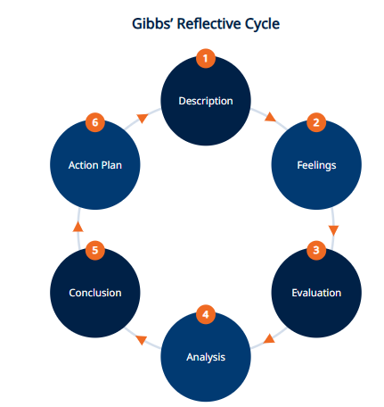
Figure 9: Gibbs’ Reflective Cycle (Gibbs, 1988)

2.1 Description
Comparing the international marketing in the country where Chanel was based (France) and the country where Chanel was “unhosted” (Japan) was a task I was asked to undertake. Utilised PESTLE and Hofstede's cultural dimensions, analysed segmentation, targeting, positioning and the 7Ps, and analysed 'How' and 'Who' Chanel entered and what were the ethical issues involved with their entry? I also came up with recommendations on sustainability, digital clienteling, localisation and controlled circularity.

2.2 Feelings
But the comparison made me all the more aware. As the Japanese found out, local differences are not eliminated by global recognition, as they had their expectations of precision, discreet communication, packaging, politeness and after-sales service. I was also a bit reluctant to use Hofstede due to the possibility of forming stereotypes in the process. This led me to wonder if I was being critical of the consumer or just dumping some general characteristics of the nation. As the work proceeded, I grew more confident as I realised that I used Hofstede as a first approximation, and not as absolute evidence.

2.3 Evaluation
PESTLE assisted me to arrange political, economic, social, technological, legal and environmental evidence, and evaluate whether all were positive and/or negative for Chanel. Hofstede found that he could compare UI, ID, and LTO. STP explained the differentiation strategy which Chanel will use in the fashion, beauty, perfume, watches and accessories business segments and explained why the company will focus on affluent consumers. The 7Ps then introduced the outgrowth of the environmental and cultural information into the decisions on product presentation, premium price, selective distribution, communication, employee behaviour, service processes and physical evidence.
A second limitation of my study was my reliance on general statements on French and Japanese consumers. National culture models may be generalising rather than specific to populations and fail to account for differences within countries (McSweeney, 2002). This critique also clearly illustrated the need for market and consumer evidence to support cultural frameworks.

2.4 Analysis
A key learning was the importance of international luxury marketing being standardised and adapted. Chanel should standardise its name, logo, craftsmanship, positioning of the brand as exclusive and the positioning of the brand with regard to its heritage. Standardise the name, the logo, the craftsmanship, the positioning of Chanel as exclusive, the positioning of Chanel in terms of heritage these create authenticity and recognition (Kapferer and Bastien, 2012). But delivery of that identity should be adapted, however. As Chanel celebrates Parisian origins, couture history, and artistic heritage, it can highlight all these attributes in France. It should be able to deliver information about the product, packaging, exact service, communication and after-sales support in Japan. It highlights the importance of balancing brand consistency with local market responsiveness (Czinkota, 2023).
I also found that the frameworks start to be more useful when they are put together. PESTLE is the identification of external opportunities and threats, and Hofstede is a cultural interpretation. Customers and positioning desired are identified through STP, and then these findings are translated into action through the 7Ps. No positioning is absolute, as the perceptual map displays.
The ethical look at luxury has altered my conception of luxury. Before, I made a correlation of durability and sustainability. Now I have a better understanding that longevity for products is a good thing but cannot solve problems with sourcing, emissions, packaging, over-consumption and greenwashing. The company Chanel, therefore, requires measurable evidence and not claims based on pictures when it comes to sustainability claims (Li, Cavender and Lee, 2025). However, interpretation instead of description is also considered crucial in effective reflection (Sow, Rasiah and Er, 2024).

2.5 Conclusion
I got to know that international marketing should not be made only on the strength of the brand or national averages. The most successful thing I did was to combine PESTLE, Hofstede, STP and the 7Ps to account for consistency in the global environment and adaptation in the local environment. Another factor I discovered while learning about Chanel is that it is very important to them to have a high entry point, which is, of course, an expensive factor, but also, they need local knowledge to ensure exclusivity with the service.

2.6 Action Plan
My next step will be to develop a comparison matrix that identifies the similarities, differences, opportunities and threats as well as strategic implications. I will use culture-based models and not country scores of consumers, industry and/or organisation as universal behaviour. I will be able to distinguish between descriptive and evaluative statements with respect to what they imply for targeting, positioning and marketing mix. I will validate Environmental claims by quantifiable evidence and be able to separate macroeconomic factors affecting pricing from company cost. Lastly, in academic writing, I will not make unsupported generalisations and every suggestion will be a logical consequence of the analysis.

References
B2B International (2025). PESTLE Analysis: A Guide to Understanding Market Influences. [online] B2B International. Available at: https://www.b2binternational.com/2025/04/03/pestle-analysis/ [Accessed 9 July 2026].
Chanel (2026a) Chanel’s sustainability ambition. Available at: https://www.chanel.com/za/sustainability/ (Accessed: 27 June 2026).
Chanel (2026b) Financial results. Available at: https://www.chanel.com/my/financial-results/ (Accessed: 27 June 2026).
Chanel (2026c) 'Service client: France'. Available at: https://www.chanel.com/fr/contact/ (Accessed: 1 August 2026).
Chanel (2026d) 'Contact form: Japan'. Available at: https://www.chanel.com/jp/contact-us/ (Accessed: 1 August 2026).
Chanel (2026e) Gabrielle Chanel, the founder of CHANEL. Available at: https://www.chanel.com/us/about-chanel/gabrielle-chanel/ (Accessed: 27 June 2026).
Czinkota, M.R. (2023) International Marketing. 11th edn. S.L.: Cengage Learning.
Eastman, J.K., Iyer, R., Shepherd, C.D., Heugel, A. and Faulk, D. (2018) ‘Do they shop to stand out or fit in? The luxury fashion purchase intentions of young adults’, Psychology & Marketing, 35(3), pp. 220–236. doi: https://doi.org/10.1002/mar.21082.
Etrend (2026). Scaling Growth in E-Commerce with the STP Marketing Model . [online] Available at: https://etrend.com/scaling-growth-in-e-commerce-with-the-stp-marketing-model/ [Accessed 9 July 2026].
ExportPlanning (2021). From 4Ps to 7Ps: Towards an Integrated Marketing Mix. [online] ExportPlanning. Available at: https://www.exportplanning.com/en/magazine/article/2021/03/03/from-4ps-to-7ps-towards-an-integrated-marketing-mix/ [Accessed 9 July 2026].
Gibbs, G. (1988) Learning by Doing: A Guide to Teaching and Learning Methods. Oxford: Further Education Unit.
Handranata, Y.W. and Kalila, S. (2025) ‘Attitude toward fashion influencers and its impact on purchase behavior: the roles of brand attitude and purchase intention’, Frontiers in Communication, 10. doi: https://doi.org/10.3389/fcomm.2025.1583602.
Hennigs, N., Wiedmann, K.-P. and Klarmann, C. (2012). Consumer Value Perception of Luxury Goods: A Cross-Cultural and Cross-Industry Comparison. Luxury Marketing, [online] pp.77–99. doi:10.1007/978-3-8349-4399-6_5.
INSEE (2026) Further slowdown in annual average consumer prices in 2025. Available at: https://www.insee.fr/en/statistiques/8726604 (Accessed: 6 August 2026).
Kapferer, J.-N. and Bastien, V. (2012) The Luxury Strategy: Break the Rules of Marketing to Build Luxury Brands. 2nd edn. London: Kogan Page.
Kotler, P., Keller, K.L. and Chernev, A. (2022) Marketing Management. 16th edn. Harlow: Pearson.
Li, M., Cavender, R. and Lee, M.-Y. (2025) ‘Consumer awareness of fashion greenwashing: insights from social media discussions’, Sustainability, 17(7), p. 2982. doi: https://doi.org/10.3390/su17072982.
Liu, X., Kim, T.-H. and Lee, M.-J. (2025) ‘The impact of green perceived value through green new products on purchase intention: brand attitudes, brand trust, and digital customer engagement’, Sustainability, 17(9), p. 4106. doi: https://doi.org/10.3390/su17094106.
McSweeney, B. (2002) ‘Hofstede’s model of national cultural differences and their consequences: a triumph of faith—a failure of analysis’, Human Relations, 55(1), pp. 89–118. doi: https://doi.org/10.1177/0018726702551004.
OECD (2024a) OECD Economic Surveys: France 2024. Available at: https://www.oecd.org/en/publications/2024/07/oecd-economic-surveys-france-2024_ea032499.html (Accessed: 27 June 2026).
OECD (2024b) OECD Economic Surveys: Japan 2024. Available at: https://www.oecd.org/en/publications/2024/01/oecd-economic-surveys-japan-2024_9289b572.html (Accessed: 27 June 2026).
OpenStax (2023) ‘Types of marketing channels’, Principles of Marketing. Available at: https://openstax.org/books/principles-marketing/pages/17-2-types-of-marketing-channels (Accessed: 6 August 2026).
Peishan, S. and Yufei, W. (2021). Luxury Brands Culture and Marketing: How Does Chanel Stay popular. [online] Www.atlantis-press.com. doi:10.2991/assehr.k.211209.234.
Ray, S. and Nayak, L. (2023) ‘Marketing sustainable fashion: trends and future directions’, Sustainability, 15(7). doi: https://doi.org/10.3390/su15076202.
Son, D.H., Ko, D. and Lee, J.-Y. (2025) ‘The effect of mental accounting in the luxury market: prepared and unprepared consumers’, Frontiers in Psychology, 16. doi: https://doi.org/10.3389/fpsyg.2025.1554350.
Sow, C.-F., Rasiah, S. and Er, H.M. (2024). A critical Exploration of Theoretical Frameworks for Reflective Learning: Reflections from a Faculty Development Workshop. Medical Science Educator, [online] 35(1). doi:10.1007/s40670-024-02173-y.
Statistics Bureau of Japan (2026) Consumer Price Index Japan: 2025 yearly average. Available at: https://www.stat.go.jp/english/data/cpi/158c.htm (Accessed: 6 August 2026).
Suttharattanagul, S.L. and Manotungvorapun, N. (2026) ‘Driving sustainable consumption: how social influence, brand image, and perceived quality shape Thai Gen Z’s purchase intentions’, Frontiers in Sustainability, 6. doi: https://doi.org/10.3389/frsus.2025.1716245.
The Culture Factor Group (2026) Country comparison tool. Available at: https://www.theculturefactor.com/country-comparison-tool (Accessed: 27 June 2026).
World Bank (2026a) France: data. Available at: https://data.worldbank.org/country/FR (Accessed: 6 August 2026).
World Bank (2026b) Japan: data. Available at: https://data.worldbank.org/country/japan (Accessed: 6 August 2026).
Wu, Z. (2022) ‘Crafting inconspicuous luxury brands through brand authenticity in China’, Frontiers in Psychology, 13. doi: https://doi.org/10.3389/fpsyg.2022.826890.
Xi, X., Yang, J., Jiao, K., Wang, S. and Lu, T. (2022) ‘“We buy what we wanna be”: understanding the effect of brand identity driven by consumer perceived value in the luxury sector’, Frontiers in Psychology, 13, pp. 1–15. doi: https://doi.org/10.3389/fpsyg.2022.1002275.
Yang, H., Su, X. and Shion, K. (2023) ‘Sustainable luxury purchase behavior in the post-pandemic era: a grounded theory study in China’, Frontiers in Psychology, 14. doi: https://doi.org/10.3389/fpsyg.2023.1260537.
Zhang, S., Fang, Y., Zhang, Y. and Zhang, S. (2022) ‘The effect of brand internationalization strategy on domestic consumers’ purchase intention: configuration analysis based on brand authenticity perspective’, Frontiers in Psychology, 13. doi: https://doi.org/10.3389/fpsyg.2022.891974.
Zhang, Y. (2025) ‘Generational perspectives on logo complexity: influencing luxury perception and purchase intention’, Frontiers in Communication, 10. doi: https://doi.org/10.3389/fcomm.2025.1475326.
Zhao, L., Peng, J. and Yu, S. (2023) ‘Sustainable luxury and consumer purchase intention: a systematic literature review’, SAGE Open, 13(4). doi: https://doi.org/10.1177/21582440231216285.

