

BMIH6007
International Meetings Management for the Hotel Industry
Assignment 1: Feasibility Plan for an International Meeting
Event Theme: Winter Event -- Christmas

Lecturer; Kathryn Flynn
Name: Nasima Akter
ID: 2210268

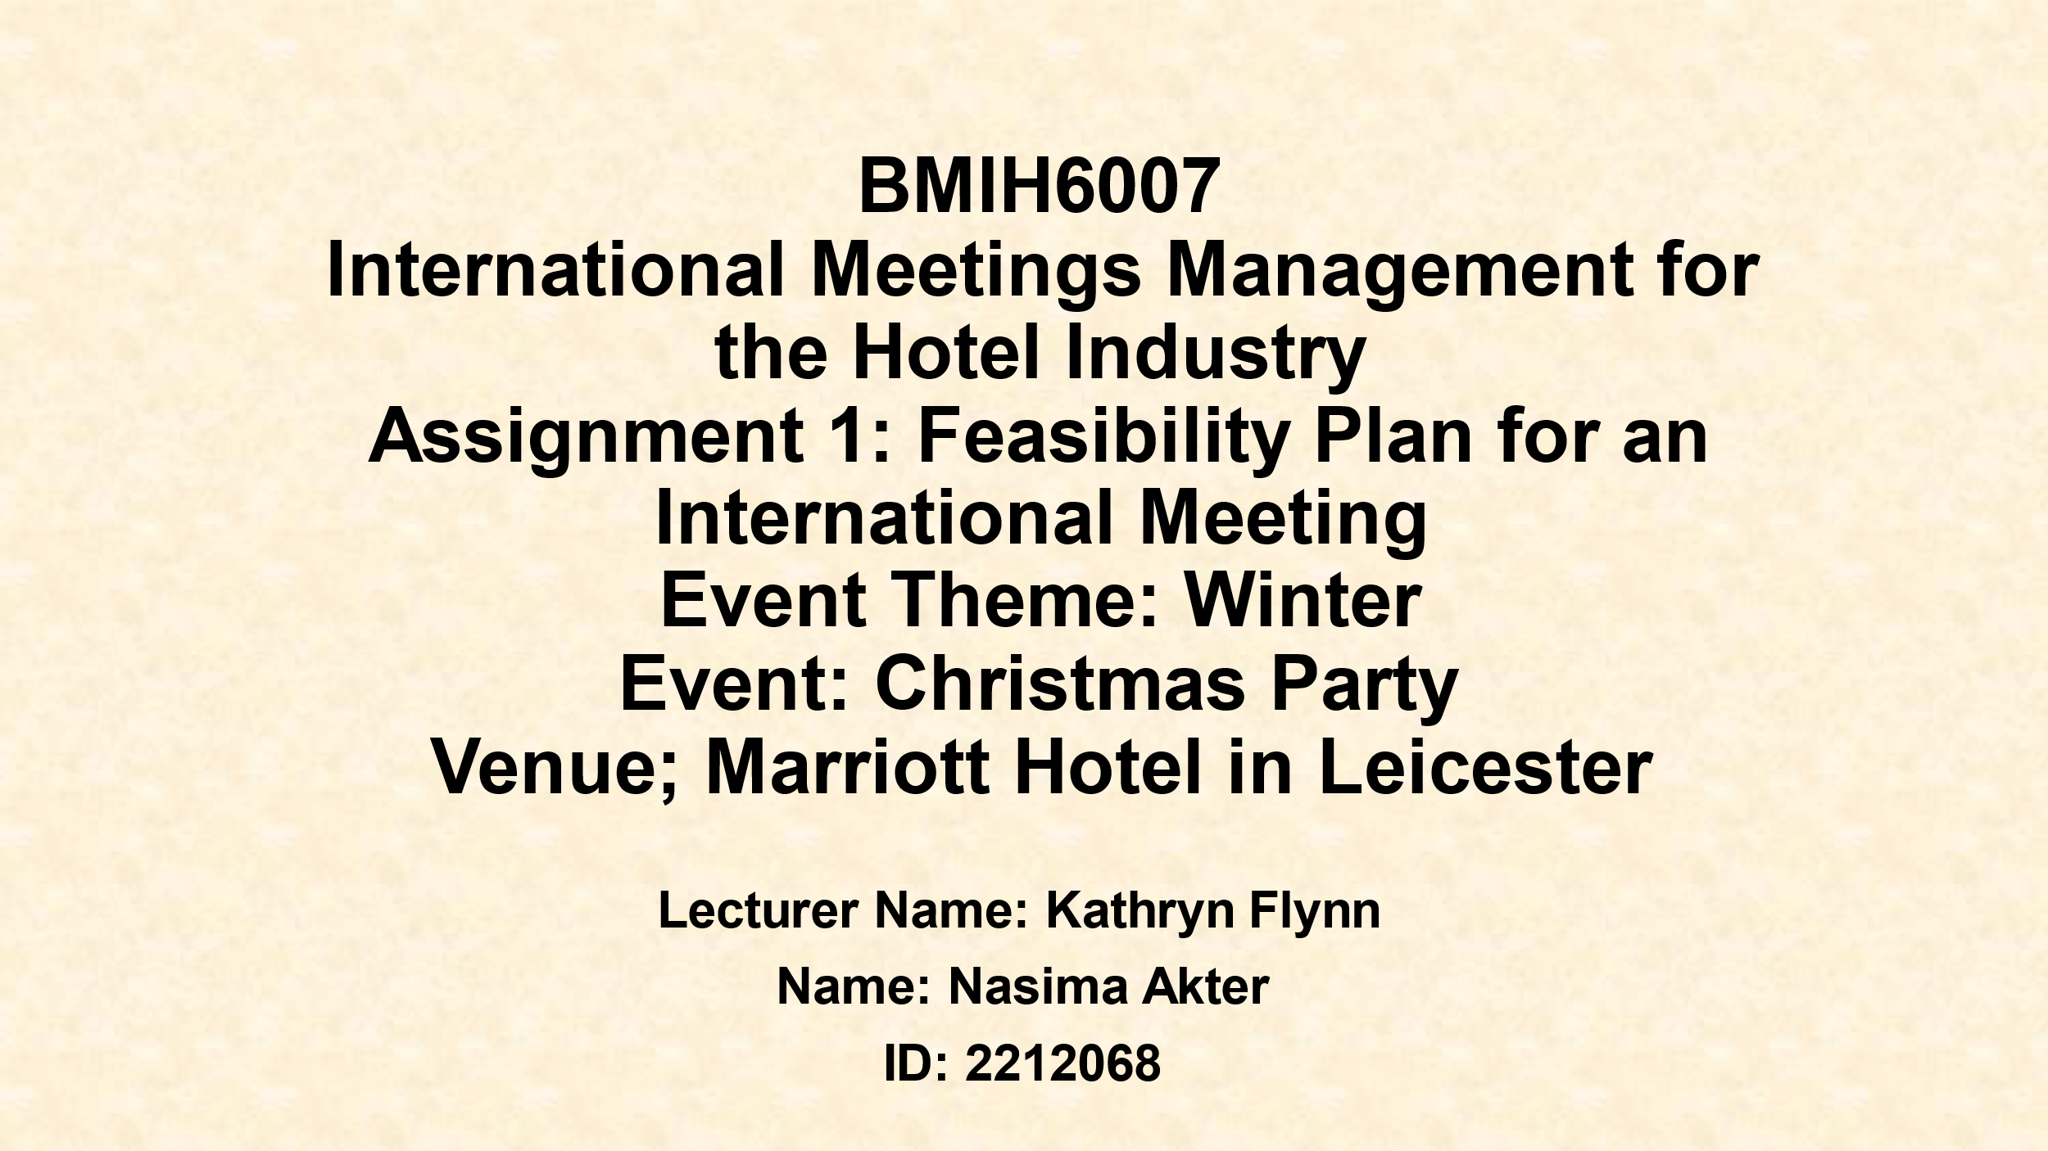
Good morning, My Name is Nasima Akter, and, in this presentation, I will be explaining the feasibility plan for the International Christmas winter event held at the Marriot Hotel in Leicester this year.
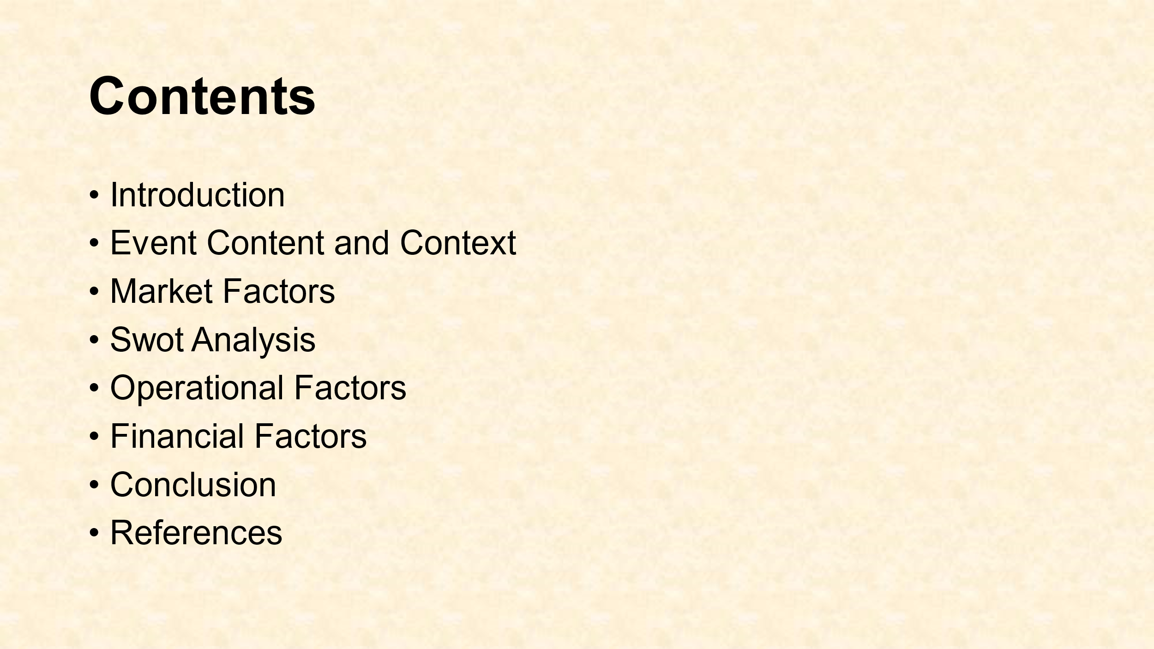
Here are my table of contents.

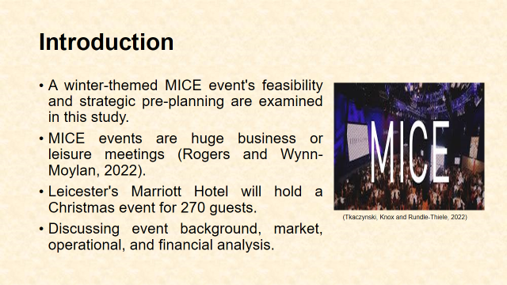
We all know how famous this big hotel is. So there no need for much explanation. This study critiques the feasibility and strategic pre-planning for a Marriott Hotel Leicester, UK, winter-themed Christmas event. Leisure-focused MICE events. Successful MICE events involve extensive organisation, resources, and logistics (Getz and Page, 2019). They entertain and serve corporate and recreational audiences. The winter Christmas celebration will host 270 leisure guests. For a strategic and memorable event, study will address commercial, operational, and financial sustainability.
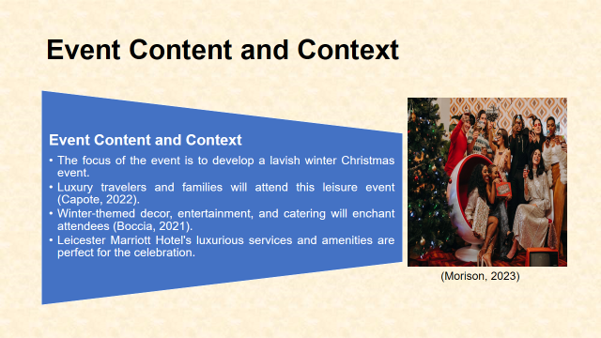
The event will have festive decor, entertainment, and delicious food. Luxury and traditional Christmas events will be combined. A gorgeous Christmas tree, lighting, live music, and winter-themed gourmet meals are included (Francis et al., 2021). The Marriott Hotel's world-class services and attention to detail make it ideal for this type of event. The Christmas celebration allows guests relax and revel in style. The event attracts families, couples, and individuals seeking a refined holiday celebration. Old Christmas rituals are merged with modern luxury to give guests a unique Christmas experience with entertainment, great cuisine, and leisure (Williams et al., 2023). Decor, entertainment, and food will reflect the winter theme, making the gathering appealing.
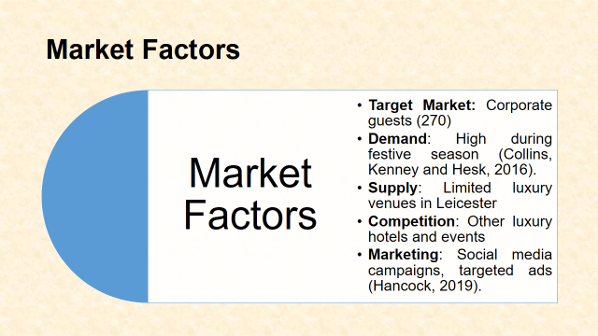
Now, focussing on the market factors, we need to look at the leisure market, especially during vacations, offers many such activities. This Christmas event targets families and individuals who want a more luxurious vacation. Elite leisure events attract wealthy and privileged people. Leicester's high-end holiday industry is strong despite fewer premium events than other UK locations (Mainolfi and Marino, 2018). Premium venue quality boosts event appeal at the Marriott Hotel. UK families desire traditional Christmas festivities, thus winter activities are popular. The projected Christmas celebration includes Christmas trees, carol singers, gourmet food, and professional entertainment to meet demand. Visitors seeking more than holiday parties enjoy the VIP experience (Parkin, 2020). Several premium hotels and Christmas-themed venues would compete. The Leicester Marriott Hotel's beautiful accommodations, convenient location, and excellent service set it apart. This event has an advantage over smaller or less notable venues due to its hospitality reputation. Despite surrounding activities, the Marriott Hotel's beauty, joy, and unique features make this event stand out.
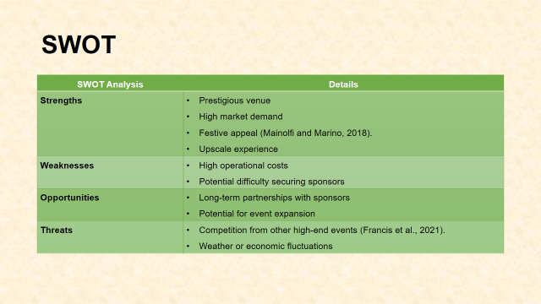
Marriott Hotel's winter-themed Christmas party has positives, cons, and risks. Premium facilities, prestige, and holiday event demand are Marriott Hotel strengths. Its elegant and joyful atmosphere attracts people. Catering, entertainment, and venue hire are expensive. Competitive holiday events make sponsorship tough. Long-term business sponsorships may boost event growth (Francis et al., 2021). Sponsorships boost brand awareness and event offers. Competition from other upscale Christmas venues is a problem. Weather and economic downturns may reduce attendance, hurting event finances.

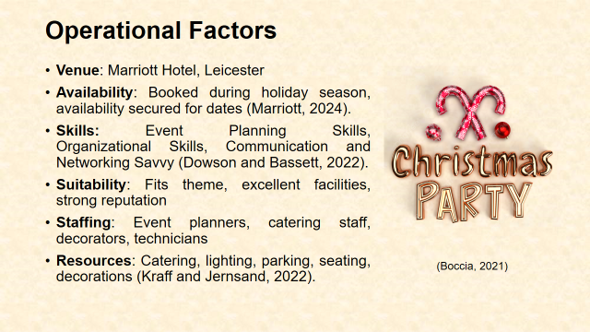
The Leicester Marriott Hotel can host huge winter events. The hotel's central location, excellent service, and event management make it ideal for Christmas. Due to early venue availability, the event will take place over the busiest holidays. Our ballroom and event facilities include plenty of space for dining, entertainment, and socialising and can accommodate any needs for this type of occasion (Khakee, 2019). Marriott Hotel has space, ambiance, and services for luxury leisure occasions. Event management at the hotel will help planners ensure a successful Christmas celebration. Its skilled staff handles large events. Hotel management, food, décor, lighting, entertainment, and guests are event stakeholders (Chinta, 2023). Event success involves clear communication and collaboration between these parties. The event require event planners, caterers, sound and lighting technicians, and guest service people. Management, food, entertainment, and guest relations are needed for event hosting (Smith, 2020). High-quality catering, smooth lighting and sound, and comfortable seating will be prioritised. More parking and services ensure guest delight.
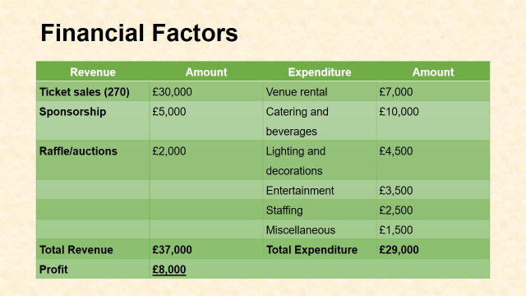
Christmas party planning requires financial feasibility and a £29,000 budget. Tickets, sponsorships, raffles, and auctions will fundraise. 270 travellers will pay £30,000 for tickets, covering most expenditures. Local and national companies promoting at high-end Christmas events will sponsor expenses (Bringas and Toudert, 2023). Sponsorships should generate £5,000.
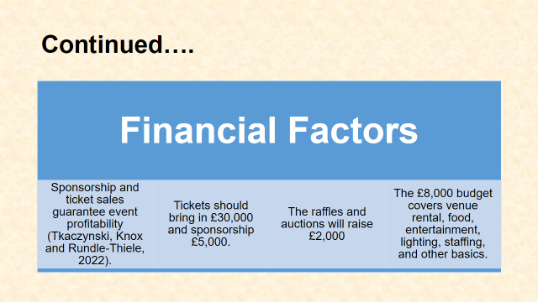
Budget and Revenue determine event profitability. The venue, food, entertainment, and décor budgets will be strict (Gasparoni, 2020). Food and drinks cost £10000, lights and decorations £4,500, and entertainment £3,500. Venue rent is £7,000. Staffing costs £2,500, marketing and administrative £1,500. Quality and attendance are guaranteed by the £29,000 event budget. It should earn £8,000 profit without losses.
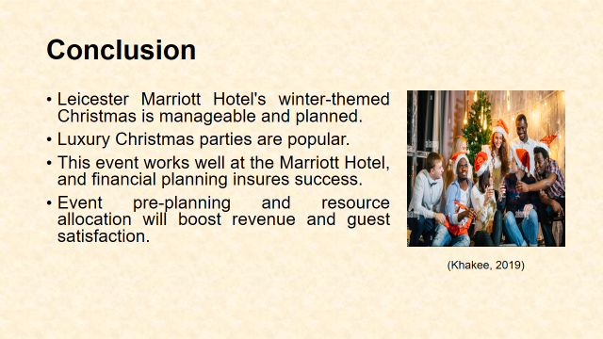
So, this winter themed Marriott Hotel Christmas party experience should let guests commemorate expertly and festively. It should work effortlessly according to the plan. The event can succeed in a live market by targeting corporate client and utilizing the venue’s strategic scene and assets.
The financial predictions specify the occasion will be lucrative, and site and resource allocation have been extensively investigated to ensure smooth performance.
Leicester Marriott Hotel's winter Christmas party will execute perfectly because of its strategy. A distinguished setting and significant demand for premium holiday parties make the event successful. The Marriott Hotel is central, luxurious, and well-respected. Financial preparation keeps gatherings affordable and fun. Due to market demand, operational feasibility, and financial sustainability make this holiday leisure event competitive.
Leicester Marriott Hotel's winter Christmas party will work because of the plan. A distinguished setting and significant demand for premium holiday parties make the event successful. The Marriott Hotel is central, luxurious, and well-respected. Financial preparation keeps gatherings affordable and fun. Market demand, operational feasibility, and financial sustainability make this holiday leisure event competitive.
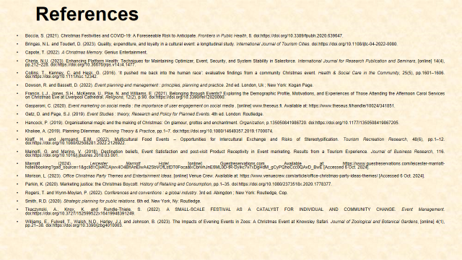
A couple of references used to create this presentation. Thanks for Listening. Any questions.
- Boccia, S. (2021). Christmas Festivities and COVID-19: A Foreseeable Risk to Anticipate. Frontiers in Public Health, 8. doi:https://doi.org/10.3389/fpubh.2020.639647.
- Bringas, N.L. and Toudert, D. (2023). Quality, expenditure, and loyalty in a cultural event: a longitudinal study. International Journal of Tourism Cities. doi:https://doi.org/10.1108/ijtc-04-2022-0080.
- Capote, T. (2022). A Christmas Memory. Genius Entertainment.
- Chinta, N.U. (2023). Enhancing Platform Health: Techniques for Maintaining Optimizer, Event, Security, and System Stability in Salesforce. International Journal for Research Publication and Seminars, [online] 14(4), pp.212–228. doi:https://doi.org/10.36676/jrps.v14.i4.1477.
- Collins, T., Kenney, C. and Hesk, G. (2016). ‘It pushed me back into the human race’: evaluative findings from a community Christmas event. Health & Social Care in the Community, 25(5), pp.1601–1606. doi:https://doi.org/10.1111/hsc.12342.
- Dowson, R. and Bassett, D. (2022). Event planning and management : principles, planning and practice. 2nd ed. London, Uk ; New York: Kogan Page.
- Francis, L.J., Jones, S.H., McKenna, U., Pike, N. and Williams, E. (2021). Belonging through Events? Exploring the Demographic Profile, Motivations, and Experiences of Those Attending the Afternoon Carol Services on Christmas Eve at Liverpool Cathedral. Religions, 12(2), p.90. doi:https://doi.org/10.3390/rel12020090.
- Gasparoni, C. (2020). Event marketing on social media : the importance of user engagement on social media . [online] www.theseus.fi. Available at: https://www.theseus.fi/handle/10024/341851.
- Getz, D. and Page, S.J. (2019). Event Studies : theory, Research and Policy for Planned Events. 4th ed. London: Routledge.
- Hancock, P. (2019). Organisational magic and the making of Christmas: On glamour, grottos and enchantment. Organization, p.135050841986720. doi:https://doi.org/10.1177/1350508419867205.
- Khakee, A. (2019). Planning Dilemmas. Planning Theory & Practice, pp.1–7. doi:https://doi.org/10.1080/14649357.2019.1700074.
- Kraff, H. and Jernsand, E.M. (2022). Multicultural Food Events – Opportunities for Intercultural Exchange and Risks of Stereotypification. Tourism Recreation Research, 48(6), pp.1–12. doi:https://doi.org/10.1080/02508281.2022.2126922.
- Mainolfi, G. and Marino, V. (2018). Destination beliefs, Event Satisfaction and post-visit Product Receptivity in Event marketing. Results from a Tourism Experience. Journal of Business Research, 116. doi:https://doi.org/10.1016/j.jbusres.2018.03.001.
- Marriott (2024). Leicester Marriott Hotel. [online] Guestreservations.com. Available at: https://www.guestreservations.com/leicester-marriott-hotel/booking?gad_source=1&gclid=CjwKCAjwx4O4BhAnEiwA42SbVOfLstDT0FocaalxCbrwhJnE6ML0D-tR-Dyikc7v7xDgHdM_gCyPQhoCcc0QAvD_BwE [Accessed 6 Oct. 2024].
- Morison, L. (2023). Office Christmas Party Themes and Entertainment Ideas. [online] Venue Crew. Available at: https://www.venuecrew.com/article/office-christmas-party-ideas-themes/ [Accessed 6 Oct. 2024].
- Parkin, K. (2020). Marketing justice: the Christmas Boycott. History of Retailing and Consumption, pp.1–35. doi:https://doi.org/10.1080/2373518x.2020.1778377.
- Rogers, T. and Wynn-Moylan, P. (2022). Conferences and conventions : a global industry. 3rd ed. Abingdon ; New York: Routledge, Cop.
- Smith, R.D. (2020). Strategic planning for public relations. 6th ed. New York, Ny: Routledge.
- Tkaczynski, A., Knox, K. and Rundle-Thiele, S. (2022). A SMALL-SCALE FESTIVAL AS A CATALYST FOR INDIVIDUAL AND COMMUNITY CHANGE. Event Management. doi:https://doi.org/10.3727/152599522x16419948391249.
- Williams, E., Fulwell, T., Walsh, N.D., Harley, J.J. and Johnson, B. (2023). The Impacts of Evening Events in Zoos: A Christmas Event at Knowsley Safari. Journal of Zoological and Botanical Gardens, [online] 4(1), pp.21–38. doi:https://doi.org/10.3390/jzbg4010003.

