Samuel Llewellyn
2403902
BA Computer Games Design
Environment Design ACCA4032

Video link:
https://youtu.be/jy5KUPAjNpk

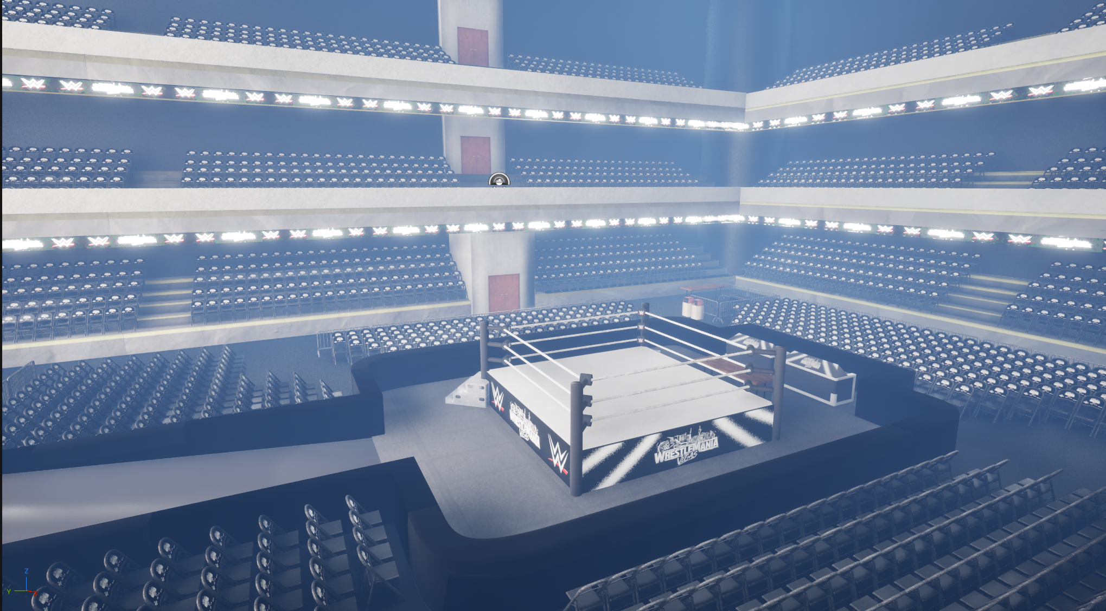
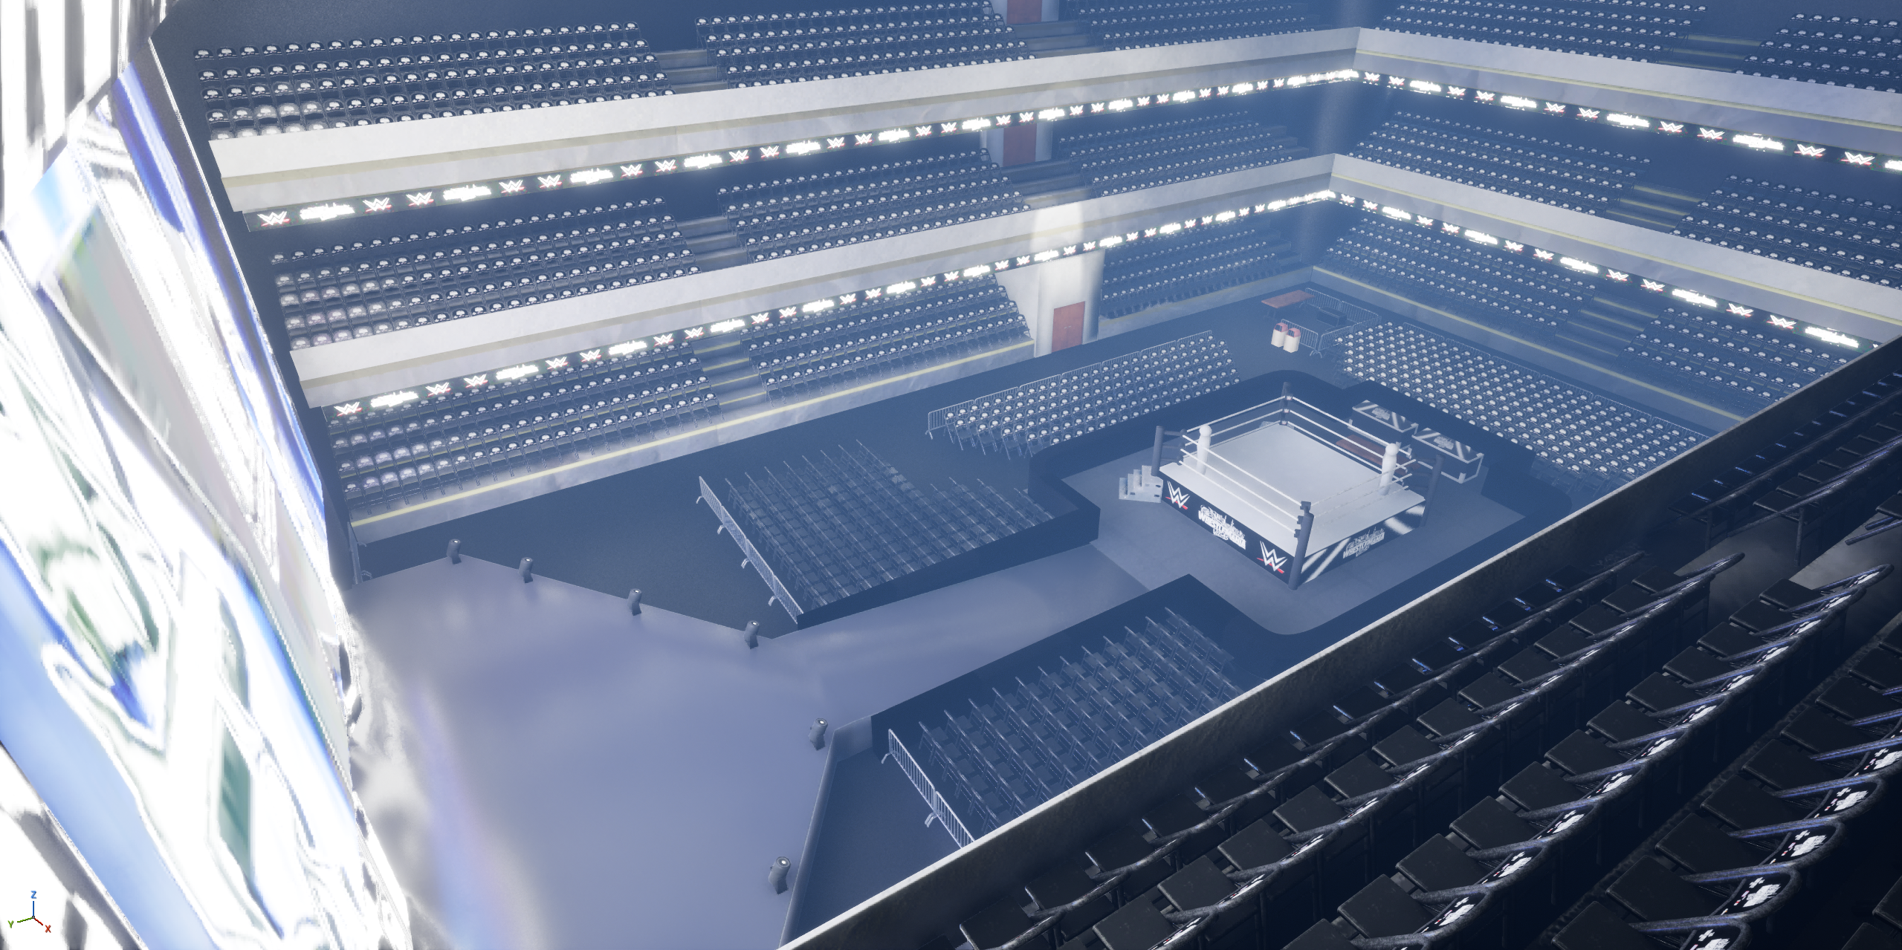
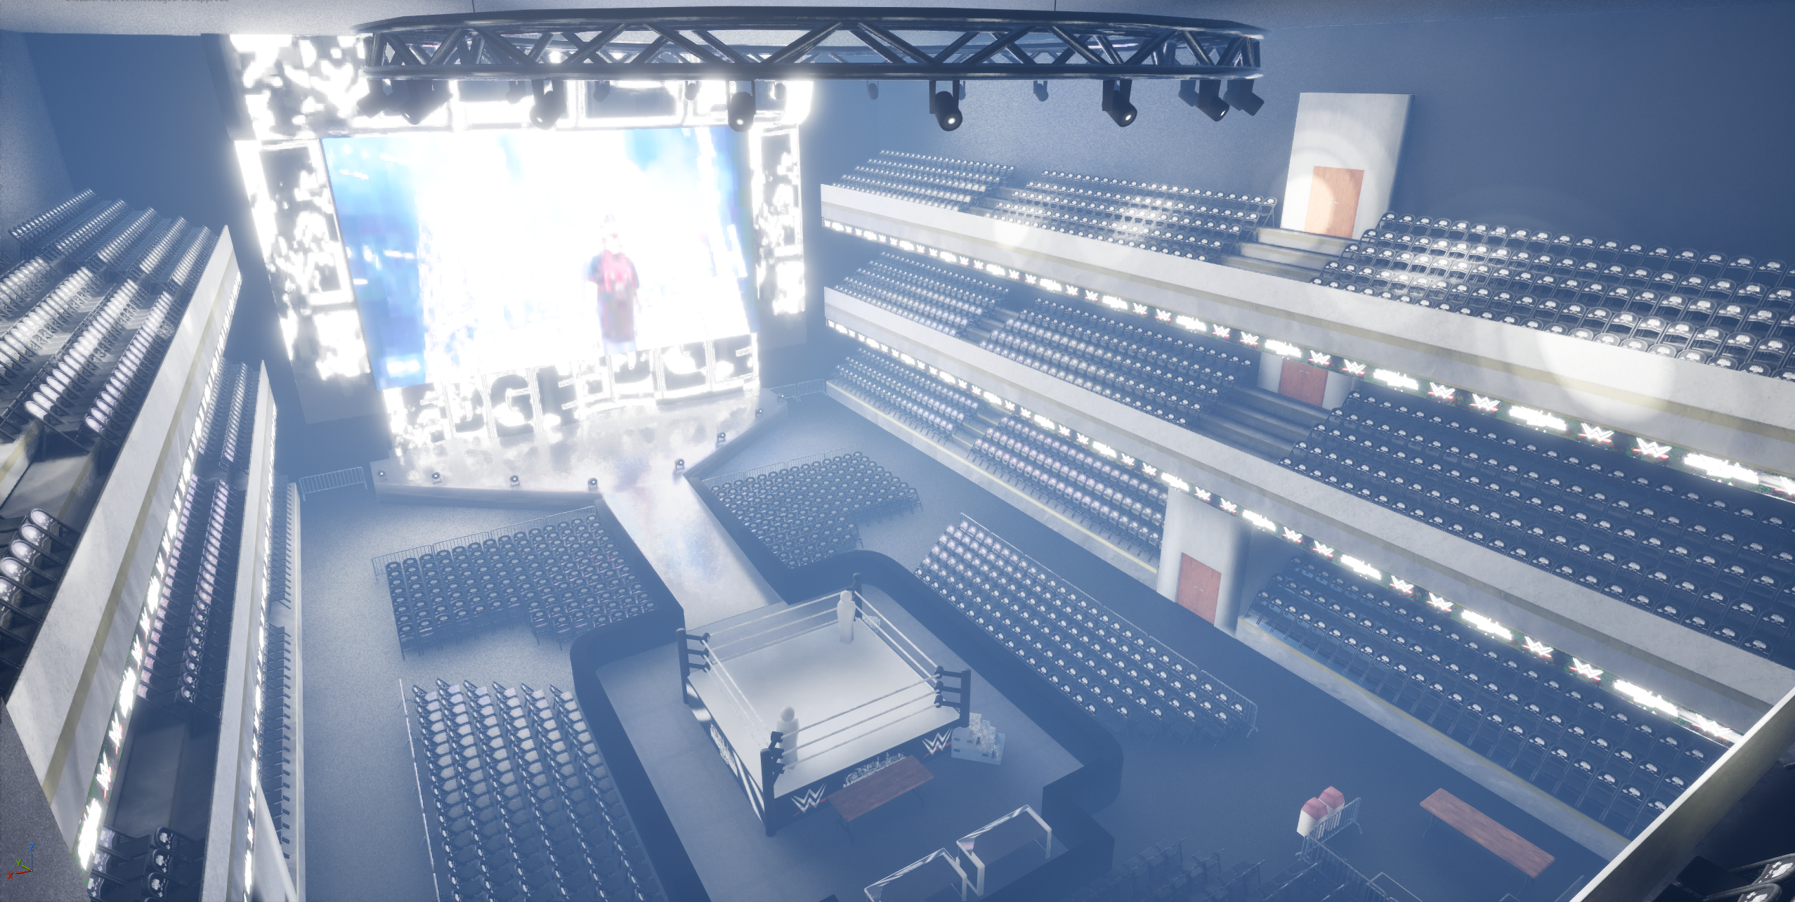

References
- [1]- Autodesk, Autodesk Maya, Autodesk Inc., 2025.
- [2]- Adobe, Adobe Substance 3D Painter, Adobe Inc., 2026
- [3]- Adobe, Adobe Photoshop, Adobe Inc., 2026
- [4]- PixelRZ, Fity.club. https://fity.club/lists/suggestions/wwe-wrestling-arena/ (accessed May 2026).
- [5]- K. Antony, “Things You Didn’t Know About The WWE Wrestling Ring,” TheSportster, Jun. 2022. https://www.thesportster.com/wwe-wrestling-ring-facts-trivia/
- [6]- “Professional Wrestling Ring Dimensions & Drawings | Dimensions.com,” www.dimensions.com. https://www.dimensions.com/element/professional-wrestling-ring
- [7]- “Chrome Plated Deluxe Breakable Ring Stairs for WWE & AEW Wrestling Action Figure Rings,” Target.com, 2026. https://www.target.com/p/chrome-plated-deluxe-breakable-ring-stairs-for-wwe-aew-wrestling-action-figure-rings/-/A-92495705 (accessed May 2026).
- [8]- Spaz Phoenix Podcast, “AJ STYLES Catches RICOCHET In A Mid-Air Styles Clash For The Win : SUMMERSLAM 2019,” YouTube, Aug. 12, 2019. https://www.youtube.com/watch?v=gnPGH43zHF0 (accessed May 2026).
- [9]- A. Ravens, “WWE Raw Reportedly Thrown Into Backstage Chaos By One Segment,” SEScoops, Nov. 04, 2025. https://www.sescoops.com/article/wwe-raw-reportedly-thrown-into-backstage-chaos-by-one-segment (accessed May 26, 2026).
- [10]- D. Bee, “WWE Extreme Rules 2014 DVD Extras Revealed, New WrestleMania 30 Trailer| Wrestling DVD Network,” Wrestling DVD Network | WWEDVDNews.com: Exclusive News on WWE DVDs and Blu-rays, WWE Network News, Upcoming WWE DVD Releases, Best Wrestling DVD Reviews, 2018 Schedule!, May 08, 2014. https://www.wrestlingdvdnetwork.com/wwe-extreme-rules-2014-dvd-extras/65425/ (accessed May 26, 2026).
- [11]- “WWE Wrestlemania 40 Chair 2024 Philly Roman Cody Ivo Bayley | #4723735138,” Worthpoint, 2024. https://www.worthpoint.com/worthopedia/wwe-wrestlemania-40-chair-2024-philly-4723735138 (accessed May 2026).
- [12]- WizeBan, “ WWE Games That Allows Crowd Fighting In The Game (Just Bring It - WWE 2K23).” Dec. 27, 2023. Accessed: May 13, 2026. [Online]. Available: https://youtu.be/idE9N6OuoW8?si=aKu5_It0mfkvuCzi
- [13]- Smacktalks, “WWE 2K25: All Table Finishers!” Mar. 06, 2025. Accessed: May 2026. [Youtube]. Available: https://www.youtube.com/watch?v=OuCUALX77Ls&t=149s
- ‌[14]- JakeH, “Discover the Versatile Range of Barricades by Crowd Control Company | Crowd Control Company,” Crowd Control Company, Jul. 05, 2023. https://crowdcontrolcompany.com/discover-the-versatile-range-of-barricades-by-crowd-control-company/ (accessed May 2026).
- [15]- harsh vardhan, “Edge Titantron And Theme Song 2010 HD(With Download Link).” Oct. 28, 2012. Accessed: May 2026. [Youtube]. Available: https://youtu.be/--5tBLiE1Fk?si=PFf0ZvUp3acf7z7p
- [16]- C. Skies, “WWE Edge Titantron (Arena Effects/Pyro Effects) 2020.” Jan. 30, 2020. Accessed: May 2026. [Youtube]. Available: https://youtu.be/63eq6wMrGmY?si=Tu-exm3ujihPAlMT
- [17]- JemGames, “How to Play Videos In Unreal Engine 5.” Nov. 06, 2025. Accessed: May 2026. [Youtube]. Available: https://youtu.be/mURmPnMT4KM?si=m2tLl8zy2aEFTkeh
- [18]- “Envato Pty Ltd.,” Envato, 2026. https://elements.envato.com/circular-truss-with-stage-lights-TWJ4TJP (accessed May 2026).
- [19]- Unreal Starter Kit, “Unreal Engine 5.6 – Easy Oscillating Spotlight Blueprint Tutorial.” Aug. 14, 2025. Accessed: May 2026. [Youtube]. Available: https://youtu.be/OpR_RAsYcSI?si=39K1cNPNol5HoOVD



