University of Wales Trinity Saint David
School of Engineering



Kinetic Energy Recovery

Alternative Propulsion Systems
ACHA5010

Nicholas Davey
2104746
24/11/2024
Contents
1.0 Introduction 10
2.0 Chosen Vehicle 11
2.1 Renault Clio 182 Trophy (2002-2005) 11
2.2 Clio 182 Trophy Specification 11
3.0 Dynamic Characteristics 12
4.0 WLTP Cycle for Clio 182 Trophy 13
4.1 What is the WLTP? 13
4.2 Chosen WLTP Cycle 13
5.0 Class 3 WLTP Cycle – Renault Clio 182 Trophy 14
5.1 Low Phase 14
15
5.2 Medium Phase 16
17
5.3 High Phase 18
19
5.4 Super High Phase 20
21
5.5 WLTP Cycle (Class 3) Data review 22
6.0 Suitable KER System for Vehicle 23
6.1 Components and Sizing 24
6.1.1 Motor-Generator Unit 24
6.1.2 Battery Pack 24
7.0 Conclusion 25
References 26

1.0 Introduction

In this report, I will explore the integration of a Kinetic Energy Recovery System (KERS) in a Renault Clio 182 Trophy to reduce fuel consumption. The Clio 182, known for its Sporty dynamics and lightweight construction, is an ideal choice for its KERS feasibility. Important vehicle features such as the test mass, frontal area, rolling resistance coefficient, and aerodynamic drag coefficient are evaluated. Implementing the WLTP cycle as a benchmark for our research, the cumulative energy demands are analysed to size a potentially compatibly KER System. Lastly, we will analyse the systems performance, efficiency, and operational implications in comparison to traditional ICE and friction braking systems.
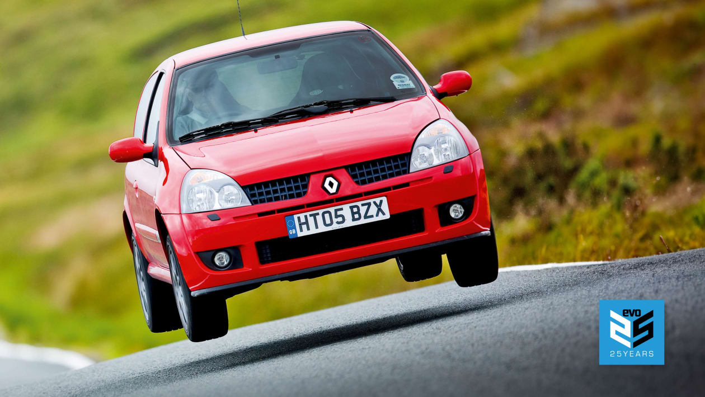
Figure 1, [Porter, R.]

2.0 Chosen Vehicle

2.1 Renault Clio 182 Trophy (2002-2005)
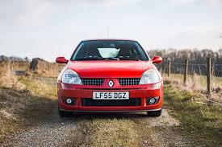
The Renault Clio 182 Trophy is a high performance, sporty hatchback. Introduced in 2005 it was part of the second-generation Clio line-up and it a sought-after vehicle for car enthusiast due to its focused driving dynamics and limited production, making it a desired model for track day events.
Figure 2, Renault Clio 182 Trophy
Powered by a 2.0-liter, 16v, naturally aspirated, inline-4 engine producing 182BHP (Hence the name). The engine is then mated to a 5-speed manual gearbox which exclusively delivers power to the front wheels with an open differential. The Clio weighs in at 1075kg which boasts a power to weight ratio that enhances its spirited performance.
The Trophy is truly set apart down to the chassis setup which was designed for extremely sharp handling and high levels of grip. It uses specially designed ‘remote reservoir dampers’ which allows for exceptional cornering precision and composure on uneven surfaces.
Due to the limited production run (500 UK units and 50 Swiss units), there is an added sense of desirability. Its lightweight characteristics, agility and braking performance make it an interesting benchmark when looking into energy storage and KERS.

2.2 Clio 182 Trophy Specification
Engine – 1,998 cc Naturally aspirated four cylinder, DOHC 16v
Output- Power: 180bhp at 6500 rpm, Torque148lb-ft at 5250 rpm
Weight- Power-to-Weight: 167bhp/ton, Torque-to-Weight: 138lb-ft/ton
Transmission- 5speed manual, FWD, Open differential
Performance- 0.60mph: 6.7s, ¼ mile: 15.5 at 90mph, Top Speed: 138mph

3.0 Dynamic Characteristics

The Dynamic Characteristics of a Renault Clio 182 trophy are ideal when analysing the integration of a KER System. The test mass, excluding additional payloads is 1075kg, which provides a lightweight foundation to implement an effective energy recovery system. The Clio’s Frontal Area is 1.94m^2, while the Coefficient of Drag (Cd) is 0.35 which expresses a fairly streamlined design.
Furthermore, the Coefficient of rolling resistance (Crr) is 0.015, which indicates a low resistance from tyre to road interaction.
These characteristics collectively influence the tractive and braking energy demands which helps us to form a basis for KER System analysis under the suitable WLTP cycle.
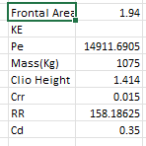
Figure 3, Dynamic Characteristics of the Clio Trophy

4.0 WLTP Cycle for Clio 182 Trophy

4.1 What is the WLTP?
The Worldwide Harmonised Light Vehicle Test Procedure (WLTP) provides standardised driving cycles which we can record and use to evaluate a vehicles energy consumption and emissions. Introduced in 2017, it was used to replace the outdate New European Driving Cycle (NEDC) to provide more accurate and realistic data for more modern vehicles.
Globally collected data is used to base the test off real-world driving conditions and patterns including varied speeds, accelerations and decelerations. It has Dynamic Test Phases consisting of Low, Medium, High and Extra-High to simulate different driving scenarios such as urban, suburban, motorway and high-speed driving situations. Furthermore, a WLTP cycle also conducts test over longer distances at higher speeds all while under stricter conditions including temperature controls and realistic driving loads. All off these test conditions help us to understand how a vehicle truly reacts in multiple realistic driving cycles.

4.2 Chosen WLTP Cycle
For the Renault Clio 182 Trophy I have chosen the class 3 WLTP cycle. This is due to its high power-to-mass ratio (PMR) and dynamic characteristics. The Clio 182 produces around 134 kW (179.7HP) of engine power with a test mass of 1075kg, which results in a PMR of approximately 124.65 kW/ton. Vehicles with a PMR that exceeds 34kW/ton fall under this specific cycle, which includes higher speeds with rapid accelerations and decelerations, making it more suited to sporty and high-performance vehicles.
The Class 3 WLTP cycle accurately represents the real-world driving behaviour of small sporty hatchbacks such as the Clio 182, which are commonly driving in dynamic urban and suburban conditions. This Specific cycle has the inclusion of higher velocity ranges and more frequent transitions between driving phases which allows for a comprehensive analysis of tractive and braking energy requirements. These are essential for sizing and evaluating the effectiveness of a Kinetic Energy Recovery System (KERS).

5.0 Class 3 WLTP Cycle – Renault Clio 182 Trophy

5.1 Low Phase

Figure 4, Vehicle Speed Vs Accel Force

Figure 5, Total Resistance to Motion

Figure 6, Energy Accumulated

Figure 7, Cumulative Tractive Energy Vs Cumulative Braking Energy

5.2 Medium Phase

Figure 8, Vehicle Speed Vs Accel Force

Figure 9, Total Resistance to Motion

Figure 10, Energy Accumulated

Figure 11, Cumulative Tractive Energy Vs Cumulative Braking Energy

5.3 High Phase

Figure 12, Vehicle Speed Vs Accel Force

Figure 13, Total Resistance to Motion

Figure 14, Energy Accumulated

Figure 15, Cumulative Tractive Energy vs Cumulative Braking Energy

5.4 Super High Phase

Figure 16, Vehicle Speed Vs Accel Force

Figure 17, Total Resistance to Motion

Figure 18, Energy Accumulated

Figure 19, Cumulative Tractive Energy Vs Cumulative Braking Energy

5.5 WLTP Cycle (Class 3) Data review
From the previous graphs (Cumulative Tractive energy Vs Cumulative Braking Energy) we can see where the braking energy spikes which suggest the car is slowing down. During the High and Super-High phases, these Spikes are accumulating almost 20,000J at certain points throughout the cycle which suggests the brakes are doing much more work to slow the car down. This can be seen as energy that can potentially be recovered during deceleration. Using these graphs, the difference in the individual lines show us the losses throughout the cycle which get much greater during the more intense phases.

6.0 Suitable KER System for Vehicle
When implementing a KER System into a vehicle such as the Clio 182 Trophy, considerations need to be taken to make sure that the most efficient system is used, all while remembering about the space confinement in the car and weight of the system itself.
The Clio 182 is hailed for its lightweight and sporty nature and is sometimes referred to as the ‘World’s Greatest Hot Hatch’ (Cackett, N. 2018). The vehicle would need to be modified in a way that doesn’t take these driving characteristics away from the experience, for example, by adding a system that is extremely heavy.
I have decided to go with a Battery Based KER System over a Flywheel based system for multiple reasons. I believe this would be better as the Clio is a very compact car with little space and due to its high-performance nature, meaning the system would also have to be lightweight so that it doesn’t affect the handling dynamics. Electric motors can be used to recover kinetic energy during braking and storing it in a battery or capacitor. The car can be modified to fit an MGU (Electric Motor-Generator-Unit) which is linked to the drivetrain to recover and deliver energy. You would then add either a lithium-ion battery or a ultracapacitor the battery-based system. However, this may mean structural changes need to be made to house the storage system without affecting the overall weight distribution of the car. Upgrading the brakes would be ideal to make sure they are able to handle the regenerative braking while maintaining stopping power. Finally, you would need to implement the control software to manage the energy recovery, storage and deployment in addition to cooling the motor and battery to prevent the system from overheating during extended operation.
A Flywheel based KER System can often be quite bulky and hard to position in such a compact car with limited space as they lack the practicality for road use causing a shift in the weight distribution of the vehicle.

6.1 Components and Sizing

6.1.1 Motor-Generator Unit
An MGU with a range between 30kW – 80kW would be appropriate to provide sufficient power to assist in acceleration and energy recovery during braking. Too high of a power output MGU could lead to excess weight or complexity while something too low may not provide enough of a boost in performance. The MGU I have selected is ‘TecMotors 55kW 4 Pole Cast Iron Electric Motor’ as it offers a middle ground of 55kW of power delivery.
Although this piece of equipment has a high initial cost (£2236.44), it is a very reliable and efficient device that is tried and tested in the automotive and motorsport industry. Over an extended period, I believe this device will be a lot more cost efficient compared to alternatives providing benefits to cost saving along with a reduced environmental impact. Finally, it is also size compatible and doesn’t weight too much which helps to preserve the driving dynamics of the vehicle.

6.1.2 Battery Pack
I have decided to use Supercapacitors as a battery pack to store and deliver the energy. Supercapacitors have their advantages and disadvantages when it comes to comparing them between alternatives such as a Lithium-ion Battery pack, however due to the application I believe they will be much more advantageous.
When a quick boost of acceleration is needed, supercapacitors can charge and discharge faster than batteries while handling the high surges of power without quickly degrading. Furthermore, they have longer life spans than their counterpart that allows for more regular and repeated energy cycles. However, they store less energy than batteries, making them ideal for short, high-power bursts over extended use.
I have chosen to use Skeleton Technologies High Power Supercapacitors. These come in D60 / D33 forms and are ideal for KERS usage. They have a capacitance of 300 – 5000 F which is brilliant at storing and releasing energy in large bursts and a specific power of 20 – 28.4 kW/kg to provide strong boosts of acceleration. Furthermore, they have a low ESR of 0.2 – 1.6 mΩ which ensures minimal energy is lost in operation with a high efficiency. Finally, these Supercapacitors also have a voltage of 2.85V/3V, suitable for compact automotive systems and have a long-life span of 15+ years with a high temperature tolerance (+65°C).
Assuming we are using 48V in our KERS setup, we would need a total of 136 supercapacitors that can be arranged in a series of 17 capacitors in 8 parallel banks to meet the energy requirement.
136 supercapacitors at 0.5kg per unit means that in total, we will be adding 68kg minimum to the total mass of the car which. To mitigate this, we can place them low and close to the centre of gravity to minimize the weight impact.

7.0 Conclusion
The investigation into the addition of a KERS for a Renault Clio 182 Trophy presents an exciting opportunity to improve both the power delivery and fuel efficiency. Through recovering kinetic energy during braking and storing it for later use, such a system would reduce reliance on traditional power sources, which allows foe the engine to operate more efficiently, lowering fuel consumption. The added power delivery, particularly in acceleration, would increase vehicle performance making the car more responsive which aligns with the lightweight and agile characteristics of the Clio.
However, these additional benefits also have their own trade-offs. Incorporation of a KER System introduces additional weight which can affect the handling dynamics of the car. The introduction of a battery pack and control systems can have a negative impact on the vehicles acceleration, braking and overall agility.
Known for being lightweight, grippy and its fun handling, careful attention must be given to weight distribution and placement due to the compact nature of the vehicle to minimize any negative impacts that this may have on the driving characteristics of the car.
Considering the performance and fuel consumption advantages, the cost of equipment needed to operate a battery-based KERS would likely make it an unviable option for such a vehicle. The batteries, supercapacitors, control software and work involved in integrating such a system would lead to unnecessary expenditure on a vehicle and significantly increase the money being put into it. Considering that the Clio is an affordable and small performance vehicle, the vast cost of the equipment and modifications needed may not be justified, especially compared to the modest gains in performance and fuel savings. Overall, this makes the setup much more impractical for use every day.
In Conclusion, while the integration of a KER System would be an exciting project to undertake due to its contribution to fuel savings and increased power gain, the overall impact on the vehicles driving dynamics regarding the weight and handling would require careful consideration. The high costs involved in the addition of a system like this further make it a less viable option for a vehicle already known for its lightweight, performance-focused setup and design. Due to the astronomical prices that would have to be faced and the vehicle adaptations that would be needed, I don’t think the addition of a KERS is a realistic and cost-effective option to aid fuel efficiency and for the potential power gains.

References
- Porter, R. (2024) Renault Sport Clio 182 trophy (2005): Review, history, prices and Specs, evo. Available at: https://www.evo.co.uk/renault/clio/182/trophy (Accessed: 27 November 2024).
- Trophy hunting - renault clio 182 trophy review (no date) Rush Magazine. Available at: https://www.rushmagazine.co.uk/post/renault-clio-182-trophy-review (Accessed: 29 November 2024).
- Our cars; Renault Clio 182 Trophy - report 002 (no date) Rush Magazine. Available at: https://www.rushmagazine.co.uk/post/our-cars-renault-clio-182-trophy-report-002 (Accessed: 29 November 2024).
- Cackett, N. (2018) Renault Clio 182 trophy: Ph heroes, PistonHeads. Available at: https://www.pistonheads.com/news/ph-features-heroes/renault-clio-182-trophy-ph-heroes/37580 (Accessed: 30 November 2024).
- Tecmotors 55kw 4 pole cast iron electric motor, three phase, B3 Foot M (no date) Wholesale Electrical Direct Limited - Trading as WED Online. Available at: https://wed-online.com/products/55kw-4-pole-cast-iron-motor-55-043teccb3-ie3?variant=45769724068134&country=GB&currency=GBP&utm_medium=product_sync&utm_source=google&utm_content=sag_organic&utm_campaign=sag_organic&gad_source=4&gclid=EAIaIQobChMI39jVxtCEigMV7JZQBh2w-QitEAQYASABEgIQQ_D_BwE (Accessed: 30 November 2024).
- High Power Energy Storage Solutions (no date) Skeleton. Available at: https://www.skeletontech.com/ (Accessed: 01 December 2024).

