
“UNDERTAKING A GREEN BELT PROJECT: STAGED WEIGHT PACKING SYSTEM”
Module: ACMB5005

May 5, 2026
University of Wales Trinity Saint David

EXECUTIVE SUMMARY
Many weight‑related PICA call‑outs were being raised, disrupting packing operations due to the existing single‑end weighing process operating at approximately a 3‑sigma capability level. Analysis identified tolerance stacking and uncontrolled box weight variation as key contributors to these packing failures.
To isolate individual component weights and improve packing process control, a staged‑weight packing system was devised. Process capability analysis demonstrated a clear improvement in performance, with the staged‑weight system achieving a Cpk value of approximately 1.33, corresponding to a 4‑sigma capability level. Real‑world variation, including supplier box weight variability and system software constraints, was factored into the final tolerance limits.
Validation confirmed that the staged‑weight system reduced the likelihood of incorrect packing while maintaining compatibility with existing packing rigs and processes. Although the staged‑weight system slightly increases packing time, it is expected to reduce engineering call‑outs, rework, and rig downtime, resulting in overall efficiency gains.
A full six‑sigma approach was not adopted, as a 4‑sigma solution aligns with organisational standards and provides a substantial reduction in defect rate compared to the current process. The staged‑weight packing system can be implemented at low cost, requires minimal process change, and offers a scalable improvement suitable for deployment across multiple packing operations.

GLOSSARY OF TERMS
- RGH – Rolled Gold Head
- PICA – Process Improvement through Cause Analysis
- PPE – Personal Protective Equipment
- WIP – Work In Progress
- SDP – Standard Discipline Procedure
- ISIR – Initial Sample Inspection Report
- POQ – Proof Of Quality
- QA – Quality Assurance
- VA – Vendor Assurance
- DMR – Defect Material Report
- RMA – Return Material Authorisation
- AM – Additive Manufacturing

TABLE OF CONTENTS
EXECUTIVE SUMMARY 1
GLOSSARY OF TERMS 1
TABLE OF CONTENTS 2
TABLE OF TABLES 5
TABLE OF FIGURES 6
INTRODUCTION 8
LEAN SIX SIGMA METHODOLOGY OVERVIEW 9
DMAIC STRUCTURE OVERVIEW 11
DEFINE PHASE 11
PROBLEM STATEMENT 11
PROCESS MAPPING 12
SIPOC OVERVIEW 12
PROCESS FLOW DIAGRAM 12
SWIMLANE DIAGRAM 13
VOICE OF THE CUSTOMER (VOC) AND CRITICAL TO QUALITY (QTCs) 14
PROJECT SCOPE 15
PROJECT CHARTER 15
PROJECT APPROACH 15
SCHEDULE 16
MEASURE PHASE 19
IDENTIFY MEASUREMENT VARIATION 19
DETERMINE DATA TYPE 19
DEVELOP DATA COLLECTION PLAN 19
MEASUREMENT SYSTEM ANALYSIS (MSA) 19
DATA COLLECTION AND ASSESS PROCESS CAPABILITY 20
COLLECTING AND SUMMARISING DATA 20
PACKING PICA DATA SUMMARY 20
INITIAL INVESTIGATION OF VARIATION IN BOX WEIGHT DUE TO SUPPLIER 21
TONIC INTERFACE WEIGHT 21
RIG VARIATION DATA COLLECTION 21
SINGLE-END WEIGHT TOLERANCES 21
PROCESS CAPABILITY ANALYSIS OF SINGLE-END PROCESS 23
PROCESS TIME 24
SINGLE-END PACKING SYSTEM 24
STAGED WEIGHT PACKING SYSTEM PRELIMINARY DATA 24
PREBUILDING TONIC INTERFACE BOXES 24
STAGED WEIGHT PACKING TRIAL 24
ANALYSE PHASE 25
PROCESS ANALYSIS METHODS 25
PACKING RIG DOWNTIME 25
INITIAL INVESTIGATION OF VARIATION IN BOX WEIGHT DUE TO SUPPLIER 26
PRIMARY SUPPLIER, FISKE, BOX WEIGHT 26
RIG VARIATION DATA COLLECTION 27
SETUP CONSIDERATIONS 27
MEASUREMENT LIMITATIONS 27
DATA SUMMARY 27
TONIC INTERFACE WEIGHT 28
REVIEW ANALYSIS METHODS 29
ROOT CAUSE ANALYSIS 29
5 WHYS ON WEIGHT ERRORS 29
GRAPHICAL ANALYSIS TOOLS 29
INITIAL INVESTIGATION OF VARIATION IN BOX WEIGHT DUE TO SUPPLIER 29
PROBABILITY PLOT FOR SELECTION OF PLOT TYPE 30
RIG VARIATION 31
HISTOGRAM PLOTS 31
WEIGHT DISTRIBUTION OF BOXES 34
EXPLORATORY DATA ANALYSIS & HYPOTHESIS TESTING 37
4-SIGMA UPPER AND LOWER WEIGHT TOLERANCES 37
4-SIGMA PROCESS CAPABILITY GRAPHS 38
IMPROVE PHASE 43
GENERATE IMPROVEMENT ALTERNATIVES & SOLUTION JUSTIFICATION 43
COST/BENEFIT ANALYSIS 43
PILOT PROPOSALS AND VALIDATE IMPROVEMENTS 44
PACKING TRIAL ROUTE MANAGEMENT 44
VALIDATE IMPROVEMENTS 44
VALIDATION PLAN 44
CONCESSION PLAN 44
VALIDATION REPORT 45
CONTROL PHASE 51
CONCLUSION 52
FURTHER WORK 53
POTENTIAL RISKS 53
Risk of packing the incorrect product 53
Customer impact risk 53
Supplier box weight variation 53
Incorrect box–product combinations 53
BIBLIOGRAPHY 54
APPENDICES 55
PACKING RIG DOWNTIME – PICA CALLOUTS 55
PICA RESOLUTION TIME – ALTERNATIVE CHARTS 58
TONIC INTERFACE DATA (2008 – 2022) 59
TONIC INTERFACE WEIGHT DATA 72
INITIAL BOX WEIGHT INVESTIGATION (LIGHT / DARK) 73
FISKE BOX WEIGHTS 74
RIG VARATION DATA 75
PROBABILITY PLOTS 79

TABLE OF TABLES
Table 1 – SIPOC 12
Table 2 – Swimlane Diagram 13
Table 3 – Yearly overview of PICA resolution time from 2020-2022 (with 2022 monthly detail) 20
Table 4 – Average time lost over a 3 month period in 2022 20
Table 7 – Average and Delta Box Weight per Supplier 21
Table 10 – Single-end Average weight and tolerances of A-9541-2036-10 and RGH24H50F33A 21
Table 11 – Time to build 10x Tonic Interface Boxes 24
Table 12 – Staged weight packing trial 24
Table 13 – Rig variation summary 27
Table 16 – 4 Sigma Process Capability Tolerlances 37
Table 17 – Packing Cost Analysis 43
Table 3 – Packing rig downtime due to PICA callouts 55
Table 21 – Tonic Interface Data (2008 – 2022) 59
Table 20 – Tonic interface weight data 72
Table 6 – Box Measurement and Weights 73
Table 8 – Fiske box weight variations 74
Table 9 – Rig variation 75
Table 14 – Average weight recorded per box on each rig 77
Table 15 – Range of variation across rigs per each box weighed 78

TABLE OF FIGURES
Figure 30 – Cpk Sigma level table (Renishaw, 2025) 9
Figure 1 – The Cpk index (Renishaw, 2025) 10
Figure 2 – Interpreting Cpk capability results (Renishaw, 2025) 10
Figure 3 – Process Flow Diagram 12
Figure 4 – Gantt Chart (weeks 1-8) 16
Figure 5 – Gantt Chart (weeks 8-16) 16
Figure 6 – Gantt Chart (weeks 16-24) 17
Figure 7 – Gantt Chart (weeks 24-32) 17
Figure 8 – Gantt Chart (weeks 32-40) 18
Figure 9 – Gantt Chart (weeks 40-48) 18
Figure 10 – Engineering time spent resolving weight alteration PICAs 20
Figure 11 – RGH24H5031A 22
Figure 12 – A-9541-2036-10 22
Figure 13 – RGH24H5031A Process capability 23
Figure 14 – A-9541-2036-10 process capability 23
Figure 15 – Weight related packing rig downtime data 25
Figure 16 – FISKE Box and component weight variations (with average) 26
Figure 17 – Average weight of Tonic Interface (30 batch) 28
Figure 18 – Box weight variation in supplier 29
Figure 19 – Probability Plot (Whole Unit) Distribution Identification 30
Figure 20 – Packing Rig Variation 31
Figure 21 – Rig variation histogram (Box, no top insert) 31
Figure 22 – Rig variation histogram (Box, top insert & Tonic) 32
Figure 23 – Rig variation histogram (Box with Tonic) 32
Figure 24 – Rig variation histogram (top insert) 33
Figure 25 – Box weight distribution histogram (whole unit) 34
Figure 26 – Box weight distribution histogram (box without inserts) 35
Figure 27 – Box weight distribution histogram (both inserts) 35
Figure 28 – Box weight distribution histogram (insert 1) 36
Figure 29 – Box weight distribution histogram (insert 2) 36
Figure 34 – 4 Sigma process cabability report (whole unit) 38
Figure 35 – 4 Sigma process cabability report (box without inserts) 39
Figure 36 – 4 Sigma process capability (Product) 40
Figure 37 – 4 Sigma process cabability report (insert 1) 41
Figure 38 – 4 Sigma process cabability report (insert 2) 42
Figure 39 – GPTR2 Packing software (Route management) 44
Figure 40 – Validation report page 1/6 45
Figure 41 – Validation report page 2/6 46
Figure 42 – Validation report page 3/6 47
Figure 43 – Validation report page 4/6 48
Figure 44 – Validation report page 5/6 49
Figure 45 – Validation report page 6/6 50
Figure 46 – PICA Resolution time (Condensed) 58
Figure 47 – PICA Resolution time (Expanded) 58
Figure 48 – probability plot variation 1 79
Figure 49 – probability plot variation 2 79

INTRODUCTION
Renishaw is a global metrology company based in the UK, co‑founded in 1973 by John Deer and Sir David McMurtry. The company designs and manufactures high‑precision measuring equipment for engineering sectors such as automotive, medical, and electronics. Renishaw products, including probes and calibration equipment, support accuracy and quality within manufacturing processes. The company also operates a large additive manufacturing (AM) production line, producing metal components using materials such as titanium for applications including dental products and high‑performance parts for elite downhill mountain bikes, currently used by the Atherton Racing team.
At Renishaw, one method used to ensure that the correct product is dispatched to customers is through weighing units during the packing process. Currently, this is carried out using a single‑end weighing system, where all items are placed into the box and weighed together after packing is complete. In recent months, there has been an increase in the number of PICAs (Process Improvement through Cause Analysis) raised in relation to issues with the packing rigs. An increase in PICAs has resulted in greater rig downtime, delays to packing operations, and increased engineering time spent resolving faults and recalibrating equipment.
These issues are believed to be linked to weight discrepancies within the packing process, including tolerance stacking between individual components and potential variation in box weights supplied by different vendors. As a result, products may need to be repacked, sometimes under concession, to avoid the risk of non‑compliance.
This report investigates the root causes behind the increase in PICAs and aims to improve the current packing process using Lean Six Sigma methodologies. The study focuses on assessing weight inconsistencies in packaging materials and packed products, evaluating component tolerances, and trialling a staged weighing packing system. To support this process change, a commissioning and validation document will also be developed.
The aim of the project is to investigate box weight inconsistencies, propose a staged weighing packing system, and trial and validate the proposed solution for suitability in production.

LEAN SIX SIGMA METHODOLOGY OVERVIEW
Six Sigma is a structured methodology used to improve process performance by reducing variation and minimising defects. A fundamental principle of Six Sigma is that process problems are best understood and solved using statistical analysis, allowing variation to be identified, measured, and controlled. Central to this statistical approach is the use of standard deviation, which describes how process data are distributed around the process mean (Montgomery, 2019).
Standard deviation is a measure of dispersion that indicates how far individual data points deviate from the mean value of a dataset. When a process exhibits a low standard deviation, the data points are closely clustered around the mean, indicating a stable and consistent process. In contrast, a high standard deviation reflects greater spread in the data, indicating increased process variability and reduced control. Understanding standard deviation is therefore essential for assessing process stability and identifying opportunities for improvement (OpenStax, 2023).
Process capability analysis is an important component of Six Sigma and is used to determine whether a stable process can consistently produce output that meets defined specification limits. Specification limits represent the acceptable range of variation for a product or process characteristic. Capability indices provide a numerical measure of how well the natural process variation fits within these limits.
Two widely used process capability indices are Cp and Cpk. The Cp index measures the potential capability of a process by comparing the width of the specification limits with the overall spread of the process variation. This index assumes that the process is perfectly centred between the upper and lower specification limits and therefore represents the best case capability scenario (Kotz et al., 1993).
The Cpk index extends this assessment by accounting for both process variation and process centring. It measures how close the process mean is to the nearest specification limit and reflects the worst case performance of the process. As a result, Cpk provides a more realistic indication of actual process capability, particularly when the process mean is not centred within the specification range (Kotz et al., 1993).
Higher Cp and Cpk values indicate a more capable process with a reduced likelihood of producing outputs outside specification limits. In practice, Cpk is generally regarded as the preferred metric for assessing production suitability, as it reflects both variability and centring and therefore gives a clearer indication of whether a process is capable of reliably meeting requirements under normal operating conditions (Montgomery, 2019).
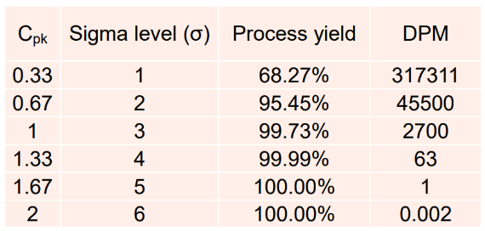
Figure 1 – Cpk Sigma level table (Renishaw, 2025)

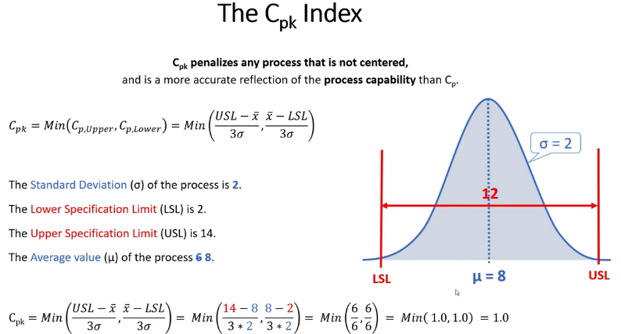
Figure 2 – The Cpk index (Renishaw, 2025)
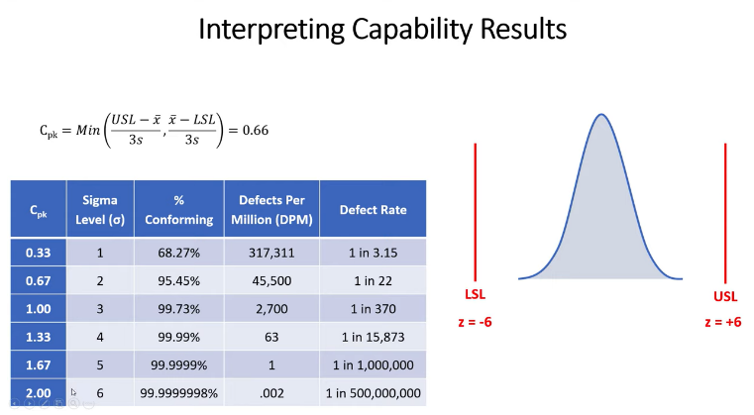
Figure 3 – Interpreting Cpk capability results (Renishaw, 2025)

DMAIC STRUCTURE OVERVIEW
The DMAIC structure cannot be attributed to a single individual, as it is an evolutionary methodology built upon the work of multiple contributors. The methodology consists of five stages: Define, Measure, Analyse, Improve, and Control. This structured approach allows users to methodically identify problems, analyse processes, and propose effective solutions.

DEFINE PHASE

PROBLEM STATEMENT
The current packing process uses a single‑end weighing system in which the product and packaging are weighed together once packing is complete. This approach presents several issues, particularly when there is overlap in packed weights between different products. Such overlaps increase the risk of incorrect items being shipped to customers, indicating that the existing weight tolerance limits are no longer fit for purpose.
Consequently, there has been a rise in the number of PICAs raised due to out‑of‑tolerance weight alarms on the packing rigs. Each PICA results in rig downtime while the issue is investigated, during which time packing operations are halted. Given that packing is a high‑throughput process with short cycle times, any interruption can lead to significant delays in unit dispatch.
Additionally, these stoppages consume engineering resources, as time is spent diagnosing issues and recalibrating rigs rather than supporting other production activities. The combination of increased downtime, delayed output, and additional engineering demand highlights a clear need to review and improve the current weighing method within the packing process.
This downtime also increases operational costs and delays product dispatch, which can negatively affect customer lead times and satisfaction.

PROCESS MAPPING
A SIPOC process map, process flow diagram, and swimlane diagram have been created to simplify and explain the current process of the single-end weigh packing system.

SIPOC OVERVIEW
Table 1 gives an overview of the SIPOC process mapping methodology.
Table 1 – SIPOC
Supplier | → | Inputs | → | Process | → | Outputs | → | Customer
Production  (In House) |  | Product (Unpacked) |  | Pack Product |  | Product (Packed) |  | Dispatch / Customer
 |  | Box |  | Weigh Unit
 |  |  |  | Dispatch

PROCESS FLOW DIAGRAM
The current single-end weighing packing process is detailed below, each step is numbered and listed. The green arrows symbolise a “Pass” and red a “Fail”, the grey dotted box also represents the hidden factory operations within the process flow. These hidden factors including rework time, rig and operator downtime, as well as time spent on PICA callouts.
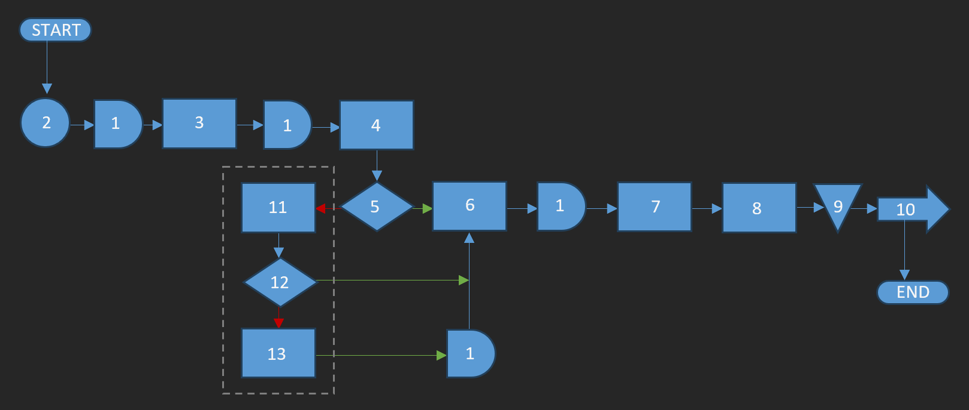
Figure 4 – Process Flow Diagram

1) Delay | 8) Process Step: Add product label to box
2) Quality Check | 9) Storage: Store product until required
3) Process Step: Pack item into box (premade) | 10) Transport: Dispatch
4) Process Step: Weigh unit | 11) Process Step: Fail = weigh unit again
5) Decision: Pass / Fail | 12) Decision: Pass / Fail
6) Process Step: Pass = print label | 13) Process Step: 2nd Fail = raise a PICA
7) Process Step: Close box

SWIMLANE DIAGRAM
Process accountability is shown below. Green represents a “Pass” route, and red a “Fail”.
Table 2 – Swimlane Diagram
OPERATOR |  | PACKING RIG  / SOFTWARE | TECHNICIANS  / ENGINEERS | STORES / DISPATCH
(Pass Route) | (Fail Route) | PACKING RIG  / SOFTWARE | TECHNICIANS  / ENGINEERS | STORES / DISPATCH
START

Quality
Check

Pack Product

Weigh Unit

 |  | Pass / Fail
Label Prints | Re-Weigh Unit
Close Box |  | Pass / Fail
Add Label | Raise a PICA
 |  |  | Resolve PICA
 |  |  |  | Store
 |  |  |  | Dispatch
 |  |  |  | END

VOICE OF THE CUSTOMER (VOC) AND CRITICAL TO QUALITY (QTCs)
VOC and CTQ are used to evaluate which areas of quality have the greatest impact on the customer and could later be expanded to cover multiple areas of the business if applicable. The QTCs include:
- CTS = Critical to Satisfaction
  - CTQ = Critical to Quality
  - CTC = Critical to Cost
  - CTD = Critical to Delivery
    - CTP = Critical to Process
Relating to the previous SIPOC overview, the QTCs align as follows:
- Inputs
  - CTQ
    - Box weight consistency
    - Correct product variant
  - CTP
    - Consistent box specification
    - Input variables available during packing
- Process
  - CTP
    - Weighing method
    - Accurate and calibrated scale
    - Minimal human error & correct zeroing
  - CTC
    - Minimal rig downtime
    - Reduction of PICAs
  - CTQ
    - Within weight tolerance
  - CTD
    - Packing time reduction
    - Rig downtime
- Customer
  - CTS
    - Delivered on time
    - Correct product shipped
  - CTQ
    - Packed consistently as specified
    - Zero accidental wrong products shipped
  - CTD
    - Minimal disruption in lead time to dispatch
  - CTC
    - Reduction in errors and returns avoids unnecessary costs and disruptions
The SIPOC analysis highlights that box and product weight consistency are critical inputs affecting process performance, while the weighing method itself is critical to process capability. These factors directly influence cost, delivery performance, and customer satisfaction through rig downtime, PICA callouts, and the risk of mis‑shipment.

PROJECT SCOPE
This project focuses on investigating and improving the current single‑end weighing process used during the packing stage. The scope includes data collection, process capability analysis, and the trial and validation of a staged weighing packing system.
The project does not include full production implementation, changes to unrelated packing processes, or long‑term post‑trial monitoring. All work will be carried out using existing equipment and within current production constraints.

PROJECT CHARTER
The current single‑end weighing process has resulted in increased PICA callouts and rig downtime due to weight variation and tolerance overlap. This project aims to evaluate and validate a staged weighing packing system as a process improvement to increase process capability and reduce downtime.
The objective of the project is to improve the existing weighing process by increasing its capability to a level suitable for production use. The scope of the project includes box and product weight analysis, process capability assessment, and validation of the proposed staged weighing method. The project excludes full production roll‑out beyond validation.

PROJECT APPROACH
The project plan consists of collecting baseline data and conducting supporting research into Six Sigma methodologies, Minitab, and SQL. An appropriate box and product pairing will then be selected to demonstrate proof of concept. The plan will involve determining box weights, including confirming whether multiple box suppliers are in use, weighing the product components, and timing the packing operation. Baseline sigma‑level data will be collected, followed by a trial of an improved sigma‑level process. The effectiveness of the trial will then be evaluated, and both a concession plan and a validation plan will be developed to support implementation.

SCHEDULE
To ensure the project was completed on time, a Gantt chart was created. A basic Gantt chart allows the user to map out three key areas: the expected time taken to complete a task, the actual time taken, and whether the task was completed on time.
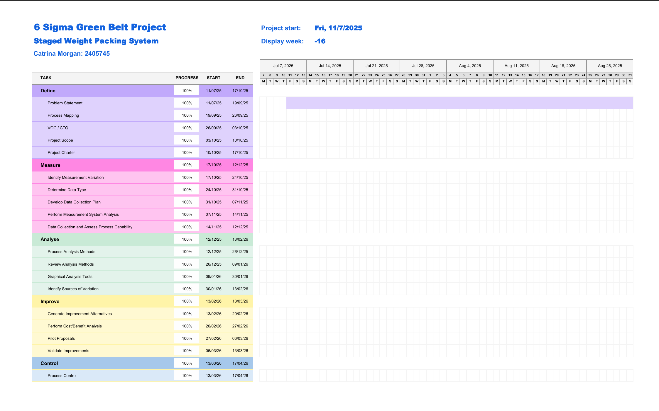
Figure 5 – Gantt Chart (weeks 1-8)
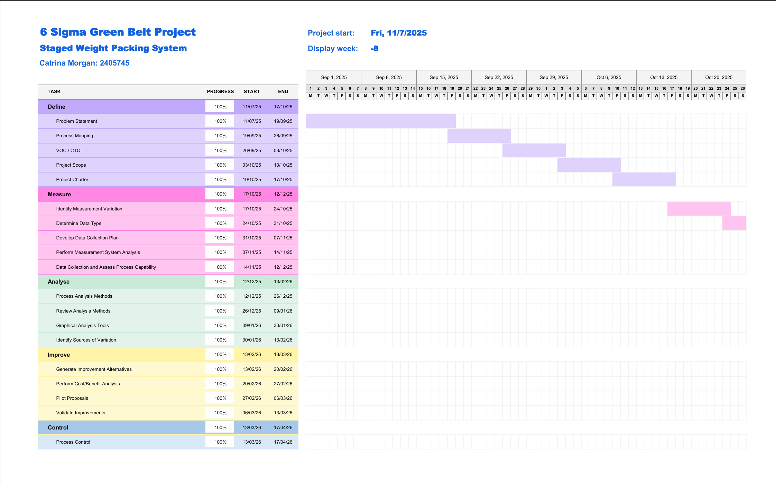
Figure 6 – Gantt Chart (weeks 8-16)
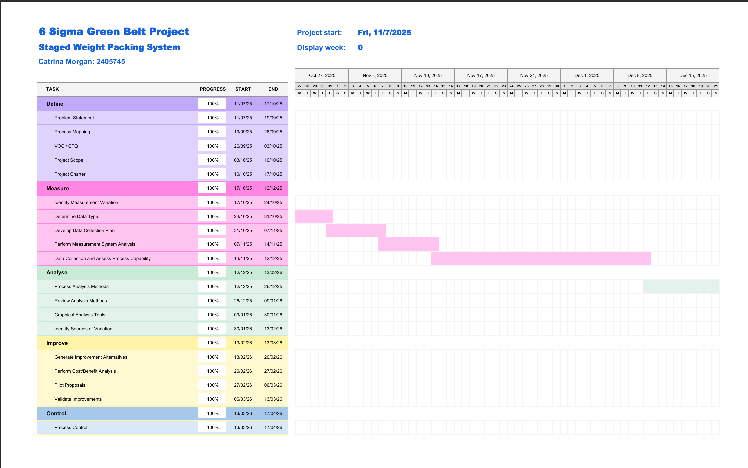
Figure 7 – Gantt Chart (weeks 16-24)
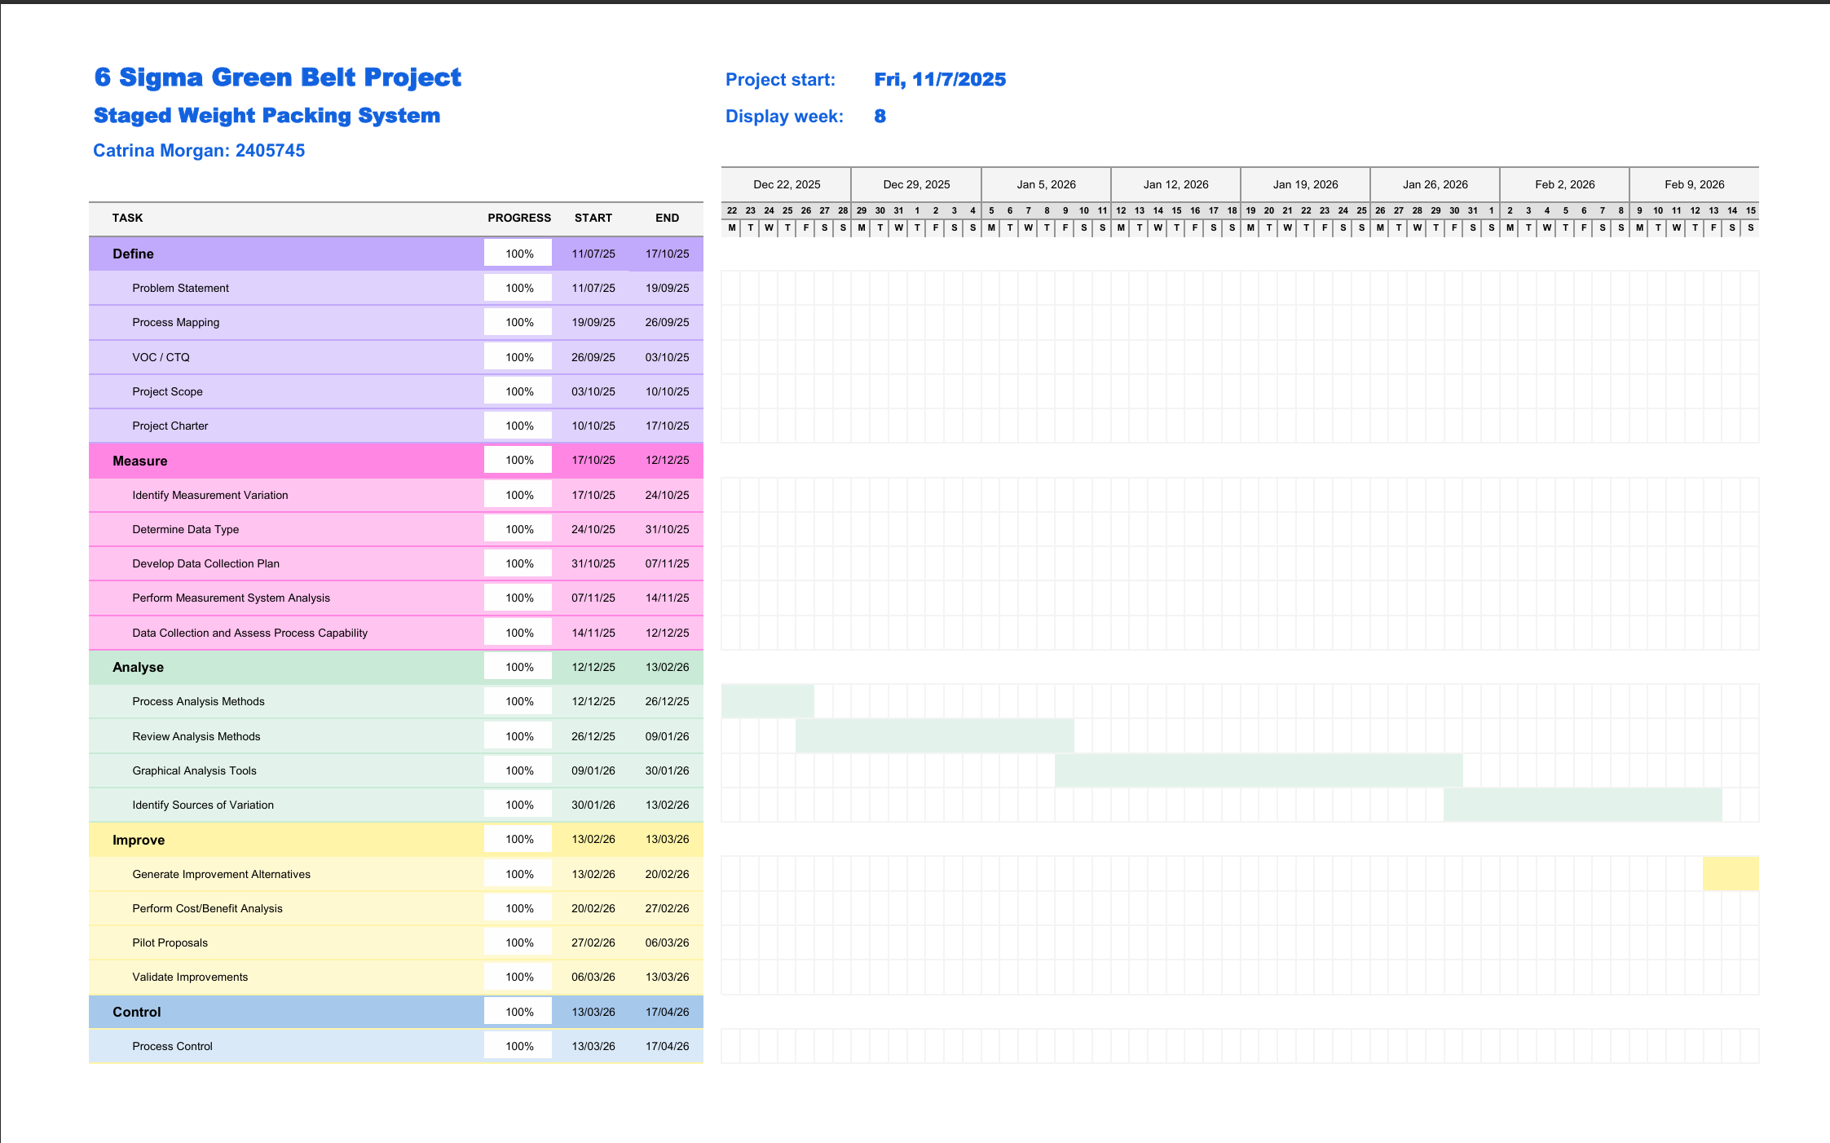
Figure 8 – Gantt Chart (weeks 24-32)
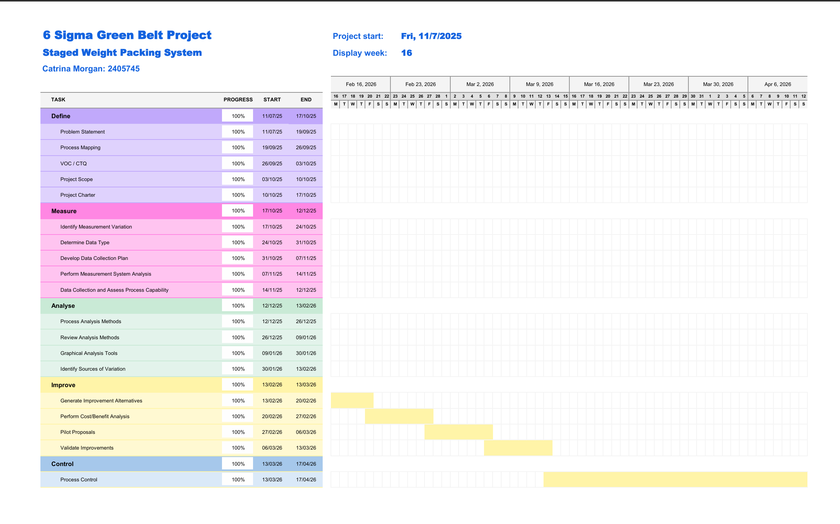
Figure 9 – Gantt Chart (weeks 32-40)
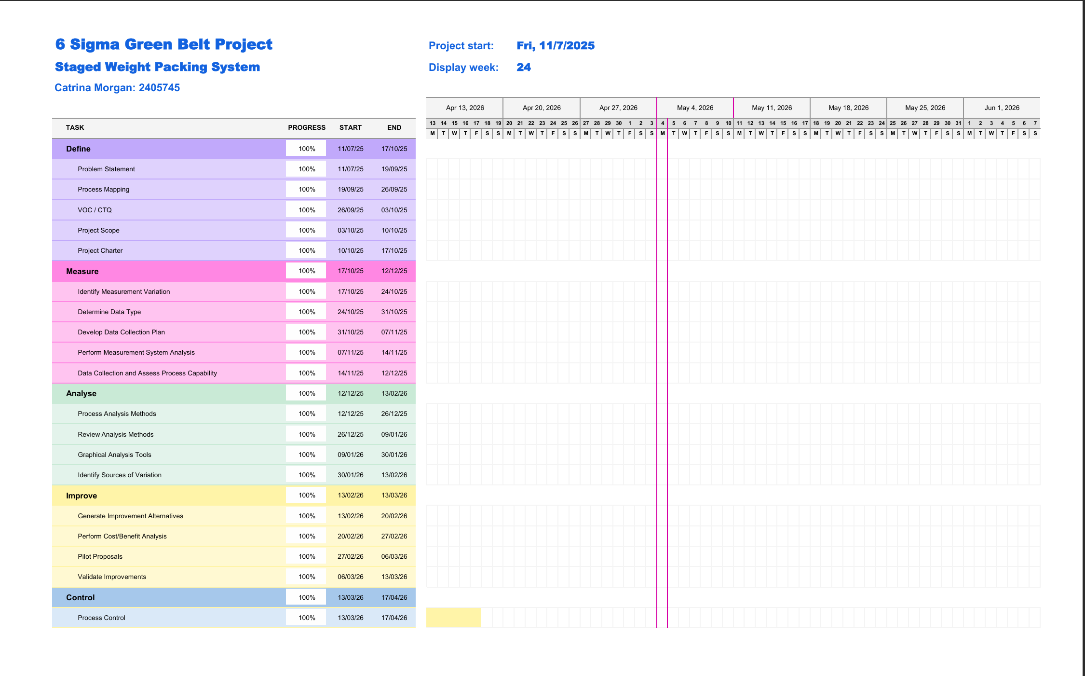
Figure 10 – Gantt Chart (weeks 40-48)

MEASURE PHASE

IDENTIFY MEASUREMENT VARIATION
Variation in the data collected could be influenced by the precision and calibration of the weighing scale, whether the zero weight on the rig was functioning correctly, and unavoidable discrepancies due to human error.

DETERMINE DATA TYPE
The data collected will be in two forms: continuous data, represented by weight measurements, and attribute data, represented by a pass or fail result.

DEVELOP DATA COLLECTION PLAN
Data will be collected from research conducted in 2023, alongside relevant historical data such as PICA records, product cost, and packing time. All current and historical data has been collected by Catrina Morgan. Access to packing rigs and operator expertise will be required.
The Gantt chart in the Define section on page 16 outlines the data analysis process, which follows the DMAIC structure to assess the process and identify improvements and future work.

MEASUREMENT SYSTEM ANALYSIS (MSA)
Due to the nature of the topic, this project is repeatable and could be reproduced to analyse the potential for roll out across multiple product packing processes across the business. All packing rigs are built in house to the same standard, so scale calibration should be the same and suitable for all processes.

DATA COLLECTION AND ASSESS PROCESS CAPABILITY

COLLECTING AND SUMMARISING DATA

PACKING PICA DATA SUMMARY
Table 12 details the PICA callouts on the packing rigs from 2020 to 2022, showing the time lost. It can be found in the appendix on page 55. Table 3 shows the time engineers spent resolving weight change PICAs on the packing rigs from 2020 to 2022.
Table 3 – Yearly overview of PICA resolution time from 2020-2022 (with 2022 monthly detail)
Sum of Total Minutes
 | Interfaces | Resolute | RGH | Grand Total
2020 | 75 |  | 240 | 315
2021 | 360 |  | 490 | 850
2022 | 535 | 145 | 575 | 1255
Jan |  |  | 60 | 60
Feb |  |  | 80 | 80
Mar |  |  | 110 | 110
May | 65 |  | 25 | 90
Jun | 165 |  | 75 | 240
Jul | 75 |  |  | 75
Aug | 45 | 130 | 195 | 370
Sep | 185 | 15 | 30 | 230
Grand Total | 970 | 145 | 1305 | 2420

Table 4 – Average time lost over a 3 month period in 2022
Month PICA Raised | Interfaces | Resolute | RGH | Total minutes spent on PICA
Jun | 165 |  | 75 | 240
Jul | 75 |  |  | 75
Aug | 45 | 130 | 195 | 370
Average time lost = | 95 | 130 | 135 | 228.33

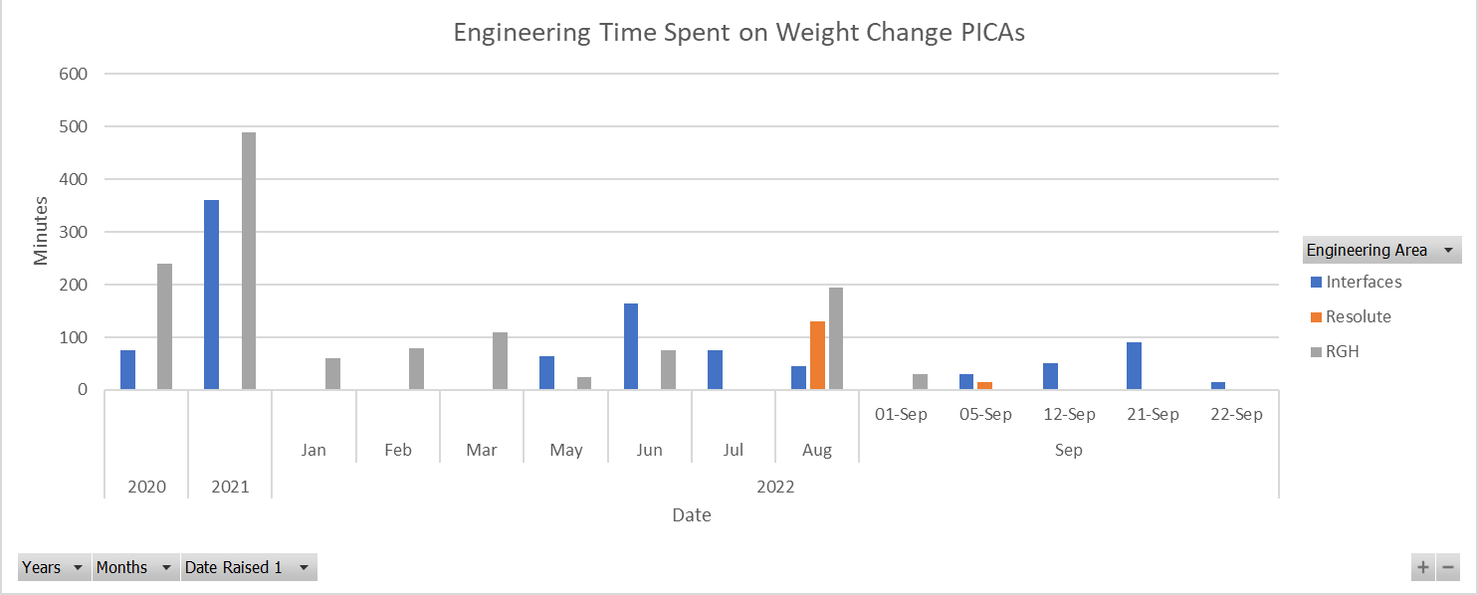
Figure 11 – Engineering time spent resolving weight alteration PICAs

INITIAL INVESTIGATION OF VARIATION IN BOX WEIGHT DUE TO SUPPLIER
The repeated occurrence of the problem is due to variations in the weight of the boxes. Recently, the packing department changed box suppliers, which, according to the data provided, marks the beginning of the weight-related issues. A test was carried out to identify which boxes varied in weight and how this affected the tolerance limits. Table 15 below shows information on the different types of boxes used, such as light and dark boxes, assumed to be from 2 different suppliers. Analysis of Table 5 shows that the dark boxes are slightly heavier than the light boxes. As a result, when operators use the dark boxes to pack the product, the additional weight can cause the tolerance boundary to be exceeded, shown in Figure 19 in the “ANALYSE PHASE” section.
Table 5 – Average and Delta Box Weight per Supplier
Average Box Weight (Grams)
Light | Dark | Delta Weight
38.966 | 42.746 | 3.78

TONIC INTERFACE WEIGHT
A batch of 30 Tonic Interface units were weighed to gain a value for the tolerance needed for the staged weighing system. See page 72 in the appendix.

RIG VARIATION DATA COLLECTION
A summary of this data can be seen in Table 9 on page 27, where the same 20 boxes were weighed across each of the 5 packing rigs. See page 75 in the appendix for the raw data.

SINGLE-END WEIGHT TOLERANCES
The minimum and maximum tolerances for a sample batch of A‑9541‑2036‑10 and RGH24H50F33A were calculated for each box configuration, including the overall tolerances, as shown in Table 6. The packed weights are plotted against the corresponding stacked tolerance limits, displayed in Figure 12 and Figure 13.
Table 6 – Single-end Average weight and tolerances of A-9541-2036-10 and RGH24H50F33A
 | A-9541-2036-10 |  |  | RGH24H50F33A
 | Min | Max | Min |  | Max
Box | 21.752 | 32.628 | 40.255 |  | 42.745
Core | 56.439 | 68.981 | 159.904 |  | 183.976
Bag | 0.64 | 1.92 | 0.64 |  | 1.92
Total Average Weight (Grams) = | 78.831 | 103.529 | 201.454 |  | 230.606

Figure 12 – RGH24H5031A

Figure 13 – A-9541-2036-10

PROCESS CAPABILITY ANALYSIS OF SINGLE-END PROCESS
Figure 14 shows a Cpk value of 1.02 and Figure 15 with 1.28, both correspond to a 3‑sigma process capability. The aim is to tighten these limits to achieve a 4‑sigma process. While a 6‑sigma process is considered ideal, it is unnecessary for this application and could result in an increased number of PICAs being raised.
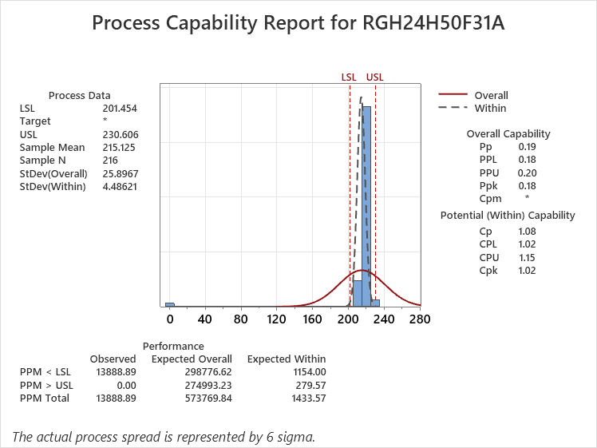
Figure 14 – RGH24H5031A Process capability
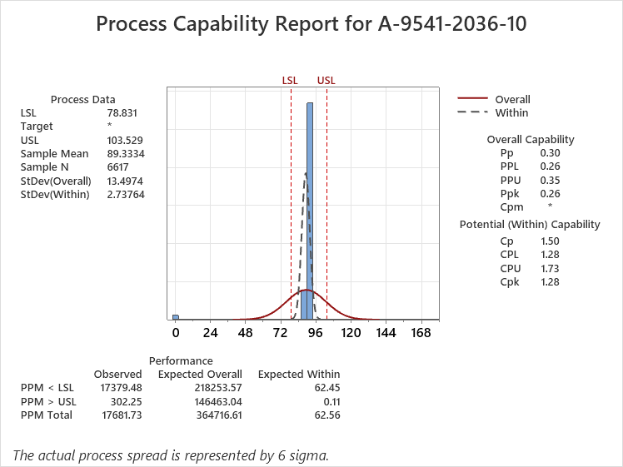
Figure 15 – A-9541-2036-10 process capability

PROCESS TIME

SINGLE-END PACKING SYSTEM
According to the Syteline system, the current runtime average for single‑end weighing of one Tonic Interface unit is 0.02 hours, which equates to 1 minute and 12 seconds (72 Seconds) per unit.

STAGED WEIGHT PACKING SYSTEM PRELIMINARY DATA

PREBUILDING TONIC INTERFACE BOXES
Table 7 displays the time taken to build x10 Tonic Interface boxes. Column 1 the time to build a box with insert 1, and column 2 the time to fold insert 2. Resulting in the average time taken to prebuild 1 complete box.
Table 7 – Time to build 10x Tonic Interface Boxes
Building x10 Tonic Interface Boxes
Building Boxes with Insert 1: | Folding Insert 2:
Time = 02:05 | Time = 00:40
Total Time to Build x10 boxes = 02:46 (minutes/seconds)
Average time to build x1 complete box = 16.6 seconds

STAGED WEIGHT PACKING TRIAL
Table 8 shows the results of a timed trial for packing 10 Tonic Interface units, with and without the box‑building time included.
Table 8 – Staged weight packing trial
Tonic Interface ID | Start time | End time | Packing Time –  Excluding Box Building |  | Packing Time –  Including Box Building
Tonic Interface ID | Min:Sec | Min:Sec | Min:Sec | Sec | Min | Sec
2371643 | 10:22:08 | 10:23:49 | 01:11 | 71 | 03:57 | 87.6
2371618 | 09:56:25 | 09:58:15 | 01:50 | 110 | 04:36 | 126.6
2371470 | 09:20:07 | 09:21:41 | 01:34 | 94 | 04:20 | 110.6
2371467 | 09:18:46 | 09:19:57 | 01:11 | 71 | 03:57 | 87.6
2371448 | 09:13:45 | 09:15:02 | 01:17 | 77 | 04:04 | 93.6
2371437 | 09:11:54 | 09:13:14 | 01:20 | 80 | 04:07 | 96.6
2371430 | 09:10:12 | 09:11:47 | 01:35 | 95 | 04:21 | 111.6
2371420 | 09:07:46 | 09:10:00 | 02:14 | 134 | 05:01 | 150.6
2371396 | 09:03:54 | 09:06:20 | 02:26 | 146 | 05:13 | 162.6
2371267 | 08:29:44 | 08:34:17 | 04:33 | 273 | 07:46 | 289.6
Average Packing Time |  |  | 1:55.1 | 115.1 | 2:11.7 | 131.7

ANALYSE PHASE

PROCESS ANALYSIS METHODS

PACKING RIG DOWNTIME
Figure 16 shows that the highest level of downtime occurred in 2021. It also indicates that blanks experienced the most weight-related issues. However, RGH and interfaces are not far behind, suggesting that this is a common issue affecting all products. The timeframe covered by Figure 16 spans 32 months and the total downtime recorded for each product is as follows:
RGH: 1,340 minutes
Interfaces: 710 minutes
Blanks: 1,600 minutes
Overall downtime: 3,650 minutes (219,000 seconds)
Using the data above, it is possible to calculate how many products could have been packed during this downtime period. On average, it takes 72 seconds to pack one unit, meaning that approximately 3,041 units could have been packed instead. This represents a substantial loss in orders caused by the original weight-related issue.

Figure 16 – Weight related packing rig downtime data

INITIAL INVESTIGATION OF VARIATION IN BOX WEIGHT DUE TO SUPPLIER
The proposed way to resolve this issue is to adjust the weight tolerance within the software, as finding a new box supplier would take a significant amount of time due to Renishaw’s required protocols. This approach focuses on changing the steps operators follow when packing products. For example, under the new method, operators would first weigh the empty box on the scales, after which the software would zero the weight while the box remains on the scale. The operator would then select “next” on the screen and be prompted to place the encoder onto the scale. This process would separate the box weight from the encoder weight, which would prevent tolerance issues and allow all parts to pass unless an obvious error occurs.
This problem has a significant impact on the packing process due to software downtime and the length of time required for engineers to restore the system. This is explored in Figure 16, showing the total downtime, measured in minutes, from November 2019 to 2022. The data represents a collection of all weight-related PICAs taken from the PICA history register, explored further in section “PACKING PICA DATA”.

PRIMARY SUPPLIER, FISKE, BOX WEIGHT
Using Syteline, the part number for the boxes was identified. Subsequent review indicated that, since May 2021, a single supplier, Fiske, has provided the branded boxes. Although a secondary supplier is listed as a back-up, no deliveries from this supplier have been recorded since that date. Therefore, any current variation is most likely attributable to the sole active supplier. The average box weight can be found in the appendix on page 73.
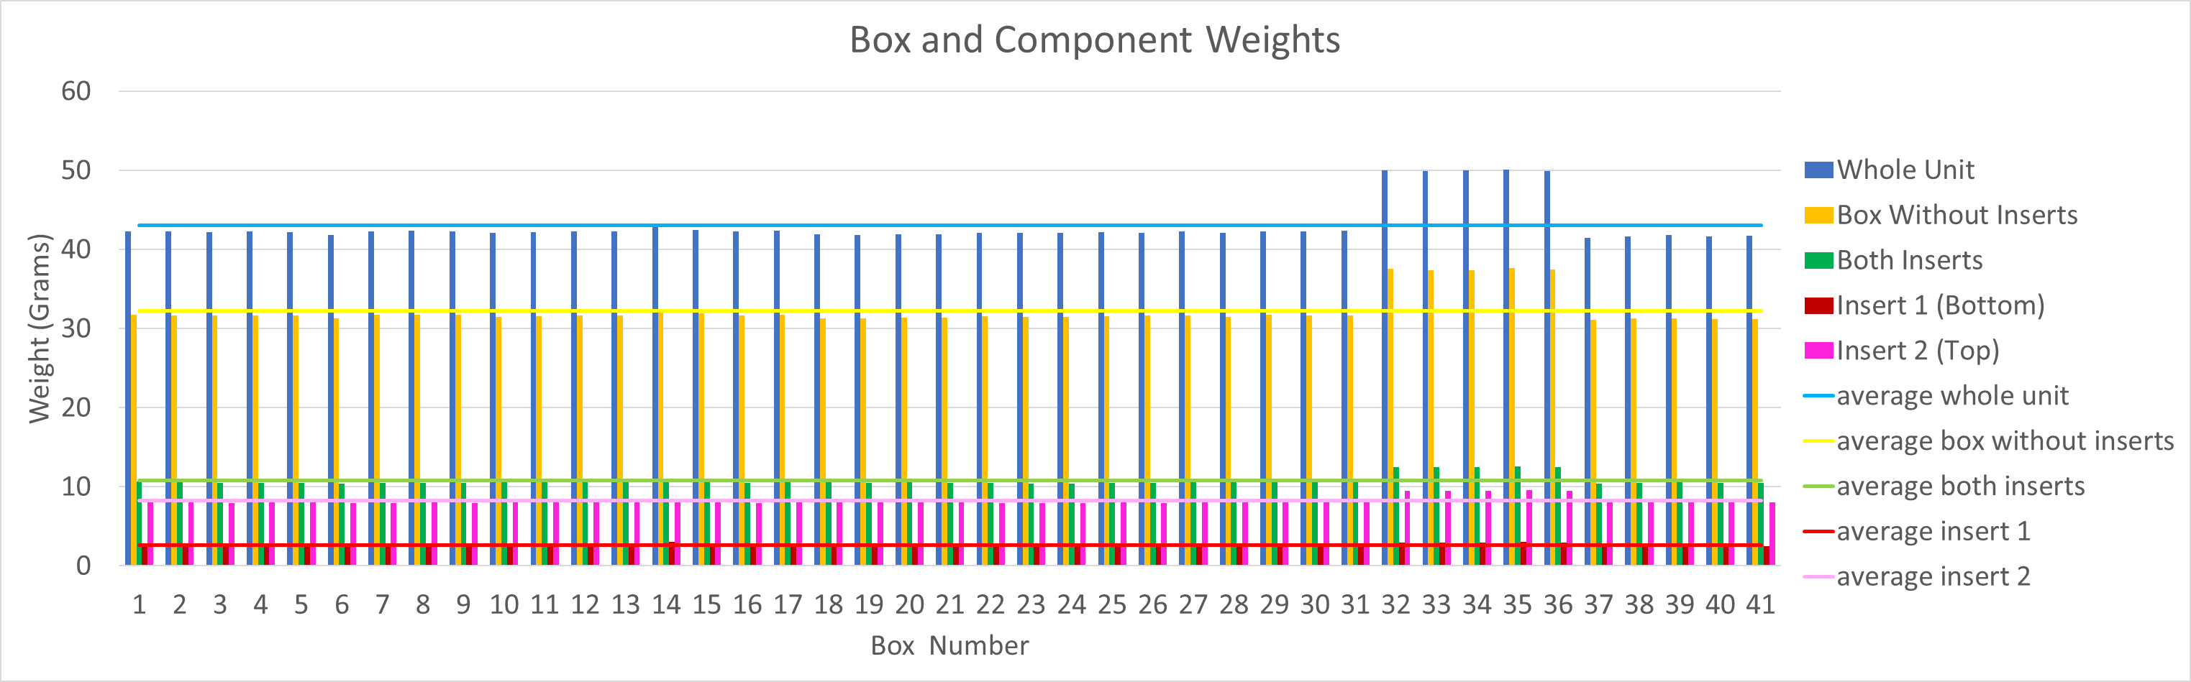
Figure 17 – FISKE Box and component weight variations (with average)

RIG VARIATION DATA COLLECTION

SETUP CONSIDERATIONS
The scale was zeroed between box changes. It was also observed that the monitor on the rig could obstruct the boxes if they encountered it, which in some cases affected the recorded weight when boxes were not placed correctly. As a result, the scales were repositioned further back.

MEASUREMENT LIMITATIONS
The same boxes, which were labelled and weighed in the same order, were measured on each of the five rigs. One limitation of the process was that the rig did not allow the weight to be frozen, so the readings had to be noted manually. While efforts were made to be as consistent as possible, the manual element means that some minor inconsistencies may have occurred. Given how sensitive the weighing scales are on the packing rigs, being able to freeze the weight before recording it would have been preferable, but this was not possible.

DATA SUMMARY
The raw data used for Table 9 can be found on page 75.
Table 9 – Rig variation summary
Rig Variation (Grams)
Rig | Box without top insert | box with tonic | box with tonic and top insert | top insert
1 | 0.57 | 0.75 | 0.73 | 0.25
2 | 0.81 | 0.81 | 0.74 | 0.38
3 | 1.09 | 0.65 | 0.63 | 2.01
4 | 0.62 | 0.83 | 0.79 | 0.37
5 | 0.65 | 0.96 | 0.88 | 0.32

TONIC INTERFACE WEIGHT
The data used to make Figure 18 can be found in Table 14 on page 21.
Tonic Interface Weight: Average = 102.653 grams.
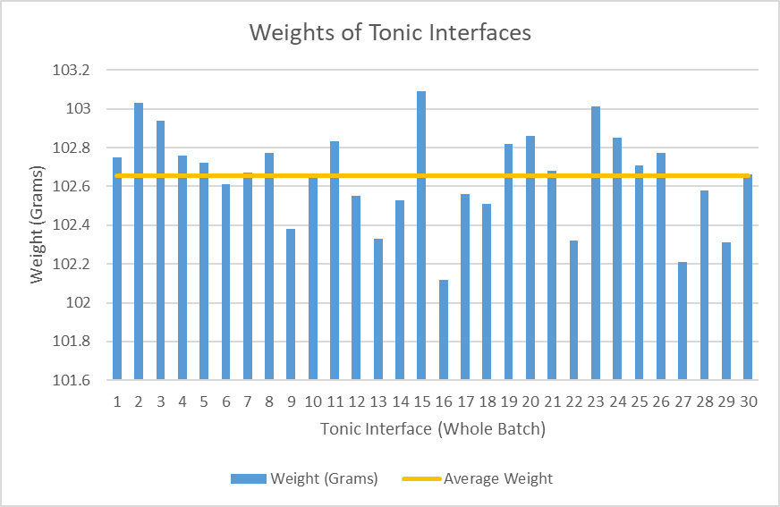
Figure 18 – Average weight of Tonic Interface (30 batch)

REVIEW ANALYSIS METHODS

ROOT CAUSE ANALYSIS

5 WHYS ON WEIGHT ERRORS
The 5 why analysis method aims to find the root cause of a problem. For this report, the problem is there is an excess of PICAs being raised due to weight errors on the packing rigs.
- Why?
An increasing number of items weighed are outside of the specified weight tolerance.
- Why?
There are multiple products of varying weights with individual packing requirements.
- Why?
The product box and component weight tolerances stack together.
- Why?
All items being packed are currently weighed together in a single-end weighing process.
- Why?
The process does not currently allow for individual item weighing.
Therefore, the root cause is the single‑end weighing method does not control tolerance stacking.

GRAPHICAL ANALYSIS TOOLS

INITIAL INVESTIGATION OF VARIATION IN BOX WEIGHT DUE TO SUPPLIER
Although the variation in weight between boxes shown in Figure 19 may seem minimal, if these were not appropriately accounted for there would be issues with a stacking of tolerance related errors.
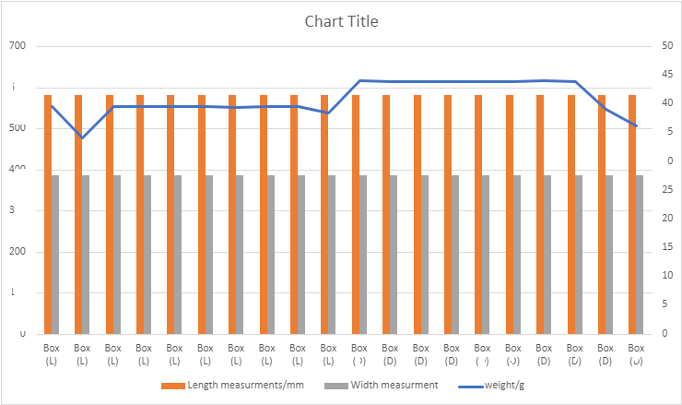
Figure 19 – Box weight variation in supplier

PROBABILITY PLOT FOR SELECTION OF PLOT TYPE
Distribution analysis was used to identify the most appropriate type of plot for assessing process capability. A best‑fit distribution was selected from the probability plot of the whole unit, as can be seen in Figure 20; the top left “Normal – 95% Cl” was chosen.
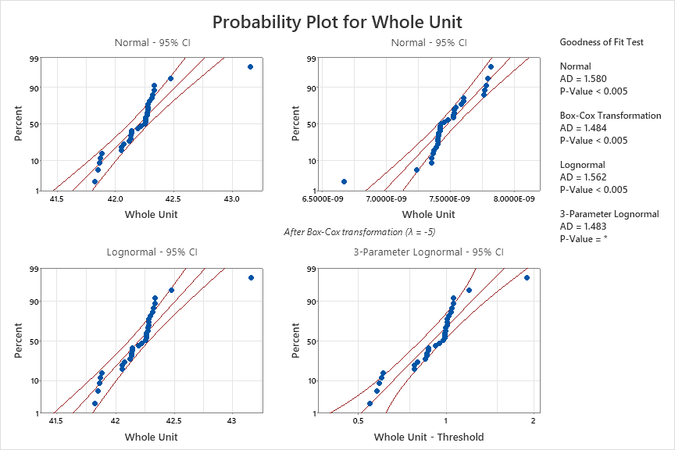
Figure 20 – Probability Plot (Whole Unit) Distribution Identification

RIG VARIATION
Figure 21 presents the weight data for 20 boxes, each of which was individually weighed across the five packing rigs. It illustrates the variation in weight between the 20 boxes, all of which were supplied by the same supplier, Fiske.
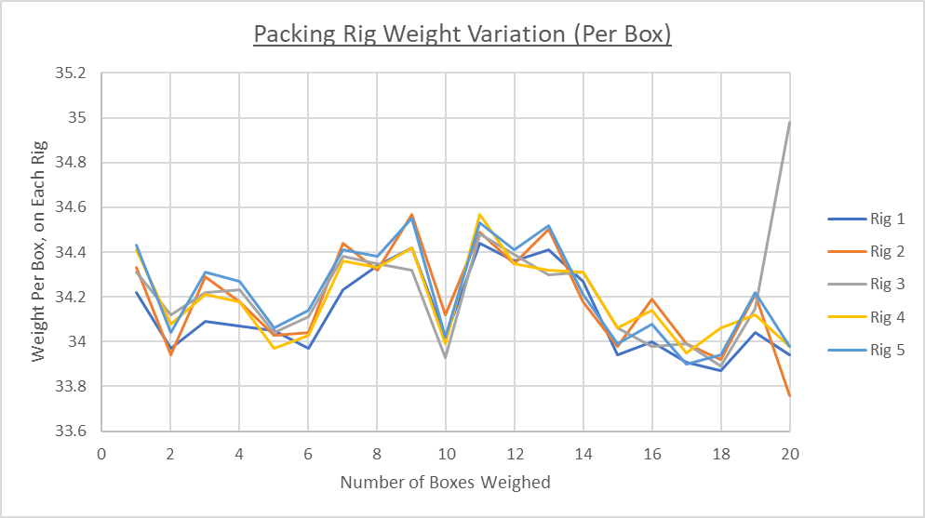
Figure 21 – Packing Rig Variation

HISTOGRAM PLOTS
Analysis of Figure 22, Figure 23, Figure 24 and Figure 25 show that rig 2 was the most reliable packing rig, which is where all trail related data will be taken from.
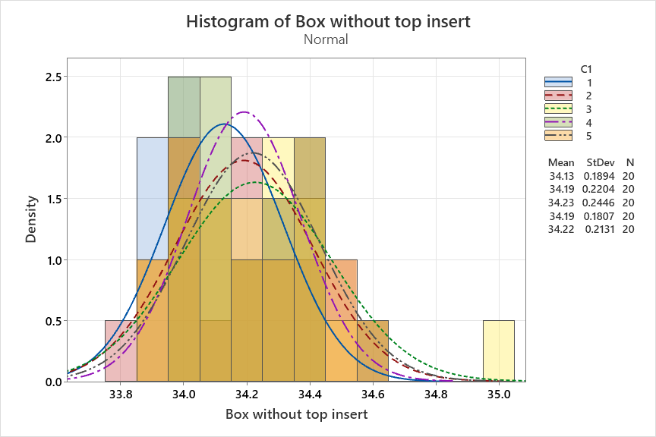
Figure 22 – Rig variation histogram (Box, no top insert)

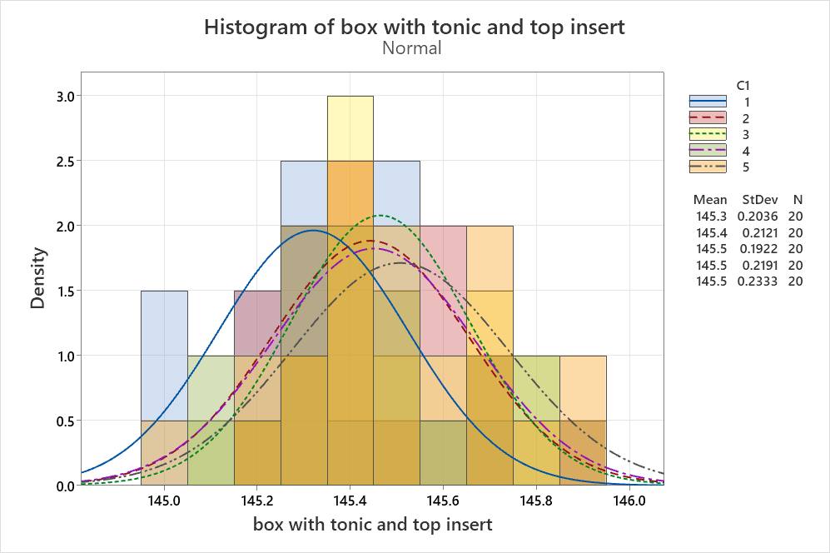
Figure 23 – Rig variation histogram (Box, top insert & Tonic)
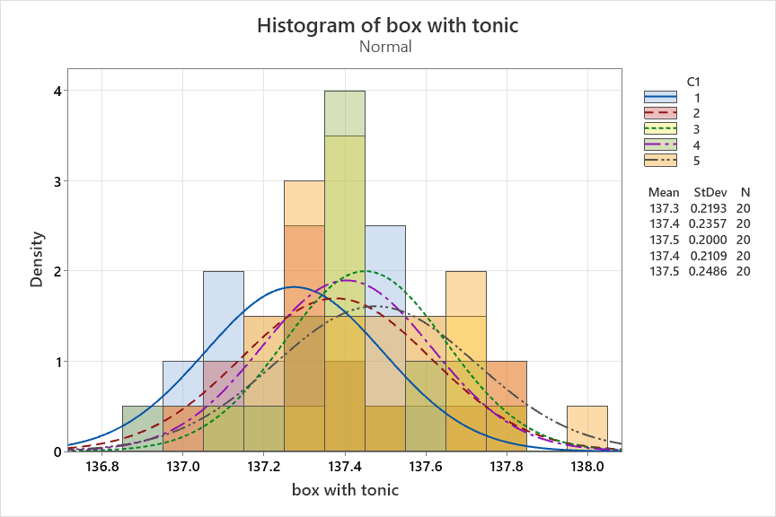
Figure 24 – Rig variation histogram (Box with Tonic)
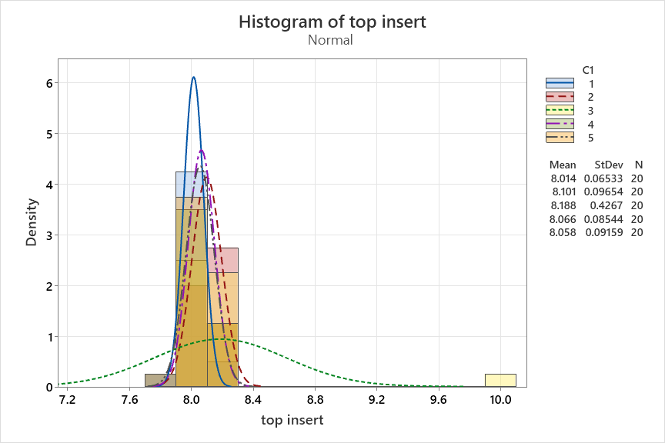
Figure 25 – Rig variation histogram (top insert)

WEIGHT DISTRIBUTION OF BOXES
To establish initial tolerances, 36 boxes were weighed on the same packing rig to gauge the variation in box weight. Following data analysis, it was observed that the weight distribution on rig 2 was the most nominal when compared across all five rigs. As a result, rig 2 was identified as the most consistent and was therefore used to assess box weight variation.
Figure 26, Figure 27, Figure 28, Figure 29 and Figure 30 illustrate the weight distribution of the 36 randomly selected boxes weighed on this rig. This analysis was used to determine appropriate upper and lower tolerance limits for packing the product.
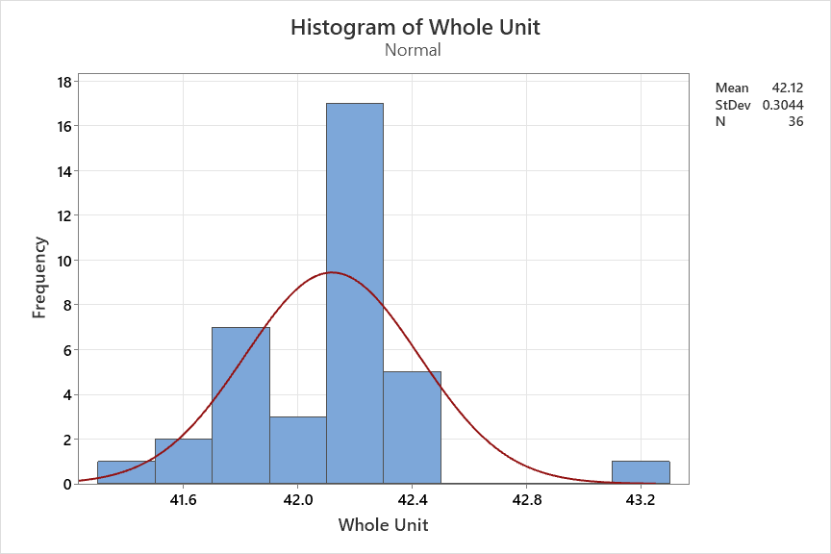
Figure 26 – Box weight distribution histogram (whole unit)
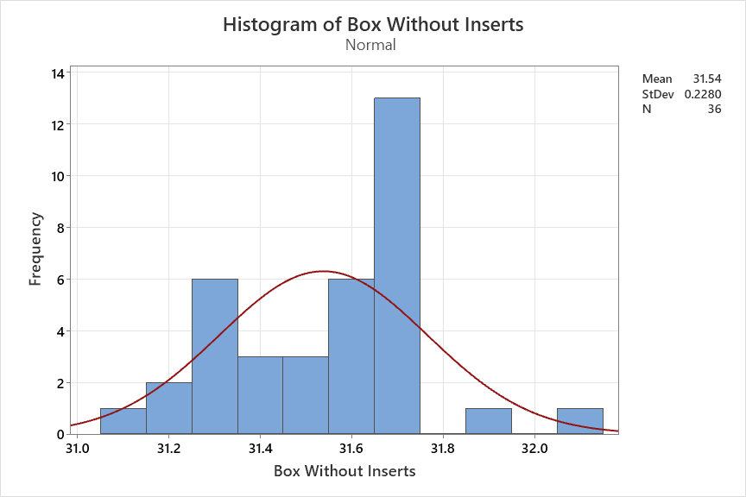
Figure 27 – Box weight distribution histogram (box without inserts)
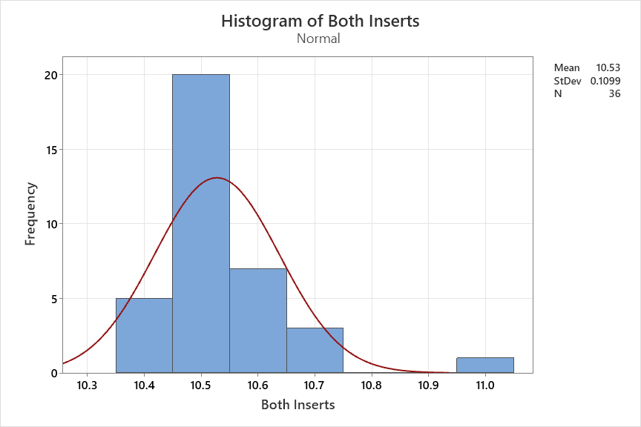
Figure 28 – Box weight distribution histogram (both inserts)

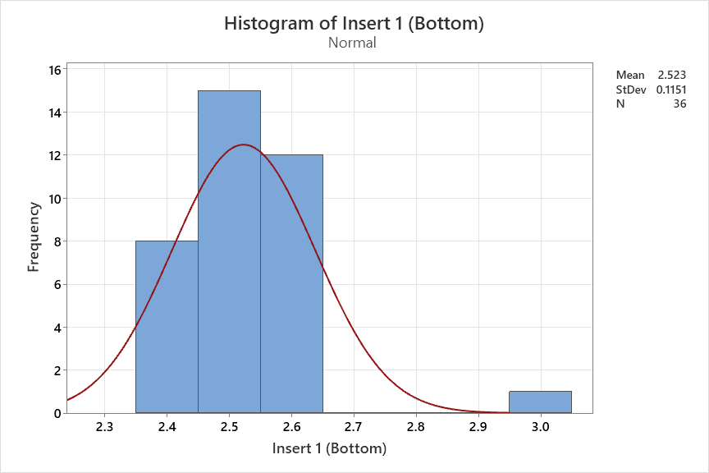
Figure 29 – Box weight distribution histogram (insert 1)
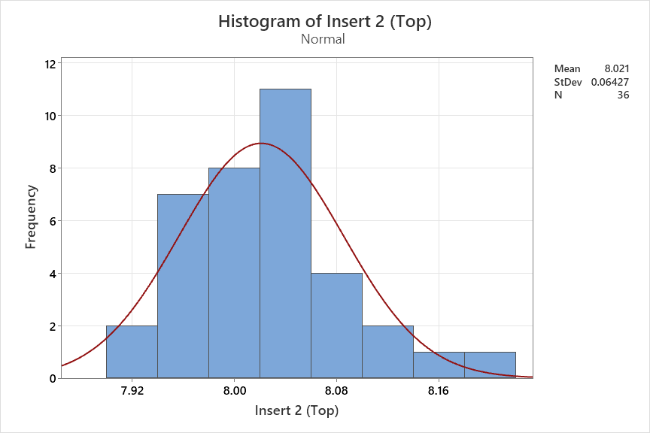
Figure 30 – Box weight distribution histogram (insert 2)

EXPLORATORY DATA ANALYSIS & HYPOTHESIS TESTING

4-SIGMA UPPER AND LOWER WEIGHT TOLERANCES
Initial tolerance limits were established using a 4‑sigma approach based on the overall standard deviation of box weight data, resulting in specification limits of 43.17 g (USL) and 41.22 g (LSL) for the empty box. An additional 1% tolerance was applied to allow for the weight of the pink static bag (approximately 1 g) and to support practical implementation.
For comparison, 2‑sigma limits of 42.69 g (USL) and 41.71 g (LSL) were calculated but found to be insufficient to accommodate observed variation. Analysis using within‑standard‑deviation values produced revised 4‑sigma limits of 41.62 g (LSL) and 42.77 g (USL), highlighting differences between short‑term and overall process variation.
Validation trials showed that the initial “ideal” tolerances were too restrictive due to supplier box weight variation. In addition, GPTR software limitations, which restrict tolerance inputs to whole‑number percentages, required further widening of limits. Final tolerances were therefore set to balance statistical capability, validation performance, software constraints, and manufacturability.
The resulting 4‑sigma tolerances were defined for the box, inserts, and product components and were supported by process capability analysis demonstrating a Cpk of approximately 1.33. A 6‑sigma approach was not adopted, as a 4‑sigma process provides a substantial defect reduction and aligns with organisational standards.
Table 10 – 4 Sigma Process Capability Tolerlances
4 Sigma Process Capability Tolerances

Object | Mean | Lower | Upper | Nominal | Lower % | Upper %
box without both inserts | 31.5939 | 31.09 | 32.09 | 31.5939 | 1.5949% | -1.5702%
Tonic interface | 102.653 | 101.69 | 103.62 | 102.653 | 0.9381% | -0.9420%
insert 1 | 2.52323 | 2.23 | 2.82 | 2.52323 | 11.6212% | -11.7615%
insert 2 | 8.01903 | 7.82 | 8.21 | 8.01903 | 2.4820% | -2.3815%
box with inserts but no product | 42.1981 | 41.62 | 42.77 | 42.1981 | 1.3700% | -1.3553%

4-SIGMA PROCESS CAPABILITY GRAPHS
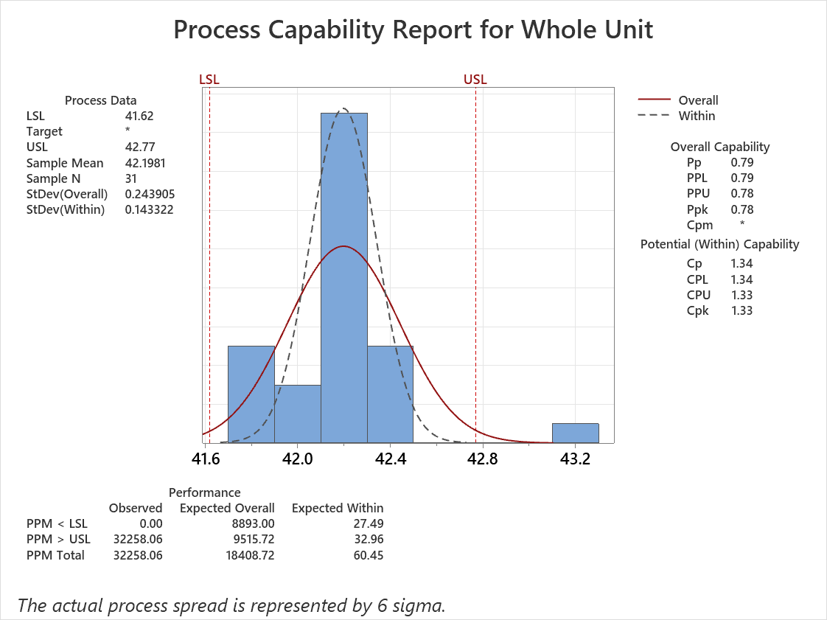
Figure 31 – 4 Sigma process cabability report (whole unit)

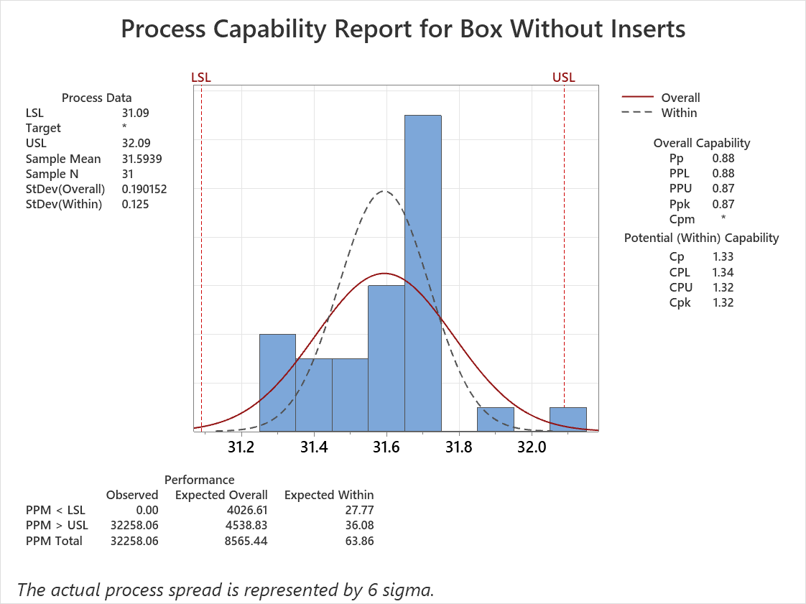
Figure 32 – 4 Sigma process cabability report (box without inserts)

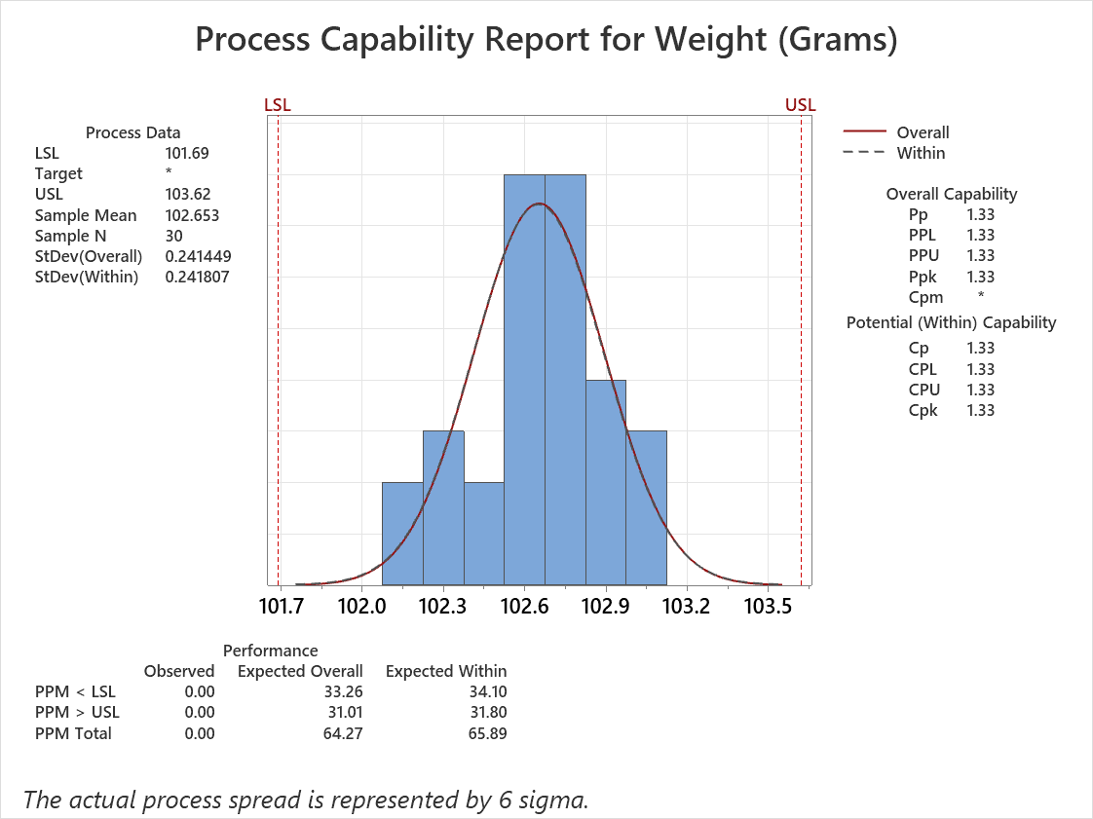
Figure 33 – 4 Sigma process capability (Product)
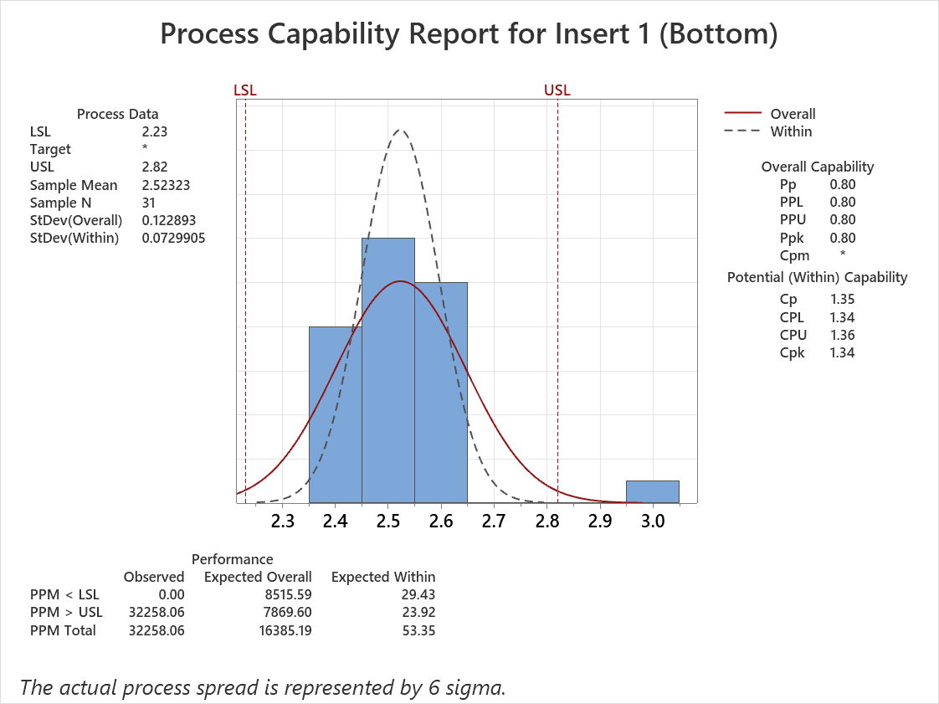
Figure 34 – 4 Sigma process cabability report (insert 1)
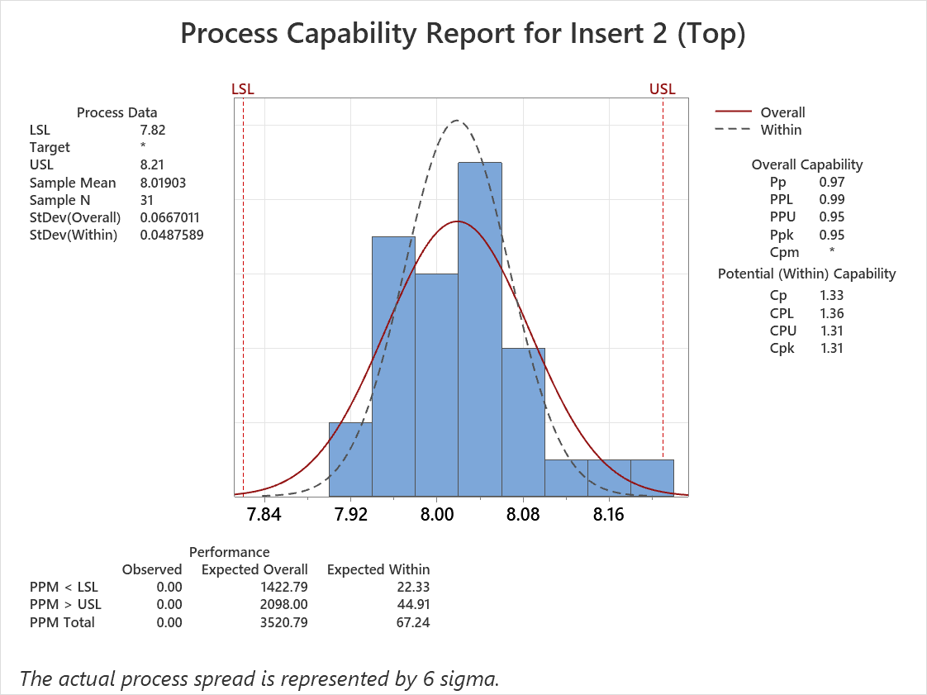
Figure 35 – 4 Sigma process cabability report (insert 2)

IMPROVE PHASE

GENERATE IMPROVEMENT ALTERNATIVES & SOLUTION JUSTIFICATION
Alternative improvement options to the current single‑end weighing process include standardising box tare weights; however, this approach could increase the risk of an incorrect box being used for the wrong product. To mitigate this, additional materials and work instructions would need to be introduced, which could add further complexity and potential for error.
Another possible solution is automated weight capture using vision equipment. While this could improve accuracy, it represents a high‑cost option and could ultimately lead to increased automation, potentially impacting operator roles.
Staged weighing is the preferred solution, as it does not negatively impact operators, requires minimal changes to the existing process, and has a low implementation cost. In addition, the potential savings in time and cost resulting from improved process efficiency make this option particularly favourable.

COST/BENEFIT ANALYSIS
Error prevention results in reduced rework and can lead to improved process compliance. Analysis of reported weight‑change PICAs between 2020 and 2022 indicates that approximately 219,000 seconds of rig downtime occurred. Based on an average packing time of 72 seconds per unit, this equates to 3,041 units that could not be packed during this period.
Using an approximate Tonic Interface unit value of £37.87, this represents a potential delayed or lost revenue value of £115,162.67 across the 2020–2022 period, excluding labour costs.
Although the staged weighing process increases packing time per unit and therefore increases labour cost, it is expected to significantly reduce the number of PICAs raised due to weight‑related issues. As a result, overall rig downtime and associated lost production capacity are anticipated to decrease.
The labour rate is approximately £37.70 per hour, equivalent to £0.01047 per second (approximately 1.05 pence per second), as shown in Table 11. The estimated additional labour cost per unit due to staged weighing is £0.46. In 2022, 33,660 Tonic Interface units were manufactured, resulting in a predicted annual labour cost increase of approximately £15,483.60.
This increase must be balanced against the reduction in downtime, rework, and PICA‑related disruptions, which represent a significant source of hidden cost within the current process.
Table 11 – Packing Cost Analysis
 | Time (Seconds) | Cost to Pack (£ per Second)
Single-end Packing (1 Unit) | 72 | £0.75384 = £0.75
Staged Packing (1 Unit) | 115.1 | £1.205097 = £1.21
Staged packing labour increase |  | = £0.46

PILOT PROPOSALS AND VALIDATE IMPROVEMENTS

PACKING TRIAL ROUTE MANAGEMENT
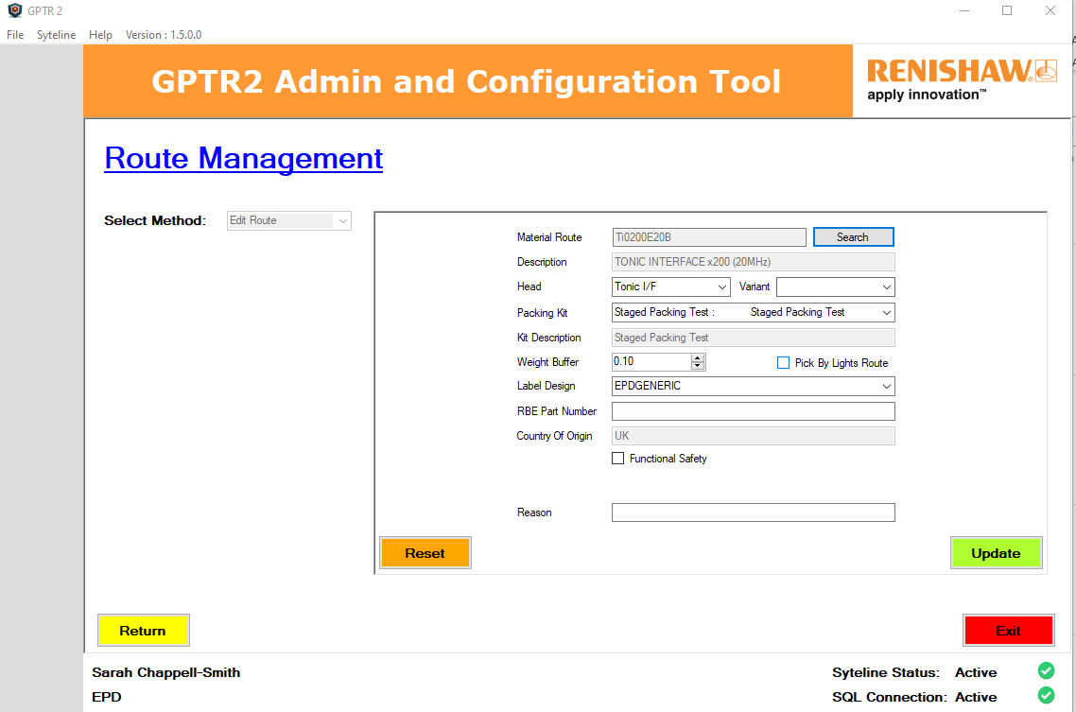
Figure 36 – GPTR2 Packing software (Route management)

VALIDATE IMPROVEMENTS
The complete validation report can be found in the appendix on page Error! Bookmark not defined.. It contains the validation activities which were carried out in the staged weight packing trials of the proposed changes to the packing system, as well as listings potential risks.

VALIDATION PLAN
The validation plan was designed to test whether the GPTR software functioned as intended with the new weight tolerances and correctly failed where anticipated. The test scenarios included the full proposed process, the process without product, an incorrect box with product, product packed without inserts, product without the bottom insert, product without the top insert, and product without both inserts.

CONCESSION PLAN
Non‑Conformity (Description of the Issue):
The current packing system is not sufficient, with PICAs being raised on a regular basis. Under the existing weighing system and tolerances, there is a risk that products may be packed into incorrect boxes, increasing the potential for process errors and mis‑shipments.
Concession (Proposed Change, Justification, and Duration):
A proof‑of‑concept batch of ten Tonic Interface units will be produced and submitted to engineering upon completion. The proposed staged weighing packing system will be trialled within the packing area under engineering oversight. Products produced during the trial will be accepted into stock. The concession will be closed following engineering approval at the conclusion of the trial.

VALIDATION REPORT
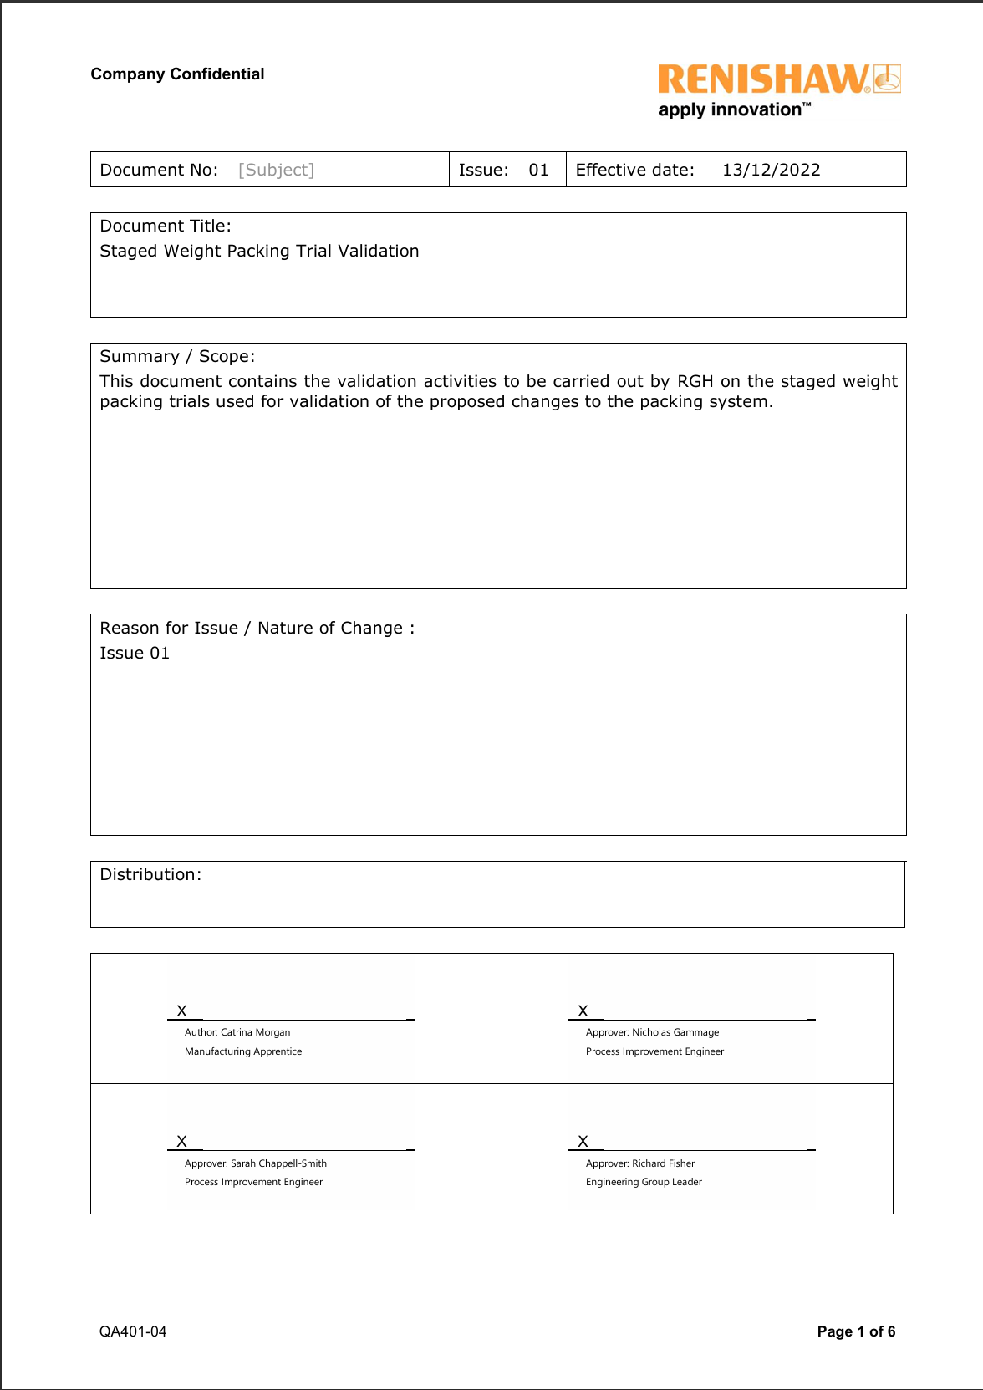
Figure 37 – Validation report page 1/6
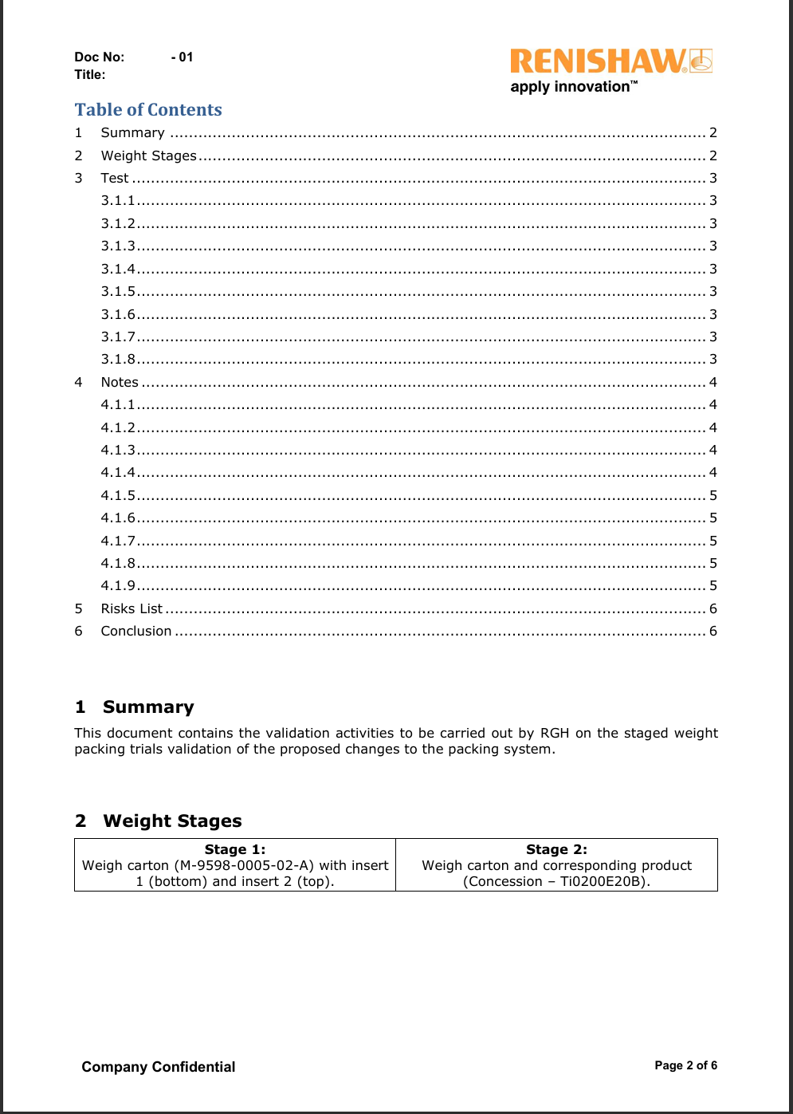
Figure 38 – Validation report page 2/6
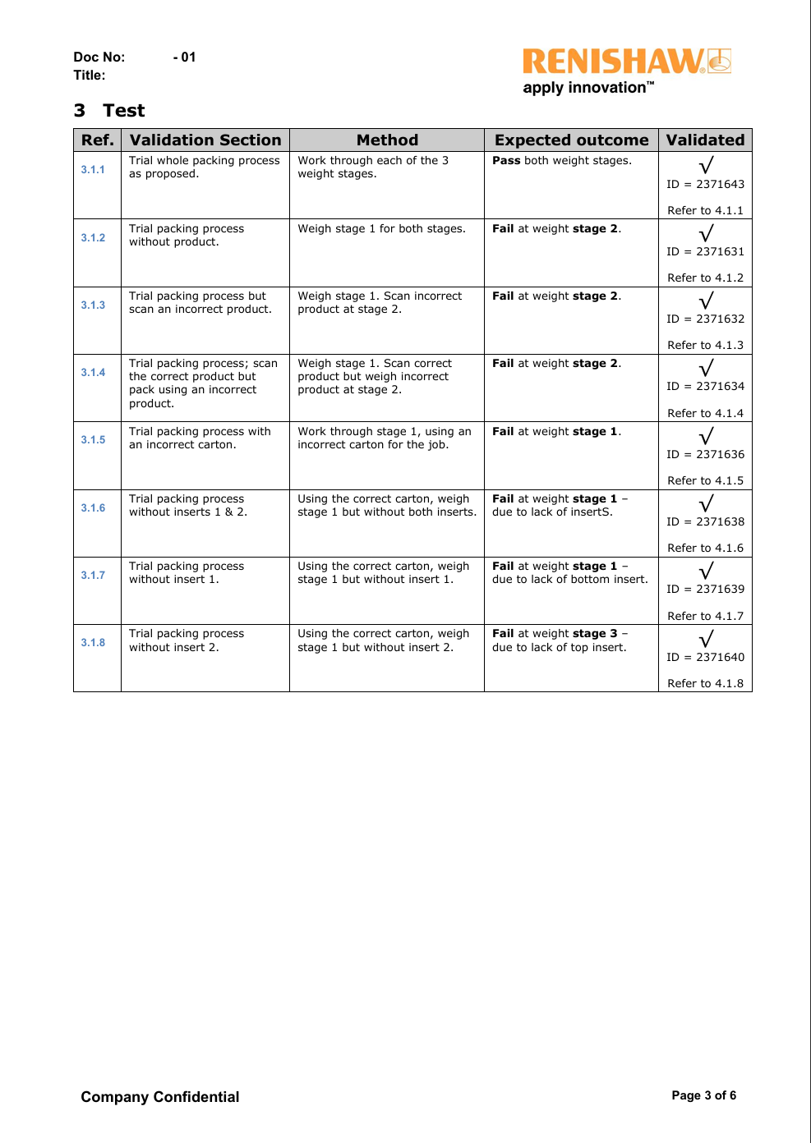
Figure 39 – Validation report page 3/6
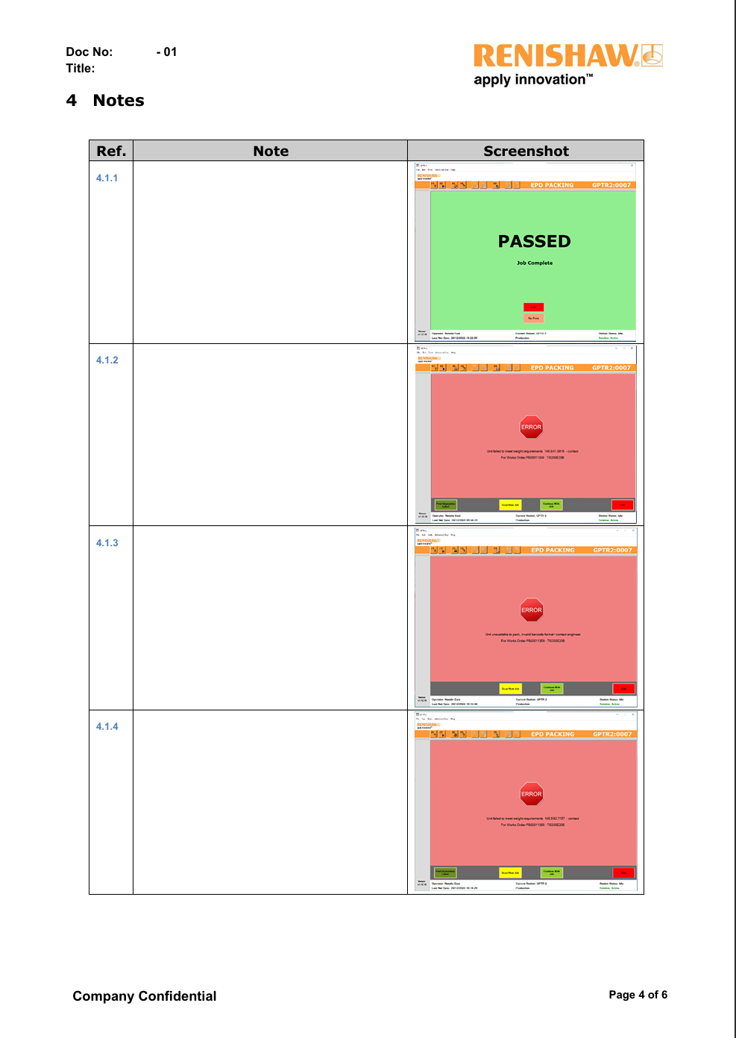
Figure 40 – Validation report page 4/6
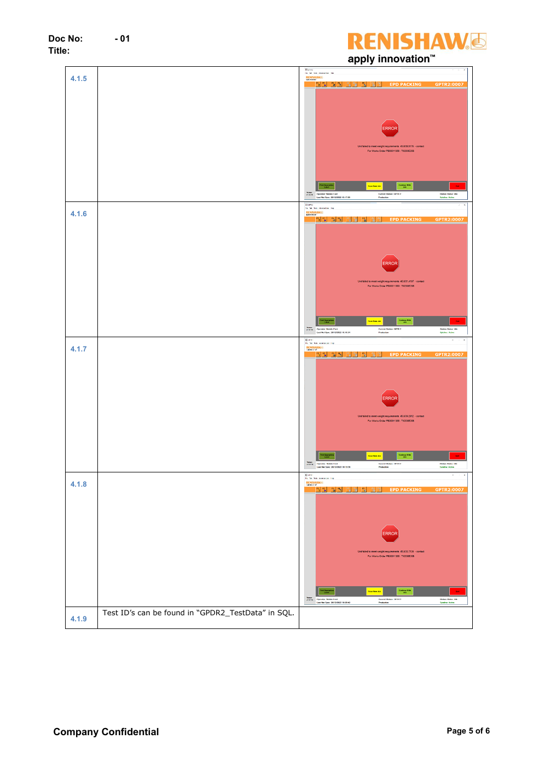
Figure 41 – Validation report page 5/6

Figure 42 – Validation report page 6/6

CONTROL PHASE
Process control measures, such as work instructions (WIs), act as the first line of defence in controlling a process and provide operators with guidance when completing their tasks. Up‑to‑date and comprehensive WIs are therefore critical to effective process control. The weight tolerances trialled in this report represent an initial step towards controlling the process with reduced reliance on operator input.
Standardising box tare weights would be an ideal solution; however, this is not currently achievable as box weights are dictated by the supplier and have been shown to vary. Each product weighed through the GPTR packing system is recorded within Syteline for reference and traceability.
Additional process monitoring could be implemented by packing cell leaders through routine spot checks, with more frequent audits conducted by the quality assurance (QA) department. Monthly control charts could also be used to visually monitor process stability. Where necessary, cell leaders may require training to carry out effective spot checks and to understand which issues require escalation to the engineering team.

CONCLUSION
In conclusion, the existing single‑end weighing process was shown to be operating at approximately a three‑sigma capability level, with a Cpk value of around 1. Following the implementation of the staged‑weight packing system, process capability improved to a Cpk value of approximately 1.33, corresponding to a four‑sigma level.
While true Six Sigma capability is generally associated with a Cpk value of 2.0 and a defect rate of approximately 3.4 defects per million opportunities, the objective of this project was to improve the performance of the existing three‑sigma process. This objective was successfully achieved through the implementation of a stable and process‑capable four‑sigma weighing system, resulting in improved control, reduced variation, and a lower likelihood of weight‑related packing errors.

FURTHER WORK
A further area of investigation is the comparison of packing run times between the current packing system and the proposed staged‑weight packing system. To evaluate this, operators would be timed packing a prove‑out batch of ten Tonic Interfaces using the existing method, including building boxes during the process rather than using pre‑made boxes. To ensure representative results, three operators would complete the same task under identical conditions. The individual timings would be averaged to establish a baseline packing time, with an additional 10%-time allowance applied as a buffer to account for normal operator and environmental variability.
The same timing study would then be repeated using the proposed packing system, following the same methodology. The resulting average packing times would be compared to determine whether the proposed system introduces any increase or reduction in build time and to assess the overall impact on packing efficiency.
In addition, a longer‑duration trial should be conducted during live production to collect PICA call‑out data specifically related to packing weight issues. Extending the trial period would enable a more robust assessment of whether the staged‑weight packing system reduces the number of weight‑related PICA call‑outs. A reduction in these call‑outs would provide further evidence that the proposed system improves process robustness, reduces variation‑driven disruptions, and enhances overall packing reliability.

POTENTIAL RISKS

Risk of packing the incorrect product
During the second validation trial, an additional 1% tolerance (approximately 1 g) was introduced to allow for the weight of the pink anti‑static bag and to widen the original tolerance limits, following unexpected failures observed in the first validation trial. While the validation report demonstrated that the incorrect product could not be packed into the boxes used during this trial, this does not guarantee that such a scenario could never occur. Further validation using a wider range of box weights and product combinations would be required to fully mitigate this risk and increase confidence in the robustness of the packing system.

Customer impact risk
If the packing system were to fail, there is a risk that an incorrect product could be dispatched to the customer. This could lead to customer complaints, damage to the company’s reputation, and potential wider reputational consequences within the customer base.

Supplier box weight variation
Supplier‑provided boxes have been shown to exhibit occasional significant weight variation. The current tolerance limits may not fully account for heavier boxes, which could result in packing issues if such boxes are introduced into production without prior detection.

Incorrect box–product combinations
There remains a risk of packing an incorrect product into an incorrect box, or the correct product into an incorrect box. Either scenario could result in insufficient protection during shipping, potentially leading to product damage.

BIBLIOGRAPHY
Apte, D., Rege, R.A., Pradhan, V. and Ambekar, S.A. (2025). Gain in profitability against reduction in hidden factory achieved through Rolled Throughput Yield – A case study. Quality Management Journal, 32(2), pp.55–66. doi:https://doi.org/10.1080/10686967.2025.2483166.
ASQ (2017). ISO 22514-2:2017: Statistical methods in process management - Capability and performance - Part 2: Process capability and performance of time-dependent process models | ASQ. [online] Asq.org. Available at: https://asq.org/quality-press/display-item?item=T1097E [Accessed 4 Mar. 2026].
Brown, C. (2019). Why and how to employ the SIPOC model. Journal of Business Continuity & Emergency Planning, [online] 12(3), pp.198–210. Available at: https://www.ingentaconnect.com/content/hsp/jbcep/2019/00000012/00000003/art00002 [Accessed 30 Mar. 2026].
Czabak-Górska, I.D. and Lorenc, M. (2017). AN ANALYSIS OF OCCURRENCE OF THE HIDDEN FACTORY PHENOMENON IN PRODUCTION – BASED ON THE SELECTED YIELDS – CASE STUDY. CBU International Conference Proceedings, 5, pp.94–98. doi:https://doi.org/10.12955/cbup.v5.908.
Edgeman, R.L. (2025). SIPOC and COPIS: The Business Flow—Business Optimization in a Six Sigma Context. International Encyclopedia of Statistical Science, pp.2350–2353. doi:https://doi.org/10.1007/978-3-662-69359-9_573.
Illowsky, B. and Dean, S. (2020). OpenStax. [online] openstax.org. Available at: https://openstax.org/details/books/statistics [Accessed 4 Mar. 2026].
ISO (2026). ISO 22514-2. [online] ISO. Available at: https://www.iso.org/standard/88883.html [Accessed 3 Feb. 2026].
Keil, S., Eberts, D. and Rainer Lasc (2013). Designing product workflow for logistics a hidden potential for cycle time and cost reduction as well as quality improvement in high-tech-factories. doi:https://doi.org/10.1109/asmc.2013.6552770.
Kotz, S., Pearn, W.L. and Johnson, N.L. (1993). Some Process Capability Indices are More Reliable than One Might Think. Applied Statistics, 42(1), p.55. doi:https://doi.org/10.2307/2347409.
Mishra, P. and Kumar Sharma, R. (2014). A hybrid framework based on SIPOC and Six Sigma DMAIC for improving process dimensions in supply chain network. International Journal of Quality & Reliability Management, 31(5), pp.522–546. doi:https://doi.org/10.1108/ijqrm-06-2012-0089.
Montgomery, D.C. (2019). Introduction to Statistical Quality Control. Wiley.
Renishaw (2025). Six Sigma Process Capability Training Material. [Video].

APPENDICES

PACKING RIG DOWNTIME – PICA CALLOUTS
Table 12 – Packing rig downtime due to PICA callouts
Item Description | Engineering Area | PICA Priority | Total Minutes Resolving
 | Interfaces | Red | 15
 | Interfaces | Amber | 90
 | Interfaces | Amber | 50
 | Packing | Red | 60
TONIC ANALOGUE INTERFACE | Interfaces | Amber | 15
TONIC INTERFACE x40 (1MHz) | Interfaces | Amber | 15
 | Resolute | Red | 15
RGH20 0.5um 5m CABLE 9w-D | RGH | Red | 30
RGH20 0.5um 5m CABLE 9w-D | RGH | Amber | 10
RGH24 1Vpp 3m CABLE No Conn | RGH | Amber | 10
 | RGH | Amber | 30
RGH22 0.5um 5m CABLE 15w-D | RGH | Amber | 40
 | Resolute | Red | 15
 | Resolute | Amber | 15
RGH20 1um 5m CABLE 9w-D | RGH | Green | 30
RGH22 0.1um 1m CABLE 10MHz | RGH | Green | 30
TONIC INTERFACE x200 (25MHz) | Interfaces | Red | 40
TONIC INTERFACE x2000 (10MHz) | Interfaces | Red | 5
RGH22 0.5um 0.3m CABLE 15w-D | RGH | Red | 20
RH200 1Vpp 3.0m CABLE 9w-D | RGH | Red | 5
53-00891 READHEAD 0.5um 3m F/LEAD | RGH | Red | 20
RESOLUTE FAN 1nm 37BIT 5.0M 9WD RTLA | Resolute | Amber | 15
RESOLUTE MITS 50nm 4 WIRE 9.0M 10W RTLA | Resolute | Red | 10
RESOLUTE UHV BiSS 26BIT/100DIA 0.5M FL | Resolute | Red | 75
TONIC DUAL O/P INTERFACE 5um 50MHz | Interfaces | Amber | 30
 | Interfaces | Red | 45
TONIC DUAL O/P INTERFACE 0.2um 20MHz | Interfaces | Red | 25
 | Packing | Amber | 60
 | Interfaces | Red | 30
RGH22 0.5um 0.5m CABLE 15w-D | RGH | Red | 35
RGH22 1um 5m CABLE 15w-D | RGH | Red | 10
TONIC DUAL O/P INTERFACE 0.1um 50MHz | Interfaces | Green | 10
TONIC INTERFACE x200 (40MHz) | Interfaces | Amber | 90
TONIC INTERFACE x200 (40MHz) | Interfaces | Amber | 10
RGH22 1um 5m CABLE 15w-D | RGH | Red | 30
 | Interfaces | Red | 40
 | RGH | Red | 25
 | Interfaces | Amber | 25
RGH22 0.1um R/TOP 20MHz | RGH | Amber | 20
RGH22 1um 0.7m CABLE 9w-D | RGH | Amber | 60
RGH22 0.5um 0.3m CABLE 15w-D | RGH | Amber | 30
RGH24 0.1um 1m CABLE 9wD 8MHz | RGH | Amber | 35
RGH22 0.1um 3m CABLE 5MHz | RGH | Red | 45
 | Packing | Amber | 30
 | Packing | Red | 30
RGH20U VACUUM 1.5m CABLE 15WD | RGH | Red | 30
 | RGH | Red | 30
 | RGH | Amber | 50
RGH22 1Vpp 1m CABLE 15w-D | RGH | Amber | 35
 | Packing | Red | 40
53-70036 READHEAD 1um 1.5m F/LEAD | RGH | Red | 30
53-70036 READHEAD 1um 1.5m F/LEAD | RGH | Amber | 30
RH200 0.5um 0.5m CABLE 9w-D | RGH | Green | 20
RGH24 1um READHEAD JST | RGH | Amber | 30
RGH34 INTERFACE 0.2um 4MHz REF | RGH | Amber | 20
 | Packing | Amber | 30
RGH41 1um 1.5m CABLE 15w-D D/L | RGH | Amber | 20
RGH41 0.4um 5m CABLE 5MHz | RGH | Amber | 15
 | Packing | Amber | 10
RGH34 INTERFACE 0.2um 4MHz REF | RGH | Red | 30
 | RGH | Amber | 15
 | RGH | Amber | 15
DONGLE INTERFACE ASSEMBLY | Interfaces | Red | 15
REE INTERPOLATOR x100 (12MHz) | Interfaces | Red | 20
 | Packing | Red | 30
 | Interfaces | Red | 30
TONIC INTERFACE x200 (20MHz) | Interfaces | Red | 10
 | RGH | Red | 15
RGH22X 1um 260mm CABLE IN-LINE CONNECTOR | RGH | Red | 10
RGH22 5um 0.7m CABLE 9w-D | RGH | Red | 20
REF INTERPOLATOR x2000 (8MHz) | Interfaces | Red | 15
RGH22 1um RIBBON TOP | RGH | Red | 45
RGH24 1um READHEAD JST | RGH | Red | 15
RGH22 0.5um 3m CABLE 15w-D | RGH | Red | 15
TONIC INTERFACE x20KD (1MHz) | Interfaces | Red | 0
RGH22 1Vpp RIBBON TOP | RGH | Red | 30
REE INTERPOLATOR x400 (3MHz) | Interfaces | Red | 15
RGH24 0.1um READHEAD JST 4MHz | RGH | Red | 15
RGH20 0.5um 5m CABLE 9w-D | RGH | Red | 15
TONIC INTERFACE x2000 (20MHz) | Interfaces | Amber | 10
 | Packing | Red | 10
 | Interfaces | Red | 20
 | Interfaces | Red | 0
 | Packing | Red | 30
TONIC INTERFACE x20 (20MHz) | Interfaces | Red | 35
 | Interfaces | Red | 35
 | Interfaces | Red | 30
TONIC INTERFACE x400 (8MHz) | Interfaces | Amber | 15
DSi 15WAY FULL, REMOTE, LINE DR, 6MHz | Interfaces | Amber | 5
 | Packing | Amber | 15
 | Packing | Amber | 15
 | Packing | Red | 60
 | Interfaces | Red | 30
TONIC ANALOGUE INTERFACE | Interfaces | Red | 5
 | Packing | Red | 5
TONIC DUAL O/P INTERFACE 20nm 4MHz | Interfaces | Red | 5
TONIC DUAL O/P INTERFACE 0.1um 25MHz | Interfaces | Red | 5
TONIC INTERFACE x200 (40MHz) | Interfaces | Red | 60
DSI 15W FULL,REMOTE,LINE DR,1MHz, DIV4 | Interfaces | Red | 15
 | Packing | Red | 15
 | Packing | Red | 15
RGH34 INTERFACE 0.1um 8MHz REF | RGH | Red | 10
TONIC DUAL O/P INTERFACE 0.5um 12MHz | Interfaces | Red | 10
 | Packing | Red | 15
RGH34 INTERFACE 1um REF MARK | RGH | Amber | 10
RGH24 50nm 3m CABLE 9wD 12MHz | RGH | Amber | 30
RH200 0.5um 3.0m CABLE 9w-D | RGH | Red | 15
RGH24 1um 5.0m CABLE 15WD | RGH | Amber | 45
RGH24 0.5um 3m CABLE 9w-D | RGH | Red | 30
RH200 1um 1.5m CABLE 9w-D | RGH | Red | 30
TONiC Analog 2V5 VMID INTERFACE | Interfaces | Red | 15
 | Packing | Red | 5
RH200 0.5um 0.5m CABLE 9w-D | RGH | Red | 5
RGH24 0.1um READHEAD JST 12MHz | RGH | Red | 5
RGH20 5um 5m CABLE No Conn | RGH | Red | 10
TONIC DUAL O/P INTERFACE 5um 1MHz | Interfaces | Red | 10
TONIC INTERFACE x100 (1MHz) | Interfaces | Red | 5
TONIC INTERFACE x4000 (20MHz) | Interfaces | Red | 5
TONIC DUAL O/P INTERFACE 0.2um 12MHz | Interfaces | Red | 15
RGH24 0.1um 0.5mCABLE 15wD 12M | RGH | Red | 20
RGH34 INTERFACE 0.1um 8MHz REF | RGH | Red | 10
RGH20 0.1um 5m CABLE 12MHz | RGH | Red | 10
RGH20 0.2um 1.5mCABLE 15wD 6MH | RGH | Red | 10

PICA RESOLUTION TIME – ALTERNATIVE CHARTS
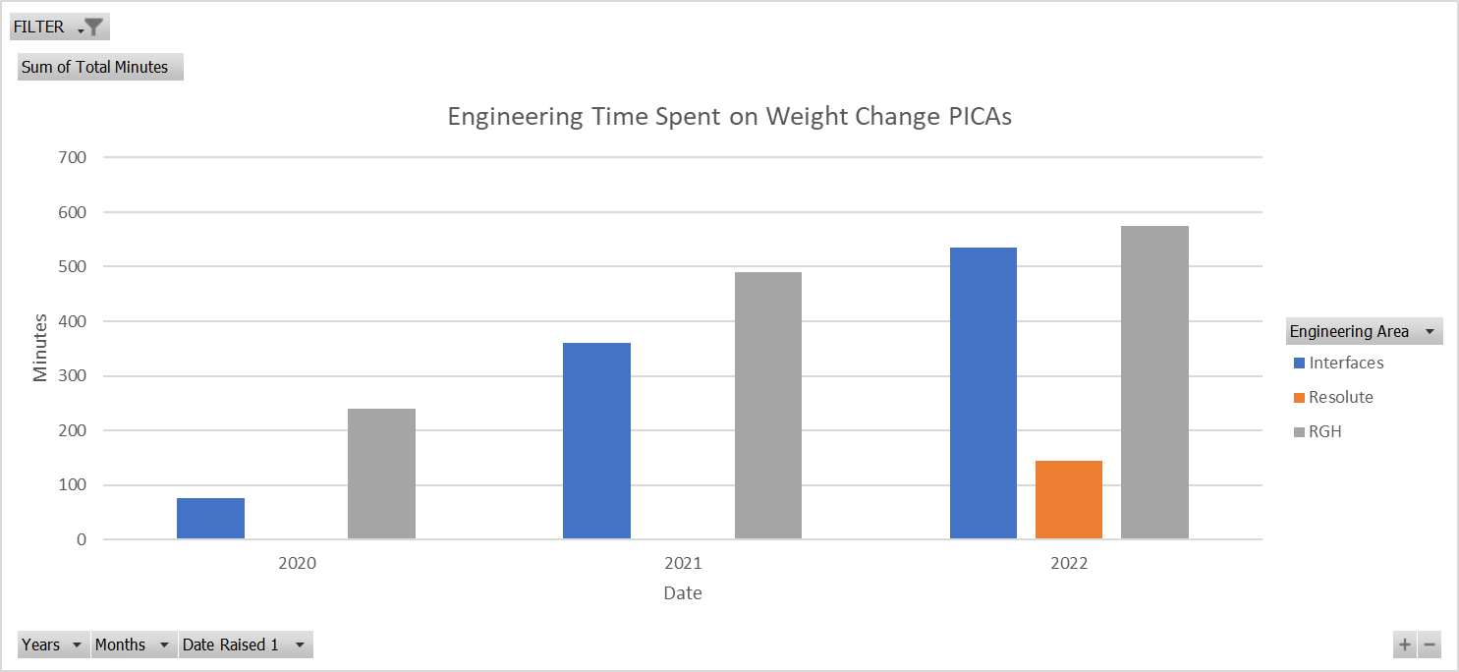
Figure 43 – PICA Resolution time (Condensed)
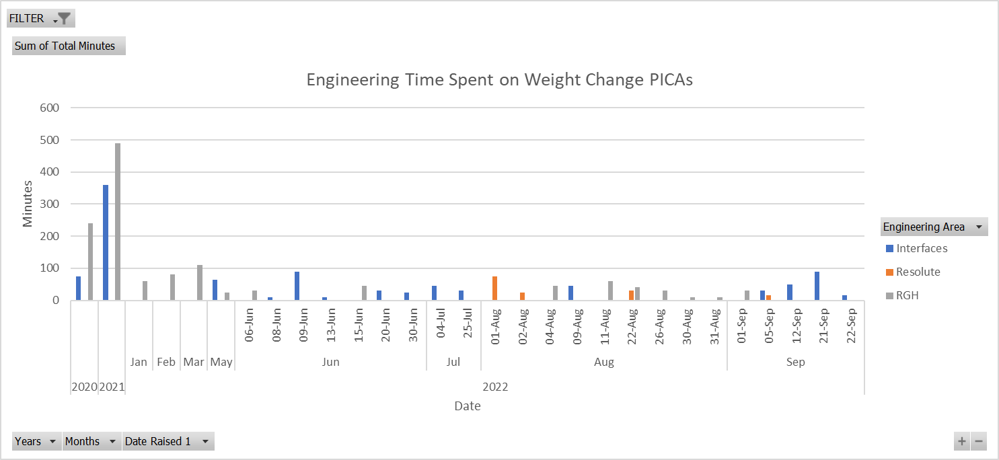
Figure 44 – PICA Resolution time (Expanded)

TONIC INTERFACE DATA (2008 – 2022)
Table 13 – Tonic Interface Data (2008 – 2022)
Description | Unit Cost | Avg Lot Size | Unit Weight (KG) | Qty On Hand | Dynamic Lead Time | Manufactured Prev Year | Sold Prev Year | Date
TONIC ANALOGUE INTERFACE | 13.4919 | 30 | 0.099 | 206 | 10 | 20,237.00 | 18,735.00 | 26/08/2008 11:19
TONIC INTERFACE x100 (4MHz) | 37.8687 | 1 | 0.144 | 0 | 10 | 25 | 25 | 05/09/2008 14:53
TONIC INTERFACE x4 (1MHz) | 37.8687 | 20 | 0.145 | 0 | 10 | 20 | 20 | 19/09/2008 09:18
TONIC INTERFACE x4 (40MHz) | 37.8687 | 1 | 0.143 | 0 | 10 | 0 | 0 | 19/09/2008 10:21
TONIC INTERFACE x40 (20MHz) | 37.8687 | 19 | 0.099 | 40 | 10 | 1,428.00 | 1,421.00 | 17/10/2008 06:57
TONIC INTERFACE x4 (4MHz) | 37.8687 | 2 | 0.144 | 0 | 10 | 93 | 93 | 13/11/2008 16:07
TONIC INTERFACE x40 (1MHz) | 37.8687 | 7 | 0.145 | 2 | 10 | 157 | 157 | 18/11/2008 16:10
TONIC INTERFACE x40 (40MHz) | 37.8687 | 1 | 0.147 | 0 | 10 | 33 | 33 | 28/11/2008 11:52
TONIC INTERFACE x40 (25MHz) | 37.8687 | 1 | 0.144 | 0 | 10 | 2 | 2 | 04/12/2008 07:20
TONIC INTERFACE x40 (10MHz) | 37.8687 | 3 | 0.146 | 2 | 10 | 313 | 313 | 05/12/2008 07:45
TONIC INTERFACE x4 (10MHz) | 37.8687 | 1 | 0.145 | 0 | 10 | 26 | 26 | 17/12/2008 16:15
TONIC INTERFACE x20 (10MHz) | 37.8687 | 3 | 0.099 | 0 | 10 | 38 | 11 | 17/12/2008 16:21
TONIC INTERFACE x100 (1MHz) | 37.8687 | 1 | 0.145 | 1 | 10 | 18 | 18 | 19/12/2008 07:58
TONIC INTERFACE x40 (4MHz) | 37.8687 | 6 | 0.143 | 0 | 10 | 371 | 370 | 19/12/2008 12:35
TONIC INTERFACE x20 (4MHz) | 37.8687 | 20 | 0.144 | 0 | 10 | 1,052.00 | 1,057.00 | 19/12/2008 12:39
TONIC INTERFACE x40 (8MHz) | 37.8687 | 4 | 0.143 | 0 | 10 | 0 | 0 | 08/01/2009 11:40
TONIC INTERFACE x4 (40MHz) | 37.8687 | 1 | 0.145 | 0 | 10 | 1 | 1 | 08/01/2009 16:12
TONIC INTERFACE x40 (8MHz) | 37.8687 | 2 | 0.142 | 0 | 10 | 12 | 13 | 23/01/2009 14:11
TONIC INTERFACE x20 (50MHz) | 37.8687 | 10 | 0.145 | 0 | 10 | 164 | 164 | 09/02/2009 15:54
TONIC INTERFACE x20 (20MHz) | 37.8687 | 4 | 0.145 | 0 | 10 | 486 | 486 | 16/02/2009 09:14
TONiC Analog 2V5 VMID INTERFACE | 15.9829 | 25 | 0.098 | 90 | 10 | 6,087.00 | 6,150.00 | 13/03/2009 12:22
TONIC INTERFACE x40 (10MHz) | 37.8687 | 1 | 0.143 | 0 | 10 | 0 | 0 | 19/03/2009 15:33
TONIC INTERFACE x20 (10MHz) | 37.8687 | 2 | 0.138 | 0 | 10 | 0 | 0 | 19/03/2009 15:38
TONIC INTERFACE x40 (12MHz) | 37.8687 | 17 | 0.143 | 0 | 10 | 6 | 5 | 19/03/2009 15:57
TONIC INTERFACE x20 (1MHz) | 37.8687 | 4 | 0.145 | 1 | 10 | 127 | 127 | 31/03/2009 14:25
TONIC INTERFACE x20 (12MHz) | 37.8687 | 3 | 0.145 | 0 | 10 | 110 | 110 | 07/04/2009 16:19
TONIC INTERFACE x4 (1MHz) | 37.8687 | 2 | 0.143 | 1 | 10 | 18 | 18 | 09/04/2009 16:48
TONIC INTERFACE x4 (8MHz) | 37.8687 | 1 | 0.143 | 0 | 10 | 0 | 0 | 17/04/2009 09:33
TONIC INTERFACE x4 (8MHz) | 37.8687 | 1 | 0.146 | 0 | 10 | 0 | 0 | 17/04/2009 09:34
TONIC INTERFACE x4 (50MHz) | 37.8687 | 1 | 0.14 | 0 | 10 | 0 | 0 | 17/04/2009 10:01
TONIC INTERFACE x100 (10MHz) | 37.8687 | 11 | 0.144 | 0 | 10 | 485 | 485 | 22/05/2009 10:19
TONIC INTERFACE x40 (50MHz) | 37.8687 | 6 | 0.143 | 0 | 10 | 106 | 106 | 10/06/2009 16:06
TONIC INTERFACE x20 (6MHz) | 37.8687 | 1 | 0.143 | 0 | 10 | 0 | 0 | 10/08/2009 15:44
TONIC INTERFACE x20 (8MHz) | 37.8687 | 5 | 0.099 | 0 | 10 | 69 | 69 | 13/08/2009 13:27
TONIC INTERFACE x20 (1MHz) | 37.8687 | 12 | 0.144 | 0 | 10 | 50 | 50 | 03/09/2009 15:34
TONIC INTERFACE x40 (1MHz) | 37.8687 | 2 | 0.144 | 0 | 10 | 15 | 15 | 02/11/2009 07:42
TONIC INTERFACE x40 (6MHz) | 37.8687 | 6 | 0.143 | 0 | 10 | 38 | 36 | 27/11/2009 11:05
TONIC INTERFACE x4 (20MHz) | 37.8687 | 2 | 0.145 | 0 | 10 | 15 | 15 | 07/12/2009 10:29
TONIC INTERFACE x40 (4MHz) | 37.8375 | 2 | 0.143 | 0 | 10 | 0 | 0 | 11/12/2009 08:38
TONIC INTERFACE x100 (8MHz) | 37.8687 | 10 | 0.146 | 0 | 10 | 91 | 91 | 21/12/2009 06:39
TONIC INTERFACE x40 (4MHz) | 37.8375 | 1 | 0.144 | 0 | 10 | 16 | 16 | 28/01/2010 11:26
TONIC INTERFACE x20 (4MHz) | 37.8375 | 9 | 0.143 | 0 | 10 | 45 | 45 | 30/01/2010 08:37
TONIC INTERFACE x20 (20MHz) | 37.8375 | 1 | 0.143 | 0 | 10 | 0 | 0 | 30/01/2010 08:45
TONIC INTERFACE x20 (6MHz) | 37.8687 | 2 | 0.101 | 33 | 10 | 0 | 3 | 09/02/2010 14:18
TONIC INTERFACE x40 (25MHz) | 37.8375 | 1 | 0.143 | 0 | 10 | 0 | 0 | 18/02/2010 08:22
TONIC INTERFACE x20 (10MHz) | 37.8375 | 2 | 0.143 | 0 | 10 | 0 | 0 | 05/03/2010 14:41
TONIC INTERFACE x40 (4MHz) | 37.8375 | 1 | 0.143 | 0 | 10 | 1 | 1 | 08/03/2010 06:24
TONIC INTERFACE x40 (20MHz) | 37.8375 | 2 | 0.143 | 0 | 10 | 0 | 0 | 08/03/2010 06:28
TONIC INTERFACE x20 (12MHz) | 37.8687 | 2 | 0.143 | 0 | 10 | 0 | 0 | 15/03/2010 12:50
TONIC INTERFACE x4 (1MHz) | 37.8687 | 30 | 0.146 | 0 | 10 | 52 | 52 | 16/03/2010 06:48
TONIC INTERFACE x4 (12MHz) | 37.8687 | 7 | 0.144 | 0 | 10 | 147 | 147 | 22/03/2010 11:52
TONIC INTERFACE x4 (50MHz) | 37.8687 | 1 | 0.135 | 0 | 10 | 0 | 0 | 15/04/2010 15:32
TONIC INTERFACE x20 (10MHz) | 37.8375 | 2 | 0.143 | 0 | 10 | 0 | 0 | 16/04/2010 12:24
TONIC INTERFACE x4 (6MHz) | 37.8687 | 2 | 0.138 | 0 | 10 | 0 | 0 | 19/04/2010 15:40
TONIC INTERFACE x20 (40MHz) | 37.8687 | 1 | 0.144 | 0 | 10 | 0 | 1 | 18/05/2010 11:42
TONIC INTERFACE x20 (4MHz) | 37.8687 | 1 | 0.145 | 0 | 10 | 0 | 0 | 18/05/2010 13:34
TONIC INTERFACE x4 (4MHz) | 37.8687 | 1 | 0.141 | 0 | 10 | 0 | 0 | 09/06/2010 10:26
TONIC INTERFACE x4 (4MHz) | 37.8375 | 1 | 0.145 | 0 | 10 | 0 | 1 | 10/06/2010 08:27
TONIC INTERFACE x20 (8MHz) | 37.8375 | 1 | 0.143 | 0 | 10 | 0 | 0 | 08/07/2010 14:23
TONIC INTERFACE x40 (4MHz) | 37.8375 | 2 | 0.098 | 0 | 10 | 7 | 7 | 23/07/2010 11:10
TONIC INTERFACE x4 (4MHz) | 37.8375 | 1 | 0.142 | 0 | 10 | 41 | 41 | 03/08/2010 13:48
TONIC INTERFACE x20 (1MHz) | 37.8375 | 1 | 0.144 | 8 | 10 | 12 | 2 | 16/08/2010 13:10
TONIC INTERFACE x20 (10MHz) | 37.8375 | 12 | 0.143 | 0 | 10 | 0 | 0 | 24/08/2010 10:05
TONIC INTERFACE x20 (1MHz) | 37.8375 | 4 | 0.145 | 0 | 10 | 8 | 8 | 26/08/2010 10:31
TONIC INTERFACE x4 (1MHz) | 37.8375 | 2 | 0.101 | 0 | 10 | 5 | 5 | 02/09/2010 15:40
TONIC INTERFACE x40 (1MHz) | 37.8375 | 2 | 0.143 | 0 | 10 | 0 | 0 | 03/09/2010 08:05
TONIC INTERFACE x40 (20MHz) | 37.8375 | 1 | 0.144 | 0 | 10 | 0 | 0 | 10/09/2010 10:18
TONIC INTERFACE x20 (1MHz) | 37.8375 | 2 | 0.145 | 0 | 10 | 16 | 14 | 13/09/2010 13:57
TONIC INTERFACE x40 (4MHz) | 37.8375 | 2 | 0.143 | 0 | 10 | 0 | 0 | 15/09/2010 15:28
TONIC INTERFACE x40 (4MHz) | 37.8687 | 1 | 0.143 | 0 | 10 | 0 | 0 | 20/09/2010 15:17
TONIC INTERFACE x40 (1MHz) | 37.8687 | 20 | 0.145 | 0 | 10 | 223 | 223 | 21/09/2010 15:23
TONIC INTERFACE x20 (25MHz) | 37.8687 | 2 | 0.143 | 1 | 10 | 0 | 0 | 22/09/2010 09:36
TONIC INTERFACE x40 (1MHz) | 37.8375 | 2 | 0.143 | 0 | 10 | 0 | 0 | 27/09/2010 16:01
TONIC INTERFACE x20 (1MHz) | 37.8687 | 2 | 0.143 | 0 | 10 | 0 | 0 | 19/10/2010 13:03
TONIC INTERFACE x20 (4MHz) | 37.8687 | 1 | 0.144 | 0 | 10 | 8 | 8 | 16/11/2010 13:15
TONIC INTERFACE x20 (50MHz) | 37.8375 | 100 | 0.143 | 0 | 10 | 0 | 0 | 18/01/2011 14:55
TONIC INTERFACE x4 (20MHz) | 37.8375 | 10 | 0.143 | 0 | 10 | 0 | 0 | 18/01/2011 15:47
TONIC INTERFACE x100 (4MHz) | 37.8375 | 2 | 0.144 | 2 | 10 | 0 | 0 | 25/01/2011 13:33
TONIC INTERFACE x4 (25MHz) | 37.8687 | 2 | 0.143 | 0 | 10 | 0 | 0 | 09/02/2011 10:11
TONIC INTERFACE x40 (4MHz) | 37.8687 | 1 | 0.143 | 0 | 10 | 0 | 0 | 17/03/2011 07:51
TONIC INTERFACE x40 (4MHz) | 37.8687 | 2 | 0.144 | 0 | 10 | 26 | 26 | 23/03/2011 11:38
TONIC INTERFACE x20 (1MHz) | 37.8375 | 5 | 0.144 | 0 | 10 | 331 | 331 | 05/04/2011 09:23
TONIC INTERFACE x100 (1MHz) | 37.8375 | 1 | 0.143 | 0 | 10 | 4 | 4 | 18/05/2011 11:06
TONIC INTERFACE x20 (4MHz) | 37.8375 | 2 | 0.143 | 0 | 10 | 12 | 12 | 24/05/2011 15:45
TONIC INTERFACE x20 (10MHz) | 37.8687 | 1 | 0.143 | 0 | 10 | 0 | 0 | 31/05/2011 08:44
TONIC INTERFACE x20 (6MHz) | 37.8375 | 1 | 0.143 | 0 | 10 | 0 | 0 | 01/06/2011 09:48
TONIC INTERFACE x40 (20MHz) | 37.8687 | 26 | 0.147 | 0 | 10 | 2 | 2 | 24/06/2011 09:04
TONIC INTERFACE x20 (20MHz) | 37.8687 | 4 | 0.145 | 0 | 10 | 21 | 24 | 14/07/2011 11:05
TONIC INTERFACE x20 (50MHz) | 37.8687 | 1 | 0.143 | 0 | 10 | 0 | 0 | 02/09/2011 11:38
TONIC INTERFACE x4 (20MHz) | 37.8687 | 1 | 0.146 | 0 | 10 | 0 | 0 | 09/09/2011 07:32
TONIC INTERFACE x40 (20MHz) | 37.8375 | 3 | 0.143 | 0 | 10 | 65 | 65 | 22/09/2011 08:17
TONIC INTERFACE x4 (1MHz) | 37.8375 | 3 | 0.143 | 0 | 10 | 0 | 0 | 12/10/2011 08:03
TONIC INTERFACE x20 (12MHz) | 37.8687 | 1 | 0.145 | 0 | 10 | 0 | 0 | 18/10/2011 15:09
TONIC INTERFACE x20 (8MHz) | 37.8687 | 2 | 0.143 | 0 | 10 | 0 | 0 | 24/11/2011 15:46
TONIC INTERFACE x20 (12MHz) | 37.8687 | 1 | 0.143 | 0 | 10 | 10 | 10 | 28/11/2011 15:45
TONIC INTERFACE x40 (4MHz) | 37.8687 | 7 | 0.143 | 0 | 10 | 0 | 0 | 08/12/2011 13:12
TONIC INTERFACE x20 (1MHz) | 37.8375 | 1 | 0.143 | 0 | 10 | 0 | 0 | 19/12/2011 14:41
TONIC INTERFACE x20 (20MHz) | 37.8687 | 2 | 0.143 | 0 | 10 | 0 | 0 | 13/02/2012 11:46
TONIC INTERFACE x40 (50MHz) | 37.8687 | 1 | 0.143 | 0 | 10 | 0 | 0 | 17/02/2012 12:02
TONIC INTERFACE x20 (20MHz) | 37.8687 | 2 | 0.143 | 0 | 10 | 0 | 0 | 12/03/2012 08:52
TONIC INTERFACE x40 (6MHz) | 37.8687 | 12 | 0.141 | 0 | 10 | 8 | 8 | 13/03/2012 13:45
TONIC INTERFACE x40 (20MHz) | 37.8687 | 4 | 0.143 | 0 | 10 | 0 | 0 | 05/04/2012 09:48
TONIC INTERFACE x20 (4MHz) | 37.8687 | 1 | 0.143 | 0 | 10 | 0 | 0 | 17/04/2012 11:16
TONIC INTERFACE x20 (8MHz) | 37.8687 | 6 | 0.143 | 0 | 10 | 0 | 0 | 08/05/2012 15:32
TONIC INTERFACE x4 (10MHz) | 37.8687 | 2 | 0.143 | 0 | 10 | 0 | 0 | 30/07/2012 15:43
TONIC INTERFACE x40 (20MHz) | 37.8687 | 30 | 0.143 | 0 | 10 | 0 | 0 | 15/08/2012 14:32
TONIC INTERFACE x40 (20MHz) | 37.8687 | 9 | 0.143 | 0 | 10 | 0 | 0 | 15/08/2012 14:33
TONIC INTERFACE x20 (12MHz) | 37.8687 | 2 | 0.143 | 2 | 10 | 0 | 0 | 04/09/2012 14:20
TONIC INTERFACE x100 (10MHz) | 37.8375 | 1 | 0.144 | 0 | 10 | 0 | 0 | 09/10/2012 14:50
TONIC INTERFACE x20 (1MHz) | 37.8687 | 3 | 0.143 | 0 | 10 | 0 | 0 | 30/10/2012 13:17
TONIC INTERFACE x20 (25MHz) | 37.8687 | 1 | 0.149 | 0 | 10 | 1 | 1 | 31/10/2012 14:42
TONIC INTERFACE x40 (8MHz) | 37.8375 | 1 | 0.143 | 0 | 10 | 0 | 0 | 09/11/2012 08:17
TONIC INTERFACE x4 (1MHz) | 37.8687 | 1 | 0.143 | 0 | 10 | 0 | 0 | 07/01/2013 08:27
TONIC INTERFACE x4 (6MHz) | 37.8687 | 1 | 0.143 | 0 | 10 | 0 | 0 | 07/03/2013 08:24
TONIC INTERFACE x20 (12MHz) | 37.8687 | 4 | 0.143 | 0 | 10 | 0 | 0 | 12/03/2013 08:12
TONIC INTERFACE x4 (8MHz) | 37.8687 | 1 | 0.143 | 0 | 10 | 0 | 0 | 27/03/2013 15:37
TONIC INTERFACE x20 (8MHz) | 37.8687 | 4 | 0.146 | 0 | 10 | 0 | 0 | 02/04/2013 14:50
TONIC INTERFACE x20 (1MHz) | 37.8687 | 3 | 0.143 | 0 | 10 | 0 | 0 | 14/05/2013 16:06
TONIC INTERFACE x4 (20MHz) | 37.8375 | 8 | 0.151 | 0 | 10 | 0 | 0 | 11/06/2013 10:49
TONIC INTERFACE x4 (10MHz) | 37.8687 | 2 | 0.142 | 1 | 10 | 0 | 0 | 20/06/2013 13:28
TONIC INTERFACE x40 (1MHz) | 37.8687 | 2 | 0.143 | 1 | 10 | 0 | 0 | 18/07/2013 15:19
TONIC INTERFACE x20 (20MHz) | 37.8687 | 2 | 0.147 | 0 | 10 | 0 | 0 | 22/07/2013 14:12
TONIC INTERFACE x40 (20MHz) | 37.8687 | 3 | 0.143 | 0 | 10 | 0 | 0 | 22/07/2013 14:59
TONIC INTERFACE x4 (25MHz) | 37.8687 | 4 | 0.143 | 0 | 10 | 0 | 0 | 21/08/2013 10:58
TONIC INTERFACE x40 (1MHz) | 37.8687 | 1 | 0.144 | 0 | 10 | 0 | 0 | 05/09/2013 10:52
TONIC INTERFACE x8 (40MHz) | 37.8687 | 6 | 0.143 | 0 | 10 | 0 | 0 | 19/09/2013 12:06
TONIC INTERFACE x40 (10MHz) | 37.8375 | 5 | 0.143 | 0 | 10 | 0 | 0 | 29/10/2013 08:30
TONIC INTERFACE x40 (20MHz) | 37.8687 | 20 | 0.147 | 0 | 10 | 190 | 189 | 14/11/2013 15:41
TONIC INTERFACE x40 (10MHz) | 37.8687 | 2 | 0.143 | 0 | 10 | 0 | 0 | 11/12/2013 09:40
TONIC INTERFACE x40 (1MHz) | 37.8687 | 2 | 0.143 | 0 | 10 | 0 | 0 | 16/01/2014 09:12
TONIC INTERFACE x100 (6MHz) | 37.8687 | 2 | 0.136 | 0 | 10 | 0 | 0 | 20/01/2014 08:13
TONIC INTERFACE x100 (4MHz) | 37.8687 | 10 | 0.145 | 0 | 10 | 30 | 30 | 21/01/2014 15:46
TONIC INTERFACE x20 (40MHz) | 37.8687 | 5 | 0.139 | 0 | 10 | 0 | 0 | 04/02/2014 13:14
TONIC INTERFACE x40 (50MHz) | 37.8687 | 4 | 0.143 | 2 | 10 | 0 | 0 | 12/02/2014 08:21
TONIC INTERFACE x4 (25MHz) | 37.8687 | 2 | 0.143 | 0 | 10 | 0 | 0 | 20/02/2014 13:20
TONIC INTERFACE x20 (25MHz) | 37.8687 | 2 | 0.143 | 0 | 10 | 2 | 2 | 21/02/2014 08:30
TONIC INTERFACE x40 (12MHz) | 37.8375 | 1 | 0.143 | 0 | 10 | 0 | 0 | 10/07/2014 09:26
TONIC INTERFACE x20 (50MHz) | 37.8687 | 1 | 0.143 | 0 | 10 | 0 | 0 | 31/07/2014 16:55
TONIC INTERFACE x40 (25MHz) | 37.8375 | 1 | 0.143 | 0 | 10 | 0 | 0 | 15/08/2014 10:17
TONIC INTERFACE x40 (25MHz) | 37.8687 | 2 | 0.143 | 0 | 10 | 0 | 0 | 01/09/2014 15:13
TONIC INTERFACE x4 (10MHz) | 37.8375 | 6 | 0.146 | 0 | 10 | 0 | 0 | 06/10/2014 08:26
TONIC INTERFACE x20 (4MHz) | 37.8687 | 3 | 0.143 | 0 | 10 | 0 | 0 | 06/11/2014 16:46
TONIC INTERFACE x80 (20MHz) | 37.8687 | 2 | 0.143 | 0 | 10 | 0 | 0 | 11/12/2014 11:24
TONIC INTERFACE X4 (50MHz) | 37.8375 | 3 | 0.143 | 0 | 10 | 0 | 0 | 18/12/2014 07:55
TONIC INTERFACE X20 (50MHz) | 37.8375 | 5 | 0.139 | 0 | 10 | 0 | 0 | 18/12/2014 08:00
TONIC INTERFACE X40 (50MHz) | 37.8375 | 1 | 0.143 | 0 | 10 | 0 | 0 | 18/12/2014 08:31
TONIC INTERFACE x40 (8MHz) | 37.8687 | 1 | 0.143 | 0 | 10 | 0 | 0 | 14/01/2015 08:57
TONIC INTERFACE x40 (40MHz) | 37.8375 | 1 | 0.143 | 0 | 10 | 0 | 0 | 23/01/2015 08:30
TONIC INTERFACE x100 (1MHz) | 37.8687 | 5 | 0.144 | 0 | 10 | 0 | 0 | 02/02/2015 13:47
TONIC INTERFACE x20 (40MHz) | 37.8687 | 2 | 0.143 | 0 | 10 | 0 | 0 | 02/03/2015 09:12
TONIC INTERFACE x20 (20MHz) | 37.8687 | 3 | 0.149 | 0 | 10 | 2 | 2 | 17/03/2015 10:46
TONIC INTERFACE x40 (12MHz) | 37.8687 | 2 | 0.146 | 0 | 10 | 0 | 0 | 05/06/2015 11:50
TONIC INTERFACE x40 (1MHz) | 37.8687 | 2 | 0.143 | 0 | 10 | 0 | 0 | 13/07/2015 08:30
TONIC INTERFACE x100 (4MHz) | 37.8687 | 3 | 0.14 | 0 | 10 | 0 | 0 | 21/08/2015 08:55
TONIC INTERFACE x40 (20MHz) | 37.8687 | 1 | 0.143 | 0 | 10 | 0 | 0 | 01/09/2015 13:20
TONIC INTERFACE x4 (20MHz) | 37.8687 | 2 | 0.144 | 0 | 10 | 0 | 0 | 16/10/2015 09:03
TONIC INTERFACE x40 (12MHz) | 37.8687 | 2 | 0.143 | 0 | 10 | 0 | 0 | 26/11/2015 08:55
TONIC INTERFACE x4 (12MHz) | 37.8687 | 1 | 0.144 | 0 | 10 | 0 | 0 | 03/12/2015 16:28
TONIC INTERFACE X20 (20MHz) | 37.8375 | 2 | 0.139 | 2 | 10 | 0 | 3 | 08/01/2016 08:27
TONIC INTERFACE x20 (4MHz) | 37.8687 | 1 | 0.143 | 0 | 10 | 0 | 0 | 12/01/2016 11:16
TONIC INTERFACE x100 (10MHz) | 37.8687 | 100 | 0.143 | 0 | 10 | 0 | 0 | 04/04/2016 14:35
TONIC INTERFACE x20 (20MHz) | 37.8375 | 1 | 0.143 | 0 | 10 | 0 | 0 | 25/04/2016 08:33
TONIC INTERFACE x4 (4MHz) | 37.8687 | 4 | 0.148 | 0 | 10 | 0 | 0 | 07/06/2016 11:47
TONIC INTERFACE x20 (1MHz) | 37.8687 | 1 | 0.143 | 0 | 10 | 0 | 0 | 08/11/2016 16:06
TONIC INTERFACE x40 (1MHz) | 37.8375 | 2 | 0.144 | 0 | 10 | 16 | 16 | 15/11/2016 08:06
TONIC INTERFACE x4 (50MHz) | 37.8375 | 5 | 0.143 | 0 | 10 | 0 | 0 | 16/11/2016 09:11
TONIC INTERFACE x80 (20MHz) | 37.8375 | 19 | 0.144 | 0 | 10 | 640 | 640 | 13/12/2016 08:05
TONIC INTERFACE X20 (40MHz) | 37.8375 | 1 | 0.143 | 0 | 10 | 0 | 0 | 04/01/2017 07:34
TONIC INTERFACE x20 (1MHz) | 37.8687 | 1 | 0.143 | 0 | 10 | 0 | 0 | 29/03/2017 07:37
TONIC INTERFACE x20 (1MHz) | 37.8687 | 1 | 0.143 | 0 | 10 | 0 | 0 | 12/04/2017 14:34
TONIC INTERFACE x100 (4MHz) | 37.8687 | 9 | 0.143 | 0 | 10 | 0 | 0 | 03/05/2017 11:21
TONIC INTERFACE x40 (6MHz) | 37.8687 | 1 | 0.143 | 0 | 10 | 0 | 0 | 28/06/2017 11:12
TONIC INTERFACE X4 (4MHz) | 37.8687 | 1 | 0.143 | 0 | 10 | 0 | 0 | 12/07/2017 09:46
TONIC INTERFACE x20 (4MHz) | 37.8687 | 1 | 0.143 | 0 | 10 | 0 | 0 | 13/07/2017 15:05
TONIC INTERFACE x4 (1MHz) | 37.8687 | 1 | 0.143 | 0 | 10 | 0 | 0 | 01/08/2017 13:36
TONIC INTERFACE X20 (12MHz) | 37.8375 | 2 | 0.143 | 0 | 10 | 0 | 0 | 08/08/2017 07:17
TONIC INTERFACE x40 (50MHz) | 37.8687 | 1 | 0.143 | 0 | 10 | 0 | 0 | 30/08/2017 07:29
TONIC INTERFACE x100 (6MHz) | 37.8375 | 2 | 0.143 | 0 | 10 | 0 | 0 | 04/09/2017 08:10
TONIC INTERFACE x20 (20MHz) | 37.8687 | 4 | 0.143 | 0 | 10 | 0 | 0 | 12/10/2017 07:52
TONIC INTERFACE x40 (4MHz) | 37.8687 | 1 | 0.143 | 0 | 10 | 0 | 0 | 22/01/2018 08:37
TONIC INTERFACE x100 1MHz | 37.8687 | 1 | 0.145 | 0 | 10 | 1 | 1 | 16/02/2018 07:54
TONIC INTERFACE x4 (1MHz) | 37.8375 | 1 | 0.151 | 0 | 10 | 0 | 0 | 24/05/2018 15:03
TONIC INTERFACE x20 (1MHz) | 37.8375 | 1 | 0.139 | 0 | 10 | 0 | 0 | 24/05/2018 15:13
TONIC INTERFACE x4 (1MHz) | 37.8687 | 100 | 0.143 | 0 | 10 | 0 | 0 | 04/09/2018 08:30
TONIC INTERFACE x40 (4MHz) | 37.8687 | 8 | 0.142 | 6 | 10 | 20 | 10 | 11/12/2018 08:40
TONIC INTERFACE x4 (10MHz) | 37.8687 | 4 | 0.144 | 0 | 10 | 4 | 4 | 29/01/2019 07:55
TONIC INTERFACE x4 (50MHz) | 37.8687 | 100 | 0.143 | 0 | 10 | 0 | 0 | 04/02/2019 11:48
TONIC INTERFACE x4 (25MHz) | 37.8375 | 1 | 0.14 | 1 | 10 | 0 | 0 | 13/03/2019 11:06
TONIC INTERFACE x4 (4MHz) | 37.8375 | 100 | 0.143 | 0 | 10 | 0 | 0 | 08/10/2019 08:10
TONIC INTERFACE x4 (12MHz) | 37.8687 | 100 | 0.145 | 1 | 10 | 0 | 0 | 24/01/2020 09:44
TONIC INTERFACE x100 (8MHz) | 37.8375 | 1 | 0.144 | 0 | 10 | 0 | 0 | 08/09/2020 09:09
TONIC INTERFACE x4 (4MHz) | 37.8687 | 16 | 0.144 | 0 | 10 | 0 | 0 | 09/12/2020 07:59
TONIC INTERFACE X80 (8MHZ) | 37.8375 | 100 | 0.145 | 1 | 10 | 0 | 0 | 25/02/2021 11:47
TONIC INTERFACE x20 (10MHz) | 37.8687 | 100 | 0.155 | 1 | 10 | 0 | 0 | 12/05/2021 12:13
TONIC INTERFACE x4 (12MHz) | 37.8375 | 1 | 0.147 | 0 | 10 | 1 | 2 | 19/10/2021 15:07
TONIC INTERFACE x40 (10MHz) | 37.8375 | 10 | 0.145 | 0 | 10 | 0 | 4 | 17/01/2022 13:45
TONIC INTERFACE x4 (20MHz) | 37.8375 | 1 | 0.147 | 0 | 10 | 0 | 0 | 15/03/2022 08:21
TONIC INTERFACE x20 (20MHz) | 37.8375 | 100 | 0.144 | 0 | 10 | 0 | 1 | 19/04/2022 15:45
TONIC INTERFACE x40 (10MHz) | 37.8687 | 100 | 0.146 | 1 | 10 | 0 | 0 | 27/06/2022 10:45
TONIC INTERFACE x40 (40MHz) | 37.8687 | 6 | 0 | 1 | 10 | 0 | 0 | 02/11/2022 13:28

TONIC INTERFACE WEIGHT DATA
Table 14 – Tonic interface weight data
Tonic Interface | Weight (Grams)
1 | 102.75
2 | 103.03
3 | 102.94
4 | 102.76
5 | 102.72
6 | 102.61
7 | 102.67
8 | 102.77
9 | 102.38
10 | 102.66
11 | 102.83
12 | 102.55
13 | 102.33
14 | 102.53
15 | 103.09
16 | 102.12
17 | 102.56
18 | 102.51
19 | 102.82
20 | 102.86
21 | 102.68
22 | 102.32
23 | 103.01
24 | 102.85
25 | 102.71
26 | 102.77
27 | 102.21
28 | 102.58
29 | 102.31
30 | 102.66
Average = | 102.653

INITIAL BOX WEIGHT INVESTIGATION (LIGHT / DARK)
Table 15 – Box Measurement and Weights
Box Number | Box Supplier  (1 = Light, 2 = Dark) | Weight (Grams) | Length (mm) | Width (mm)
1 | Light | 39.7 | 583 | 387.5
2 | Light | 34.2 | 583 | 387.5
3 | Light | 39.6 | 582.5 | 387
4 | Light | 39.71 | 582.5 | 387.5
5 | Light | 39.6 | 582.5 | 387.5
6 | Light | 39.6 | 582.5 | 387.5
7 | Light | 39.5 | 582.5 | 387.5
8 | Light | 39.7 | 583 | 387.5
9 | Light | 39.6 | 583 | 387
10 | Light | 38.45 | 582.5 | 387.5
1 | Dark | 44.1 | 583 | 387.5
2 | Dark | 44 | 583 | 387
3 | Dark | 43.9 | 583 | 387
4 | Dark | 43.91 | 583 | 387
5 | Dark | 44 | 583 | 387
6 | Dark | 44 | 583 | 387
7 | Dark | 44.2 | 583 | 387.5
8 | Dark | 44 | 583 | 387
9 | Dark | 39.15 | 582.5 | 387.5
10 | Dark | 36.2 | 583 | 387.5

FISKE BOX WEIGHTS
Table 16 – Fiske box weight variations
Weight (g)
Box | Whole Unit | Box Without Inserts | Both Inserts | Insert 1 (Bottom) | Insert 2 (Top)
1 | 42.29 | 31.72 | 10.66 | 2.55 | 8.11
2 | 42.28 | 31.66 | 10.52 | 2.58 | 7.99
3 | 42.19 | 31.62 | 10.47 | 2.51 | 7.93
4 | 42.26 | 31.65 | 10.49 | 2.47 | 8.04
5 | 42.22 | 31.68 | 10.47 | 2.51 | 7.98
6 | 41.82 | 31.26 | 10.38 | 2.41 | 7.94
7 | 42.27 | 31.69 | 10.43 | 2.4 | 7.93
8 | 42.33 | 31.73 | 10.48 | 2.35 | 7.98
9 | 42.31 | 31.72 | 10.47 | 2.46 | 7.94
10 | 42.13 | 31.43 | 10.58 | 2.51 | 8.04
11 | 42.14 | 31.58 | 10.58 | 2.61 | 8.05
12 | 42.27 | 31.66 | 10.68 | 2.64 | 8.17
13 | 42.28 | 31.63 | 10.67 | 2.64 | 8.2
14 | 43.16 | 32.13 | 11.02 | 3.03 | 8.04
15 | 42.47 | 31.94 | 10.59 | 2.62 | 8.09
16 | 42.26 | 31.65 | 10.48 | 2.43 | 7.97
17 | 42.33 | 31.74 | 10.52 | 2.57 | 8.03
18 | 41.88 | 31.26 | 10.57 | 2.54 | 8.08
19 | 41.85 | 31.27 | 10.51 | 2.53 | 8.02
20 | 41.87 | 31.32 | 10.56 | 2.57 | 7.99
21 | 41.86 | 31.35 | 10.48 | 2.49 | 8.04
22 | 42.12 | 31.55 | 10.47 | 2.42 | 7.96
23 | 42.05 | 31.49 | 10.41 | 2.36 | 7.96
24 | 42.07 | 31.44 | 10.42 | 2.43 | 7.95
25 | 42.14 | 31.53 | 10.51 | 2.4 | 7.99
26 | 42.13 | 31.6 | 10.51 | 2.49 | 7.96
27 | 42.25 | 31.64 | 10.52 | 2.52 | 7.99
28 | 42.05 | 31.45 | 10.56 | 2.59 | 8.06
29 | 42.26 | 31.69 | 10.54 | 2.52 | 8.05
30 | 42.28 | 31.66 | 10.56 | 2.51 | 8.07
31 | 42.32 | 31.67 | 10.53 | 2.56 | 8.04
32 | 50 | 37.5 | 12.5 | 2.9 | 9.5
33 | 49.9 | 37.4 | 12.5 | 2.9 | 9.5
34 | 50 | 37.4 | 12.5 | 2.9 | 9.5
35 | 50.1 | 37.6 | 12.55 | 3 | 9.55
36 | 49.9 | 37.45 | 12.47 | 2.95 | 9.49
37 | 41.45 | 31.05 | 10.4 | 2.45 | 7.99
38 | 41.62 | 31.25 | 10.46 | 2.57 | 8.02
39 | 41.77 | 31.31 | 10.54 | 2.57 | 8.12
40 | 41.59 | 31.2 | 10.48 | 2.49 | 8.01
41 | 41.71 | 31.15 | 10.48 | 2.52 | 8.03
Average Weight | 43.07756098 | 32.26146341 | 10.76878049 | 2.572439024 | 8.202439024

RIG VARATION DATA
Table 17 – Rig variation
 | Weight of Box Staged Weighing (grams)
Rig | Box Number | Box without top insert | box with tonic | box with tonic and top insert | top insert
1 | 1 | 34.22 | 137.54 | 145.49 | 7.95
1 | 2 | 33.97 | 137.11 | 145.15 | 7.94
1 | 3 | 34.09 | 137.46 | 145.54 | 8.02
1 | 4 | 34.07 | 137.05 | 145.12 | 8.06
1 | 5 | 34.05 | 137.37 | 145.26 | 7.99
1 | 6 | 33.97 | 137.22 | 145.3 | 7.94
1 | 7 | 34.23 | 137.13 | 145.23 | 8.02
1 | 8 | 34.34 | 137.52 | 145.69 | 8.03
1 | 9 | 34.42 | 137.53 | 145.62 | 8.03
1 | 10 | 34.02 | 137.28 | 145.36 | 8.09
1 | 11 | 34.44 | 137.6 | 145.52 | 7.94
1 | 12 | 34.36 | 137.34 | 145.3 | 7.96
1 | 13 | 34.41 | 137.42 | 145.5 | 8.14
1 | 14 | 34.27 | 137.34 | 145.3 | 8.05
1 | 15 | 33.94 | 137.49 | 145.48 | 7.89
1 | 16 | 34 | 136.98 | 145.04 | 7.99
1 | 17 | 33.91 | 136.85 | 144.96 | 8.01
1 | 18 | 33.87 | 137.16 | 145.28 | 8.06
1 | 19 | 34.04 | 136.98 | 145.03 | 8.06
1 | 20 | 33.94 | 137.12 | 145.23 | 8.12
2 | 1 | 34.33 | 137.75 | 145.72 | 8.06
2 | 2 | 33.94 | 137.13 | 145.33 | 8.11
2 | 3 | 34.29 | 137.51 | 145.64 | 8.18
2 | 4 | 34.18 | 137.09 | 145.25 | 8.06
2 | 5 | 34.03 | 137.43 | 145.35 | 7.91
2 | 6 | 34.04 | 137.34 | 145.41 | 8.1
2 | 7 | 34.44 | 137.32 | 145.41 | 8.19
2 | 8 | 34.32 | 137.62 | 145.72 | 8.07
2 | 9 | 34.57 | 137.77 | 145.89 | 8.26
2 | 10 | 34.12 | 137.42 | 145.3 | 8.12
2 | 11 | 34.49 | 137.68 | 145.59 | 8.04
2 | 12 | 34.35 | 137.31 | 145.44 | 8.08
2 | 13 | 34.5 | 137.62 | 145.64 | 8.27
2 | 14 | 34.18 | 137.26 | 145.38 | 8.01
2 | 15 | 33.98 | 137.59 | 145.62 | 8.13
2 | 16 | 34.19 | 137.17 | 145.26 | 8.19
2 | 17 | 33.99 | 136.96 | 145.15 | 8.13
2 | 18 | 33.92 | 137.29 | 145.46 | 8.13
2 | 19 | 34.21 | 137.17 | 145.15 | 8.08
2 | 20 | 33.76 | 137.15 | 145.16 | 7.89
3 | 1 | 34.31 | 137.73 | 145.67 | 9.97
3 | 2 | 34.12 | 137.35 | 145.38 | 8.03
3 | 3 | 34.22 | 137.66 | 145.63 | 8.15
3 | 4 | 34.23 | 137.21 | 145.26 | 8.16
3 | 5 | 34.04 | 137.42 | 145.44 | 8.06
3 | 6 | 34.11 | 137.42 | 145.48 | 8.08
3 | 7 | 34.38 | 137.39 | 145.4 | 8.14
3 | 8 | 34.35 | 137.64 | 145.75 | 8.18
3 | 9 | 34.32 | 137.62 | 145.66 | 8.03
3 | 10 | 33.93 | 137.34 | 145.31 | 8.03
3 | 11 | 34.48 | 137.76 | 145.76 | 8.04
3 | 12 | 34.39 | 137.41 | 145.46 | 7.96
3 | 13 | 34.3 | 137.56 | 145.61 | 8.16
3 | 14 | 34.31 | 137.44 | 145.42 | 8.03
3 | 15 | 34.06 | 137.74 | 145.73 | 8.1
3 | 16 | 33.98 | 137.16 | 145.13 | 8.07
3 | 17 | 33.99 | 137.11 | 145.2 | 8.23
3 | 18 | 33.89 | 137.38 | 145.43 | 8.11
3 | 19 | 34.15 | 137.16 | 145.22 | 7.98
3 | 20 | 34.98 | 137.52 | 145.36 | 8.25
4 | 1 | 34.41 | 137.77 | 145.88 | 8.19
4 | 2 | 34.08 | 137.37 | 145.46 | 8.2
4 | 3 | 34.21 | 137.53 | 145.61 | 8.04
4 | 4 | 34.18 | 137.26 | 145.25 | 8.05
4 | 5 | 33.97 | 137.39 | 145.29 | 7.88
4 | 6 | 34.03 | 137.38 | 145.42 | 7.99
4 | 7 | 34.36 | 137.38 | 145.44 | 8.09
4 | 8 | 34.33 | 137.66 | 145.75 | 8.06
4 | 9 | 34.42 | 137.63 | 145.66 | 8.05
4 | 10 | 33.99 | 137.28 | 145.31 | 8.02
4 | 11 | 34.57 | 137.73 | 145.75 | 8.05
4 | 12 | 34.35 | 137.42 | 145.48 | 7.96
4 | 13 | 34.32 | 137.36 | 145.41 | 7.98
4 | 14 | 34.31 | 137.42 | 145.4 | 8.08
4 | 15 | 34.06 | 137.62 | 145.69 | 8.07
4 | 16 | 34.14 | 137.22 | 145.21 | 8.14
4 | 17 | 33.95 | 136.94 | 145.09 | 8.08
4 | 18 | 34.06 | 137.42 | 145.53 | 8.25
4 | 19 | 34.12 | 137.07 | 145.13 | 8.03
4 | 20 | 33.98 | 137.25 | 145.27 | 8.1
5 | 1 | 34.43 | 137.95 | 145.91 | 8.22
5 | 2 | 34.04 | 137.29 | 145.39 | 7.99
5 | 3 | 34.31 | 137.78 | 145.89 | 8.23
5 | 4 | 34.27 | 137.26 | 145.39 | 8.06
5 | 5 | 34.06 | 137.45 | 145.48 | 7.95
5 | 6 | 34.14 | 137.45 | 145.46 | 8.07
5 | 7 | 34.41 | 137.28 | 145.4 | 8.05
5 | 8 | 34.38 | 137.66 | 145.71 | 8.02
5 | 9 | 34.55 | 137.73 | 145.74 | 8.12
5 | 10 | 34.02 | 137.37 | 145.38 | 8
5 | 11 | 34.53 | 137.83 | 145.71 | 7.95
5 | 12 | 34.41 | 137.54 | 145.52 | 8.01
5 | 13 | 34.52 | 137.68 | 145.7 | 8.26
5 | 14 | 34.21 | 137.37 | 145.37 | 7.94
5 | 15 | 33.99 | 137.73 | 145.79 | 7.99
5 | 16 | 34.08 | 137.25 | 145.32 | 8.07
5 | 17 | 33.9 | 136.99 | 145.03 | 8.02
5 | 18 | 33.94 | 137.39 | 145.45 | 8.03
5 | 19 | 34.22 | 137.27 | 145.23 | 8.06
5 | 20 | 33.98 | 137.27 | 145.28 | 8.11

Table 18 – Average weight recorded per box on each rig
Average of Weighing Stages per Rig (Grams)
Box Number | Box without top insert | box with tonic | box with tonic and top insert | top insert
1 | 34.34 | 137.748 | 145.734 | 8.478
2 | 34.03 | 137.25 | 145.342 | 8.054
3 | 34.224 | 137.588 | 145.662 | 8.124
4 | 34.186 | 137.174 | 145.254 | 8.078
5 | 34.03 | 137.412 | 145.364 | 7.958
6 | 34.058 | 137.362 | 145.414 | 8.036
7 | 34.364 | 137.3 | 145.376 | 8.098
8 | 34.344 | 137.62 | 145.724 | 8.072
9 | 34.456 | 137.656 | 145.714 | 8.098
10 | 34.016 | 137.338 | 145.332 | 8.052
11 | 34.502 | 137.72 | 145.666 | 8.004
12 | 34.372 | 137.404 | 145.44 | 7.994
13 | 34.41 | 137.528 | 145.572 | 8.162
14 | 34.256 | 137.366 | 145.374 | 8.022
15 | 34.006 | 137.634 | 145.662 | 8.036
16 | 34.078 | 137.156 | 145.192 | 8.092
17 | 33.948 | 136.97 | 145.086 | 8.094
18 | 33.936 | 137.328 | 145.43 | 8.116
19 | 34.148 | 137.13 | 145.152 | 8.042
20 | 34.128 | 137.262 | 145.26 | 8.094

Table 19 – Range of variation across rigs per each box weighed
Range of Rig Variation (Grams)
Box Number | Box without top insert | box with tonic | box with tonic and top insert | top insert
1 | 0.21 | 0.41 | 0.42 | 2.02
2 | 0.18 | 0.26 | 0.31 | 0.26
3 | 0.22 | 0.32 | 0.35 | 0.21
4 | 0.2 | 0.21 | 0.27 | 0.11
5 | 0.09 | 0.08 | 0.22 | 0.18
6 | 0.17 | 0.23 | 0.18 | 0.16
7 | 0.21 | 0.26 | 0.21 | 0.17
8 | 0.06 | 0.14 | 0.06 | 0.16
9 | 0.25 | 0.24 | 0.27 | 0.23
10 | 0.19 | 0.14 | 0.08 | 0.12
11 | 0.13 | 0.23 | 0.24 | 0.11
12 | 0.06 | 0.23 | 0.22 | 0.12
13 | 0.22 | 0.32 | 0.29 | 0.29
14 | 0.13 | 0.18 | 0.12 | 0.14
15 | 0.12 | 0.25 | 0.31 | 0.24
16 | 0.21 | 0.27 | 0.28 | 0.2
17 | 0.09 | 0.26 | 0.24 | 0.22
18 | 0.19 | 0.26 | 0.25 | 0.22
19 | 0.18 | 0.29 | 0.2 | 0.1
20 | 1.22 | 0.4 | 0.2 | 0.36

PROBABILITY PLOTS
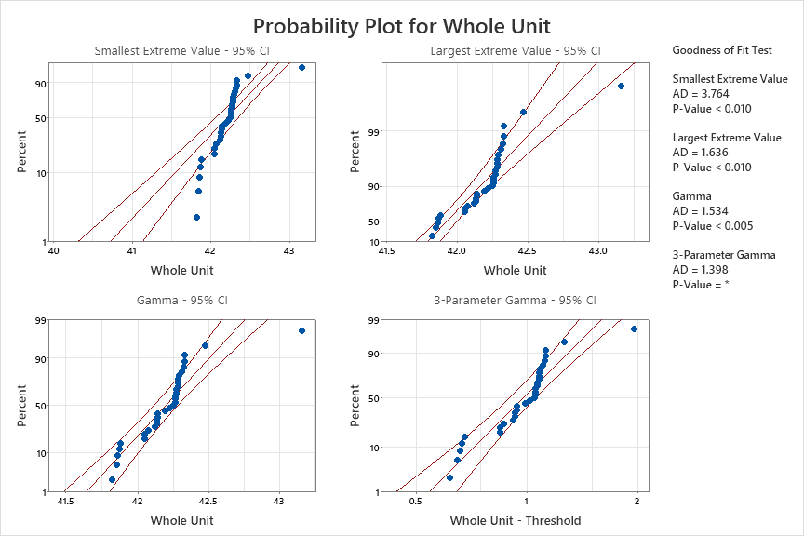
Figure 45 – probability plot variation 1
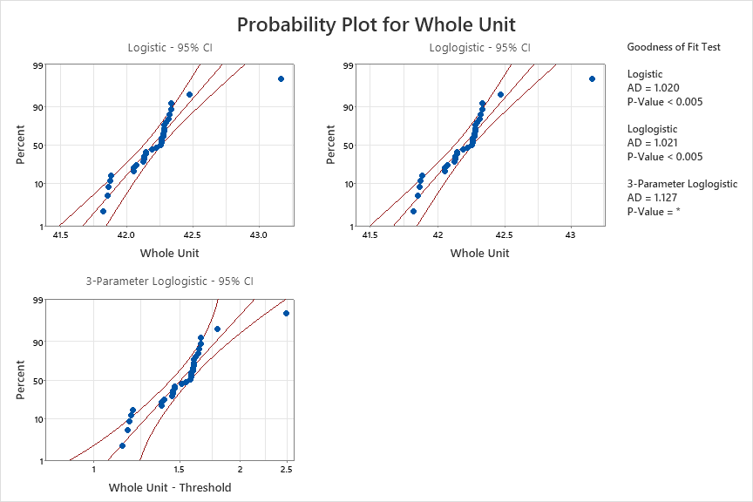
Figure 46 – probability plot variation 2

