Madison Jay Willow Oats
DATE: MAY 7 2023

HND APPLIED COMPUTING – LEVEL 5 – WEB AND MOBILE TECHNOLOGIES
MOBILE ENABLED WEBSITE UTILISING REST SERVICES (JSON)

Contents
Introduction 2
Mobile Enabled Website Utilising Rest Services (JSON) 3
Artists List API Call Code Listing 3
Artists List Page Design 3
Plain Text Data in Browser 4
Website UI Images 4
Appendices 5
Artists List API Call Code Listing 5

Introduction
In this report, I will be discussing the creation and functionality of my website, I will be providing annotated code listings of API calls made. In addition, I will also be writing a conclusion about my work.

Mobile Enabled Website Utilising Rest Services (JSON)
For this assignment, I wanted to create a website and APIs which were interesting to me and could help me but also give knowledge to others. The aim of my website was to have an API call which would pull a list of artists from my database and display them, within there, there would be an album count and an album subpage, within there there’d then be a song subpage.
During this assignment, I realised I didn’t have the required ability to correctly do what I wanted, so I adapted my plan. My new plan was to create three Private API calls. One would be for Artists; one would be for Albums and one would be for Songs. All this information would be displayed on 3 separate pages, 3 API calls. Again, during this, I again had struggles with getting my APIs to display the information.
One of my API calls which I had written, was for the artists page. I got to the point where I could get the information to display in a browser in plain text from .php file. However, I could not get the API to pull the data from the database and display it. Below you will see an example of the data for the artist page being shown in plain text in browser. You will also find an example plan of how I wanted the page to look. In addition, if you follow the below cross reference link, you will find a code list of the artist API call.

Artists List API Call Code Listing

Artists List Page Design
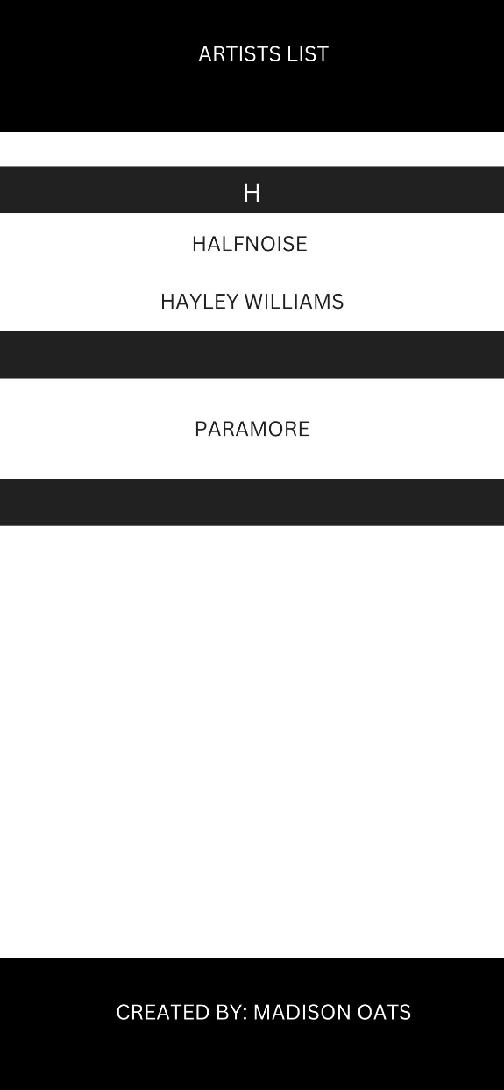

Plain Text Data in Browser
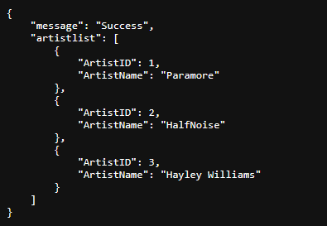
For the UI of my website, I wanted to keep it simple and I wanted to blend different colours, such as Black, White, and Mint Green. I think these colours blended well and helped distinguish different parts of the webpage. I wanted the buttons to be mint green, as it stands out and the user will know where they need to go to access the webpages where the data will be display.
Below are some images of the UI of my website.

Website UI Images
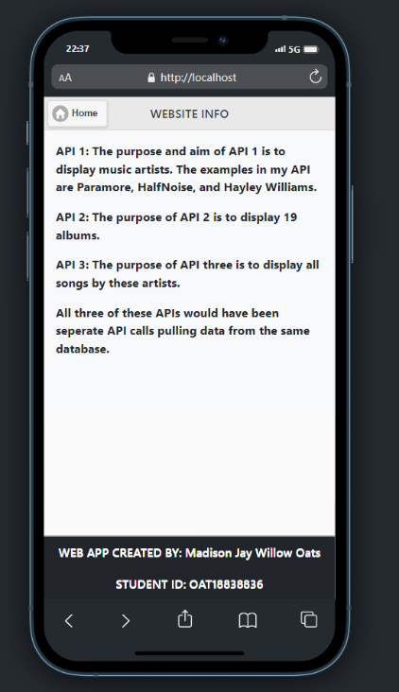
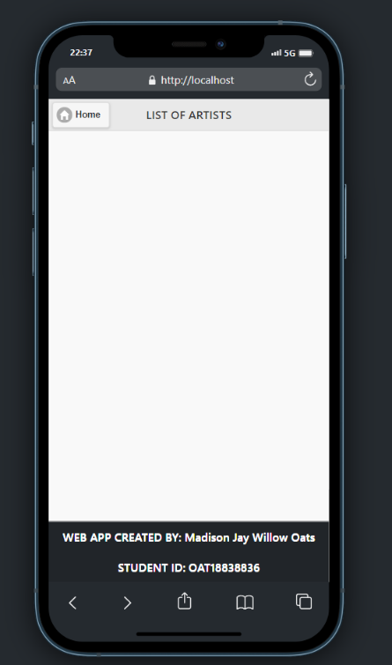
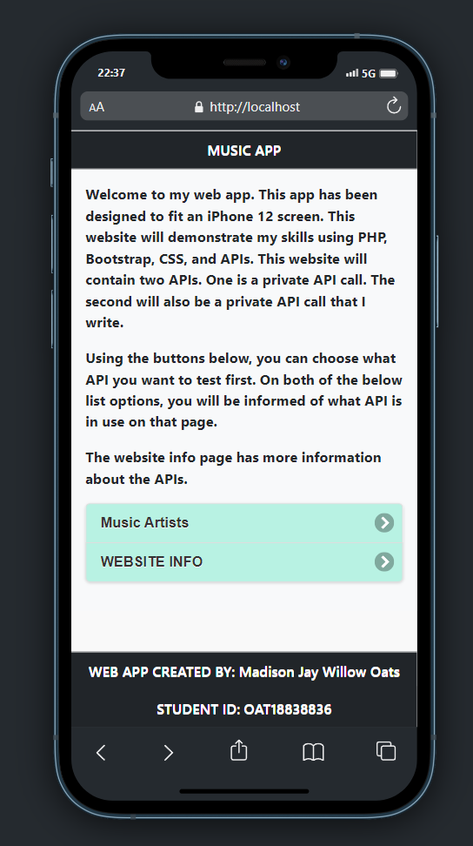

Conclusion
After attempting this assignment and attempting to design, create, and deploy a mobile website which utilises REST services, I realise that this is an area where I need to learn more about and try to develop my skills so that I can get better, and in the future be able to create a mobile website and be able to achieve getting the API call to successfully work.

Appendices

Artists List API Call Code Listing
<?php
$artist = '';
if(isset($_GET['artist']))
$artist = $_GET['artist'];

// will attempt to connect to the database.
$dbconn = mysqli_connect("localhost", "root", "", "madisonsmusicdatabase");
if ($dbconn->connect_error > 0)
{
die("cannot connect to db");
exit();
}

// Will select ArtistID and ArtistName from the Artists table to display it on webpage.
$sql = $dbconn->prepare("SELECT ArtistID, ArtistName from Artists");
// Will execute query and return a result and display
$sql->execute();
$result = $sql->get_result();

// Create an array which will store the artist data.
$artistarray = array();
if($sql->affected_rows == 0)
{
http_response_code(404);
echo json_encode(
array("message" => "No artists found")
);
}
else
{
while($row = $result->fetch_assoc())
{
$artistarray[] = $row;
}
http_response_code(200);
header('Content-Type: application/json');
header('Access-Control-Allow-Origin: *');
header('Access-Control-Allow-Methods: GET, PUT, POST, DELETE, OPTIONS');
header('Access-Control-Allow-Headers: Content-Type, Content-Range, Content-Disposition, Content-Description');
$result = [
'message' => 'Success',
'artistlist' => $artistarray,
];
echo json_encode($result, JSON_PRETTY_PRINT);

}
?>

