

BSc (Hons) Health and Social Care
Module: Health, wellbeing, and Sustainable Development. (BMHP6021_LON)

Student name: Elizabeth Owusu
Student ID: 1917244
Lecturer name: Diola Bijihout
Date: 30/08/2022

A consultancy report of Lambeth borough local council on Health, Wellbeing, and Sustainable Development within the Health Care sectors in the UK.
Topic
Content Page………………………………………………………………………………………2

Introduction…………………………….…………………………………………………………….3
Defining Sustainable Development…………………………………………………………………4
Sustainable development goals: Overview…………………………………….…………….…….4
Brief discussions on Sustainable Development Goals 1- 17…………………………………5- 7
A detailed discussion of Goal 3…………………………………………………………………….8
A detailed discussion of Goal 4…………………………………………………………………….9
A detailed discussion of Goal 17………………………………………………………………….9
UK policies and initiatives identified to meet SDGs, 3, 4, and 17......................................10
Lambeth Borough Council……………………………….…………………………………11- 14
Local Policies of Lambeth Borough identified to meet SDGs, 3, 4, and 17……………….14-15
Reviewing the status of Lambeth to meet SDGs 3, 4, and 17…………………………….15- 16
Lambeth Action Plan for SDGs 3, 4, and 17…………………………………………………16- 17
Principles of achieving its objectives……………………………………………………………17
Recommendation……………………………………………….…………………………………18
Conclusion…………………………………………………………………………………………...18
References
Appendices

Introduction
Life satisfaction has been found to relate to factors including earnings, employment, health, and individual traits, like age, gender, and personality as well as significant life events. According to Halpern (2010), life happiness has been demonstrated to vary among countries in ways that can be explained by variations in freedom, social capital, and trust
According to IPCC, 2022, the evolution of humanity has led to an unsustainable planet since economic welfare was given the top priority at the expense of social, environmental, and ecological well-being. At the UN Summit, the United Nations endorsed the notion of Sustainable Development objectives, concepts, and models of reforms (Bexell, 2017), on how societies might organize in response to the need for a sustainable way of life and economic development, institution-building in social and economic life (Argyrou, 22).
UN members have ratified the 17 sustainable goals, which include eradicating poverty and hunger, promoting equality within and between nations, fostering the development of peaceful societies, defending human rights, and preserving the planet long natural resources from climate change (Fong, 2022).
This report will look at the steps taken in the UK health sector to meet the three sustainable development objectives on health and well-being, quality education, and partnership, which are 3, 4, and 17. It will start with a brief discussion of the sustainable development goals, and a broader discussion on goals 3, 4, and 17. It will further examine UK policies and initiatives identified in these three goals to meet the need of the community to obtain sustainability (GOV., 2022). The paper will examine the development of education, employment, and finances through the three SDGs. The paper will then review the status, the policies needed to meet these goals, how the council is working to achieve them, and finally recommendations and conclusion.

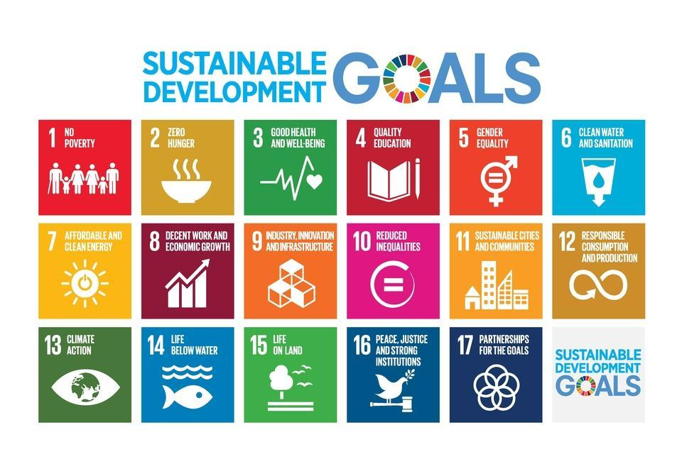
Defining Sustainable Development
Sustainable development is the process of addressing present needs while preserving the capacity of communities. It is the guiding principle behind planning and essential to the nation’s economic, environmental, and social success (Bexell, 2017). The idea acknowledges the significance of making sure that everyone can meet their fundamental needs and leads lives of higher quality, both now and in the future (UK. Gov, 2O19).
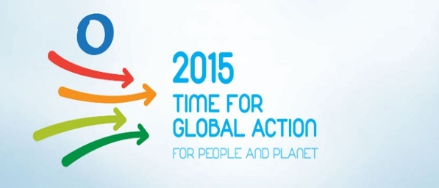

Sustainable Development Goals: Overview
United Nations’ role: Building a sustainable future
Organizations act as crucial linkages between the larger field and local levels in constitutional change (Heinze, 2016).

The Sustainable Development Goals are a universal political agenda (Sweileh, 2020), a shared roadmap for the world we want to see by 2030. The goals are a global set of objectives, and benchmarks, for UN members, and are intended to utilize to guide these political agendas over the next 15 years (Ford, 2015). They served as a framework for the discussion of various actors, stakeholders, and nations. The United Nations System, international financial institutions, commercial industries, civic society, scientists, and young people are all participating. The creation of a global online stakeholder has been set up to gather opinions, first-hand knowledge, and suggestions from all parties involved and make them widely available before the event (UN, 2022). This was ratified by 193 nations, at the UN Development Summit 2015. All countries and all industries must contribute to its implementation, The UK oversees achieving the objectives on the home front and aiding in their international achievements (UK. Gov, 2O19). The WHO’s global strategy goals for the transitional approach centre on factors such as people living longer, universal Health and Well-being, climate change, chemical safety, radiation safety, healthcare settings, workplaces, and national and international contexts (Argyrou, 22).
Sector
SDG 1: No Poverty
SDG 1
Sustainable Development Goal1, aims to eradicate all forms of poverty, enhance social protection, and guarantee that the underprivileged and vulnerable have equal access to economic resources (UN, 2020).
Sector
SDG 2; Zero hunger
Economic; Employment; Educational; Housing, and Health.

The Environment; Land; Food; Sustainability; Safety; Fairness, and Health (Fong, 2021).
The ability to end hunger, ensure food availability, and ensure advanced sustainable agriculture (UN, 2020).
SDG 3, Good health, and well-being
Sector
Economy; Environmental sustainability; Justice; Security; Education; Infrastructure; Housing; Communal food, and health (Fong, 2021).

SDG3; Ensures healthy lives and promotes well-being for all ages. It aims to create a more prosperous and sustainable world (UN, 2020).
SDG 4, Quality education
Sector

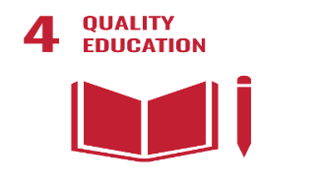
Goal 4 promotes opportunities for everyone to pursue lifelong learning while ensuring inclusive and equitable quality education. SDG4 aims to provide free, egalitarian, and high-quality education, for everyone by 2030 to support the acquisition of knowledge and skill necessary for sustainable development (DID, 2021).
SDG 5; Gender equality
Sector
Early life; Education, and Health
Justice; Security; Health Early life; Education; Employment, and Health (Fong, 2022).
Goal 5; is to eliminate prejudice, achieve gender equality, and provide all women and girls the power they deserve. It aims to achieve gender equality by ending all forms of discrimination (UN, 2020).
Sector
Health; sustainability; environment; Justice; Housing, and Security
SDG 6, Clean water and sanitation
Goal 6, aspires to ensure that everyone has access to, and can sustainably manage water and sanitation to meet basic requirements (UN, 2021).

SDG7; promotes affordable and clean energy

Sector
Sustainable; Infrastructure; Planning; Economy; Housing, and Health.

Goal 7; aims to ensure that everyone has access to modern, affordable, dependable, and sustainable energy. The Clean Growth Strategy is intended to be implemented by empowering industry-academia, and civil society (Ford, 2015).
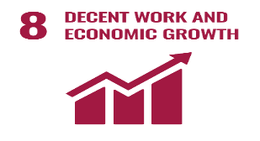
SDG 8; Work and economic growth
Sector
Goal 8, encourage sustained, inclusive, and sustainable economic growth that leads to full and productive employment and decent work for everyone (UN, 2022).
SDG 9; Industry, innovation, and infrastructure

Work and employment; Security; Justice; Housing; and Health.
Sector
The purpose of Goal 9, is to produce a quality, dependable, sustainable, and resilient infrastructure for economic development and social well-being. It also aims to foster innovation (Gov.UK, 2021).
Sector
Affordability; Sustainability; Economics; Environment, and Health.
Finances; Instruction; Employment; Justice; Safety, and Health.
SDS 10; Reduce inequalities
SDG 10; is to reduce inequality both inside and between nations, and that policies must be put in place to enable the social, economic, and political inclusion of everyone (Macssa, 2021).
Sector
SDG 11: Sustainable cities and communities
With aid of effective local government and democratic institutions, Goal 11, strives to establish inclusive, secure, and sustainable cities.
Housing; Community services; Transportation planning; Law and order, and culture; Health.
SDG 12; Responsible consumption anproduction
Sector
Goal 12, attempts to advance the social, economic, environmental, and competitive growth of urban areas that choose sustainable modes of production and consumption patterns (Sachs, 2020).
Agricultural; Environmental; economic, and health factors.
Sector
Environmental responsibility; Planning; Early childhood; Education; Security; Culture; Justice, and Health.
SDG13; Climate Action
SDG 13 concerned the effects of global water, toxic waste, and climate change on world welfare (Tse-Lun, 2020).
Sector
Land; Culture; and planning environment; stable economy; employment, and health.
SDG14; Life below water
SDG 14 focuses on preventing and reducing all forms of marine pollution.
Sector
SDG 15; Life on land
Goal 15, aims to stop biodiversity loss, manage forests, and contribute to the preservation and restoration of sustainable use of terrestrial ecosystems.
Environmental; Agriculture; Food; Sustainability; Planning; Economy; Employment, and health are all related to the land.
SDG 16; Strong Institution; Justice, and Peace
Sector
Economy; Sustainability; Security; Justice, and Health.
Goal 16 strives to advance the peace of societies. It aims to ensure that everyone has access to justice, and to create inclusive, effective institutions at all levels (Fong, 2021).
Sector
SDG 17; Partnership for the goals
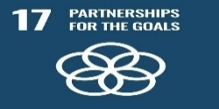
Economy; Sustainability; Justice; Security; Housing; Community services; Education; Infrastructure; Transportation; Early life; Land use; Planning; Agriculture; Food, and Health (Fong, 2021).
Partnerships for Goals (SDG17) are meant to improve domestic tax and other revenue collection, strengthen domestic resource mobilization, advance technological development, boost building capacity, and promote commerce (DID, 2021).

Sustainable Development Goals 3, 4, and 17.

In recent years, there has been a great deal of philosophical and theoretical interest in the idea of protecting future generations’ interests, which originates from the definition of sustainable development (Davies, 2016). SDG 3; guarantees a healthy lifestyle and promotes well-being for everyone, regardless of age (UN, 2022). It calls for all nations to work to advance the capabilities of all their citizens, enabling everyone to fulfill their potential regardless of class, or gender. ethnicity religion, or race, and that all nations will track the well-being of their citizenry through improved life satisfaction measurement and reporting, paying particular attention to young children, young adults, and the elderly, addressing the vulnerabilities and needs of each age group (Sachs, 2012), the relationship between health and literacy, and societal well-being (Popoola, 2019). SDG 3 aims to tackle the problem of noncommunicable illnesses and their risk factors (Nabyonga-Orem, 2017). It ensures all people should have access to the healthcare they require, including those for palliative care, rehabilitation, preventive, and health promotion (UN, 2020). To improve work quality while addressing climate change. It also seeks to improve water quality, less waste, healthy vegetation, and both land and aquatic fountains (Sachs, 2012). SDG3; aims to decrease crime, increase equality in the UK, create a local government sector that is resilient and sustainable, deliver priority services, and empower communities. It also aims to end rough sleeping by the ‘’Homelessness Reduction Act 2017’’ through effective crisis intervention and prevention services, as well as decreasing homelessness in the UK (HSA, 2022) (DID, 2021).

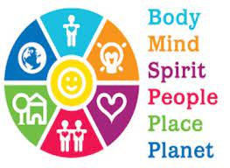
For each individual and the entire country, the social, environmental, and economic aspects of sustainable goals are important. The framework for promoting health and well-being serves as a guide for a more comprehensive application of the SDGs. It ensures that health and well-being are overarching and unifying issues that can strengthen health in all policies approach (Nunes, 2016). (See appendices for Table, measurement, and comments).

Sustainable Development Goal 4

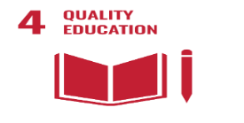
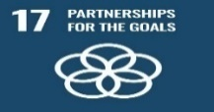
SDG 4, encourages the government to promote levels of awareness and to work together to achieve sustainable development globally. These goals call for a dedication to the rules of law, human rights, transparency, participation, inclusion, and good economic institutions that support the public. (Sachs, 2012). Goal 4, also promotes opportunities for everyone to pursue lifelong learning and assures inclusive and equitable quality education (UN, 2020). (OECD, 2021). Education promotes socioeconomic mobility and is essential for avoiding poverty (DID, 2021). UNESCO is taking action with several initiatives, including collaboration and guaranteeing that education never stops (UN, 2020). SDG 4, which promotes gender equality is crucial for the development of peaceful societies, as well as human potential and sustainability (UN, 2021). SDG 4, strives to advance economic growth by enhancing the pipeline for skills, raising productivity levels, fostering employment, and boosting community and national cohesion. SDG 4 also promotes early education and care of the highest calibre, boosts standards, and enables parents to work (DID, 2021).
Partnerships for Goals (SDG17) aims to increase domestic tax collection and other forms of income generation, strengthen domestic resource mobilization, advance technological development, boost building capacity, and promote commerce (Argyrou, 22). Through policy coordination and coherence for sustainable development, the partnership for goals aims to improve global macroeconomic stability (Bexell, 2017). By 2020 and 2030, the alliance wants to increase capacity-building assistance for developing nations (UN, 2020). SDG17 aims to safeguard society from harm and extend and amplify the influence of the United Kingdom in the world, especially through the successful application for ASEAN preferred partner status (DID, 2021). According to Santos (2012), sustainable market entrepreneurs directly contribute to the creation of new formal institutions by internalising both the positive and negative externalities problems that have been ignored in the economy and by providing solutions that are bought to the attention of the legislators and policymakers (Argyrou, 22).
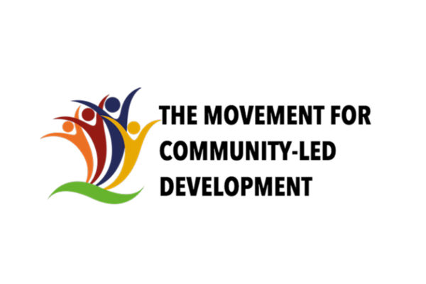

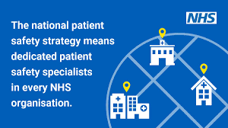
The NHS has set out on a journey to become one of the safest healthcare systems in the world (Care, 2018). The National Patients Safety Strategy and Patients Safety Collaborative are currently implementing a locally owned improvement initiative for all NHS organisations in their region to support development. The NHS assists with the identification and growth of integrated care systems, transformation, and partnerships for sustainability.

The UK policies and initiatives identified to meet SDGs 3, 4, and 17

The UK is doing well, in terms of health-related SDGs (DID, 2021). The NHS, and PHE both provide quality and safe medical treatment and provide the necessary staff to maintain people’s independence and health in their local communities (Commons, 2012). The national committees contribute to environmental preservation and sustainable development and evaluate how well they perform on those objectives (Parliament, 2021). 110 million pounds has been in support by UK aid, for Vaccines Project to keep emerging diseases under control, all about SDGs 3,4, and 17 (Care, 2018). Public Health England and the NHS, (National Health Service), which was created on the 5th of July 1948 has been a key national system for support in terms of health.

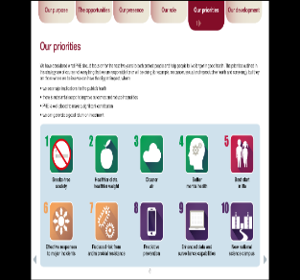
Public Health England sees `to reduce health disparities and promote public health, and healthier lifestyles (Rutter, 2020). The system accomplishes all its objectives (PHE, 2020). It works around the clock’’ to safeguard and enhance the nation’s health. (PHE, 2020). These are all in relation to SDGs 3 and 4 (UK. Gov, 2O19).
.
.
Public Health Priorities 2020-2025

The public health England (PHE), was created in April 2013 from ‘’70’’ previous organisations (CQC, 2018), and it has now been replaced by the UK Health Security Agency ( UKHSA), which oversees shielding every citizen from the dangers of infectious diseases, accidents involving chemicals, biological, or nuclear weapons, as well as other health risks, and to ensure the security of the country’s health (HSA, 2022). Five guiding principles for sustainable development were established by the UK government: Preserving the environment’s boundaries, Achieving a sustainable economy, Ensuring a robust (Macssa, 2021), healthy, and just society, and properly using sound science (Holmes, 2011). Around 75% of what we eat is produced in the UK, and over the past 20 years, that percentage has been largely consistent (UK, 2022). Environmental Act (2021), Fisheries Act (2020), and Agriculture Act (2020) ensure continuous productivity and a sustainable environment (UK, 2022). The Department of Environment, Food, and Rural Affairs, UK, funded more resource utilization projects that are predicted to help the industry save up to 23 billion pounds (Tse-Lun, 2020). Financial goal: Entrepreneurship, and environmental (UK. Gov, 2O19). Bringing market transformation, and significant societal growth (Johnson, 2020).
Lambeth Borough Council, London, UK

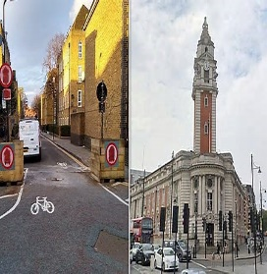
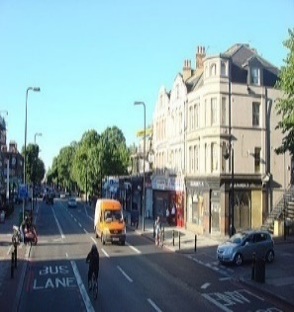
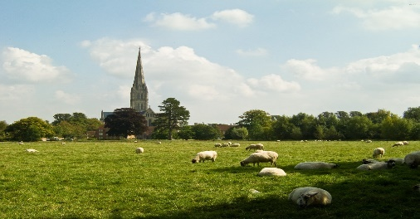
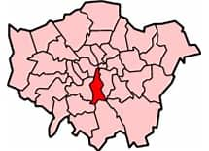
Old Lambehitha
New Lambeth
Borough of Lambeth, London

Coat of arms



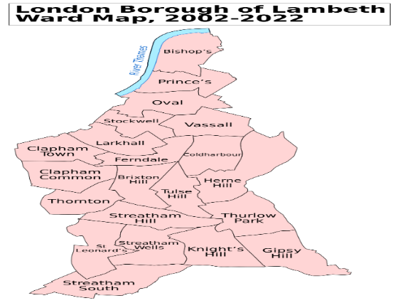

There are 25 wards in Lambeth, 13 of which are represented by 3 councilors and 12 by 2 councilors. In 1964, the council was first put to vote.
Population census: - 2011-03-27
Population estimated: - 2020-06-30
Population census: 2001-04-29
London Borough of Lambeth Ward Map 2002-2022

321,813
303,086
266,169
0.65%
Annual population change: - 2011-2020

Lambeth borough is one of Greater London’s 32 published Borough councils in the UK with its Council Town Hall is in Brixton, London, where meetings are held. Lambeth has a size of 10.36 square miles. Annie Gallop is the current mayor. In 1062, the name was given Lambehitha, ("landing place for lambs"), and in 1255, it was given the name Lambeth.
Created in April 1965

Lambeth Council
With almost 11,300 inhabitants per square kilometer. One of the most densely populous districts in the country is Lambeth. The Borough is expected to have 272,649 households by 2036, up from 143,655 in 2016 (Lambeth, 2020).
Administration Headquarters | 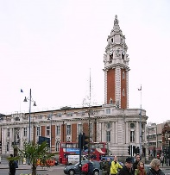  Brixton Hill, Lambeth Town Hall  This Photo by Unknown Author is licensed under CC BY-SA
Government | Density 31,000 square miles
  Types | Lambeth Borough Council.
  Community | Lambeth, Borough of London
  Leaders | Leader and Cabinet.
  Mayor | Annie Gallop (Labour).
  London Assembly | Marina Ahmad (Labour)
  MPs | Florence Elshalomi, Helen Hayes (Labour), Bell Ribeiro- Addy (Labour).
  Council Leader | Clir Claire Holland (Labour).
Area
  Total | 10.36 square (26.82 km2). P. density-11,998/km 2
  Rank | 304th of 309

Lambeth has estimated residents of 321,813 as of June 2022, with a 0.65 percent yearly population change between 2011 and 2020. Lambeth is the 32nd most populous borough in England, with a population density of 31,000 square miles, and its white population is made up of 39% whites. White Irish, 2.5%, white Gipsy or Irish travelers 0.1%, and 15.5% other whites. Indian 1.6 percent, Chinese 1.5 percent, other Asian accounts for 2%, white and Caribbean 2.7%, black African 1.4%, white Asian 1.2%. Pakistan 1%, and Bangladesh 0.7% make up the remaining 2.3% of the population (Lambeth, 2020). (See Appendix 3, for Table and comments). In comparison to the rest of the capital, Lambeth has a population that is more ethnically diverse, and its age distribution is younger than that of both the nation and London (Lambeth, 2020). (See appendix 4 for important places).

The unemployment rate in Lambeth council is 6.2 percent, which is higher than the London average of 4.9 percent. Compared to most other London boroughs, the borough has a greater percentage of working-age residents receiving unemployment 8.4%, are of working age, compared to London’s rate of 7.7%. Among the 136,000 residents of Lambeth, only 15% are employed and live and work in the Borough, making it a low live-and-work ratio.
Employment
There are 62 primary schools, 27 secondary schools, and 5 nurseries. 5 colleges and two student referral centres, and five special schools are also present. Between 2009 and 2014, there was a 195 increase in demand for Reception spots in Lambeth schools. Lambeth added over 500 permanent reception spots and 800 temporary expansion spots to schools (Lambeth, 2020). Lambeth has created 165 new Special Education Needs and disabilities (SEND) spaces and 450 additional sixth form spots (Lambeth, 2020).
Education

Table 2 (Macassa, 2021). (Lambeth, 2020).
Community assets, and important places in Lambeth







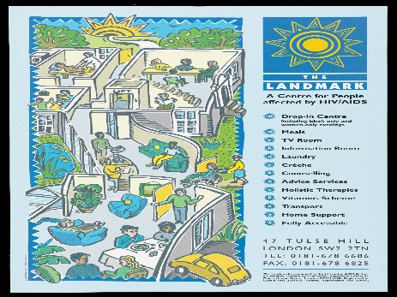

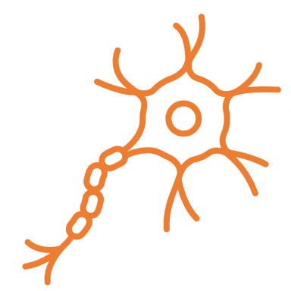










.
See appendix 4 for some of the important places in Lambeth and the key names.

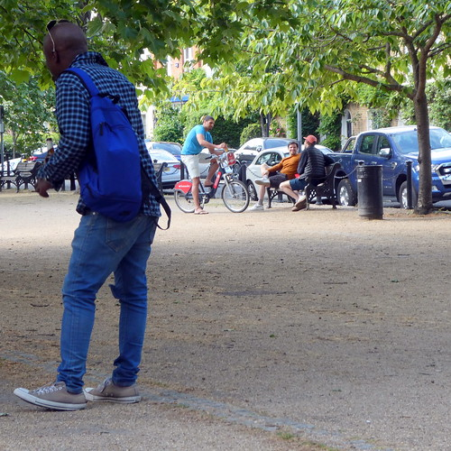
There are substantial mental health issues and a turnover test in Lambeth. As of right now, Lambeth Primary Care Trust purchases mental health treatments on behalf of the Borough. While the Trust provides community-based -care, The social inclusion agenda has highlighted the significance of having access to regular, mainstream activities, concerning inequity that those with mental health difficulties encounter (Eric, 2016). Approximately 6,462 persons with learning disabilities are likely to live in the Borough as of 2019, and that figure is expected to rise to 7,016 by 2035 (Lambeth, 2020).

Health and well-being
Local policies of Lambeth Borough identified to meet the SDGs 3, 4, and 17

To achieve an economically, socially, and environmentally viable Borough, Lambeth is determined to start its community strategy known as Future Lambeth

The SDG 3 targets relate to human health (Healthy lives for all ages) (Sachs, 2020). Lambeth is dedicated to promoting overall well-being, including mental health, It aims to the community member’s life expectancy (Lambeth, 2020). Lambeth is working to ensure access to healthcare and quality medical treatment (UN, 2021).
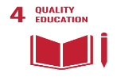
Regardless of age, race, or ethnicity, Lambeth is committed to providing inclusive and equitable education for all. Early childhood, primary, secondary, tertiary technical, and summer camp training (UN, 2021). Lambeth is ensuring people with disabilities, children, and youth, as well as those in vulnerable situations, have access to lifelong learning opportunities and can fully participate in society (Lambeth, 2020).
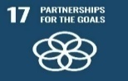
Lambeth is creating a new Inclusive Opportunity and Sustainable Growth Strategy that characterises sustainable growth as a means of achieving greater prosperity (Gadsby, 2020). The council is working with relevant partners to deliver affordable housing to the Borough’s housing requirements of 13,350 homes for the ten years 2019/20 to 2028/29 (Lambeth, 2020).
The council work and promote employment and training programs in relation to the London Plan Policy E11. It aims to increase local job possibilities and help solve skill shortages in the community (Lambeth, 2020). The council is working on securing a safe, and safe Borough for everyone through crime prevention and counterterrorism (Lambeth, 2020).

Reviewing the status of Lambeth borough to meet the 3 sustainable goals

Lambeth is an exciting, dynamic community that is full of possibilities. People that desire to settle there come from across the UK (Gadsby, 2020). It aims to mobilize community resources to promote equity by actively involving community members in design, and delivery (Lambeth, 2020). The key component of the local community for increasing health and well-being and decreasing inequalities is involving and empowering the local communities. The Care Act (2014) states that a person’s sense of well-being is tied to their sense of personal dignity, like how they are treated. The socioeconomic determinant of health is being addressed and can be addressed to attain health equity, according to several academics (Macssa, 2021).

Lambeth’s life expectancy has increased over time, although during 2010- 2012, the increase has slowed. Male life expectancy is 4.8 years less than female life expectancy. Male life expectancy is roughly a year less than the national average of 78.7 years. Female life expectancy is about 0.4 years higher than the national average of 83.5. The average life expectancy in deprived areas is 5.5 years less for men and 3.7 years for women (Lambeth, 2020). Lambeth’s economy is a significant component of London, and it has grown more rapidly than the UK. North of Lambeth is a component of London’s central activities zone (CAZ), which is home to important companies and valuable cultural and tourism resources (Lambeth, 2020). Significant suburbs are further south, including, waterloo, Brixton, Clapham, Streatham, and West Norwood (Gadsby, 2020). These areas serve as important employment hubs and are home to young people with high skill levels, with over 45 percent of residents having completed a degree, according to statistics (SOB, 2016) report (Lambeth, 2020).
Local Plan 2020–2035, Lambeth

According to the London Plan 2021, between 2019-20 and 2028-2029, 1,335 net extra houses must be built in Lambeth, including financial specialist retail, tourist, information, and cultural uses and activities (Lambeth, 2020). Index of Multiple Deprivation (IMD), 2015, has ranked Lambeth as the 22nd most impoverished Borough in England and the eighth most deprived Borough in London (Lambeth, 2020).

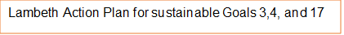
Childcare
Vulnerable groups
Gender Equality
Addressing Caregivers’ exposure to economic collapse.
Taking action to stop gender-based violence, including domestic violence.
Collaboration between all population.

Inclusive Accessible Health Care
Secure quality education
Create a searchable health database to disseminate correct information to everyone.
Reduce the digital divide, make remote learning more accessible, and increase climate education.
Youth forums, commissions and young people’s enthusiasm and energy are all used.
Youth participation

(Lambeth, 2020). Lambeth strives to improve its citizens’ economic, social, environmental, and cultural well-being (Davies, 2016).
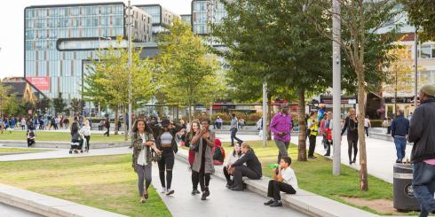
Environmental sustainability.
Healthier and safer streets for Lambeth (Gadsby, 2020).

Public safety and crime reduction are among Lambeth residents’ top priorities (SOB, 2016). In terms of Total Notifiable Offences (TNOs), Lambeth is now rated fifth in London, up from third in 2018. Knife crime offenses rose in 2017/18 and fell by 50% by September 2018, but Lambeth gun crime offenses rose by 5% between 2017/18 and 2018/19 (Lambeth, 2020).


Social Inequalities

The Care Quality Commission asserts that a change in how the effectiveness of health and social care devices is assessed is necessary to promote collaboration (CQC, 2018). The council is working to promote and improve working conditions, a more level playing field for all workers, and fairness in the labour market by developing and implementing inclusive policies for everyone, assisting families, and offering housing help. It serves to support the socially underprivileged and promote social mobility, by encouraging people also to advance in their jobs, to create a more prosperous society (Lambeth, 2020).
Principles for achieving its objective goals

Lambeth will collaborate with other organizations locally, in London, and nationally to achieve its goals (Lambeth, 2020).
Lambeth will commission superior services that are efficient and profitable and will take advantage of new technologies (Lambeth, 2020).

Lambeth will concentrate on minimizing disparities in terms of social and economic obligations, housing, health, and education (Lambeth, 2020).

SDG 3, 4, and 17
Lambeth Council will help build a resilient society that promotes the general health and well-being of the community (Lambeth, 2020).

(Lambeth, 2018).
Lambeth will focus on community-centered approaches to health and wellbeing in empowering local communities, especially underprivileged ones. As a result, we can more effectively combat professional-led services by promoting health and well-being and reducing inequalities (Lambeth, 2020).

Recommendation
1) Lambeth should strive to further SDGs implementation, financing for local organisations should prioritise community involvement, capacity building, and community support, as well as maintaining and strengthening connections with the health sectors (UN, 2022).
2) Lambeth should work to eliminate unequal social structures through enhancing income redistribution measures and continue to promote equality of opportunity for everyone, especially the most disadvantaged segments in society (Macassa, 2021).
3) Partnership forums should prioritise health, education, and inclusive participation policies with a focus on young engagement (Lambeth, 2020). Also, policies that drive carbon and air pollution extinction, stabilise climate change below dangerous levels and minimise ecological disturbance must prioritise health (Sachs, 2020).
4) Lambeth borough must aim to protect residents from abuse and neglect, ensuring control over daily activities, safer streets, comfortable living, and social and economic well-being. Also empowerment of individual’s contribution to society (Lambeth, 2018).

Conclusion
The legacy and education of the SDGs give us lessons and experience to start working on new objectives (Macssa, 2021), and the Lambeth council must continue to push for gender equality and improved health care (Ketut, 2020). In terms of health disparities, Lambeth performs significantly worse than the national average. Lifestyle issues contribute to the burden of poor health, which includes diseases and chronic ailments including cancer and heart disease (Lambeth, 2020). Even though health inequalities are being addressed, they still pose a public health risk in some areas of the borough and society as a whole (PHE, 2020), because of how social economic, and environmental factors are distributed about where people live, learn, work, play, and generally spend their time. (Lambeth, 2020).
The council needs official development assistance to promote commerce and growth to revitalize the global partnerships for sustainable development. There is also a need for empowerment to increase developmental money (Lambeth, 2020).

In The Appendices are:

Tool for measuring well-being -Appendix 1
Social inequalities- Appendix 2

UK Policies continue- Appendix 2
Lambeth council services -Appendix 3/ C
Housing Policies: All in relation to SDGs 3, and 4.- Appendix 3/ C
Important places in Lambeth- Appendix 4

References

Argyrou, et al (2022). The versatile role of sustainable market entrepreneurs. Business Strategy and the environment, 22 May, 1(1), pp. 2-15.
Bexell, et al, (2017). Responsibility and the United Nations’ Sustainable Development Goals. Forum for development studies, November, 44(1), pp. 13-29.
DHSC, (2018). Annual review: Global Health Security Programme – Vaccines Project (2018). [Online]
Available at: https://www.gov.uk/government/publications/vaccines-project-annual-review-2018
[Accessed 114 July 2018].
Commons, (2012). Measuring well-being: Environmental Audit. [Online]
Available at: https://publications.parliament.uk/pa/cm201213/cmselect/cmenvaud/667/667.pdf
[Accessed 17 July 2022].
CQC, (2018). Beyond Barriers. Care Quality Commission, July, 72(3), pp. 15-48.
Daniels, Thomas, and Molten Kamp., (2022). Social Justice. [Online]
Available at: https://www.investopedia.com/terms/s/social-justice.asp
[Accessed 24 July 2022].
Davies, H., (2016). ‘The Well-being of Future Generations (Wales) Act 2015: Duties or aspirations?’. Environmental Law Review, 11 March, 18(1), pp. 41-56.
DID, (2021). Implementing the Sustainable Development Goals. [Online]
Available at: https://www.gov.uk/government/publications/implementing-the-sustainable-development-goals/implementing-th
[Accessed 3 August 2022].
Eric, W., (2016). Reallocating Mental Health Resources in the Borough of. Academia, April, 12(1), pp. 5-11.
Fong et al. (2021). Sustainable Development Goal 3: Health and Well-being of Ageing in Hong Kong. 1 ed. London: Routledge.
Fong et al (2022). Health and Well-being of Ageing in Hong Kong. Hong Kong: Taylor& Francis.
Ford, L. (2015). Sustainable Development Goals: all you need to know. New York: The Guadian.
Gadsby, C. (2020). Homelessness and Rough Sleeping Strategy and Action Plan, London: Lambeth. https://www.bing.com/search?q=lambeth+council&cvi
[Accessed 26 July 2022]

UK, Gov, (2022). Welcome to Gov. UK. [Online]
Available at: https://www.gov.uk/
[Accessed 5 August 2022].
Gov.UK, (2021). implementing the Sustainable Development Goals. [Online]
Available at: https://www.gov.uk/government/publications/implementing-the-sustainable-development-goals/implementing-the-sustaina
[Accessed 5 August 2022].
Heinze, et al, (2016). Translating Institutional Change to Local Communities: The Role of Linking Organizations. Organizational studies., 10 September. pp. 141-1169.
Holmes, D. (2011). The National Planning Policy Framework. [Online]
Available at: https://publications.parliament.uk/pa/cm201012/cmselect/cmcomloc/1526/1526vw02.htm
[Accessed 11 July 2022].
HSA, (2022). Gov.UK. [Online]
Available at: https://www.gov.uk/government/organisations/uk-health-security-agency
[Accessed 14 July 2022].
Johnson, M. and Schategger, S. (2020). Entrepreneurship for Sustainable Development: A Review and Multilevel Causal Mechanism Framework. Entrepreneurship Theory and Practice, 44(6), pp. 141-1173.
Ketut, P. (2020). Measuring the Achievement of the Unemployment and Poverty Target in the Sustainable Development Goals Program in Pandemic Covid-19. In: B. Setiawan, et al. eds. The 4th ICSSED, International Conference of Social Science and Education. s.l.: Science, pp. 304-308.
Lambeth, C. (2020). Lambeth Local Plan 2020–2035. Lambeth, September, Volume 85, p. 8. https://www.bing.com/search?q=lambeth+council&cvi
[Accessed 12 July 2022]
Lambeth (2020). The Mayors. London, Greater London Authority. https://beta.lambeth.gov.uk
[Accessed 10 July 2022]
Lambeth (2018). Lambeth, Southwark and, London: Lambeth Council.
Loiselle, et al., (2017). Citizen Scientist Supporting environmental Research Priorities. Science of the Total Environment, 3(143), pp. 0048-9697.
Macassa, G. (2021). Social Enterprise, Population. Annals of Global Health, 87(1), pp. 52, 1-9.
Nabyonga-Orem, J. (2017). Monitoring Sustainable Development Goal 3: How ready are the health information systems in low-income and middle-income countries? BMJ global health, 25 October, 2(4), p. e000433.
Nunes, et al. (2016). The importance of an integrating framework for achieving the Sustainable Development Goals: the example of health and well-being. BMJ Global Health, 2 September.11(1).
OECD (2017). The education sustainable development goal. In: Education at a Glance 2017. Paris: OECD Publishing, pp. 27-39.
OECD (2021). Rethinking equity in education in today’s digital world. Education at a Glance 2021. [Online]
Available at: https://www.oecd.org/education/education-at-a-glance/
[Accessed 6 August 2022].
Parliament (2021). Environmental Audit Committee. [Online]
Available at: https://committees.parliament.uk/committee/62/environmental-audit-committee/
[Accessed 17 July 2022].
PHE (2020). Public Health England. [Online]
Available at: https://www.instituteforgovernment.org.uk/
[Accessed 12 July 2022].
Popoola, B. (2019). Involving libraries in improving health literacy to achieve Sustainable Development Goal-3 in developing economies: a literature review. Health Information and Libraries Journal, June, 36(2), pp. 111-120.
Quinlivan, L and Sulivan T., et al (2020). Applying citizen science to monitor for the Sustainable Development Goal Indicator 6.3.2: a review. Environmental Monitoring and Assessment, 192(4), p. 218.
Rutter, J and Thomas, A. (2020). Working to make government more effective. [Online]
Available at: (https://www.instituteforgovernment.org.uk)
[Accessed 28 July 2022].
Sachs, J. (2012). From Millennium Development Goals to Sustainable. Viewpoint, 9 June. pp. 2206-22011.
Sachs, J. (2020). Sustainable Development Goals. In: W. K. Al-Delaimy, ed. The health of People, Columbia: Springer, pp. 63-93/ 391.
Sweileh, W. ( 2020). Bibliometric analysis of scientific publications on “sustainable development goals” with emphasis on “good health and well-being” goal. Research- Open Access, 28 July, 16(68), p. 6332.
Tse-Lun, et al. (2020). Implementation of green chemistry principles in the circular economy system towards sustainable development goals: Challenges and perspectives. Science of The Total Environment, 10 May.716(1).
The UK. Gov. (2O19). Voluntary National Review of progress, London: HM Government. Available at: https://www.gov.uk/government/puplications/government
[Accessed 5 August 2022].
The UK, Gov. (2022). Department for Environment, Food and Rural Affairs. [Online]
Available at: https://www.gov.uk/government/publications/government-food-strategy/government-food-strategy
[Accessed 5 August 2022].
The UK, Gov. (2022). Environmental principles policy statement. [Online]
Available at: https://www.gov.uk/government/publications/environmental-principles-policy-statement
[Accessed 5 August 2022].
UN, (2021). Employment, decent work for all, and social protection. London, United Nations. Available at: https://www.un.org/en/
[Accessed 8 August 2022],
UN, (2021). The Sustainable Development Goals are a call for action by all countries — poor, rich, and middle-income — to promote prosperity while protecting the planet. [Online]
[Accessed 2 August 2022].
UN, (2022). 2022 United Nations ECOSOC Partnership Forum, London: ECOSOC Partnership. Available at: https://www.un.org/en/
[Accessed 6 August 2022].
UN, (2022). UN Sustainable Development Goals. [Online]
Available at: https://www.un.org/en/
[Accessed 4 August 2022].
Zahawi, et al. (2022). Department for Business, Energy & Industrial Strategy, [Online]
Available at: https://www.gov.uk/government/news/400-energy-bills-discount-to-support-households-this-winter
[Accessed 4 August 2022].

Appendix 1
Tool for measuring Well-being
SWEMWBS

Objective Well-being Measurement

Statement | None of the time | Rarely | Some of the time | Often | All the time
I have been feeling optimistic about the future
I have been feeling useful
I have been feeling relaxed
I have been dealing with problems well
I have been feeling close to other people
I have been thinking clearly
I have been able to make up my mind about things

Your life is worthwhile
ONS
Subjective Wellbeing Measurement
Questions 0 1 | 2 | 3 | 4 | 5 | 6 | 7 | 8 | 9 | 10
How satisfied are you with your life nowadays?
Overall, how happy did you feel yesterday?
Overall, how anxious did you feel yesterday?
Overall, to what extent do you feel the things you do in your’

Measuring Well-being
subjective well-being, which is viewed as personal, is measured by directly asking them about their thoughts and feelings about their well-being. This includes questions about life satisfaction, positive emotions, and whether their life is meaningful. Objective well-being is based on assumptions about fundamental human rights and needs, such as adequate food, physical health, education, and safety (Commons, 2012)

People’s perception of their well-being serves as the foundation for one of the ways the United Nations Statistics Office collects data on subjective well-being. In the past, it was assumed that objective factors like people’s health and income might have an impact on each person’s level of well-being. Contrarily, subjective well-being measurements are based on individual preferences and take into consideration what is important to people by letting them determine what is (Commons, 2012)

Appendix 2
Social Inequalities

The concept of social inequality is a worldwide issue. Inequalities exist among classes, countries, and racial or religion. Social inequality is the term used to describe relationship patterns in society that have the potential to injure or lower a group’s social standing, social class, and social network. Social inequality can develop when society understands what the proper gender roles are or when social stereotyping is pervasive (DID, 2021). Additionally, discriminatory laws can be used to establish it (Commons, 2012).

Continuation of UK policies and initiatives identified to meet SDGs 3, 4, and 17
Three overarching goals for sustainable development are outlined in the national planning policy. Goals 3, 4, and 17; - Financial goal: to ensure that there is enough land of the right kinds accessible to promote expansion, innovation, increased and productivity by identifying and coordinating the provision of infrastructure. It aims to promote a safe environment with accessible services, and open spaces that reflect current and future needs (Care, 2018). Entrepreneurship for sustainable development has been a multifaceted phenomenon that has linked social, environmental, and economic aspects of the entrepreneurial process, market transformation, and significant societal growth (Johnson, 2020).

Lambeth goals

SDG17
SDG4
SDG 3

Appendix 3
Lambeth council services
Lambeth council services
l

Population  (mid-2019 est.)
  Total | 326,034 321,813  2020
  Rank | 32nd of 309
  Density | 31,000 square miles
  Ethnicity
    White British | 39%
    White Irish | 2.5%
    White Gipsy or Irish traveler | 0.01%
    Other mixed | 2.3% | Indian | 1.6%
    Pakistan | 1% | Chinese | 1.5%
    Bangladesh | 0.7% | Other Asian | 2%
    White & Black African | 1.4% | White & Black Caribbean | 2.7%
    Other white | 15.5% | White-Asian | 1.2%
 | With almost 11,300 inhabitants per square kilometer, Lambeth is one of the most densely populated districts in the nation. The Borough is expected to have 272,649 household by 2036, up from 143,655 in 2016
Time Zone | UTC (GMT). Summer: (DST) UTC+ (BST)
Postcodes | Area code(s) | ONS code | GSS code
SE, SW | 020 | 00AY | E09000022

Website
www.lambeth.gov.uk

Police
  Metropolitan police

Lambeth Council Services

Environmental Services | Planning and building control
Housing | Council Tax
Family Services and Information | Benefit and financial support
Adult Social Care and Health | Voting and Elections
Schools and Education | Parks, Sports, and Leisure
Libraries and achieves | One bag a week challenge
Streets, roads, and transport | Parking
Accessibility | Tenants Carter
Register or login into your homeowner account My Lambeth
Children, young people, and families
Business rates, services, and licensing | About the Council
Leasehold alteration guidance | Voting and election
Noise, nuisance, anti-social behavior, and safety | Coronavirus Test
Births, deaths, ceremonies, and citizenships | Rubbish and recycling
Coronavirus support for residents | Coronavirus support for business

Appendix 4
Important places in Lambeth
Table 1
1 | 2 | 3 | 4 | 5 |  | 6 | 7 | 8 | 9 | 10
 | Town hall | St Paul cathedral | Public. consultation | First Wed-  day | Gert. Brixton |  | Brixton Recreational Centre | Garden  Museum | L/B  Estate | Blackwell Park
Key to Community assets in Lambeth
11 | Streatham Ice Centre | 13 | Brixton Tube Station/Victoria Line
12 | Hotels | 14 | Norwood Pubs

6
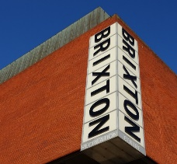
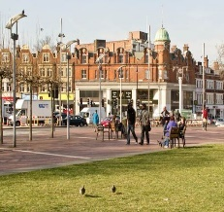

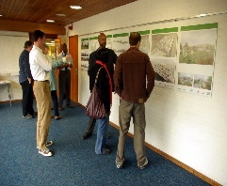
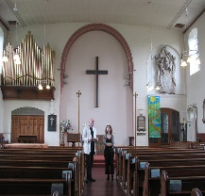
2 3 4 5
This Photo by Unknown Author is licensed under CC BY-SA
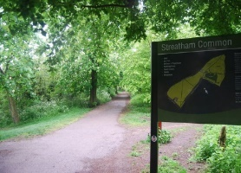
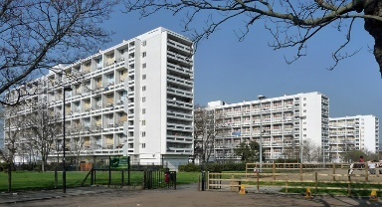


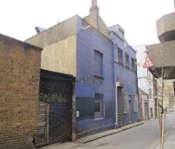
7 8 9 10

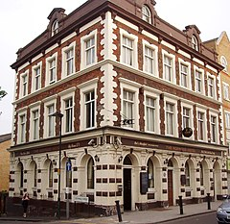
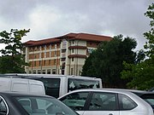
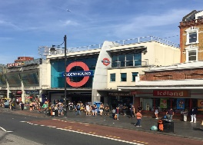
This Photo by Unknown Author is licensed under CC BY-SA
11 12 13 14 15
This Photo by Unknown Author is licensed under CC BY-NC

