Exploring Barriers to Literacy Portfolio

Kimberley George
Contents Page

Introduction………………………………………………………………………………….3

What is literacy?…………………………………………………………………………….3

Child F’s contextual statement……………………………………………………….........3

Pentrehafod Literacy Reading Intervention…………………………………………….4-5

Evaluation of method…………………………………………………………………......5-6

Conclusion…………………………………………………………………………………6-7

Reflective Log…………………………………………………………………………….7-9

Reference List…………………………………………………………………………….10

Appendices…………………………………………………………………………….11-12

Introduction
This portfolio will briefly discuss the definition and importance of literacy and give an overview of a pupil who has undertaken an intervention to help develop their literacy skills. It will briefly explore how the intervention was developed, what the intervention entails and the aims. It will show how much progress the pupil has made and how this has helped develop further in his education. It will evaluate the intervention and discuss the positives and negatives, and briefly explain Vygotsky’s (1978) theory on the Zone of Proximal Development. Finally, a reflective log will describe what went well, what challenges were faced and how these challenges were overcome during the intervention.
What is literacy?
Literacy is having both the ability to read, write, speak, and listen, and to be able to communicate effectively and have an understanding of the world around us. Alberta Education (2021, pg.1) state that “From the moment child is born, his or her literacy journey begins. Children’s literacy abilities are nurtured through their families and communities”. Having literacy skills is vital to life as having low literacy skills can hold a person back. To help support pupils and develop their literacy skills they should be encouraged to read then discuss what they have read to ensure they have understood. Also play games that support literacy development and implement interventions/ strategies when needed (Best, J. 2021, pg.1).
Child F’s Contextual Statement
Child F is 8 years old and is currently in a year 4 class in a mainstream school, they also have English as an additional language (EAL). Their home language is Arabic, and they have quite extensive language skills, however, can sometimes lack understanding. Sword (2018) suggests “When students feel supported – and when they are helped to understand and use the language of their curriculum – they are more likely to achieve at the expected level (or above)”. Child F has a good attitude to learning and will always try his best, however, can sometimes lack confidence as they are not at the same stage as their peers and are aware of this. Teachnology (2021) suggest “One of the main difficulties a student may face as a result of being unable to read properly is a knock to their confidence. Trying to keep up with the mainstream group but being unable to do this can cause serious emotional strain”.

Pentrehafod Literacy Reading Intervention
The reading intervention was created by a group of teachers who believed that children in middle ability groups are not always pushed enough to close the skills gaps. It focusses mainly on the child’s reading skills however it can help develop other skills, the intervention was introduced into the setting in 2015 after having positive results in other schools. When the teaching assistant attended the training all the resources were provided to carry out the intervention. The resources consisted of 3 different books, as well as lesson plans (Appendix 1) to follow and worksheets to be completed by the children. A group of 6 pupils are selected by the class teacher who they feel need extra support with their reading to help them catch up with their peers. The teacher will test the pupils to determine their current reading age, they are then reassessed after completing the intervention to see how much progress they have made. The children have one session a week and each session last an hour, at the beginning of each session the children are given a sheet of 100 words (see appendix 2) which they chant together, they will then read a chapter of the book. Activities are carried out during the session to ensure pupils have understood what they have read, for example writing about how the characters are feeling, and questions they would like to ask the characters. The aims of this intervention are to take a group of children in a middle ability group and improve not only their reading skills but develop an understanding of what they are reading and extend their vocabulary. As this intervention concentrates on pupils reading, they are told from the start not to worry about spelling when carrying out written work however it can help children with their spelling. Another aim is for the pupils to reach their standardized reading age however if this is not achieved after completing all the sessions from the first book pupils will continue the intervention and move on to the next book.
This table (see appendix 3) shows the age of the pupils who undertook the intervention, their pre project reading age and their post project reading age. Child F made the most progress during the intervention, when he was assessed, he had the reading age of 6 years and 11 months. However, after completing the intervention child F was reassessed and had the reading age of 8 years and 5 months, this was an improvement of 19 months. After every session, the teaching assistant would write comments about what went well and what the pupils found challenging, in the first session child F found it difficult to chant the 100 words in time with their peers. However, by session 7 child F began chanting the 100 words with confidence. Child F had difficulty expressing their opinions and ideas during the first few sessions however, child F’s confidence began to grow which led to them being more open in discussions with their peers. McLeod (2019, pg.1) “According to Vygotsky (1978), much important learning by the child occurs through social interaction with a skilful tutor”. Prior to taking part in the intervention child F was reading stage 7 books, after completing the intervention skipped 3 stages and became a free reader which meant child F could choose any book that they would like to read.

Evaluation of Method
This intervention was implemented into the setting because it was a concern that the pupils in middle ability groups were not getting the same level of support as their more able and lower abilities peers. Higher ability groups are often pushed to reach their full potential to ensure they are being challenged, keeping them interested in their learning. Interventions are often put into place for pupils in lower ability groups to help them progress in their learning. However, it is often middle ability groups that are often just left to get on with their work and forgotten about. Dabell (2021, pg.1) states “In every primary classroom, there will be a range of abilities that will likely change over time. Rather than focusing on only stretching those more able learners among your class, there should be a 'revolving door' of attempts to engage those who could also achieve more”. There were a number of positive and negative aspects in regard to this intervention. The negative aspects include finding time to take the pupils out of class for the sessions, for the intervention to be completely effective the children are meant to have two 1-hour sessions a week. However, they were only allowed to be taken out of class for an hour a week, this is due to the fact that the teacher did not want them to miss lessons in class that was vital to their learning. Another negative was trying to find a quiet space to take the pupils, the setting does not have many free rooms, rooms have to be timetabled as other staff members carry out various interventions and need a quiet space. Unfortunately, not all pupils progressed during the intervention however, these pupils will have the opportunity to continue with the intervention. The positives include, pupils develop various skills, they can catch up with their peers and the pupils enjoyed the intervention. The skills the pupils develop include reading skills, writing skills, spelling, confidence, creativeness, knowledge and understanding of the world, and social skills. After undertaking the intervention most pupils were at the same reading level as their ‘higher ability’ peers, this can boost their confidence. There are specific books required for this intervention, all the pupils enjoyed reading these books and the activities linked to the book. Taking a small group out gave the pupils the opportunity to learn off each other, each child has different personalities and have their own ideas and opinions. Vygotsky’s (1978) theory included the Zone of Proximal Development which he defined as being what learners can achieve without help and what they can achieve when they have guidance and encouragement from a more skilled leaner. For learners to move through the Zone of Proximal Development there are three important components that need to be focussed on including having a more knowledgeable other present, they need to observe a skilful tutor, and activities to help support their learning should be provided by an educator (McLeod, 2019, pg.1). The assessment shows that child F made the most progression, this could be because they always put the most effort into the sessions. Child F was determined to improve their reading skills as they wanted to be at the same level as their peers. Towards the end of the intervention child F became more confident in class and with their peers, this made a difference in all aspects of their work.
Conclusion
In conclusion ensuring children develop literacy skills from a young age is vital for their future and how they will fit into society. Many pupils in middle ability groups can often be forgotten about this can be because a lot of focus can be put more on higher and lower ability groups. Middle ability groups need to be given the opportunity to push themselves to reach their full potential. The reading intervention can be very successful if implemented appropriately however, this was not always possible due to lack of time and a quiet space to take the pupils. Despite experiencing these barriers most of the children made progress with their reading as well as developing a variety of other skills. Vygotsky’s (1978) theory on the Zone of Proximal Development is defined as what learners can achieve without support and what they can achieve with the help of a more knowledgeable other. During the intervention there were activities the pupils could achieve independently as they had prior knowledge on that subject, however there were other sessions where they needed support off the teaching assistant and their peers in order to achieve the task.

Reflective Log
What happened?

What went well? | 5 out of 6 pupils developed their reading skills after completing the intervention. Child F progressed most; their reading age improved by 19 months. During the intervention child F’s confidence grew and they were more willing to voice their opinions.
What were the main challenges / problems/ difficulties you faced? | In the beginning the biggest challenge was getting child F to express their own ideas. I found that pupils often struggle using their imagination, I feel this could be due to the advancement in technology, so children are not having the play experiences needed at a young age to help develop imagination skills.
How did you react to the challenges? | I would start off the discussions by sharing my ideas which then helped child F think about if they agree or have a different view. I also reassured child F that there was no right or wrong answer. This also helped the group to bounce off each other’s ideas.
How did you feel? | Initially I felt worried that if I could not get child F to engage in the discussions, he would not make much progress. However, when their confidence built, I was relieved that they joined in more.
What surprised you? | In the beginning I was surprised that the pupils struggled to use their imagination and express their ideas. After attending a number of sessions this started to change.
What were you familiar with? | I am the teaching assistant in child F’s class, so I was aware of their lack of confidence.
Have your beliefs and expectations changed or been challenged? | I went into the intervention expecting the pupils would make progress with their reading skills. After the children were reassessed most of them made progress. However, I believed that some of them would have made more progress.

Critiquing your experience

How well did you think you managed the challenging situation? | I feel like I managed the situation well, by reassuring child F they became more engaged in the discussions.
Has this experience changed your mind or opinion in any way? | Yes, I assumed young children would have the ability to be imaginative and creative. However, after delivering the intervention, I realise that some pupils need to be prompted to expand on their ideas.
Were you given any feedback (formal or informal)? Can you seek further advice from anyone in order to give you another perspective? | Verbal feedback was given from the class teacher, they stated that they had seen a change in child F’s confidence in class and felt that was because of the way I was delivering the intervention. When I attended the training, the trainer provided me with contact details for any further queries I may have regarding the intervention.
Is there any other reading or research you could follow up regarding the subject matter? | I could research the importance of building children’s confidence in learning. Also, how to develop imagination skills in children.
What skills do you need to develop to address this incident more effectively in the future? | I need to develop my questioning skills. I felt initially when the pupils were not engaging in discussions, I was giving them ideas. I should have asked them more questions to help them extend on their ideas.
What conclusions have you drawn? | Imagination is a vital part of literacy, and pupils need to have the opportunity to be more creative to help develop this skill.

What next?

Given the same event; would you do anything different next time? | I think next time at the start of every session I would carry out activities that enabled the pupils to use their imagination.
What are the key lessons learned for future use? | I learnt that some pupils need to be given more time to think about things and they need to be reassured that there are no right or wrong answers when expressing their own ideas.
How might your learning feed into your assignment/s? | In future I will try to manage my time better when writing my assignments.

Reference List

- Alberta Education (2021) ‘What is Literacy?’, Alberta Education. Available at: Literacy - What is literacy? (alberta.ca) (Accessed: 26th April 2021)
- Best, J. (2021) ‘What is Literacy and Why is it Important’, 3P Learning, 17 August. Available at: What is Literacy and Why is it Important? | 3P Learning (Accessed: 26th April 2021)
- Dabell, J. (2021) ‘Challenging Higher Ability Pupils and Pushing Middle Ability Groups’, One Step. Available at: Challenging Higher Ability Pupils and Pushing Middle Ability Pupils - OneStep CPD (Accessed: 29th April 2021)
- McLeod, S. (2019) ‘The Zone of Proximal Development’, Simply Psychology. Available at: Zone of Proximal Development and Scaffolding | Simply Psychology (Accessed: 7th May 2021)
- Sword, R. (2018) ‘How to Support EAL Students in the Classroom’, hub, 4 January. Available at: Supporting EAL Learners | Teaching Methods & Tips (highspeedtraining.co.uk) (Accessed: 26th April 2021)
- Teachnology (2021) ‘What is Reading Intervention’, Teachnology. Available at: What Is Reading Intervention? (teach-nology.com) (Accessed: 26th April 2021)

Appendices
Appendix 1:
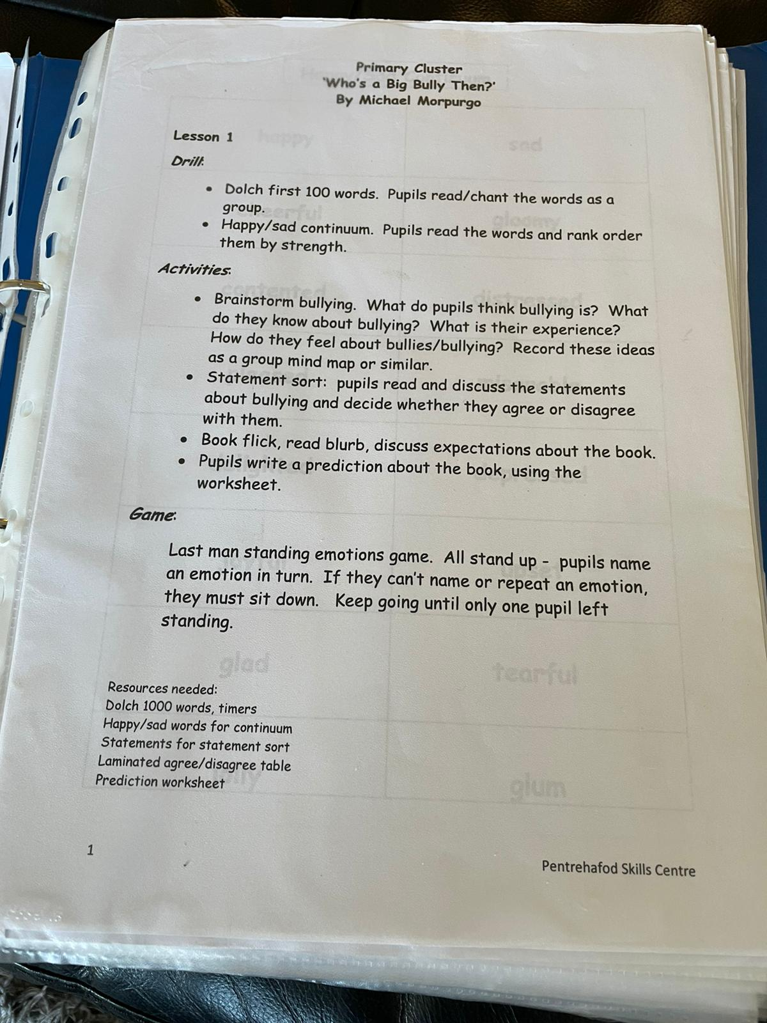

Appendix 2:
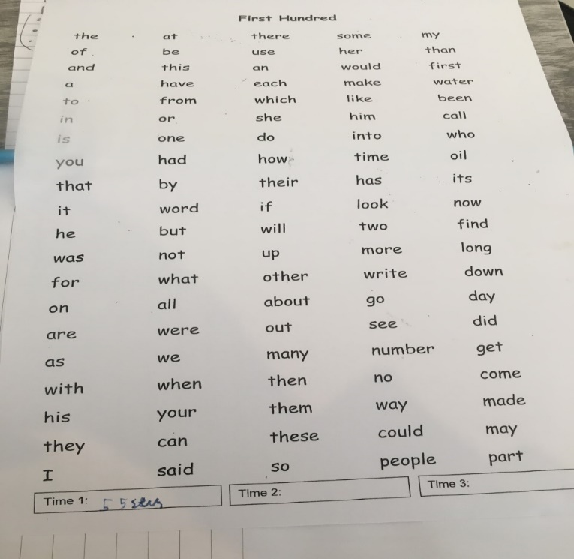

Appendix 3:
 | Pre project chronological age | Pre project reading age | Post project reading age | +/-  Months
Child A | 8:2 | 8:5 | 8:8 | +3m
Child B | 9:1 | 8:5 | 8:7 | +2m
Child C | 8:4 | 8:2 | 8:5 | +3m
Child D | 8:2 | 8:5 | 8:5 | 0m
Child E | 8:7 | 8:5 | 8:9 | +4m
Child F | 8:4 | 6:11 | 8:5 | +19m

