Business Plan

fisa_bakes

Module Title: Enterprise and Entreprenurship
Module Code: LCLM 4006
Assessment: Component 1
Student Name: Nafisa Ali Hussain
Student Number: 2505672
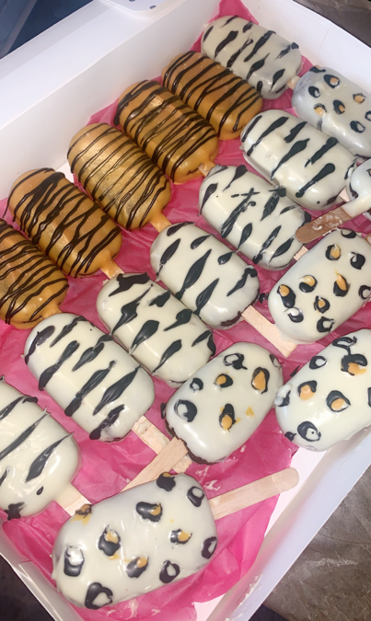
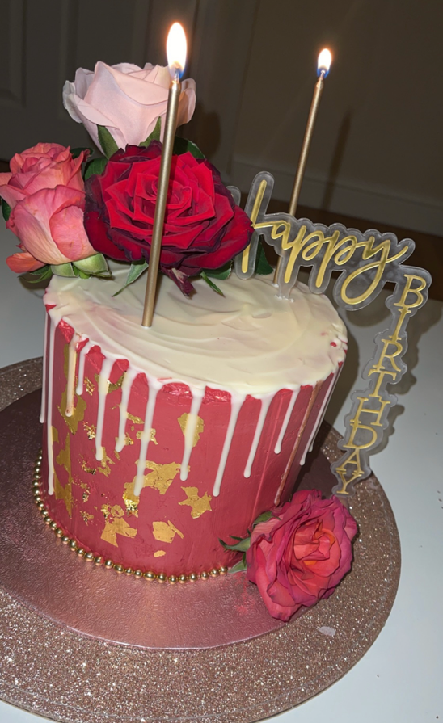
Lecturer’s Name: Mucahit Ozden

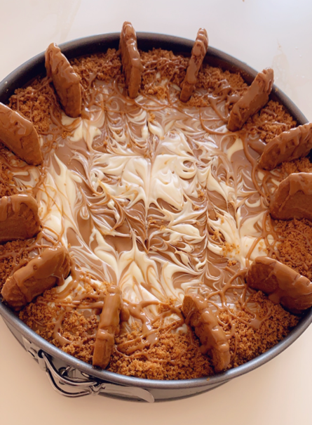

Table of Contents
Executive Summary 3
Overview of the business idea 4
Management Structure 5
PESTEL Anaylsis 6
Competitors Analysis 7
Market Communication 8
Financials 9
REFERENCE LIST 10

Executive Summary

Fisa_bakes is a Birmingham based home baking business. Fisa_bakes offers freshly made sweet and savoury treats, with a focus on dietary local sourced ingredients, and personal hand-crafted quality. Operated initially as a home-based startup where we serve customers across the West Midlands through social media pre- orders, local collection and offers delivery to.
Our core strengths lie in flexible customisable offerings (including gluten-free, vegan, diabetic-friendly and allergy safe options), competitive pricing, and community- focused marketing. This plan outlines our marketing opportunity, operational strategy, and financial requirements to launch successfully and scale gradually.
We are seeking £650 in startup funding to cover essential equipment, stock and marketing costs, with full repayment projected within 6 months of launch.
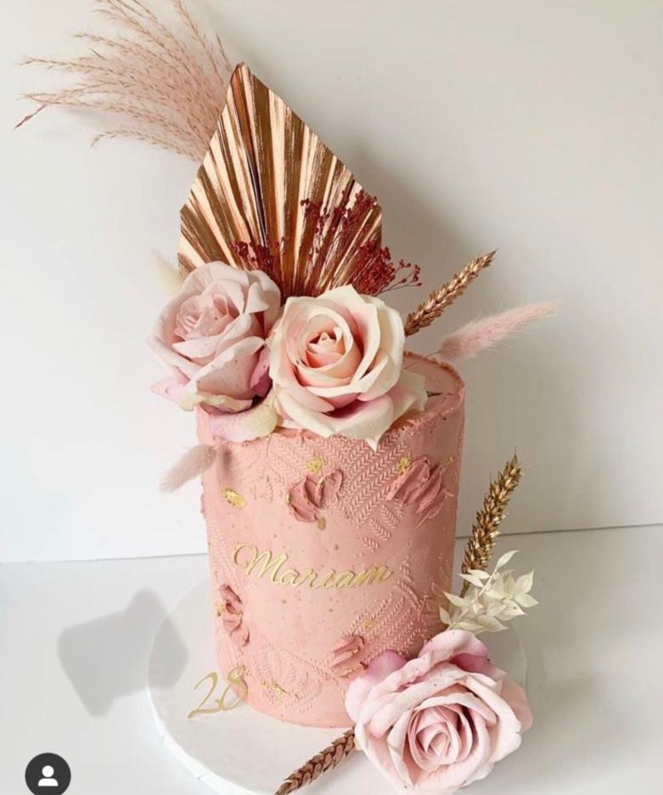
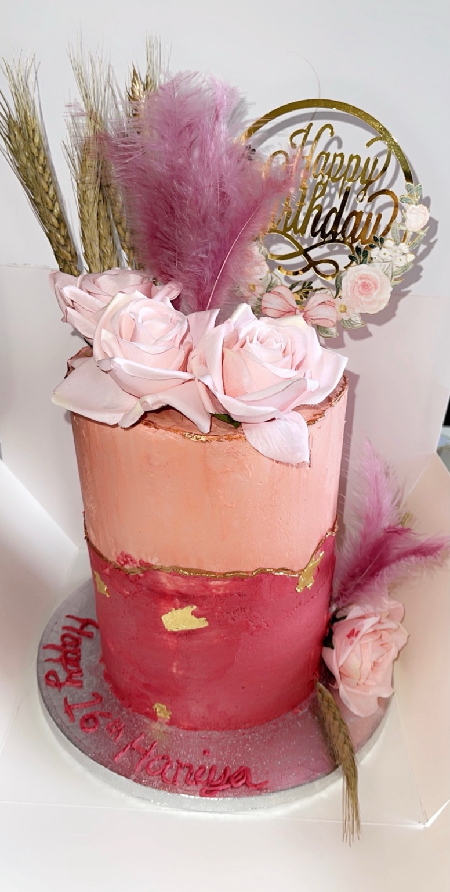

Overview of the business idea
Fisa_bakes is a home-based baking business, specialising in:
- Celebration cakes, cupcakes, bento cakes and traybakes for birthdays, weddings and family parties and events.
- Daily treats: scones, cookies, biscuits, brownies and savory bakes such as somosa chaat traybake, somosas and spring rolls.
- A full range of dietary-friendly options, cleary labelled and prepared in a dedicated allergen-safe workplace.
- Bespoke orders, tailored to customers preference, flavours and design requests.
All products are made from scratch using high-quality, local sourced ingredients wherever possible, with no artificial preservatives or pre-mixes. We priortise freshness. All orders are baked to order, and available for collection or delivery within the 24-48 hours of booking. Wedding and largers orders need a minimum a week in advance notice.

Management Structure
As a sole trader, I will manage all core operations initially: baking, order management, customer services, adminstration and marketing. I bring strong organisationl, comunication and time management skills from my 9 years of educational adminstration alongside my passion of baking experience. I have a Level 2 Food Hygiene and Safety for Catering qualification.
As the business grows, I will recruit casual support staff for my deliveries and order fulfilment.

Legal Format
The business will operate as a sole trader, the most suitable structure for a low cost, homebased startup. This offers simple set-up, full control over operation, and straightforward tax management system. I have registered myself with my local Birmingham council for my food business approval, completed a food safety managment system and hold public liability insurance to cover customer and product safety.
Market Research
Our primary customer base is local to Birmingham and the wider West Midlands including:
- Individual customers and families looking for high-quality custom treats for their personal occasions.
- Local small businesses, schools and community groups who require caterings for meeting, events small wedding gatherings and charity fundraisers.
- Customers with specific dietary requirements who struggle to find tasty, affordable and reliable baked goods from mainstream retailers.
- Social media users seeking aesthetic and shareable treats for gatherings and celebrations.

PESTEL Anaylsis

Factor | Impact on the Business
Political | UK government support for local business, including reduced VAT for small traders.  Birmingham City council actively promotes independent food businesses, creating a supportive local environment.
Economic | Cost of living pressures have increased, there is a a very strong demand for afforadable, high-quality treats and small luxury prices. Customers are choosing to buy from independent businesses over larger supermarkets, and home-based operations keeps overheads low to support competitive pricing.
Social | There is a rising preference for handcrafted, personal products over mass-produced from supermarkets goods. Social media platforms such as TikTok, Snapchat, Instagram make it easy to show your creative bakings to local audience.
Technological | Free or low-cost digital tools, enable easy marketing, management and orders. In 2026 social media has become the primary platforms and channels to reach out new customers and online payment system such as bank transfers have allowed for a secure and convenient way of transactions.
Environmental | We will use local sourced ingredients, plastic free packaging where possible and eco-friendly materials. Workinf from also reduces carbon footprint compared to larger commercial premises
Legal | We follow all UK food and safety regaultions, including FSA guidlelines, allergy labelling requirements and loca local food hygiene standards. We also adhere to insurance requirements for food businesses

Competitors Analysis
Our competitors fall into three categories:
- Large supermarkets bakeries: offer low- cost products but limited customisations, few dietary options, and mass-produced quality.
- Local commercial bakeries: provide high-quality goods but often hve higher prices and limited flexibility for bespoke requests.
- Other home bakers: offer similar personal services but ofte lack formal food safety training, clear allergen information, or consistent branding.
Our competitive advantages:

- Full range of clearly labelled dietary options, prepared in a separate allergen-safe area
- Flexible customisation for all orders, at no extra cost for small design changes
- Competitive pricing, made possible by low home-based overheads
- Professional, reliable service built on strong communication and trust
- Local delivery and flexible collection slots to suit customers

Market Communication

Our marketing strategy is low-cost, community-focused, and designed to build long-term customer loyalty:

Social Media Marketing

This is where we’ll grow our profile and get orders. We’ll use Instagram and Facebook to share great photos, short videos of our bakes, a peek behind the scenes, and real reviews from happy customers. We’ll reach people locally with area hashtags, join local groups, and share content for nearby residents. Regular posts will show seasonal picks, dietary options and customer favourites, so people get to know, trust and engage with us.

Local Community Engagement

We’ll get known locally with these easy steps:
• Hand out small sample packs at local schools, community spots and independent shops
• Team up with nearby cafes and gift shops to stock a selection of our treats on commission
• Turn up at local fairs, farmers’ markets and events to meet people face-to-face
• Offer 10% off for NHS staff, teachers and emergency workers – our way of saying thanks

Keeping Customers Coming Back

We’ll make sure people want to order again:

• Simple loyalty deal: every 10th order gets a free little treat
• Quick personal messages after purchases to hear what they think
• Special seasonal offers just for our regulars
• Always being open, reliable and consistent, so people know they can count on us

Brand Identity

We’ll build a friendly, recognisable look with a clear logo, matching packaging and easy-to-read product info. Every item will have a full ingredients list and clear allergen details, so anyone with dietary needs can choose with total confidence.

Financials

Funding Requirement & Sources

We require £650 in total startup funding, which will be provided from personal savings. No external loans or investors are required, ensuring full control of the business and minimal financial risk.

Startup Expenses (First Month of Operations)

Item | Cost | Rationale
Essential. Baking equipment | £220 | Durable, high qulaity tools for consistent, professional results
Initial ingredients stock | £130 | Core supplies including standard, vegan and gluten options
Food safety supplies | £50 | Meets UK legal standards and ensures customer safety
Packaging materials | £70 | Safe, professional and eco-friendly packaging for all orders
Insurance + counci registration | £110 | Legal requirement, with 5 million public liabilty cover
Marketing materials | £70 | Low-cost items to build initial local brand awareness
TOTAL | £650 | Full initial investment required

Projected Income & Cash Flow

Based on local market research, we project:

• Month 1: 15 orders, average order value £22 = £330 revenue
• Month 3: 35 orders, average order value £25 = £875 revenue
• Month 6: 60 orders, average order value £28 = £1,680 revenue

Monthly ongoing costs (ingredients, packaging, travel) will be approximately 40% of revenue, meaning the business will become profitable from Month 3, and full recovery of startup costs will be achieved by Month 6. Pricing will remain competitive while ensuring all costs are covered, with gradual adjustments as the business grows.

REFERENCE LIST

• Food Standards Agency. (2026). Starting a food business. Retrieved from https://www.food.gov.uk/business-guidance/starting-a-food-business

• Birmingham City Council. (2026). Registering a food business. Retrieved from https://www.birmingham.gov.uk/business-and-licensing/food-safety/register-a-food-business

• Gov.uk. (2026). Set up as a sole trader. Retrieved from https://www.gov.uk/set-up-sole-trader

• Office for National Statistics. (2025). Consumer spending trends for food and drink. Retrieved from https://www.ons.gov.uk/

• Small Business Administration. (2025). PESTEL analysis for food startups. Retrieved from https://www.sba.gov/

