

ASSIGNMENT 2

STUDENT: MARIA GHEORGHE
STUDENT ID: 2243301
MODULE: DATA HANDLING AND BUSINESS INTELLIGENCE
MODULE CODE: LCBB5000
LECTURER: MD SADEQUE IMAM SHAIKH

TABLE OF CONTENT

INTRODUCTION
- Data handling- a crucial factor in modern world
- The meaning and importance of a database
MAIN BODY
- The importance of data analysis tools
- Evaluation of EXCEL functions in “USA housing dataset”
- Data presentation using EXCEL functions (CHARTS AND GRAPHS)
- Correlation and scatterplot in SPSS
- Overall analysis conclusion
- Advantages and disadvantages of EXCEL
- The meaning and importance of Data Mining Cycle
CONCLUSION
REFERENCES

INTRODUCTION
“The convergence of computing and communication has produced a society that feeds on information” (Witten, Frank and Hall, 2011). Data handling is the process of collecting, organizing, maintaining, and presenting available, accurate and secure information to analyse, make decisions, and secure efficiency. Segalla and Rouzies (2023) stated that managing data is a key factor in marketing strategies, creating great opportunities for companies to be ahead of the competition, keeping them better-informed, with a higher probability to make predictions and reach conclusions in their challenges. According to Kocakoc and Erdem (2010), in a competitive business environment that must constantly adapt to customers’ satisfaction, is important to collect and store data, and select usable and correct information from it. The information can be stored under different patterns, such as words, numbers, or images, and can have various size and complexity. To make the data easier to access, the companies use databases, to efficiently organize and modify the information to fit the neds of customers. They are crucial in any industry, storing in a digital format accurate and up-to-date data about businesses, that, once analysed, transforms into valuable information, offering the opportunity of knowledgeable decision making regarding the future of the business and its profit. The process of analysing row data to collect useful insight is called data analytics and is applied on different data analytics software, depending on the needs of the business.
The report will discuss and analyse the “USA housing dataset” database using the Microsoft EXCEL and SPSS software, with some of their specific analytics tools, to process the basic data of the business and analyse its needs. It will also outline the meaning and the Importance of Data Mining Cycle, as well as the advantages and disadvantages of using EXCEL as a data analytics software.

MAIN BODY
SECTION 1
The increased amount of data generated by multiple sources that circulates within a company can be difficult and challenging to analyse. Therefore, business intelligence made it possible through various analytics software that use data analytics tools designed to convert large amount of information into business insights, creating a better understanding of the company’s performance and help in the process of decision making. Using EXCEL and SPSS analytics tools, the report will analyse the data from the “USA housing dataset”. The dataset contains information about the USA housing selling price, which can differ based on various features. The dataset is based on sales done within a three-month period, between May 2nd and July10th 2014. There have been four thousand forty-one sales, price varying depending on the number of rooms, the dimension of the area, the number of floors, condition of the house, the year of building, and the location. Using the analytics software EXCEL, the report will analyse the dataset to evaluate:
- the mean value for price
- the median value for price
- the mode of the price
- the standard deviation for number of bedrooms
- the larger variance of the variable
- the larger standard deviation of the variables
- the interpretation of the last three outcomes.
EXCEL enables an effective data analysis, providing the right tools to manipulate, organize and analyse the information, to identify trends and patterns that will help in decision making and problem-solving process. EXCEL uses three functions that represent measures of central tendencies. According to DeAngelis K. J. and Ayers S. (2009), the functions provide a single number that represents the data midpoint. These central measures are the mean, median, and mode value.
A)
- The mean value is the average value of the analysed data. It is important as it show an approximate location of the core value in a dataset. Summarizing a great amount of data into one value, helps the analysts to have a better understanding of the business and predict future outcomes. According to Gravetter and Wallnau (2008), it is also one of the most accurate measures of centre tendency as it considers all the data points in the dataset. However, there are cases when the mean value is not a good representation of a dataset (DeAngelis and Ayers, 2009). If the data has much higher and lower points in regard to the rest of the data, it will affect the mean, resulting in a higher or lower mean value than it should normally be and it would lead to errors in dataset analyse. For this reason, the mean function should not be used in houses sale reports.
By adding up the given data values in the dataset and dividing the result to the total number of them, the result will be the mean value of the given data. The formula used in EXCEL is =AVERAGE(the range of required numbers).
In the “USA Housing Dataset” the mean value of the price is calculated for the column B where the prices are listed, so the formula would be =AVERAGE(B2:B4141). Therefore, the mean value of the price is 553062,8773.
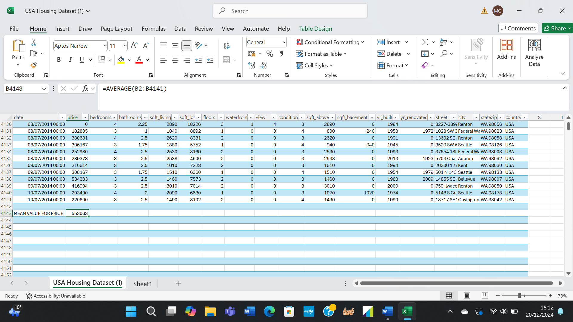
The mean value for Price

- The same as the mean value, the median value is a central measure. It represents the number in the middle of an ascending or descending list. The median value is not used in many statistics, as it cannot be used in mathematical calculations. It simply represents the middle axis of an order, the fiftieth percentile. Therefore, is easy to calculate, and comprehend. The median works well with numeral data, but cannot be used with nominal data, as the latter cannot be ordered. The following formula is used to calculate the median in EXCEL: =MEDIAN(the array of required values). In the “USA Housing Dataset” The median value for price is calculated for the column Price and using the formula =MEDIAN(B2:B4141). The result is 460000.
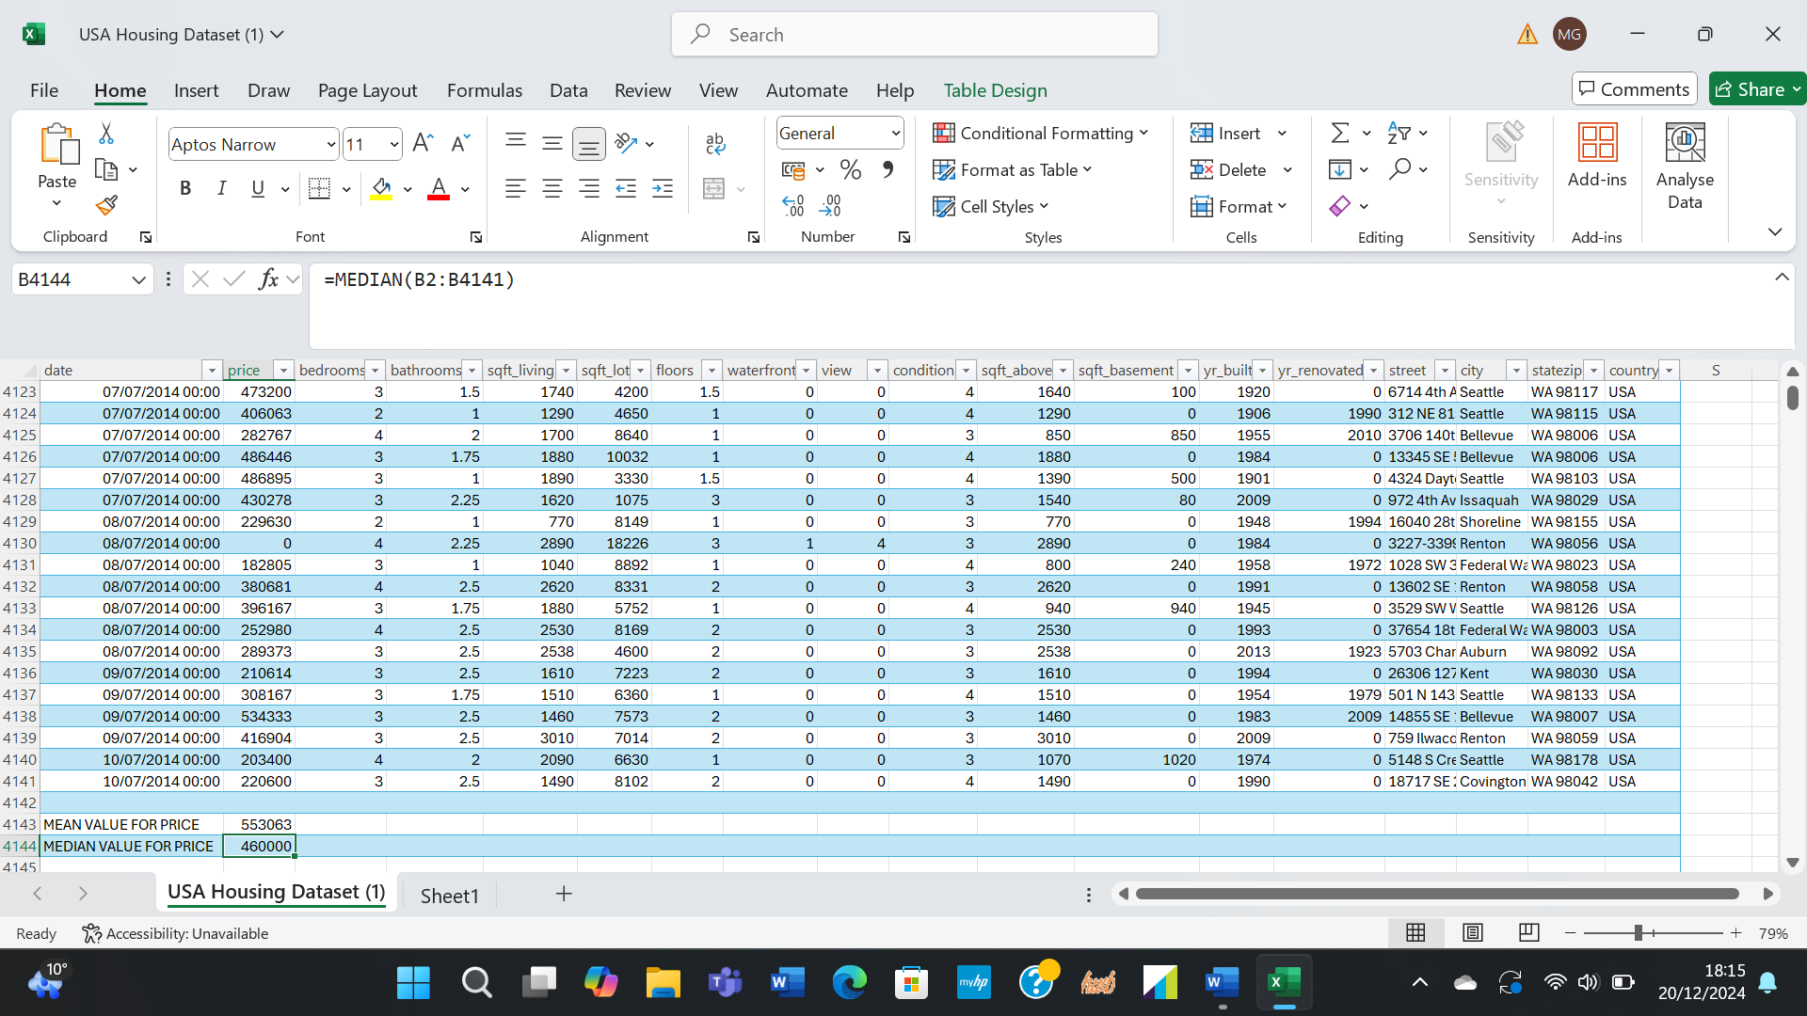
The median value for Price
- The mode value, the third measure of centre tendency, is the value that repeats the most in the dataset. It is suitable to use with all sorts of data, ordinal, and nominal. Although the function is preferred in working with nominal data, when it comes to ordinal data, the mode value is not delivering representative information to analyse a set of data for what it really is. The mode value is more useful in finding common trends and values in a set of data. If there are more than one mode, the function will show the smallest value. If amongst the numeral data there are also texts, logical values or empty cells, the mode functions will ignore them. And if the data doesn not have repeated values, the response will be an error.
The formula for analysing the mode value is: =MODE( the set of data to analyse). In the “USA Housing Dataset” the mode value formula is: =MODE(B2:B4141) and the result is 0.

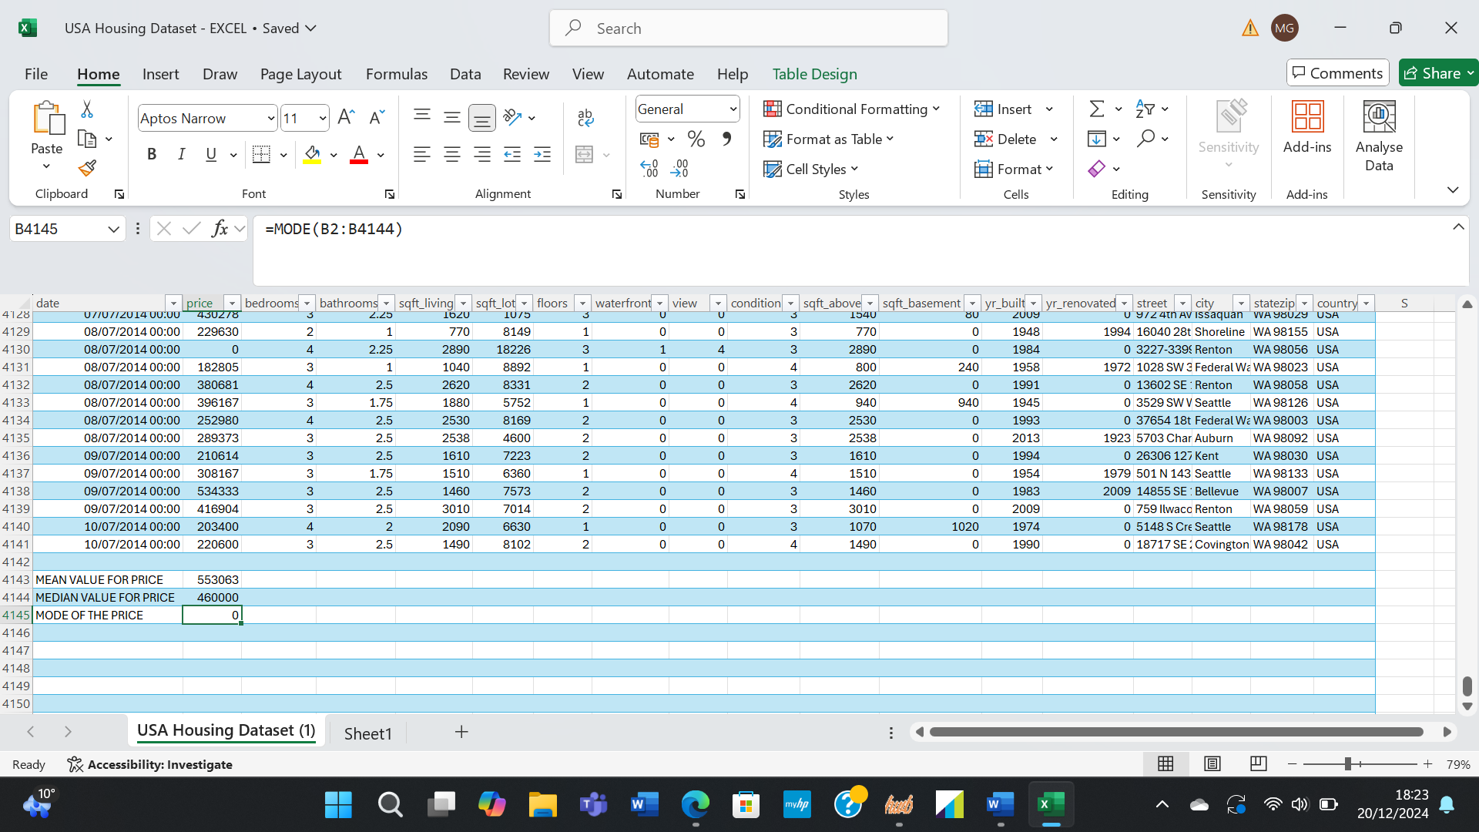
The Mode value for Price

- The concept of standard deviation was first developed in 1983 by Karl Pearson (Mahato, 2023), declaring it to be considered the total variation in the mean. The function is a measure of dispersion, showing how far the values are dispersed above or below the mean value. A high standard deviation means that the value points are far from the average, which means the data is not reliable, and a low standard deviation shows a closure to the mean value, signifying that the data is more reliable. An ideal standard deviation is as close as possible to zero, indicating the data points close to the mean. Analysing standard deviation value offers the opportunity to identify the outliners and helps in decision making to outrun possible negative outcome. At the same time, standard deviation can indicate if the distance between two averages is considerable. The formula to calculate the function in EXCEL is: =STDEV.S(the array of data to analyse). This formula is used to analyse sample data. If the analyse is for population data, the formula is: =STDEV.P(the array of data).
In the “USA Housing Dataset”, the standard deviation for bedrooms is calculated using the formula: =STDEV.S(C2:C4141) with the result equal to 0,903938796. The standard deviation for bedrooms is low, as it is close to zero, meaning that the data is reliable, the data points being close to the mean.
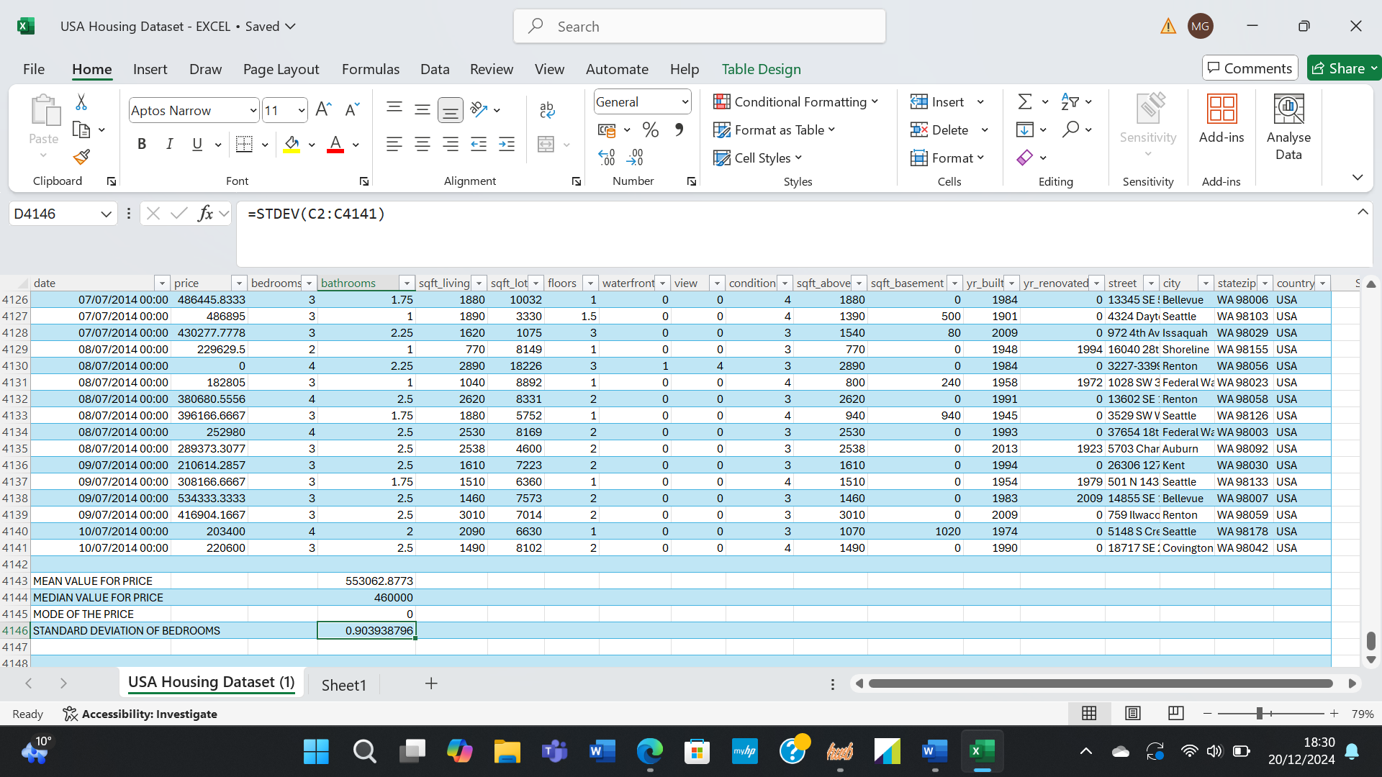
The standard deviation for Bedroom
- Variance calculation shows the spread of values against the average. If the variance is zero. All the numbers in the set of data are the same. If the numbers grow, the variance will be higher, and if the numbers decrease, the variance will go down as well. Variance is most like standard deviance, the difference being in what they analyse. While standard deviation calculates how dispersed the average of the value is from the mean, variance calculates the distance of each number from the mean. Variance is the squared value of the standard deviation. The formula for variance is: =VAR.S(the array of numbers).
The report requires to calculate find the larger variance from the variables. So, the formula for the variable Price is: =VAR.S(B2;B4141), the result being 3,4069, and the formula for the variable Bedroom is: =VAR.S(C2:C4141) with the result 0.8171. Between the variables Price and Bedroom, Price has a larger variance of 3,4069 compared to 0,8171 for Bedroom. This means that by analysing the data of the two variables it can be established that it will be harder to do a prediction on the Price, while the Bedroom data is more reliable.

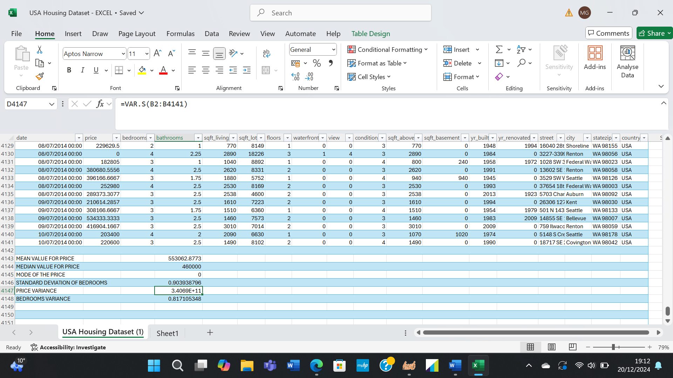
The larger variance between Price and Bedroom
- Between the Price and the Bedroom variables, the Bedroom has a lower standard deviation, being closer to zero, and the price is higher, as the data points are widely dispersed from the mean value.
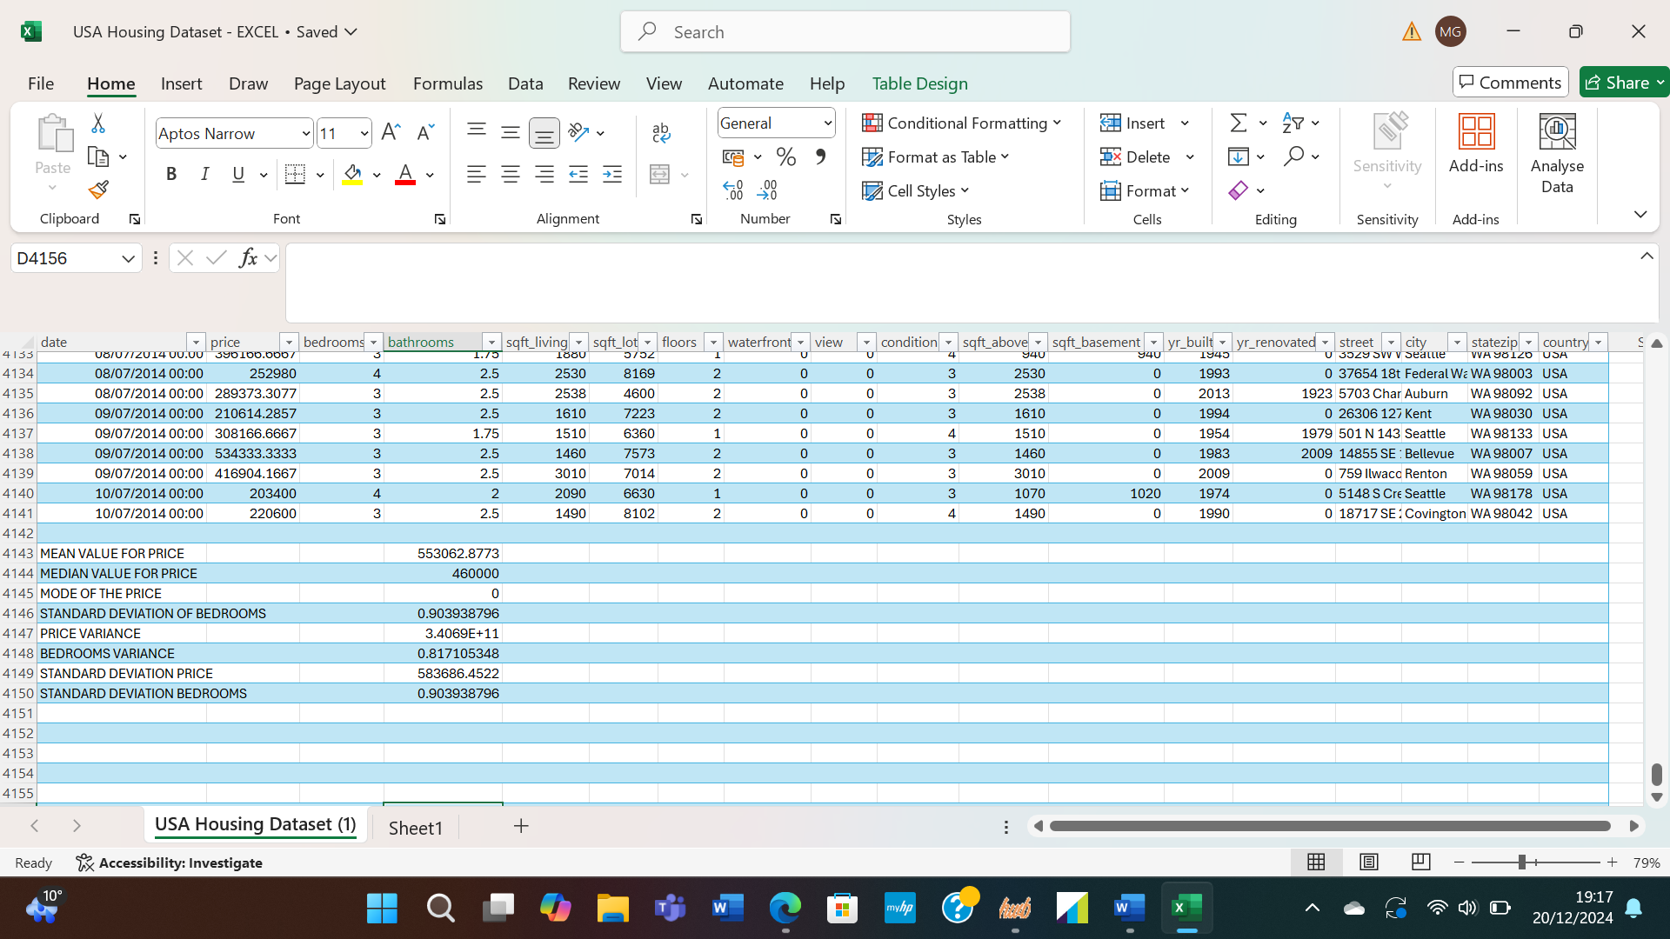
The larger standard deviation between Price and Bedroom
- Looking at the last outcomes when analysing the differences between the variables Price and Bedroom, it is obvious that in both variance and standard deviation, the Price has a higher value. Considering that standard deviation for bedroom is close to 0 and the variance is its squared value, it would be advisable to keep the standard deviation constant, as if it would decrease, the variable will decrease also. But it is recommended to try to bring the Price values closer to the mean value, because the high value of the variance means the average value is not reliable.
B)
When analysing complex datasets that are difficult to communicate, it becomes easier to understand when represented through graphs or charts. EXCEL gives analysts the opportunity to transform row written information into suggestive images. Charts are used to analyse data and predict future movement, while graphs analyse data to indicate future trends. There are different types of graphs and chart available for research, such as line graph, bar graph, histogram, scatter plot, pie chart, bullet chart, and more.
In the analyse of the data in the “USA Housing Dataset”, two variables are represented through graphs and charts. The Bedroom variable is divided in different parts of different sizes in a Pie Chart, considering the percentage each part has in the variable. The pie chart is a good data representation of data segmentation and market research.
The Price variable is represented in a Cluster Column graph. It is clear how the prices vary, the graph supporting the theory of the standard deviation and the variance being of high value with widely dispersed data points. The graph gives a better understanding of the future trends of the price. Comparing the two variables, bedroom and price, represented in the graphs, an obvious relationship can be found related to the highest column on the graph and the smaller percentage on the chart. The analyse can be helpful in decision making regarding the future marketing.
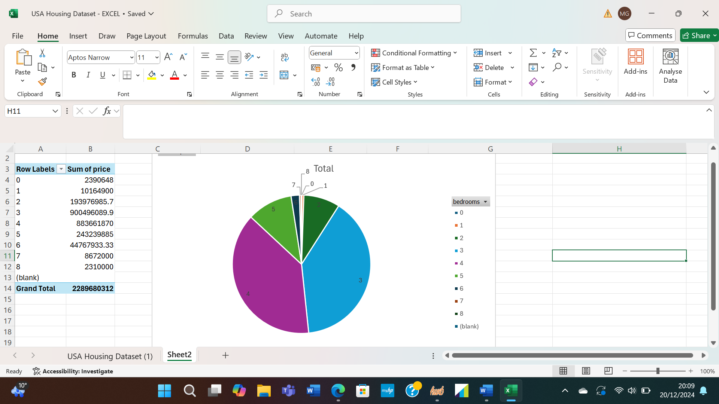
Pie Chart for Bedroom

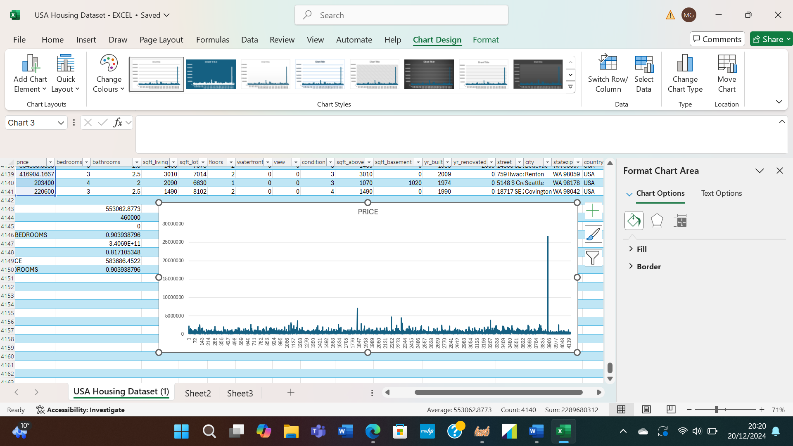
Cluster Column Graph for Price
C)
SPSS, Statistical Package for Social Science, is an analytics software used in statistical analysis, mostly for large datasets with multiple variables. It also can analyse multiple data along with graphical representations [Garth, 2008 (cited by Rahman and Muktadir, 2021)], giving the analysts the opportunity to quickly process logical information to get insights of future trends. SPSS uses a large range of statistical analytics methods, being easy to use and suitable for simple and complex projects, resulting in efficiency, better decision-making, risk minimising and accurate future predictions. Using thy SPSS analytics tools, correlation and scatterplot, the report will present the relationship between the variables Price and Bedroom from the “USA Housing Dataset” and their value.
- According to Gogtay and Thatte (2017), correlation analysis defines the association between two or multiple quantitative variables, measuring the extent to which the variables are related. The relationship between the analysed data is stronger if the line representing the correlation is ascending and weaker if the line is lowering. Considering the line a scale from -1 to 1, as the correlation value is always a number in between, if the correlation coefficient is closer to 0, the strength of the relationship is weaker. The edge points of -1 and 1 are achieved only if the relationship is perfectly linear.
The correlation between Price and Bedroom is weak, as the value result equals 0,01.

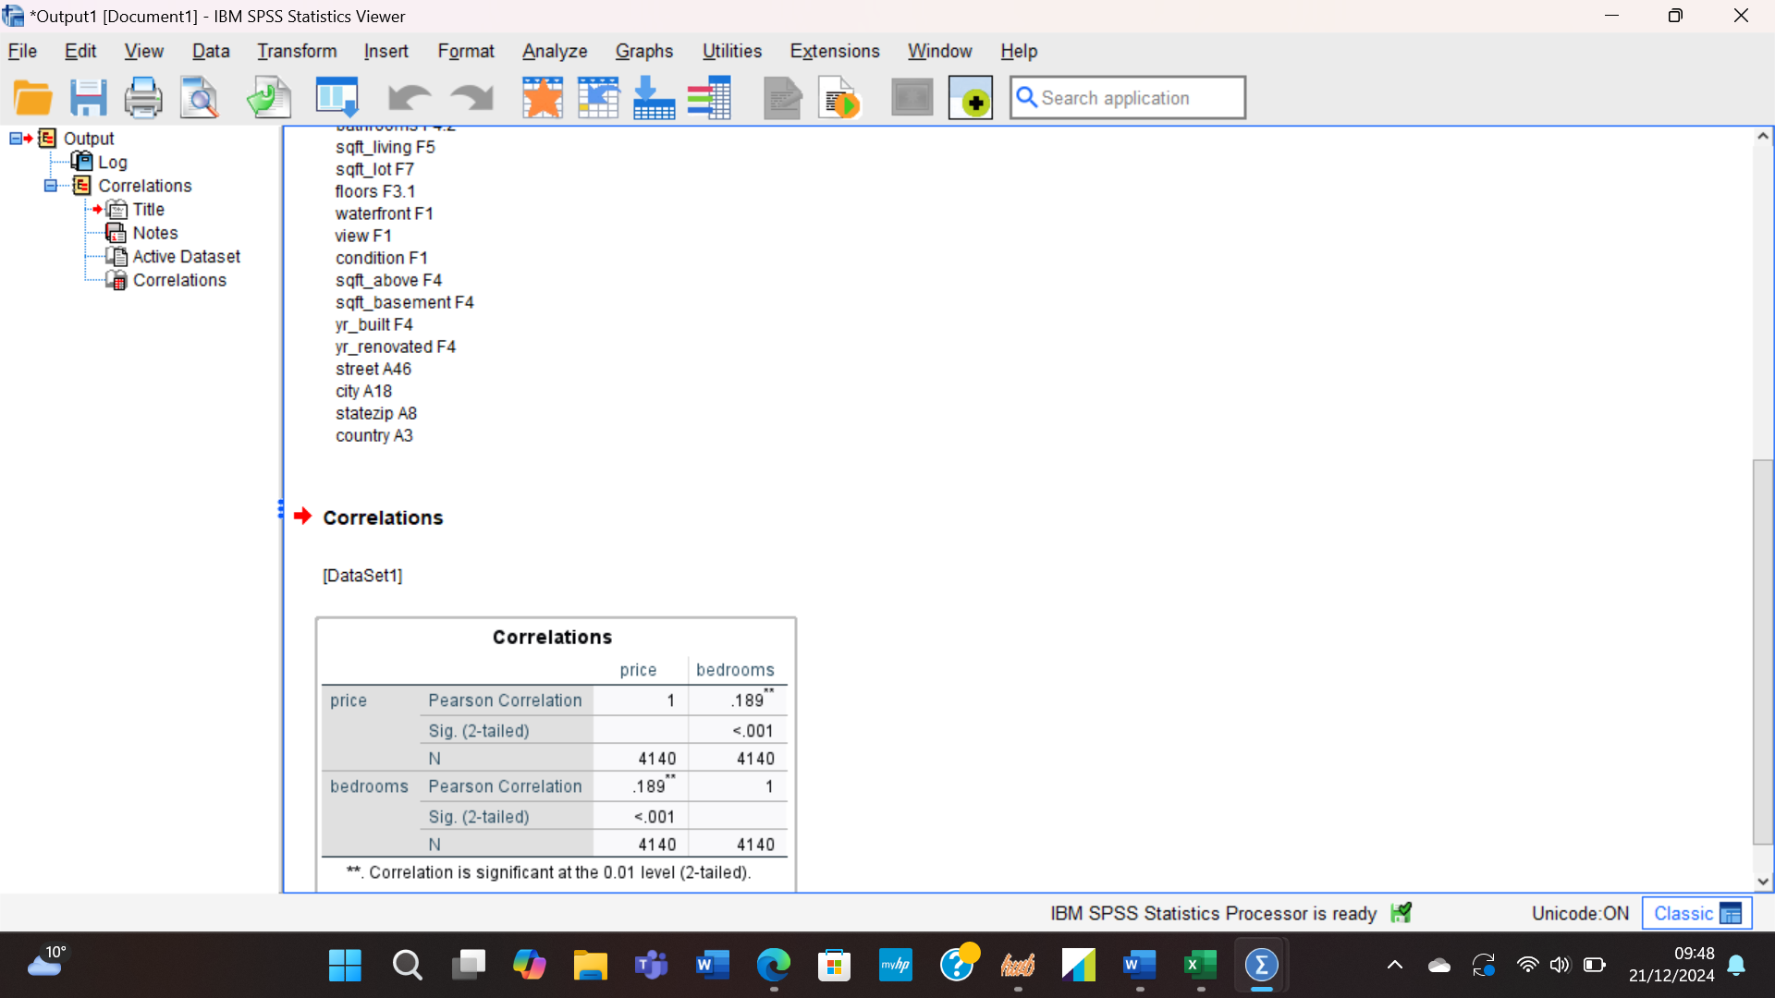
Correlation between Price and Bedroom

- Analyst mostly use scatterplot graph to present the relationship between two quantitative. The graphic position one variable on the horizontal axis and the second on the vertical one, each data point of the analysed variables being displayed as dots on the graph. When the data point are arranged closer to a line on the graph, the relationship between the variables is stronger, resulting in a positive correlation.
The relationship between Price and Bedroom as shown in the scatterplot graph is a weak one, as the data points are spread al over the vertical axis, with tendency toward the middle of the graph, revealing a wide number of outliners, resulting in a negative association.

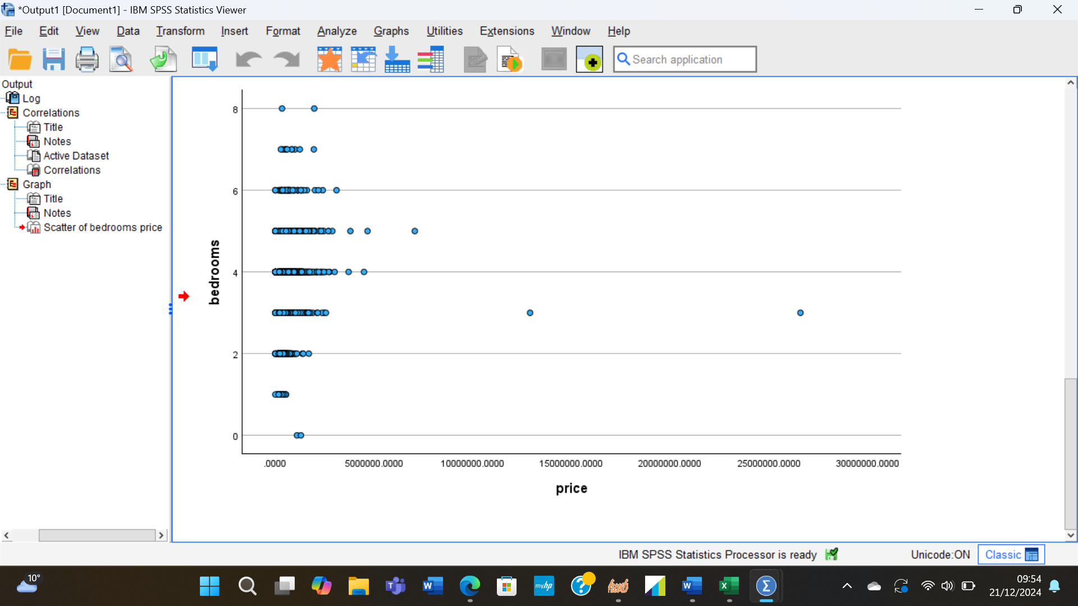
Scatterplot of Price and Bedrooms
Using analytics software like EXCEL and SPSS to analyse and manage data has improve the efficiency of analysts and researcher in the present business world, creating an appropriate environment to develop innovation and creativity. The business intelligence enables statistical analytics tools to help in predicting accurate future trends and influence the process of decision making.
SECTION 2
- Advantages and Disadvantages of Excel
Microsoft Excel is a program software that enables researcher to organize, analyse, calculate and modify data in spreadsheets. Some of the advantages of the software are:
- It is efficient to use. The Excel functions enable calculations through formulas, creating tables, graphs and charts for a better representation and of data. For example, Human resources use Excel to record the employees attendance, payrolls and achievements.
- It stores large dataset. According to Microsoft (2024), Excel contains 1,048,575 rows by 16,384 columns to create model and ensures the tools to perform analysis against any large model.
- Excel is accessible, as it can be easily shared through various platforms, such as OneDrive or SharePoint (Baraza Carlos, 2024)
Excel has its disadvantages as well:
- As the spreadsheets are handled by people, the possibility of human error is highly probable. An incorrect formula, of a wrong number, a missing data can lead to incorrect results and wrong decisions.
- Although it enables working with large datasets, the worksheets are limited by memory and size, therefore it does not support complex Data Models (Microsoft, 2024)
- Data Integrity is hard to achieve when there are multiple handlers of the spreadsheets. Sometimes the accuracy of the information can be compromised simply by lack of attention.

- Data Mining Cycle
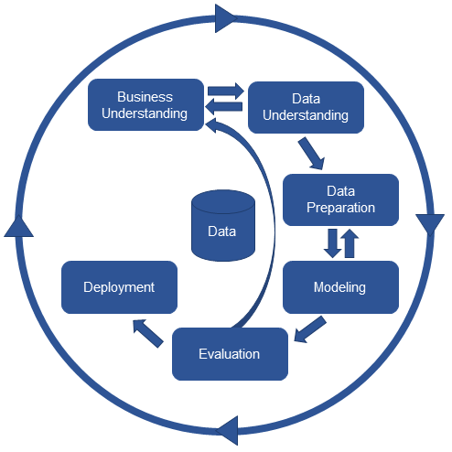
As Maheshwari (2015) outlines, a blending of business skills and technological aptitudes can lead to an effective data mining process. The Data Mining Cycle requires several important steps in its process. The first step is the understanding of the business and What sort of data need to be analysed to ensure the success of the project. Once the first step is completed, it is important to collect the necessary data to provide the business with uniqueness and competitive advantage. The next step is ensuring that the data is accurate and qualitative, followed by data analysing using different analytics software and tools. The data must be verified with the use of various data mining techniques before removing unessential items. Once the business and technological skills are successfully applied it the Data Mining Cycle, managing the business toward success is only a matter of decision making.

Data Mining Cycle (Maheshwari, 2015)

REFERENCES
Baraza Carlos, (2024), 20 Advantages and Disadvantages of Microsoft Excel. Available at: https://barrazacarlos.com/advantages-and-disadvantages-of-microsoft-excel/ (accessed:21.12.2024)
DeAngelis, K. J. and Ayers, S. (2009), What Does Average Really Mean? Making Sense of Statistics, Schools Business Affairs, U.S. Department of Education (.gov). Available at: https://files.eric.ed.gov/fulltext/EJ918578.pdf (accessed:20.12.2024).
Garth, A, (2008), Analysing Data Using SPSS, Sheffield Hallam University. Available at: https://docslib.org/doc/6562274/analysing-data-using-spss-a-practical-guide-for-those-unfortunate-enough-to-have-to-actually-do-it (accessed:21.12.2024).
Gravetter, F. J. and Wallnau L. B. (2008), Essentials of Statistics foe the Behavioural Science, 6th ed., Belmont, Calif: Thompson Wadsworth.
Ian H. Witten, Eibe Frank and Mark A. Hall (2011) Data Mining: Practical Machine Learning Tools and Techniques. Burlington, MA: Morgan Kaufmann. Available at: https://research-ebsco-com.ezproxy.uwtsd.ac.uk/linkprocessor/plink?id=07d67f3e-5156-3c93-9f07-e76c03a9f3b4 (Accessed: 19 December 2024).
Kocakoc, I. D. & Erdem, S. (2010). Business Intelligence Applications in Retail Business: OLAP, Data Mining & Reporting Services, Journal of Information & Knowledge Management, 9(02), 171-181.
Mahato, T. K. (2023), Biostatistics: Simple practical way to use Microsoft Excel to find mean, median, mode, standard deviation and correlation, Journal of Pharmaceutical Research and Health Care, 12(03), pp.150-155. Available at: https://www.researchgate.com (accessed:20.12.2024).
Maheshwari, A, (2015) Business Intelligence and Data Mining. New York: Business Expert Press. Available at: https://viewer-ebscohost-com.ezproxy.uwtsd.ac.uk/EbscoViewerService/ebook?an=935070&callbackUrl=https%3a%2f%2fresearch.ebsco.com&db=nlebk&format=EB&profId=ehost&lpid=lp_45&ppid=&lang=en&location=https%3a%2f%2fresearch-ebsco-com.ezproxy.uwtsd.ac.uk%2fc%2fonvpsy%2fsearch%2fdetails%2fsssi2wqsen%3fdb%3dnlebk&isPLink=False&requestContext=&profileIdentifier=onvpsy&recordId=sssi2wqsen (accessed: 21.12. 2024).

Microsoft (2024), Create a memory-efficient Data Model using Excel and the Power Pivot add-in, Available at: https://support.microsoft.com/en-gb/office/create-a-memory-efficient-data-model-using-excel-and-the-power-pivot-add-in-951c73a9-21c4-46ab-9f5e-14a2833b6a70 (accessed 21.12.2024).
Microsoft (2024), Excel specification and limits, Available at: https://support.microsoft.com/en-us/office/excel-specifications-and-limits-1672b34d-7043-467e-8e27-269d656771c3 (accessed:21.12.2024)
Rahman, A. and Muktadir, G. (2021), SPSS: An Imperative Quantitative Data Analysis Tool for Social Science Research, International Journal of Research and Innovation in Social Science, 5(10), pp. 300-301. Available at: https://scholar.google.co.uk (accessed: 21.12.2024).
Witten, I.H., Frank, E. and Hall, M.A. (2011) Data mining: practical machine learning tools and techniques. 3rd ed. Amsterdam: Elsevier/Morgan Kaufmann.

