

Student Name: Chirag Arvind Kapadia

Student ID:2521160

Module Name: International Marketing

Module Code: LCMB7026

Lecturer’s Name: Tushara Balendran

Term 2

Market Entry Strategy Analysis:
Emirates Airline's Potential Entry into Iceland
A Critical Analysis of International Strategy, Macro-Environmental Attractiveness and Entry

Introduction
This assignment examines the international market entry considerations of Emirates airline, the flag carrier of the United Arab Emirates (UAE) and the principal airline subsidiary of the Emirates Group, wholly owned by the Investment Corporation of Dubai (ICD) (Emirates Group, 2025). Emirates operates a global network from its Dubai hub to 152 destinations across 76 countries (FlightConnections, 2026), yet, based on publicly available scheduling, route and destination data as of 1 June 2026, it has no wholly-owned direct scheduled service, subsidiary, ground-handling operation or formal commercial presence in Iceland. Third-party travel agents and metasearch sites list Emirates among carriers 'flying to' Reykjavík (Keflavík); however, closer inspection shows these are interline or connecting itineraries routed through partner-operated legs rather than Emirates-operated flights, and Iceland does not appear among the countries Emirates serves directly (FlightConnections, 2026; Booking.com, 2026). This limited, indirect presence is noted and set aside for the purposes of this analysis, which treats Iceland as a genuine 'no significant operational presence' target market, consistent with the assignment brief.
The report is structured in three parts. Section 1 classifies Emirates' international strategy using Bartlett and Ghoshal's (1989) typology and appraises its global configuration. Section 2 critically evaluates Iceland's political, economic, legal and cultural environment as it pertains specifically to long-haul aviation and inbound tourism, before synthesising these findings through Dunning's (1988; 2001) eclectic (OLI) paradigm. Section 3 examines Emirates' historical entry-mode pattern, assesses its strategic fit for Iceland, and concludes with an evidence-based recommendation. Two figures are included to ground the analysis in verifiable, current data: Emirates Group's financial trajectory (Figure 1) and Iceland's tourist-arrival trend (Figure 2).

Section 1: Organisational Classification and Global Strategy

1.1 Strategic Categorisation
Bartlett and Ghoshal's (1989) integration-responsiveness framework classifies multinational firms along two axes: pressure for global integration/efficiency and pressure for local responsiveness, generating four archetypes — multinational, international, global and transnational. Positioned against this matrix, Emirates is best classified as pursuing a predominantly global strategy, tending toward high integration and comparatively low local responsiveness. Evidence for this classification includes: a single, centrally controlled hub-and-spoke network radiating from Dubai International Airport, through which almost all route planning, fleet allocation, scheduling and pricing decisions are coordinated centrally rather than devolved to national subsidiaries (Emirates Group, 2025); a highly standardised product and service proposition — consistent cabin design, uniform crew training, a single global brand identity and loyalty programme (Emirates Skywards) — applied with minimal local adaptation across all 76 countries served; and a vertically integrated group structure (encompassing dnata ground handling, Emirates Flight Catering, Emirates Holidays and Arabian Adventures) that concentrates value-creating activities in Dubai rather than dispersing them to locally responsive units (Companies History, 2026).
This classification nonetheless requires critical qualification. Bartlett and Ghoshal's framework was developed principally with reference to manufacturing and fast-moving consumer goods multinationals whose responsiveness pressures arise from differentiated consumer tastes and local regulatory product standards. Airlines are a service-network industry in which 'local responsiveness' is constrained less by strategic choice than by the bilateral Air Service Agreement (ASA) system that governs traffic rights between sovereign states; the appearance of global standardisation is therefore partly an artefact of the regulatory environment rather than solely evidence of Emirates' deliberate strategic posture. Furthermore, Emirates' state ownership by the ICD removes the shareholder-driven pressure toward joint-venture or locally incorporated market entry that publicly listed competitors (for example, alliance-based network carriers) often face, reducing responsiveness pressure structurally rather than strategically. Applied with this caveat, the global classification remains defensible but should be read as reflecting industry structure as much as corporate choice.

1.2 Global Configuration and Competitive Advantage
Emirates' geographic footprint is built around Dubai's position as a 'super-connector' hub, situated within an eight-hour flight radius of roughly two-thirds of the world's population. This configuration allows Emirates to aggregate sixth-freedom transfer traffic — passengers travelling between two other countries via Dubai — at a scale that regional, point-to-point carriers cannot replicate, and it underpins the airline's long-haul, premium-oriented widebody fleet strategy (principally the Airbus A380, Boeing 777 and, increasingly, the Airbus A350) (Routesonline, 2026). The concentration of engineering, catering, crew basing and cargo operations in Dubai, largely self-supplied through Emirates Group subsidiaries such as dnata and Emirates Flight Catering, generates scale and scope economies that materially contribute to competitive advantage. As Figure 1 shows, the Emirates Group's revenue and profitability have grown consistently since the pandemic-era loss recorded in FY2021-22, culminating in a record pre-tax profit of US$6.2 billion on revenue of US$39.6 billion in FY2024-25, when Emirates was independently recognised as the world's most profitable airline (Emirates Group, 2025).
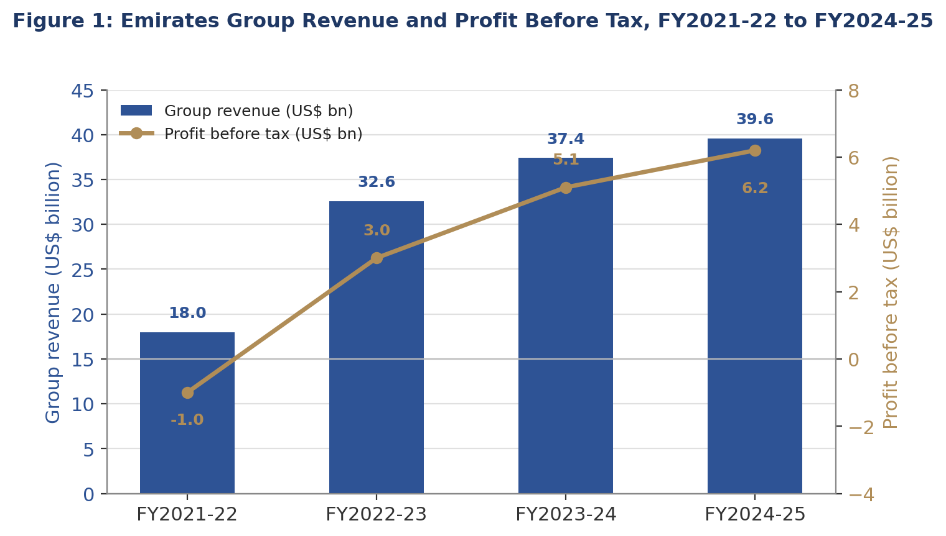

The trend in Figure 1 is analytically significant for the market-entry decision explored later in this report: the sharp post-pandemic recovery and now-consistent double-digit profit growth demonstrate that Emirates possesses the balance-sheet strength and reinvestment capacity to fund expansion into new, unproven markets such as Iceland without relying on external equity partners or debt-financed risk-sharing — a materially different resource position from that of smaller network carriers. However, this highly centralised configuration also concentrates risk. Emirates' near-total dependence on a single hub exposes it disproportionately to localised disruption — whether airspace closures linked to regional conflict, Dubai airport capacity constraints, or UAE-specific diplomatic friction — in a way that alliance-based competitors with multiple hubs can better diversify. Relatedly, Emirates' longstanding refusal to join a global alliance (Star Alliance or oneworld) is a deliberate configuration choice that preserves full network control and brand consistency but forces reliance on a patchwork of bilateral codeshare and interline agreements (for example, with China Southern Airlines, flydubai and, historically, a minority equity stake in SriLankan Airlines) to extend reach into markets it does not serve directly (Companies History, 2026; Reference for Business, n.d.). This is a configuration trade-off directly relevant to the Iceland decision: Emirates' global, centralised model is well suited to high-volume trunk routes but is structurally less flexible when testing thin, uncertain, peripheral markets such as Iceland, where a lower-commitment mode may better fit the firm's configuration logic.

Section 2: Macro-Environmental Appraisal and Market Attractiveness
This section evaluates Iceland's political, economic, legal and cultural environment, focusing specifically on the factors most material to long-haul network aviation and inbound tourism rather than providing an exhaustive descriptive PESTLE overview.

2.1 Political Environment
Iceland is a stable parliamentary democracy with consistently high rankings for institutional quality, rule of law and low corruption, which substantially reduces the sovereign and expropriation risk typically associated with new market entry. As a member of the European Economic Area (EEA) and the Schengen Area, though notably not the European Union, Iceland aligns its external border and, to a significant degree, aviation safety regulation with EU frameworks while retaining independent trade and fisheries policy (Schengen Traveler, 2026). Most significantly for Emirates, the Icelandic government has pursued an explicitly liberal, growth-oriented aviation and tourism policy: in June 2026 Iceland extended visa-free entry to more than ninety countries, including several Gulf states, explicitly framed by policymakers as a measure to diversify inbound tourism source markets and strengthen aviation connectivity (Travel and Tour World, 2026). While UAE passport holders already benefit from Schengen visa-exempt status for stays of up to ninety days (OraVisa, 2026), this policy signals a government disposition favourable to welcoming new long-haul carriers and additional traffic rights at Keflavík.
This liberal posture is corroborated by observable market behaviour: Keflavík has added multiple new long-haul carriers in quick succession, with Alaska Airlines becoming a fifth foreign long-haul operator from May 2026 alongside Air Canada, Delta, United and WestJet, and foreign carriers collectively increasing summer 2026 seat capacity by around 20% year-on-year (Air Service One, 2026a; 2026b). This pattern of political and regulatory openness to new entrants is a genuine attraction factor. The principal political-legal uncertainty, addressed further below, is that no evidence was found of an existing bilateral Air Service Agreement specifically between the UAE and Iceland — a gap that, while probably resolvable given Iceland's demonstrated openness, nonetheless represents an unresolved precondition to entry rather than a settled advantage.

2.2 Economic Environment
Iceland is a small, high-income, open economy with 2026 nominal GDP of approximately US$43.8 billion and GDP per capita among the highest in Europe, variously estimated between roughly US$78,000 and US$87,000 depending on source and year (Lloyds Bank Trade, 2026; FocusEconomics, 2026). This affluence signals strong purchasing power among the resident population; however, Iceland's total population of only around 380,000 means the absolute size of any potential outbound origin-destination (O&D) travel market between Iceland and the UAE is intrinsically small — a structural constraint no policy change can offset. Growth has also been volatile: Statistics Iceland recorded GDP growth swinging from 5% in 2023 to 0.5% in 2024, before the OECD (2026) projected a recovery from 1.3% in 2025 to 1.6% in 2026, while the IMF-referenced projection cited by Lloyds Bank Trade (2026) suggests a somewhat higher 2.2% for 2026 — the divergence itself illustrating forecasting uncertainty in a small, externally exposed economy.
The more economically decisive factor for an airline is not the domestic Icelandic market but inbound tourism, which accounts for approximately 40% of Iceland's export income and roughly 8% of GDP, making the economy structurally dependent on, and therefore sensitive to, international visitor flows (Lloyds Bank Trade, 2026). As Figure 2 illustrates, inbound arrivals via Keflavík collapsed during the pandemic before recovering to, and now plateauing around, 2.2-2.3 million visitors annually — a pattern confirmed by the Icelandic Tourist Board, which records 2.26 million arrivals in 2024 and forecasts approximately 2.24 million for 2026, essentially flat on the prior two years (Ferðamálastofa, 2026; Travel and Tour World, 2026).
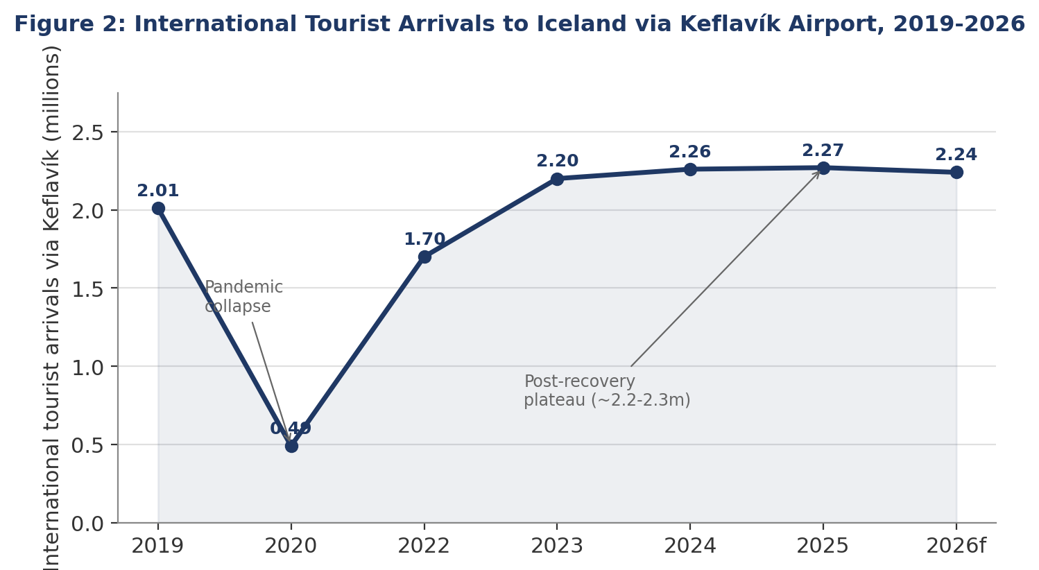

The plateau visible in Figure 2 is a critical finding for market attractiveness: it suggests Iceland's inbound tourism market, while large relative to its own population, has matured rather than being in a phase of continued rapid growth, which tempers the demand case for a new long-haul entrant relative to a market still expanding at double-digit rates. Emirates' true addressable opportunity is therefore not local Icelandic outbound demand but a share of this plateaued, but sizeable, global inbound flow — particularly Gulf, South Asian and onward-connecting leisure travellers seeking access to Iceland's natural attractions (geothermal spas, glaciers, the aurora borealis) via Dubai's hub. Critically, this demand is currently served almost entirely by European, North American and low-cost long-haul carriers rather than any Middle Eastern network carrier, meaning Emirates would be creating new connecting traffic rather than capturing an existing but underserved segment — a materially higher-risk demand proposition than entering an established trunk market.

2.3 Legal Environment
Iceland's EEA and Schengen membership provides a familiar, harmonised regulatory environment for Emirates: aviation safety oversight follows European Union Aviation Safety Agency (EASA) standards, which Emirates already operates under extensively across its European network, minimising compliance and certification risk relative to entering an unfamiliar regulatory jurisdiction. Iceland also imposes no meaningful restriction on foreign carriers operating scheduled services into Icelandic airports, and no local incorporation or joint-venture requirement exists for a foreign airline to fly into Keflavík, provided the requisite traffic rights are held — a materially more permissive legal environment than markets requiring mandatory local equity partners.
The critical, unresolved legal constraint is the absence of publicly identifiable evidence of a bilateral Air Service Agreement between the UAE and Iceland analogous to those Emirates relies upon elsewhere. Securing fifth- or sixth-freedom traffic rights, or at minimum third/fourth-freedom rights for direct Dubai–Keflavík services, would likely require new or expanded diplomatic negotiation. A second, more operational legal-regulatory constraint concerns airport capacity: Keflavík is managed by state operator Isavia and is currently dominated by Icelandair, which holds approximately 54–62% of available seat capacity depending on the reporting period, with the airport itself flagged in industry commentary as approaching a genuine slot and capacity crunch even as a terminal expansion project proceeds (Air Service One, 2026a; Aviation Week, 2026b). Any new widebody long-haul entrant would need to negotiate slot access within this increasingly congested environment, which — while not a legal prohibition — functions as a practical barrier closely tied to the regulatory allocation of scarce airport capacity.

2.4 Cultural Environment
Iceland's Nordic culture is characterised, in Hofstede's (2001) terms, by low power distance, high individualism and a strong preference for egalitarianism, understatement and environmental consciousness — a marked contrast to the UAE's higher power-distance, more collectivist and status-conscious home culture from which Emirates' premium brand positioning is derived. Icelandic and broader Nordic consumers have also demonstrated, in tourism-marketing commentary, a preference for simplicity, sustainability and value-for-money over conspicuous luxury, potentially creating a values mismatch with Emirates' flagship A380 first- and business-class product, which is more strongly attuned to South Asian, Gulf and Western long-haul premium travel segments. This risk is partially mitigated by Emirates' own multicultural service delivery model — the airline employs cabin crew of more than 160 nationalities and has extensive experience serving culturally diverse markets (Routesonline, 2026) — but the mismatch nonetheless reinforces the earlier economic finding that Emirates' realistic target segment in an Iceland service would be inbound global tourists and connecting passengers rather than the domestic Icelandic outbound market.
Applying Ghemawat's (2001) CAGE distance framework as a complementary lens reinforces this picture: cultural and administrative distance between the UAE and Iceland is moderate — different language, religion and social norms, though both are stable, high-institutional-quality states — while geographic distance is substantial (a nonstop Dubai–Keflavík sector would be among the longer routes in Emirates' network) and economic distance is low, given both are high-income economies. On balance, distance is manageable rather than prohibitive, but it is not negligible, and it further supports the case, developed in Section 3, for a staged rather than immediate full-commitment entry.

2.5 Synthesis Using Dunning's Eclectic (OLI) Paradigm
Dunning's (1988; 2001) eclectic paradigm holds that a firm will engage in and benefit from foreign market entry where it possesses Ownership-specific advantages, the target location offers Location-specific advantages, and the firm can capture greater value by Internalising the transaction than by using arm's-length market mechanisms. Applied to Emirates and Iceland, the framework produces a mixed but instructive picture.
Ownership (O) advantages are substantial and highly transferable. Emirates possesses strong global brand equity, a differentiated premium product, and — critically, as evidenced in Figure 1 — state-backed access to low-cost capital that has enabled record financial performance without reliance on external equity partners (Emirates Group, 2025). Its vertically integrated group structure (dnata, Emirates Flight Catering) also constitutes an ownership advantage in that ground services, catering and engineering support could in principle be self-supplied even in a new market, reducing dependence on unfamiliar local suppliers.
Location (L) advantages of Iceland are real but modest relative to Emirates' typical target markets. Positive factors include a liberal, growth-friendly aviation policy environment, a high-value and currently underserved (by Middle Eastern carriers) inbound tourism market of approximately 2.2-2.3 million annual visitors, and Iceland's geographic position as a North Atlantic waypoint. Negative location factors are, however, significant: an intrinsically small resident population limiting local O&D demand, the demand plateau evident in Figure 2, currency risk associated with the Icelandic króna, and — most concretely — approaching capacity and slot constraints at Keflavík driven by Icelandair's dominant position. Relative to the large gateway cities (London, New York, Mumbai, Sydney) that typically anchor Emirates' route economics, Iceland's location advantages are comparatively thin.
Internalisation (I) advantages are ambiguous and, on balance, weak for a full wholly-owned entry at this stage. Emirates' historical preference is to internalise network operations directly (own aircraft, own crew, own AOC) rather than franchise route operation, which favours a fully owned service. However, the very small scale of a single new long-haul route into a thin, plateaued market does not obviously justify the fixed-cost commitment of establishing dedicated ground-handling, sales and station infrastructure that internalisation would typically involve, particularly when Icelandair — the dominant incumbent — already controls scarce Keflavík slot capacity and possesses an extensive partner network (including JetBlue, Alaska Airlines, WestJet and Finnair) that Emirates could access via a lower-commitment, non-equity arrangement (Aviation Week, 2026a). The OLI synthesis therefore indicates that while Emirates has ample ownership advantages to succeed almost anywhere, Iceland's constrained location advantages and the weak commercial case for full internalisation of a single thin route point toward a lower-commitment entry mode as the economically rational starting position — the question examined directly in Section 3.

Section 3: Entry Mode Strategy and Strategic Synthesis

3.1 Historical Pattern Recognition
Emirates' dominant historical entry mode for route (airline-service) expansion has been organic, wholly-owned greenfield growth: launching new scheduled services directly under its own Air Operator's Certificate from the Dubai hub, rather than acquiring or franchising foreign carriers. Notably, in its founding phase in 1985, Emirates itself entered the market with a risk-minimising, low-capital mode — wet-leasing a Boeing 737-300 and an Airbus A300B4 from Pakistan International Airlines for its inaugural Dubai–Karachi and Dubai–Mumbai services on 25 October 1985 — before transitioning to its first wholly-owned aircraft, an Airbus A310-304, on 3 July 1987 once the network had proved commercially viable (Emirates, 2024). This staged, evidence-led escalation from a lighter-commitment mode toward full ownership is a recurring feature of the airline's growth philosophy, even though its steady-state, mature-market entry mode today is typically direct, wholly-owned route launch.
A second consistent pattern is Emirates' preference for bilateral codeshare and interline partnerships over global alliance membership as a mechanism for extending network reach without ceding control — arrangements historically held with carriers such as China Southern Airlines and flydubai, alongside a rare minority equity stake in SriLankan Airlines (Companies History, 2026; Reference for Business, n.d.). At the Emirates Group level, by contrast, the ground-services and travel-management subsidiary dnata has entered international markets more frequently through acquisition — for example, the 2015 acquisition of RM Ground Services in Brazil, the 2016 acquisition of Ground Services International in the United States, and the 2023 majority-stake acquisition of UK-based cruise distributor Imagine Cruising (Companies History, 2026; Gulf News, 2023). This distinction matters: Emirates' flying operations and its ancillary services businesses have historically used markedly different entry-mode logics, and this report concerns the former.

3.2 Strategic Fit and Justification for Iceland
Applying Emirates' default entry mode — a wholly-owned, direct widebody service — to Iceland is not well supported by the evidence developed in Section 2. Financial risk is elevated because the addressable local O&D market is intrinsically small and demand has plateaued (Figure 2), meaning route economics would depend almost entirely on connecting/transfer traffic through Dubai for a destination Emirates has never previously served, and cannot be forecast from existing route performance data. Operational risk is non-trivial given documented slot and capacity constraints at Keflavík, Icelandair's dominant incumbent position, and challenging North Atlantic operating conditions. Political-legal risk is moderate: while Iceland's policy environment is genuinely favourable, the apparent absence of an existing UAE–Iceland bilateral Air Service Agreement introduces a precondition and timeline risk outside Emirates' direct control.
Against this risk profile, a lower-commitment alternative — an interline or codeshare partnership with Icelandair, rather than an immediate wholly-owned service — better fits the strategic and financial realities of the market. Icelandair already commands a majority of Keflavík's seat capacity and, despite pursuing an independent (non-alliance) strategy of its own, maintains an extensive partner network including JetBlue, Alaska Airlines, WestJet and Finnair (Aviation Week, 2026a). A codeshare arrangement would allow Emirates to place its code on Icelandair-operated connections between Keflavík and European or North American gateways Emirates already serves, generating incremental connecting revenue and market intelligence on Iceland-linked demand at minimal capital exposure, while avoiding a premature and potentially uneconomic widebody deployment into a capacity-constrained, thinly populated market. This mirrors the staged, risk-calibrated logic Emirates itself applied at its 1985 founding — starting with a lower-commitment arrangement and escalating only once demand is demonstrated.
Weighing resource commitment against control and flexibility: a wholly-owned direct service maximises brand control and revenue capture but commits substantial fixed costs (aircraft, crew basing considerations, slots, marketing) against unproven, plateaued demand, and is difficult to reverse without reputational cost. A codeshare/interline mode sacrifices some control and brand visibility but preserves flexibility and option value, allowing Emirates to observe actual passenger volumes, yield and connecting-traffic patterns before committing capital — a materially more prudent risk-adjusted choice given the demand and infrastructure constraints identified in Figure 2 and Section 2.3. This also aligns with a long-term strategic-fit consideration: should Keflavík's ongoing terminal expansion alleviate current capacity pressure, and should the newly liberalised visa regime measurably increase Gulf and Asian visitor volumes to Iceland, Emirates would then have an evidence base to justify escalating to a seasonal, and eventually year-round, wholly-owned direct service using a right-sized aircraft such as the Airbus A350, consistent with its broader recent pattern of adding niche, previously underserved long-haul destinations such as Bogotá and Madagascar (Emirates Group, 2025).

3.3 Conclusion and Recommendations
This report classifies Emirates as pursuing a predominantly global international strategy under Bartlett and Ghoshal's (1989) framework, underpinned by a centralised, vertically integrated Dubai hub configuration that, as Figure 1 demonstrates, generates substantial and growing competitive advantage but also concentrates operational risk. Iceland presents a politically stable, legally hospitable and increasingly tourism-liberalised market, but one that, as Figure 2 shows, is economically small, has plateaued in demand terms since 2023, and is increasingly capacity-constrained at its principal gateway airport. Dunning's OLI framework indicates that while Emirates possesses ample ownership advantages, Iceland's location advantages are comparatively modest and the internalisation case for an immediate, fully-owned route is weak relative to the scale of opportunity.
The recommendation is therefore a phased, evidence-led entry strategy: first, establish a codeshare or interline partnership with Icelandair to generate connecting traffic and market data at minimal capital risk; second, pursue in parallel the diplomatic negotiation of a UAE–Iceland bilateral Air Service Agreement to secure the traffic rights a future direct service would require; and third, escalate to a seasonal and, if justified by demonstrated demand, year-round wholly-owned Dubai–Keflavík service once Keflavík's capacity expansion is realised and connecting-traffic volumes substantiate the investment. This staged approach reconciles Emirates' historically preferred mode of full ownership and control with the genuine demand and infrastructure uncertainties specific to the Icelandic market, and mirrors the risk-calibrated logic Emirates itself used when entering its very first international routes.

Section 2: Reflective Account
This reflection uses Gibbs' (1988) Reflective Cycle — Description, Feelings, Evaluation, Analysis, Conclusion and Action Plan — to critically examine the process of researching, analysing and preparing Section 1 of this assessment.

Description
The task required selecting a multinational corporation and a target country in which it had no significant operational presence, then applying established international business frameworks — Bartlett and Ghoshal's (1989) integration-responsiveness model, a focused macro-environmental analysis, Dunning's (1988; 2001) eclectic paradigm, and an entry-mode evaluation — to build an evidence-based recommendation. I selected Emirates airline and Iceland. My process began with verifying, through current route-network and destination data, that Emirates genuinely had no direct operational presence in Iceland, before systematically gathering financial, regulatory, tourism and competitive data on both the firm and the host market, constructing supporting visualisations of the key financial and tourism trends, and finally synthesising these findings against the theoretical frameworks specified in the brief.

Feelings
Initially I felt some uncertainty about whether an airline was an appropriate case for frameworks that are more commonly applied to manufacturing or consumer-goods multinationals in course materials and textbook examples. This uncertainty was productive rather than paralysing: it prompted me to think critically about the limits of the models rather than applying them mechanically. Confidence grew once verified, current data — Emirates Group's multi-year financial results, Iceland's tourist-arrival series, and Keflavík capacity reporting — was assembled and visualised, because the analysis could then be grounded in evidence rather than assumption. There was a recurring tension between wanting to present Iceland as an attractive opportunity (which would make for a tidier narrative) and the discipline of critical analysis, which required acknowledging real constraints such as the demand plateau visible in Figure 2 and capacity limits even where they complicated a clean recommendation.

Evaluation
What worked well was triangulating multiple independent sources for each factual claim — for example, cross-checking Emirates' route network across several airline-data providers before concluding that no direct service existed, and cross-checking Iceland's tourist-arrival figures against both the national tourist board and independent statistics providers before charting them. Structuring research around the assignment's explicit sub-headings, and building the two figures directly from tabulated multi-year data rather than a single-year snapshot, helped maintain focus on trends genuinely material to an airline's market-entry decision, rather than producing a purely descriptive country profile. What was less effective initially was a tendency to gather broad country-level data before narrowing to aviation- and tourism-specific sources; recognising this and consciously re-focusing research toward industry-specific outlets (aviation trade press, airport capacity reporting, the national tourist board) substantially improved the relevance and analytical depth of the final output.

Analysis
The most significant challenge was the near-total absence of a documented Air Service Agreement between the UAE and Iceland, which meant a key legal precondition to entry could not be confirmed as either resolved or actively negotiated from public sources. Rather than treating this gap as a weakness to be concealed, course learning on critical analysis — particularly the principle that acknowledging genuine uncertainty strengthens rather than undermines an argument — supported the decision to flag this explicitly as an unresolved risk factor requiring further negotiation, rather than assuming its existence or omitting the issue. A second analytical challenge was applying Bartlett and Ghoshal's (1989) typology, developed with manufacturing multinationals in mind, to a service-network industry structurally shaped by bilateral aviation regulation rather than purely strategic choice; lecture material on the limitations of foundational strategy frameworks, and the expectation that frameworks be applied critically rather than descriptively, directly supported the decision to qualify the classification rather than present it as an uncomplicated fit. A third challenge was ensuring the two figures added genuine analytical value rather than decorative content: I addressed this by explicitly interpreting each figure in the surrounding text (for example, linking the profit trend in Figure 1 to Emirates' capital capacity, and the plateau in Figure 2 to demand-side risk) rather than leaving the data to speak for itself.

Conclusion
This assignment deepened my understanding that international business frameworks are analytical lenses to be applied critically and adapted to industry context, not templates to be completed mechanically. I learned to prioritise recent, verifiable, industry-specific data over generic country profiles, to treat unresolved uncertainties (such as the absent bilateral agreement) as legitimate, reportable findings rather than gaps to be smoothed over, and to use data visualisation purposefully — as evidence integrated into the argument rather than as illustrative decoration. I also gained a clearer appreciation of how ownership, location and internalisation advantages interact dynamically — for instance, how strong ownership advantages (evidenced quantitatively in Figure 1) can still yield a cautious entry-mode recommendation when location advantages are modest (evidenced in Figure 2) and internalisation is not commercially justified at the initial scale of entry.

Action Plan
For future assignments of this kind, I intend to begin industry-specific and regulatory research earlier in the process, before broad country-level data gathering, to keep analysis focused from the outset. I will also build a habit of explicitly cross-referencing at least two independent sources for any quantitative claim, and of constructing a simple visualisation early in the research process (rather than only at the writing stage), as this proved effective both for spotting trends such as the tourism plateau and for strengthening the evidential basis of the final argument. Finally, I plan to practise applying strategic frameworks to a wider range of industries beyond manufacturing examples covered in lectures, so that I become more comfortable identifying and articulating a framework's boundary conditions — as I did here with Bartlett and Ghoshal's model — rather than only its straightforward applications.

References (Harvard Style)
Air Service One (2026a) Keflavik gained 4 airlines in 2024/2025, with a new long-haul carrier coming in 2026. Available at: https://airserviceone.com/keflavik-gained-4-airlines-in-2024-2025-with-a-new-long-haul-carrier-coming-in-2026/
Air Service One (2026b) Strong summer for Keflavik Airport as airlines expand network and capacity. Available at: https://airserviceone.com/strong-summer-for-keflavik-airport-as-airlines-expand-network-and-capacity/
Aviation Week (2026a) How Icelandair aims to tackle Norwegian's transatlantic ambitions, Keflavík capacity crunch and fleet renewal. Available at: https://aviationweek.com/air-transport/airports-networks/how-icelandair-aims-tackle-norwegians-transatlantic-ambitions
Aviation Week (2026b) Routes & Networks Latest: Rolling Daily Updates (W/C June 8, 2026). Available at: https://aviationweek.com/air-transport/airports-networks/routes-networks-latest-rolling-daily-updates-wc-june-8-2026
Bartlett, C.A. and Ghoshal, S. (1989) Managing Across Borders: The Transnational Solution. Boston, MA: Harvard Business School Press.
Booking.com (2026) Book affordable flights to Iceland from the United Arab Emirates. Available at: https://www.booking.com/flights/route/to-country/ae/is.html
Companies History (2026) Emirates Net Worth, Marketcap, Revenue, Competitors 2026. Available at: https://www.companieshistory.com/emirates/
Dunning, J.H. (1988) 'The eclectic paradigm of international production: a restatement and some possible extensions', Journal of International Business Studies, 19(1), pp. 1-31.
Dunning, J.H. (2001) 'The eclectic (OLI) paradigm of international production: past, present and future', International Journal of the Economics of Business, 8(2), pp. 173-190.
Emirates (2024) History Timeline | About us | Emirates. Available at: https://www.emirates.com/us/english/about-us/timeline/
Emirates Group (2025) Emirates Group Achieves Record Profit of AED 22.7 bn (US$ 6.2 bn) in 2024-25. Available at: https://www.emirates.com/media-centre/emirates-group-achieves-record-profit-of-aed-227-bn-us-62-bn-in-2024-25/
Ferðamálastofa (Icelandic Tourist Board) (2026) Numbers of Foreign Visitors. Available at: https://www.ferdamalastofa.is/en/recearch-and-statistics/numbers-of-foreign-visitors
FlightConnections (2026) Emirates Flights and Destinations. Available at: https://www.flightconnections.com/route-map-emirates-ek (Accessed: 1 June 2026).
FocusEconomics (2026) Iceland Economy: GDP, Inflation, CPI & Interest Rates. Available at: https://www.focus-economics.com/countries/iceland/
Ghemawat, P. (2001) 'Distance still matters: the hard reality of global expansion', Harvard Business Review, 79(8), pp. 137-147.
Gibbs, G. (1988) Learning by Doing: A Guide to Teaching and Learning Methods. Oxford: Further Education Unit, Oxford Polytechnic.
Gulf Business (2023) Emirates Group reports record annual profit of Dhs10.9bn for FY2022-23. Available at: https://gulfbusiness.com/emirates-group-reports-annual-profit-of-dh10-9-bn/
Gulf News (2023) Dnata acquires 51% stake in UK's Imagine Cruising. Available at: https://gulfnews.com/business/tourism/dnata-acquires-51-stake-in-uks-imagine-cruising-1.1468993
Hofstede, G. (2001) Culture's Consequences: Comparing Values, Behaviors, Institutions and Organizations Across Nations. 2nd edn. Thousand Oaks, CA: Sage.
Lloyds Bank Trade (2026) The Economic Context of Iceland. Available at: https://www.lloydsbanktrade.com/en/market-potential/iceland/economical-context
OECD (2026) Iceland Economic Snapshot. Paris: OECD. Available at: https://www.oecd.org/en/topics/sub-issues/economic-surveys/iceland-economic-snapshot.html
OraVisa (2026) Iceland Visa from Dubai: Complete Guide 2026. Available at: https://oravisa.com/blog/iceland-visa-from-dubai-complete-guide/
Reference for Business (n.d.) The Emirates Group - Company Profile, Information, Business Description, History, Background Information. Available at: https://www.referenceforbusiness.com/history2/10/The-Emirates-Group.html
Routesonline (2026) Overview | Emirates | Routes. Available at: https://www.routesonline.com/airlines/3475/emirates/
Schengen Traveler (2026) Travel to Iceland: Entry Requirements & Tips (2026). Available at: https://schengentraveler.com/travel-iceland/
Trading Economics (2026) Iceland Full Year GDP Growth. Available at: https://tradingeconomics.com/iceland/full-year-gdp-growth
Travel and Tour World (2026) Iceland is surging the tourism industry with new visa free entry policy for over ninety countries including Brazil, Japan, Australia, Schengen and Gulf nations. Available at: https://www.travelandtourworld.com/news/article/bovsbnlx0qcj/

