Thomas Sellwood (2215661)

Computer Architecture and Operating Systems – Operating Systems

Key Functions of General Operating Systems 2
Processor Management 2
Memory Management 2
Device Management 2
File Management 2
Security 2
Use of Windows OS CLI Commands 3
1. Get-ChildItem 3
2. Get-Process 3
3. New-Item 5
4. Set-Location 5
5. Start-Process 6
6. Stop-Process 6
7. Get-Command 6
8. Get-Help 7
9. Invoke-WebRequest 7
10. Remove-Item 8
Use of Linux OS CLI Commands 8
1. ls 8
2. mkdir 8
3. cd 8
4. rmdir 8
5. cp 9
6. mv 9
7. grep 9
8. chmod 9
9. echo 10
10. Cat 10
Use of Windows OS Scripts 10
Use of Linux OS Scripts 12
Conclusion 15
Appendices 15
15

Key Functions of General Operating Systems

An operating system, is a computer program that once it has been loaded onto a computer by a boot program, will manage all the other computer programs that that computer will use [1].
The operating system will interact with the applications on the computer utilising a specific API [1]. The applications on the PC will request use of resources by utilising this API with the operating system [1].
Users have various methods of interacting with the operating system. This can be done by using a command line interface (CLI) or by using a graphical user interface (GUI) [1].
The operating system has various common functions that users can utilize to service their needs. Below some of the common features have been highlighted and discussed.

Processor Management
An operating system in a multi-programming environment will determine to order on which processes have access to the CPU. This aspect of processor management is called process scheduling [2]. A traffic controller will be utilised to keep track of processes, allocate CPU cores to processes, and then once the process is finished de-allocates the CPU core [3].

Memory Management
Another aspect of the functions of an operating system is managing the memory of a computer. The operating system will manage the allocation and deallocation of memory to the processes whilst also ensuring that memory is not consumed by the process [2].

Device Management
An operating system will also manage device communication via the respective drivers to hardware such as, speakers, keyboards and mice [2]. The operating system controls the access to this hardware using the drivers with an I/O controller [3]. If a process would like to use hardware such as a Wi-Fi adaptor or speakers, the operating system will allow the process to access the device if it is available [3].

File Management
An operating system has a file system that can handle all the files and directories on the computer’s hard drives [3]. The files are organized into directories for efficient and easy navigation [2]. It can keep track of location, the information about creation and modification, and other data related to the file such as transfer and any copying [2][3]. The operating system defines the file directory structure and then maps this virtual structure to the physical location of the data on the device [3]. It also handles and controls access to the files to maintain the integrity and structure of the data in the files [2].

Security
An operating system manages the accounts of users who access files and program on the devices [2]. The operating system will use password protection to prevent users from accessing data or applications that they are prohibited from accessing [2]. It makes sure that users can only access files they have created or have been allowed access to from another user, this protects the integrity and confidentiality of the data [2][3]. Operating systems additionally have the functionality for encryption of files, which can add an extra layer of security [2].

Use of Windows OS CLI Commands

Document the use of approx. 10 Batch or PowerShell commands, with screenshots and accompanying narration. Approx. 350 words, cite several reference sources.

1. Get-ChildItem
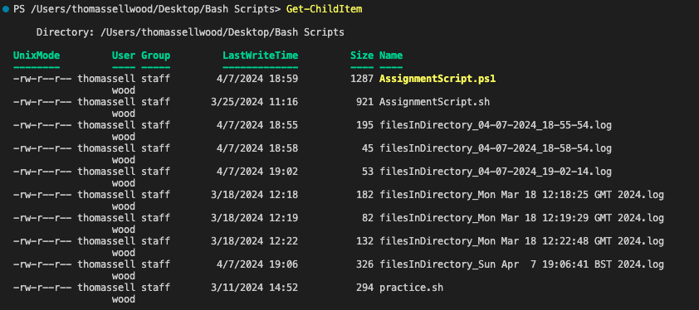
The Get-ChildItem cmdlet in PowerShell is used to list the contents of the specified directory [4]. In this example, it lists the items in the "/Users/thomassellwood/Desktop/Bash Scripts" directory.

2. Get-Process
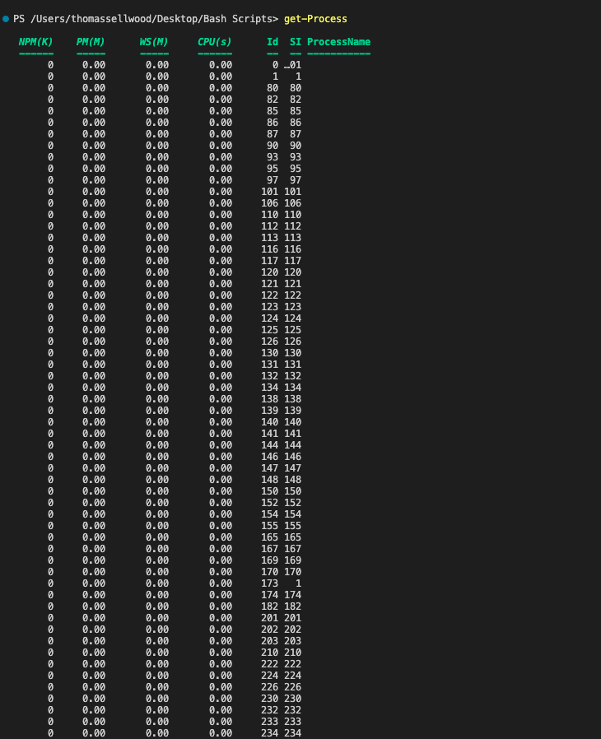
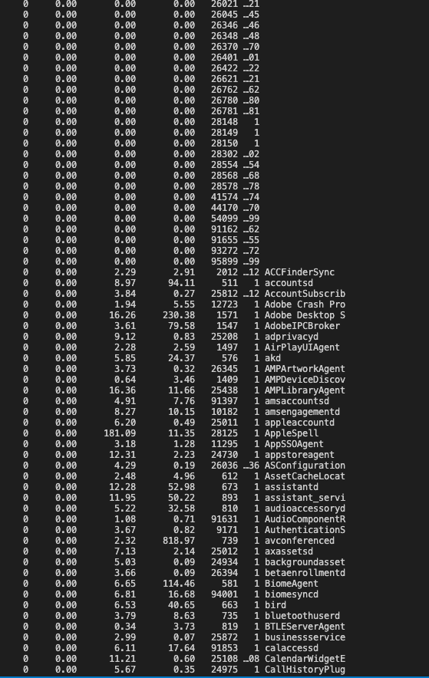
The Get-Process cmdlet displays the processes running on the local machine. In this example, it has displayed all running services, it can also be used to view a specific process by entering the process name [5].

3. New-Item
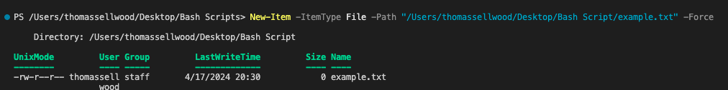
The New-Item cmdlet creates a new file named "example.txt" in the specified path "/Users/thomassellwood/Desktop/Bash Script/” [4]. The cmdlet can be used to create any new file, you can create multiuple files by using a comma [4].

4. Set-Location
The Set-Location cmdlet sets the file location to the user sepcified path. This allows user to move to different locations also using this command [4].

5. Start-Process
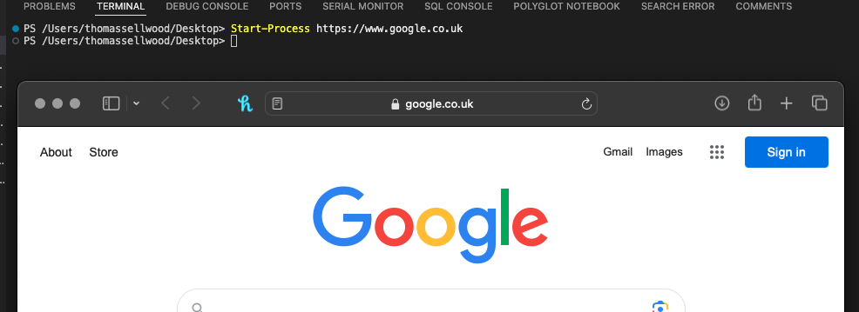
The Start-Process cmdlet with the combination of a web url, will open a web page for the specified url using the system default browser. The start-process cmdlet can start one or more processes on a pc at one time. [6]

6. Stop-Process
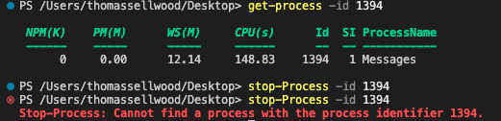
The Stop-Process cmdlet stops the messages process in this example. The cmdlet takes a process id or name as input and stops the process, some processes cannot be stopped [7].

7. Get-Command

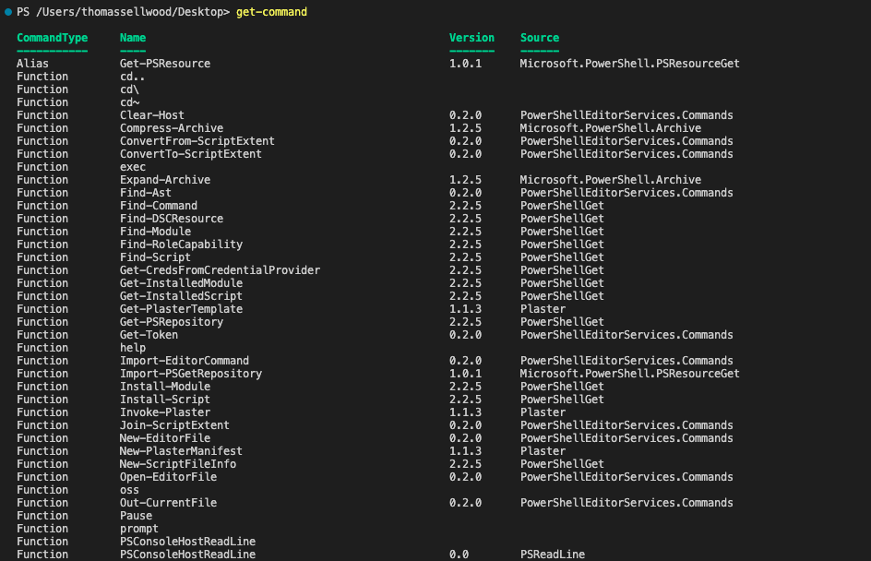
The Get-Command cmdlet retrieves all available commands in PowerShell, this includes aliases, functions, cmdlets, scripts, filters and any applications [8].

8. Get-Help
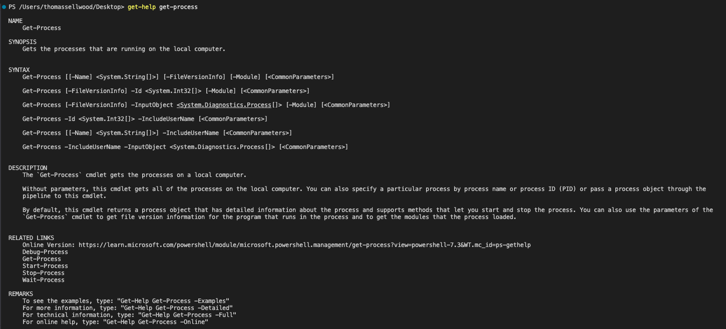
The Get-Help cmdlet retrieves help information for the specified command, cmdlet, functions, workflows and scripts. In this example, it provides help for the Get-Service cmdlet. [9]

9. Invoke-WebRequest
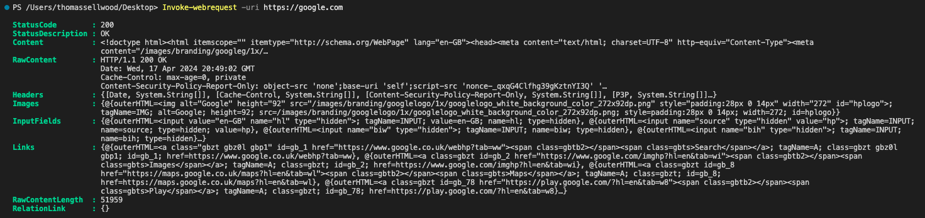
The Invoke-WebRequest cmdlet sends a http and https requests to a webserver. It will parse the response and return collections of images, and other significant elements of the HTML [10].

10. Remove-Item
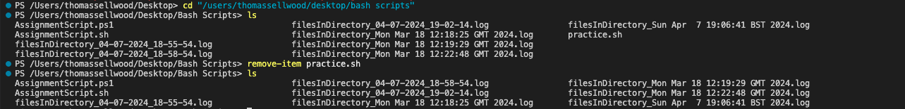
The Remove-Item cmdlet deletes the file named "practice.sh" in the specified path. Caution should be taken as this will permanently delete the specified file and this cannot be undone [4].

Use of Linux OS CLI Commands

1. ls
The ls command in Bash is used to list the contents of the current directory. In this example, it displays the files and directories in the current working directory of Bash Scripts [11].

2. mkdir
The mkdir command creates a new directory named "test" in the current working directory. This command allows you to create new directories in the terminal [11].

3. cd
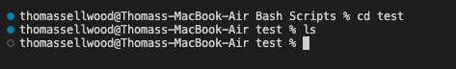
The cd command is used to change the current working directory to the specified path. This command allows the user to navigate through directories, in the above example the user has navigated to the test directory [11].

4. rmdir
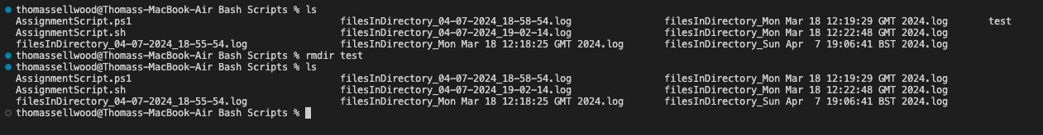
The rmdir command removes empty directories, in this example the directory named "test" is deleted. To delete an empty directory using this command you specify an applicable option for the command and then the directory name [12].

5. cp
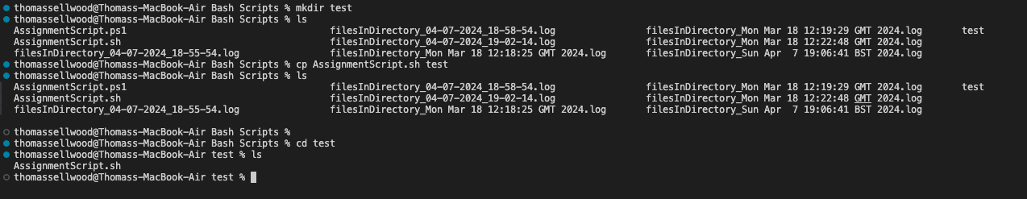
The cp command copies the file named "AssignmentScript.sh" to the directory named "test." To utilize this command type cp, with the filename and destination [13].

6. mv
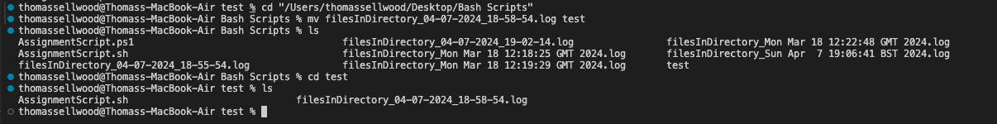
The mv command moves the file to a new directory, in the examples "filesInDirectory_04-07-2024_18-58-54.log" from "Bash Scripts" to the directory “test”. This command can also rename files in an existing directory by typing the old name of the file then the new name [13].

7. grep
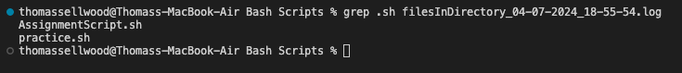
The grep command searches for the specified pattern in a file, in this example the file is used " filesInDirectory_04-07-2024_18-55-54.log ". In this example it has specified the two lines present that have “.sh”. Grep stands for global regular expression print [11].

8. chmod
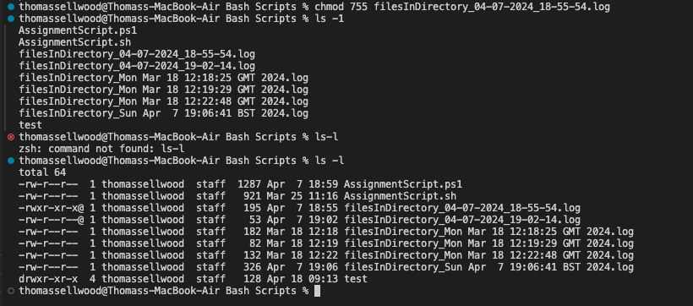
The chmod command sets the permissions of the files and directories. In the example" filesInDirectory_04-07-2024_18-55-54.log " has had its permissions changed to read, write, and execute for the owner, and read and execute for others [11].

9. echo
The echo command displays the text "Hello, World!" in the terminal. The user types echo and the encapsulates the required text to be displayed in single quotation marks [11].

10. Cat
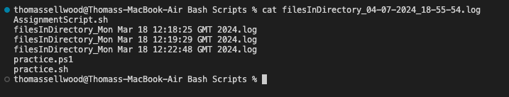
The cat command displays the contents of the file, its main use is to display the contents of a file without opening a text editor [13]. In the example the contents of the file" filesInDirectory_04-07-2024_18-55-54.log " is displayed in the terminal.

Use of Windows OS Scripts

The PowerShell scripting language is a powerful tool which is highly utilized in task automation across many different platforms, below the key features of the language will be discussed [14].
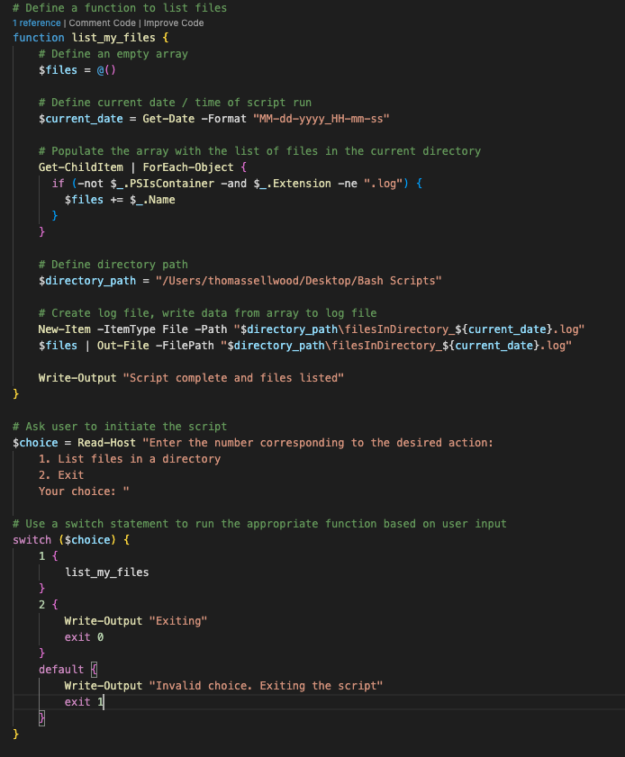
The above image shows a PowerShell script, within in the script are some key fundamentals of the language.
The key features of the PowerShell language can be defined as functions, arrays, if statements, switch statements, variables and loops.
A function can be as simple or as complex as the user requires it to be, in essence the function is a list of PowerShell statements that has a user defined name [15]. In the script, the function list_my_files defines the logic for capturing files within the specified-directory.
The first part of the function defines an empty array utilizing the $, the name of the array then follows, followed by an = which defines the value of array. The array sub-expression operator @() is then used to create the empty array [16].
An array is data structure which is designed to store a collection of items which could be the same value or different values [16].
Once the array has been defined, the script then uses the Get-ChildItem command, the pipe operator and the ForEach-Object command. The Foreach statement will iterate through each value obtained from the Get-ChildItem command [17].
Used in combination with the Foreach command is an if statement, the if statement is a conditional test to evaluate whether a condition or conditions are true, based on the outcomes of the test code can run, code can also be run if no conditions is met [18]. In the instance of the code the if statement is used to evaluate whether the files are a directory and whether they have .log extension. If the conditions within the if statement are met these are then added to the array using the $files+= $_.Name command.
Within the next section of code we initialize a variable called $directory_path, this variable stores a string of the directory that we output the created log file. Variables are a unit of memory where values can be stored, they are a string of text with $ sign at the beginning [19].
The script then creates the log file, this uses the New-Item –ItemType and File –Path commands which creates the file, within the file name we use a variable from earlier on in the function which obtains the current date time for insertion into the name of the log file. Once the file has been created the script writes the values in the $files array to the log file created in the line above. An output is written then to the terminal to confirm to the user that script has completed successfully.
Outside of the function block the script has a section which presents the user with an options menu to choose the input they need, this stores the users input then in the variable $choice.
The switch statement below that then takes the users choice from the $choice variable and executes the code applicable to the users choice. The switch statement is equivalent to an if statement but for multiple if statements the switch statement is simpler to use [20].
The below images show the different outputs a user could expect.

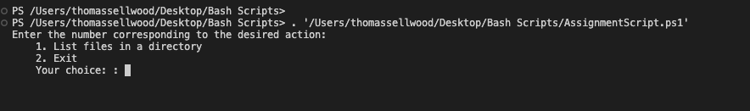
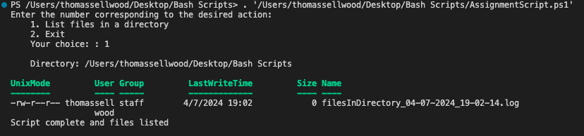

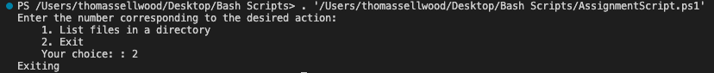

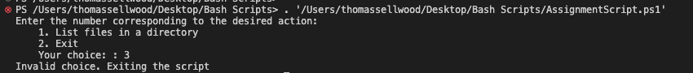

Use of Linux OS Scripts

Bash is command-line interface shell program that is used in Linux and macOS [21]. Bash allows users to control their computer or OS without utilising a gui. Using bash as oppose to a gui is less resource-intensive for the device [21].
Much like what has been discussed above for PowerShell files the same applies for bash scripts. Bash scripts allow users to automate tasks, allow users to run any programming language from the same application, sorting data and cleaning and updating data [21].

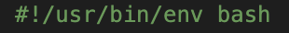
All bash scripts start with what’s known as a “shebang”; this is a character combination of a #! Which identifies the script as a bash script [22]. This is then followed by a reference of what the script should be run using [22].
The Bash script showcased in the below images encompasses several foundational elements of the language, including functions, arrays, if statements, variables, case statements, and loops.
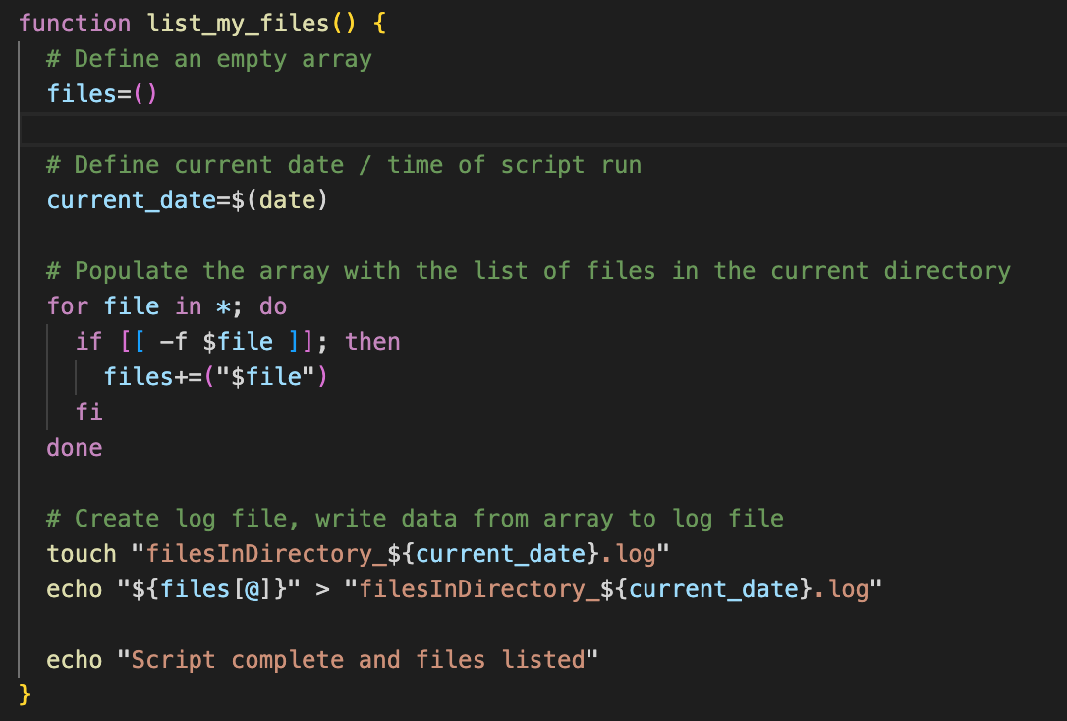
In Bash, a function is a sequence of commands grouped together under a user-defined name, these can be executed like a regular Bash command, when the function is called all the commands within it are executed [23]. Functions can vary in complexity depending on the requirements of the task. The list_my_files function in this script defines the logic for gathering files within the specified directory.
The initial segment of the function establishes an empty array using the files=() syntax, indicating the initialization of the array. An array in Bash serves as a data structure designed to store a collection of items, in Bash there are two types of arrays one dimensional indexed arrays and associate array variables [23].
Following array initialization, the script utilizes a for loop and a conditional statement. The for loop iterates over each file in the current directory obtained via the wildcard (*) character. Within the loop, an if statement is employed to determine whether each item is a regular file (-f $file). If the condition is met, the filename is appended to the files array using the += operator.
The subsequent section of code initializes a variable named directory_path, which stores the directory path where the created log file will be placed. In Bash, variables serve as a container for storing data.
The script then proceeds to create the log file using the touch command. Within the file name, the current date and time are inserted by capturing the output of the date command which is stored in the current_date variable.
Then the script writes the contents of the files array to the newly created log file using the redirection (>) operator.
Once the file writing process is complete, a message confirming the successful execution of the script is echoed to the terminal.
Beyond the function definition, the script presents the user with a menu of options, prompting them to select the required action. The user's choice is stored in the choice variable.
The subsequent case statement evaluates the user's choice and executes the corresponding code block based on the selected option. The case statement provides a concise and efficient method for handling multiple conditions, it works similarly to an if statement [24].
The following images depict the various outputs that users may encounter when interacting with the script.

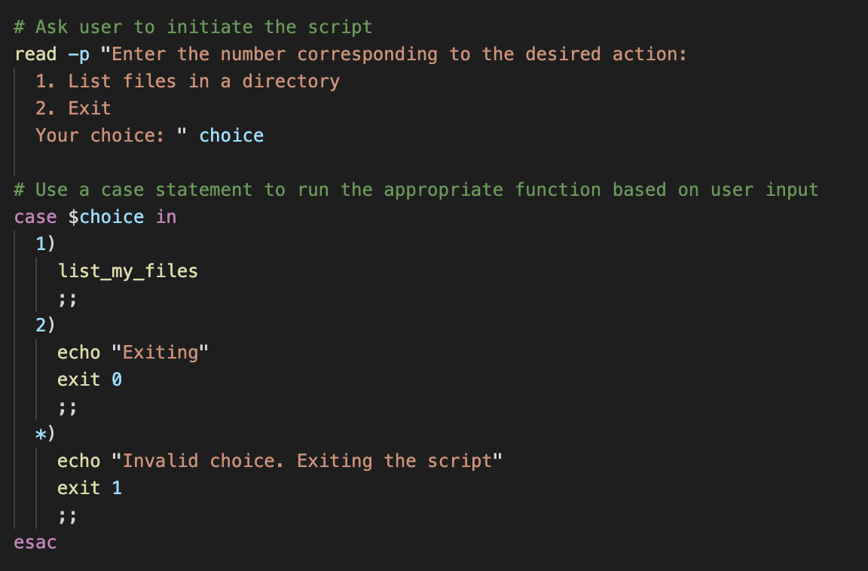
The following images depict the various outputs that users may expect to encounter when interacting with the script.

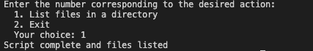
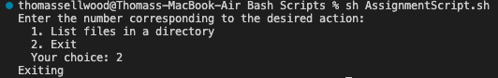
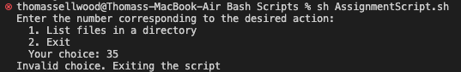

Conclusion

The document provides an overview of the key functions of general operating systems, with a focus on processor management, memory management, device management, file management, and security.
It also looks and describes the usage of PowerShell and Linux Shell CLI commands, as well as the scripting capabilities of PowerShell and Bash.
Operating systems serve as the integral part of computer systems, facilitating the communication between hardware and software components. Operating systems manage processes, allocate system resources, handle device communication, organize file systems, and enforce security measures to ensure the integrity and confidentiality of data.
PowerShell commands, offer powerful tools for managing system resources, processes, files, directories, and users.
Linux CLI commands, executed via the Bourne again shell (Bash), provide similar functionalities to that used within PowerShell but for users of Linux and macOS systems.
Both sets of commands allow the user to maximize the functionality of both languages for uses such as automation, file management and system administration.

Appendices

Tutorial 1

General-purpose operating systems are geared towards a broad spectrum of needs. They offer versatile features such as handling diverse data, an interface for user to interact with the computer and handle file management, enabling communication between hardware and software to name a few. Some examples of these are Microsoft Windows, chromeOS, and Linux [25].

Mobile operating systems are tailored for smartphones and tablets. Mobile operating systems offer an interface between the devices hardware and software, they also manage wireless and cellular network connectivity and phone access. They offer users features such as calling and messaging, internet connectivity, multitasking and access to third-party apps. There are many types of mobile operating system such as iOS and Android [26].

Network operating systems such as Windows Server, and Mac OS X are designed for supporting workstations, database sharing and application sharing for users. They also facilitate file and printer sharing, network security, user authentication, and centralized administration to ensure efficient network infrastructure management [27].
Quantum computers surpass classical ones by exploiting principles of quantum mechanics. While classical computers struggle with complex simulations like molecular behaviour, quantum algorithms efficiently create multidimensional computational spaces [28].
Qubits, the fundamental units in quantum computing, utilize superconducting circuits to maintain quantum states. By controlling qubits' behaviour through techniques like superposition and entanglement, quantum computers achieve powerful computational capabilities [28].
IBM Quantum's roadmap focuses on scaling processors and advancing error correction techniques. Their Qiskit quantum SDK and Qiskit Runtime enable developers to harness quantum-classical applications and high-performance computing (HPC) hybrid computations. Quantum computing holds promise for revolutionizing fields like chemistry, finance, and machine learning, offering unprecedented computational power for solving real-world problems efficiently [28].

Further Learning


References
[1] S. Bigelow. "operating system (OS)." Tech Target. https://www.techtarget.com/whatis/definition/operating-system-OS (accessed 12/02/).
[2] "Functions of Operating Systems." geeksforgeeks. https://www.geeksforgeeks.org/functions-of-operating-system/ (accessed 04/03/).
[3] S. Miller. "What Is an Operating System?" Code Academy. https://www.codecademy.com/resources/blog/operating-system/ (accessed 12/02/).
[4] T. Dawson, "Introduction to the Windows Command Line with PowerShell," The programming historian, no. 5, 2016. doi: 10.46430/phen0054.
[5] B. Posey. "Top PowerShell commands you must know, with cheat sheet." Tech Target. https://www.techtarget.com/searchwindowsserver/tip/Top-PowerShell-commands-you-must-know-with-cheat-sheet (accessed 18/04/).
[6] "Start-Process." Microsoft. https://learn.microsoft.com/en-us/powershell/module/microsoft.powershell.management/start-process?view=powershell-7.4 (accessed 18/04/).
[7] "Managing Processes with Process cmdlets." Microsoft. https://learn.microsoft.com/en-us/powershell/scripting/samples/managing-processes-with-process-cmdlets?view=powershell-7.4 (accessed 18/04/).
[8] "Get-Command." Microsoft. https://learn.microsoft.com/en-us/powershell/module/microsoft.powershell.core/get-command?view=powershell-7.4 (accessed 18/04/).
[9] "Get-Help." Microsoft. https://learn.microsoft.com/en-us/powershell/module/microsoft.powershell.core/get-help?view=powershell-7.4 (accessed 18/04/).
[10] "Invoke-WebRequest." Microsoft. https://learn.microsoft.com/en-us/powershell/module/microsoft.powershell.utility/invoke-webrequest?view=powershell-7.4 (accessed 18/04/).
[11] A. Walia. "Top 50+ Linux Commands You MUST Know." Digital Ocean. https://www.digitalocean.com/community/tutorials/linux-commands
[12] "How to Remove a Directory in Linux." Phoenix Nap. https://phoenixnap.com/kb/remove-directory-linux (accessed 18/04/).
[13] D. Diaz. "The 40 Most-Used Linux Commands You Should Know." Kinsta. https://kinsta.com/blog/linux-commands/ (accessed 18/04/).
[14] "What is PowerShell?" Microsoft. https://learn.microsoft.com/en-us/powershell/scripting/overview?view=powershell-7.4 (accessed 08/04/).
[15] "about_Functions." Microsoft. https://learn.microsoft.com/en-us/powershell/module/microsoft.powershell.core/about/about_functions?view=powershell-7.4 (accessed 08/04/).
[16] "about_Arrays." Microsoft. https://learn.microsoft.com/en-us/powershell/module/microsoft.powershell.core/about/about_arrays?view=powershell-7.4 (accessed 08/04/).
[17] "about_Foreach." Microsoft. https://learn.microsoft.com/en-us/powershell/module/microsoft.powershell.core/about/about_foreach?view=powershell-7.4 (accessed 08/04/).
[18] "about_if." Microsoft. https://learn.microsoft.com/en-us/powershell/module/microsoft.powershell.core/about/about_if?view=powershell-7.4 (accessed 08/04/).
[19] "about_Variables." Microsoft. https://learn.microsoft.com/en-us/powershell/module/microsoft.powershell.core/about/about_variables?view=powershell-7.4 (accessed 08/04/).
[20] "about_Switch." Microsoft. https://learn.microsoft.com/en-us/powershell/module/microsoft.powershell.core/about/about_switch?view=powershell-7.4 (accessed 08/04/).
[21] M. Klein. "What is Bash Used For?" Code Academy. https://www.codecademy.com/resources/blog/what-is-bash-used-for/ (accessed 11/03/).
[22] "Intro to shell scripts in Terminal on Mac." Apple. https://support.apple.com/en-gb/guide/terminal/apd53500956-7c5b-496b-a362-2845f2aab4bc/mac (accessed 15/04/).
[23] "Bash Reference Manual." GNU. https://www.gnu.org/software/bash/manual/bash.html (accessed 15/04/).
[24] "Bash Case Statement." Linuxize. https://linuxize.com/post/bash-case-statement/ (accessed 15/04/).
[25] "What is a general purpose computer." Lenovo. https://www.lenovo.com/us/en/glossary/general-purpose-computer/?orgRef=https%253A%252F%252Fwww.google.com%252F (accessed 18/04/).
[26] M. Goad. "What is a mobile operating system." Tech Target. https://www.techtarget.com/searchmobilecomputing/definition/mobile-operating-system (accessed 18/04/).
[27] M. Rouse. "What is a network operating system." Techopedia. https://www.techopedia.com/definition/3399/network-operating-system-nos (accessed 18/04/).
[28] "What is quantum computing." IBM. https://www.ibm.com/topics/quantum-computing (accessed 18/04/).

