Worksheet: Creating a Web App Using an Image from a Private Azure Container Registry
In this worksheet, you will create a web app which is a serverless container designed specifically for web applications but the pull the image from an Azure Container Registry (ACR).
IMPORTANT: Where you see angle brackets < >, this represents a value that you must provide yourself. For example, <YOUR_RESOURCE_GP> requires you to enter an appropriate resource group name of your choice. Unless otherwise stated, these are the names that should be given to a resource or the name of an existing resource that you have already created.
Values not in brackets represent names of resources that you have already created or you should already know, so use the corresponding name for that resource. For example, YOUR_RESOURCE_GP means that you have already created a resource group and you should provide the name of this resource group here.

Only do this once……
If this if the first time you are using Azure, then setup your subscription details as the default so that you do not need to enter them whenever you wish to execute a command.
az account list -o table
az account set --subscription YOUR_SUBSCRIPTION_ID

Once you have set the default subscription, there is no need to repeat this process ever again!!

Fork and Clone the Existing GitHub Repository
A UWTSDStudents/basicnodeapi repository is required for this exercise.
Login to GitHub and fork your own version of this repository.
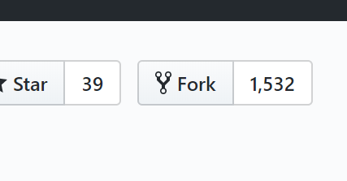
Read the URL of your forked repository so that you can clone it.
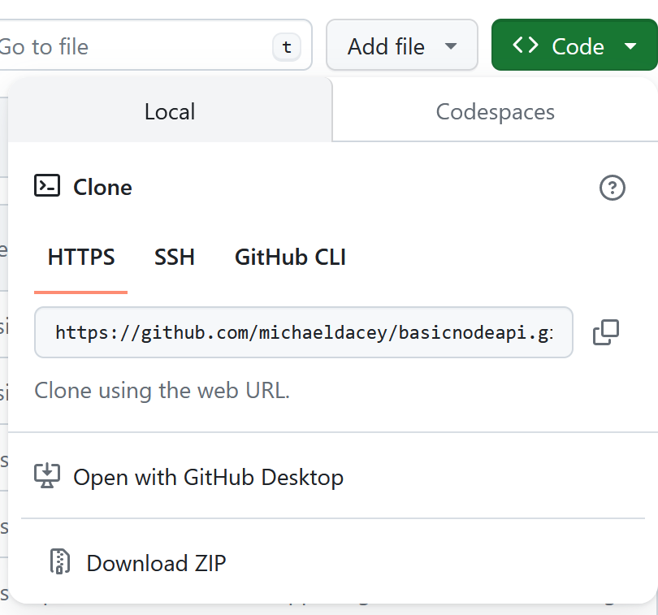

PULL A COPY OF A BASIC NODE.JS API AND BUILD IT
$ mkdir nodeapp
$ cd nodeapp
$ git clone https://github.com/<YOUR REPOSITORY>/basicnodeapi.git .
$ npm install

WARNING: IF DO NOT RUN DOCKER COMMANDS IN Git Bash, INSTEAD OPEN A CMD PROMPT WINDOW TO USE DOCKER COMMANDS
BUILD THE DOCKER IMAGE AND TEST IT
C:> docker image build --target local -t basicnodeapi .
C:> docker container run --name=nodeapi --volume “.":/var/www/node -d -p 8081:80 basicnodeapi
TEST THE API

In Git Bash or WSL you can use “curl” otherwise just use your browser.
$ curl localhost:8081
Welcome!
$ curl localhost:8081/hello/fred
Hello fred

Remove the container.
C:> docker container rm -f nodeapi

Resource Group
Before creating any resources, you must create a resource that can contain those resources. For student Azure accounts your location is “uksouth”. Choose an appropriate resource group name.
# create resource group
az group create --name <YOUR_RESOURCE_GP> --location YOUR_LOCATION

You can list resource groups:
# List all the resource groups
az group list -o table
az group list -o table --query "[?location=='ukwest'].name"

Create an Azure Container Registry (ACR)
We create an ACR in the same resource group as we want to deploy the application to keep the image local to the container the image will be deployed into. This is good practice.
# Create the ACR
acrName="<YOUR_ACR_NAME>$RANDOM"
az acr create --resource-group YOUR_RESOURCE_GP --name $acrName --sku Basic --admin-enabled true

# Retrieve the ACR id
acrId=$(az acr show --resource-group YOUR_RESOURCE_GP --name $acrName --query id --output tsv)

# List the ACRs in the resource group
az acr list --resource-group YOUR_RESOURCE_GP --query [].name -o tsv

# Required URL for ACR
az acr show --resource-group YOUR_RESOURCE_GP --name $acrName --query loginServer -o tsv
# Looks something like this: mywebappacr21566.azurecr.io

# Get the ACR login username and password
echo $acrName
mywebappacr21566
az acr credential show --resource-group YOUR_RESOURCE_GP --name $acrName --query "passwords[0].value" --output tsv
Tsx6P6Wwvs6Pn……..irsCUuz8lj/D+ACRBUsCkR

Push the Docker Image to the ACR
Tag and push the image to the ACR.
The ACR_NAME should be something like” mywebappacr21566” which was displayed in the previous step.

In CMD prompt window or WSL.
C:> docker image build --target azureappservice -t basicnodeapi .
C:> docker image tag basicnodeapi ACR_NAME.azurecr.io/basicnodeapi-image:latest
C:> docker login ACR_NAME.azurecr.io See ACR URL above
Enter the username and password from the previous step to login to the ACR
C:> docker push ACR_NAME.azurecr.io/basicnodeapi-image:latest
For example
Check the image was pushed:
# List all the repositories created in the registry
az acr repository list --name $acrName -o tsv
# Show all the tagged versions of this image
az acr repository show-tags --name $acrName --repository basicnodeapi-image -o tsv

Create a User-Assigned Managed Identity
To allow resources to communicate with each other within Azure, we need to some form of resource to which we can apply a role. We never apply individual permissions such as you have permission to “Read” or you can “Write”. Instead, a set of permissions is always created and associated with a specific role such as “Contributor” and we then associate that role with a specific resource to provide it the permissions to perform those activities on another resource.
For example, to give a student access to a resource group we would add them as and Active Directory “User”. A User is a security principal and we can associate roles to it. Let say we create a resource group, then we can give the User we just create the role of “Contributor” on the resource group so that this student has the ability to view and create resources in that group. If we want another Azure resource such as VM to have the same access to this resource group then we need to provide it with a service principal to which roles can be associated. A service principal is assigned to a resource (known as the assignee) to give it permission to access a second target resource (known as the scope, since the scope of the permissions is confined to just giving access to this target resource and nothing else).
Since managing these service principals requires some work, we typically avoid creating them directly and instead use a Managed Identity instead. A user-assigned managed identity is one that we have to create and manage ourselves, but we can assign it to multiple resources so that the same permissions only have to be applied to one service principal to grant the same access to multiple resources.
Note: The alternative is known as a system-assigned managed identity because once enabled a service principal is created and belongs to the associated resource. Since the system-assigned service principal is now “owned” by a specific resource, it is only ever assigned to this resource and cannot be assigned to multiple resources. What’s more, we no longer need to manage it since destroying the resource also destroys the associated system-assigned identity (and principal). Both types of managed identities have a service principal and you can give them roles and scope them to a specific target resource.
Create a user-assigned managed identity assign its service principal the role of “AcrPull” scoped to our ACR.
# Create a user-assigned managed identity
uMgmtId=<YOUR_USER_ID_NAME>
az identity create --resource-group YOUR_RESOURCE_GP --name $uMgmtId
# Retrieve the ID of the user-assigned managed identity
id=$(az identity show --resource-group YOUR_RESOURCE_GP --name $uMgmtId --query id --output tsv)
# Retrieve the service principal ID that was created for the user-assigned
# managed identity
principalId=$(az identity show --resource-group YOUR_RESOURCE_GP --name $uMgmtId --query principalId --output tsv)
# Grant the user-assigned managed identity permission to pull from the
# container registry
az role assignment create --assignee-principal-type ServicePrincipal --assignee-object-id $principalId --scope $acrId --role "AcrPull"

Later we need to assign this user-assigned managed identity to our application to grant access to pull images from our ACR.

Create an Application Service Plan
A application service plan defines the size of the servers being used for running the serverless containers, whether they are Windows or Linux, number of workers, etc. You need to create a plan to create the serverless web app.
The sku defines the tier of the plan. The Free and Shared tiers are shared with other customers and cannot scale out. You can only have 1 FREE app service plan per subscription and the --num-of-workers must equal 1. They are intended to be used only for development and testing purposes. The sku defines the size of the servers, shared resources, etc. We will not enable per-app scaling for this exercise. Note: for Linux we cannot use the Shared tier, instead use B1 if we cannot use the FREE tier.
az appservice plan create --resource-group YOUR_RESOURCE_GP --name my_appsrv_plan --sku FREE --is-linux --number-of-workers 1

Create the Web App
The web app is created using the app service plan and the private image we just created and pushed to the ACR.
# We need a globally unique name for the web app
export webAppName="<YOUR_APP_NAME>$RANDOM"

# Get the image name including the registry containing it
imageName="$acrName.azurecr.io/basicnodeapi-image:latest"

# Create a web app using the image we poshed to the ACR
az webapp create --resource-group YOUR_RESOURCE_GP --plan my_appsrv_plan --name $webAppName --deployment-container-image-name $imageName
# MAY TAKE A FEW MINUTES

# Specify the WEBSITES_PORT environment variable to expose the containers port number
az webapp config appsettings set --resource-group YOUR_RESOURCE_GP --name $webAppName --settings WEBSITES_PORT=80

Now we have created the app we need to assign the user-assigned managed identity to it so that it can pull images from the ACR.
# Assign the user-assigned managed identity to the web app
az webapp identity assign --resource-group YOUR_RESOURCE_GP --name $webAppName --identities $id

A couple of additional steps are required to get the web app to use this managed-identity when pulling from the ACR.
# Enable the manage identity for ACR usage
az webapp update --resource-group YOUR_RESOURCE_GP --name $webAppName --set siteConfig.acrUseManagedIdentityCreds=true
# Because we are using a user-assigned managed identity we need tell the web
Which identity to use for the ACR.
clientId=$(az identity show --resource-group YOUR_RESOURCE_GP --name $uMgmtId --query clientId --output tsv)
az webapp update --resource-group YOUR_RESOURCE_GP --name $webAppName --set siteConfig.AcrUserManagedIdentityID=$clientId

Automated the Pull from the ACR
We can setup the application so that it can automatically pull the image from the container whenever we push a new image into the ACR. To achieve this, we use a “webhook” which essentially is a URL that the ACR can call whenever an image is pushed into it.
# Get the URL that the ACR should use when a new image is pushed into it.
deployUrl=$(az webapp deployment container config --resource-group YOUR_RESOURCE_GP --name $webAppName --enable-cd true --query CI_CD_URL --output tsv)
# Create a webhook by giving the ACR this URL, the action “push” that should trigger it and the registry to watch “basicnodeapi-image:latest”
appSrvCD=appserviceCD

az acr webhook create --name $appSrvCD --registry $acrName --uri $deployUrl --actions push --scope basicnodeapi-image:latest

# Test it worked
eventId=$(az acr webhook ping --name $appSrvCD --registry $acrName --query id --output tsv)

az acr webhook list-events --name $appSrvCD --registry $acrName --query "[?id=='$eventId'].eventResponseMessage"
.

Browse the Web App
The URL of the web app can be obtained as follows, but we may need to give it sometime for it to start.
# Get the browser URL to see the webapp
az webapp show --resource-group YOUR_RESOURCE_GP
# If the above does not work then use this URL instead
az webapp show --resource-group YOUR_RESOURCR_GP --name $webAppName --query defaultHostName -o tsv
.

FINISH: Delete Everything
The easy way to stop and delete everything we have created is to just delete the resource group that contains all these resources.
# Clean up
az group delete --name YOUR_RESOURCE_GP --yes

