

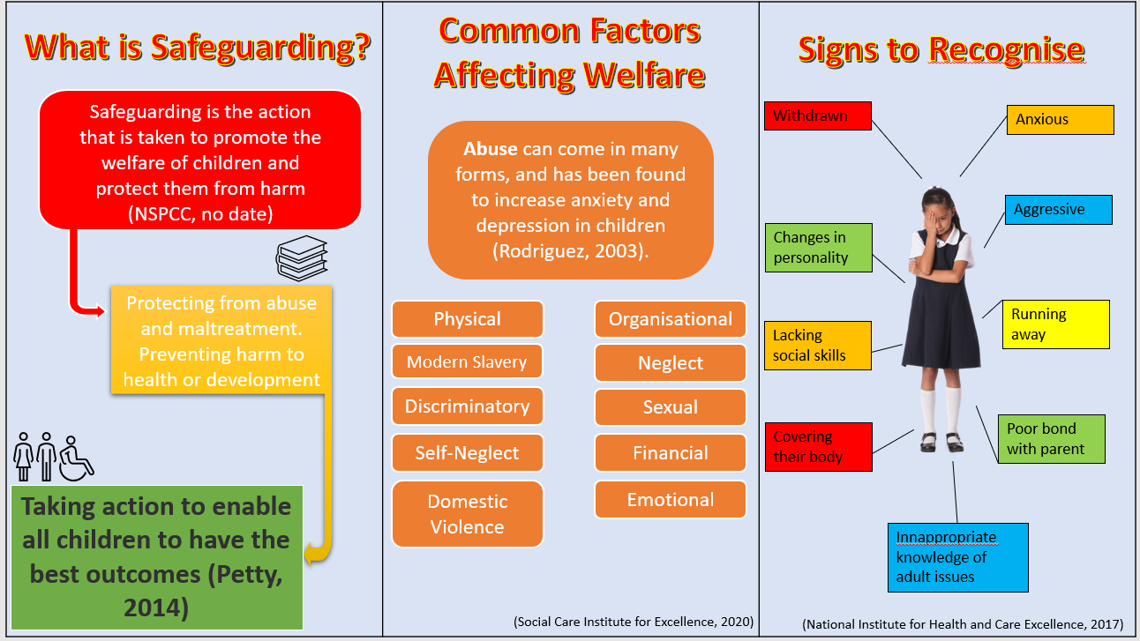
Everyone who works in education should share the same goals to keep children and young people safe (Welsh Government, 2015). Safeguarding and child protection are terms that have seen significant growth, research and understanding in recent years around the world. The education sector specifically and the professionals who work within the sector are particularly important as they can identify concerns early, provide help for children, and prevent concerns from escalating (Keeping Children Safe in Education, no date). Definitions of both safeguarding and child protection will be explored, with an insight into the positive and negative affects they can have on children and young people. Policies, procedures, and reports surrounding these topics will be considered, including The Children Act (1989) (2004), UNCRC Every Child Matters (2007) and the All-Wales Child Protection Procedures (AWCPP) (2008). Reflecting upon these policies and reports, and whilst using personal experience and knowledge of working within a special education setting, they will be critically analysed alongside local school policies and conclusions will be reached about their success, outcomes, and effectiveness. A discussion of barriers and previous mistakes surrounding safeguarding, child protection and promoting the welfare of children will be examined within this essay, with recommendations to improve the effectiveness following. Accompanying this rationale is a leaflet promoting the background and importance of safeguarding, which will be referenced to throughout. This subject and the contents of the leaflet will also be analysed. Throughout the essay, personal experience of working within special needs education will be used to analyse policies, procedures, and practises effectively.
According to NSPCC (No date), safeguarding is the action that is taken to promote the welfare of children and protect them from harm. This should include protecting them from abuse and maltreatment, preventing harm to their health or development, ensuring they grow up within a safe and effective care provision, and taking the necessary action to enable all children and young people to have the best possible outcomes. Child protection is seen as part of the safeguarding process. It is more individualised which focuses on protecting individual children who may be identified as suffering. Part of this process should include child protection procedures which show how to respond to concerns about a child. In more informal terms, safeguarding is an umbrella, where there are proactive policies and procedure in place for all children within a setting to benefit from, and child protection is seen as a segment within the umbrella, looking at specific children who are at risk or suffering significant harm.
As noted in the accompanying leaflet, it has been found (Wilkinson & Bowyer, 2017) that children with disabilities and health complications are more susceptible or at risk to abuse and other child protection factors. There is yet to be any further research into why this is happening, or how it can be stopped, and it has shown in extensive research, lasting for over 10 years, that there have been very few studies which sought disabled children’s own accounts of abuse or safeguarding (Stalker & McArthur, 2010). It has appeared that criminal justice services and therapeutic services often fail to take account of disabled children’s needs and heightened vulnerability. Across the UK, the four jurisdictions share a mainstreaming approach to safeguarding, however, it has shown that Scotland have largely failed with their commitments to protect disabled children. England have shown in their safeguarding policies that the needs of disabled children have been considered with a range of policies aimed at improving their lives and safeguarding issues specifically. Wales and Northern Ireland have proved that their policies are more focused and based upon the social model of disability (Stalker et al. 2010) There have been issues surrounding children with communication impairments, who are at a high level of risk. There is a definite need for improved skills and confidence, which can be intricately linked to meeting children’s needs and respecting their human rights. As a result of these findings however, significant improvements have been reported in child protection over recent years. England have raised their awareness of disabled children’s rights and needs with a greater acknowledgement of their abilities. Scotland have also shown through the For Scotland’s Disabled Children campaign that perceptions can change for the better. Furthermore, and as a continuous result of these findings emerging in previous years, in 2006 the Minister for Children in Scotland published a review of the Children’s Hearing System, entitled Getting it Right for Every Child (Creegan et al. 2006), and Welsh Government (2009) produced a 5-year rolling action plan in response to the Concluding Observations of the UN Committee on the Rights of the Child 2008.
In modern society, child protection and safeguarding should not be allowed to get to such a dark place in which changes to policy and practice should have to take place. As stated previously, many countries have failed in their attempts to keep up to date with child protection and because of poor findings when research has been conducted, policies have been updated and practices have been changed. Unfortunately, this is no new pattern in society.
The first formal child death inquiry dates to 1945 in England. Dennis O’Neill was killed at the age of 12 by his foster father. Fast forward to 1973 and the death of 7-year-old Maria Colwell. It was not until this point where our modern child protection system was established. Further changes were then prompted by the inquires into several other child deaths, including 4-year-old Jasmine Beckford in 1984. 1989 seen the establishment of The Children Act (1989) in England Wales. This legislative framework led people to believe such children would not slip through the net and the correct child protection procedures were going to be put in place regularly, consistently, and effectively. That was, however, until 2000 which seen perhaps one of the most infamous child protection stories within the UK. The death of 8-year-old Victoria Climbie led to Lord Laming’s report (2003), which led to sweeping changes to way the children’s services were structures in England and Wales, with an outstanding 108 recommended changes to policy. Subsequently these recommendations were then adopted into the Children Act (2004). Victoria’s death was a tragic incident which in result could have been avoided, had it been for successful partnership working for safeguarding stepped into the situation earlier. As seen within the accompanying leaflet, The National Institute for Health and Care Excellence (2017) lay out the most recognised signs to recognise child abuse. Although it may be easy to recognise the signs of abuse, it is important that it is reported and acted upon, which did not happen for Victoria Climbie, as doctors and other health professionals presumed social services would investigate these matters. There has been an obvious increase into research and guidance within child protection and safeguarding responsibilities, such as the appointment of a Minister for Children and Families, and pilot schemes being introduced for improved record keeping and information sharing in children’s services, however, these are merely the foundations which need to be built upon. There should be an emphasis on improving multi-agency working, encouraging early intervention, preventing abuse and neglect, and supporting all children regardless of their background of circumstances (Department for Education and Skills, 2004).
After having an insight into previous years, policies, and child protection cases within the UK, what procedures are schools following today to prevent child abuse and promote child protection?
School A (2018) puts emphasis on all staff employed by or volunteering on behalf of the school are responsible for safeguarding and child protection. A Designated Senior Person (DSP) for safeguarding is selected to oversee any allegations and to ensure all safeguarding aims are being applied. They aim to prevent safeguarding through the teaching and pastoral support offered to pupils, support those who may have been abused, and ensure school staff are well placed to observe signs of abuse, with correct procedures for identifying and reporting alleged abused are in place. School A also states that they will work with other agencies to ensure there is a robust system. Site security, promoting safe practice whilst challenging poor practice and preventing unsuitable people from working with children and young people are just some of the examples in their effort to protect children. Multi-agency approaches to child protection has seen its fair share of barriers over recent years, which has been presented in findings across the UK (Home Office, 2013). There has been a common misunderstanding as to what client information is permitted to be shared amongst professionals, leading to low confident and uncertainty. IT has caused significant barriers to multi-agency approaches, such as many agencies using secure email systems, which not everyone has access to. Multiple IT systems have also been found to hamper attempts to join agencies together to share information for risk assessments. Whilst these difficulties have been attempted to overcome, further challenges have presented themselves, preventing chid protection procedures from going forward. Funding constraints have been perceived to be a significant challenge for the future, due to the increased demand for services. As a consequence of this, it may mean that the voluntary and community sector must focus more on their own priorities. Communication was identified as the most common facilitator of multi-agency work and therefore the key to its success (Atkinson et al. 2007). Providing sufficient time for the development of multi-agency working, and the provision of joint training and agreement of joint aims and objectives have also been found to be important factors to the success of multi-agency approaches.
Schools can play a tremendous part within the multi-agency approach to child protection. This is due to them having regular contact with children and young people, so they are in an extraordinarily strong position to recognise and identify any signs of abuse or neglect (NSPCC, no date). Not only this, but schools also put huge contributions into the ongoing support and monitoring of any abused children. School staff can provide guidance on child protection, but only if they receive adequate training and they are equipped with the relevant skills. Studies have shown (Campbell & Wigglesworth, 1993), that although teachers and school staff possess appropriate knowledge on the signs of child abuse, only 40% of those felt confident in handling these issues in practice. To overcome this particular barrier, schools or training providers may feel the need to consider the design of regular training courses, with emphasis on following procedures confidently and competently. The importance of schools in a multi-agency approach has proven how pivotal they are in child protection matters. Perhaps one of the biggest and most unprecedented barriers to date has been the affects of the COVID-19 pandemic. With the closure of schools and educational facilities, schools have seen their doors shut or seen a significant reduction in students attending school regularly. These school closures may have harmed children as child abuse has been able to remain hidden, with school staff no longer being able to oversee the recognition for the signs of abuse. Child protection medical examination referrals have fallen by 39.7% in 2020 consequently (Garstang et al. 2020). Schools must explore the possibility of mandatory attendance at schools in the near future of other viable alternatives found. There also may be a significant increase in safeguarding referrals when schools have reopened fully, as children may disclose the abuse they have experienced over the past year at home. Schools will need to have a holistic and effective approach to this to ensure all children’s needs are met.
Safeguarding and child protection is everybody’s business. The definitions and fundamental aspects of safeguarding and child protection have been moulded into everyday life amongst schools, education providers and other childcare settings. The terms are no longer something which is only thought of in an extreme circumstance, but they are now terms that becomes part of every school’s ethos and daily operations in a way that considers the need to promote the welfare of children (Welsh Government, 2015). It has been shown that there are specific groups of children who are more susceptible to child protection factors, with a certain need for improvement and research in this field. With luck, countries will be able to act upon this quickly and effectively to promote the welfare of all young people equally, before it is too late, and history repeats itself. History has shown that child protection matters somehow only take a U-turn when a fatal incident occurs. There are certainly many barriers which diminish the quality of multi-agency approaches, with funding playing a tremendous part of this. According to The All-Wales Child Protection Procedures (2008), the implementation of procedures can only be affective when supported by good practice, based on thorough assessment through professional skill and judgement which is supported by evidence and critical analysis.
To conclude, there are many policies and vast amounts of guidance in the world surrounding child protection and welfare. It is then the responsibility of those around the young people, to apply this knowledge correctly and effectively if we wish to have their best interests prioritised. Funding should never become an issue when a child’s health is in question, and if only everyone had this outlook on life, many children may have been saved long before harm was brought to them. Those children who lost their lives will always be remembered, not just for being innocent and helpless, but for the impact they have had on today’s society, and the many lives they will save through a legacy bound in policy, which will live on forever.

References
ALL WALES CHILD PROTECTION PROCEDURES. (2008)
ATKINSON, M., JONES, M., LAMONT, E. (2007) Multi-agency working and its implications for practice: A review of the literature.
CAMPBELL, H., WIGGLESWORTH, A. (1993) Child protection in schools: a survey of the training needs of Fife schoolteachers.
CHILDREN ACT 1989 CHAPTER 41. Available at: https://www.legislation.gov.uk/ukpga/1989/41/pdfs/ukpga_19890041_en.pdf (Accessed: 15th March 2021).
CHILDREN ACT 2004 CHAPTER 31. Available at: http://www.legislation.gov.uk/ukpga/2004/31/contents (Accessed 16th March 2021)
CREEGAN, G., HENDERSON, G., KING, C. (2006) Getting it right for every child: children and young people’s experiences of advocacy support and participation in children’s hearing system. Edinburgh: Scottish Executive.
DEPARTMENT FOR EDUCATION AND SKILLS. (2004) Every Child Matters: Change for Children.
GARSTANG, J., DEBELLE, G., ANAND, L., et al. (2020) Effect of COVID-19 lockdown on child protection medical assessment: a retrospective observational study in Birmingham, UK.
HOME OFFICE (2013) Multi-Agency Working and Information Sharing Project, Early Findings.
KEEPING CHILDREN SAFE IN EDUCATION. (No date) Part One: Safeguarding information for all Staff. Available at: https://www.keepingchildrensafeineducation.co.uk/info_sch_part_one_sg_info.html#role (Accessed 14th March 2021)
KENNY, M.C., 2001. Child abuse reporting: Teachers’ perceived deterrents. Child abuse & neglect, 25(1), pp.81-92.
LAMING, L. (2003) The Victoria Climbie inquiry: report of an inquiry by Lord Laming. Norwich: The Stationery Office (TSO).
NATIONAL INSTITUTE FOR HEALTH AND CARE EXCELLENCE. (2017) Child abuse and neglect: Recognising, assessing and responding to abuse and neglect of children and young people.
NSPCC. (No date) Safeguarding and child protection in schools. Available at: https://learning.nspcc.org.uk/safeguarding-child-protection-schools#:~:text=Schools%20play%20an%20essential%20role,signs%20of%20abuse%20and%20neglect. (Accessed 16th March 2021).
NSPCC. (No date) Safeguarding Children and Child Protection. Available at: https://learning.nspcc.org.uk/safeguarding-child-protection (Accessed 14th March 2021).
PETTY, L. (2014) The Definition of Safeguarding Children. Available at: https://www.highspeedtraining.co.uk/hub/safeguarding-children-definition/ (Accessed 14th March 2021).
RODRIGUEZ, C.M., 2003. Parental discipline and abuse potential affects on child depression, anxiety, and attributions. Journal of Marriage and Family, 65(4), pp.809-817.
SCHOOL A. (2018) Policy Document for Safeguarding.
SHARE CARE. (No date) Which children are most vulnerable to abuse?
SOCIAL CARE INSTITUTE FOR EXCELLENCE. (2020) Types and Indicators of Abuse. Available at: https://www.scie.org.uk/safeguarding/adults/introduction/types-and-indicators-of-abuse (Accessed 14th March 2021).
STALKER, K., LISTER, P, G., LERPINIERE, J., MCARTHUR, K. (2010) Child Protection and the Needs and Rights of Disabled Children and Young People: A Scoping Study.
STALKER, K., MCARTHUR, K. (2010) Child abuse, child protection and disabled children: a review of recent search. Child Abuse Review.
WELSH GOVERNMENT (2014) Safeguarding children in education: handling allegations of abuse against teachers and other staff.
WELSH GOVERNMENT. (2009) Getting it right 2009 United Nations Convention of the Rights of the Child.
WELSH GOVERNMENT. (2015) Keeping Learners Safe. The role we all have under the Education Act 2002.
WILKINSON, J., BOWYER, S. (2017) The Impacts of Abuse and Neglect on Children; and Comparison of Different Placement Options.

