

Course Title: BEng Electrical/Electronic Engineering
Module: Applied Programmable Logic Controllers
Assignment Number: 1
Assignment Title: Factory Control
Student Name: Carys Williams
Student Number: 1708572
Date: 17/01/2022
Supervisor Name: Dr. Adel Ismel

Contents
1 Introduction 4
2 PLCs in industry 5
2.1 Types 5
2.1.1 Compact or Modular 5
2.1.2 Power Supply (PS) Module 5
2.1.3 Central Processing Unit (CPU) 5
2.1.4 Interface module (IM) 6
2.1.5 Signal Module (SM) 6
2.1.6 Function Modules (FM) 6
2.1.7 Communication Processor (CP) 6
2.2 Backplane 6
2.2.1 Active Backplanes 6
2.2.2 Passive Backplane 6
3 Flow Chart 7
4 Ladder logic Program 8
4.1 Run System 9
4.2 Start 9
4.3 Stop 10
4.4 Reset 11
4.5 Emergency 11
4.6 Individual Counters 12
4.6.1 Large Boxes 12
4.6.2 Small Boxes 12
4.6.3 Heavy Medium 13
4.6.4 Light Medium 13
4.7 Total boxes exiting Conveyor 13
4.8 Pushers 14
4.8.2 Small Boxes 14
4.9 Scale Direction and reset 15
4.10 Scale Pause 16
4.11 Stack Light and Alarm 16
4.12 Belts working on command 19
4.13 Number of boxes Entered System 20
4.14 3D view of System 21
4.14 Close up of control panel 22
4.15 Input and Outputs on Driver 23
4.16 HDMI control Panel 24
4.16.1 Screen 1 (Buttons) 24
4.16.2 Screen 2 (Box Size display) 24
Improvements 25
Reference 26
Bibliography 27

1 Introduction
With the functions of the factory control system, it will sort out 4 different packages depending on weight and height. It will be designed in Factory I/O and it will contain the following as a minimum: -
- 4 Conveyor belts
- 2 Pushers
- 1 Scale
- 2 Sensors
- 1 Emergency stop
- 2 Buttons
- 1 Siren
- 1 Warning light
- 2 Stack lights
- 1 Package emitter
- 1 Package Remover
For the conveyors they should start in sequence with each other to limit the current draw.
The system also requires an HMI for operating interaction. It must have the following controls and display: -
- Start and Stop Button
- Emergency Button
- Reset – all counters
- Counter display – for each package
- Replication of the stack lights
- Fault and warning indicator

2 PLCs in industry
For PLCs there are many factors that need to consider when looking at ones in industry.

2.1 Types

2.1.1 Compact or Modular
There are different types of modules suck as Compact which are also known as Fixed PLC, there are also Modular PLCs which allows expansions of the system through adding additional modules. Multiple modules can be added or connected to the hardware of the modular PLC. Several components are fitted to a chassis, rack, or bus with different slots. [1]
Content | Compact/Fixed | Modular / Rack-Mounted
Diagram | 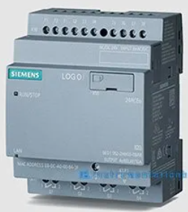 | 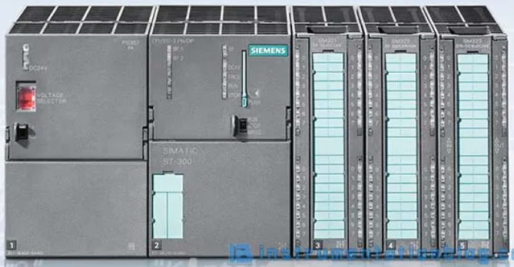
I/O | Fixed Inputs and Outputs  Manufacturer decides om I/O | Not-Fixed input and Outputs  User can add I/O
Module | Inputs and Outputs modular with fitted CPU | Several components fitted different slots
Repair | Difficult | Simple in comparison
Memory | Less memory, fewer was to store data/information | Has more memory to sore data/ information
Use | Small applications  Domestic Purpose | Industrial purpose  Future industrial expansion / growth
Size | Small | Large (I/O connectivity, Power supply e.g)
Cost | Economical model | More expensive than compact
[1]

2.1.2 Power Supply (PS) Module
With a power Supply module, it converts any AC (120ACV – 240ACV) to DC (5DCV – 24DCV) to power the rack, and the backplane (mostly used in siemens s7-300 PLC) output is 2A – 5A at 5DCV. [2]

2.1.3 Central Processing Unit (CPU)
This acts as the brain of the PLC system. It performs by controlling specific operations by the programming instructions. CPU has different types of operating modes. These are : [2]
- Programming Mode
The CPU downloads the logic from the editing programs on the PC. [2]
- Running mode
This is when the CPU executes the program for the process.[2]

Interface module (IM)
Interface modules are an option or an additional module. It is used in the rack allow communication in multi-tier configurations in the modular PLC system. [2]

Signal Module (SM)
This exchanges the data through the input and output modules. The input signal modules connect the digital or analogue field inputs to the PLC. And the output signal modules connect digital or analogue field outputs from the PLC. Both input and output signals can be interfaced with through signal modules.[2]

Function Modules (FM)
This is another added optional module which is used only in Modular PLC’s and not Compact PLC’s. Both Analogue and Digital types of modules can be used. [2]

Communication Processor (CP)
Again, this is another optional module if additional communication ports are needed for the communication protocols. It is used for networking communication between multiple processors or PLC. As well as exchanging data between PLC, SCADA, HMI, and other systems. [2]

2.2 Backplane

2.2.1 Active Backplanes
Active backplane is mostly used in Siemens (S7-400) PLC. They can be placed into three different types of racks. Central rack, Universal Rack and Expansion are the three main types of PLC racks used in modular PLC. [3]
It consists of multiple slots and additional circuitry and can easily control all communications between slots.[3]

2.2.2 Passive Backplane
This only consists of Slots with no additional circuitry. And it is mostly used in siemens (S7-300) PLC’s. [3]

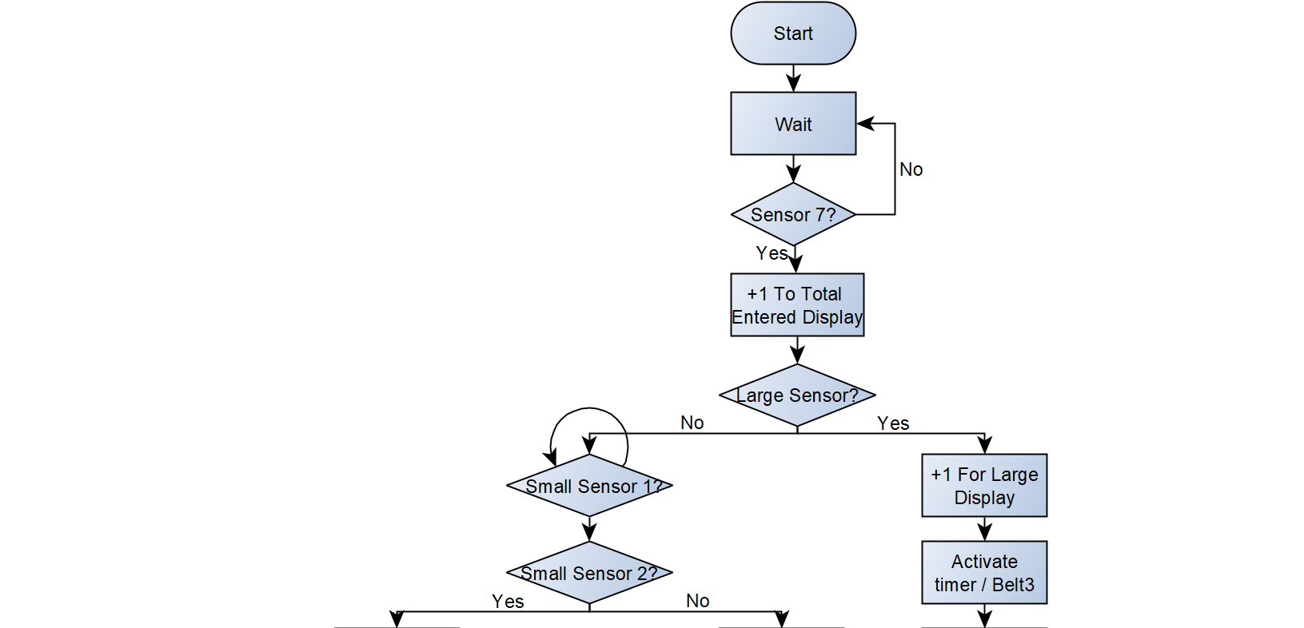
3 Flow Chart

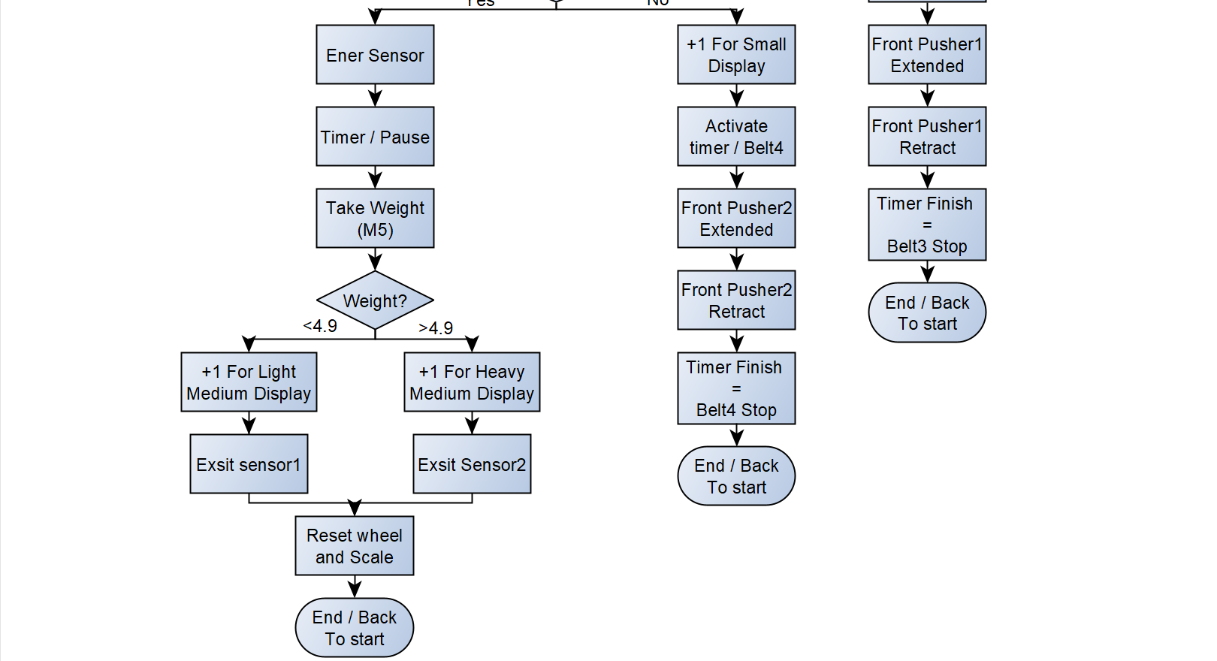

This is a basic flow chart to show what the program will do.

4 Ladder logic Program
Ladder Logic is used in many Industrial automotive applications such as Siemens, Mitsubishi Electric, ABB, Omron, Unitronics, just to name a few. For this assignment Factory I/O was used to create a factory design. Siemens was then used to create the ladder logic needed to work the factory. [4]
Programmable Logic Controller (PLC) needs code to run. For this Ladder logic is one option to use to program it. Ladder Logic is a geographical PLC programming language that expresses logic operations with symbols. [4]
They operate with binary signals (0’s or 1’s) also known as Boolean. Each line is named a rung. A rung is typically ‘read’ from left; set conditions, to right; instructions that can be triggered if conditions are met. Each instruction is either TRUE (1, On, High, Yes) or FALSE (0, Off, Low, No).
Name | Image  Input / Output | Explanation
Normally OPEN | -[ ]- / -( )- | Represent 0, unless activated (1) and return to inactivated (0). ‘Power’ can’t go through if this symbol I used.
Normally CLOSED | -[ / ]- / -( / )- | Represents 1, Unless de-activated (0) but will turn back to 1. ‘Power’ can go through if this symbol is showing.
Set | - [S] - / - (S)- | Same as Normally OPEN however it will ‘set’ which will stay keep to 1.
Reset | - [R] - / - (R) - | Same as Normally OPEN however will ‘reset’ which will turn all ‘Set’ (1) to 0.
Negative edge | -[N]- / -(N)- | Will activate on the negative side (back of the box)
Positive edge | -[P]- / -(P)- | Will activate on the positive side (start of box)
Reset Timer | -[ RT ]- | Output only, Resets timer from 0 but will restart to designated time
Table 2 [5]
There are many types of instruction in ladder logic PLC programming. They are as shown below in table 1:

Name | Programming name | Explanation
Input | %I”.” | This is the name of the gate at the start of each rung
Output | %Q”.” | This is the name of the gates at the end of the rung
Memory | %M”.” | This is a memory, meaning it will store the conditions and can be added to any rung.
Table 3

4.1 Run System
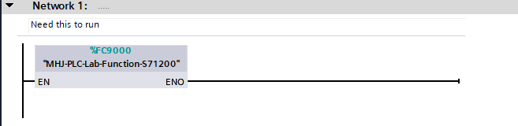
This feature is in the code because it is needed to ensure the software will run.

4.2 Start
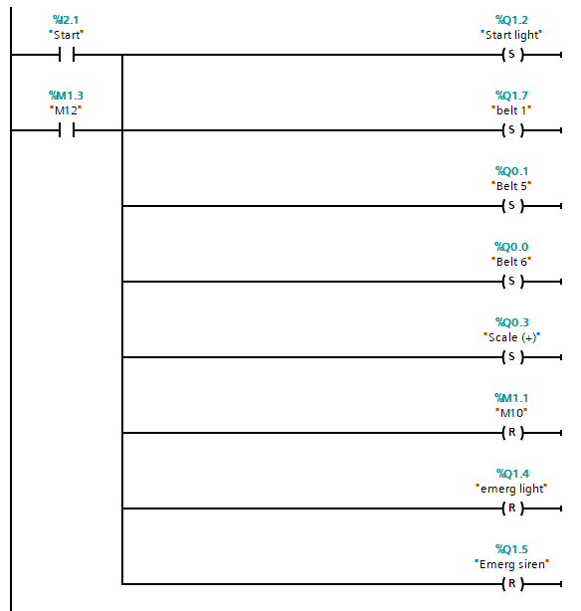
This image shows the start feature of the programming that has been developed. As seen, there are many possible ‘instructions’ and ‘conditions’ that can be chosen. These are all mentioned in the table 2 as well as table 3.
So, when start has been activated it will also activate all the outputs on the right-hand side of the rung. All of these have been put down as SET or RESET due to the nature of there features.

4.3 Stop
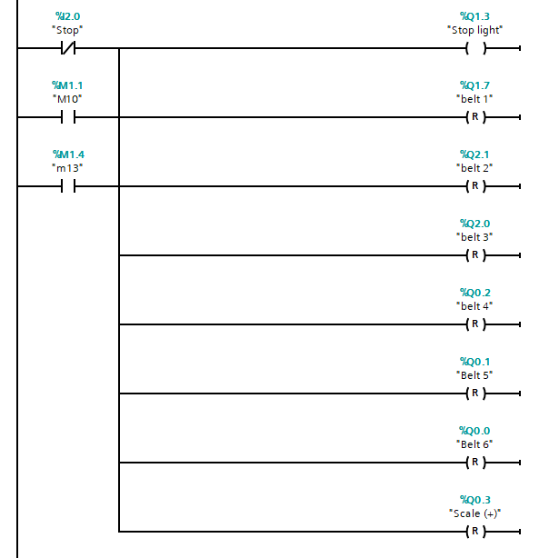
The image above shows the section of the code that has been created for the Stop button. As stated under the start section, When Stop is activated all the rungs will activate the outputs. Again, due to the nature of the outputs they have all be set to RESET, except for the light which is only now activated.
On the Left-hand side there are also 2 memory inputs. These will also activate the stop sequence Which have conditions which are shown further down the code

4.4 Reset
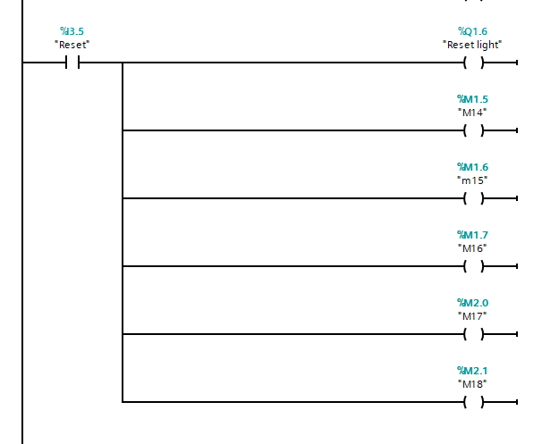
Here is an image of the reset program. It has many memories as the output, and this is to allow the values of the counters to be reset entirely from just one Button.

4.5 Emergency
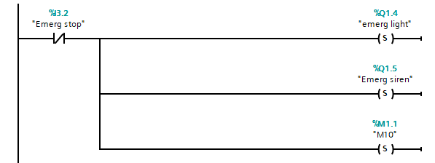
When the emergency stop button has been activated it allows an emergency light and siren to be on. At the same time ‘M10’ is stored as an output. This allows the conveyor belt to immediately stop as it is an input function on the stop network.

4.6 Individual Counters
For Individual counter there is a function block needed. These are called Counters. Counters have conditions in them that the programmer needs to fill.
CU = Input (what condition is needed before it activates)
R = Reset
PV = Maximum value (this is connected to the HDMI and will be shown later)
CV = Display (this is on the control panel in Factory I/O)
Q = Output
These are on all the counters under this section as shown below.

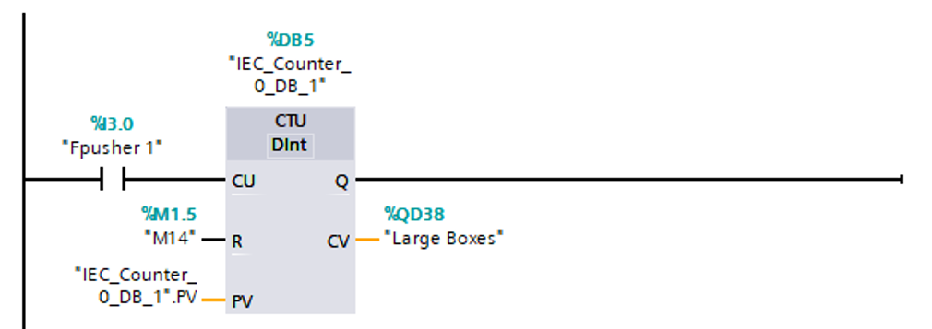
4.6.1 Large Boxes

4.6.2 Small Boxes
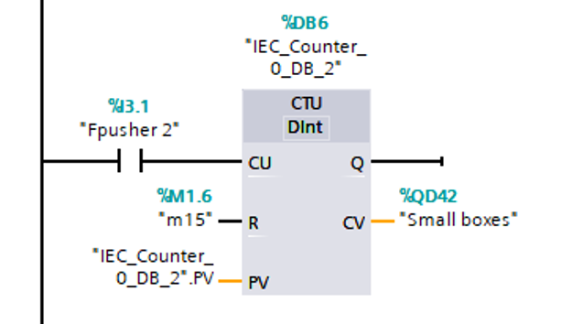

4.6.3 Heavy Medium
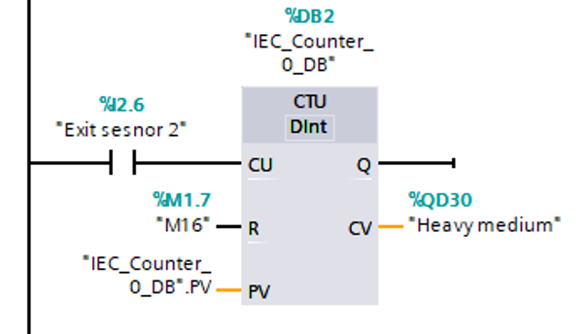

4.6.4 Light Medium
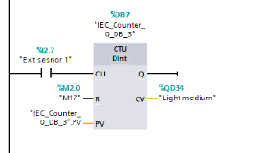

4.7 Total boxes exiting Conveyor
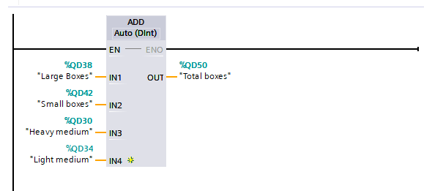
Like individual counters this is a function called ‘Add’. As the name states it adds together the inputs and gives an output. For this function all the Displays have been incorporated into this function to show the total of boxes that have left the conveyor belt.

4.8 Pushers
When mentioning pushers, they are a very simple device. They require an input and a reset to work. For this program all the pushers will be activated by different sensors, however, they all will be reset by the positive edge (fully extended arm) of the front pusher. This will cause it to go back to its original position.

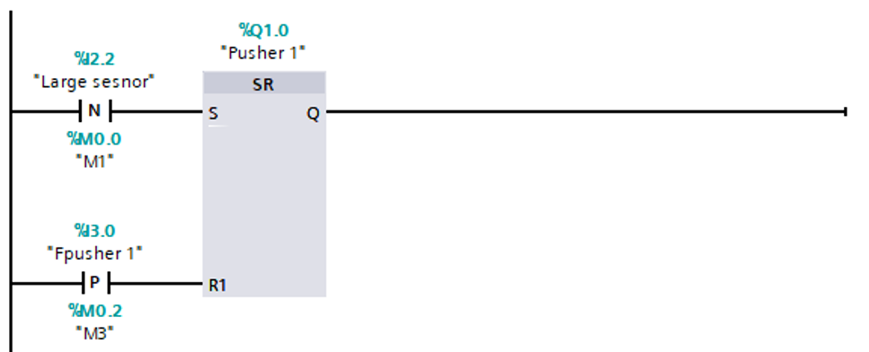
3
Here is an image showing the code that was created to remove large boxes from the main belt to its own designated belt.

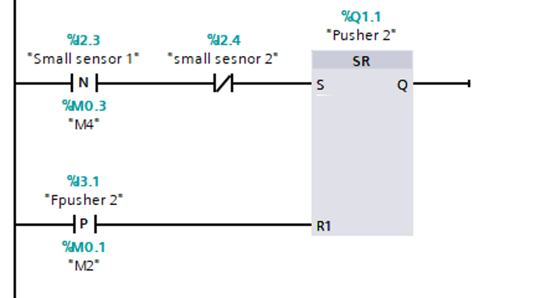
4.8.2 Small Boxes

This is the image showing how the pusher will extract the small boxes from the main conveyor onto its own belt. It consists of using 2 sensors. The reason two sensors were needed was to determine which boxes were small and which one were of different size. As seen the ‘small sensor 1’ states negative edge. This was used because when the ‘small sensor 2’ is activated it cancels the command for ‘small sensor 1’

4.9 Scale Direction and reset
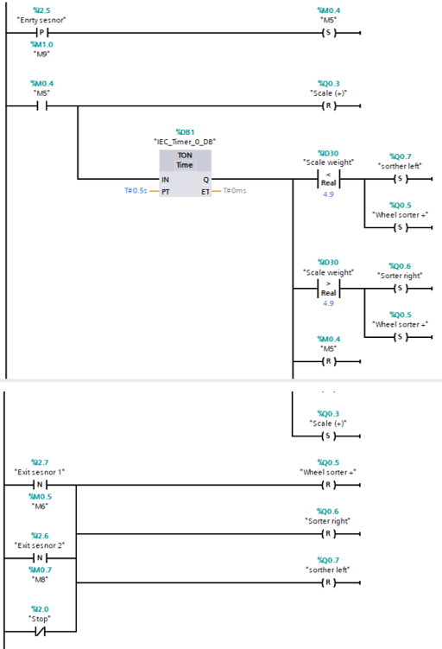

This section of the code was very difficult to produce as there were many different conditions that effected many parts. However, as shown many ‘set’ and ‘reset’ inputs and outputs were used as well as a timer, greater than also a less than.

4.10 Scale Pause
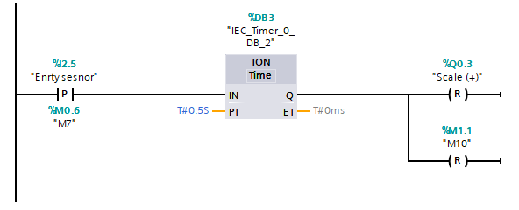
Scale Pause was a necessity for this program. It helped sort out the box sizing by keeping the box still for 500ms on the scale. The weight would then be stored in a memory to allow the program to determine if the box was heavy or light.

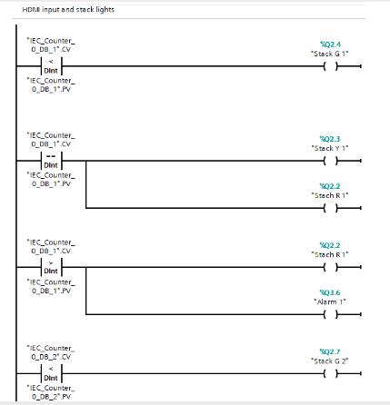
4.11 Stack Light and Alarm

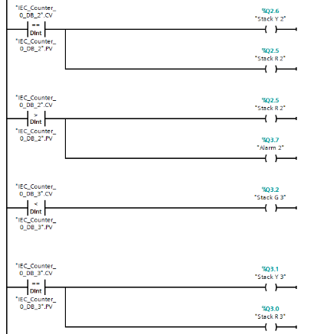
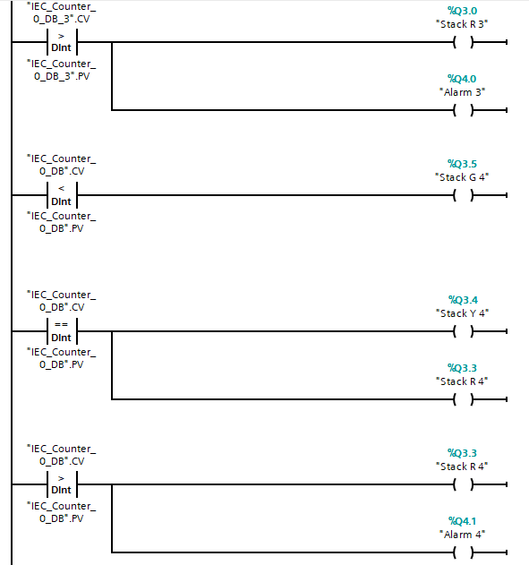
This section was simple yet repetitive as it needed all 4 sections to contain the stack lights (which each have 3 light indicators) as well as an alarm. As shown on the left hand side all the inputs represent the counter for each size. By putting in the maximum value into the HDMI it allows this circuitry to work.
Green showing when the value is below the required amount
Yellow and Red showing when the value is equal to the required amount
Red and alarm being activated when the required amount has been excided

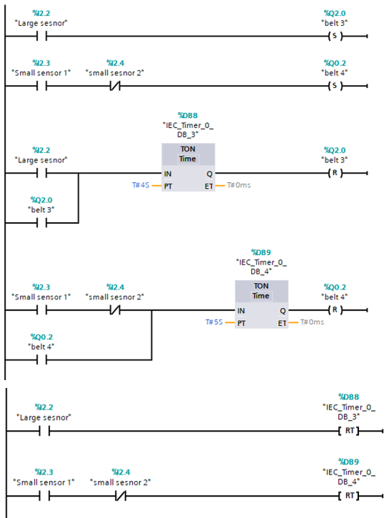
4.12 Belts working on command

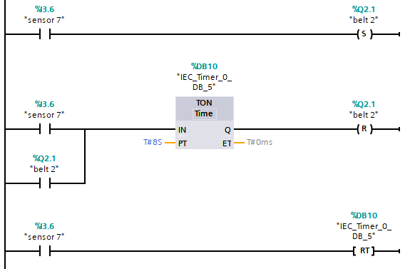
Sequential Belts were a requirement that needed to be implemented into the code. Here shows how it was accomplished. All the sensors activated there corresponding belt. However, the medium boxes do not have a sequential belt sequence. This is down to not fully understanding the turn table.

4.13 Number of boxes Entered System
For this function it was decided to use a sensor to calculate how many boxes entered the conveyor belt. Sensor 7 was added to make this happen. As seen, it is the same as when looking at the individual counters. A counter block is used, and the sensor (7) is the input, ‘M18’ is the reset, For the PV I input the maximum value of boxes that were allowed by the program to run. Then you have the display that is shown on the main control panel.

4.14 3D view of System
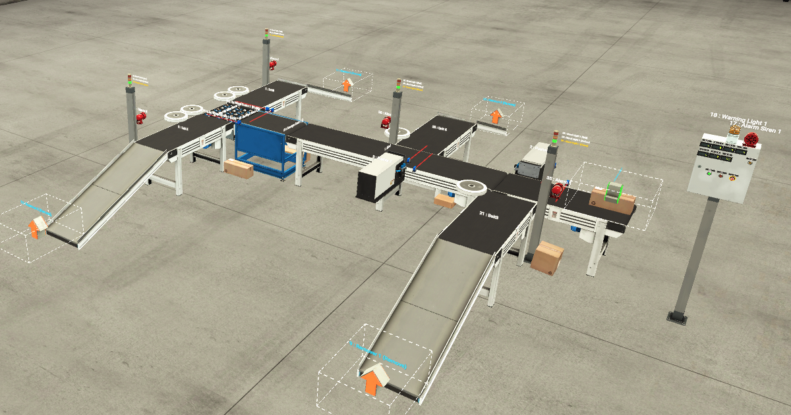
Here is a 3D view of the system that was designed. It consists of 6 conveyor belt, 7 sensors, tun table, weighing scales, 1 emitter, 2 pushers, 4 stack lights, 5 alarms, 1 emergency light, 7 displays, 3 standard buttons, 1 emergency button, 4 removers.

4.14 Close up of control panel
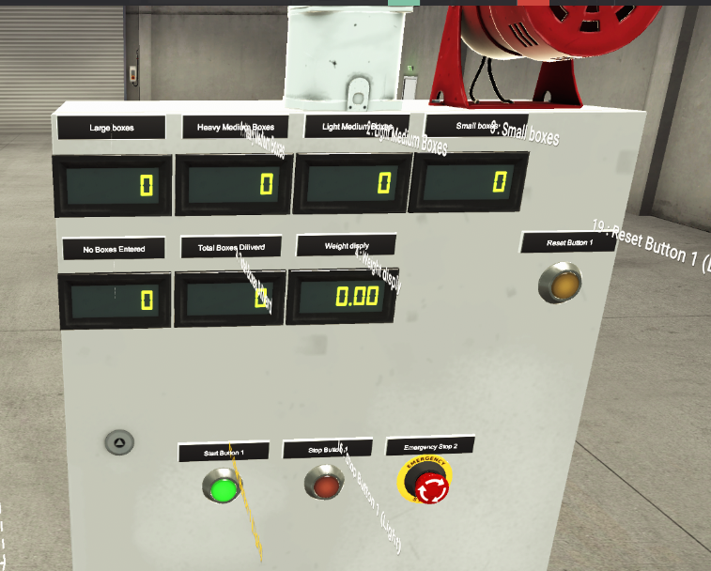

Here is an image showing a close-up of the control panel on the factory floor. These show all the displays for the sizes sorted, Total boxes entered and exiting the system. As well as the weight of the box on the scale.
Above the display is an emergency light and siren which gets activated by the emergency button. Also, there is a Start, Stop and Reset button.

4.15 Input and Outputs on Driver
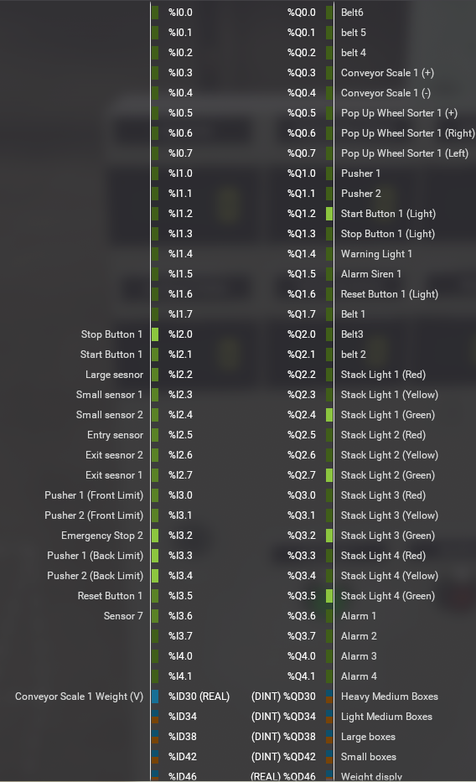
Here is an image showing the driver for the Factory I/O. When connecting either input or output there is a corresponding letter and value which is what is used in the ladder logic program.

4.16 HDMI control Panel

4.16.1 Screen 1 (Buttons)
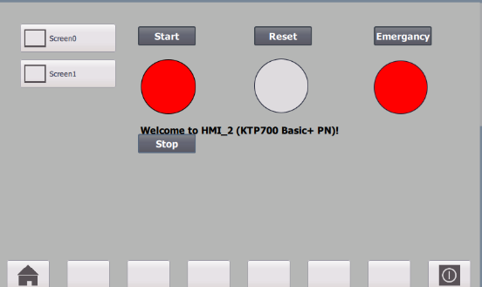
Here is an image of the Screen 1 on the HDMI system. It consists of the buttons that are seen on the display panel on the factory floor. The rectangles are the buttons that can be selected, and the circles are there to represent the function that is in progress. As seen, this is the outcome of an emergency button been presses. The circle under emergency turns red as well as the stop button. The reason for this is because they both get activated when emergency is pressed.

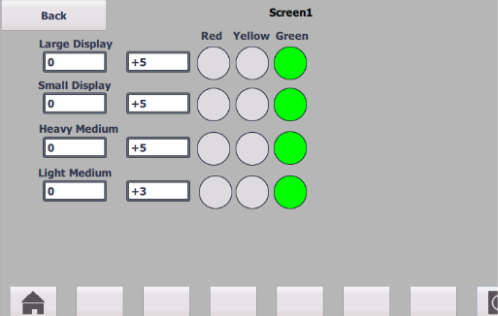
4.16.2 Screen 2 (Box Size display)
Here is an image showing screen 2. Here is where the user decides on the value of maximum boxes the system is required to take.
As stated in the code each light will turn on at different stages. On the right-hand side, it shows three circles which is to represent the light on the stack lights. As shown all the boxes are below the designated value so the green light is activated.

Improvements

There are many different improvements that could help make this system more productive and have extra features. Having a better understanding of how the ladder logic works in siemens would help drastically. The reason I have stated this is because the code can be simplified a lot, and this would help the program run smoothly.
With the HDMI section, extra displays could improve the system. This would include a display to show how many boxes entered the system as well as the total boxes that have been assorted into size altogether.
Buttons are another aspect that could be improved. As shown under the HDMI screen 1, My display consists of light indicators and simple buttons to correspond. However, adding a master key to this system would be beneficial as it could override everything.
Also, for this section fault and warning indicators need to be added as this has not been implemented in. However, with the code when the boxes reach their maximum value a red light is indicated on the HDMI as well as on the floor. An alarm is activated through, but it is only shown on the factory floor.
When looking at the ladder logic code itself, many adjustments could be implemented into it. These include when the boxes reach the maximum value the conveyor belt stops. This would allow for palates to be moved when needed. For this to happen a button is required for continuing. But the counter for that size would need to be reset, as well as ensuring the total box count entering and sorted dose not decrease as they are part of the system.

Reference
[1] www.dipslab.com, 2022. [Online]. Available 09 Difference between Compact PLC and Modular PLC | Block Diagram (dipslab.com) . [Accessed 1/12/2021].
[2] ] www.dipslab.com, 2022. [Online]. Available 7 Different Types of PLC Modules | Siemens PLC Modules (dipslab.com) . [Accessed 3/12/2021].
[3] www.dipslab.com, 2022. [Online]. Available Difference between Rack and Chassis of a PLC | Types of Rack & Purposes (dipslab.com) . [Accessed 6/12/2021].
[4] www.ladderlogicworld.com 2022. [Online]. Available Ladder Logic Basics - Ladder Logic World
[5] PLC Programming | How to Read Ladder Logic (solisplc.com) . [Accessed 10/12/2021].

Bibliography
7 Different Types of PLC Modules | Siemens PLC Modules (dipslab.com)
09 Difference between Compact PLC and Modular PLC | Block Diagram (dipslab.com)
PLC manufacturers - Google Search
Uses of PLCs in industries (mobileautomation.com.au)
Douglas V. Hall, Microprocessors and Interfacing Programming and Hardware, Singapore, McGraw-Hill Book Co, 1986.
[1] 09 Difference between Compact PLC and Modular PLC | Block Diagram (dipslab.com)
[2] 7 Different Types of PLC Modules | Siemens PLC Modules (dipslab.com)
[3] Difference between Rack and Chassis of a PLC | Types of Rack & Purposes (dipslab.com)
[4] Ladder Logic Basics - Ladder Logic World
[5] PLC Programming | How to Read Ladder Logic (solisplc.com)

Basics of PLC Modules | Different Types of PLC Modules (instrumentationblog.com)
Basics of PLC Modules | Different Types of PLC Modules (instrumentationblog.com)

