Scene from the Bayeux Tapestry; Harold swears an oath to William

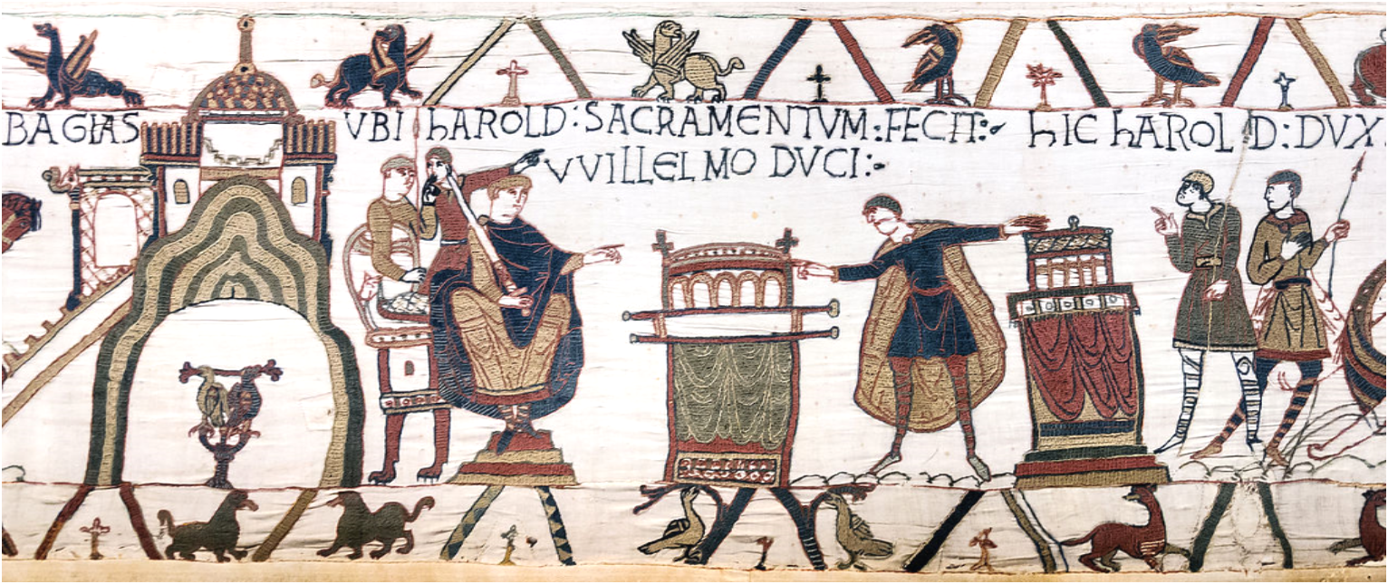

The Bayeux Tapestry has for centuries been one of the most useful sources for historians to better understand the Norman conquest of England in a unique and visual manner. Although the entire tapestry is itself a very interesting topic to discuss, this commentary will focus on the scene early in the artwork that depicts an occasion where Harold Godwinson swore an oath upon holy relics that he would accept that William, Duke of Normandy would succeed Edward the Confessor when he died. This is an extremely crucial component of the tapestry and the message that it is trying to portray as if this was indeed the case then Harold had relinquished any claim he may have had to the throne of England many years before the Battle of Hastings although there are many issues with this scene, which will be discussed further throughout this work.

The text which is above this particular scene roughly translates to “where Harold took the oath to Duke William” before visually demonstrating Harold using both hands on two separate relics to seemingly pledge allegiance to William, who is watching on nearby. The first thing that should be highlighted when considering this piece of evidence was that whether it is an accurate representation of actual history or not, this would have been a hugely important event in this story of succession if is to be believed. It is important to consider here how important all people during the eleventh century considered religion to be and the act of swearing on a holy relic was something that would have been taken extremely seriously, both by Normans and Anglo-Saxons of the period. Combine this with the fact that Harold is made to swear on not just one holy relic but two separate relics, one can begin to understand how the Normans wanted to portray this occasion as extremely significant in order to reinforce and back up Williams claim to the throne. Going against an oath to God in the manner that the Normans accused Harold of doing was an unfathomable sin to the Medieval mind and is something that would surely lead to a person facing the full consequences for their actions, something which is referenced later on in the artwork when Harold is depicted as having been struck down by an arrow straight through his eye, which was a fate reserved for people who commit such horrendous acts as perjury, although that scene itself is a topic of great debate and controversy for many of the same reasons as the scene being discussed here. Another implication of the holy importance of this section of the story is the increased use of crosses in the border art surrounding this section.

The key point that the creators of the tapestry are trying to put across in these sections, that Harold is a sinner who went against his promise to God, is also reinforced by some literary evidence from the period. One example of this is found within the work of William of Jumiege’s Gesta Normannorum Ducum, where in a speech before the battle of Hastings Harold is referred to as “lying and infamous perjuring king and adulterer”, which is clearly an attack on the character of Harold from several different aspects. This type of blatant attack on Harold in the aftermath of the Norman Conquest was something that would become fundamental to William by using art and literacy to further cement his legitimacy and claim to the English throne by implying that his predecessor was not fit to rule the country in any case. It would take many years after the days of William the Conqueror for the regular people of England to accept the Normans as their rulers or that they had any legitimacy at all, so the use of propaganda and exaggerated stories was something that the Normans were able to use to their advantage and became rather good at doing during the course of this “golden age” of historiography, and this particular section of the work is a good demonstration of how this can apply to visual works as well as literary sources.

When thinking about this idea of the Normans portraying events in the way that perhaps they wanted them to be portrayed taking priority over what actually happened, it is important to consider what evidence we have to support these claims. The Normans have become well known among historians for these tactics and although it means one should be mindful of this when looking at source material, it by no means implies that these sources can not help us achieve a better understanding of the Normans themselves from how they portray both their enemies and themselves. In this example, the difference in the two main characters is noticeable. While Harold is seen swearing an oath using the relics, William is seen in true Norman glory, looking on in a regal pose with a sword in his hands, looking like he is directly commanding to Harold what he must do. This could once again be interpreted as a sign of William’s authority over Harold, even fourteen years before the conquest took place.
A final thought to consider is the question of whether or not this event ever took place in the style that the Normans depicted on the tapestry. As an example, one anonymous writer claimed that the relics were covered in a sheet during the oath itself, only to be revealed to a distraught Harold after it has been completed. While there is no official proof of this version of events taking place, nor do the relics shown in the tapestry appear to be fully covered by fabric, it is interesting to highlight the two figures behind William in the scene, who almost look as though they are either pointing or laughing at Harold during his oath. While this is open to interpretation, it would not be an unreasonable suggestion to consider that perhaps certain elements of the scene provide some subtext to what the creator really knows and although they may be required to produce a certain product, one may find subtle hints of a slightly different side of events when investigated closely enough.

In conclusion, this section of the Bayeux Tapestry is a useful example to historians of the way the Normans portrayed themselves as well as how they portrayed their enemies. Whether this event truly took place or not, William made sure to include it within his masterpiece to show that he was the one rightful ruler of England and that even his competition had conceded that fact, all while being unfit to rule in the first place as a liar and a sinner. Like much of the rest of the tapestry, one can not be entirely accurate of its validity, but it certainly helps us gain a better understanding of the techniques and characteristics of the Normans and the way in which they used the divine power of God to use to their own advantage and to discredit their enemies while securing themselves further, which can be seen in how the Normans created a visual and literary image of themselves.

Bibliography

Primary Sources
The Bayeux Tapestry
William of Jumieges, Gesta Normannorum Ducu. Translated by E.Houts (London: Oxford University Press, 1995).

Secondary Sources
Bates. D, and Curry. A, England and Normandy in the Middle Ages (London: The Hambledon Press, 1994).
Crocker. G, ‘Hunger for England: Ambition and Appetite in the Bayeux Tapestry’, English Studies, 2012, Vol.93 (5), p.539-549
Huscroft. R, Ruling England (London: Pearson, 2005).
Lawrence. C, The Saxon and Norman Kings. (London: Blackwell, 2001).
Parisse. M, Bayeux Tapestry. (New York: James Clarke & Co, 2002).
Stenton. F, The Bayeux Tapestry: A Comprehensive Survey (New York: Phaidon, 1965).

D. Bates, and A. Curry, England and Normandy in the Middle Ages (London: The Hambledon Press, 1994). pp.22-23
F. Stenton, The Bayeux Tapestry: A Comprehensive Survey (New York: Phaidon, 1965). p.116
G. Crocker, ‘Hunger for England: Ambition and Appetite in the Bayeux Tapestry’ , English Studies, 2012, Vol.93 (5), p.539-549
The Bayeux Tapestry.
William of Jumieges, Gesta Normannorum Ducu. Translated by E.Houts (London: Oxford University Press, 1995).
R. Huscroft, Ruling England (London: Pearson, 2005).p.34
C, Lawrence. The Saxon and Norman Kings. (London: Blackwell, 2001). pp. 186-190
The Bayeux Tapestry
M, Parisse. Bayeux Tapestry. (New York: James Clarke & Co, 2002). p.107
R. Huscroft, Ruling England (London: Pearson, 2005).p.31

