

MODULE CODE: Digital Skills for Personal Development and Business Growth BMSW4008
ASSESSMENT COMPONENT: PORTFOLIO

STUDENT NAME: Roxana Horvatova

STUDENT NUMBER: 2506472

LECTURER: Aqsa Shabir

DATE: 30th November 2025

Contents
Task 1 3
Assessment of Digital Skills 3
References 3
Task 2 4
LinkedIn Learning Certificates for Office365 4
Task 3 5
Essay on Relevance of Excel in professional and personal life. 5
References 5
Task 4 6
7 Minute Reflective Presentation 6
References 6

Task 1

Assessment of Digital Skills

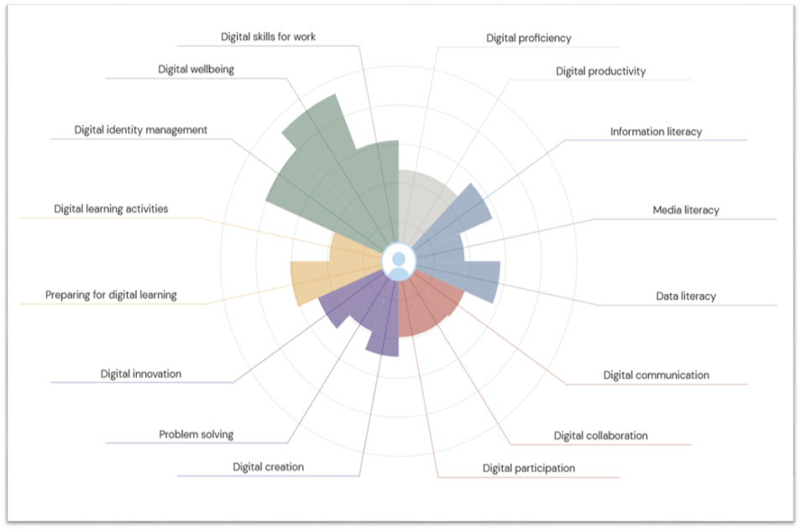
Strengths
I have three strengths that I am good at and know what they are about. These are:
- Digital skills for work
I know about Digital Skills for Work because they are important because they increase productivity, improve communication, and allowing employees to use technology efficiently, adapt to new tools, and help their businesses succeed. I am confident in this because technology is used everywhere such as school, and daily life, and helps people work in the workplace with ease.
- Digital wellbeing
This is another of my strength that I am confident in because I know of the importance of knowing how to use technology by being mindful of knowing how to take care of yourself as it can damage your eye sights and mental health. It is best to not be too much and overdo it by being too much on your technology devices. I am confident in this area because I know how damaging technology can be to a person's wellbeing.
- Digital identity management
This is another of my strength as I understand that this means to protect one's identity online and your personal information from being misused. For organizations, I understand the process of verifying a person's identity and controlling accesses of who can access which specific systems and comply with security and date privacy.
Weaknesses
I have three weaknesses that I am not good at which includes:
- Digital communication
This means that by using electronic devices, you can exchange information by messages, emails, and social media. Although I can do this, I am still lacking in this area because for professional communication and emails, I must make sure that it is written clearly and correctly without any misunderstanding. To get better at this, I will focus on my clarity, tone, and professionalism by being concise, proofreading for errors, and making sure my tone is appropriate.
- Digital collaboration
This means to enable people to work in teams to work together on projects by communicating, sharing information and ideas, and coordinating efforts, even if they are located far away from everyone else. I am bad at this because I have not done this before and I do not know much about it. I am although confident I will get better at it if I try to collaborate with others. To get better at this, I will be improving my confidence, my communication clarity, using the right digital tools effectively, and establishing clear shared goals.
- Digital participation
This is another of my weakness which means active involvement of citizens in the digital society using modern information and communication technology. This is to engage the public online and know what is happening. I am bad at this because I have never done this before. This is because I do not know how to. However, I would like to get better at it by trying to practice by using many different apps and websites and improve my digital literacy. I would also need to focus what people are into and to build trust.

Task 2

LinkedIn Learning Certificates for Office365
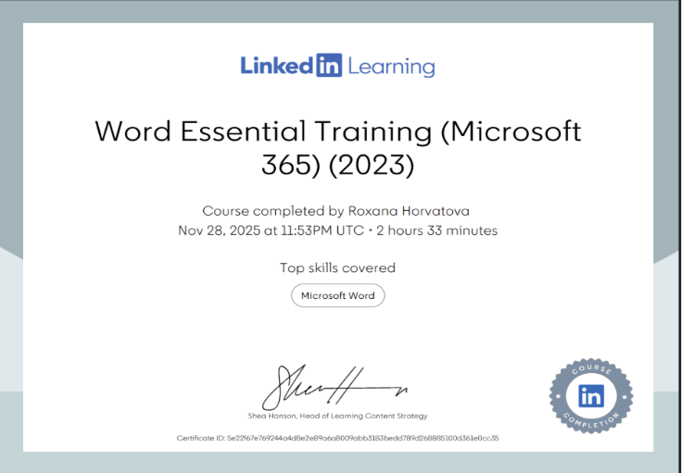
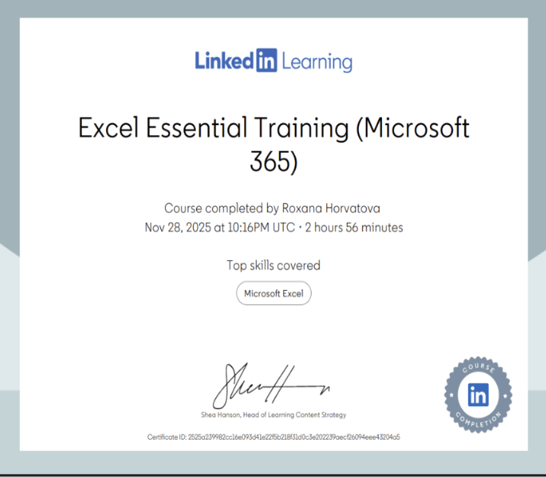

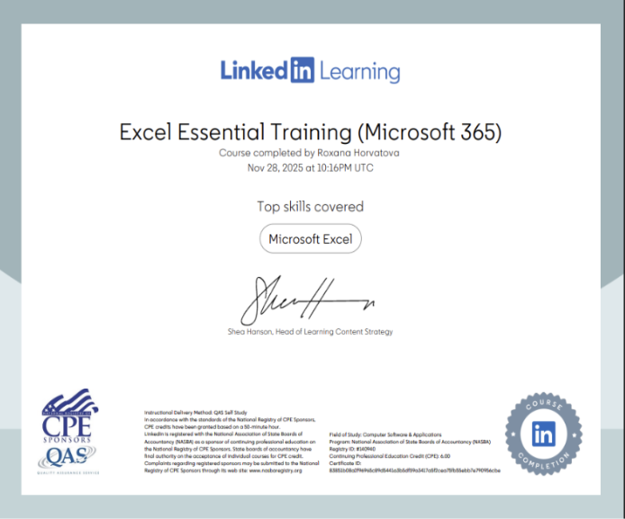
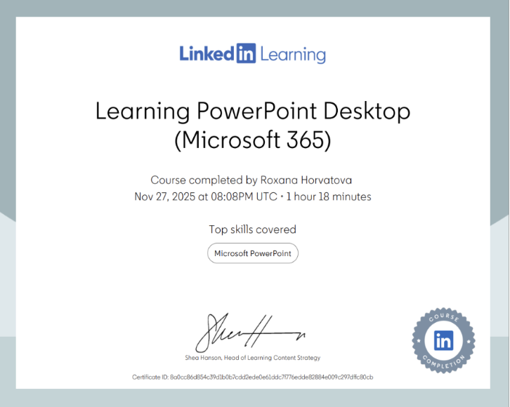
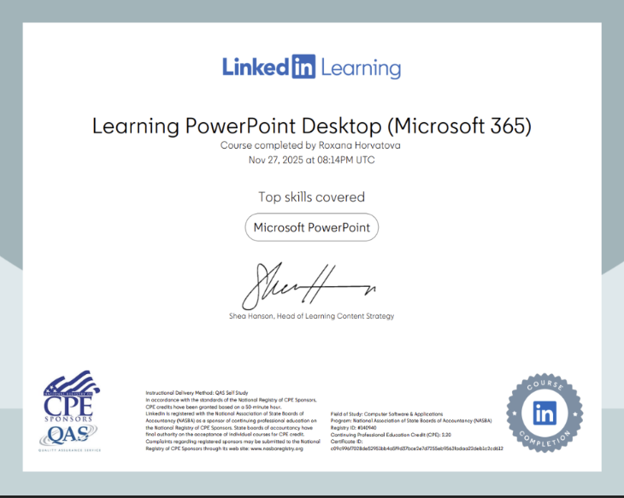

Task 3

Essay on Relevance of Excel in professional and personal life.
Excel is a powerful spreadsheet application by Microsoft that is used for organizing, analysing, and visualizing data through a grid of cells. It allows users to perform calculations using formulas, creating charts, and to manage large datasets for tasks like budgeting, forecasting, and data analysis. Excel is available on desktop, mobile, and online, and supports real-time collaboration. Excel also provides security features to protect your data, making it a reliable choice for managing sensitive information because Excel offers multiple layers of security to safeguard your work.
Excel is important because it is a powerful tool for data analysis, organization, and calculation, used across many industries for tasks like finance, marketing, and project management. Its importance in the modern workplace is reinforced by its frequent inclusion as a required skill in job descriptions, demonstrating its value in making informed decisions and improving efficiency. Excel is important and it varies on the person managing it whether they will find it difficult or not. It is an essential tool for doing many important things, especially in Finance. The way it works is you write a heading, the names in the first collum, the amounts of cost, and then the total cost. This has become especially useful and beneficial for people who work in this area especially financial analyst, Accountant, Administrative assistant, Sales manager, Cost estimator and many more.
Excel is important because it is easier and faster to do it especially after you know how to use Excel and are specialized in this area. It is quicker to do it digital rather than paper based as it takes to time and can be overwhelming. Microsoft Excel is also popular, considered the most widely used spreadsheet with millions of users across all office jobs. It is popular by its versatility for tasks and its continuous updates that keep it relevant for modern business needs. Not only is Excel used for Business needs, but it can also be used for personal use such as tracking your own income and expenses, create budgets, and monitoring your savings. It can also be used for planning your vacations, parties, weekly meals, monitoring health data, workout routines, or other personal lists. Excel was also popular when it came out in 1985, due to its strong graphics, faster processing, and superior macro language. Its popularity surged, helping to drive the growth of the Windows platform itself. Because of this, Excel has become the most popular and successful platform because of how amazing it is and loved by many people.

This is why many people like Excel because it is easy to use if you know the basics, such as how to format, add words in the columns and to add any tables. It can be used for many things which gives it a major boost in the workplace and in personal use. It is likeable because it is important in many jobs and it makes it also easy to use rather than doing it on paper because it is confusing and time consuming. It is also safer to use Excel rather than on paper-based because paper-based spreadsheet is less secure and easy to steal if it not placed in a secure place because it is confidential. However, digital excel is better because it is safer and because it has password protection, which can prevent unauthorized access. If the security is tight, then it prevents hackers from accessing any confidential files.
To learn Excel, start with the basics of navigation and simple formulas, then practice with real-world projects and online tutorials from sites. Once you are comfortable, move on to more advanced topics like PivotTables, data validation, and conditional formatting to build your skills. Practicing and watching tutorials of how to use Excel will help you to know better of how to use it more efficiently and because it is important to know how to use it if you do not want to struggle. It is best to learn the basics and slowly try other things that are a bit difficult to enhance your skills better.
To understand how to use Excel and be good at it varies on the person using it. Some people will understand more quickly about how to use Excel and will be better at it than other people. While others will face problems and will have a harder time understanding how to work with Excel. It takes time for an individual to understand and master how to use Excel with ease. Some people will have problems with Excel such as error, data integrity issues, scalability limits, data entry mistakes, complex or incorrect formulas, difficulty managing large datasets, and security vulnerabilities. This is why it is important to know the basics of how to use Excel as it can be tricky for some individuals. After some time of working on Excel, a person will gradually get better at it over time and even master it in a length that they will work on it with ease.
In conclusion, Excel is a useful tool in both professional and personal life because of how versatile Excel is and because of how it is efficient and powerful in data-handling. In the workplace, it supports decision-making, enhances productivity, and enables users to organize, analyse, and present information with accuracy. In personal life, Excel helps individuals manage budgets, track goals, plan events, and monitoring your savings. Because of the many features Excel provides, it is still unbelievably valuable for many people and in the work area. This is why I believe that Excel is an amazing tool to work on because it has many features and it is also an important tool in many workplaces and in personal life. If you learn the basics and gradually get better, you will work on it with ease which will also help you in your work life as you will have no need to go through a lot of paper-based spreadsheets which is really overwhelming and because digital Excel is easier and doesn't require a lot of stress.

References
Coursera Staff (2025) What is Excel? Formulas, Functions, and more. Available at: https://www.coursera.org/articles/what-is-excel
Insightsoftware (2023) Why do we use Excel? Available at: https://insightsoftware.com/blog/why-do-we-use-excel/
Patty. C (2025) Is Excel hard to learn? Available at:
https://www.onlc.com/blog/how-hard-is-it-to-learn-excel/

Indeed Editorial Team (2025) 13 jobs that use Excel (with salaries and primary duties) Available at: https://uk.indeed.com/career-advice/finding-a-job/jobs-that-use-excel
Kat (2023) How to Use Excel for Personal Stuff (Or: An Ode to Spreadsheets) Available at: https://corporette.com/how-to-use-excel-for-personal-stuff/
Mike. S (2020) Spreadsheets: A Dangerous Weapon. Available at: https://cws-software.com/spreadsheets-a-dangerous-weapon/
Sheetcast. Seven Essential Ways to Protect Your Spreadsheet. Available at: https://sheetcast.com/articles/seven-essential-ways-to-protect-your-spreadsheet
Laiba. S (2024) Learn Excel in 2025: A Complete Guide for Beginners. Available at: https://www.datacamp.com/blog/learn-excel

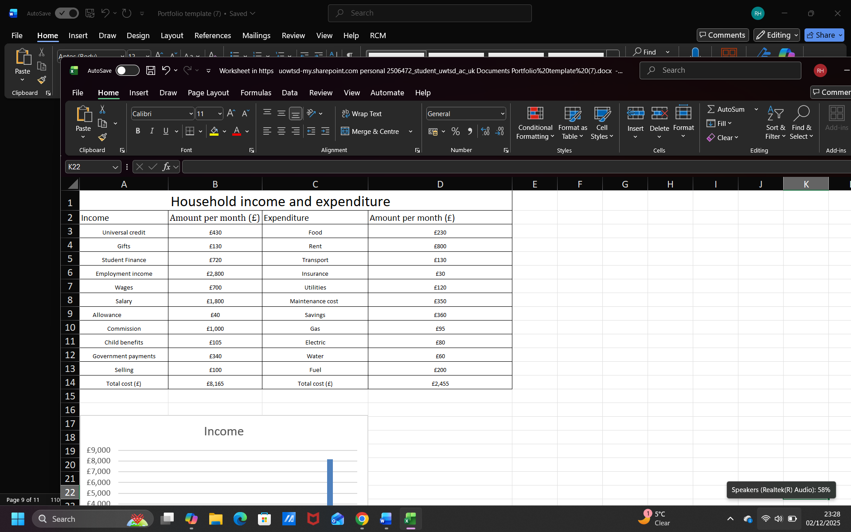
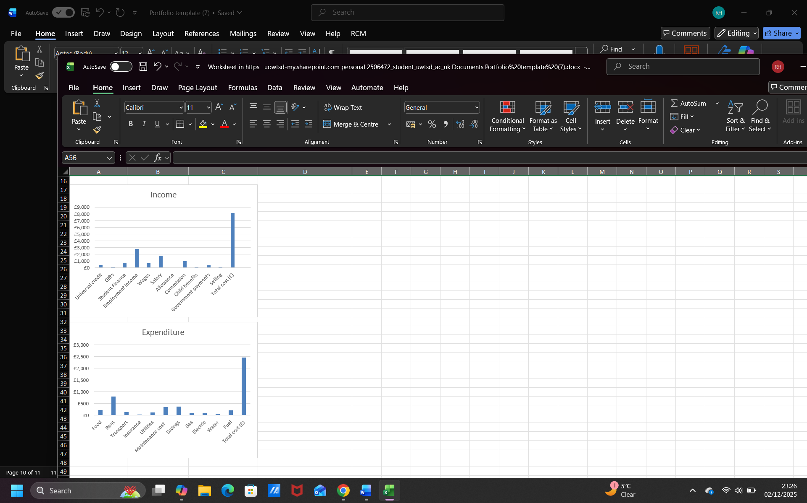

Task 4


