

STUDENT NAME: CHRIS ANTWI BOASIAKO
STUDENT ID: 2432249
MODULE: NETWORK OPERATING SYSTEMS AND SERVICES
MODULE CODE: ACCA 5023
ASSIGNMENT TITLE: CONFIGURE AND MANAGE THE VIRTULISED ENTERPRISE
NETWORK
LECTURER: Md ABRAR JAHIN ALMAZI BIPON
DATE: 24/07/2026

TABLE OF CONTENTS:
DESCRIPTION PAGE

Introduction 4
Routing 4
Routing in Birmingham Network 4
Domain Server (Birmingham) 5
Creating a Forest Name 5 Creating a New Active Directory Forest 6
Configuring Active Directory Database, Log Files and SYSVOL Path 7
Domain Controller Options 8
Prerequisites Checks 9
Configuring DNS Forwarders 10
Creating a DNS Host (A) Record 11
Verifying DNS Host Records in the Forward Lookup Zone 12
DNS Manager Forward Lookup Zone with Active Directory and Host (A) records 13
Creating and configuring a DNS Zone 14
Creating a Reverse Lookup Zone 15
Configuring the Reverse Lookup Zone Network ID 16
Verifying the Reverse Lookup Zone 17
Verifying Pointer (PTR) Records in the Reverse Lookup Zone 18
Configuring the Birmingham Website in IIS 19
Installing Remote Desktop Services (RDS) 20
Confirming Remote Desktop Services Installation 21
Configuring SSL Settings for the IIS Website 22
Testing the IIS Website 23
Testing Remote Desktop Web Access (RD Web Access) 24
Virtual Machine Storage Configuration 25
Configuring Virtual Machine Storage 26
Initialising the Additional Virtual Hard Disk 27
Disk Management – Creating a New Volume 28
Creating a Shared Data Folder 29
File Server Configuration – Advanced Sharing 30
Configuring Network Access and Share Permissions 31
Completing the Shared Folder Configuration 32
Configuring Network Access for the Shared Folder 33
Network Connectivity and DNS Testing 34
Client IP Address and DNS Configuration 35
Testing Network Connectivity 36
Testing Network Connectivity from the Linux Client 37
Verifying Internet Connectivity from the Linux Client 38
Active Directory Domain Services (AD DS) Installation and Configuration 39
Active Directory Users and Computers Showing Organisational Unit (OU) for NOSS Users 40
PowerShell Configuration 41
Executing a PowerShell Script to Import Active Directory Users 42
Selecting the DHCP Server Role in the Add Roles and Features Wizard 43
Installation of the DHCP Server Role 44
Completion of the DHCP Post-Install Configuration Wizard 45
Verifying the DHCP Client Service in Windows Services 46
DHCP Management Console Showing the Authorised DHCP Server 47
Configuring Domain Name and DNS Server Options for the DHCP Scope 48
Completed DHCP Scope Configuration for the Birmingham Network 49
Verifying the DHCP Server Network Configuration Using the ipconfig /all Command 50
Verifying Client DNS Configuration and IP Address Using NSLOOKUP 51
Verifying Active Directory DNS SRV Records Using NSLOOKUP 52
Successful Domain User Login on the Client Computer 53
Verifying Successful Domain User Login Using the WHOAMI Command 54

INTRODUCTION:
This assignment focuses on designing, configuring, and testing a Windows Server network environment using Oracle VM VirtualBox. It involves installing and configuring key server roles, including Active Directory Domain Services (AD DS), Domain Name System (DNS), Internet Information Services (IIS), Remote Desktop Services (RDS), and file sharing. The assignment also includes configuring Windows and Linux client machines, assigning IP addresses, creating shared resources, and verifying network connectivity through practical testing. By completing these tasks, the assignment demonstrates the implementation of a secure, reliable, and functional enterprise network that supports user authentication, resource sharing, remote access, and web services.

ROUTING
Routing in Birmingham Network

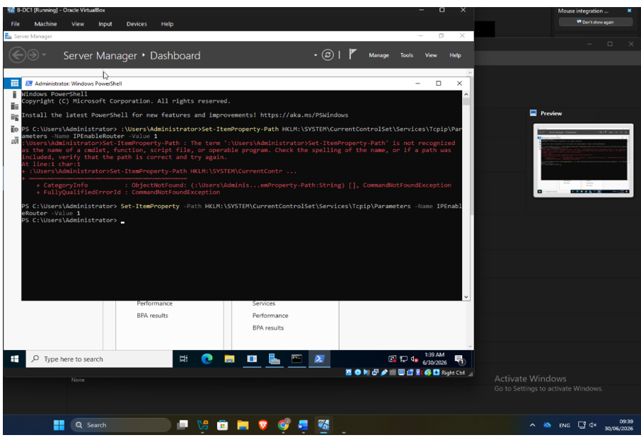
Figure 1: Enabling IP Routing on the Birmingham Windows Server using PowerShell
The screenshot shows B-DC (Birmingham Domain Controller) running Windows PowerShell. Initially, an incorrect PowerShell command was entered, resulting in a CommandNotFoundException. By setting the IPEnableRouter value to 1 registry value
allowed the Windows Server to forward IP packets, which is a prerequisite for routing traffic between different network segments. This configuration supports communication between the Birmingham and London networks.

Domain Server (Birmingham)

Creating a forest named (yourname.acca ) e.g. chris.acca

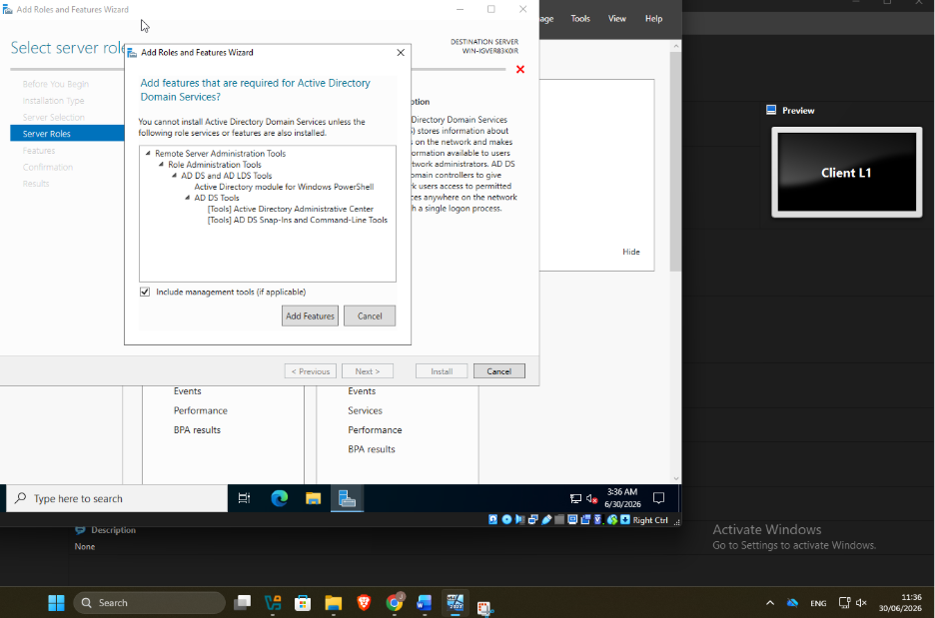
Figure 2: Installing the Active Directory Domain Services (AD DS) Role

This screenshot shows the installation of the Active Directory Domain Services (AD DS) role using the Windows Server Add Roles and Features Wizard.

Creating a New Active Directory Forest

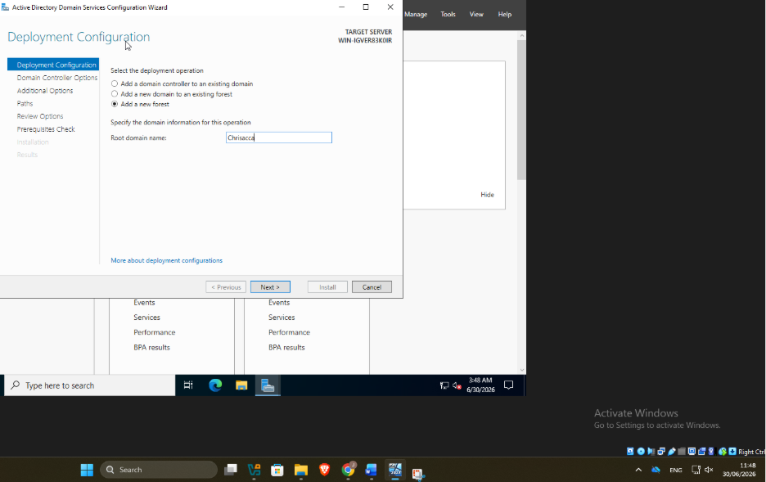
Figure 3: Creating a New Active Directory Forest

This screenshot shows the Active Directory Domain Services Configuration Wizard during the deployment configuration stage.

Configuring Active Directory Database, Log Files and SYSVOL Path

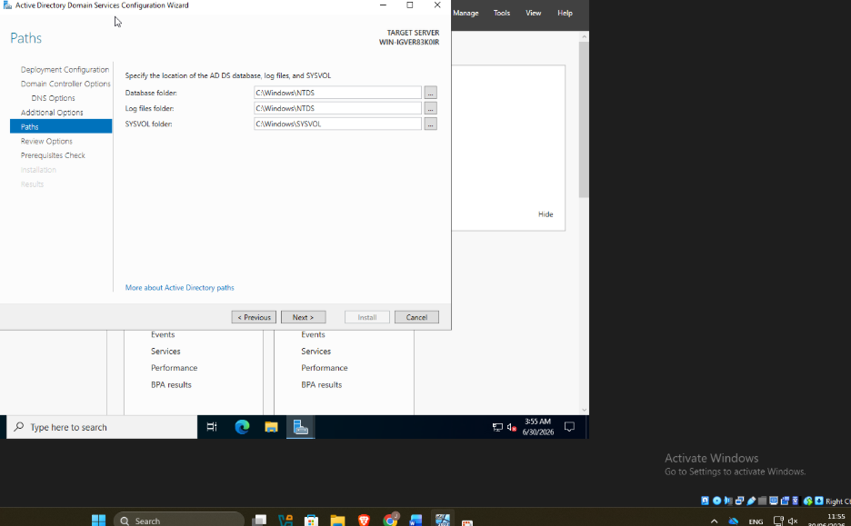
Figure 4: Configuring Active Directory Database, Log Files and SYSVOL Path

This screenshot shows the Paths page of the Active Directory Domain Services Configuration Wizard. During the promotion of the server to a Domain Controller, the default storage locations for the Active Directory database, transaction log files, and SYSVOL folder were configured.

Domain Controller Options

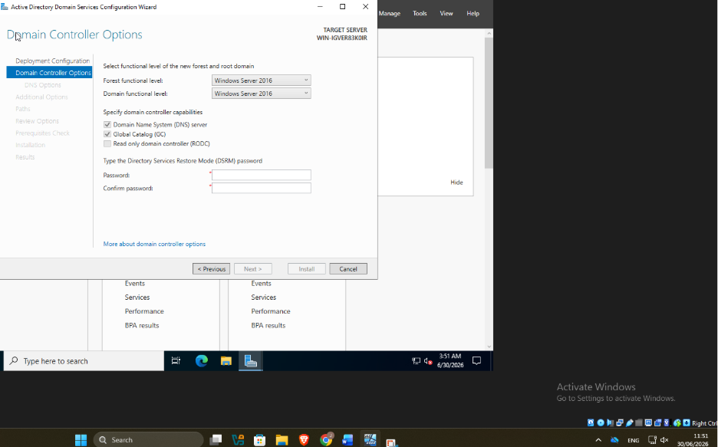
Figure 5: Configuring Domain Controller Options

This screenshot shows the Domain Controller Options page during the promotion of the Windows Server to a Domain Controller.

Prerequisites Checks
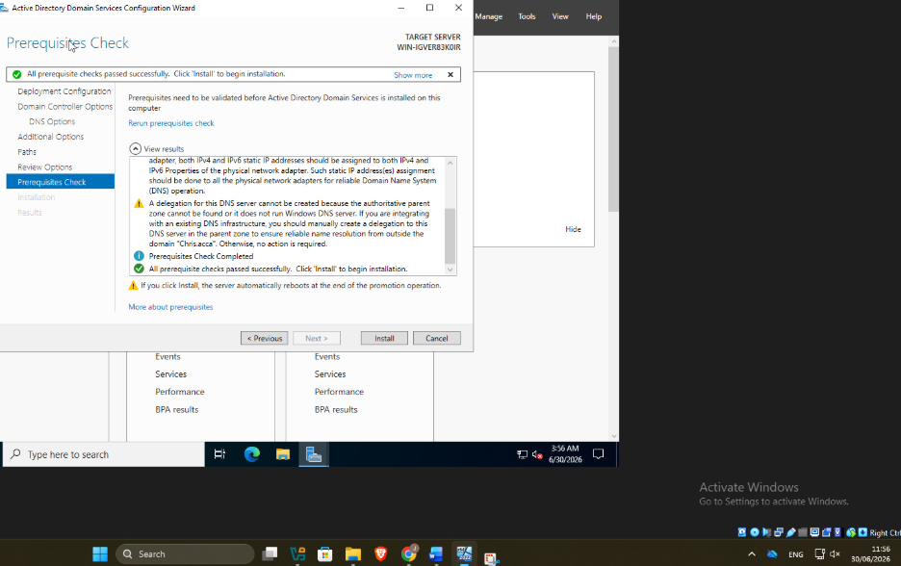
Figure 6: Active Directory Domain Services – Prerequisites Check completed successfully before Domain Controller installation.

Configuring DNS Forwarders

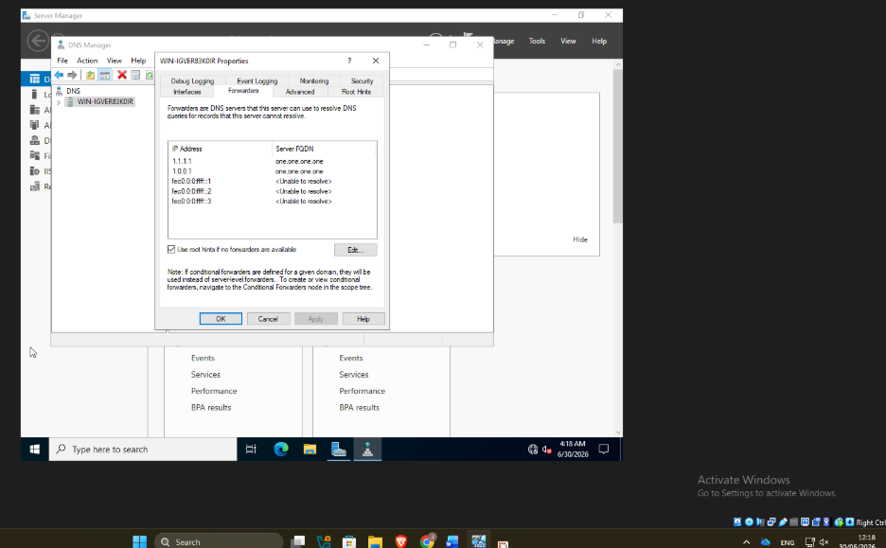
Figure 7: DNS Manager showing configured DNS Forwarders for external name resolution.

This screenshot shows the DNS Manager on a Windows Server, specifically the Properties window of the DNS server with the Forwarders tab selected.

Creating a DNS Host (A) Record

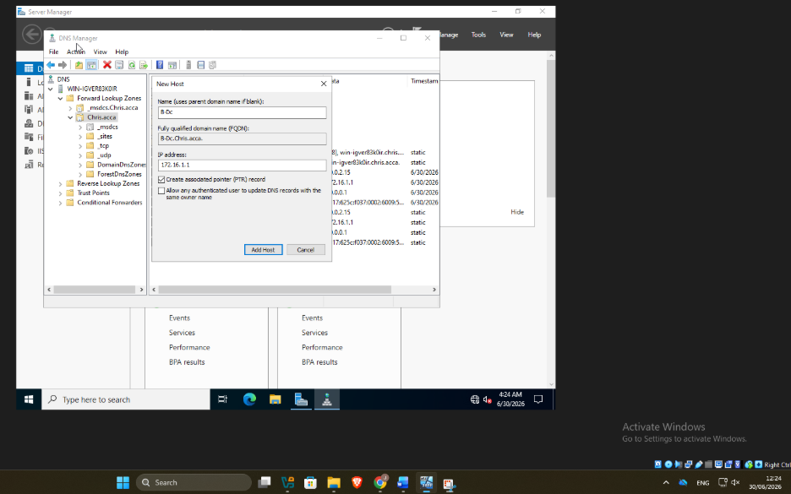
Figure 8: Creating a Host (A) Record in DNS Manager for the B-DC server.

This screenshot shows the creation of a Host (A) Record in DNS Manager. A new host named B-DC was added to the Chris.acca forward lookup zone and assigned the IP address 172.16.1.1.

Verifying DNS Host Records in the Forward Lookup Zone

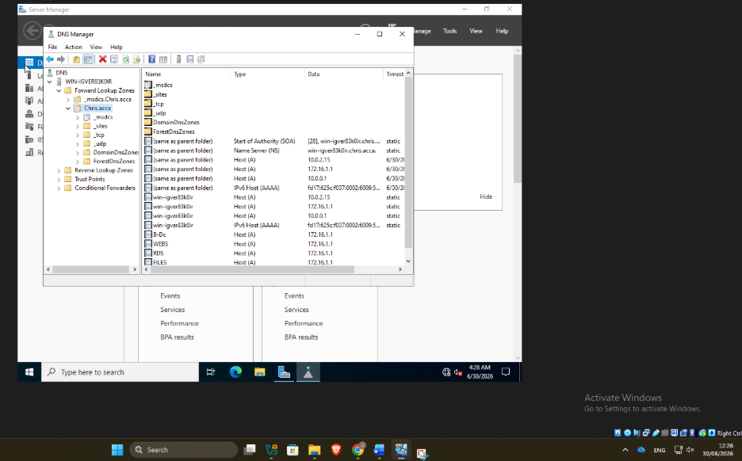
Figure 9: DNS Manager displaying configured Host (A) records in the Forward Lookup Zone.

This screenshot shows the completed Forward Lookup Zone in DNS Manager after creating multiple Host (A) records. The DNS zone contains the default Active Directory records, including the SOA and NS records, together with custom host records such as B-DC, WEBS, RDS, and FILES.

DNS Manager Forward Lookup Zone with Active Directory and Host (A) records.

Figure 10: DNS Manager showing the Forward Lookup Zone with Active Directory and Host (A) records.

Creating and configuring a DNS Zone

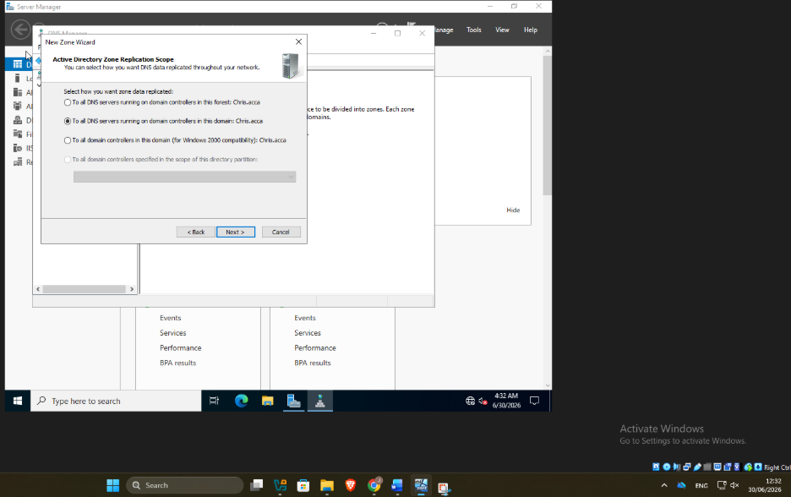
Figure 11: Configuring the Active Directory DNS Zone Replication Scope in the New Zone Wizard.

This screenshot shows the Active Directory Zone Replication Scope page in the New Zone Wizard.

Creating a Reverse Lookup Zone

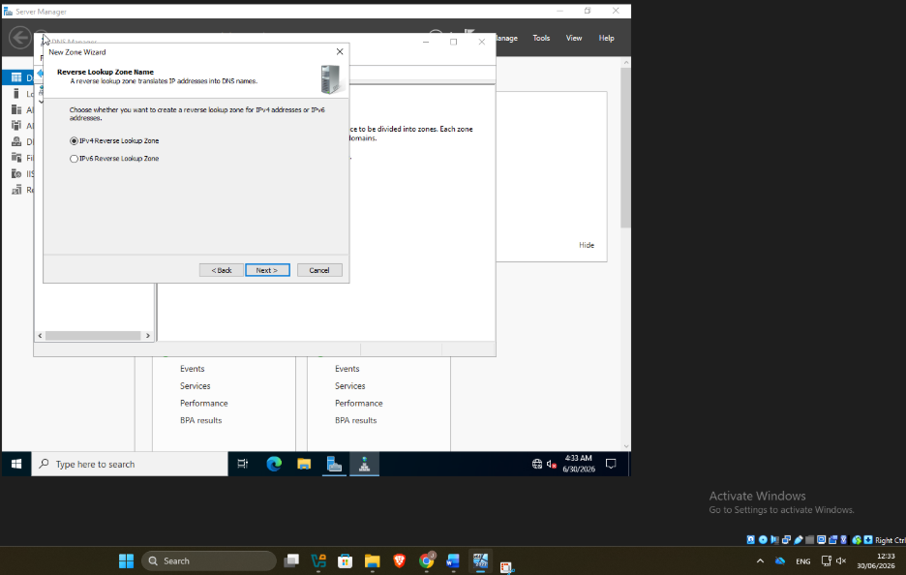
Figure 12: Selecting an IPv4 Reverse Lookup Zone in the DNS New Zone Wizard.

This screenshot shows the Reverse Lookup Zone Name page in the DNS New Zone Wizard.

Configuring the Reverse Lookup Zone Network ID

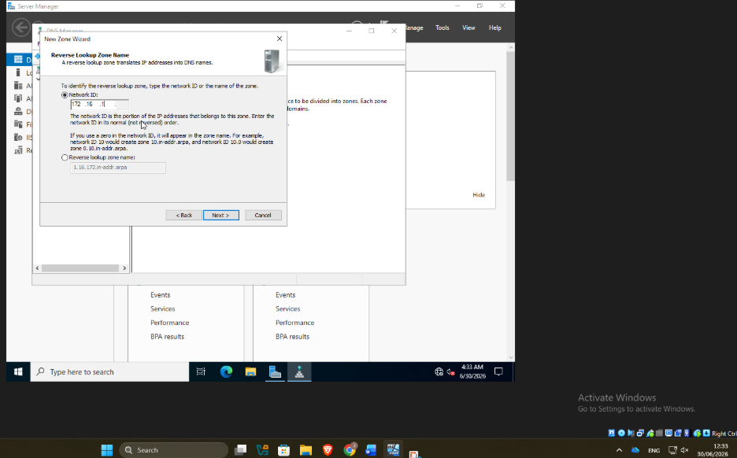
Figure 13: Configuring the Network ID for the IPv4 Reverse Lookup Zone in DNS Manager.

This screenshot demonstrates that the Reverse Lookup Zone has been configured with the correct network ID, ensuring that devices in the 172.16.1.0/24 network can be identified by both their IP addresses and host names.

Verifying the Reverse Lookup Zone

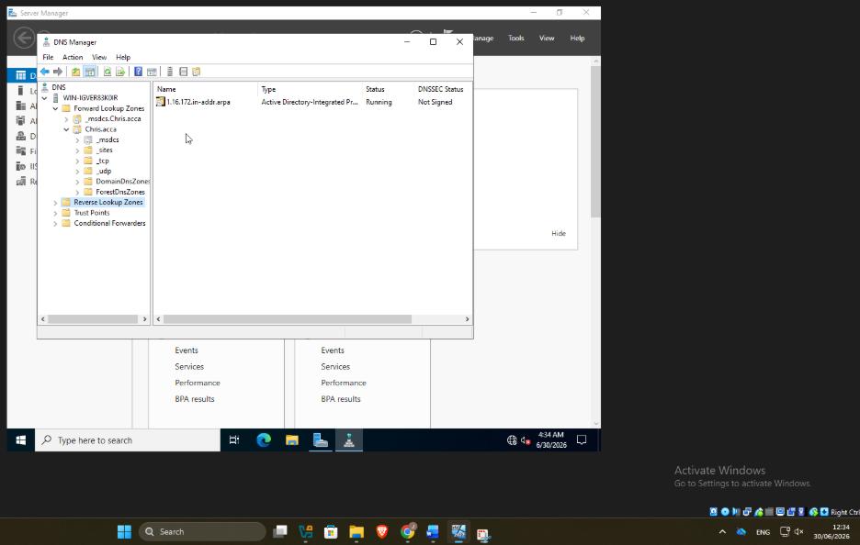
Figure 14: DNS Manager showing the Active Directory-Integrated Reverse Lookup Zone

This screenshot provides evidence that the Reverse Lookup Zone has been successfully created and is operational.

Verifying Pointer (PTR) Records in the Reverse Lookup Zone

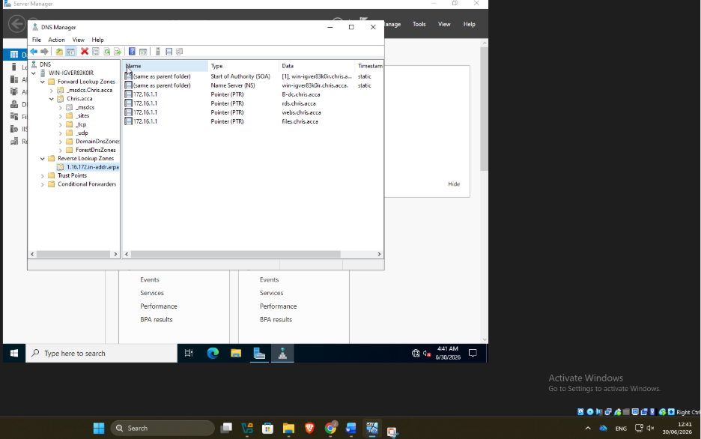
Figure 15: DNS Manager displaying PTR records in the Active Directory Reverse Lookup Zone.

This screenshot provides evidence that reverse DNS resolution has been successfully configured, demonstrating that IP addresses can be resolved back to their corresponding host names.

Configuring the Birmingham Website in IIS

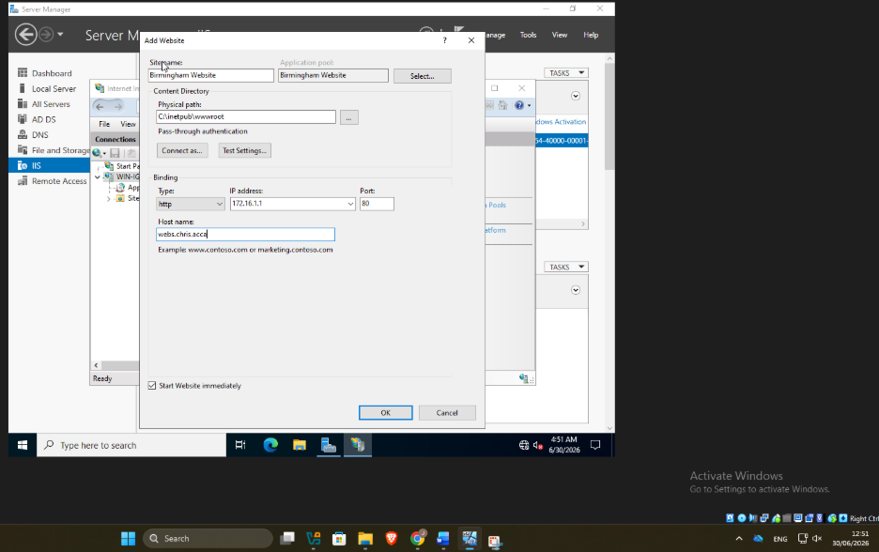
Figure 16: Creating the Birmingham Website in IIS Manager with HTTP bindings and the host name webs.chris.acca.

This screenshot provides evidence that the IIS website has been configured correctly with the appropriate site name, physical path, IP address, port, and DNS host name.

Installing Remote Desktop Services (RDS)

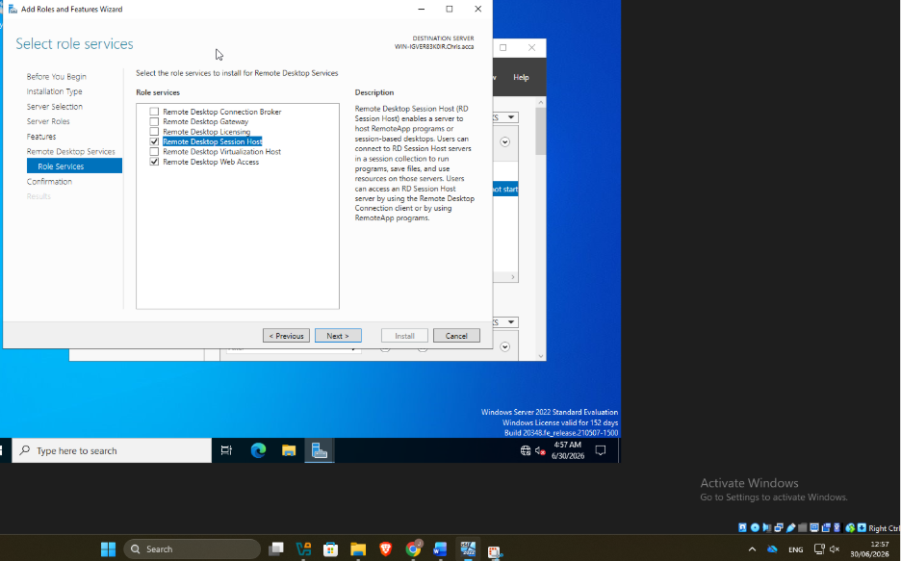
Figure 20: Selecting Remote Desktop Services role services during Windows Server installation.

This screenshot shows the Add Roles and Features Wizard in Windows Server, specifically the Select Role Services page for installing Remote Desktop Services.

Confirming Remote Desktop Services Installation

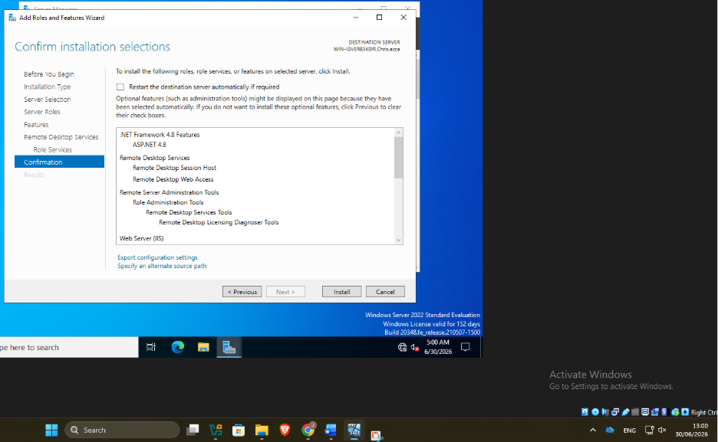
Figure 21: Confirming the installation of Remote Desktop Services and supporting Windows Server features.

This screenshot shows the Confirm Installation Selections page of the Add Roles and Features Wizard in Windows Server.

Configuring SSL Settings for the IIS Website

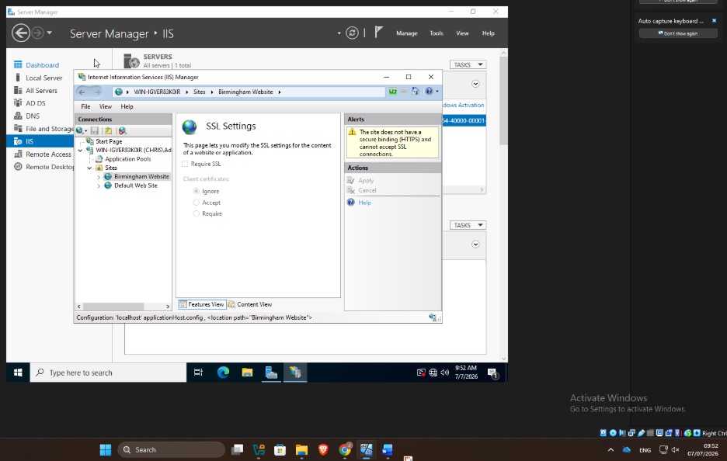
Figure 22: SSL Settings for the Birmingham Website in IIS showing that HTTPS is not yet configured.

This screenshot shows the Internet Information Services (IIS) Manager with the SSL Settings feature opened for the Birmingham Website.

Testing the IIS Website

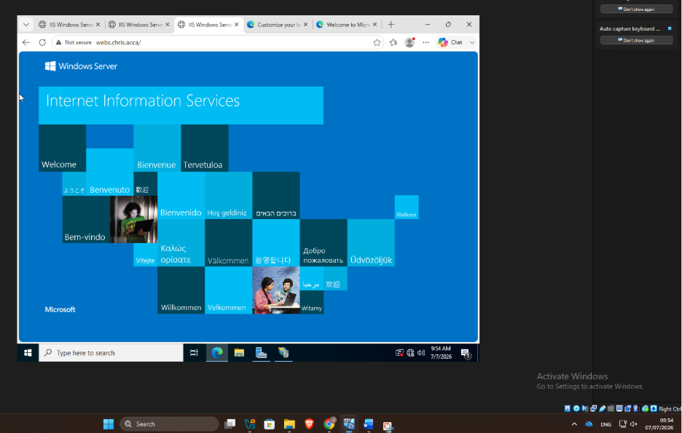
Figure 23: Successful access to the Birmingham Website through IIS using the DNS hostname webs.chris.acca.

This screenshot shows the successful testing of the Birmingham Website after it was deployed on Internet Information Services (IIS).

Testing Remote Desktop Web Access (RD Web Access)

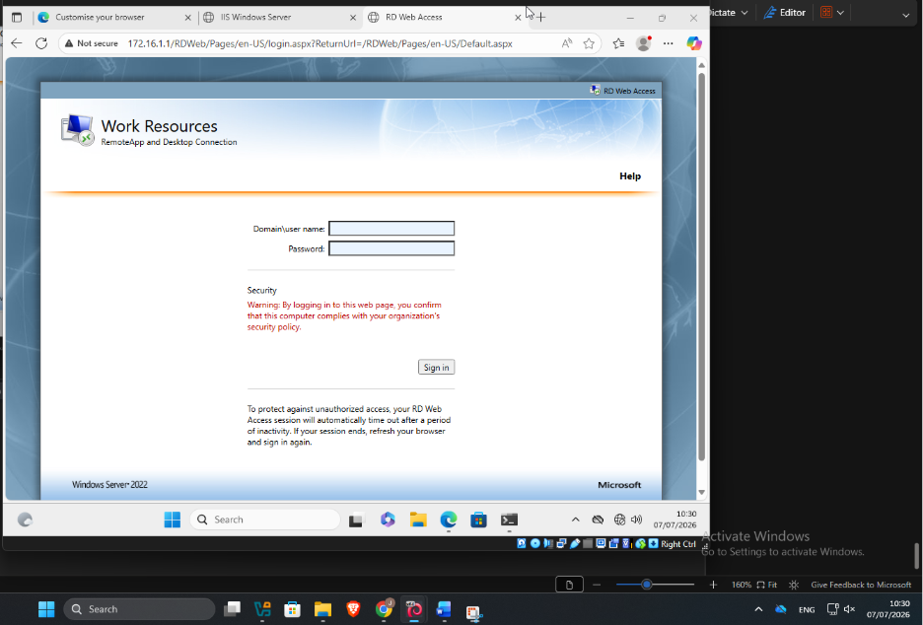
Figure 24: RD Web Access login page confirming successful deployment of Remote Desktop Services on Windows Server 2022.

This screenshot shows the Remote Desktop Web Access (RD Web Access) login page hosted on Windows Server 2022.

Virtual Machine Storage Configuration

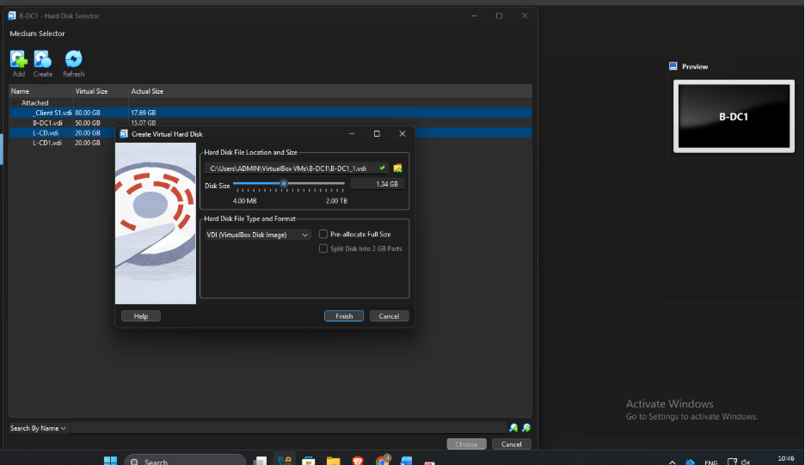
Figure 25: shows the creation of a Virtual Hard Disk (VDI) in Oracle VM VirtualBox for the B-DC1 virtual machine

Configuring Virtual Machine Storage

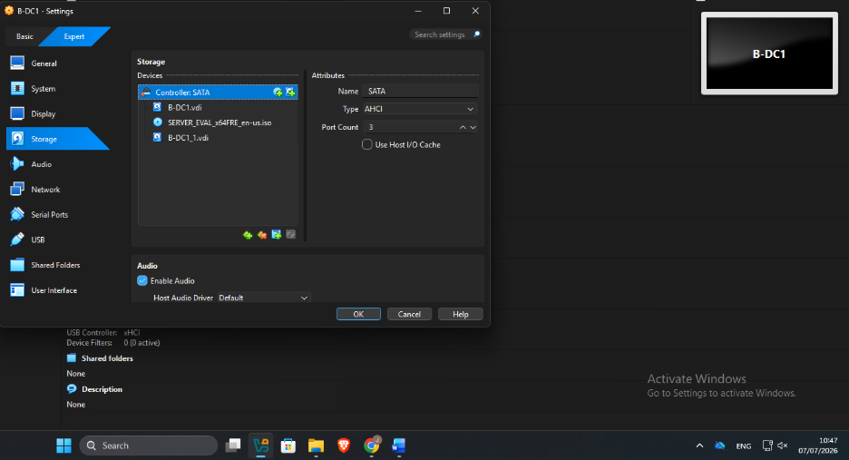
Figure 26: Storage configuration of the B-DC1 virtual machine in Oracle VM VirtualBox.

This screenshot shows the Storage settings of the B-DC1 virtual machine in Oracle VM VirtualBox.

Initialising the Additional Virtual Hard Disk

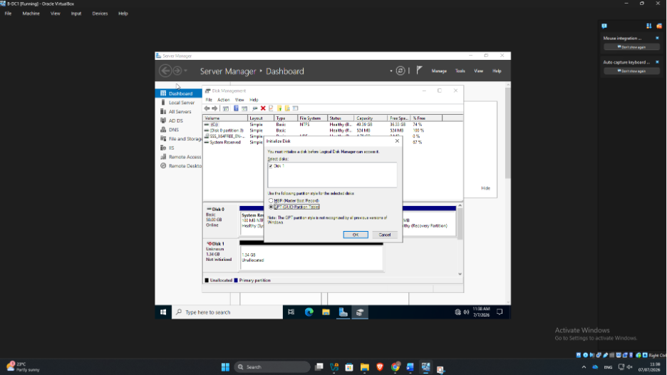
Figure 27: Initialising a new virtual hard disk using GPT in Windows Server Disk Management.

This screenshot shows the Disk Management tool in Windows Server during the Initialize Disk process.

Disk Management – Creating a New Volume

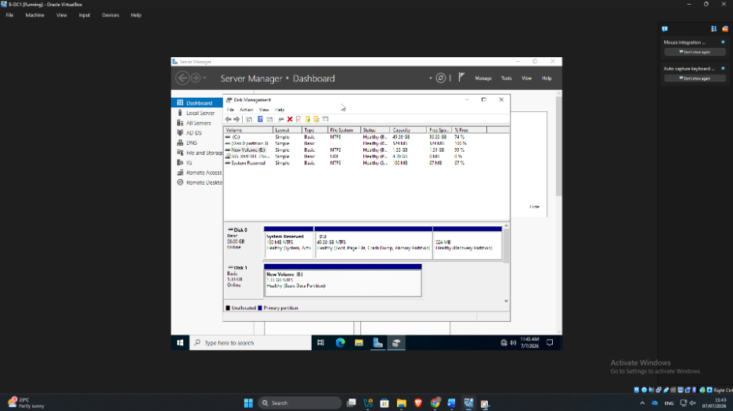
Figure 28: shows the Disk Management console after the additional virtual hard disk was successfully configured.

This screenshot shows the Disk Management console after the new virtual hard disk has been successfully initialised, partitioned, and formatted.

Creating a Shared Data Folder

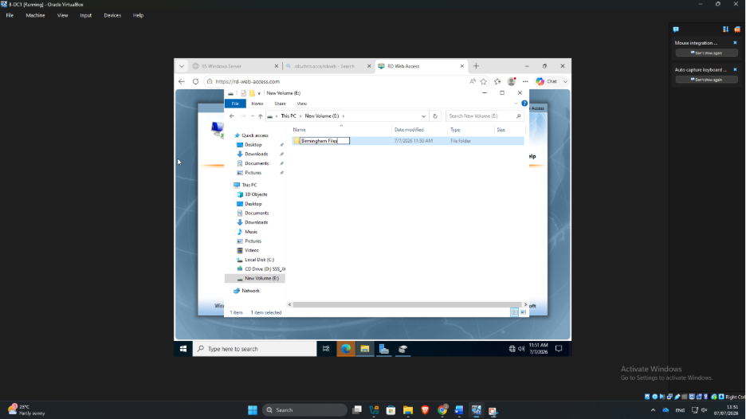
Figure 29: Creating the "Birmingham Files" folder on the E: drive for shared network storage.

This screenshot shows the creation of a new folder named Birmingham Files on the E: drive in Windows Server.

File Server Configuration – Advanced Sharing

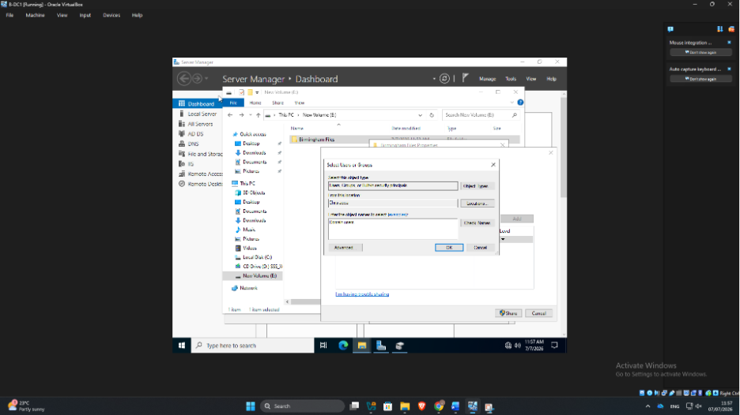
Figure 30: Configuring Advanced Sharing for the “Birmingham Files” shared folder.

This screenshot shows the Advanced Sharing configuration for the Birmingham Files folder in Windows Server.

Configuring Network Access and Share Permissions

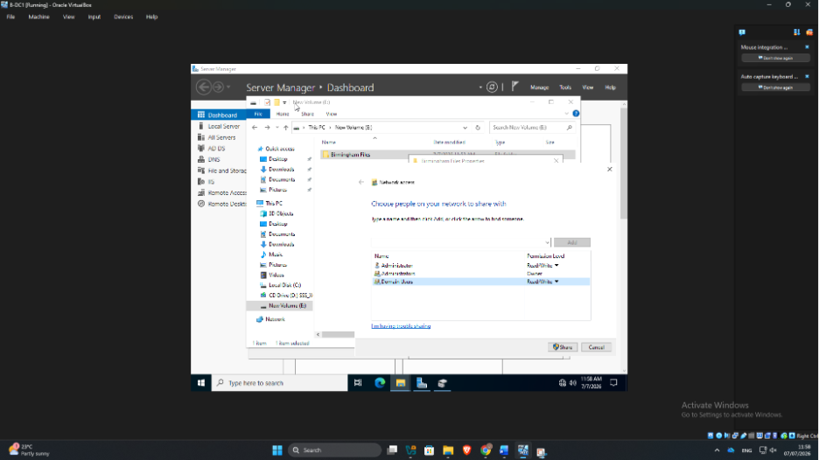
Figure 31: Configuring network access and Read/Write permissions for the Birmingham Files shared folder.

This screenshot shows the Network Access page of the File Sharing Wizard in Windows Server. It demonstrates that the Birmingham Files folder is being configured as a shared folder with specific users and permissions.

Completing the Shared Folder Configuration

Figure 32: Final configuration of network sharing for the Birmingham Files folder with Read/Write permissions.

Configuring Network Access for the Shared Folder

Figure 33: Configuring Read/Write network permissions for the Birmingham Files shared folder.

This screenshot shows the Network Access page of the Windows File Sharing Wizard, where the Birmingham Files folder is configured with the users and groups who are allowed to access it over the network.

Network Connectivity and DNS Testing

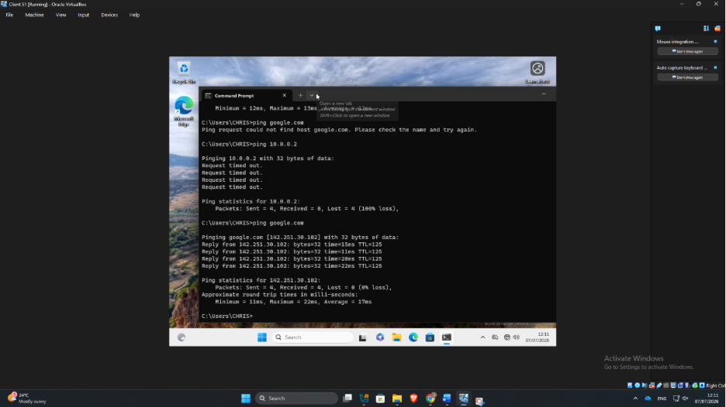
Figure 34: Verifying network connectivity and DNS resolution using the ping command on the Client computer.

This screenshot serves as evidence that the network configuration was tested and validated, demonstrating that DNS resolution and Internet connectivity were successfully established after troubleshooting any initial connectivity issues.

Client IP Address and DNS Configuration

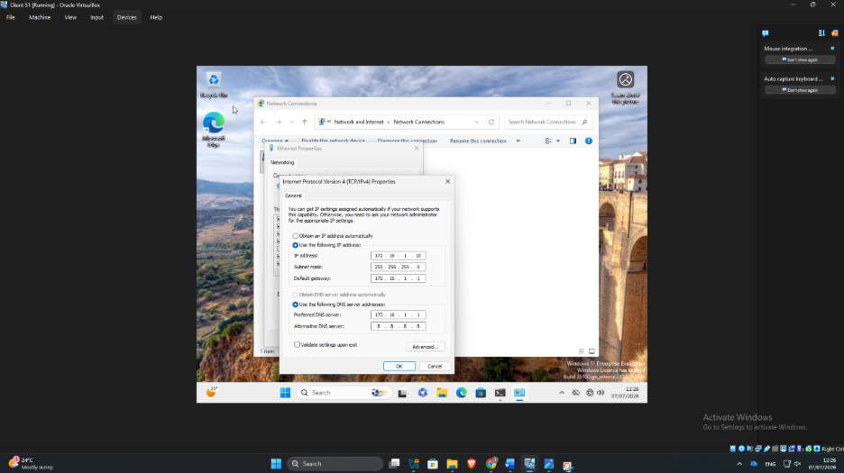
Figure 35: Configuring a static IPv4 address and DNS settings on the Windows Client computer.

This screenshot shows the Internet Protocol Version 4 (TCP/IPv4) Properties window on a Windows Client computer, where a Static IP address and DNS server are being configured.

Testing Network Connectivity

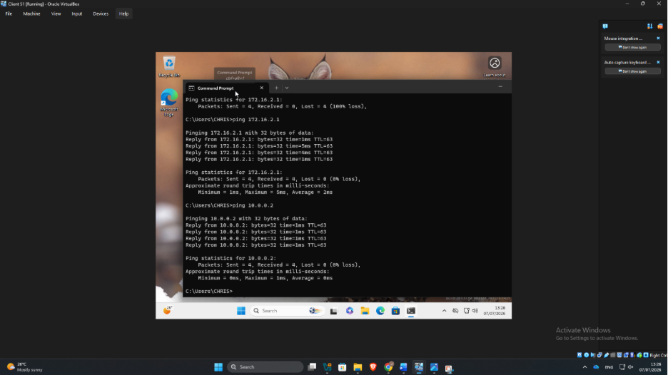
Figure 36: Successful network connectivity test using the ping command from the Client computer.

This screenshot shows that the client successfully communicated with the Windows Server at 172.16.2.1 and another network device at 10.0.0.2.

Testing Network Connectivity from the Linux Client

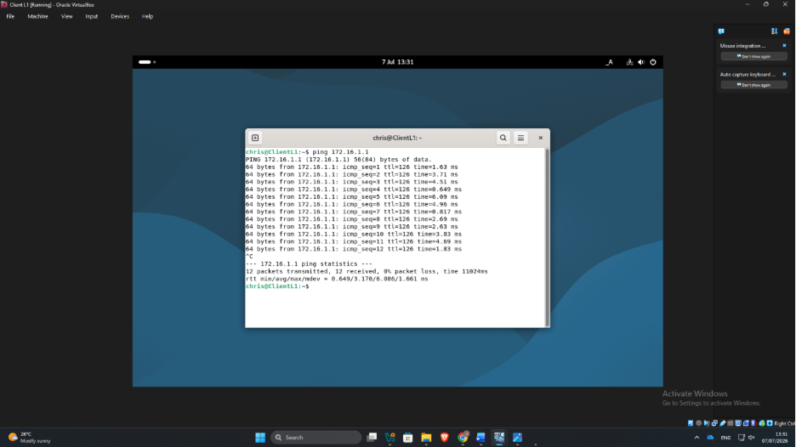
Figure 37: Successful ping test from the Linux client to the Windows Server

This screenshot shows a Linux Client machine (Debian) using the Terminal to test connectivity to the Windows Server with the ping command.

Verifying Internet Connectivity from the Linux Client

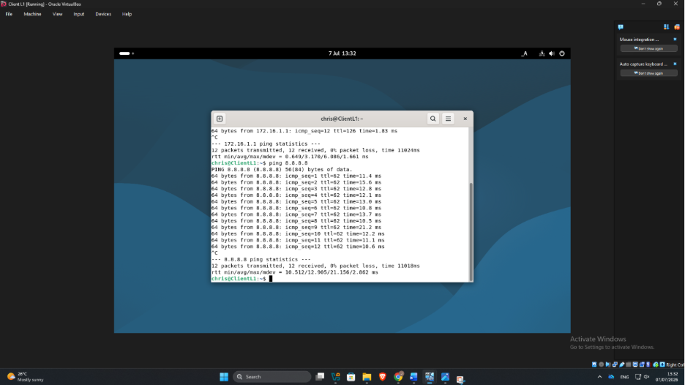
Figure 38: Successful Internet connectivity test from the Linux Client using ping 8.8.8.8.

This screenshot shows the results of an Internet connectivity test performed from the Linux Client using the ping command.

Active Directory Domain Services (AD DS) Installation and Configuration

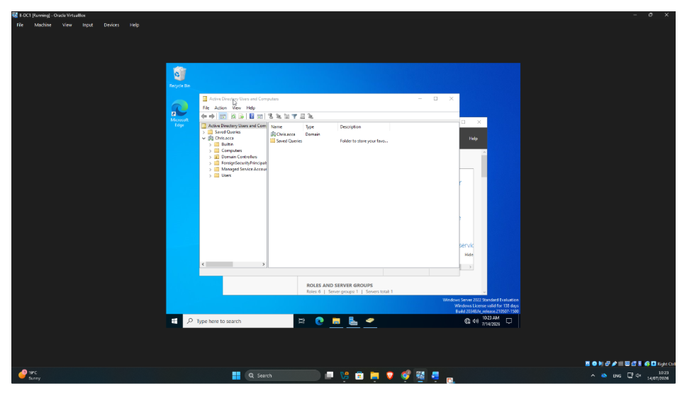
Figure 39: Active Directory Users and Computers showing the successfully created domain (Chris.acca) and default Active Directory containers.

This screenshot illustrates the Active Directory Users and Computers console after the successful installation and configuration of Active Directory Domain Services (AD DS).

Active Directory Users and Computers Showing Organisational Unit (OU) for NOSS
Users

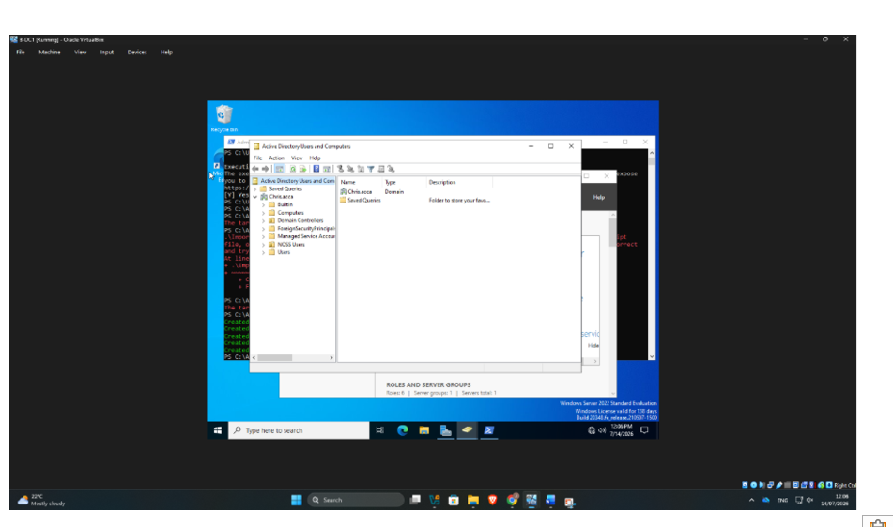
Figure 40: Active Directory Users and Computers showing the custom "NOSS Users" organisational unit within the Chris.acca domain.

PowerShell Configuration

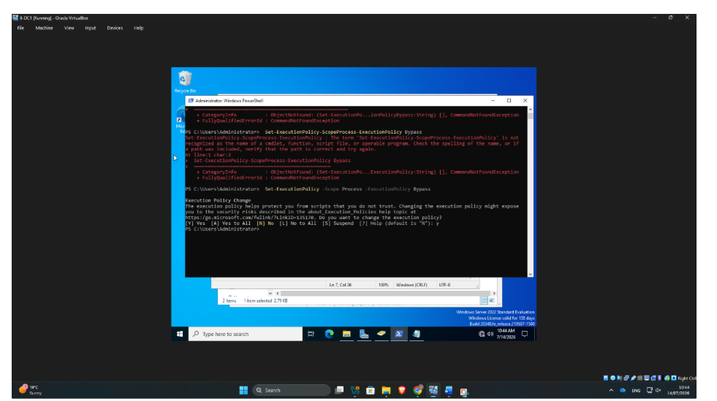
Figure 41: Changing the PowerShell Execution Policy to Allow Script Execution

This screenshot shows the Windows PowerShell console where the execution policy was temporarily changed to Bypass for the current process after correcting the administrator confirmed the change by selecting Y (Yes) to allow trusted PowerShell scripts to run during server configuration without permanently reducing the system's security settings.

Executing a PowerShell Script to Import Active Directory Users

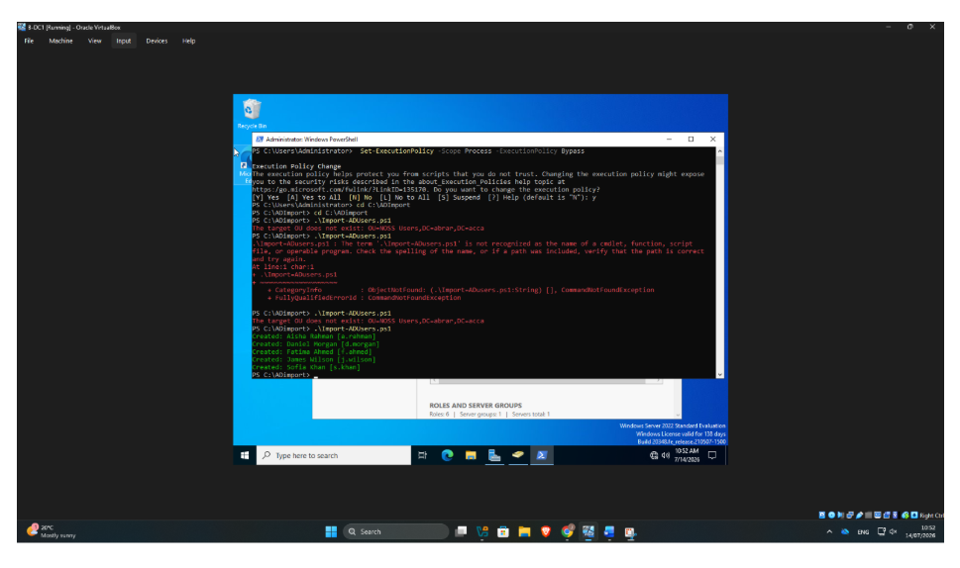
Figure 42: Successful execution of the Import-ADUsers.ps1 PowerShell script to automatically create Active Directory user accounts.

Selecting the DHCP Server Role in the Add Roles and Features Wizard

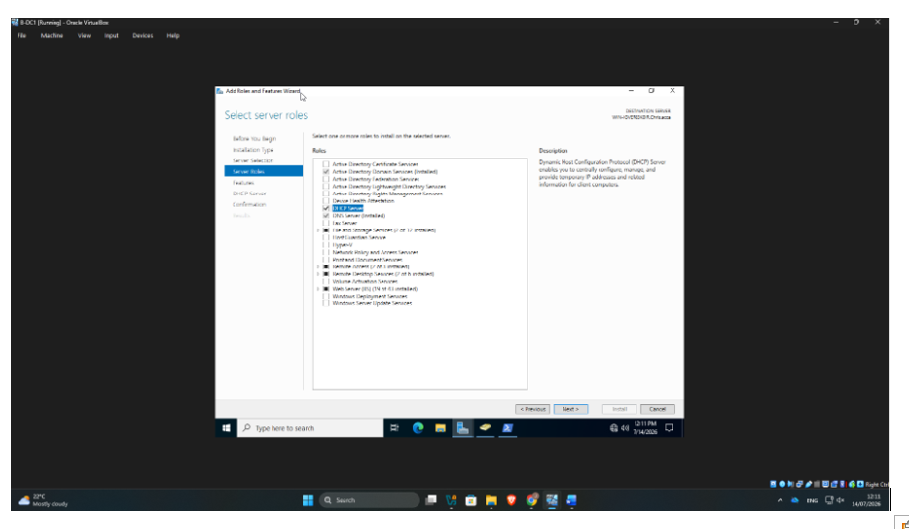
Figure 43: Selecting the DHCP Server role in the Windows Server Add Roles and Features Wizard.

This screenshot shows the Add Roles and Features Wizard during the installation of the DHCP Server role on Windows Server. The DHCP Server role has been selected to enable automatic allocation of IP addresses and network configuration settings to client computers. The DNS Server role is also selected to support name resolution within the Active Directory domain.

Installation of the DHCP Server Role

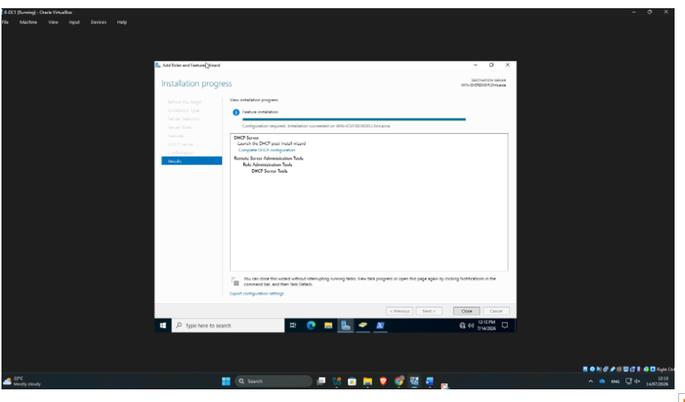Figure 44: Successful installation of the DHCP Server role, indicating that post-installation configuration is required.

This screenshot shows the Installation Progress page of the Add Roles and Features Wizard on Windows Server after the DHCP Server role has been installed successfully.

Completion of the DHCP Post-Install Configuration Wizard

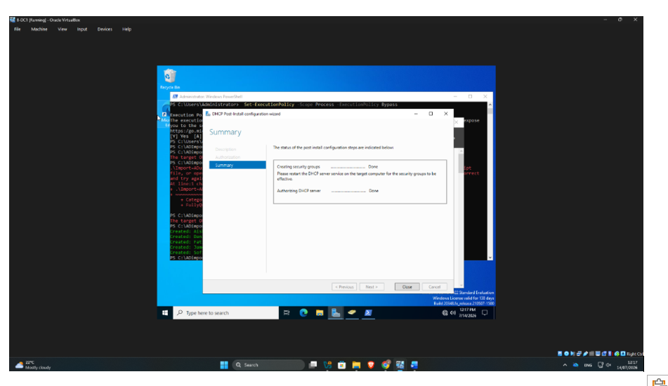
Figure 45: DHCP Post-Install Configuration Wizard confirming successful creation of DHCP security groups and authorization of the DHCP server in Active Directory.

This screenshot shows the DHCP Post-Install Configuration Wizard after the DHCP Server role has been installed on the Windows Server.

Verifying the DHCP Client Service in Windows Services

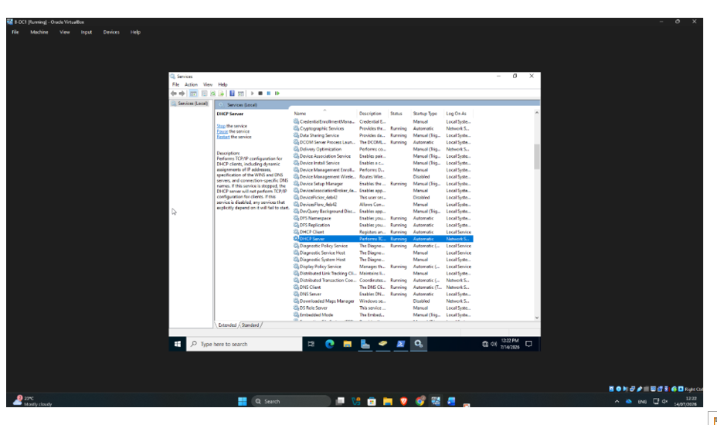Figure 46: Windows Services console showing the DHCP Client service running with an automatic startup type.

This screenshot shows the Services console with the DHCP Client service running. The service is configured with an Automatic startup type, ensuring that it starts whenever the operating system boots.

DHCP Management Console Showing the Authorised DHCP Server

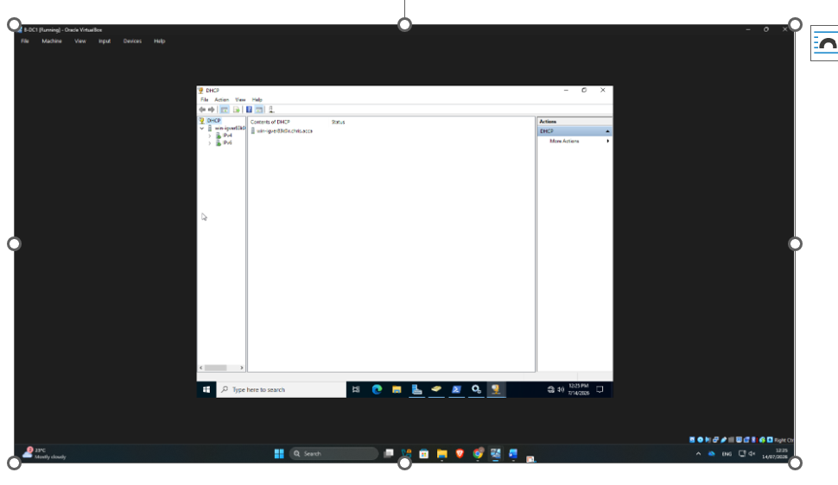Figure 47: DHCP Management Console displaying the authorised DHCP server before configuring IPv4 and IPv6 scopes.

This screenshot shows the DHCP Management Console on the Windows Server after the DHCP role has been successfully installed and authorised.

Configuring Domain Name and DNS Server Options for the DHCP Scope

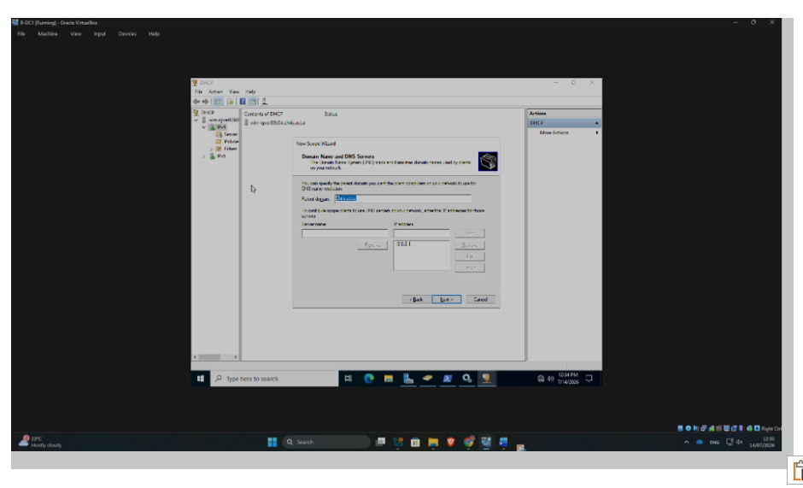Figure 48: Configuring the domain name and DNS server settings in the DHCP New Scope Wizard.

This screenshot shows the New Scope Wizard within the DHCP Management Console on Windows Server.

Completed DHCP Scope Configuration for the Birmingham Network

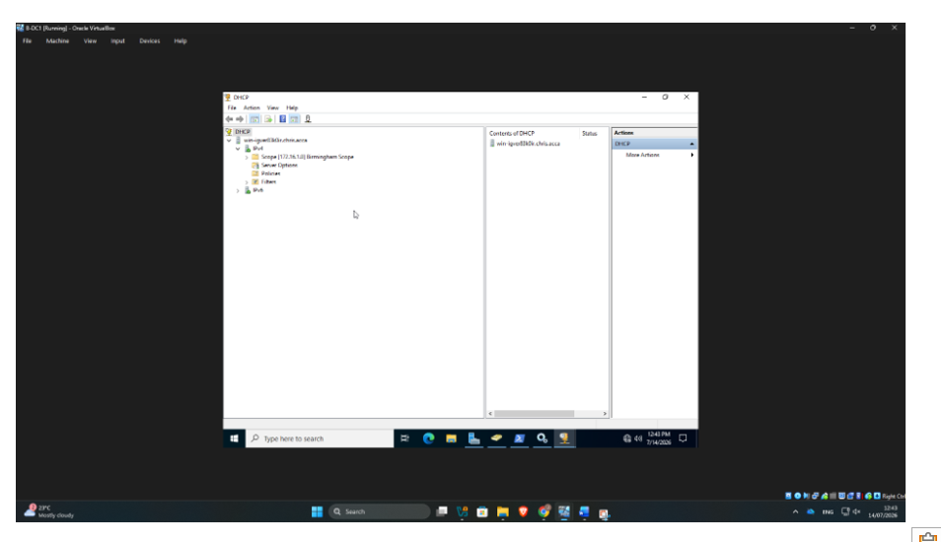Figure 49: DHCP Management Console showing the completed and Active Birmingham Scope (172.16.1.0/24) with its Address Pool, Address Leases, Reservations, and Scope Options.

Verifying the DHCP Server Network Configuration Using the ipconfig /all Command

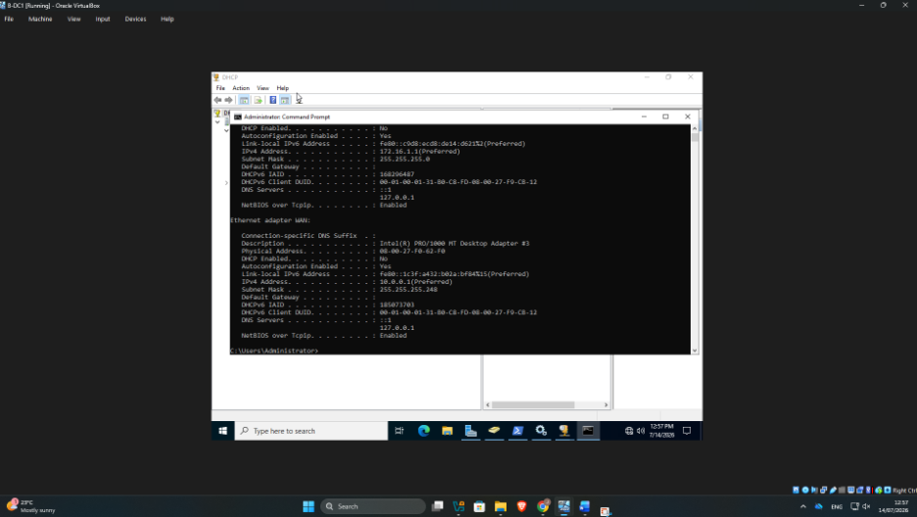
Figure 50: Output of the ipconfig /all command verifying the Windows Server's TCP/IP, DHCP, and DNS configuration

This screenshot confirms that the server is configured with the static IP address 172.16.1.1, a subnet mask of 255.255.255.0, and the Chris.acca domain as its primary DNS suffix.

Verifying Client DNS Configuration and IP Address Using NSLOOKUP

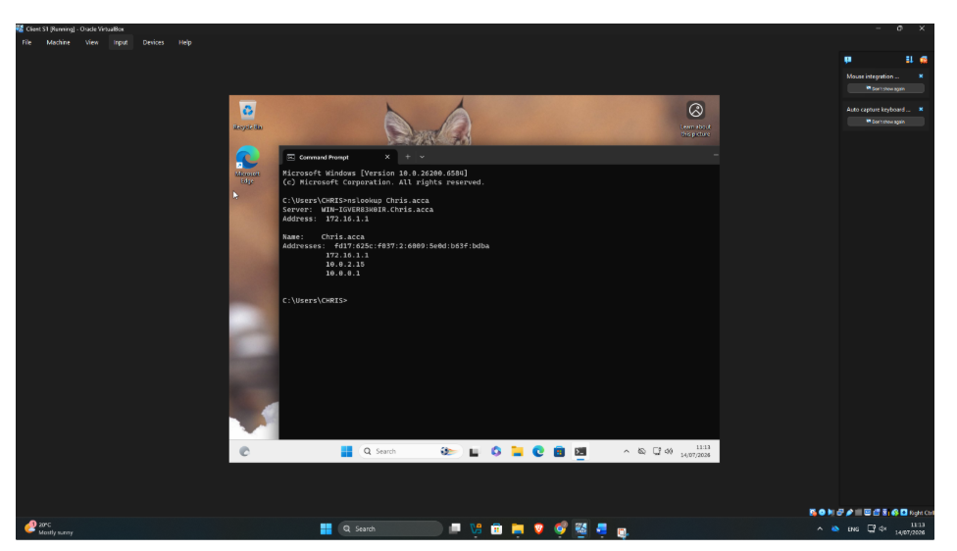
Figure 51: Successful DNS name resolution using the nslookup command from the Client computer.

This screenshot shows the Command Prompt on a Windows Client machine (Client S1) running in Oracle VirtualBox.

Verifying Active Directory DNS SRV Records Using NSLOOKUP

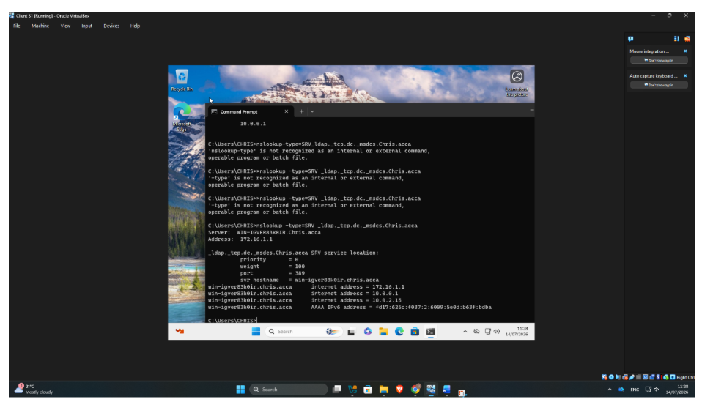Figure 52: Successful verification of the Active Directory LDAP SRV record using the nslookup -type=SRV command.

This confirms that the DNS server has correctly registered the Active Directory LDAP SRV records, allowing client computers to locate the domain controller for services such as user authentication, group policy processing, and domain logon.

Successful Domain User Login on the Client Computer

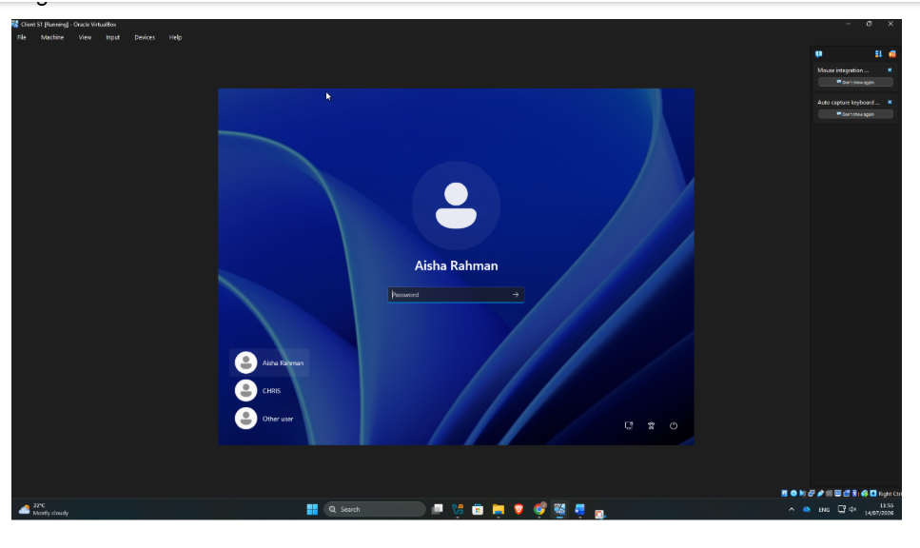Figure 53: Windows Client login screen showing the Active Directory domain user (Aisha Rahman) available for authentication

This screenshot shows the Windows Client computer after it has successfully joined the Chris.acca Active Directory domain.

Verifying Successful Domain User Login Using the WHOAMI Command

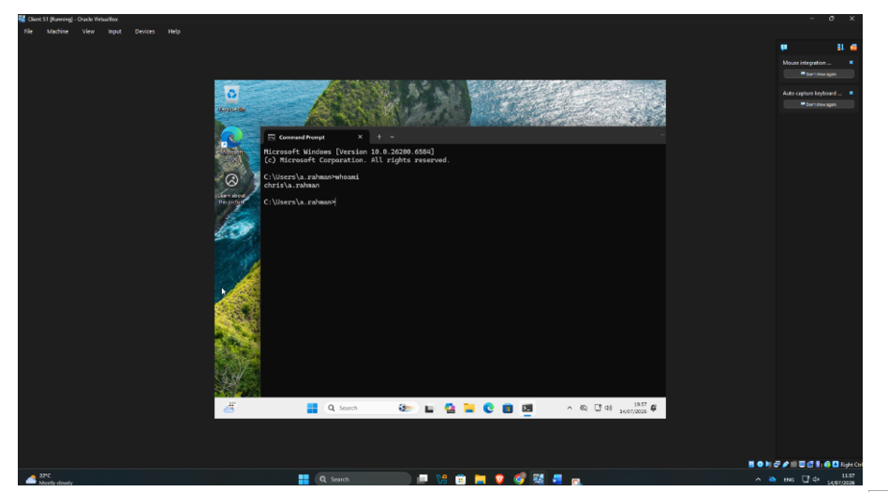
Figure 54: Using the whoami command to verify that the client is logged into the Active Directory Domain as user chris\a.rahman.

This screenshot shows the successful verification of a domain user login using the whoami command.

