“YOU CAN’T AIM A DUCK TO DEATH”
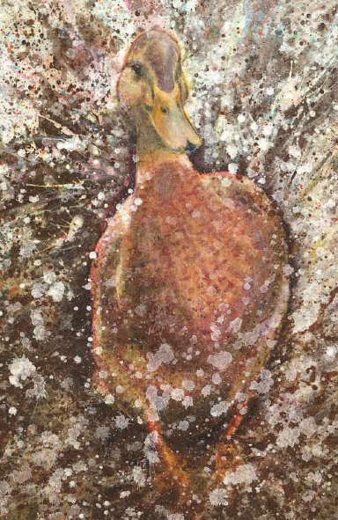

Table of Contents
Summary 2
Introduction: 3
Chapter 1 6
Chapter 2 14
Chapter 3 24
Conclusion 30
Bibliography 33
Reading List 35

Title quoated from Lillian Brower (2016) Miss Brower’s sayings (Publisher)
Illustration by: Cathy Fisher (2017) The Pond

List of Illustrations
All illustrations in this dissertation are taken from:
Davies, N. and Fisher, C. (2017). The Pond. Llanelli: Graffeg Limited.
Illustrated by Cathy Fisher (2017)

Figure 1- First spread of The Pond- Before Shock Stage…………………..…page 8
Figure 2 – Second spread of The Pond – After Shock Stage…………………page 8
Figure 3 – Third spread of The Pond – Denial Stage …………………………page 12
Figure 4 – First spread of The Pond – Showing 4 ducks ………………………page 13
Figure 5 – First spread of The Pond - Zoomed in on 3 ducks …………………page 13
Figure 6 - Fourth spread of The Pond – Anger Stage …………………………page 17
Figure 7 – Second, third and fourth spread of The Pond – Page alignment …page 18
Figure 8 – Fifth spread of The Pond – Age envy...………………………………page 19
Figure 9 – Sixth spread of The Pond - Zoomed in silhouette of a duck……….page 20
Figure 10 – Sixth spread of The Pond – Resentment and depression ……….page 20
Figure 11 - Seventh spread of The Pond – Depression stage to testing stage page 23
Figure 12 – Eighth spread of The Pond – Testing stage ………………………page 27
Figure 13 – Ninth spread of The Pond – Testing stage ………………………page 28
Figure 14 – Eleventh spread of The Pond – Family acceptance ……………page 29
Figure 15 – Twelfth spread of The Pond – Acceptance ………………………page 30

Summary
By using Elizabeth Kubler-Ross’s theory on the 7 Stages of Grief, this dissertation will explore the newly published picture book ‘The Pond’ written by Nicola Davies and Illustrated by Cathy Fisher. It will focus on how the writer and illustrator collaborated with each other to make an image and text relationship.

Introduction:
This dissertation will be analysing the formal elements used to portray a story with a difficult theme. It will focus on the newly published picture book ‘The Pond’ by Nicola Davies and illustrated by Cathy Fisher because it is particularly interesting how the narrative is structured through the 7 Stages of Grief.
The 7 Stages of Grief is a theory constructed by Doctor Elizabeth Kubler-Ross. This framework is created to identify the emotions dealt when experiencing loss. The stages of grief are: shock, denial, bargaining, anger, depression, testing and acceptance.
When talking to Davies about writing The Pond, she explains
I like to research into the situation at hand to make it as realistic and educational as possible, which is how I came across the 7 Stages of Grief. Construction of picture books are extremely important. I like to focus on the page turns and compare them to a theatrical scene. Each stage of grief is a page turn to evoke the reader’s emotions.
(Nicola Davies, 2017)
A picture book can be demonstrated in many different ways. For the purpose of this study, the definition of a picture book will be:
“Text, illustrations, total design; an item of manufacture and a commercial product; a social, cultural, historical document; and foremost, an experience for a child. As an art form, it hinges on the interdependence off pictures and words, on the simultaneous displace of two facing pages, and on the drama of turning the page. On its own terms and possibilities are limitless”
(Bader, 1976:5)
The use of picture books when written and illustrated successfully can create a great impact on how a child may perceive the loss of a family member. Child Development Specialist, Susan Hois, states
Separation from or loss of parents due to death, divorce, incarceration or removal to foster care will have a major impact on the child’s psychological development and possibly on his/her cognitive and physical development as well.
(Hois, 2014:2)
It is important to note that every child responds differently to information. Children can process information at a different pace which may make it difficult for them to relate to some of the emotions in the Grief Cycle. Psychologist Reznick states “People mourn in their own time, and children will mourn differently depending on their age, personality, and maturity level.” (Reznick 2009:18).
For this reason, I will not be using primary research to carry out this investigation. I will be using secondary sources from books, journals, articles, and websites to find theorists and psychologists to support my comments.
Research behind the psychology of formal elements is important for me as a practicing illustrator as I embark on composing an old classic Aesops Fable, but focusing on the theme of anxiety. Learning about these theories and analysing Fisher’s skills will benefit my work when creating a picture book.
In Chapter 1, I intend to discuss how Davies and Fisher use contrast and page turns to demonstrate the first three stages of grief: shock, denial and bargaining
In Chapter 2, I will discuss how emotions of anger and depression are demonstrated with the use of tone, line and symbolism.
In Chapter 3, I will be going to deliberate how testing and acceptance is illustrated through the use of page breaks to allude to the sense of moving on. I will also argue whether or not the symbolism used is effective when illustrating acceptance.

Chapter 1
The Early Stages of Grief.

“Will there be ducks?”
“Oh yes” he said “Of course there will be ducks!”

The first stage in the Grief cycle is Shock. Shock will be defined as “a sudden upsetting or surprise event or experience” (Collins Dictionary, 2013: 249)

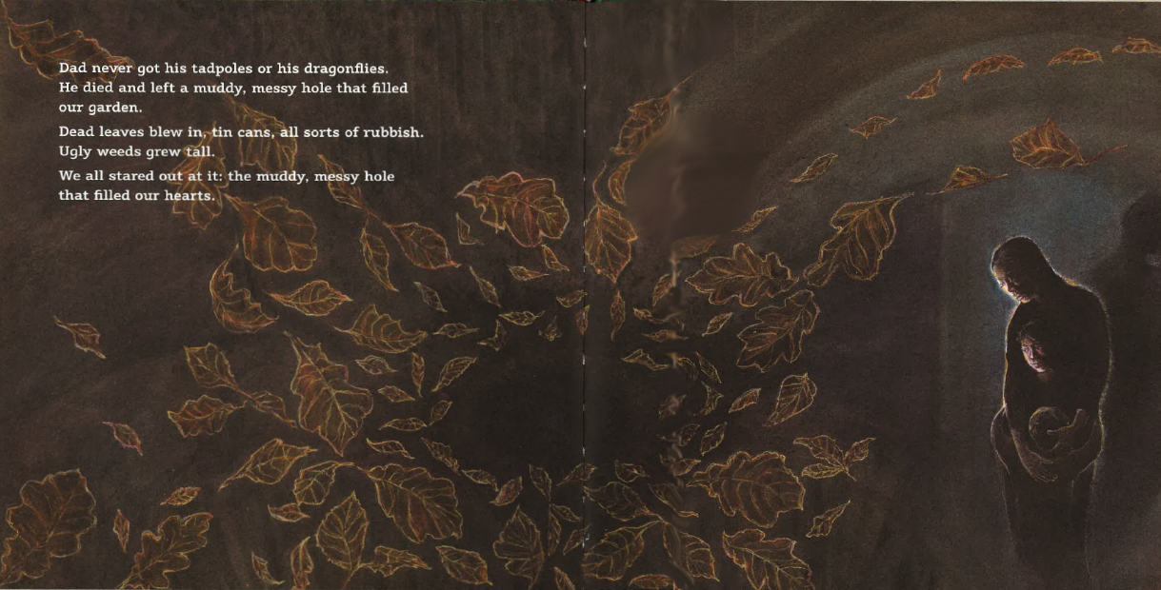
Figure 1 - First spread of The Pond – Before finding out the news
Figure 2 - Second spread of The Pond. – After finding out the news

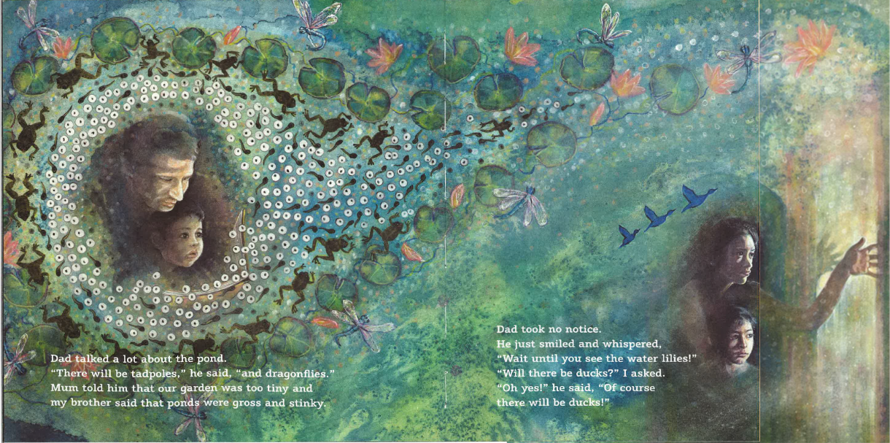
For Fisher to illustrate shock within the page turns, she creates a contrast between the two compositions. For a designer, creating contrast has two purposes: “to create interest on the page” and to “aid in organisation of information” (Williams, 2015:84). Fisher has used this contrast for the reader to instantly understand the context of the story within the first two pages. The strongest contrast on these pages is colour. The choice of colour is important in setting the mood of the life and death of spring time. Greens and blues compose Figure 1 to welcome the reader into the narrative. Goethe’s theory of colour suggests blue is “a soothing calming colour, encouraging reflection” (Wright, 2010:26) and green is “representing a perfect balance in life” (Wright, 2010:27). As demonstrated in Figure 1, using these two colours together to dominate the composition can help encourage the reader to reflect on the good times with their lost one.
Figure 2 uses mostly dark, muted, monochrome browns. The hues of brown psychologically help the reader empathise with the family and relate to the sudden mood change. Having someone to relate to in this stage of grief is important, to feel like you are not alone.
These choices of colour create light and dark tones. The dark background can help signify the sense of the unknown because “White or light backgrounds feel safer to us than dark backgrounds. Because we can see well during the day and poorly at night” (Bang, 2010:68). The illustrator uses the contrast of tone and colour to convey the distressing feeling of shock when finding out bad news.
Another contrast in these pages are the placements of text. When talking about typography placement, Bang (2010) states: “When people are said to be ‘high’, it implies that they may eventually have a ‘terrible downer’ when they ‘come back to earth’” (Bang, 2010:54). The text placed in Figure 1 is sat on the bottom of the page, to create a sense of security for the reader and narrator, as opposed to the text in Figure 2 where it is floating in the air to create an uncertain tension for the reader. Also, the text sits in front of a gust of leaves in the background of the composition, creating the allusion that the words will be blown away with the leaves.
In Figure 1, brown circles are used to create a sense of love and comfort between the father and daughter. Frog eggs, tadpoles and frogs are illustrated to create the path line for the eye to follow which Fisher may have illustrated to hint at the cycle of life. However, in Figure 2, the narrator exclaims ‘the muddy, messy hole that filled our hearts”. This illustrates how the daughter’s heart was once full, but now her father has died her heart is empty. The illustrator uses shapes to create a subtle contrast between love and emptiness. When talking about empty shapes, Psychologist Rudolf Arnheim (1974) states:
“This view tends to be uncomfortable and hard to hold. This is because the empty loop requires us to see the surface of the paper as a continuous background, or to put it differently, so see the spaces on both sides of the line as related to it symmetrically.”
(Arnheim, 1974:220)

Shock is symbolised through these empty shapes. In Figure 1, where the circles are full this could convey the family’s hearts once being full of love and positivity and the feeling of loss is illustrated through the emptiness of the circle. The empty circle encourages empathy for the reader when looking at Figure 2 because the composition is ‘uncomfortable to look at’ just like death. Circles and holes are a common symbol of the heart throughout the book. When these symbols or elements enter the muddy hole in future spreads, it means the heart is slowly healing through the stages of grief.
It is important to note at this stage that there has been no description or illustration of the details regarding the father’s death. It could be argued that Davies has constructed this to leave the narrative more open. By leaving the narrative open, it allows the reader to put their own experience of loss into the story, to relate and empathise with the characters. While some readers could be experiencing death of a father figure, it could also be another family member or any other kind of significant loss.
Psychologist Nicholas Tucker (1990) explains that children
Want to occasionally to experiment with the feelings of separation and mourning as a way of testing themselves out, just as they often experiment - in play or in the imagination - with other fears or anxieties
(Tucker, 1990:56).
Children who want to experiment with the feeling of loss will be able to use the illustrations in the book as a way to explore their emotions of grief. For example, in Figure 1 and Figure 2 they can experience the contrasting tonal elements and relate them to the happiness and sorrow that comes with grief. Exploring these feelings can help them develop empathy.
It could be argued that the language that Davies uses could unintentionally scare children. Arnal (2012) states “Words like death or dying have little place in the picture books…the word (death) is concealed but the concept is not” (Arnal, 2012:1) to make for a less intimidating story. However, the choice of words is a conscious choice made by Davies (2017) as she feels “Parents try to protect, and try to hide the disasters that are happening in order to protect them. To protect them until the last moment where they are hanging on”. This is a personal view that Davies has concluded from her own experience. By using words such as “Death” and “Dying” in her narrative, she challenges the taboo around the subject. However, this could also be controversial when educating children.
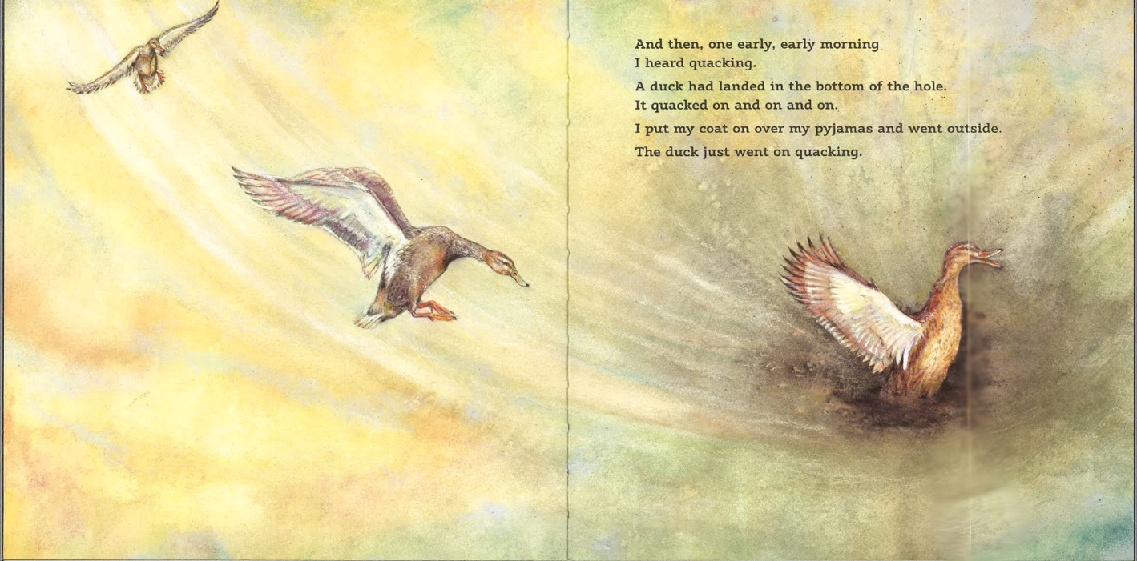
The second stage of Grief is Denial. This shall be defined as “the refusal of acknowledgement” (Collins Dictionary 2013:72). Davies has chosen to write the narrator in denial by changing the subject in attempt to escape from thinking about it.
Figure 3 - Third spread of The Pond - Introducing the duck
Figure 3 diverts the attention away from the initial shock to illustrating an animal – a duck. When talking about this symbolism in her article, sinology specialist Melissa Russel (2014) states “The bird is generally thought to be a symbol of freedom …. Birds are free to roam to earth and the sky. Many cultures believe that they are a symbol of eternal life; the link between heaven and earth.”
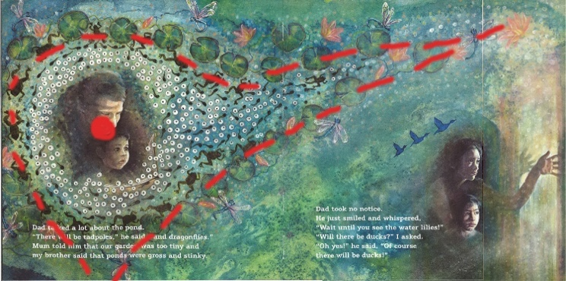
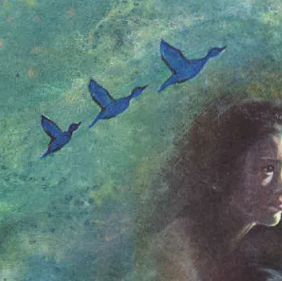
In the context of this narrative, Fisher has illustrated a physical reminder of the father, thus creating a link between the heavens and the earth. Subtle imagery of a duck is seen in Figure 1, where there are three distinct birds flying and the fourth duck is illustrated through line to direct the eye around the page.
Figure 5- Zoomed in on 3 ducks flying
Figure 4 – Red line Showing shape of duck
“Principle of Alignment states: Nothing should be placed on the page arbitrarily. Every item should have a visual connection with something else on the page” (Williams, 2015:33). By doing this, Fisher subtly introduces the relationship between the father, daughter and duck. Additionally, the leaves shown in figure 2 are subtly shaped as a duck head. The leaves are placed to direct the reader’s eye around the page and back to the shadow of the father, creating the association between the duck and the father.
In figure 3, it could be argued that a duck could be chosen to help a child reader engage more with a story. Psychologists Joseph and Chava Schwarcz (1991) state
Children feel close to animals and love them dearly because of their funny, feathery, and furry presence and their abundant kinetic energy, and also because children have little trouble understanding the relatively simple behaviour of animals, and, finally, because children can identify with the vulnerability of small animals.
(Schwarcz and Schwarcz 1991:11)
By Fisher and Davies illustrating a duck as a symbol of the father, it may be argued that children are more able to engage with the story and relate to each stage of grief. It would also create a relief in a negative heart-wrenching narrative for a child, by trying to find the duck on each page.
By associating the duck as the father, it is interesting how Fisher has chosen to illustrate the composition. She illustrates the duck swooping into the composition. The texture lines used to illustrate this creates a fast-paced movement for the reader to follow. The duck lands in the bottom of the hole, which could be symbolism for the child’s heart filling at being reminded of her father. There are no elements for being distracted, which forces the reader to follow along the fast paced movement from the top of the page to the bottom, alluding to a downward spiral of emotions.
This is supported through Fisher’s use of colour. It is the first time the reader sees yellow in the book. At first sight, yellow can be seen as a happy colour, immediately demonstrating that the character is trying to distract herself by being in the stage of denial. However, Fisher reminds the audience that despite being distracted in a stage of denial, the dark feelings will always return. This is illustrated by the use of browns mixing in with the yellow.
Overall, the early stages of grief are successfully demonstrated by Fisher and Davies by creating a distraction from a difficult topic.
The next stage of Kubler- Ross’s grief cycle is bargaining. The definition of Bargaining is “an attempt to postpone… and set a self-imposed deadline. Psychologically, promises may be associated with quiet guilt.” (Kubler Ross,1970:72)
The bargaining stage is not touched on a lot in the book, and difficult to distinguish between the Denial stage. Nevertheless, as discussed in Chapter 1, the daughter wants to fulfil the father’s promise of creating a pond filled with tadpoles, dragonflies, waterlilies, and ducks. When met with the duck that lands in the hole, the girl fills it with water in hopes to make the pond. This could be interpreted as an attempt to postpone or deny that her father has died.
The concept of bargaining is demonstrated through Davies’s writing to some extent, but Fisher decides to focus more on the emotive feelings of happiness, sadness, anger and depression rather than illustrating the process of bargaining and denial.

Chapter 2
Present stages of Grief: Bargaining, Anger and Depression.

“A duck had landed in the bottom of the hole.
It quacked on and on and on.”
Anger is the fourth stage of the grief cycle. Kubler-Ross (1970) states, “When the first stage of denial cannot be maintained any longer, it is replaced by feelings of anger, age envy, and resentment” (Kubler-Ross, 1970:44). It is important to demonstrate anger when talking about grief because it is unfair to think of a lost one negatively. Hois states:
The child’s egocentric magical thinking can cause him to misunderstand the causes of the separation and loss. It is important that adults work hard to identify the child’s personal magical thinking about the loss. Does he think he caused the loss? Does he think he can do something to reverse it?
– Hois (2014:2)
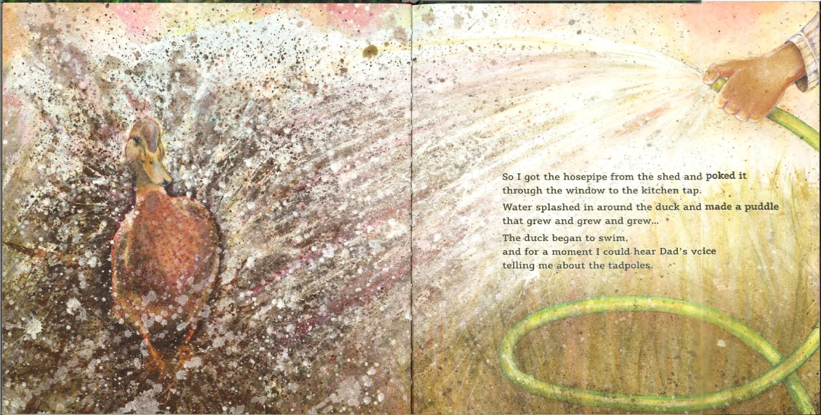
Using the Pond as an example, having a negative perception of your father can be destructive for a child growing up. In this case, a child could see the father as abandoning them and being angry at being out of control.
Figure 6 - Fourth Spread of The Pond - Anger Brewing
To express the feeling of anger, Figure 6 shows Fisher creating textures using paint, to convey a dramatic sense of movement, completely contrasting with the stillness of death.

The expressive use of texture and the picture of water spurting from the hosepipe could illustrate the feeling of the girl’s heart exploding with grief. This is supported by Davies’s writing “and made a puddle that grew and grew and grew”. Fisher has created a the visual representation of the character’s explosion of anger and frustration that will be overwhelming through the use of the hosepipe.
The thought of the duck being the trigger is supported by the use of line. Until this spread, Fisher has composed the spreads to view as a continuous line. Kubler-Ross says: “anger is displaced in all directions and projected onto the environment at times almost at random” (Kubler Ross, 1970:44).
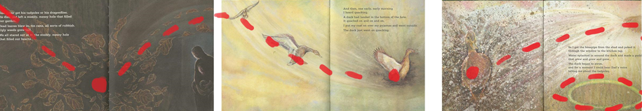
This is particularly projected onto this page to heighten the tension of the relationship between the main character and the duck. While it is not the duck’s fault, the reminder of the father makes the girl project her anger into the environment by making a mess. The illustration on the left takes up the full page to fully involve the reader and demonstrate how overwhelming these feelings can be.
Figure 7 - Three spreads aligned to show page alignment
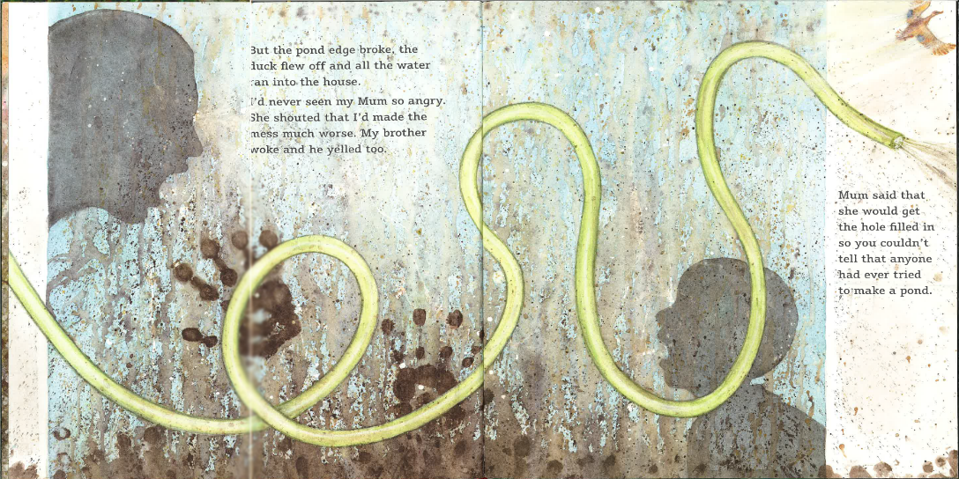
As demonstrated in figure 7, the page alignment is used to show a change in focal direction to hint towards looking back on old memories. The first two spreads (in figure 7) have had the main element on the right hand side of the spread. The third spread is the first time where the main object of the composition is on the left. At the turn of the page, the reader is met with the main focal point, and the drama surrounding the filling of the pond. Fisher’s composition follows an up and down motion as a play on words of the saying ‘a rollercoaster of emotions’. However, in the third spread of figure 6, the direction of the eye takes a reverse action referring to the girl looking back on the past and being reminded of the father promising a beautiful pond with tadpoles, ducks and waterlilies. Instead she has created a muddy hole.
Figure 8- Fifth spread of The Pond. - Age envy
Continuing onto the next spread, the alignment of the hosepipe is placed in the foreground. The backgrounds holds a scheme of age envy. This is a common feeling for children as a loss in their life is out of their control, so when someone of a higher authority figure makes decisions for them, it creates tension. Supporting this, Tucker claims that ”Anti authority themes in literature, therefore may reflect small children's occasional anger at being continually controlled and manipulated by those bigger than themselves. (Tucker, 1981:53)
In Figure 8, we see the mother going through her own stages of grief, by Davies narrating “I’ve never seen mum so angry”. It is clear from the narrative that the mother does not want to remember her husband, and is taking a different approach to grief by removing any memories that could potentially trigger her. In the case of the story, it is the pond that her husband was passionate about building. This goes against what the child wants because the father promised her the pond, and she wants to fulfil that purpose. Being out of control of this situation is what causes the conflict between the family, an understandable but negative emotion in the situation. This is where we see the age envy.
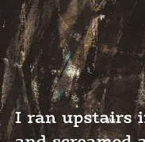
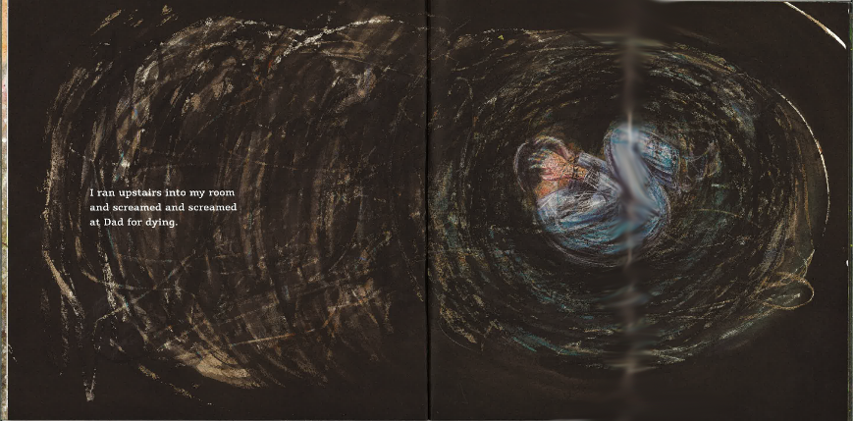
This is visualised by Fisher through the silhouettes of the mother and daughter. The use of silhouettes means that no facial details are rendered. This is odd because we have previously seen each of the characters in previous spreads. Fisher may have illustrated this for the reader to be able to put themselves in the situation and relate to the narrative, creating a more engaging experience.
Figure 9 – Zoomed in Silhouette of duck
Figure 10 - Sixth Spread of The Pond - Resentment and Depression
In Figure 10, the narrator expresses her anger through words for the first time. In the previous spreads, a hint of anger has been suggested through Fishers use of formal elements to compose the illustrations. It is the first time the words and pictures match up perfectly to set the mood of anger and depression.
People mourn in their own time, and children will mourn differently depending on their age, personality, and maturity level. Some kids become angry, withdrawn, or distraught.
(Reznick 2009:18).
Reznick’s quote about people mourning differently is a perfectly good example of how to describe this spread. All three of these moods are conveyed through this composition. Fisher would have to relate to all different types of children in relation to how they deal with grief. For example, the anger is shown through the use of tonal texture. Fisher chooses to use ink and charcoal which initially creates a sense of uneasiness. It is the first time Fisher has used a dark colour to dominate the composition since Figure 2, where the reader first comes to terms with the death of her father. As the reader, we then realise we associate any dark colour within the book with some sort of dark recurring thought. We see the characters mourn the death of the father in only these two pages so far in the book.
The sense of withdrawal for the reader could come from the notion that the previous spread contained lots of colour and controlled lines to direct the reader (Figure 7). However, this spread is intentionally chaotic. The page itself does not follow the previous layout of the page so it stands apart from earlier spreads.
It could be argued that Fisher has subtly placed symbolic imagery within the composition to unconsciously give a child reader a fun-filled game to counteract from the gloomy composition. For example, as shown in figure 9, a symbol of a duck could be seen above the text on the left hand side of the page, in line with the girl. While it may be fun for a young child to find the duck, it could be a good introduction to describe the emotions the girl in the story is going through.
The girl is positioned in a foetal position, immediately showing distress, however she is facing away from the text and covering her eyes. It could be argued that the textures surrounding her are her feelings in her mind, a messy black hole. A faint symbol of a duck sits above the text she is facing away from, creating the illusion that she does not want to physically face looking back at any past memories.
It is interesting that the figure of the child is not directly in the centre of the piece. It lies just above and to the left of the recto. The use of this is to bring more attention to the main focal piece. Bang states: “The picture is more dynamic. … This sense of movement comes about because our eyes are now encouraged to move.” (Bang, 2010:64)
In relation to the composition, Fisher has chosen to compose it this way. She uses the emotional lines to direct the eye differently to what she has illustrated in previous spreads. She makes the reader's eye go around the page repetitively until it reaches the little girl. However, with it placed off centre, it makes the reader feel uncomfortable, as we usually gravitate and feel better towards things that are perfectly in the centre. Because of this sense of comfort, the reader may want to look at other elements on the page, but their eye will always reach back to the little girl. This motion is created because of the use of line.
The invisible lines of force are ever-present. We are aware of gravity as we move up and down and across the page. At the same time, we are aware the centre as our eyes go back and forth across it; we are aware of the [jagged] lines dividing the page down… Whatever we do with the centre, our eyes are drawn to it and our feelings are strongly affected by it.
(Bang, 2010:64)
So not only would we feel empathetic towards the girl in the story for feeling such strong emotions, but as the reader we would fully empathise until we physically turn the page of the book. By turning the page, we expect to stop feeling these emotions and move on to something else because that is the pattern Davies and Fisher have kept up so far (each page conveys a different emotion). They have deliberately followed this spread with another dark emotional composition to emphasise the feeling of no escape from the sadness.
Figure 11 - Seventh Spread of The Pond - Depression to Testing
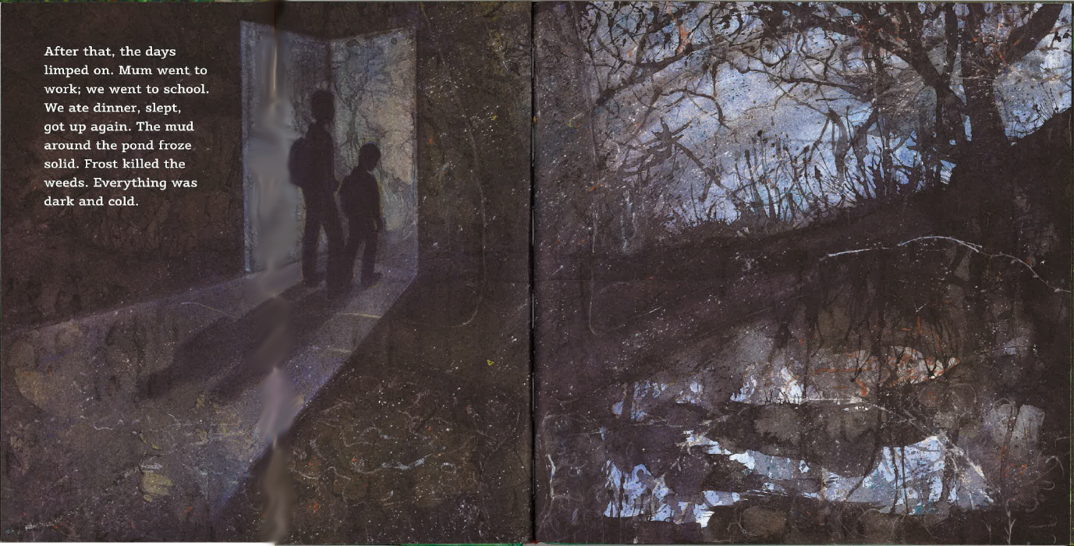
It is important to note that this scene takes place in the winter, so the duck that has been present in previous spreads would have flown away to a warmer place for winter. The symbolism of the hosepipe and the water giving life would be frozen cold because of the temperature, alluding to life standing still. Additionally, because of the winter no plant or pond life can grow. This means the fathers promise to the daughter has also taken a stand-still and she could feel like there is currently no purpose. All of these elements are visual embodiments of what depression can feel like for the child.
Furthermore, tonal elements are explored further in this Figure 11. As previously discussed in Chapter 1 in regards to Figure 2, a dark background will make the reader feel uncomfortable because we are unable to see in the dark. This creates a sense of the unknown, and an anxiety about going outside to the garden. But by using this theory by Bang, we are able to see that Fisher is trying to hint towards moving forward in the grief cycle. While the foreground holds a lot of attention for the reader because of its dominating black colour scheme, behind the trees on the right hand side of the page shows a lighter colour. This lighter colour can also be seen in the reflection of the frozen pond, and a lighter colour makes the reader feel safe because we can see in the light.
The use of light and dark tones is not the only similarity between Figure 11 and Figures 1 and 2. The characters here are illustrated standing at an open door, as if they are pondering moving forward into the light and out of their comfort zone. Fisher may have illustrated this because in the beginning of the book, before we find out the father has died, the mother is reaching into an abstract looking door. This could be a metaphor of the family entering this grief cycle, and now they are on their journey to moving forward. They begin to test themselves for their future.

Chapter 3
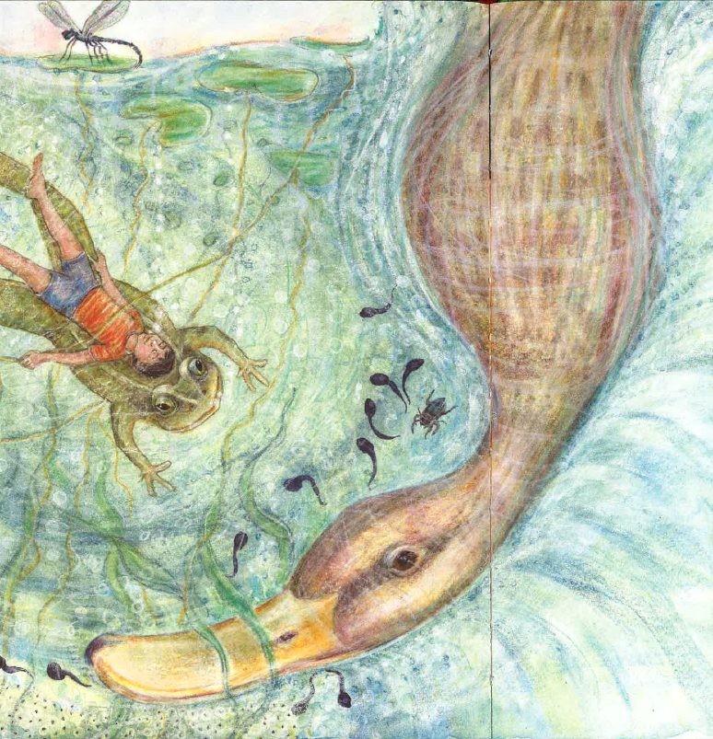
Late Stages of Grief – Testing and Acceptance

“It wasn’t really big enough for ducks to live on”

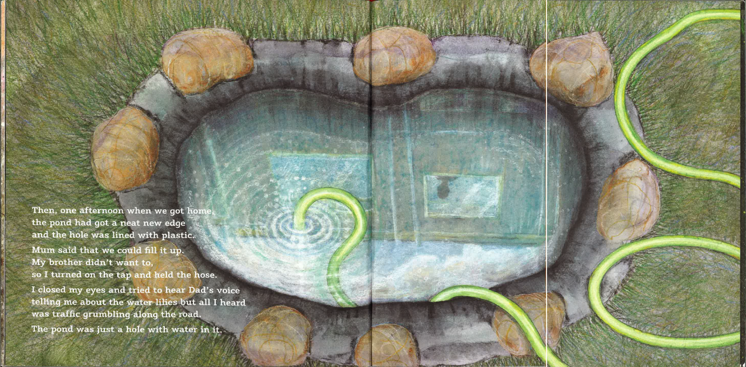
The sixth stage of grief is the Testing stage. This is defined as “to test their own strength in peculiar ways” (Kubler-Ross 1970:246) and is an important stage when dealing with grief.
Figure 12 – Eighth spread of The Pond – Testing
The characters testing themselves is illustrated through the use of alignment in the hose and the pond interacting in Figure 12. In reference to this image, the family are not afraid to look back, the hosepipe allows the reader to visually engage by looking back with the family.
The green in the hosepipe could refer to thinking positively, unconsciously making the reader think that looking back can also be a positive experience. In addition, feeding water into the pond to fulfil the fathers desires could be an illustrative metaphor for feeding life back into the family.
It could be argued that the testing stage was demonstrated in Figure 6 when the girl is trying to make a pond for the duck and fulfil her father’s desires. However, this demonstrates a real life scenario whereby the testing stage may not always have a positive outcome, and skipping stages without acknowledging the anger and depression may have negative impacts.
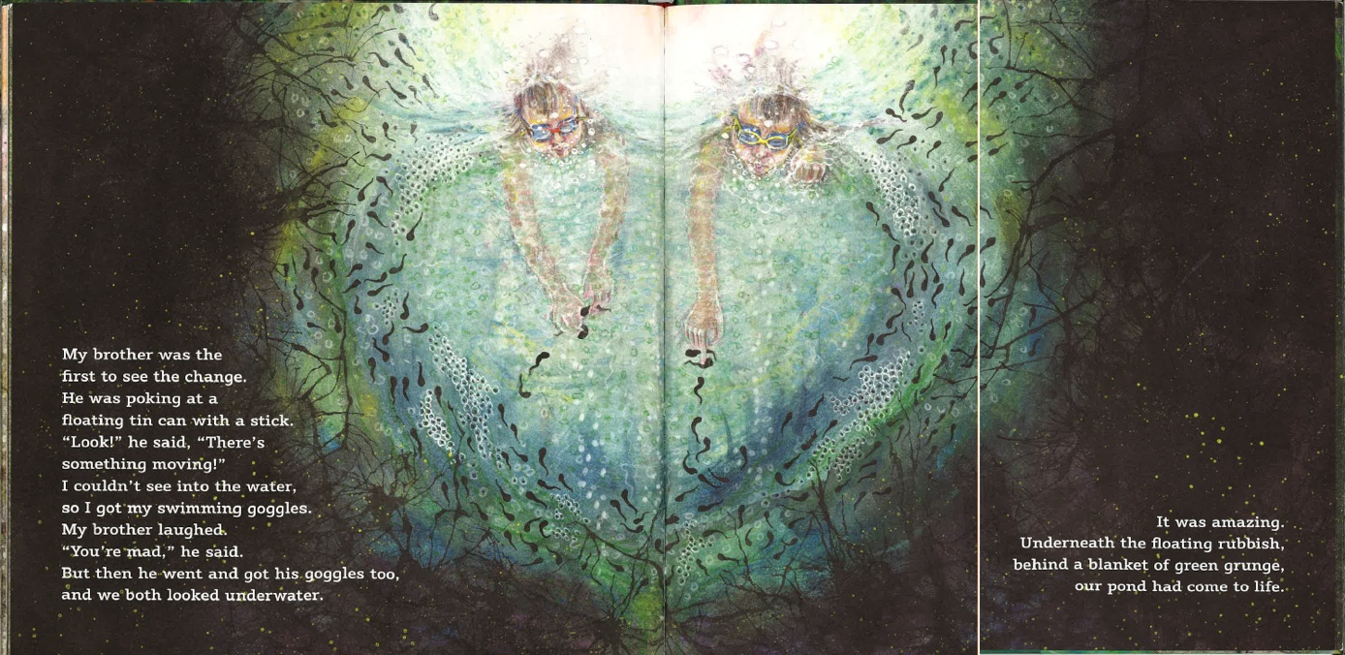
Fisher has illustrated the pond as a centre piece of the spread. Bang states that having a main element placed in the centre is the ‘most effective’ to direct the reader ‘point of the greatest attraction’ (Bang: 2000:62). This means that the elements previously mentioned are effectively heightened by interacting with a big focal point of the composition. Fisher has dominated the page with the element of the pond to allude to readers that it is difficult to escape from the past, and it is best to try and test yourself and not be scared of the outcome.
Figure 13 – Ninth Spread of The Pond – Testing
The reader is positively encouraged to accept that the testing stage worked. In Figure 13, the children are seen head first into the pond, happy and enjoying the experience. This is composed and illustrated beautifully by Fisher, the use of colour and tone to demonstrate moving into the light. The characters are now illustrated floating on top of the water, but not fully embodying the experience, to allude to testing themselves. The water is coloured lighter than the surrounding composition to make a connection to when Fisher illustrated the depression stage in Figure 11. The sense of the unknown is still illustrated through the same silhouette of the trees, still making the composition spine-chilling, yet instead of hesitating at the door, they are being brave. They are seen interacting and playing with the tadpoles which could symbolise them starting a new life. As demonstrated in Figure 13 the composition is shaped in a heart shape to conclude the love and energy the family are feeling in the right step to acceptance.

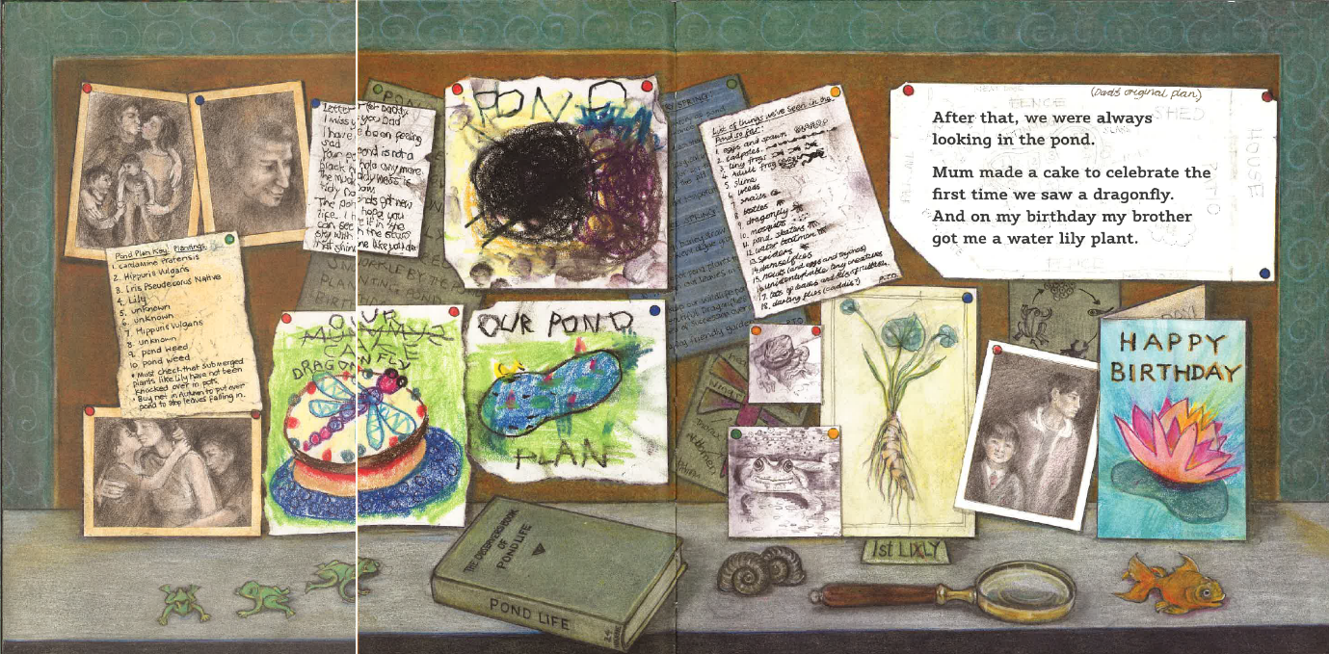
Acceptance is the last stage of grief in Kubler-Ross’s framework. It is defined as “gradually face the reality of impending separation and come to an acceptance of it together“ (Kubler Ross, 1970:163).
Figure 14 - Eleventh Spread of The Pond - Notice board
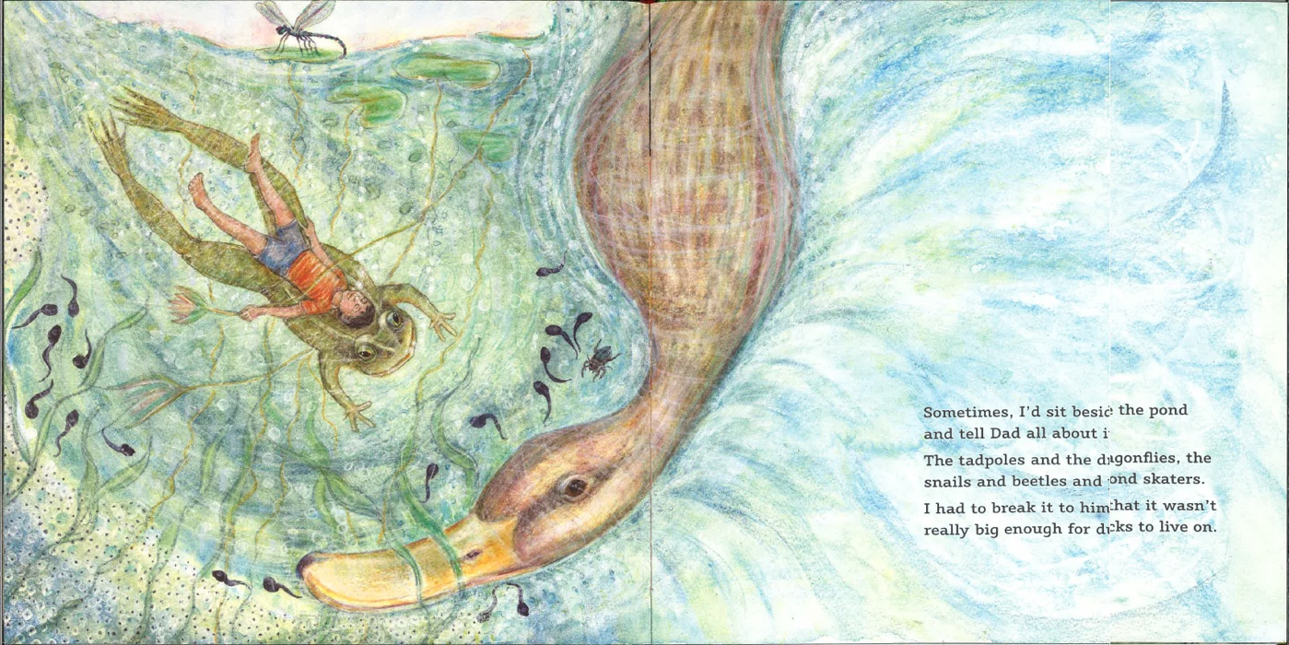
Acceptance is first seen illustrated cleverly though the notice board seen in Figure 14. This is a way the family have created to accept together but remember to still move forward. The notion of moving forward is illustrated by Fisher through the page breaks in the centre. On the left, we see images that have been pinned up such as family photos, lists, letters, and drawings centred on the theme of pond and pond life. This is shown for the reader to reflect on the whole story as a remembrance. The imagery on the right shows imagery to illustrate time moving on. The children have grown up, and the drawings have improved. The typography for the narrative has been placed over the father’s ‘Original plan’ for the pond to show that the family are not too precious about little things.
Figure 15 Twelfth Spread of The Pond - Acceptance
In Figure 15, we see acceptance from the child narrating the story. This is the first time we have seen the character interact with symbols in one image that once would cause grief. Fisher still uses the page break to her advantage by making a divide between the past and the present. The elements are positioned on the left, which could symbolise she is looking at the past with a more positive outlook than previously in the book; hinting towards acceptance. The biggest element showing that she has accepted the loss is through the Duck. She is illustrated riding on the back of a frog with a waterlily in her hand but the duck is blocking her way of moving to the right, present side of the book. Davies in conjunction writes “It wasn’t really big enough for ducks to live on” hinting towards no longer wanting a big negative weight in her life.
In addition to this, Fisher uses blues and greens like seen at the beginning of the book in Figure 1. However, she has made the colours more opaque to lighten the composition. While blues are usually used to express sadness, it could be argued that with this colour dominating the composition of the spread, it could refer to a state of fresh cleanliness, and thinking of the future as a fresh start.
While it is illustrated in the narrative that the characters have accepted the father’s death and are moving on with life, it is important to note how a child reader may perceive this misinterpreted view of passing away. Davies writes “Sometimes, I’d sit beside the pond and tell Dad all about it… I had to break it to him that it wasn’t really big enough for ducks to live on.” While the father is not illustrated in the composition, there may be children who read the book and think the rebuilding of the pond has brought the father back to life. Supporting this claim, two different studies reveal
Before the age of 5, children see death as temporary and reversible- perhaps sleep from which a person will wake a trip from which the traveller will return, or sickness from which the patient will recover…
(Clements, 2013:3)
Gardner (1974) demonstrated that 4-year-old children could match pairs of polar adjectives (e.g., "loud-quiet") not only to literal alternatives (e.g., loud and quiet sounds) but also to metaphorical ones (e.g., pairs of colours, faces, etc.).
(Gardner, 1974:4)

While it is clear that Davies and Fisher combat this by using symbolism, there is still the possibility of children may not quite fully understanding the metaphorical value. Without the right guardian to explain to them, it could be damaging in long-term development. For this reason, it could be argued that because children before the age of five aren’t able to fully grasp the universality of loss they will not fully engage with the narrative.

Conclusion
To conclude this research analysis, I believe Davies and Fisher have successfully and sensitively demonstrated the 7 stages of grief. The book is a good resource for parents to refer to when dealing with grief within the family through the narrative and the illustrations that are both literal and metaphorical -
This book, as a children’s story, has complex symbolism that a child may not consciously pick up on. However, this has the potential to be a very successful tool to start a conversation between a child and their guardian about a subject that is rarely illustrated because society in general treats death as a taboo subject.
This creates a stronger emotional bond in the stages of grief.
It can also be used as a tool to educate others to help them understand what stage of the grief process they are at, and identify what stage other members of the family are at so they can help each other in a sensitive manner. This can only be done because the book is educating you on the stages of grief.
Despite Clements’ (2013) and Gardeners (1974) statement that children aren’t able to pick up on metaphors before the age of 7, if this is the case it could be argued how successful the book is for educating children because of its heavy use of symbolism. However, it still becomes a good resource for adults and parents who are able to understand metaphorical language.
It is clever how Davies has represented remembrance of the father through the symbolism of a duck. It makes the story more engaging for children who do not understand how death works, and assure them that their lost one is not gone forever. It also a relief for children to try and find the duck in each spread, introducing humour to a difficult situation.
By analysing this book, I have developed a wider understanding of how to compose a picture book sensitively to apply the skills of Fisher to my own illustration work. The use of formal elements to evoke emotions speaks personally to the reader, particularly in stages of anger and depression. The reader can find something to relate to and feel they are not alone.
The emotive harsh textured lines evident in a lot of my work, makes me realise I could be unconsciously making the viewer anxious or on edge, whether or not I intended to. To improve my work, I want to be sensitive to how every mark can hold a meaning depending on how the mark is constructed.

Bibliography
Books
- Arnheim, R, (1986). New Essays on the Psychology of Art. California: University of California Press.
- Arnheim, R. (1974). Art and visual perception. Berkeley: University of California Press.
- Bader, B (1976) American Picturebooks from Noah’s Ark to the Beast within, Macmillan.
- Bang, M. (2010). Picture this. San Francisco: Chronicle Books.
- Collins Dictionary (2013) ed.12, Glasgow: Harper Collins
- Kübler-Ross, E. and Byock, I. (1970). On death & dying. Great Britain: Tavistock Publications Limited.
- Reznick, C. (2009). The power of your child's imagination. 1st ed. New York: Perigee.
- Schwarcz, J. and Schwarcz, C. (1991). The picture book comes of age. Chicago [u.a.]: American Library Assoc.
- Tucker, N. (1981). The child and the book. Cambridge: Cambridge University Press.
- Williams, R. (2015). The non-designers design book. 4th ed. Berkeley, Calif.: Peachpit Press.
- Wright, A (1995) The beginners guide to Colour psychology

Articles:
- Arnal, T (2012) ‘Pediatrics; Telling children about death’ NewsRx: NewsRx Health & Sceience;Atlanta, Available at: https://search.proquest.com/docview/915461073/667D276098E249BFPQ/1?accountid=130472
- Clements, L (2013) ‘Death and the Empathetic Embrace in Four Contemporary Picture Books’ Bookbird: A journal of International Childrens Literature, vol. 51, no 4, pp.1-10 Available at: https://muse.jhu.edu/article/521857 (Accessed: 2nd December 2017)
- Gardner, H (1973) ‘Metaphors and Modalities: How Children project Polar Adjectives onto Diverse Domains’ Harvard. Available at: https://files.eric.ed.gov/fulltext/ED080142.pdf (Accessed 4th November 2017)
- Hois S (2012) ‘Effects of Separation and Loss on Children’s Development’ Prevent Child Abuse Vermont, vol 6, pp1-4. Available at: https://pcavt.org/assets/files/Articles/'s%20Development.pdf (Accessed 4th November 2017)
Websites:
- Russel, M (2014) Symbolism of a Duck: Available at: http://signology.org/bird-symbol/duck-symbol.htm (Accessed 5th December 2017)
Works Cited:
- Davies, N (2017) The Pond Graffeg Limited
- Davies, N. (2017) Writing a Picture Book [lecture]. Narrative Illustration. Swansea College of Art, 24th October.

Reading List
Books
- Doonan, J, (1993). Looking at Pictures in Picture Books. Great Britain: Short Run Press
- Gombrich, E.H (1968). Art and Illusion: A study in the psychology of pictorial representation. 3rd ed. London: Phaidon Press
- WINNICOTT, D. (1971). PLAYING AND REALITY. Great Britain: Psychology Press.
- Wittgenstein, L., Anscombe, G., McAlister, L. and Schättle, M. (2007). Remarks on colour. Berkeley: University of California Press.

