Critical Discussion of CSR Theory
Management Ethics Assignment 1 M5X00803
Lucy Crocker (1701540)
2018
Contents
Executive Summary: 2
1. Introduction 3
2. Main Findings 3
2.1 What is Corporate Social Responsibility? 3
2.2 Business and Ethics 4
2.3 Models of corporate responsibility: 4
2.4 Shareholder Vs Stakeholder theory 5
3. Recommendations 6
4. Conclusion 6
References 7

Figure 1: Carroll's CSR Model (Tutor2u, 2018) 3
Figure 2: Mendelow's Theory (Oxford College Of Marketing , N.D) 4

Executive Summary:

This report contains an insight into an unethical business practice performed by an organisation. The task that was assigned to the author was to develop a poster based on an unethical business practice and their contrasting views on Corporate Social Responsibility. The author has decided to investigate the use of child labour within Nestle’s cocoa farms on the Ivory Coast.
The models that have been discussed in this report are Carroll’s Model of Corporate Social Responsibility and Mendelow’s stakeholder theory. After applying Mendelow’s stakeholder theory the author has established that the key stakeholders for Nestle are governments, suppliers, media and shareholders, whilst other important shareholders include customers, non-government organisations, local communities, investors, regulators and employees. After applying Carroll’s model of corporate social responsibility, the legal tier of the model has the most influence on the organisation’s image as they have repeatedly faced litigations regarding the use of child labour within their production line.

The recommendations of this report are:
- To introduce procedures that will be developed to decrease the risk of potential injures caused by their working conditions. Such as conducting risk assessments on site.
- Providing essential education, to improve prospects for children reducing future reliance on child wages.
- Supporting charities that work within the local communities effected

Introduction
The case of unethical business practice that the author will be investigating for this report is the practice of utilizing child labor during the production of goods by international corporations, the majority of which are based in less economic developed countries, and the corporation that the author has chosen to investigate is Nestle.
The content of this report is based upon the tasks that were assigned to the author of firstly, developing a poster identifying a case of unethical business practice within an organization, with the additional task to assess their contracting views on corporate social responsibility.

Main Findings
Child labor has been defined by the International Labour Organization (ILO) as:
“work that deprives children of their childhood, their potential and their dignity, and that is harmful to physical and mental development” (International Labour Organization, 2018).
The ILO also states that;
“Worldwide 218 million children between 5 and 17 years are in employment”.
This report provides an insight into the example of the use of child labor within the international corporation Nestle, and specifically the use of child labor during the production of cocoa on farms on the Ivory Coast (BBC, 2012).

2.1 What is Corporate Social Responsibility?
Corporate social responsibility has been defined by (Crane & Matten, 2016) as “the attempt by companies to meet the economic, legal, ethical, and philanthropic demands of a given society at a particular point in time”, and appears to be identified as a “positive contribution to business performance” especially during the long term (Sloman, et al., 2016). CSR has also been defined as to “how a company should conduct itself within society, and different views on what a business is for and how it should act” (Mullins & Christy, 2016, p. 617).

2.2 Business and Ethics
The ethics of business has been a continuous issue for debate. Milton Friedman states in his 1970 paper “The Social Responsibility of Business is to Increase its Profits”, that "there is one and only one social responsibility of business--to use its resources and engage in activities designed to increase its profits so long as it stays within the rules of the game” (Friedman, 1970). Nestle’s social responsibility as a corporation is to increase its profits annually, where their sales figures have varied on occasions, for example, Nestle had a sales figure of 91.1 CHF in 2005, 109.9 CHF in 2008 and 89.79 CHF in 2017 (Statista, 2018).
It is the view of the author that Milton’s view is incorrect, Crane & Matten (2016) argue that social responsibility benefits shareholders through increasing the satisfaction of customers who value corporations who are appear to be socially responsible, as well as the advantage of reducing costs via the implementation of socially responsible actions such as saving energy which would benefit not only the consumer but the shareholders themselves through increased profits.

2.3 Models of corporate responsibility:
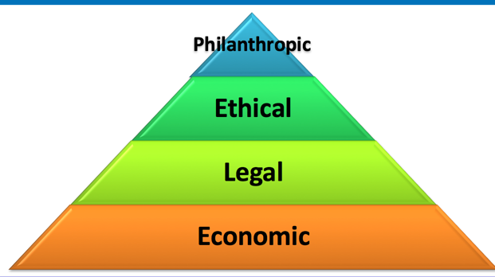
Carroll’s model of corporate social responsibility is made up of four tiers which consists of, economic, legal, ethical and philanthropic responsibilities of an organisation.
The first tier consists of an organisations economic responsibilities, where an organization will need a satisfactory economic element to succeed as a business. In relation to Nestle the organization are reducing their costs to maximize their profits and satisfy the needs of their consumers by introducing newer varieties of their products.
Figure 1: Carroll's CSR Model (Tutor2u, 2018)

The second tier consists of Nestle’s legal responsibilities. Nestle’s code of business conduct claims that the since the company was founded, they will comply with all appropriate laws and that the reputation of Nestle remains one of their most important assets (Nestle , 2018 A). However, as of recently Nestle have been reported to have employed children under the age of 15 to work on their cocoa farms on the Ivory Coast, where a report was conducted and exhibited that after a review of 260 farms, that were used by Nestle, there were 56 workers under the age of 18 and 27 workers were under the age of 15 (The Guardian, 2015). A recent article states that Nestle was sued with allegations of using child labor in its cocoa production on the Ivory Coast, after The US Supreme Court had rejected Nestle’s appeal to disdain the lawsuit (The Independent, 2016).
The third tier consists of an organisations ethical responsibilities. An example of ethical responsibilities for Nestle is their policies regarding zero tolerance for fraud, bribery, data protection and privacy (Nestle , 2018 B).
The final tier consists of an organisations philanthropic responsibilities. One example of a philanthropic responsibility by Nestle, was raising £700,000 for action for children, through a variety of activities which include baking and other events, over a course of three years (Action For Children, 2015).

2.4 Shareholder Vs Stakeholder theory
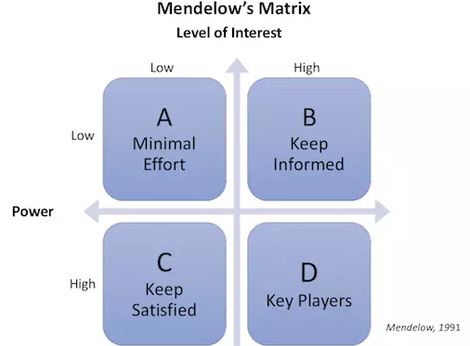
The term “Stakeholder” was essentially introduced in the 1960’s, but its theoretical approach was introduced by Edward Freeman in 1980 (Crane & Matten, 2016). According to Crane & Matten (2016), there are a variety of definitions for stakeholder theory, which make it difficult to determine a specific definition for the term. Organisations use stakeholder analysis to identify the stakeholders who are most likely to be affected by activities of the organisation and to asses how the stakeholders could have an impact on the organisation’s performance. One approach of analyzing the importance of stakeholders in an organisation is by using the Mendelow theory. Nestle’s stakeholders include customers, local communities, employees, industry, government and non-government organisations, suppliers and investors. The shareholders are the individuals who take ownership of a corporation, in Nestle their shareholders would be the owners as their interests would take a higher priority.
Figure 2: Mendelow's Theory (Oxford College Of Marketing , N.D)

Recommendations

An approach recommended by the ILO to tackle this ongoing issue is to accept that child labor is inevitable, and instead procedures should be developed in order to minimize potential risks and ensure that all young workers get a fair wage (The Guardian , 2012). Another approach which has been recommended by UNICEF is to “attack it at its roots”, which would include conducting risk assessments on site, providing essential education in order to decrease the amount of families reliant on the income of their child/children and discourage the culture of expecting young children to be in employment at a young age (UNICEF, 2013). Another approach to decreasing the ongoing issue of child labor is to raise awareness of charities who are working to end child labor, for example, save the children, but also to get involved with fundraising events organized by the charities in order to support their projects (Save The Children, 2017).

Conclusion
To conclude this assignment, as stated previously corporate social responsibility is valuable to corporations as it improves their image as an organisation to the public. Nestle have acknowledged that child labour is an issue within its farms, because they have shown that they are responsible in other areas, such as the philanthropic donations to Save The Children, it can be hoped that Nestle are making improvements to eliminate its use of child labour. There are various strategies that can be of use to decrease levels of children in hazardous working conditions, such as completing risk assessments.

References
Action For Children, 2015. Companies That Support Us: Nestle. [Online]
Available at: https://www.actionforchildren.org.uk/how-to-help/corporate-giving/companies-that-support-us/nestl%C3%A9/
[Accessed 09 11 2018].
BBC, 2012. Nestle 'failing' on child labour abuse, says FLA report. [Online]
Available at: https://www.bbc.co.uk/news/world-africa-18644870
[Accessed 09 11 2018].
Crane, A. & Matten, D., 2016. Business Ethics. Fourth ed. s.l.:Oxford .
Friedman, M., 1970. The Social Responsibility of Business is to Increase its Profits. [Online]
Available at: http://www.umich.edu/~thecore/doc/Friedman.pdf
[Accessed 11 11 2018].
International Labour Organization, 2018. What is Child Labour. [Online]
Available at: https://www.ilo.org/ipec/facts/lang--en/index.htm
[Accessed 03 11 2018].
Mullins, L. J. & Christy, G., 2016. Management & Organisational Behaviour. 11th ed. Harlow: Pearson.
Nestle , 2018 A. Code Of Business Conduct. [Online]
Available at: https://www.nestle.com/investors/corporate-governance/codeofbusinessconduct
[Accessed 08 11 2018].
Nestle , 2018 B. Ethical business. [Online]
Available at: https://www.nestle.com/csv/what-is-csv/ethical-business
[Accessed 10 11 2018].
Nestle, 2018. Stakeholder Engagement. [Online]
Available at: https://www.nestle.com/csv/what-is-csv/stakeholder-engagement
[Accessed 04 11 2018].
Oxford College Of Marketing , N.D. What is Mendelow's Matrix And How Is It Useful?. [Online]
Available at: https://blog.oxfordcollegeofmarketing.com/2018/04/23/what-is-mendelows-matrix-and-how-is-it-useful/
[Accessed 12 11 2018].
Save The Children, 2017. Causes of child labour in India and how it can be prevented. [Online]
Available at: https://www.savethechildren.in/resource-centre/articles/causes-of-child-labour-in-india-and-how-it-can-be
[Accessed 13 11 2018].
Sloman, J., Garratt, D., Guest, J. & Jones, E., 2016. Economics For Business. Seven ed. Harlow: Pearson.
Statista, 2018. Nestlé Group's sales worldwide from 2005 to 2017. [Online]
Available at: https://www.statista.com/statistics/268892/nestle-groups-global-sales/
[Accessed 13 11 2018].
The Guardian , 2012. Eliminating child labour from the supply chain. [Online]
Available at: https://www.theguardian.com/sustainable-business/eliminating-child-labour-supply-chain
[Accessed 10 11 2018].
The Guardian, 2015. Child labour on Nestlé farms: chocolate giant's problems continue. [Online]
Available at: https://www.theguardian.com/global-development-professionals-network/2015/sep/02/child-labour-on-nestle-farms-chocolate-giants-problems-continue
[Accessed 08 11 2018].
The Independent, 2016. Nestle is being sued for allegedly using child slaves on cocoa farms. [Online]
Available at: https://www.independent.co.uk/news/world/americas/nestle-is-being-sued-for-allegedly-using-child-slaves-on-cocoa-farms-a6806646.html
[Accessed 09 11 2018].
Tutor2u, 2018. Carroll's CSR Pyramid. [Online]
Available at: https://www.tutor2u.net/business/reference/carrolls-csr-pyramid
[Accessed 08 11 2018].
UNICEF, 2013. To eliminate child labor. [Online]
Available at: https://www.unicef.org/media/media_70610.html
[Accessed 11 11 2018].

Appendices:

Nestle Stakeholder Map (Mendelow’s Theory)


