Ryan Williams 1908507
BEng MECHANICAL AND MANUFACTING engineering (PART TIME)
university wales trinity saint david Engineering science: energy in a flywheel

Contents

1.0 Introduction 2
2.0Experimental procedure 3
3.0 Results 5
4.0 Analysis 6
5.0 Conclusion 7
6.0 Evaluation 9
7.0 Further work 10
Bibliography 11

1.0 Introduction

A fly wheel is a rotating mechanical device that is used in machinery and engines to store rotational energy. Every time you stop a machine/engine the kinetic energy is wasted through the braking system. Fly wheels store the kinetic energy to be used when needed again, think of it as a type of mechanical battery, however it’s storing its energy from kinetic energy as opposed to chemical energy stored in a traditional electric battery. (www.explainthatstuff.com, n.d.)
This experiment is used to prove the theory of flywheels by lifting a series of different weights with the fly wheel and allowing it to travel vertically through a distance of 280mm to 0 and back to its maximum height. We shall record the maximum height (h2) and the total time taken (t) to work out the potential energy (PE), potential energy loss (PE LOSS) and kinetic energy(KE) to work these out we will have to also have work out the acceleration(a) and velocity(v) both linear and angular.
Potential energy of a body is the energy it possesses due to its position in gravitational field i.e. its height above the ground. Kinetic energy of a body is the energy it possesses due to its velocity (zammit, 1987)
If the mass returns to its original height, then the fly wheel will have given up all its kinetic energy back to the mass and therefore the potential energy would be equal to the kinetic energy. However due to friction in the bearings and other factors the returning mass will reach a lower height this is known as potential energy loss.
I will also have to consider the moment of inertia for the fly wheel.
The moment of inertia is a measure of resistance of a body to angular acceleration about a given axis that is equal to the sum of the products of each element of mass in the body and the square of the elements distance from the axis. (www.merriam-webster.com, n.d.)
In this experiment I was given the nominal inertia values for both the fly wheel and the shaft and pulley.

2.0Experimental procedure

As a group using the Tecquipment potential and kinetic energy kit ES9
Which consisted of the following (figure 1):
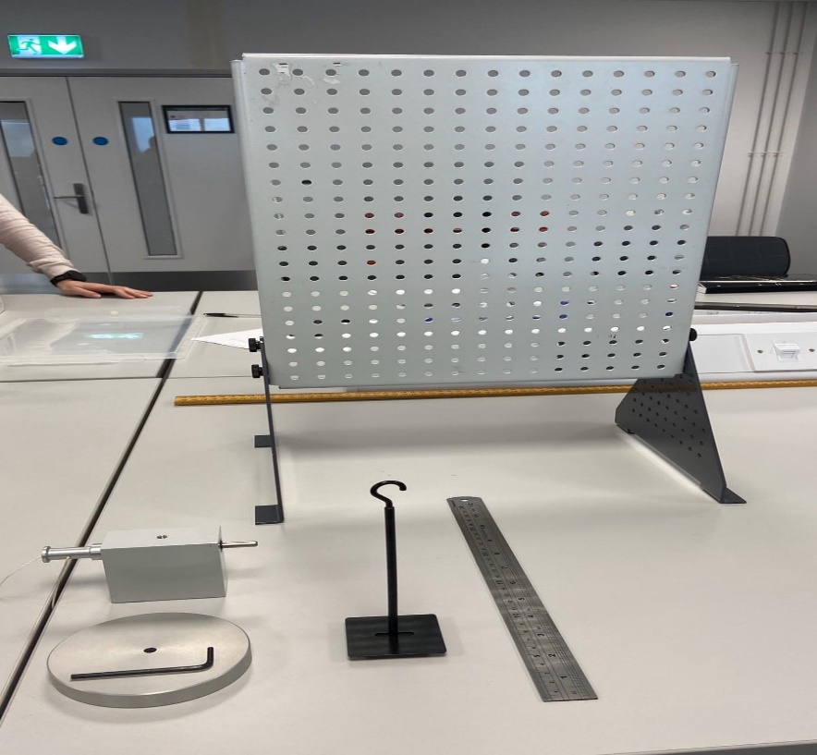
e
d
c
b
aa
Figure 1 experiment components

- A work panel
- A bearing block and shaft
- A fly wheel
- A weight hanger/string
- Magnetic metal rule
- And a bag of 10g weighted disks. (not pictured)

- Firstly, start by assembling the fly wheel to the shaft.
- Next attach the bearing flywheel assembly to the top of the work panel using the supplied bolts and Allen key.
- Then attach the string to the bearing block shaft and attached the weight hanger to the string.
- Next stick the magnetic rule to the work panel running parallel to the string making sure that the bottom of the weight hanger will travel through a vertical drop of just over 290mm (see figure 2)
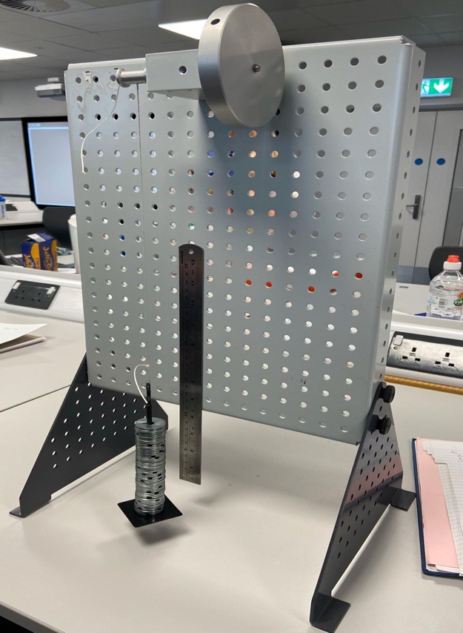
Figure 2 assembled components

.
- With the weight hanger at the bottom of its travel align the 0mm line of the rule with the bottom of the weight hanger.
- As the unladed hanger already weighs 10g add 9 x 10g weights to the weight hanger to give a total of 100g of weight.
- Now slowly turn the flywheel until the bottom of the hanger reached 280mm on the rule.
- Using a stopwatch, time how many seconds it takes for the hanger to fall from 280mm to 0mm and back up to its maximum height.
- Using a video camera, record the maximum height reached.
- Repeat these 3 times and take an average of the recorded results.
- Repeat the experiment another 4 times using different weights 200g, 300g, 400g, and 500g respectively and recorded the results.

3.0 Results

Here is a table of the raw data collected, which includes the different weights used, the time taken, and the heights reached.

Table 1 raw data

Mass | Time taken t1 | Height reached h2
100 g | 4.12 seconds | 243 mm
200 g | 2.93 seconds | 252 mm
300 g | 2.12 seconds | 255 mm
400 g | 2.03 seconds | 245 mm
500 g | 1.75 seconds | 245 mm

4.0 Analysis

The results and calculations of the experiment are as follows:
Figure 3 Excel table of results
This is a chart to find the moment of inertia: (mg-ma) against a/r based on actual results. Plotting this graph in excel and using the slope function should give a good average value for I.

Figure 4 angular acceleration/torque graph Table

Table 2 average I figure

5.0 Conclusion

I constructed an excel table and to work out all the results we needed:
Using the knowns, I was able to work out the potential energy:
PE = $Mx g x h1$
To work out the PE loss, falling time, acceleration, velocity (both linear and angular) angular acceleration, torque and kinetic energy I used the following equations.
PE loss adjusted: joules = $Mg(h1-h2)(\frac{h1}{h1+h2})$
I = total inertia for fly wheel and shaft (given) = 0.0004696
C = circumference of fly wheel = 0.0408
r = radius of pulley = 0.0065

Falling time (tf) seconds = $t1\left(\frac{h1}{h1+h2}\right)$
Acceleration (a) m/s^2 = $2(\frac{h1}{tf^{2}})$
Velocity (v) m/s = $a x tf$
Angular velocity (ω) rads/s = $2π\left(\frac{v}{c}\right)$
Angular acceleration (α) = $\frac{a}{r}$
Torque (t) nm = $Mg-Ma$
Kinetic energy: joules = $0.5(Iω^{2})$
From our results it’s clear that as the mass increases the time taken to fall increases just as I expected therefore so does the velocity and acceleration.
As the mass increases so does the potential energy loss this is because higher loads become less effected by frictional losses, however when we loaded the mass with 0.4kg and 0.5kg we recorded less returning height this was potentially because of the resulting increase in velocity and acceleration created an instability at the end point/bottom of travel which in turn created a swinging effect to the mass giving us incorrect readings.
Before the experiment based on theory, I expected the Kinetic energy to be lower than the potential Energy however this wasn’t the case with my figures.
The potential reasons for this are based on the formula I used $KE=0.5 (Iω^{2})$ our given value for inertia could be wrong. To work out our velocity we used the given circumference of the fly wheel and we didn’t physically check this, or our recorded times weren’t accurate enough.
It’s clear from my research into flywheel experiments that’s is possible and if the moment of inertia is calculated as well as the energy lost per revolution of the fly wheel just like an experiment, I found
In which a set length of string is used which allow the mass to fall through height h at which point the string leaves the axle and therefore the potential energy lost by the weight is converted to kinetic energy of the weight, kinetic energy of the flywheel and heat. If the energy lost is E and the flywheel makes n1 revolutions during acceleration, then: $mgh=\frac{1}{2}mv^{2}+\frac{1}{2}{}^{2}+n1 E$
then the flywheel is allowed to come to rest due to frictional forces and stops a further n2 revolutions then: $\frac{1}{2}ω^{2}=n2E$
therefore: $mgh=\frac{1}{2}mv^{2}+Iω^{2}+\left(\frac{n1}{n2}\right)$ or $\frac{1}{ 2}mv^{2}+\frac{1}{2}Iω^{2}(1+\frac{n1}{n2})$
(www.schoolphysics.co.uk, n.d.)

6.0 Evaluation

Initially it was decided to record the return height from directly in front of the dropping hanger but discovered that it made it hard to accurately record the returning height therefore as a group decide to reposition the steel rule and also change our viewing angle and record with a phone camera and play it back in slow motion to validate opinions.

Originally three separate times where recorded for each repetition and an average was worked out from these, however after using those figures to construct our excel table it was obvious some spurious results had been recorded so it was decided to repeat the experiment with only 1 recorded time which gave results which looked more like you’d expect to see. By taking these steps I believe we reduced human error in the findings.

Overall the experiment has helped me gain an understanding of kinetic and potential energy and also gained some experience of constructing excel tables and formulas.

7.0 Further work

If I was to repeat this experiment with an unlimited budget and time to make it more accurate, I would implement the following:
- I would use a dead stop to create a datum for the height raised to giving the height accurate repeatability.
- I would use a high-quality slow-motion video camera to record the returning height
- I would also look at creating an experiment to allow me to accurately measure the inertia and kinetic energy lost for the flywheel and pulley

Bibliography
(n.d.). Retrieved from www.merriam-webster.com: https://www.merriam-webster.com/dictionary/flywheel
(n.d.). Retrieved from www.explainthatstuff.com: https://www.explainthatstuff.com/flywheels.html
(n.d.). Retrieved from www.schoolphysics.co.uk: http://www.schoolphysics.co.uk/age16-19/Mechanics/Rotation%20of%20rigid%20bodies/text/Moment_of_inertia_measurement/index.html
tecquipment. (n.d.). potential and kinetic energy experiment.
zammit, s. j. (1987). motor vehicle engineering science for technicians.

