Title: Understanding and Engaging in the Customer Experience: BMSK5003
Michel Nelson: 1709423
Lecture: Dr Rexon Nting

Introduction 1
1. Critical analysis of the factors that influence Marks and Spencer’s ability to maximise customer value 2
1.1 Value Chain Analysis 3
M&S tries to maximise the customer value through its value chain mostly. From production to the delivery of products & services, the firm tries to add value to the customers in every activities of its value chain. 3
1.2 Quality modules & standards 5
1.3 Framework of customer value 5
1.4 Ethical standards 7
2. Critical understanding of Marks and Spencer’s quality processes & its effectiveness in meeting customer requirements 8
2.1 Quality process for buying products 8
2.2 Quality control process by Marks & Spencer 9
2.3 Quality process under Customer Relationship Management 10
2.4 Evaluation of M&S’s existing operations management processes 12
2.5 Analysing the customer experience of Marks and Spencer 13
Conclusion 15
References 16

Introduction
The value and requirement of customers depend on a company’s ability to build & run efficient quality processes and able to manage the factors of quality effectively. For this reason, firms in all industry are focusing on customer-centric strategy for running quality process, satisfying customers & optimising customers’ experience (Webb, 2011). Thus, the success in engaging in the customer experience requires effective management of the factors of maximising customer value and quality processes of a firm (Goodman, 2011). Marks and Spencer have been selected as the case study firm to analyse factors of enhancing customer value & asses the effectiveness of its quality processes in meeting the requirements of customers. Marks & Spencer Group plc is a British multinational retailer founded in 1884 at Leeds, United Kingdom. It’s headquartered is in Westminster, London and sell clothing, accessories & home products around the UK and different key international markets (marksandspencer.com, 2019).

Critical analysis of the factors that influence Marks and Spencer’s ability to maximise customer value
Customer value is a combination of a number of things than just products or services. It can be defined as the ultimate satisfaction and loyalty a customer gets from a brand (Doligalski, 2016). However, customer services, customer-centric practices & strategies and products/services having quality modules & standards have considerable influence on the maximisation of customer value by a firm (Gibbert, Woodside and Golfetto, 2011). Mello (2012) defined customer value as the expected products and services customers get from a firm at a competitive price. Customer’s value depends on two elements according to many researchers and scholars. They are perceived customer value & desired customer value. The demand and expectation of a customer from a product are called perceived customer value.
After the purchase, when customers think that they have the desired benefits and value, it can be called perceived customer value. Thus, the maximisation of customer value and its factors must be focused on customer expectation and perceived value. When the factors of the maximisation of value prioritise these elements, customer value is perceived on a highly positive note (Mello, 2012). Marks and Spencer have been chosen to analyse the influential factors that influence their ability to enhance customers’ value. To maximise the customer value, Marks and Spencer give importance to the quality of its product and services (Assael, 2011). However, it has a focus on other factors too. The factors are analysed critically in the following.
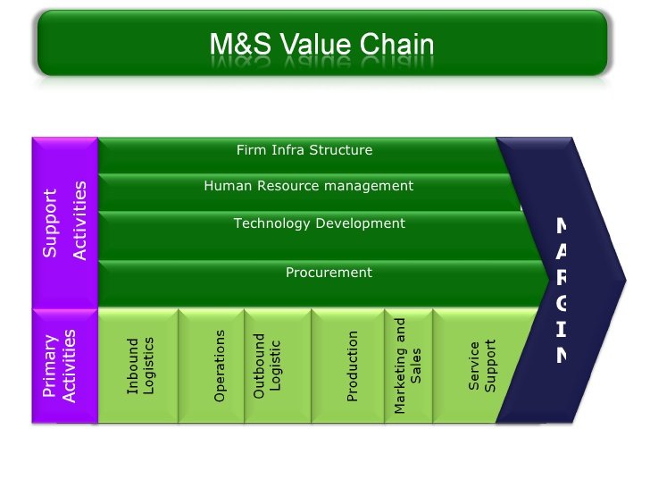
Figure 1: Quality control through a vertically integrated Value Chain (Michelli, 2012).
  - Value Chain Analysis

M&S tries to maximise the customer value through its value chain mostly. From production to the delivery of products & services, the firm tries to add value to the customers in every activity of its value chain.
- Inbound logistics: M&S receive, store & distribute the raw materials and products under its ‘Plan A’ sustainability program. This plan helped the firm create products and offer services at a low cost with great efficiency. The firm has been able to get a significant lead in customer value, create step changes in its global supply chain and won the GBS supply chain award due to this plan (Marksandspencer.com, 2019). Efficient inbound logistics has helped M&S to achieve competitive advantage over its competitors & get a commendation from EC, receive European Business Award for the Environment and build a stronghold on sustainability.
- Operations: M&S is training and rewarding store teams to give the best customer experience according to its plan of 2016 annual report. The key goal is the increase customer visits and enhances customer value through “Inspiring and effortless experience” (Marksandspencer.com, 2019). The firm is its managing online operations through its hi-tech distribution centre in Castle Donington (Butler, 2015). Thus, the investment in the upgrade of its IT systems has helped M&S to offer products at less price through better supply chain management. However, the operation of M&S failed in keeping the personal details of its customers as 800 online customers’ personal details were leaked recently.
- Outbound logistics: M&S tries to create customer value under outbound logistics through collecting, storing & distributing its product and services multi-channel strategy. It offers shopping through click & collect options, catalogue, online shopping along with its in-store shopping (Assael, 2011). The investment in warehousings such as the automated store in Bradford and merger of smaller warehouses for its clothing and home business has made the supply chain & distribution more efficient (Marksandspencer.com, 2019).
- Marketing and sales: M&S have venture lab under its Digital division that uses lean startup technologies for increasing the quality of customer interaction and enhance their shopping experience. Under its marketing, M&S uses Multi-channel experience through a mobile, online & catalogue to facilitate the seamless shopping experience (Marksandspencer.com, 2019). Although M&S has improved the digital experience, it’s customer engagement via multi-social media platforms and use of customer loyalty data are not strong. Thus, it is lagging in high impact promotions & enhancement of value for customers.
- Services: To enhance the value of products, services remain a considerable factor for M&S. The firm uses services as a key tool to facilitate customer loyalty. Thus, it offers great customer service increasing speed of delivery to customers, adding free returns by post, maximising product availability in the stores and making delivery free (orders above £50) (Marksandspencer.com, 2019). However, the firm needs to work on space for food halls and manage the area for its clothing & fashion items (Assael, 2011). Marks & Spencer is cutting its fashion space for incrthe easing the size of its food halls which can be the wrong decision for the growth of its fashion sales.
Marks and Spencer focus on customer service to make their customer value stronger. Thus, it makes good use of the of its product quality, enhances the shopping experience of the customers and maintains a good culture within the firm to maximise customer value through service (Nickels, McHugh and McHugh, 2013). For example, Marks and Spencer offer online inquiries, trained staffs at stores, electronic waiting & payment system, call centres, instant replay at social media, exchange of faulty dress and after-sales services of its products (Shaw, 2013). These services are having a great influence on the maximisation of customer value by M&S. The fundamentals of customer value followed by the company in providing customer are shown and explained in the following.
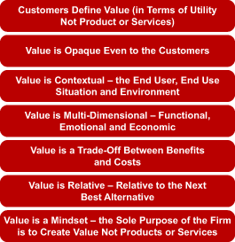
Figure 2: Fundamentals of customer value followed by M&S (Webb, 2011).
Based on the fundamentals of customer value it can be said these fundamentals help a firm to think from a different angle and provide value to the customers by thinking from their perspectives. Marks and Spencer focus on understanding these perspectives and use them to render services to their customers (Marksandspencer.com, 2019). However, all the fundamentals mentioned in the figure are not followed by the M&S. Although it provides customer value through multi-dimensional and mindset-based thinking, the value-based perspectives of M&S lack contextual and relative thinking in its products or services.
  - Quality modules & standards
This is one of the crucial factors for M&S in enhancing customer value. The standards and quality module of M&S help the firm to maintain the desired quality over time, update the business & marketing strategies according to the plan and implement techniques based on the standards. For example, the actions plan of Marks and Spencer regarding marketing programs, production, customer services and online activities all are monitored under the quality modules and standards (Michelli, 2012). Marks and Spencer can maintain the top class quality of its product, maintain good relations with the suppliers & customers and focus on the management of sustainability through quality modules and standards. Thus, appropriate control maintained through the quality standards and modules. From production manager to executives of stores, all are bound to follow the guidelines and standards to maintain service standards & quality of products. Here, M&S focus on consistency while guiding people through its sustainable models & standards (Marksandspencer.com, 2019). Apart from improving the value chain process, the control & guidance through standards & modules improve the value chain process, increase customer satisfaction, enhance loyalty and maintain product quality. From the raw materials to the interaction with the customers, all fell under the quality standards and modules (Paluch and Blut, 2013). These initiatives of M&S reduce the manufacturing faults, increase the productivity of employees and facilitate the efficient execution of marketing & business plans.
  - The framework of customer value
Fundamentals of customer value do not give prosper direction all the time and M&S focus on the framework of customer value graph for identifying different aspects of customer expectations and issues (DOLIGALSKI, 2016). M&S tries to identify the customer needs & expectation that are not visible through this framework and read the customer mind through the elements of this framework. Although the framework has not been fully effective for the firm in the accessories retail, it has been quite successful in understanding the customer mind in the clothing retail. For example, professionals and students prefer M&S for their latest collections and trendy outfits (Marksandspencer.com, 2019). The staffs who interact with the customer physically give input in the product development process and M&S put emphasize of those recommendations while implementing the customer value framework through product development.

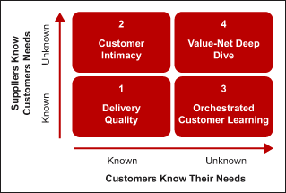
Figure 3: Customer Value Framework (Shaw, 2013).
As customer value depends on the knowledge of the value by both customers and the firm, a deeper look at the elements of the framework will portray the situation of Marks and Spencer in the value framework.
- Delivery quality: In this case, a marketer like M&S know the needs and details of customers. For example, formal clothing of Man and Women. The needs and products & services for fulfilling those are set by both the customers and M&S (Marksandspencer.com, 2019). However, the firm enhances customer value by using pilot project levels, Fast waiting and Radio Frequency Identification technology to create a unique customer experience and maintain a congenial relationship with the customer in all touch points (Rajagopal and Castano, 2015).
- Customer intimacy: It is the case where M&S does not know the customer needs and applying the customer vicinity path to know the consumer needs and requirements are mandatory here (Marksandspencer.com, 2019). Marks and Spencer use the online discussion board, customer surveys, after sales feedback, market intelligence and customer intimacy programs to understanding the unknown needs of the customers (Paluch and Blut, 2013). However, M&S has failed to do it many times in which competitors like Zara and Primark has taken advantage by identifying the latest trends and needs of the customers.
- Orchestrated Customer learning: In this stage, customers are unaware of the system, process & offerings of a firm (Jerger and Wirtz, 2017). Marks and Spencer have a customer learning process under which it teaches customers about the offerings and systems of the firm through social media posts, website catalogues, video tutorials and in-store suggestions by the staffs. Here, cooperation is an important thing where customer’s willingness is needed for showing them the unknown things where most of the retailers like M&S fail to understand (Marksandspencer.com, 2019).
- Value-not deep dive: Here, both customers and the firm are unaware of the needs, systems or actual value. Thus, a lacking balance between the relationship of consumer & the organisation is noticed in this case. Marks and Spencer enhance the customer value in this case by sitting with sample customers and brainstorming about new ideas or value (Paluch and Blut, 2013). Supporting each other to know the not deep drive value is the key consideration here.

Ethical standards
The ethical standards of Marks and Spencer are called ethical consumer. According to Ethical Consumer Magazine, M&S is the most ethical high street clothing retailer in the UK. The ethical behaviour of M&S has helped the firm to maximise customer value by creating positive brand value, offering products that do not harm society and consider the welfare of the society. After surveying more than over 25 of the UK's leading clothes shops, Ethical Consumer Magazine named M&S as the most ethical high street retailer of the clothing industry (marksandspencer.com, 2019). Regular and positive ethical & environmental track record of M&S in its everyday products and services has helped the firm to earn this reputation and provide the best services to the customers (Martínez Barreiro, 2014).
M&S tackled numerous social & environmental issues in 2007 through its Plan A program. over 180 specific commitments to tackle social and environmental issues. Assurance of sustainability in all aspects of the supply chain of its clothing has brought more than 100 awards for M&S (Marksandspencer.com, 2019). However, Marks and Spencer have not been the industry leaders in fulfilling the ethical standards and more works need to be done through the improvement in standards regarding people & the environment. At M&S, the sourcing of raw material and actions of the business should be more responsible both in the UK & worldwide.

Critical understanding of Marks and Spencer’s quality processes & its effectiveness in meeting customer requirements
The quality process of Marks and Spencer is called a ‘golden rule’ where it helps customers by taking ownership and taking feedback about its services. The service quality of staffs at Marks and Spencer are controlled by three principles. They are acknowledging every customer with a hello & smile, understanding the needs of the customer through building a relationship & good interaction and saying ‘have a good day’ to customers (marksandspencer.com, 2019). The quality process of M&S is improved constantly through feedbacks collected from store, online surveys & survey forms in store.

2.1 Quality process for buying products
The selectors, merchandisers, quality control managers and technologists work together to control the quality of products provided by the suppliers. This process is maintained strictly to meet the high standards of the products. Firstly, information & measurements regarding the base size of products & their style are provided to the suppliers to maintain the standards (Paluch and Blut, 2013). Although M&S gives this information in written, a quality control employee is missing here from the side of M&S who can communicate this information to the suppliers during production (marksandspencer.com, 2019). Secondly, pre-production meetings are done with the suppliers for discussing production viability based on the standards & packaging details of M&S (Dsl-toys.com, 2019). Here, the firm has a lacking and that is the absence of pricing from the perspectives of the suppliers.
As the third stage, Test lots are checked by the employees of M&S to confirm the viability of patterns, fulfilment of the standards and make-up methods. Fourthly, the quality control manager and merchandiser check & approve dimensions & fit of sizes of the grades. Finally, Wearer trials are done for assessing the performance of garments that customers will use ultimately (Dsl-toys.com, 2019). The staffs check the colours, fit, trims, labels & fabric are in this stage of development. M&S does not conduct test trails by the actual customers that have been lacking in the final stage.
As a major supplier of M&S, Courtaulds Textiles has a relationship with Marks & Spencer (Marksandspencer.com, 2019). Thus, they play a key role in the quality processes if the firm. M&S needs to consider a few other suppliers too can give better quality products to the firm at a competitive price. Since both the party had few differences in the past, the differences should be solved to maintain the shared goals & values of the quality process.

2.2 Quality control process by Marks & Spencer
Operational management process is another quality control process of M&S and it has been controlled by ISO 9001: 2015 (marksandspencer.com, 2019). The achievement of this certification required the firm to work on its marketing, operation, management, accounting, finance, production and supply chain departments to achieve the quality standards. Although the key goal of Marks and Spencer operational management is to get the high-quality products & designs, improvements are needed in the operational part of the firm to reduce costs, compete effectively and achieve the operational goals (Dsl-toys.com, 2019). Thus, the combination of quality control & quality assurance is needed for maintaining operational quality.
Although these two techniques ensure the quality requirements & standards of the products of Marks and Spencer, the effective implementation of quality standards in the operations is needed for Marks and Spencer. This, the use of quality process and standards in operational management has become necessary for the firm. Quality assurance, checks & evaluation of the operational activities can facilitate the meeting of quality requirements (marksandspencer.com, 2019). M&S has standard practices for making sure the quality standards of products but the superiority of the organization operation is absent within the operational management of Marks and Spencer (Marksandspencer.com, 2019). The basic operational management which Marks and Spencer follow for maintaining quality is provided below.
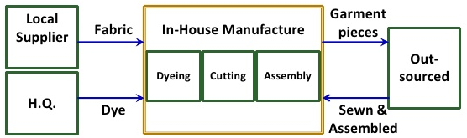
Figure 5: Operational management process of M&S for quality assurance (marksandspencer.com, 2019).

The quality process under Customer Relationship Management
The quality process of CRM is maintained through CRM software by M&S. The firm has separate CRM strategies that direct the quality process and standards of CRM (Dsl-toys.com, 2019). M&S has been successful to modify the goals, standards and strategies of the quality process through its CRM. Through understanding the demand for popular products & designers, Marks and Spencer have been able to fulfil customer requirements under its quality process of CRM. The quality process of CRM has helped the firm to meet the customer needs through identifying the latest trends, unpopular products, customer preferences & requirement of quick reaction (Marksandspencer.com, 2019).
The key objective of M&S in the quality process under its CRM strategy is to provide the greatest value to its customers. The quality process M&S’s CRM has been capitalising the potential of the firm by attracting new clients, increasing purchases of the current customers, and lessening costs (Dsl-toys.com, 2019). Although the firm has not been successful enough in penetrating the existing customer base due to intense competition and service failures, it has been trying to avoid the high costs of attracting the new customers under the CRM process (Gummesson, 2015).
Marks & Spencer is trying to fulfil the customers’ requirements through the IDIC model under its CRM system. The quality standards and guidelines are integrated into every business functions and activities to engage the customer & generate greater value.
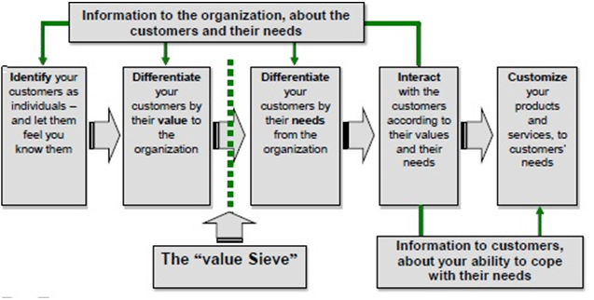
Figure 6: IDIC model of Marks & Spencer (Michelli, 2012).
At first of this quality process M&S identify individual customers through their profile, previous purchases or website visit. Next, the customers are differentiated based on their value and needs to M&S. Here, CRM assists to add value through providing different information, choices, behaviours and market intelligence to distinct customers and facilitate the development of product & services according to the needs of the customers (Gartner L2: Benchmarking Digital Performance, 2019). After that, Marks and Spencer interact with the customers through personalised offerings and maintain try to maintain a continuous relationship with the customers (I-cio.com, 2019). Thus, IDIC Model portrays that information about the customers is the key issue here and Marks and Spencer true to add value in each step in the model through using information of CRM and standards of the quality process.
In the IDIC model, it has found that identification of different category customers is important to understand their needs and offer products based on the needs & value. Marks and Spencer do this by categorising customers under its differentiation strategy. The categories help the firm to offer exclusive products, special price, price bundles, discounts and level of after sales services based on the categories (Goodman, 2011).
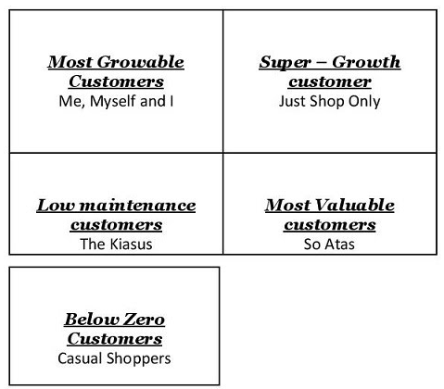
Figure: Customer categories of M&S (Armstrong and Kotler, 2014).
Through operational management, M&S performs all activities to convert materials, primary inputs of clothing, customer’s requirements, company resources, information, skills & finance etc. into final clothing products, services & satisfaction of final customers. To fulfil the customer requirements and maintain the quality of the operational management process M&S receives good raw material under its improved & efficient supply chain and executes the transformation process through highly skilful worker force (Gartner L2: Benchmarking Digital Performance, 2019). Thus, the branded clothes M&S brings with high-quality services are the results of its excellent operational management. M&S should order good quality material, handle logistics & process information efficiently to improve its Strategic Quality and Systems management (Hobbs, 2019). This will help the firms to offer clothes and accessories before the competitors and in the desired place of the customers. For example, marketing and finance operations of M&S operate the investment, positioning, brands and product development efficiently and effectively that help the firm to offer high quality & innovative products to its customers with excellent services (Marksandspencer.com, 2019).

2.4 Evaluation of M&S’s existing operations management processes
Marks and Spencer have been able to meet the customer requirements and satisfy customers through utilising its available resources efficiently and delivering quality products at a reasonable price timely under its operational management process. This has facilitated M&S to gain higher operating profit, get positive feedback from the customers and increase sales.
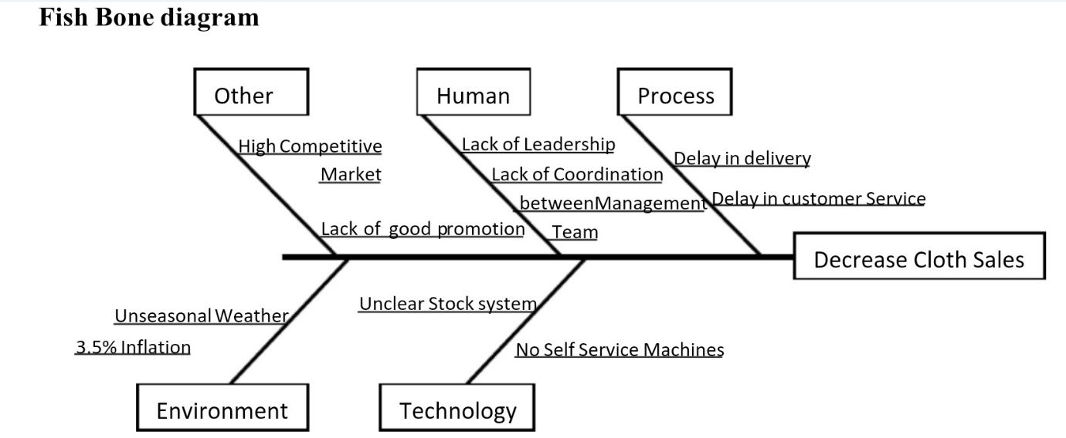
Source: (Marksandspencer.com, 2019).
The Fish Bone Diagram signals that M&S has been quite successful in meeting its operational management objectives. This has been successful due to the implementation of the operational plan in a defining the period. The yearly report 2016/17 of M&S indicates that its international sales have increased by 4.5% as the store performance of rolling store increased by 3% & the sales of home furniture have increased by 2% (Marksandspencer.com, 2019). This happened due to the faster delivery times, high efficiency in operations and maintenance of quality standards in the functional areas of operations. However, the down in clothing sales of M&S by 2.4% in 2017 has signalled a negative situation in operation management too (Hobbs, 2019).
Marks and Spencer did not able to excel in this area due to difficult trading conditions, lack of good promotion compared to the other firms in the clothing market & bad weather. So, the sales of clothes segment should be increased by appointing a new management team and bringing development in the stock management & supply chain system (Hobbs, 2019). To materialise this, M&S can create a new team, initiating good promotional strategies and listening carefully about the suggestions of the customers relating to the effective operation management (Turban, 2011). Under the quality process of operation management, M&S should promise customers to deliver difference and creativity in its new products than the competitors (Marksandspencer.com, 2019).

2.5 Analysing the customer experience of Marks and Spencer
Customer experience is the most crucial factor in attaining success in the apparel industry nowadays. Recent surveys signal that firms like Marks and Spencer who are offering great customer experience are being successful to increase customer satisfaction rates, facilitate loyalty of customers & reduce customer churn (Dsl-toys.com, 2019). In Marks and Spencer, 4Es are used in marketing and branding for improving the customer experience. Use of augmented reality to show the products; integrated & automated distribution for every market, real-time segment-pricing for the clothing & accessories & personalised promotion etc. initiatives of Zara are constantly helping the firm to enhance customer experience (Hobbs, 2019). The quality process of Marks and Spencer under the customer experience is run by putting customers at the centre of the strategy. The augmented reality experience of M&S stores has helped the firm to pull customers through increasing curiosity & enhancing the customer experience of the products. However, M&S is lagging in using the push strategy like its competitors such as Zara and H&M in improving the customer experience. So, M&S should focus on improving the customer’s experience from 4E strategy.
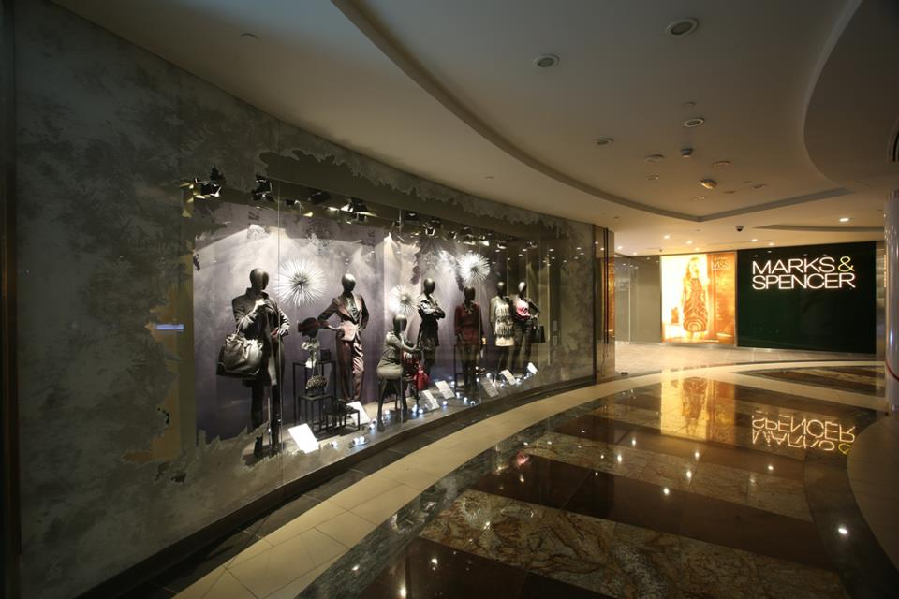
Figure: Marks and Spencer’s Virtual Closet (Gartner L2: Benchmarking Digital Performance, 2019).
Apart from the virtual environment, the quality process of Marks and Spencer under the customer experience cover excellent store experience. In-store experience along with the hottest trends, affordable price, creative new offerings have facilitated the loyal customer base for Marks and Spencer (Armstrong and Kotler, 2014). However, the use of interactive services such as self-service checkouts & aiding technologies is not used in Marks and Spencer to improve the customers’ experience (such as using do-it-yourself kiosks) and reduce long waiting. Finally, M&S should include easier online order system and fitting room to reduce the lead-time of ordering and make the customer experience more coordinated & easier at the store respectively.

Conclusion
Numerous factors, activities and strategies of M&S have been analysed critically throughout the report to find out the effectiveness of the firm in offering quality products & service and meeting the requirements of customers. The factors that influence the ability of M&S in satisfying the customer requirements are value chain, quality standards & control, ethical considerations and framework of customer value. The quality process that defines the effectiveness of Marks and Spencer in satisfying the customer requirements are operation management process, customer relationship management, quality control process, customer experience process and quality process for buying products.

References
Armstrong, G. and Kotler, P. (2014). Marketing. Upper Saddle River, N.J.: Prentice Hall.
Assael, H. (2011). Consumer Behavior and Marketing Action. 5th ed. Cincinnati, Ohio: South-Western College Pub.
Dsl-toys.com. (2019). Quality and Standards. [online] Available at: http://www.dsl-toys.com/quality-and-standards/ [Accessed 18 Mar. 2019].
DOLIGALSKI, T. (2016). INTERNET-BASED CUSTOMER VALUE MANAGEMENT. [Place of publication not identified]: SPRINGER INTERNATIONAL PU.
Dukes, A. and Zhu, Y. (2016). Why Customer Service Frustrates Consumers: Exploiting Hassle Costs by a Tiered Customer Service Organization. SSRN Electronic Journal.
Goodman, J. (2011). Strategic customer service. New York: AMACOM.
Gibbert, M., Woodside, A. and Golfetto, F. (2011). Creating and managing superior customer value. Bingley: Emerald Group Publishing Limited.
Gartner L2: Benchmarking Digital Performance. (2019). Flash of Genius: Marks & Spencer’s Virtual Closet. [online] Available at: https://www.l2inc.com/daily-insights/flash-of-genius-marks-spencers-virtual-closet [Accessed 18 Mar. 2019].
Hobbs, T. (2019). M&S looks to augmented reality in a bid to boost GM sales. [online] Marketing Week. Available at: https://www.marketingweek.com/2017/08/01/marks-and-spencer-considers-augmented-reality/ [Accessed 18 Mar. 2019].
I-cio.com. (2019). M&S: Navigating retail technology’s shifting sands | I-CIO. [online] Available at: https://www.i-cio.com/innovation/it-infrastructure/item/m-s-navigating-retail-technology-s-shifting-sands [Accessed 18 Mar. 2019].
Jerger, C. and Wirtz, J. (2017). Service Employee Responses to Angry Customer Complaints. Journal of Service Research, 20(4), pp.362-378.
Jones, R. (2018). Engineering Cheerful Robots: An Ethical Consideration. Information, 9(7), p.152.
Marksandspencer.com. (2019). Make it Matter | Turn good intentions into great actions | M&S. [online] Available at: https://www.marksandspencer.com/s/make-it-matter [Accessed 18 Mar. 2019].
Marksandspencer.com. (2019). The M&S Archive. [online] Available at: https://www.marksandspencer.com/c/style-and-living/the-mands-archive [Accessed 18 Mar. 2019].
Mello, S. (2012). Value innovation portfolio management. Boca Raton, Fla.: J. Ross.
Michelli, J. (2012). The new gold standard. New York: McGraw-Hill.
Nickels, W., McHugh, J. and McHugh, S. (2013). Understanding business. New York: McGraw-Hill Irwin.
Paluch, S. and Blut, M. (2013). Service Separation and Customer Satisfaction. Journal of Service Research, 16(3), pp.415-427.
Rajagopal and Castano, R. (2015). Understanding consumer behaviour and consumption experience. Hershey, Pa: Business Science Reference.
Shaw, C. (2013). Revolutionize your customer experience. Houndmills, Basingstoke, Hampshire: Palgrave Macmillan.
Turban, E. (2011). Information technology for management. Hoboken, NJ: J. Wiley & Sons.
Webb, N. (2011). The digital innovation playbook. Hoboken, N.J.: Wiley.

