Title: A critical evaluation and the identification of next teaching and learning steps focusing on a case study of an individual learner or a group of learners, based on an observed critical incident.

1- Introduction
The aim of this essay is to reflect on a critical incident that was identified by observation during placement, which highlights the issue of potential exclusion within the school environment. Relevant educational theories will help determine why the critical incident was significant and why the child/children acted in a particular way. Researching these theories will help underpin the next teaching and learning steps to better understand this process and recognise why this critical incident was apparent in the lesson, and the necessary steps to take, to improve the classroom environment.
It is important to get a good knowledge of critical incidents and how they are handled in the classroom, to better understand the role of the teacher. Throughout this essay there will be information that underlines the key pedagogical approaches involving the critical incident, which involve the role of critical reflection, which connects observation to the Four Purposes highlighted by Donaldson (Donaldson, 2006) and other theories such as Gibbs reflective cycle (Markkanen, et al.,2020). Additional research will be explored in the topic area involving Hereditary Spastic Paraplegia (HSP) as the critical incident observation, and reflections will involve how this condition and its importance to the student involved, identify this as a critical incident. In particular, the mobility problems, accessibility within the classroom environment and how the disability affects children will be critically appraised. The overall study will discuss the critical incident, including reflecting and evaluating to identify next steps.
A study by Bruster, and Peterson, (2013), discusses the use critical incidents have as a ‘tool’ to reflect and allow for a good framework to begin the reflective process. An incident is seen as critical when the reflection has taken place after the incident has occurred. Further research reviewed will underpin the understanding of the critical incident and its link with classroom observation to show its reliability and value, as this has achieved success with other researchers. This research on the critical incident will help improve professional practice because it allows for better understanding on what is needed from the teachers as well as advancing organisational development through learning (Serrat, 2017). Throughout this reflection there will be many theories considered, such as Social Learning Theory (SLT) by Albert Bandura (McLeod, 2011), where there was previous research on child development with contextualism and Skinner's operant conditioning is also considered as an underpinning factor. Further research is referenced on the cognitive development theory by Piaget and Vygotsky (Tudge, and Rogoff,1999) which gauges a better understanding of how these theories would affect the students in the critical incident.

1.1-The role of critical reflection
What is a critical reflection?
Critical reflection allows you to explore and question the critical incident, to investigate what happened and why it happened (‘Critical’ Reflection Framework. 2007). Throughout this investigation, critical reflection allows for a deeper understanding of a person’s assumptions and the way an issue is perceived, showcasing actions, feelings and beliefs associated to the investigation or incident. A critical reflection is started from course materials such as a lecture, discussion, or an observation (June, Yaacob, and Kheng, 2014). The researcher identifies what theories are connected or if there is bias, the researchers explore the cause or triggers in the incident to identify the core problems, and the underlining problems where the bigger issue are discovered (University of Waterloo, 2019). The study by Smith (2011) states that critical reflection is professionally and ethically a positive tool, and it is promoted in several areas of professional development and practice.
What is the role of a critical reflection?
The role of a critical reflection is to develop a theory base, it is a rational move for students to follow that observing critical incidents is to be able to recognise and negotiate complicated ethical and professional matters, although according to Smith (2011) there are challenges with curriculum design, assessment, and professional development by teaching critical reflection. The role and purpose of critical reflecting is to identify if an incident is critical, which according to Bruster, and Peterson (2013) is the reason why an incident needs to be researched to determine why the incident is problematic. The purpose of a critical incident is to build an environment that is a trusting learning space where pupils can try new things and take risks while feeling safe. Fook, and Askeland, (2007) highlight that there is a connection with critical reflections and the place of emotions, such as feeling safe. However, these articles are not recent and having more current literature would allow a deeper understanding of this critical incident.
Developing the role of teaching as a profession
The role of the teacher is to use critical reflection to improve the quality of their work, which was identified by Darling-Hammond, and Hyler, (2013) who also suggest that the teacher cares about the development of the teaching as an ever-developing profession. Darling-Hammond, and Hyler, (2013) also state the implementation of assessments in teaching, is around critical strategies for developing teachers’ knowledge, as well as improving the quality and preparation of the teacher. According to Bruster, and Peterson, (2013), critical reflection has been an acknowledged element within student teacher training for many years and this research clearly shows its importance within teaching.

Link to reforms in education and the roles of teachers.
The First Minister (Carwyn Jones) understood that the educational system in Wales was unacceptably poor and needed to be reformed. He felt it was important to hire a recognised politician that understood and could change the system for the better (Andrews, 2014). The new, improved and developing curriculum was the product of the introduction of Leighton Andrews to the Welsh assembly. The evidence gathered by the review included extensive engagement with schools, teachers, young people, parents, and major Welsh organisations and individuals (Donaldson, 2016). The Curriculum allows more flexibility and autonomy for teachers and schools, while promoting active forms of pedagogy and twenty-first-century skills (Sinnema, Nieveen, and Priestley, 2020). Reflection has become an accepted component of teacher education programs (Beauchamp, 2015). Concepts of reflection are very important to answer what exactly is a teacher (Korthagen, 2004) and (Brookfield, 2017).
2- Observation School and Class context
During this placement, the observation was based on a Welsh speaking primary school in South Wales, observing one year group (year two) with only thirty students in this year group, over a two-day period. The level of Welsh in this lesson was varied but to a good standard that was praised and taught throughout by the teacher. By observing this year group, it allowed a deeper understanding of the students who were observed in several different lessons. During the observation, the purpose was to identify a critical incident to gain a deeper understanding of the smaller details around the students with physical disabilities in the lessons. The student’s proximity in the lesson, made it clear that there were obstacles to teaching the student who had a physical disability, which is when it was decided that this was the critical incident that needed to be researched.
BERA 2018 was used to ensure the school and students were anonymised throughout my observation of the critical incident, not naming the school or student and ensuring all research on this critical incident is kept secure.In addition not naming the school in any notes collected and therefore used the BERA guidelines throughout. The school had a significant amount of knowledge surrounding the disability. This clearly showed that the teachers had an interest in helping the students, although not all areas of the school were adequate, some areas had limited access, but overall, the school clearly tried to ensure the student did not feel excluded.
2.2- Critical incident linked to Donaldson’s Four Purposes
The critical incident that was observed was in relation to a student with a physical disability, Hereditary Spastic Paraplegia (HSP). Throughout the observation it was clear that many obstacles and barriers were evident each day surrounding the student, such as the environment of the classroom and school not being accessible to the student’s disability or walking frame; this can be shown in appendix B, C and D. The classroom was obstructed by tables and toys and the school layout was not appropriate, with small steps to get into the classroom, a slope to get into the playground and the cloak room was too small, with other student’s bags and coats on the floor which made it difficult for the student to move around. Additionally, some activities during the observation were not suitable for the student, these activities were mainly interactive, which had all students standing up and moving around. Due to the student's physical disability, the student took much longer than the other children to complete the activity and it was clear that the student struggled and got tired more easily because of the extra effort used to do the tasks that others found simple and effortless. The student had a happy and resilient nature and always wanted to try and complete the activity, but the student could not retain their energy and consistency to complete the whole activity. This effected the student’s performance during the rest of the day in their work and resulted in their energy level decreasing during the observation of this critical incident.
Linked to Donaldson’s four purposes theory within the observation, the critical incident clearly linked to the purpose ‘enterprising’ which overall, means learners are ready to play a full part within life and work. This was linked to the observation because the student was almost never ready to start the lesson, as it took the student longer to settle and get into their place. Additionally, the student often struggled with pain in their legs which led to the student being ‘off task’ and therefore not ready to learn. This happened more after interactive activities where the student was tired after participating. Although the student has a physical disability, they have a happy, healthy, and confident character in the classroom which is linked to the purpose ‘healthy’ in Donaldson’s four purposes (Gatley, 2020).

3- Literature review

1- Disability
  - What is disability?
A disability is any condition of the body or mind (impairment) that makes it more difficult for the person with the condition to perform activities (activity limitation) and adapt/ interact with the world around them (Albrecht & Devlieger, 1999). Disabilities affect a diverse group of people with a large scale of additional needs (Hogg et al., 2001). The literature reviewed here shows that disability is one of the main global problems on different levels: social, health and economic (Barnes & Mercer, 2010). It has been estimated that over one billion people in the world live with some form of disability (Groce, 2004). At least one-fifth of these, approximately 200 million individuals, suffer from severe disabilities. As a result, they are forced to endure significant difficulties and problems throughout aspects of everyday life (Cassese & Raiola, 2017). The research has found that two individuals who suffer with the same disability will experience different struggles; no two cases are the same (Woolfson, 2004). Furthermore, some disabilities may be hidden or not easy to see (Wendell, 1989). A theme that runs parallel alongside disability is impairment (Jette, 2006). The term impairment is prominently associated with a loss or no form of psychological, physiological, or anatomical structure or function (Jette, 2006). Having an ‘abnormal structure’ of the brain can result in complications with mental functions, or problems with the structure of the eyes or ears which can result in difficulty with the functions of vision or hearing (Bogdashina, 2011).
Hereditary spastic paraplegia.
Hereditary Spastic Paraplegia (HSP) is a genetic disorder that usually leads to spasticity in the lower limbs. Wolf, et al. (2011). The disability is hereditary, meaning the gene is passed from parent to child. This gives an insight into this student’s home life as some of their family members have the same disability (the maternal grandfather). The researchers Solowska, and Baas, (2015) openly state that this disease/disability is ‘poorly understood’ meaning that this would make including the student in this critical incident harder because of the lack of understanding that research has on the disability. Additionally, the research by Adair et al. (2012), explained that there is not yet a decision on the most appropriate method to determine changes in the psychometric properties or functional mobility of measurement tools in children with HSP. There is little understanding of this disability within children, with little idea of how the condition affects children, this shines a light on the study by De, et al. (2010) which explains that countless children are mistakenly diagnosed with cerebral palsy, when they have HSP. This is an area that should be changed because the research states that the treatments for the two conditions are different. De Bot, et al. (2010) research shares that medical information on this condition is overshadowed by adult cases, which shows that it is difficult to evaluate a child's condition with HSP. Overall, HSP is well known but with most research being conducted on adults, it is harder to link the research to the child/student in this case study. Therefore, the central question in this critical incident, is, how does this condition impact as a potential ‘barrier to learning’?

- Physical disability in school
2.1- What things are put in place for students with physical disabilities in school.
There are many things that the Welsh government and schools have put in place to ensure students with disabilities are included within education. There are different policies given by the Welsh government for schools to follow, depending on the learning or physical disability (GOV.WALES. n.d.). Linking to this, the UK government introduced the Equality Act 2010, with regulations coming into force to ensure that students with disabilities are included and not discriminated against (Miles, 2021). When thinking of students with physical disabilities in school, it is important to consider all elements of inclusion in school, such as in the classroom (appendix B), in the playground (appendix D) and the school environment (appendix C). According to Bennett, and Hay, (2007) there is a link between the relationship the family has with the school, such as parental involvement and the improvement in the students’ social skills which ties in with the importance of Social Learning Theory (SLT) mentioned in the introduction to this essay. Research by Singh, (2007) states that teachers often do not have sufficient skills and knowledge to teach students with physical disabilities, feeling unprepared or lacking confidence in their ability to include learners with physical disabilities. This clearly shows that although the government and schools have policies and regulations to include all students, more work is needed to support the teacher when educating students with physical disabilities. Additionally, the research by Heller, et al (1999) expanded on the evidence that there is little help and insufficient courses given to teachers to support them teaching students with disabilities.

2.2- Facts and statistics about HSP within schools in Wales.
Hereditary Spastic Paraplegia as previously mentioned is a general term for a group of rare inherited disorders that cause weakness and stiffness in the leg muscles. Symptoms gradually get worse over time. In Wales, estimates range from 1 in 11,000 people to 1 in 77,000 people have this condition. The severity and progression of symptoms will vary from person to person. About 90% of people with Hereditary Spastic Paraplegia have what is known as a "pure form" of the condition. This means their symptoms are mainly confined to lower limb weakness and involuntary spasms and muscle stiffness (spasticity). The remaining 10% have a complicated or complex form of the condition (111.wales.nhs.uk). It is hard to investigate further into the statistics of HSP in Wales due to the lack of data provided. It is crucial that the case study is reliable (Easton, 2010). Investigating this disorder further will ensure more is known to educate and help others for the future. Reliability identifies the degree to which a person's information is true and free from measurement error. If information is deemed not reliable, it cannot be valid since it will not provide a good estimate of the ability or trait that the test intends to measure (Thompson, 2013). Providing an extra source of information will improve the reliability of other researchers’ work and will also back up the information supplied during this investigation into the critical incident.

3-Students with HSP and their potential setbacks.
Hereditary spastic paraplegia is a disease that effects the lower part of the body. It is difficult to always include those students with disabilities, especially after Singh, (2007) states that teachers do not have the training, knowledge, or confidence to teach students with physical disabilities. There are many potential setbacks that can be caused from being excluded especially when the student is being excluded because of having a physical disability. Setbacks with students with physical disabilities, could include both mental health and physical setbacks.
3.1-Mental health setback
The mental health setbacks with students with physical disabilities can cause psychological problems, (Tarren‐Sweeney, and Hazell, 2006). Things such as anxiety and depression are likely setbacks which students experience with physical disabilities when being excluded. The research by Kuper, (2019) shows that parents who have children with disabilities witness their children suffer with depression and anxiety as well as other mental health conditions. This is stressful for the parents. Both researchers Kuper (2019) and Urizar et al (2022) show similarities in their work and declare that parents with children with physical disabilities find it harder to parent due to the level of anxiety, stress and depression that children with physical disabilities can suffer from. Disabled children are seen to have either one or multiple psychiatric disorders and Jahan (2020) states that many of the psychiatric conditions are diagnosed in children with disabilities who suffer with depression. This shows a high importance to ensure that children with physical disabilities are included to prevent them suffering with their mental health.

3.2- Physical setbacks
Daniels and Cole (2010;12) show the importance of not being excluded; they stated that “I don’t think anyone should get excluded because it ruins your life”, this shows the detrimental effect that being treated differently and not being included can have on a person’s life. Children with disabilities often witness exclusion because of their mobility problems, especially at times during covid and school, (Steptoe, and Di Gessa, 2021). Those with disabilities and their families are at risk of burnouts because of the stress of exclusion. This causes a selection of issues that cause setbacks and restrictions, from emotional or learning disabilities, to physical illnesses or disabilities (Gérain, and Zech, 2018). Physical setbacks within school can be linked to the school `environment, such as accessibility to all areas of the school, so the students can move freely in the classroom or school environment to able them to have an easier time at school (Gebremariam, 2017). Setbacks can affect people with physical disabilities in later life. People with a disability are less likely to get a job in comparison to those with no disability (Van Beukering, 2021). It is important to understand the significance of barriers of learning, such as mental and physical setbacks because it can hinder a student's learning and affect their development as a child.

4-Reflection, evaluation, and next steps.
Gibbs reflective cycle was selected to reflect on and evaluate the critical incident selected while on observation. Within the study conducted by Adeani, Febriani, and Syafryadin (2020), the results revealed that Gibbs’ reflective cycle is a useful framework used especially by student teachers when reflecting on literacy assignments that are being worked on as it allows for a deeper understanding of the literacy. Additionally, Gibbs is considered the most appropriate reflective framework to be used, to ensure students and student teachers write a good quality reflection. I found that using this framework to reflect on this critical incident would be best suited as it is simple to understand and covers all areas of the incident being described. In addition, it allows the feelings around the critical incident to be expressed, as well as evaluating and analysing the incident being observed and finally it helps guide the student teacher toward a conclusion of the whole critical incident; finishing on an action plan to identify what could be changed next time to better the outcome.
Description
This observation took place during a year two lesson. This is where the critical incident was identified, this incident involved a student with a physical disability and how this student handled school life. From the start it was clear that the student had a physical disability as they used a walking frame to get around, with a clear lack of mobility in their legs. The aim of the observation was to see if the environment this student studied in was appropriate for her to succeed. Although the student clearly enjoyed the sessions and school, it was clear that some aspects were more difficult and not the most appropriate for the student’s needs. It became apparent that the school environment was not always suitable: with a small step coming into the classroom and a ramp to get into the playgroup. Finally, chairs and tables were placed inappropriately for the student to move around the classroom easily. Images of the environment are shown in appendix B, C, and D. One activity observed was when the class was reading the story of the Gruffalo. Each time the teacher said the ‘Gruffalo’, all the students were instructed to stand, stomp their feet and move their arms just like the Gruffalo would do. This activity was fun and exciting for the students and showed who was listening, but the student with the physical disability struggled to keep up with the other students and could not complete all the exercises leaving them tired for the rest of the school day. This activity was a good idea, and all the students enjoyed it but the student with the disability found it harder.
Feelings
Watching the student struggle doing the things everyone else took for granted was hard to watch. Linking above, activities that others take for granted were the things that the student struggled with the most. For example, the small step to get into the classroom each time they entered the school to learn. After watching the student, it was clear that although others were conscious of her ability and empathised, it did not completely hinder the student’s ability to learn, as they took part and enjoyed everything. The student does has adapted to ensure they are able to succeed. By the end of the observation the feelings towards the critical incident changed from a sad experience watching a student with a physical disability and struggling, to a student that can overcome and adapt to challenges and succeed.
Evaluation
This observation showed clear areas for improvement. The school could improve immediately on the accessibility for the students entering the classroom or playground and areas within the classroom; the layout could be improved to be made easily accessible. Images are shown in appendix B, C. Additionally, the research by Gebremariam, (2017) shows there can be physical setbacks due to the learning environment not being accessible for all disabilities. With all aspects considered, the school is inclusive and allows the student to feel an equal, treating the student with kindness and care and giving the student freedom just like everyone else, which ensured the student was happy in the lessons. This was discussed within the research by Miles, (2021) around the equality act 2010 and how being treated equal has a positive effect.

Analysis
Areas that could be improved around the environment can difficult and expensive to change but the school could look to adapt some aspects, such as add ramps, a clear floor policy and changing the layout of classrooms which are easier to implement. Examples of the restrictions within the school environment can be seen in appendix B, C, and D. It is hard to control the overall environment to suit the student’s needs. However, staff made sure that all students felt included and equal and this approach worked well in the lesson, as the student was treated like their peers and not treated any differently because of their disability. Nonetheless, Singh, (2007) states that teachers often do not have the appropriate training and knowledge on how to effectively teach students with disabilities. Although teachers feel they have insufficient knowledge, the priority is to ensure that all students are included and treated equally, regardless of the training available. With this lack of knowledge, teachers may not be willing to put the extra effort in. In relation to this critical incident, this was not the case, the teacher made sure all students were happy and succeeded to the best of their ability.

Conclusion (in Gibbs reflective cycle)
Overall, the observation suggests that there were situations that were learnt and can now be looked back and reflected on. To begin the assumption was made that the student with physical disability would be excluded, but by the end of the observation it was clear that regardless of the disability, the student involved themselves in everything, to drive and push to achieve everything others were doing. This was an observation, looking at how the teachers worked in these situations allowed me to see and develop my own skills considering this as a critical incident.
Action plan
Revisiting this observation would lead to similar actions. Although there was no intervention with the student, by stepping back and watching, more was learnt. The skills observed will help develop future teaching practice to help those with disabilities. The opportunity for more responsibility to put new skills into practice, while conscious of further and continuous development using observations will also help gain more skills. By stepping back and watching the critical incident unfold in its natural environment allowed skills such as analysing and understanding. By observing this critical incident it allows the researchers to look back and see what they can do next time to change and adapt the lesson to make sure everyone is included. An example could involve the children standing up for the story and waving their hands like the Gruffalo because all children in this classroom had the ability to lift their arms.
Gibbs reflective cycle will be used in future work to make certain that reflection and evaluation is made on my work as a teacher to progress and to better my teaching practise. Observing this critical incident with the student with a physical disability and looking at how the school adapted, is an area to reflect on, also knowing all students’ abilities in class will help to ensure the classroom and teaching is suitable for everyone’s needs in lessons. WWW.ewc.wales.(n.d.) state that completing academic writing is where student teachers show their progression as a reflective practitioner. It is also important to remember that with the curriculum changing it is important to look back on Gibbs to reflect on your own practice.

- Conclusion
To summarise the critical incident, the student with Hereditary Spastic Paraplegia enjoyed all lessons, although there were clear challenges faced. The learning environment around the school left some clear risks and challenges for the student, as shown in appendix B, C and D; things such as the layout of the room, unsuitable for the student’s walking frame, the playground and even the classroom entrance was challenging because the environment was not built or suitable for the student’s disability.
A reflective practitioner will have knowledge of the school, including the students and the curriculum, to overall increase the teaching process. Linking to the observation of this critical incident and from research undertaken and discussion with the teacher, knowledge was gained to be able to get the best understanding of the student and their disability. To maximise the teaching process within this observation, the overall need is to understand the student’s disability and how the environment affected the student’s mobility in a holistic manner.
This approach is closely linked to the new professional standards for teaching, such as the teacher’s professional attributes, professional knowledge and understanding, and professional skills, which provides overall clarity on how teachers educate (Stronge,2018). Active interprofessional education in a patient-based setting increases perceived collaborative and professional competence. This is linked to observation, as during this time there was a need to identify a critical incident, while considering what is a critical incident, and if the critical incident is reliable enough and if the critical incident could be researched (Hallin, et, al.,2009). After all these factors there were three critical incidents selected. After research the final critical incident was selected because of the interest to include the student and the lack of research in this area. It is clear that this critical incident is also linked to self-determination theory because the student showed motivation by choosing to complete a task that would be considered as challenging.
In conclusion, an overview of the critical incident involving the disability Hereditary Spastic Paraplegia clearly show that there is minimum amount of knowledge and research around the disability, especially when a child is diagnosed with the disability. There is a clear need for more research and training surrounding the disability and how children are affected by it in a learning environment. With more research and training, it will help teachers educate those students and to ensure that all students are included and treated equally in the lesson.

- APPENDICES
Appendix A
ARSYLWI / NODIADAU MAES

Cofnod 1

Dyddiad ac amser, grŵp blwyddyn: 26 ain o Medi 2022, Blwyddyn dau

Ble a Phryd: Cyd-destun yr arsylwi – pwnc/MDPh, cyd-destun cyffredinol yr ystafell ddosbarth

Y wers hon oedd sesiwn gyntaf y dydd cyn amser egwyl.

Beth ddigwyddodd: disgrifiad manwl o’r digwyddiad critigol (gorau po fwyaf o fanylder er mwyn gallu cyfeirio ato yn eich gwaith diweddarach)

Digwyddiad critigol
-Myfyriwr gyda pharlys paraplegia sbastig etifeddol.
-Wrth ddarllen y llyfr ar y Gruffalo, bob tro dywedodd yr athro fod yr enw Gruffalo i gyd yn rhoi'r gorau i stampio gyda'u breichiau i fyny a llaw fel crafangau. Oherwydd anabledd corfforol y myfyriwr, cymerodd y myfyriwr lawer hirach na'r plant eraill i sefyll i fyny, hyd yn oed pan wnaeth y myfyriwr sefyll, ni allent gwblhau'r holl symudiadau oherwydd eu bod yn dal eu pwysau corff ar y ffrâm gerdded. Cwblhaodd y myfyriwr y gweithgaredd o godi ac i lawr heb gwblhau'r holl symudiadau gyda gwên ond oherwydd yr ymdrech ychwanegol a ddefnyddiwyd i sefyll i fyny roeddent yn aml allan o amser gan y myfyrwyr eraill oherwydd y cyflymder na allent sefyll i fyny mor gyflym â'r lleill. Erbyn diwedd y gweithgaredd roedd y myfyriwr wedi ymlâdd, a daeth yn fwy amlwg erbyn diwedd y llyfr ei bod yn llawer arafach na'r myfyrwyr eraill gan y gallent gadw eu hegni a'u cysondeb i gwblhau'r holl weithgaredd.

Meysydd archwilio posibl: beth yn eich barn chi a allai fod “o dan yr wyneb” yn y digwyddiadau hyn? Pa lwybrau ymchwil gallech chi eu hystyried?

Etifeddwyd yr anabledd corfforol, a allai achosi ymdeimlad o normalrwydd efallai na fydd gwelliant i'w hanabledd yn flaenoriaeth. Yn ogystal, o'i harchwilio daeth i'r amlwg bod trefniadau byw gartref yn awgrymu nad oedd addasiadau priodol yn addas ar gyfer anabledd y stydnetau sydd â chysylltiad agos â'r ysgol heb addasu'r cyfleuster ysgol yn llawn i gyd-fynd ag anabledd y myfyrwyr.

Nodiadau: unrhyw fanylion gallwch eu nodi (ydy hi’n amgylchedd prysur, ydy hi ar ôl cinio, oes llawer o bethau’n tynnu sylw’r cyfranogwyr, ydy cyfarwyddiadau’n cael eu gwneud yn eglur – gorau po fwyaf o bethau y gallwch gyfeirio atynt yma)

-5 awr am danwainiau, waithiau mynd i Ty bach
- angen gweud amgylchedd addas

Cofnod 2

Dyddiad ac amser, grŵp blwyddyn: 26 ain o Medi 2022, Blwyddyn dau .
Ble a Phryd: Cyd-destun yr arsylwi – pwnc/MDPh, cyd-destun cyffredinol yr ystafell ddosbarth

Beth ddigwyddodd: disgrifiad manwl o’r digwyddiad critigol (gorau po fwyaf o fanylder er mwyn gallu cyfeirio ato yn eich gwaith diweddarach)

Myfyrwyr ag awtistiaeth Mae strategaethau ar waith i'w helpu er ei bod yn amlwg ei fod wedi ymgartrefu yn ei ddosbarth ond weithiau'n gallu teimlo wedi'u llethu weithiau. Ar ôl siarad gyda'r athro cafodd y myfyriwr ei lethu'n fwy ym mlwyddyn un a'r feithrinfa ac mae wedi dangos gwelliannau gydag ef yn teimlo wedi'u llethu. Nid oes gan y myfyrwyr un i un oherwydd ei ymddygiad mewn gwers mewn da, mae hyn yn dod â phryderon ac amheuon y gallai ddisgyn ar ei hôl hi yn ddiweddarach yn y blynyddoedd diwethaf.

Meysydd archwilio posibl: beth yn eich barn chi a allai fod “o dan yr wyneb” yn y digwyddiadau hyn? Pa lwybrau ymchwil gallech chi eu hystyried?

Byddaf yn edrych i ymchwilio i'r effaith y mae un i un cynorthwyydd addysgu yn ei gael ar blentyn/ myfyriwr ag awtistiaeth, i anniweidrwydd os yw hyn yn effeithiol y stydi.

Nodiadau: unrhyw fanylion gallwch eu nodi (ydy hi’n amgylchedd prysur, ydy hi ar ôl cinio, oes llawer o bethau’n tynnu sylw’r cyfranogwyr, ydy cyfarwyddiadau’n cael eu gwneud yn eglur – gorau po fwyaf o bethau y gallwch gyfeirio atynt yma)

- Pethau yn cymrud sylw
- siarad un cywair
- pan fo pethau'n mynd yn galed mae'r myfyrwyr yn mynd yn rhwystredig

Cofnod 3

Dyddiad ac amser, grŵp blwyddyn: 26 ain o Medi 2022, Blwyddyn dau .

Ble a Phryd: Cyd-destun yr arsylwi – pwnc/MDPh, cyd-destun cyffredinol yr ystafell ddosbarth

Roedd yr arsylwad hwn yn seiliedig ar lesosn a ddisgrifiodd y myfyrwyr gruffalo gan ddefnyddio ansoddeiriau

Beth ddigwyddodd: disgrifiad manwl o’r digwyddiad critigol (gorau po fwyaf o fanylder er mwyn gallu cyfeirio ato yn eich gwaith diweddarach)

Roedd gwers ar ddisgrifio anghenfil a grewyd ganddynt, gwnaed hyn drwy edrych ar eu llun maent wedi gwneud o'r blaen ac ysgrifennu gan ddisgrifio geiriau o gwmpas y mwyaf. Y digwyddiad tyngedfennol a welais yma fod yr athro yn nodi bod y myfyrwyr yn gweithio o'u blaenau. Gwnaed hyn heb unrhyw ryngweithio rhwng yr athro a'r myfyrwyr gyda'r marcio a ganfyddais y byddai wedi bod yn fwy defnyddiol i'r tsudnest gael adborth geiriol tra roedd y techaer yn marcio oherwydd bod y grwpiau rhwng pump a chwech. Gyda niferoedd bach yn y grwpiau gallai fod mwy o ryngweithio rhwng yr athro a'r myfyriwr wrth farcio i roi'r adborth gorau i wella eu gwaith, oherwydd fel hyn doedd yr athro ddim yn rhoi sylw llawn iddi i'r grŵp roedd hi'n ei ddysgu. Hefyd roedd yr athro yn amlwg yn croesi'r gwaith oedd yn anghywir oedd yn gallu effeithio ar y myfyrwyr oedd yn gallu eu gweld yn hawdd.

Meysydd archwilio posibl: beth yn eich barn chi a allai fod “o dan yr wyneb” yn y digwyddiadau hyn? Pa lwybrau ymchwil gallech chi eu hystyried?

Gwnaed y marcio mewn coch felly rwyf am ymchwilio os byddai'r lliw coch yn effeithio ar eu hyder, megis cyswllt â choch gyda stop a pherygl.

Nodiadau: unrhyw fanylion gallwch eu nodi (ydy hi’n amgylchedd prysur, ydy hi ar ôl cinio, oes llawer o bethau’n tynnu sylw’r cyfranogwyr, ydy cyfarwyddiadau’n cael eu gwneud yn eglur – gorau po fwyaf o bethau y gallwch gyfeirio atynt yma)

Fyddai'r marcio yn fwy buddiol i'r athrawon, na'r myfyrwyr.

Appendix B
Classroom
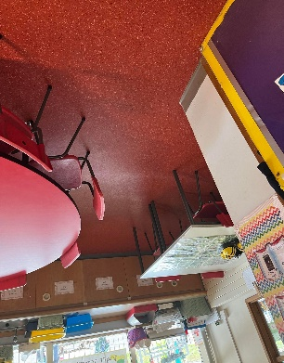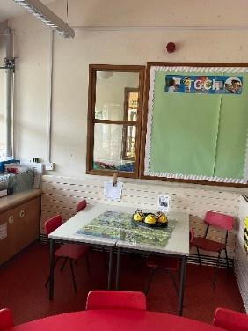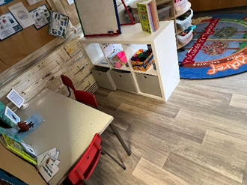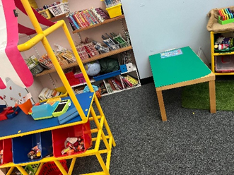

Appendix C
Cloak room
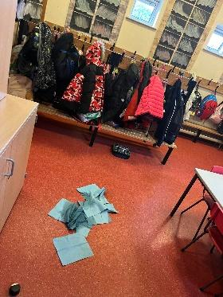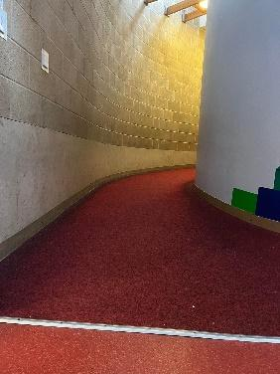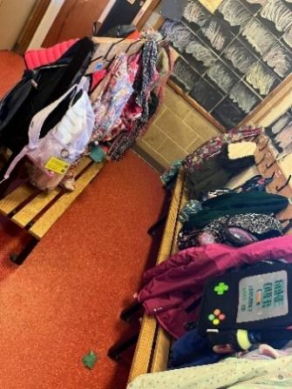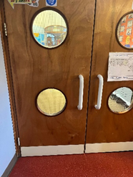

Appendix D
Play ground
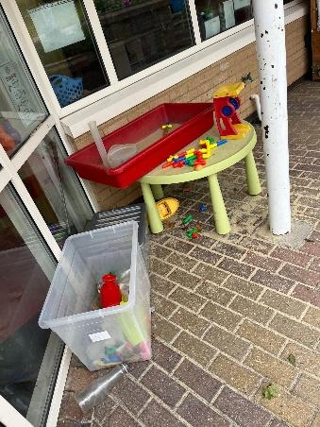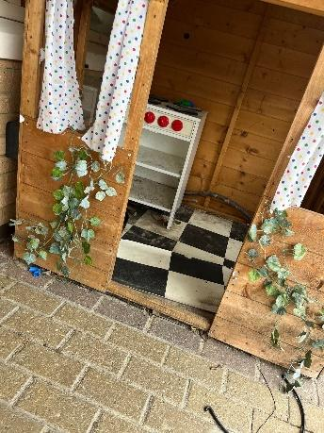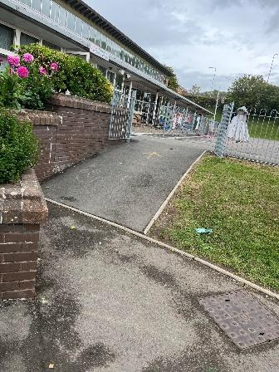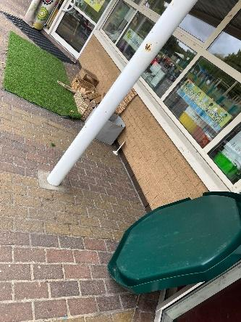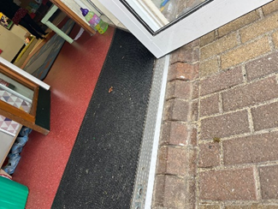

Reference list
111.wales.nhs.uk. (n.d.). NHS 111 Wales. [online] Available at: https://111.wales.nhs.uk/Spasticparaplegia [Accessed 10 Oct. 2022]
Adair, B., Said, C.M., Rodda, J. and Morris, M.E., 2012. Psychometric properties of functional mobility tools in hereditary spastic paraplegia and other childhood neurological conditions. Developmental Medicine & Child Neurology, 54(7), pp.596-605.
Adeani, I.S., Febriani, R.B. and Syafryadin, S., 2020. USING GIBBS’REFLECTIVE CYCLE IN MAKING REFLECTIONS OF LITERARY ANALYSIS. Indonesian EFL Journal, 6(2), pp.139-148.
Albrecht, G.L. and Devlieger, P.J., 1999. The disability paradox: high quality of life against all odds. Social science & medicine, 48(8), pp.977-988.
Andrews, L., 2014. Ministering to education: A reformer reports. Parthian Books.
Barnes, C. and Mercer, G., 2010. Exploring disability. Polity.
Beauchamp, C., 2015. Reflection in teacher education: Issues emerging from a review of current literature. Reflective practice, 16(1), pp.123-141.
Bennett, K.S. and Hay, D.A., 2007. The role of family in the development of social skills in children with physical disabilities. International Journal of Disability, Development and Education, 54(4), pp.381-397.
Bogdashina, O., 2011. Autism and the edges of the known world: Sensitivities, language and constructed reality. Jessica Kingsley Publishers.
Brookfield, S.D., 2017. Becoming a critically reflective teacher. John Wiley & Sons.
Bruster, B.G. and Peterson, B.R., 2013. Using critical incidents in teaching to promote reflective practice. Reflective Practice, 14(2), pp.170-182.
Cassese, F.P. and Raiola, G., 2017. The importance of sport in disability management. Sport Science, 10(1), pp.7-11.
Critical’ Reflection Framework. (2007). [online] Available at: https://www.education.vic.gov.au/Documents/childhood/professionals/support/reffram.pdf.
Daniels, H. and Cole, T., 2010. Exclusion from school: short‐term setback or a long term of difficulties?. European Journal of Special Needs Education, 25(2), pp.115-130.
Darling-Hammond, L., & Hyler, M. E. (2013). The role of performance assessment in developing teaching as a profession. Rethinking schools, 27(4), 10-15.
De Bot, S.T., Van de Warrenburg, B.P.C., Kremer, H.P.H. and Willemsen, M.A.A.P., 2010. Child neurology: hereditary spastic paraplegia in children. Neurology, 75(19), pp.e75-e79.
Donaldson, G., 2006. Cultivating leadership in schools: Connecting people, purpose, and practice. Teachers College Press.
Donaldson, G., 2016. A systematic approach to curriculum reform in Wales. Cylchgrawn Addysg Cymru/Wales Journal of Education, 18(1), pp.7-20.
Easton, G., 2010. Critical realism in case study research. Industrial marketing management, 39(1), pp.118-128.
Fook, J. and Askeland, G.A., 2007. Challenges of critical reflection:‘Nothing ventured, nothing gained’. Social work education, 26(5), pp.520-533.
Gatley, J., 2020. Can the New Welsh Curriculum achieve its purposes?. The Curriculum Journal, 31(2), pp.202-214.
Gebremariam, M.K., Vaqué-Crusellas, C., Andersen, L.F., Stok, F.M., Stelmach-Mardas, M., Brug, J. and Lien, N., 2017. Measurement of availability and accessibility of food among youth: a systematic review of methodological studies. International Journal of Behavioral Nutrition and Physical Activity, 14(1), pp.1-19.
Gérain, P. and Zech, E., 2018. Does informal caregiving lead to parental burnout? Comparing parents having (or not) children with mental and physical issues. Frontiers in Psychology, 9, p.884.
GOV.WALES. (n.d.). Learning Disability Strategic Action Plan 2022 to 2026. [online] Available at: https://gov.wales/learning-disability-strategic-action-plan-2022-2026 [Accessed 11 Oct. 2022].
Groce, N.E., 2004. Adolescents and youth with disability: Issues and challenges. Asia Pacific Disability Rehabilitation Journal, 15(2), pp.13-32.
Hallin, K., Kiessling, A., Waldner, A. and Henriksson, P., 2009. Active interprofessional education in a patient based setting increases perceived collaborative and professional competence. Medical teacher, 31(2), pp.151-157.
Heller, K.W., Fredrick, L.D., Dykes, M.K., Best, S. and Cohen, E.T., 1999. A national perspective of competencies for teachers of individuals with physical and health disabilities. Exceptional Children, 65(2), pp.219-234.
Hogg, J., Cavet, J., Lambe, L. and Smeddle, M., 2001. The use of ‘Snoezelen’as multisensory stimulation with people with intellectual disabilities: a review of the research. Research in developmental disabilities, 22(5), pp.353-372.
Jahan, S., Araf, K., Gozal, D., Griffiths, M.D. and Mamun, M.A., 2020. Depression and suicidal behaviors among Bangladeshi mothers of children with Autistic Spectrum Disorder: a comparative study. Asian journal of psychiatry.
Jette, A.M. and Field, M.J. eds., 2007. The future of disability in America.
June, S., Yaacob, A. and Kheng, Y.K., 2014. Assessing the use of YouTube videos and interactive activities as a critical thinking stimulator for tertiary students: An action research. International Education Studies, 7(8), pp.56-67.
Korthagen, F.A., 2004. In search of the essence of a good teacher: Towards a more holistic approach in teacher education. Teaching and teacher education, 20(1), pp.77-97.
Kuper, H., Lopes Moreira, M.E., Barreto de Araújo, T.V., Valongueiro, S., Fernandes, S., Pinto, M. and Lyra, T.M., 2019. The association of depression, anxiety, and stress with caring for a child with Congenital Zika Syndrome in Brazil; Results of a cross-sectional study. PLoS neglected tropical diseases, 13(9), p.e0007768.
Markkanen, P., Välimäki, M., Anttila, M. and Kuuskorpi, M., 2020. A reflective cycle: Understanding challenging situations in a school setting. Educational Research, 62(1), pp.46-62.
McLeod, S. (2011). Albert Bandura's social learning theory.
Miles, J. ed., (2021). The Equality Act 2010 (Disabled School Pupils) (Wales) Regulations 2021. [online] Available at: https://gov.wales/sites/default/files/publications/2022-01/equality-act-2010-disabled-school-pupils-wales-regulations-2021.pdf.

Norstedt, M., 2019. Work and invisible disabilities: Practices experiences and understandings of nondisclosure. Scandinavian Journal of Disability Research, 21(1), pp.14-24.
Serrat, O., 2017. The critical incident technique. In Knowledge solutions (pp. 1077-1083). Springer, Singapore.
Singh, D.K., 2007. General Education Teachers and Students with Physical Disabilities. Online Submission, 14(7), pp.205-214.
Sinnema, C., Nieveen, N. and Priestley, M., 2020. Successful futures, successful curriculum: What can Wales learn from international curriculum reforms?. The Curriculum Journal, 31(2), pp.181-201.
Smith, E., 2011. Teaching critical reflection. Teaching in higher education, 16(2), pp.211-223.
Solowska, J.M. and Baas, P.W., 2015. Hereditary spastic paraplegia SPG4: what is known and not known about the disease. Brain, 138(9), pp.2471-2484.
Steptoe, A. and Di Gessa, G., 2021. Mental health and social interactions of older people with physical disabilities in England during the COVID-19 pandemic: a longitudinal cohort study. The Lancet Public Health, 6(6), pp.e365-e373.
Stronge, J.H., 2018. Qualities of effective teachers. Ascd.
Tarren‐Sweeney, M. and Hazell, P., 2006. Mental health of children in foster and kinship care in New South Wales, Australia. Journal of paediatrics and child health, 42(3), pp.89-97.
Thomas, R. M. (2000). Comparing theories of child development. Wadsworth/Thomson Learning.
Thompson, N.A., 2013. Reliability & Validity. Assessment Systems.
Tudge, J., & Rogoff, B. (1999). Peer influences on cognitive development: Piagetian and Vygotskian perspectives. Lev Vygotsky: critical assessments, 3(6), 32-56.
University of Waterloo (2019). Critical reflection. [online] Writing and Communication Centre. Available at: https://uwaterloo.ca/writing-and-communication-centre/critical-reflection.
Urizar Jr, G.G., Ramírez, I., Caicedo, B.I. and Mora, C., 2022. Mental health outcomes and experiences of family caregivers of children with disabilities during the COVID‐19 pandemic in Bolivia. Journal of Community Psychology, 50(6), pp.2682-2702.
Van Beukering, I.E., Smits, S.J.C., Janssens, K.M.E., Bogaers, R.I., Joosen, M.C.W., Bakker, M., Van Weeghel, J. and Brouwers, E.P.M., 2021. In what ways does health related stigma affect sustainable employment and well-being at work? A systematic review. Journal of Occupational Rehabilitation, pp.1-15.
Wolf, S.I., Braatz, F., Metaxiotis, D., Armbrust, P., Dreher, T., Döderlein, L. and Mikut, R., 2011. Gait analysis may help to distinguish hereditary spastic paraplegia from cerebral palsy. Gait & posture, 33(4), pp.556-561.
www.ewc.wales. (n.d.). Sharne Watkins and Paul Herrington - Enquiry-based practice: enabling student teachers to take responsibility for their professional learning. [online] Available at: https://www.ewc.wales/site/index.php/en/43-english/about/staff-room/blog-archive/102-sharne-watkins-and-paul-herrington-enquiry-based-practice-enabling-student-teachers-to-take-responsibility-for-their-professional-learning.html [Accessed 11 Oct. 2022].

