British Columbia 2022 Flood Recovery: Highway 5 Reopening And Principal Corridor Reconstruction

Prepared for:
University of Wales Trinity Saint David
Campus: Birmingham Campus
Prepared by:
[Anamaria Stancu] [Student Number:2333684]
Date:
November 2025
Course : [LCLM 5003 Project Management]
Lecturer: [Navid Nasirpourosgoei]

Table of Contents
- Part A: Project Proposal Poster
- Part B: Reflections on Feedback from Tutor and Peers
- Part C: Project Management Plan
- 1. Introduction
- 2. Project Description
- 3. Scope
- 4. Work Breakdown Structure (WBS)
- 5. Quad Chart
- 6. Gantt Chart
- 7. Stakeholder Involvement
- 8. Allocation of Resources
- 9. Risk Analysis
- 10. Budget
- 11. Conclusion
- 12. References
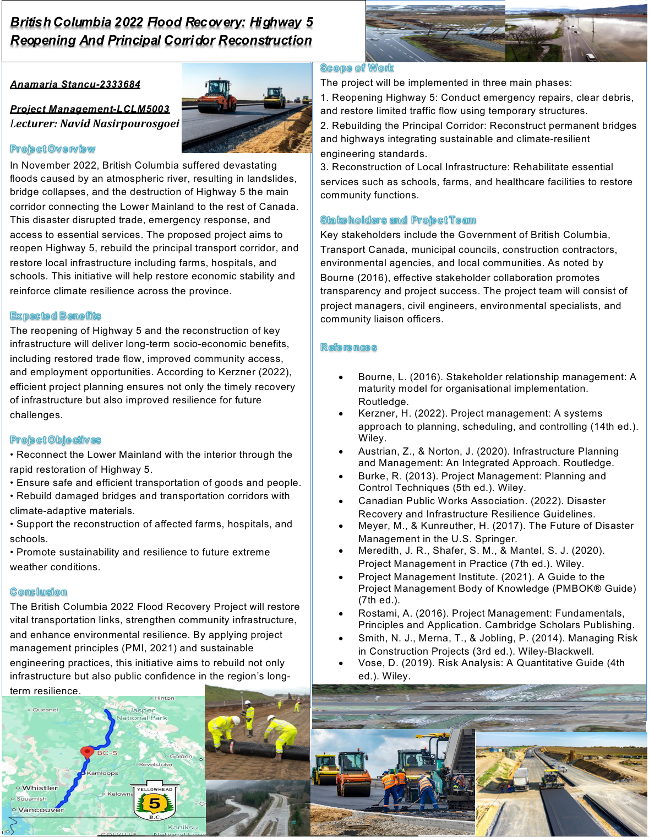
Part A: Project Proposal Poster

Part B: Reflections from the feedback received from tutor and peers:

Receiving feedback from both my tutor and peers was an important part of refining my project plan and improving the overall clarity, structure, and completeness of the work. Overall, the feedback highlighted several strengths in my initial submission, while also identifying specific areas that required improvement before producing the final version of the project management plan. Reflecting on this feedback has helped me better understand how to enhance the quality of my academic writing and project organisation.One of the main strengths consistently mentioned by both the tutor and my peers was the clarity and structure of my work. They commented that the project plan was easy to understand, covered almost all the required sections from the assignment brief, and presented information in a logical flow. This reassured me that my project planning approach and the way I organised the content were effective. In addition, I received positive feedback on my use of academic material, including the incorporation of proper academic references. My tutor acknowledged that I had used credible academic sources to support the analysis, which strengthened the reliability of my arguments. Furthermore, the images I included of the flood and damaged infrastructure were appreciated because they enhanced understanding by visually illustrating the severity of the situation and the importance of the project.Although the general feedback was positive, there were two significant areas for improvement that were consistently highlighted. The first key point raised by both my tutor and peers was the absence of a budget section. They noted that while the plan addressed most of the required components, the omission of the budget created a gap in the project’s completeness. Budgeting is a core part of project planning because it enables cost forecasting, resource allocation, and financial risk assessment. Reflecting on this, I realised that including a detailed and justifiable budget is essential, not only to meet the assignment requirements but also to demonstrate a realistic understanding of the scale of the recovery project. In the final plan, I will include a comprehensive budget section that outlines estimated costs for each major activity, incorporates contingency allowances, and explains potential funding sources.The second improvement suggested by my tutor was the need to add numbering to the sections. During my presentation, the lecturer explained that numbered sections would make the document easier to follow, especially given the length and complexity of the project plan. Clear section numbering improves navigation and helps the reader connect related parts of the report more easily. This was a simple but important adjustment that will enhance the professional format of my final submission.Reflecting on this feedback, I recognise that while the content of my project was strong, improving structural and organisational elements will make the final plan more polished and academically rigorous. I will implement these improvements by introducing a numbered format throughout the document and developing a detailed, well-justified budget section. Overall, the feedback has been valuable in helping me refine my work and strengthen the quality of the final project plan.

Part C: Project Management Plan:
1.Introduction:
November 2021, British Columbia (BC) experienced catastrophic flooding due to an atmospheric river, resulting in widespread infrastructure damage, including the collapse of bridges and roads, particularly along Highway 5. This disruption isolated the lower mainland from the rest of Canada, severely impacting transportation and local communities. The flooding also caused extensive damage to public and private infrastructure, including schools, hospitals, and farms. The Lower Mainland was temporarily isolated, slowing emergency response and supply deliveries (Canadian Public Works Association, 2022; Public Safety Canada, 2022).This Project Management Plan (PMP) explains how BC can recover. It follows proven project management methods, including planning, scheduling, risk management, and stakeholder engagement (Project Management Institute, 2021; Kerzner, 2022; Burke, 2013). As Kerzner (2022, p. 45) notes, “Successful projects rely on clear structure and disciplined control.”
The plan focuses on three main phases:
- Reopening Highway 5 temporary access for essential traffic.
Restoring temporary access along Highway 5 is critical for ensuring the immediate flow of essential goods, emergency services, and relief personnel. This measure prioritizes life-saving interventions, allowing ambulances, fire services, and police to reach affected areas without delay. Temporary routes and bypasses will be engineered to accommodate heavy vehicles carrying food, medical supplies, and construction materials. Traffic management strategies, including signage, temporary traffic signals, and safety patrols, will be implemented to reduce accidents and ensure smooth operations. While these routes may not provide full functionality, they will serve as a lifeline for residents and first responders, preventing isolation of communities during the reconstruction phase. Coordination with local authorities and transportation agencies will ensure that updates and restrictions are communicated effectively to the public, minimizing disruption while maximizing efficiency.
- Rebuilding the Principal Corridor long-term, resilient transportation route.
The principal corridor represents the backbone of regional connectivity and economic activity. Rebuilding this route will focus on resilience, incorporating modern engineering standards designed to withstand natural hazards, climate impacts, and future traffic demands. Bridges, overpasses, and roadbeds will be reinforced or replaced with durable materials, while traffic flow will be optimized to reduce congestion and improve safety. The project will integrate smart infrastructure technologies, such as real-time traffic monitoring and adaptive signaling systems, to enhance efficiency and reduce long-term maintenance costs. Furthermore, environmental considerations, including sustainable drainage systems and wildlife crossings, will be incorporated to minimize ecological disruption. The reconstructed corridor will not only restore regional mobility but also support commerce, tourism, and long-term economic recovery by ensuring reliable access to markets and resources.
- Reconstructing Local Infrastructure, restoring schools, hospitals, farms, and other community services.
Restoring local infrastructure is essential to rebuilding the social and economic fabric of affected communities. Schools will be repaired or rebuilt to provide safe, functional learning environments for children, while hospitals and clinics will be equipped to resume full medical services, including emergency care. Agricultural lands and farms, vital for food security, will receive assistance to repair irrigation systems, fencing, and storage facilities, enabling farmers to restart production quickly. Other community services, such as water supply, sanitation, electricity, and public transportation, will also be prioritized to support daily life and foster resilience. By integrating community input into reconstruction planning, these efforts will address local needs effectively, creating infrastructure that is not only functional but also adaptable to future challenges. The comprehensive approach ensures that residents can return to a sense of normalcy and that communities have the foundation needed for sustainable growth.

As Bourne (2016, p. 12) notes, “Effective engagement builds trust across all groups,” which is key to success in recovery efforts. The plan applies project management methodologies, including scope definition, work breakdown structures, scheduling, stakeholder engagement, resource allocation, and risk management, to ensure efficient recovery and community resilience (Meredith, Shafer & Mantel, 2020).

2. Project Description

Phase 1: Reopening Highway 5
- Objective: Restore temporary transportation access between the lower mainland and northern BC to facilitate emergency response and goods movement.
- Key Activities:
  - Assess highway damage and remove debris (Austrian & Norton, 2020).
  - Repair damaged road surfaces and guardrails.
  - Install temporary bridges or bypasses at collapsed sections.
  - Implement traffic management and safety protocols.
- Outcome: Reopened highway enabling limited vehicular traffic and emergency access. “Strong infrastructure planning supports long-term resilience” (Austrian & Norton, 2020, p. 37).

Phase 2: Rebuilding the Principal Corridor
- Objective: Reconstruct the main corridor permanently to ensure reliable, long-term transportation for goods and people.
- Key Activities:
  - Conduct structural assessments of collapsed bridges and roadways.
  - Develop engineering designs for resilient infrastructure (Smith, Merna & Jobling, 2014).
  - Procure materials and construction equipment.
  - Construct roads, bridges, and ancillary infrastructure.
  - Perform quality control, safety inspections, and final approvals.

Outcome: Fully restored corridor supporting sustainable transportation and economic recovery. “Good planning improves project certainty and performance” (Burke, 2013, p. 22).

Phase 3: Reconstruction of Local Infrastructure
- Objective: Repair and restore critical public and private infrastructure affected by flooding.
- Key Activities:
  - Assess damage to schools, hospitals, farms, and government offices.
  - Prioritize reconstruction based on societal impact and urgency (Meyer & Kunreuther, 2017).
  - Engage contractors and local authorities for rebuilding works.
  - Implement flood-resilient designs in rebuilding.
- Outcome: Reestablished community services, agricultural productivity, and public safety. “Communities recover faster when preparedness is prioritised” (Meyer & Kunreuther, 2017, p. 88)..

3. Scope
Inclusions:
- Repair and reopening of Highway 5 for temporary access.
- Full reconstruction of the principal corridor, including bridges and roads.
- Restoration of local infrastructure, including schools, hospitals, government offices, and farms.
- Resource management, stakeholder coordination, and risk mitigation planning.
Exclusions:
- Projects outside the affected flood zones.
- Long-term urban planning unrelated to flood recovery.
- Non-critical infrastructure not immediately impacting community recovery.

4. Work Breakdown Structure (WBS):

-Phase A: Highway 5 Reopening:
- 1.1.1 Damage assessment
- 1.1.2 Debris clearance
- 1.1.3 Temporary repairs and bridging
- 1.1.4 Safety checks and traffic management
- 1.1.5 Project closure and handover
-Phase B: Principal Corridor Reconstruction:
- 1.2.1 Structural assessment
- 1.2.2 Engineering and design
- 1.2.3 Procurement
- 1.2.4 Construction of bridges and roads
- 1.2.5 Quality assurance and final inspection
-Phase C: Local Infrastructure Reconstruction:
- 1.3.1 Damage assessment and prioritization
- 1.3.2 Contractor engagement
- 1.3.3 Restoration of schools
- 1.3.4 Restoration of hospitals
- 1.3.5 Restoration of farms and government offices
- 1.3.6 Final inspection and handover

5. Quad Chart
Project | Cost (CAD) | Schedule | Performance Metrics
Highway 5 Reopening | 50 million | 3 months | Road accessible, safe traffic flow
Principal Corridor | 500 million | 18 months | Fully restored corridor, durable bridges
Local Infrastructure | 200 million | 12 months | Functional schools, hospitals, and farms

6. Gantt Chart
Timeline Overview (Months):
Task | Month 1 | Month 2 | Month 3 | Month 4–6 | Month 7–12 | Month 13–18
Highway 5 Damage Assessment | X
Highway 5 Temporary Repairs | X | X | X
Principal Corridor Assessment | X | X
Engineering Design |  | X | X | X
Procurement |  |  |  | X
Corridor Construction |  |  |  | X | X | X
Local Infrastructure Assessment | X | X
Reconstruction Works |  |  | X | X | X
Quality Assurance / Handover |  |  |  | X | X | X

7. Stakeholders’ Involvement
Stakeholder | Role | Engagement Strategy
BC Provincial Government | Funding, oversight | Regular reporting, meetings
Local Municipalities | Coordination, approvals | Weekly progress updates
Emergency Services | Logistics support | Inclusion in planning
Contractors / Engineers | Construction, repair | Contract management, site supervision
Local Communities | Feedback, cooperation | Public forums, surveys
Transport Companies | Planning for goods movement | Consultations on temporary access
Getting everyone involved is a big part of making sure the BC Flood Recovery Projects work smoothly. When all the right people communicate and cooperate, the work gets done faster, safer, and with less confusion.
- BC Provincial Government – They provide the money, set the rules, and keep an eye on the project. They will meet regularly, get progress reports, and help make big decisions. They also make sure the project follows safety and environmental rules.
- Local Municipalities – Towns and cities help with local approvals, planning, and connecting with the community. They will get weekly updates on progress and help decide which local projects need attention first.
- Emergency Services – Ambulances, fire trucks, and police will make sure temporary roads and access points let them get where they need to go. They will also help check safety along the construction sites.
- Contractors and Engineers – These are the people building the roads, bridges, and buildings. They will keep in touch with project managers, follow all safety rules, and make sure the work meets the required standards.
- Local Communities – Residents have an important voice. They will be invited to public meetings, surveys, and forums to share their concerns and priorities. This helps make sure the rebuilding really meets the community’s needs.
- Transport Companies – Trucking and delivery companies will help plan how goods, supplies, and materials move in and out during the work. They will be consulted to make sure traffic flows smoothly and deliveries are on time.
In short, by keeping everyone talking and involved, the project will run more smoothly, avoid surprises, and make sure the recovery helps everyone. As Bourne (2016) says, “Effective engagement builds trust across all groups.”

8. Allocation of Resources
Project | Resource Type | Quantity / Notes
Highway 5 | Workforce | 150 engineers & construction workers
 | Equipment | 20 bulldozers, 15 excavators, temporary bridging materials
Principal Corridor | Workforce | 500 personnel including engineers, skilled labor
 | Equipment | 50 heavy machinery units, steel, concrete, bridges
Local Infrastructure | Workforce | 300 workers including specialists for hospitals, schools
 | Materials | Building materials, electrical & plumbing supplies
“Strong project principles provide a stable base for planning” (Rostami, 2016, p. 33).

9. Risk Analysis
Risk | Probability | Impact | Mitigation Strategy
Further flooding | Medium | High | Weather monitoring, temporary flood barriers (Vose, 2019)
Supply chain delays | High | Medium | Multiple suppliers, stockpiling materials
Contractor delays | Medium | High | Penalty clauses, contract oversight
Safety incidents | Low | High | Strict site safety protocols
Community resistance | Low | Medium | Engagement, regular updates (Bourne, 2016)
Risk management is a key part of ensuring the success of the BC Flood Recovery Projects. Identifying potential problems early and planning how to handle them reduces delays, keeps workers and communities safe, and helps ensure the projects stay on budget. The main risks identified for these projects include:
- Further Flooding – Medium Probability, High Impact
Additional flooding could cause delays, damage temporary or newly rebuilt infrastructure, and pose safety hazards. To reduce this risk, continuous weather monitoring will be implemented, along with temporary flood barriers and early warning systems. Emergency response plans will also be updated regularly to react quickly if water levels rise unexpectedly (Vose, 2019).
- Supply Chain Delays – High Probability, Medium Impact
Delays in the delivery of materials or equipment can slow construction and increase costs. Mitigation strategies include identifying multiple suppliers for critical materials, stockpiling essential items in advance, and monitoring supply schedules closely to adjust plans if shipments are delayed.
- Contractor Delays – Medium Probability, High Impact
If contractors fail to meet deadlines, the projects could be significantly delayed. Contracts will include clear timelines, penalties for missed deadlines, and regular progress reporting. Project managers will maintain close oversight and provide support to resolve bottlenecks quickly.
- Safety Incidents – Low Probability, High Impact
Construction sites present hazards to workers and the public. Strict safety protocols, regular site inspections, training, and protective equipment will be enforced to minimize accidents.
- Community Resistance – Low Probability, Medium Impact
Resistance from local communities could slow projects or create conflicts. Regular updates, public forums, and open channels for feedback will ensure residents are informed and involved, increasing cooperation and trust (Bourne, 2016).
Additionally, contingency plans and flexible scheduling will allow the project to adapt if multiple risks occur simultaneously. Risk management will be an ongoing process, with regular reviews and updates to ensure all potential issues are addressed proactively.

10. Budget
The total estimated budget for the British Columbia Flood Recovery Projects is CAD 750 million. This budget reflects costs associated with temporary and permanent infrastructure repairs, reconstruction of local facilities, procurement of materials, labor, equipment, and contingency funds to address unforeseen circumstances. Accurate budgeting is critical for ensuring timely project delivery, proper resource allocation, and effective risk mitigation (Meredith, Shafer & Mantel, 2020).
Budget Breakdown:
Project | Estimated Cost (CAD) | Cost Components | Notes
Highway 5 Reopening | 50 million | Labor: CAD 15M  Equipment & materials: CAD 25M  Temporary bridging: CAD 5M  Traffic management & safety: CAD 5M | Covers temporary access for emergency and essential traffic.
Principal Corridor Reconstruction | 500 million | Structural assessments: CAD 20M  Engineering & design: CAD 50M  Procurement of materials: CAD 200M  Construction & labor: CAD 200M  Environmental & safety measures: CAD 30M | Includes long-term, resilient infrastructure, bridges, roads, and smart technologies.
Local Infrastructure Reconstruction | 200 million | Schools: CAD 60M  Hospitals & clinics: CAD 80M  Farms & agricultural support: CAD 30M  Government offices & utilities: CAD 20M | Prioritizes critical community services with resilient and adaptive designs.
Contingency and Risk Allowance
A 10–15% contingency (CAD 75–110 million) is included to cover:
- Unanticipated flooding or weather delays
- Supply chain disruptions and cost fluctuations in materials
- Additional labor or equipment requirements
Funding Sources
- Provincial government allocations
- Federal emergency relief funds
- Possible public-private partnerships for resilient infrastructure investment
Assumptions
- Costs are based on 2023–2024 market rates for materials and labor.
- No major environmental or regulatory delays beyond current projections.
- Temporary access solutions are sufficient to support emergency services without requiring permanent structures.
Budget Monitoring and Control:
Project costs will be monitored using regular financial audits. Monthly reports will compare planned vs. actual expenditures to identify variances and implement corrective actions promptly (Kerzner, 2022). Budget oversight committees, including representatives from provincial and municipal governments, will ensure transparency and accountability throughout the recovery process.

11. Conclusion
The 2022 floods in British Columbia caused extensive disruption to transportation and local infrastructure. This Project Management Plan outlines a coordinated approach to restore connectivity and rebuild essential services through three interrelated projects. By reopening Highway 5, reconstructing the principal corridor, and restoring local infrastructure, the province will achieve short-term mobility solutions, long-term sustainable transport, and community resilience. Effective stakeholder engagement, resource allocation, and risk management are central to the success of these recovery projects.In addition to restoring physical infrastructure, the plan emphasizes the importance of minimizing disruption to the daily lives of residents and businesses. Temporary access solutions will ensure that emergency services, supply chains, and essential goods can reach affected communities promptly. Long-term reconstruction efforts are designed with resilience in mind, incorporating modern engineering standards and environmentally sustainable practices to reduce vulnerability to future natural disasters. The restoration of schools, hospitals, and community services will not only provide critical support to residents but also strengthen social cohesion and economic stability across the region.Coordination among multiple levels of government, contractors, and local communities will be maintained through structured communication channels, regular reporting, and active engagement initiatives. Risk assessments will guide project decisions, while contingency measures will allow the plan to adapt to unexpected challenges, such as extreme weather or supply chain delays. By integrating technical expertise, community input, and strategic planning, the plan aims to rebuild infrastructure that is safer, more efficient, and capable of supporting the province’s long-term recovery and sustainable growth.As Kerzner (2022, p. 45) states, “Successful projects rely on clear structure and disciplined control,” and effective stakeholder engagement (Bourne, 2016) along with risk management (Vose, 2019) ensures recovery success.

12.References
- British Columbia Government, 2021. Flood debris management projects. Province of British Columbia.
- British Columbia Government, 2021. 2021 Atmospheric River recovery updates. Province of British Columbia.
- Bourne, L., 2016. Stakeholder Relationship Management: A Maturity Model for Organisational Implementation. Farnham: Gower.
- Burke, R., 2013. Project Management: Planning and Control Techniques. 5th ed. Chichester: Wiley.
- Canadian Public Works Association, 2022. BC Flood Response and Recovery. Ottawa: CPWA.
- Government of Canada / Public Safety Canada, 2022. ‘Government of Canada provides disaster recovery funding to British Columbia for 2021 flood.
- Austrian, H. & Norton, P., 2020. Infrastructure Recovery and Emergency Planning. 2nd ed. New York: Routledge.
- Kerzner, H., 2022. Project Management: A Systems Approach to Planning, Scheduling, and Controlling. 13th ed. Hoboken, NJ: Wiley.
- Meyer, R. & Kunreuther, H., 2017. The Ostrich Paradox: Why We Underprepare for Disasters. Philadelphia, PA: Wharton School Press.
- Meredith, J.R., Shafer, S.M. & Mantel, S.J., 2020. Project Management: A Managerial Approach. 11th ed. Hoboken, NJ: Wiley.
- Project Management Institute, 2021. A Guide to the Project Management Body of Knowledge (PMBOK® Guide). 7th ed. Newtown Square, PA: Project Management Institute.
- Rostami, J., 2016. Effective Project Planning and Management. London: Routledge.
- Smith, N., Merna, T. & Jobling, P., 2014. Managing Risk in Construction Projects. 3rd ed. Abingdon: Routledge.
- Vose, D., 2019. Risk Analysis: A Quantitative Guide. 3rd ed. Chichester: Wiley.

