

Assessment 1 – Reading Task Template
PART 1: Upload your photo of your A3 in-class notes here:
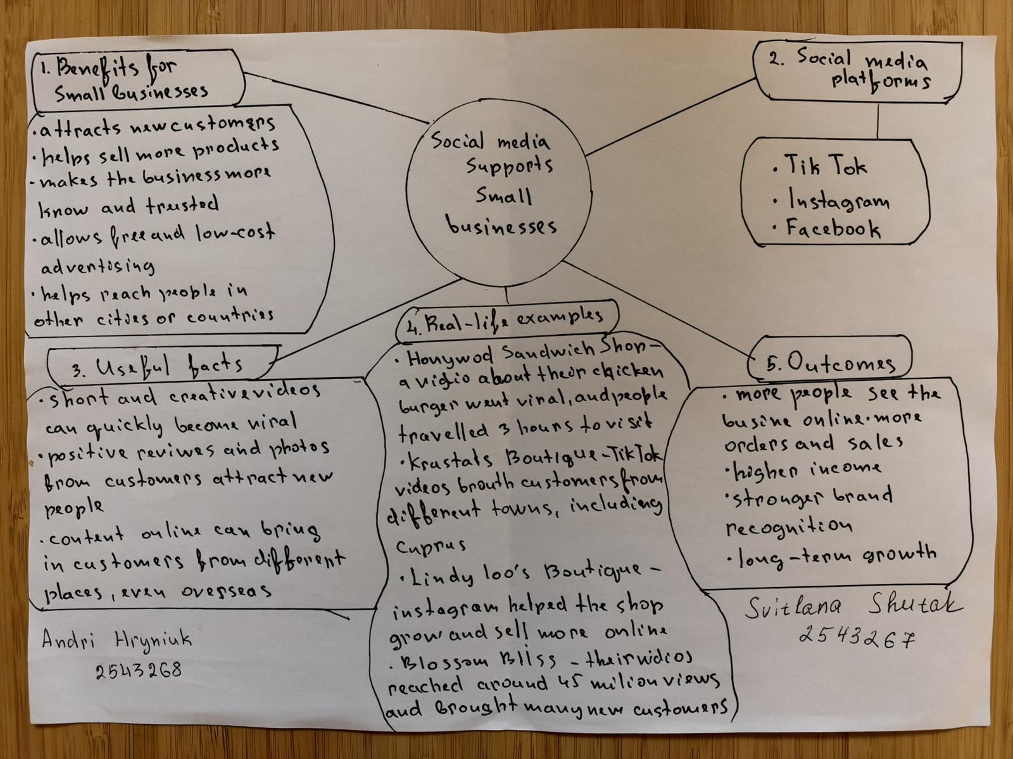

- What is the main idea of the whole text?
Social media is very useful for small businesses. It helps them get more customers and sell more products.

- What is one key point that supports the main idea, and which specific example from the text shows this?

Social media helps small businesses sell more products. For example, Linda started selling clothes online and now sends them to other countries.

- What is a different key point that supports the main idea, and which specific example from the text shows this? Social media helps people find new shops. For example, customers travelled from Cyprus to buy dresses at Kristy's shop.

- Which part of the text do you think is most important, and why? I think the chicken shop story is the most interesting. It shows how social media can help a small shop become popular.

Reflection:
- What did you find difficult in this task (including in-class components), and why was it difficult? For me, it was difficult to understand some words in the text. My English is not very good yet.

- What helped you with this difficulty, and how did it help you? I read the text a few times and translated some words. This helped me understand the story better.

