BA Business and Management

BMSP6007

Economics of Sustainability

2,500-word essay

March 2020

Introduction

The UK automotive industry has produced a 82 million pound turnover in 2019, holding a 14.4% share of the UK’s exportation of goods which allows these vehicles to be found in 160 different overseas markets (SMMT, 2020). Globally, passenger vehicles take the largest sector in the automotive industry today, with 70.6 million units in motor vehicle construction (Wagner , 2020). With 74% of the automotive industry being passenger vehicles, it is fair to acknowledge that their presence has become more than normality in current society much more than it was a decade ago with passenger car production increasing at least a third since then (Worldometer, 2020). Therefore, with the increasing number of passenger vehicles today, the risks and potential damaging effects which they are proven to cause, are also on the rise if procedure is not put in place to minimise risk.

This essay will address how the EU regulation emission reduction targets are reinventing the production of passenger vehicles and therefore revolutionising this industry into being more environmentally sustainable and lowering the detrimental risks to society associated with the output emissions their industry is partially responsible for.

Evidencing real figures, analysis of the failure to address environmental issues prior to the EU regulations within passenger car sector of the automotive industry will be tested with demonstrative diagrams to develop an understanding as to why there was failure.

There will also then be analysis of the industry post EU regulations being implemented, to generate an indication of how the industry has or has not improved since and the change of impact they have had on society. This again will be evidenced with demonstrative diagrams.

This essay has been developed using a variety of academic sources, books, journals, articles and statistics as well as referencing legal regulations and illustrative diagrams.

The failure of the passenger car industry prior to EU regulations

Passenger vehicles are responsible for up to 12% of the C02 emissions in the EU (European Commision, 2020). With C02 being the main form of greenhouse gas globally its impact on the earth, combined with the impact of other greenhouse gases, has the potential to speed up global warming to an irreversible extent (SEPA, 2020). Prior to 2009 there were no regulations as what percentage C02 emissions could be generated from passenger vehicles in the EU. This allowed car manufacturers to produce passenger vehicles in any way they saw fit and profitable and specific issues like C02 emissions were solely up to themselves. Passenger car pollution can cause significant harm to human health inclusive of conditions of cardio-respiratory disease, obesity and can even contribute to death (Douglas , Watkins, Gorman, & Higgins, 2011). As well as human health, this pollution affects the health of the planet. It can further damage the environment with expulsion of fossil fuels which fasten the pace of global warming; a process which is soon to become irreversible or take decades to eliminate (NASA, 2020).

Prior to any legislation, two decades ago, the average C02 emissions of a passenger car stood on average at 172.1g C02/km. Ahead to 2009, when legislation was gathering speed on implementing regulations for C02 emissions, the average passenger car output stood at 145.7gC02/km (European Environement Agency , 2019). The figures are inclusive of the fluctuation between emissions rates between different vehicles as the larger or heavier the passenger car the higher the emissions and the same therefore for smaller and lighter vehicles.

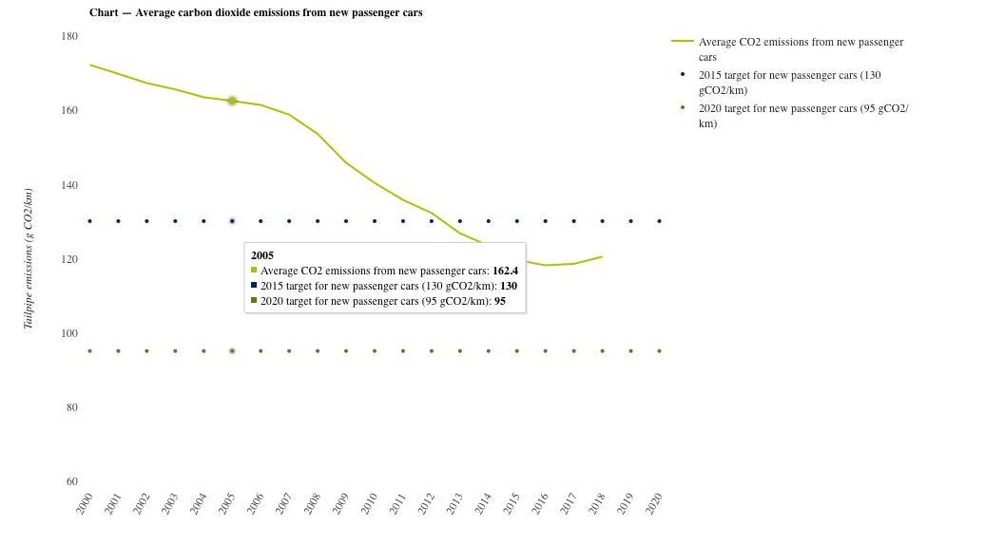
(European Environement Agency , 2019)

Prior to EU regulation and societal conscience on the issues of global warming and health risks associated to excessive C02 emissions, is it understandable to appreciate manufacturers lack of importance placed on these factors. The of changing methods and materials of manufacture would only result in a hefty profit decrease, when the end product would only appear exactly the same as before. It is for these reasons that this industry was failing prior to the EU implementations of regulations, since they were not taking in to account the marginal external costs such as marginal social costs. For example, with potential excessive C02 emissions a marginal social cost would be the pollution to the air of C02 in vast amounts affecting people’s health as well as progressing the matter of global warming. Air is a public good, a non-rival and non-excludable benefit and the pollution of that is an externality cost partly from the automobile industry meaning the failure to that industry is that of externality (Arnold, 2008).

Marginal external cost can be defined as an additional ‘cost’ to the producer accruing to a party, which is not necessarily consuming the product (Body of Knowledge on Infrastructure Regulation, 2020). Marginal external cost can impact third parties in a positive or negative way, the impact differs in its situation. In this instance, the producer is the car manufacturer and the consumer are the passenger car user. Wider society however are the benefactors of the additional cost from passenger car manufacture as they are the ones exposed to the C02 pollution in the environment as a consequence of the expelled car fumes making this a negative externality. Marginal external cost can be identified in a visual model illustrated below:

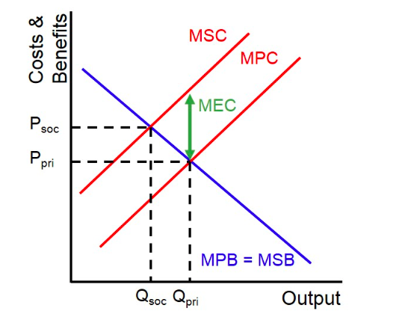

(Ezy Education, 2020)

In utilising this model, an organisation is able to measure the size of the external cost to itself and allows itself to then pitch itself in line with governmental and societal optimal factors. Marginal external cost can be identified at the point at which the marginal private cost and marginal social cost curves diverge. With utilising the passenger car industry on this model, the marginal external cost prior to 2010 could uncover that the producer was not factoring in externality cost of damaging the environment with C02 car emissions and was therefore pricing too low and producing too high of an amount of passenger vehicles.

The contributing failure of the passenger car industry is understanding that they themselves have/had no incentive to make changes to the way they produce their vehicles. It is a very competitive industry with over 60 global brands producing passenger vehicles as well as other vehicles (Gould & Zhang , 2018) so profitability is essential as part of their business plan. Without governmental regulation prior to 2010, these producers were collectively failing in their market as they weren’t factoring their external cost to the environment, only focusing on the number of vehicles produced and units sold.

Market performance in the automobile industry after EU regulations

Once it has been detected that a market is failing, methods of market improvement can vary dependant on industry and the product said industry produces. Negative externalities can potentially be resolved in one of three methods; taxation, regulation and property rights (Centermeri, 2009). Taxation and regulation are the methods associated with dealing with this particular issue as property rights and Coase theorem attribute ownership of the marginal external cost. As air cannot be ‘owned’ to any individual/s the process of property rights would not be justifiable in this situation as the purpose of the assignment of rights is to allow bargaining power from one part to another which obviously cannot be done in this circumstance (Posner & Parisi, 2013).

In the interest of this industry, regulations were put into place to reduce the impact of C02 on the environment. In 2010, EU regulations were drafted to be imposed on the passenger car industry to deal with the negative externalities being imposed by their production. The regulation was that between 2015-2019 an average emission target would be set on new passenger vehicles at a level of 130g C02/km, a fuel consumption of 6 litres per 100km (European Comission, 2020). The intended purpose of these regulations was to lower the level of marginal external cost of the industry being the air pollution. While the aim was to achieve this by 2015, passenger car manufacturers reached it earlier in 2013 as it was no longer in their best interest to ignore social cost if they wanted to remain relevant and competitive in their market (European Commision, 2020).

Using the same model as previously to identify the reason for market failure, the same model can be used to identify the improvement since the method of improvement has been applied.

(Ezy Education, 2020)

Since the regulations were implemented, the amount of C02 emissions per g/km have significantly dropped in comparison to what they were before implementation, an average drop of 27.6g C02/km (European Environement Agency , 2019). This obvious decrease in emissions will increase the marginal external cost of a business that in turn will increase equilibrium price and lower production of the good.

In terms of environmental policy, EU regulations are that of ambient standard; a designation of the quality of the environment expressed as an allowed concentration of pollutant (Callan & Thomas , 2007). There are certain implications associated with standards; standards can impact allocative efficiency of a manufacturer, where the marginal social benefit (MSB) abatement equates to the marginal social cost (MSC) abatement. In practice this would the price society is willing to pay for passenger vehicles but must be at least equal to the opportunity cost of manufacturing it, balancing the benefits of manufacture to meet consumer demand and the cost in order to maintain production (Agarwal, 2020). MSB abatement is measured by the reduction in damage to the environment by the pollution of C02. MSC abatement in the automotive industry is calculated by combing the total polluter marginal abatement (MAC) and the marginal cost of enforcement of regulation (MCE):

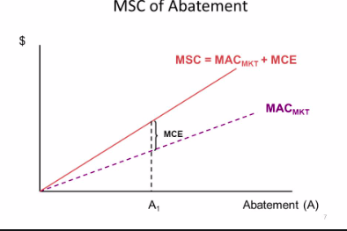

(Fields, 2020)

The level of allocative efficiency can be identified at the point at which the negative sloping MSB and positive sloping MSC curves intersect:

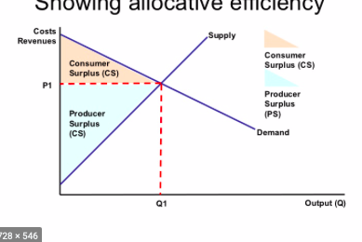

(Seldis, 2020)

With this ambient standard however, legislative constraints make the allocative efficiency difficult for manufacturers. They focus on the benefit to improve societal issues however do not take into consideration manufacturer issues brought on as a result of the changes. After the regulations changed again in 2019 to 95gC02/km for new vehicles between 2020-2025 the manufacturers of passenger vehicles are now faced with their own negative costs. According to the Volkswagen chief executive, the industry could be faced with a 30-billion-euro penalty if their emissions are not perfectly in line with EU guidelines (Campbell, 2019). As per the ambient standard, allocative efficiency may not be sustainable for many car manufacturers. The costs associated with implementing standards may require massive overhaul of resources and could potentially put manufacturers in a problematic position as to how to proceed. Many large car manufacturers are struggling to reach the 2020 EU regulations, Jaguar Land Rover are projected to lose an equivalent of 400% of their 2018 profits in order to face their emissions fines (E&T Editorial , 2020). Allocative efficiency, while being one of the more convenient of standard methods, may not always be the most multi-focused approach to market improvement as it fails to take into account the impact regulations have when enforced on industries, rather just the outer society.

The future of market performance in the automotive industry

It has been alluded to that rather than an allocative efficiency approach, which is currently being imposed upon the passenger car industry; it could be argued that a market incentive approach may be more long-term and efficient. After all, the regulation assists to regulate emissions of the firms being impacted upon and which cannot maintain business since as a result of regulations then there will be no market left to regulate. This conservative and pollution reduction strategy encourages pollution charges and pollution trading systems as an alternative to regulation. A “polluter-pays principle” would be adopted, and each individual firm would pay a charge reflective of their pollution percentage similar to how the regulations operate with variant emission rates; the less pollution i.e the lighter the vehicle, the lesser the charge. With this method rather than running manufacturers out of business or coercing illegal practices to alter emission results, Volkswagen faced a 4.5bn fine in 2015 after falsifying emission practices to avoid paying fines (Hotten, 2015), it may just gently encourage manufacturers to change adapt their methods in order to pay the lowest charge. Product charge would be imposed per passenger vehicle relative to its emission level.

If the charge imposed on a vehicle is equal to that of the marginal external cost of the vehicle it is deemed as Pigouvian tax (Polinsky & Shavell, 1981):

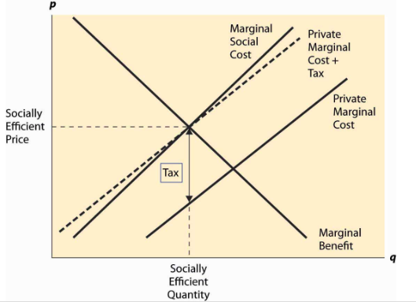
(National Bureau of Economic Research, 2020)

In setting tax at the point between private marginal cost and private marginal cost, it will allow car manufactures to operate more efficiently when manufacturing the vehicles rather than being fined greatly if their emission levels are too high.

There are implications when applying Pigouvian tax to an economy of this scale in that it can be very difficult to manage. The marginal costs will vary between manufacturers and vehicles making it more difficult to analyse exactly what the rates/taxes are for each individual. Different rates would have to be negotiated with singular/multiple polluters. Also, while discouraging high emissions in order to pay a lower tax, it is not enforcing lower emissions, firms are still able to operate in the same way as previous with just the higher tax to pay. Therefore, while it may very well be benefiting the organisations involved, it may not be benefiting the environment which when simplified is the main issue in the situation.

Conclusion

It is fair to suggest that prior to the EU regulations imposed on the passenger vehicle industry, the market was suffering greatly in its social costs. Justifiable to an extent in the fact that the working knowledge of pollution effects was much less at that time than what it is today; “Air pollution impacts on health is in no doubt and indeed has been the driver for improvements in air quality worldwide. The size of this impact has, however, been more difficult to determine, the issue being complex and attended by degrees of uncertainty” (Committee on the Medical Effects of Air Pollutants, 2009). Moving forward however, the moral and working consciousness of pollution is far more advanced and the changes made with EU regulations are definitely influencing the passenger car industry and how it operates.
I do however struggle to support the fact that the passenger car industry is now completely successful as a consequence of emission regulations or that they were completely failing prior to them. Vehicle emissions are actually rising at this current time as a result of individuals finding alternative fuels like biomass and hydrogen, making these regulation models unreliable in terms of their output (ONS, 2020). An industry cannot be deemed to be failing or successful when only one segment of their work is analysed. Many manufacturers are offering other social benefits which are not categorised in emissions test but still advancing society i.e production of electric vehicles and creating community schemes for those vehicles (Wales Online, 2019).
The models used to hypothetically understand the changes in the industry help to identify the potential benefits to the industry, as well as the social costs resulting from industry decisions. While I do believe the EU regulations are useful in terms of how they independently are making a conscious effort to lower emission rates, it is clear that those regulations alone will not be sufficient to change the rate of pollution in the atmosphere. They work well in their own use, however collaboration with other factors must be considered before a clear difference is made in the environment.

Bibliography
Agarwal, P. (2020, March 18). Allocative Efficiency . Retrieved from Intelligent Economist : https://www.intelligenteconomist.com/allocative-efficiency/
Arnold, R. A. (2008). Economics. Mason: Thomas-South Western.
Body of Knowledge on Infrastructure Regulation. (2020, March 18). Marginal External Cost. Retrieved from Body of Knowledge on Infrastructure Regulation: http://regulationbodyofknowledge.org/glossary/m/marginal-external-cost/
Callan, S., & Thomas , J. (2007). Environmental Economics and Management: Theory, Policy and Applications. Mason: Thompson South Western.
Campbell, P. (2019, April 16). Industry struggles to meet strict emission targets with potential penalties of €30bn . Retrieved from Financial Times: https://www.ft.com/content/74c04dc2-5b9c-11e9-9dde-7aedca0a081a
Centermeri, L. (2009). Environemental Damage as Negative Externality: Uncertainty, Moral Complexity and the Limits of the Market. E-Cadernos CES, 21-39.
Committee on the Medical Effects of Air Pollutants. (2009). The Mortality Effects of Long-Term Exposure to Particulate Air Pollution in the United Kingdom. Oxfordshire: Crown.
Douglas , M. J., Watkins, S. J., Gorman, D. R., & Higgins, M. (2011). Are vehicles the new tobacco? Journal of Public Health, 160-169.
E&T Editorial . (2020, March 19 ). Top car makers could face €14.5bn fines for missing the EU’s CO₂ emissions targets. Retrieved from Engineering and Technology : https://eandt.theiet.org/content/articles/2020/01/top-car-makers-could-face-145bn-fines-for-missing-the-eu-s-co-emissions-targets/
European Comission. (2020, March 18). Fuel Taxtion. Retrieved from European Comission : https://ec.europa.eu/transport/modes/road/road_charging/fuel_taxation_en
European Commision. (2020, MARCH 17). Reducing CO2 emissions from passenger vehicles - before 2020. Retrieved from European Comission: https://ec.europa.eu/clima/policies/transport/vehicles/vehicles_en
European Environement Agency . (2019). Are new passenger vehicles becoming more efficient? Eurpoean Environement Agency.
Ezy Education. (2020, March 18). Marginal external cost. Retrieved from Ezy Education : https://www.ezyeducation.co.uk/ezyeconomicsdetails/ezylexicon-economic-glossary/741-marginal-external-cost.html
Fields, A. (2020, March 19). Chapter 4 Conventional Solutions to Environmental Problems: Command-and-Control Approach. Retrieved from Slideshare: https://slideplayer.com/slide/8237695/
Gould, S., & Zhang , B. (2018, February 15). These 14 companies dominate the world's auto industry. Retrieved from Business Insider: https://www.businessinsider.com/biggest-car-companies-in-the-world-details-2018-2?r=US&IR=T
Hotten, R. (2015, December 10 ). Volkswagen: The scandal explained. Retrieved from BBC News: https://www.bbc.co.uk/news/business-34324772
NASA. (2020, March 20). Is it too late to prevent climate change? Retrieved from NASA: https://climate.nasa.gov/faq/16/is-it-too-late-to-prevent-climate-change/
National Bureau of Economic Research. (2020). Pigovian Taxes. National Bureau of Economic Research, V1.
ONS. (2020, March 19). Road transport and air emissions. Retrieved from Office of National Statistics: https://www.ons.gov.uk/economy/environmentalaccounts/articles/roadtransportandairemissions/2019-09-16
Polinsky, A. M., & Shavell, S. (1981). Pigouvian taxation with administrative costs. National Bureau of Economic Research, 19.
Posner, R. A., & Parisi, F. (2013). The Coase Theorem. Chicago: Edward Elgar.
Seldis, A. (2020, March 19). Economic effiecieny . Retrieved from Slide Share : https://www.slideshare.net/aseldis/economic-effiency
SEPA. (2020, March 17). Carbon Dioxide- Pollutant Fact Sheet. Retrieved from SEPA: https://www.google.com/url?sa=t&rct=j&q=&esrc=s&source=web&cd=4&ved=2ahUKEwj86-vy4aHoAhWFQxUIHZsjCuIQFjADegQIDBAI&url=http%3A%2F%2Fapps.sepa.org.uk%2Fspripa%2FPages%2FSubstanceInformation.aspx%3Fpid%3D2&usg=AOvVaw2dJt-39S29AKjslTGzVNb6
SMMT. (2020, March 17). Uk Automotive . Retrieved from SMMT- Driving the motor industry : https://www.smmt.co.uk/industry-topics/uk-automotive/
Wagner , I. (2020). Automotive Industry - Statistics & Facts. Statista .
Wales Online. (2019, April 2019). Rise in electric community car schemes in Wales. Retrieved from Wales Online: https://www.bbc.co.uk/news/uk-wales-48011957
Worldometer. (2020, March 17). Car Production. Retrieved from Worldometer: https://www.worldometers.info/vehicles/

