AC 1.1

In HR as People Practioners, as well as departments such as L&D, the CIPD Profession Map sets the standard for our profession – it guides us with better decision making and confidence to act on these decisions and to drive change in our organisations as well as helping us to progress further in our careers. It defines our purpose – to champion better work and working lives in our organisations.

Our work as People Professionals in the Police Force means that we interact with two groups of employees– officers, who have a unique employment status as officers of the crown rather than employees; and staff. A lot of the terms and conditions for officers are based on the Police (National) Regulations. There is a national framework of negotiated t&cs of employment for police staff which Forces supplement at a local level. We also have contact with our volunteer workers such as Special Constables and other volunteer roles. (CIPD HR-inform, 2023)
Working in the Force is varied and rewarding but does presents a number of challenges for HR. We play a significant role in the development of a positive culture in the Force, in improving employee engagement, productivity and retention. Through our recruitment processes built around the Code of Ethics we are able to ensure that we select candidates who value our principles, and who are committed to public service. I hope that we are viewed as a point of support in a world that is so tough at times. I am just beginning to learn the Employee relations side of HR, but am very experienced in our recruitment processes.
With our processes designed in accordance with the Profession Map we can be prepared to adapt to different contexts and changes so that our day-to-day work is based on solid foundations. The map sets out the purpose, values, core knowledge, behaviours and specialist knowledge that make a positive impact on our workforce. (CIPD, 2022)
The role of HR working in the Force is to ensure we deliver a fair, responsive service that engages effectively with our people, our communities, and builds on our organisational values and culture. (NPCC, 2025)

AC 1.2

The College of Policing’s (CofP) Code of Ethics sets out how we work together in policing and with the public to keep people safe. The principles are: “Courage – to demonstrate integrity and transparency in all our decisions, leading by example and challenging anything that could bring our profession into disrepute. Respect and empathy – listening to and understanding the needs of the public, trying to recognise and respond to the physical, mental and emotional challenges that both colleagues and members of the public face. Public service – the commitment to work in the public interest, communicate clearly and openly, and take pride in providing an excellent service to the public.” (CofP, 2024).

To apply an ethical value to my work and home, I would look to Deontology – focus on duty and obligation. Responsibility: Deontology is about fulfilling our duties and obligations. This could mean meeting work deadlines, keeping promises, or helping others when it's within my power to do so. Respecting rules - Deontologists believe in following rules, laws, and ethical guidelines, and this is reflected within both my organisation and self-beliefs. (BBC, n.d)

As both a team member and an individual I am supportive and mindful of diversity and fairness in my life - in all communication methods, to ensure clarity and understanding. In recruitment I am mindful of bias when reviewing applications after a vacancy closes to careful examine the eligibility criteria and any right-to-work evidence – treating applicants equally, fairly, without bias. We are aware of diversity and always do our best to help with interpretation to ensure understanding to ensure that the process is clear and transparent to all.

I am aware of the issues in society and how our service as a Force is directly involved, how we have a duty to provide an appropriate and professional service to all people regardless of their race, colour, and culture. As a Force we actively encourage and embrace diversity, inclusivity and equality and the decisions that we make day to day need to be in alignment with our mission, values and the Code of Ethics.
AC 1.3
HR Director of BAE systems, Alex Lewis, stated that "Employees aren't just looking for a job anymore they are looking at a company to have a relationship with, and a relationship isn't a mute thing, a relationship involves having a voice from both parties, that for me is really critical.. It is up to HR to champion voice in the organisation." (Newcombe, 2024)
Why is it important that People Practitioners speak up about issues and process improvements, and what happens if we don’t? To not challenge poor decisions made by senior leaders can result in a toxic workplace environment. We need to champion the importance and value of people in our organisation and celebrate their uniqueness.

As staff in the Force we all have a pay-reference or job-family that is referred to, and our Officers are referred to by their titles - PC, DC, DS, DI, but we should not lose sight of individuals within our organisation.

Effective communication can increase productivity while preventing misunderstandings. Senior leaders who can explain the benefits of policies and projects, for example, are more likely to cultivate employee buy-in - this point is important because employee support is critical to ensuring that employees use the HR services available to them.

Andrews, A (2024) reflects that there is a business case for integrating people into discussions and decisions at Senior Leadership level and as People Practioners we need to be aware to have that business case at our fingertips – because all we do in HR should be contributing to the continued growth and success of bour organisations.

How do we make sure that HR influence the workplace? Diagram 1 – illustrates the Drama triangle in the context of a workplace:

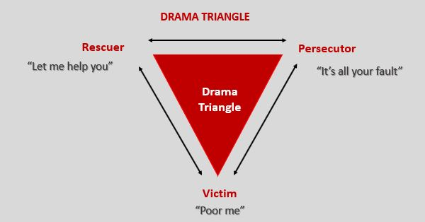

Rescuer – People Practitioner, Victim – the employee, Persecutor – the line manager.

This illustrates why it is important to speak-up, speak-out when there is a problem and what happens when we don’t - but at the same time we need to break this drama triangle and to properly address different perspectives of the problem in a managed ethical manner.
The Victim – how can they break this cycle – for example, keeping a log of positive daily outcomes / achievements, building confidence in themselves.
The Perpetrator – managing communication more effectively – having one-to-ones with their employee to discussing and reach solutions – perhaps to involving HR, the Rescuer – whose role it is to not rescue, but to communicate in a clear and confident manner, to put in place sensible and practical suggestions to manage and motivate both the victim and the perpetrator.

AC 1.4

In the Force, we all work to the Code of Ethics. This consists of two parts, both of which are non-statutory: ethical policing principles and guidance for ethical and professional behaviour in policing. The College of Policing outlines the ethical principles as selflessness, integrity, objectivity, accountability, openness, honesty and leadership. When it was written, two further principles were added to that to make the nine policing principles – these being fairness and respect. (Code of Ethics, 2024)
As policing professionals and People Practioners, we have a positive obligation for challenging or reporting behaviour that is unprofessional and/or unethical. Relatively minor failures may be simply and effectively dealt with through challenging our peers or team, normal day-to-day line management and learning through reflecting on what has happened.
It is important to step back and reflect on what is considered to be an unethical action – for example, taking credit for other's work is not illegal, although it could be viewed as unethical in that it shows a lack of integrity. Vetting checks in the Force will examine undisclosed information or misinformation, and a conditional offer may be withdrawn if a panel considers there to be a lack of integrity and honesty from a candidate.
Many but not all organisations have a Whistleblowing policy, and the existence of a whistleblowing policy shows an employer’s commitment to listen to the concerns of workers. The policy allows workers to report on perceived unethical and more serious illegal matters and where there is a Trade Union to support, members will be able to raise concerns with their representative if they do not trust their manager.
“Whistleblowing is the term used when a worker passes on information concerning wrongdoing. In this (Gov.UK) guidance, we call that “making a disclosure” or “blowing the whistle”. The wrongdoing will typically (although not necessarily) be something they have witnessed at work. To be covered by whistleblowing law, a worker who makes a disclosure must reasonably believe two things. The first is that they are acting in the public interest. This means in particular that personal grievances and complaints are not usually covered by whistleblowing law.” (Department for Business, E.& I.S. 2015)
(Whitman et al., 2019) lists the main three categories of unethical and illegal behaviour to be – ignorance, accident and intent – intent being a kind of unethical behaviour which occurs due to the individual's mindset to do so. It is therefore essential to prove that the accused person has acted intentionally which will cause damage or harm. F
Fraudulent activity in the workplace falls under intent – as it is unlikely to be done repeatedly by accident. If I was witness to, or suspect this kind of activity, I believe I would have to consider carefully what I had seen and most likely confide to a colleague about my concerns. Although if the illegal action was a witnessed sexual assault on a colleague or person, I would not be able to stand by and assess, bystander intervention would be necessary – it would depend on the nature of the illegal activity I was witnessing – possibly because one could be perceived whereas the other is directly witnessed.

AC 2.1

Ethical people practices, which prioritise inclusiveness, fairness, and respect for all employees, are critical for the success of any organisation (Gibson, 2022).
It is important to feel included, valued and be fairly-treated at work -we all want to be part of a workplace that promotes inclusion, values, and fairness towards all employees. Taking steps to ensure that your organisation follows principles to promote these values can positively impact the business and the employees significantly.
Understanding what motivates people is key to creating a thriving workplace. Maslow's Hierarchy of Needs can be used to diagnose motivational issues - if an employee is disengaged, we can consider whether their lower-level needs are being met - are they feeling secure in their job, do they feel like part of the team? Addressing these basic needs can allow them to focus on higher-level goals.
Table 3
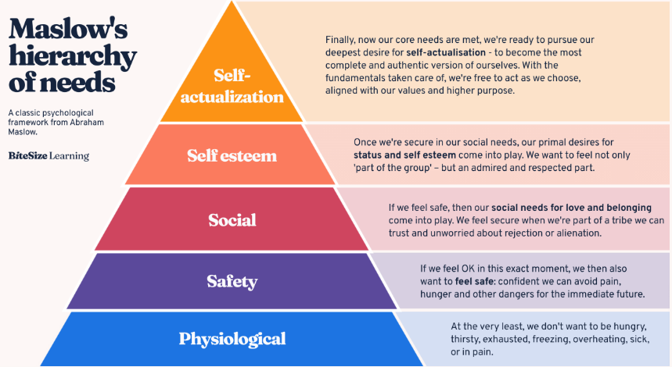
Maslow’s concept is that lower-level needs must be satisfied before higher-level needs can become motivators. As an example, if someone is struggling to put food on the table and support their family on the wages/conditions they received in their workplace, they're less likely to be focused on gaining recognition at work.
When these needs are met, employees experience better mental health and well-being, they feel a stronger connection to their teams and leaders and are more likely to be motivated, confident, and fulfilled in their work. (as cited in Parsons, 2025).
(Deci, Olafsen & Ryan, 2017) wrote in their Self-Determination Theory (SDT) that having workers be more self-motivated turns out to be better not just for employees but for organisational profitability and effectiveness as well. Although it is not yet the norm around the world, effective modern organisations are gradually being reshaped to foster more autonomously motivated workers.
SDT is based on the idea that human beings are motivated by three basic psychological needs - Autonomy - the power to act freely. Competence - the assurance of success. Relatedness - the need for affiliation. The need for connection with others highlights the importance of interpersonal relationships and the feeling of belonging in a team or group/community.
SDT enhances the concepts from Maslow’s theory and emphasises the importance of informed-choice and self-management, placing the individual at the centre of their decisions as leading their own personal growth. It can be applied in many areas such as improving employee engagement in organisations, promoting healthy behaviours and increasing training outcomes.
How can we foster lasting engagement, fulfilment, and job performance at work? Organisations can apply SDT by providing employees with decision-making autonomy, offering opportunities for skills-development and in creating a workplace culture that encourages collaboration and belonging. If we consider that lost productivity, absenteeism, and employee-turnover costs organisations in lost revenue every year; applying the principles of SDT and work motivation is essential to combine high-performance and well-being within organisations. (Oliveira, 2025)
Work is possibly the biggest part of our lives, yet we all have differing experiences – some love their jobs and find them fulfilling and rewarding - work not only represents a source of income for survival; it is also a form of self-realisation and personal satisfaction. We search for careers that have meaning. However, many find work to be something to be endured and dreaded - a drain and a burden and something which they dream of being released from.
SDT principles appear to be most applicable for organisations in our current climate – fostering positivity and motivation in employees, providing them with the tools to make a difference to themselves as well as their team.

AC 2.2:

As employees we need to understand our own roles and values. When a change is being considered it is vital to consult and engage these employees in the process to ensure engagement and understanding of the changes and how this may affect their roles day-to-day.
How do we do this? In this example I will look at introducing a new supervisor role to our HR/Recruitment team. The current structure sits at C-grades performing the support functions, and HR Recruitment Officers (HROs) E-grades performing the higher-level functions, with a Senior Manager sitting above. The implementation would mean that the role of a D-grade supervisor is created to liaise between the support staff and HROs. To see how this would work within the current structure, it has initially been approved as a 12-month temporary role.
We already know who would be affected by the changes – directly it would be the team members.
Firstly, organise a face-to-face team meeting to discuss the new temporary role and what this means for the team. Ensure we emphasise the positive outcomes - the role would be open for all eligible staff to apply for. Training would be provided to help any team-member further their prospects within the team or organisation, even if they were not interested in this role.
An open discussion would be encouraged for staff to air views and concerns on how the new role would impact the workload of the team. To explain that it would enhance the approvals process within both employee relations and recruitment, making processes more efficient, and emphasise the point that this will not impact the C or E-Grade roles. Explain that it is a temporary initiative to find out if the introduction of a supervisory role will make a positive change for all members of the team, as well as our wider colleagues and external candidates.
Explain timelines for the change and share the new role-profile and application process with the team and encourage one-to-one conversations with the Senior Manager and the involvement Unison representative if required.
Seek feedback from the team – what needs to be included in this role – how can they see this working alongside them – what obstacles can they see?
After the team-meeting, follow this up with an email to all team members and a group message on Teams to explain the internal application process, and ask staff to come forward for support if needed. Encourage open-dialogue within the team during the application process – and ensure all staff who wish to apply are being supported, in case they are not confident with writing an application.

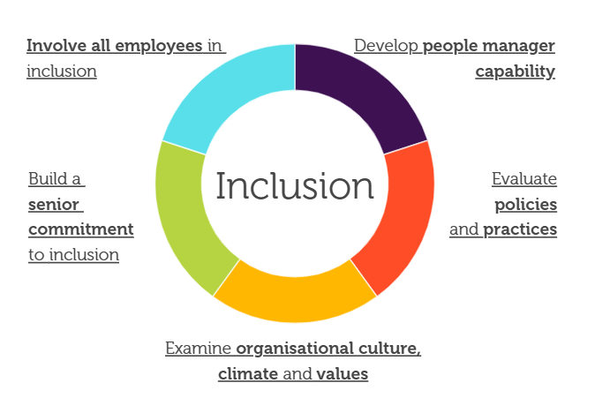(CIPD, 2023)
When applications have been reviewed, ensure that outcomes are clearly recorded and that staff who are not successful are given the opportunity to sit-down and be given clear constructive feedback on how they can move forwards and are offered opportunities with training or projects to enhance their skills in particular areas. Ensure that the outcome of the process is handled sensitively among the team, and communication is clearly handled.
Implementation of the new role would be carefully planned – who/how would this role support, what support they will provide? Levels of responsibility to support the HR and recruitment processes should be clear to all staff as well as the new post-holder.
Feedback should be sought at regular intervals following implementation –via teams messages, meetings,use a pulse survey to the staff to seek feedback. Ensure that staff know their opinions are valued to ensure that the new role is performing as it should/could be. Implement useful suggestions and communicate these actions, praising staff for their input.
Quarterly reviews of how the new role is supporting the team and enhancing efficiency of the processes should be measured through timelines / quantitative data.

AC 2.3:

Inclusivity is adopting a habit or policy to include all people, and an inclusive workplace welcomes and supports people with all kinds of differences. It’s vital to ensure everyone feels part of a team and feels accepted to build strong relationships and offer opinions freely without worry of being criticised.
I love my role in our team and take pride in helping others, whether external candidates or internal colleagues. It is crucial to build a positive image of HR.
I received my diagnosis of autism 3 years ago, and this, as well as having a neurodiverse daughter, has given me a wide- perspective of the need for inclusivity, and recognising and dealing with bias in both my life and in our organisation.
Bias is an easy trap to fall into – in recruitment when we are closing applications – names, country origins, history with right-to-work checks – we must keep an open mind and not make assumptions, I will often remind myself about the effects of bias. As an outsider moving to Wales and not speaking Welsh, I have found it difficult at times in my workplace feeling left out of conversations. I embrace the Welsh language and culture but wish that some of my colleagues would be more inclusive at times.
I show gratitude for any assistance a colleague gives me, however small - these foster positive relationships between us, both individually and as a team. It’s great to get positive reflections from my colleagues – however it is important to also weigh this up and have balanced feedback. What am I doing well? What could I do better?
In the Force, our DAP questions in our Reflective Journals reflect the Appreciative Inquiry Model (AIM) - which is a strengths-based approach to creating change – so rather than identify a problem and to look how to solve it, AIM explores what is already working and how to build on that.
AIM explores this using positive questions focused on four themes, known as the ‘4Ds’: Discover, Dream, Design and Destiny, and asking questions with these themes is used to generate positive change. AIM can be applied to training new employees – in the Police Force we can use the example of FCC Operators, who all have 7 weeks initial training before they commence their roles.
This approach is useful to use when trainees are dealing with challenges where some positively focused creative thinking could be helpful - where a challenge has been around for some time, or where a trainee is feeling anxious about a situation. It could also be used with groups of trainees to explore something together. It is an approach that can empower individuals, teams and organisations to make sustainable positive change. We can ask these trainees to consider and answer the following questions
Discover- Tell me about a time when you felt at your best? What was happening? How did you feel?
Dream - Imagine things are working exactly as you’d like them to - what would you be saying? What would others be saying?
Design - What can you take from your previous experiences that might be useful here?
Destiny - Now you’ve created some possible ways forward, which step(s) feel most useful to you? Where could taking that step take you? Who could you work with on this?
Moore, 2024) and (Lewis et al., 2016)
The below screenshot (Table 6) illustrates the application of AIM in our DAP reviews:
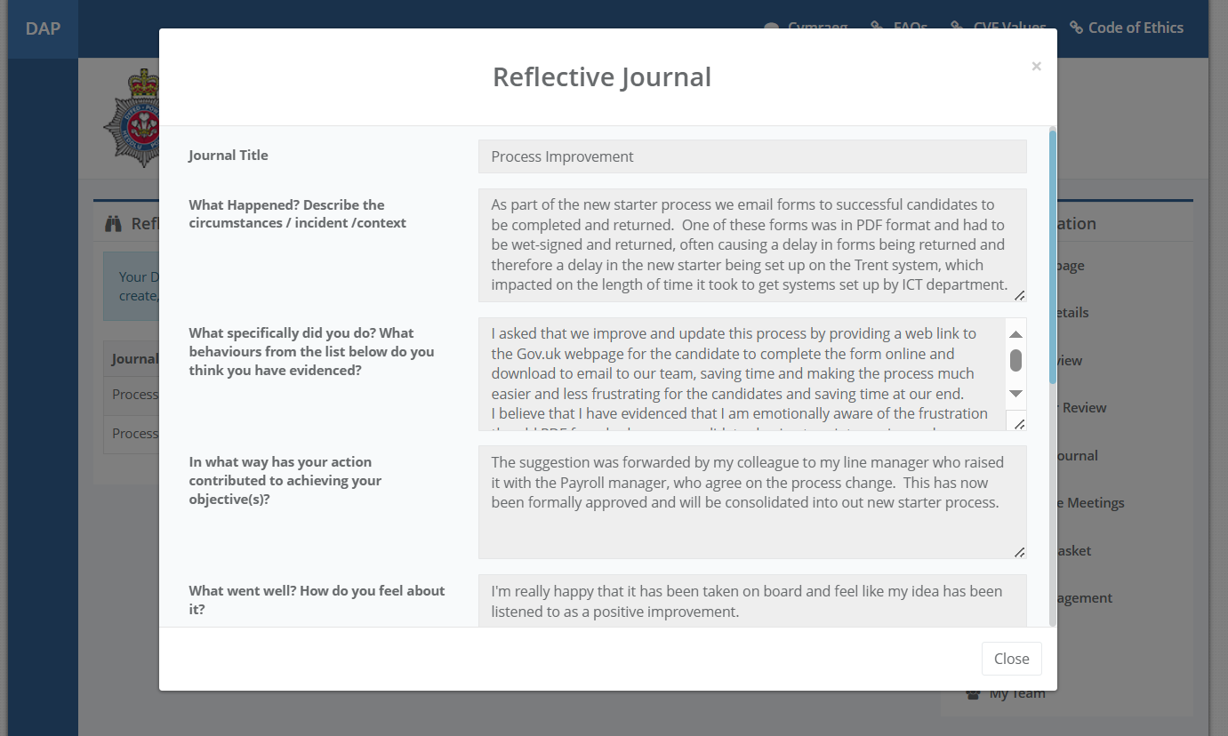

AC 3.1:

Covid-19 was a catalyst for change in the majority of workplaces. Agile working policies were implemented giving a number of employees as well as a new generation of employees the opportunity to work from home, home-based and flexible working became the norm, and in 2025 many companies such as Amazon are attempting to force a change on employees to majority of office working. But the world of work has moved on now – technology has moved on– family-friendly policies, diversity and inclusion are part of our strategic plans.
CIPD People Profession 2030 looks at a collaborative view of future trends and explores how they shape the People Profession (CIPD, 2023).
How do we make ourselves fit for the new world with AI developments endangering our job roles? With the increasing capabilities of AI being introduced into our workplaces, it is a concern how it could affect people practioners. I recognise that workplaces need to be ready for the inevitable changes that AI applications will bring - however, to examine Core behaviours in the Profession Map, we see which areas AI would have a tough job to replicate or replace.
Valuing people – being human is about compassion, empathy, understanding, being able to relate to others, not just following rules and procedures – though admittedly these are aspects which AI can assist with, and potentially reduce the size of a team by automating procedures to complete tasks.
We need to ensure that People Practice roles remains to be people-centred, strive to maintain the elements of human judgement and empathy, personal choice and understanding and but demonstrate this to be an essential irreplaceable value. Training could be replaced in part or whole by AI technology – one element certainly which could be replaced, but again this depends on which training the programme is for - services such as mental health, counselling/therapy, surely cannot be replaced? Sadly, though we are looking at the new generation who prefer to speak through technology than to a human being, so this as well is questionable.
In the report (p.21) Hackathon reported that senior leadership participants thought ‘Digital transformation initiatives need to be balanced. The people professional will need to drive the human connection element and consideration of people needs: ‘We still need to recognise the importance of people: is it how people want to work?’.
Ultimately it will come down to cost of people-versus-cost-of-new-technology, and how dependable that technology is, but I hope we never lose sight of the relevance of the human aspect of People Practitioners.
Table 7 shows my development plan and how important to me learning, understand and confidently being able to assist our employees is, to build my confidence to support them when they need assistance. It is crucial to review and examine our current processes to see if we can enhance them for more positive/timely outcomes.
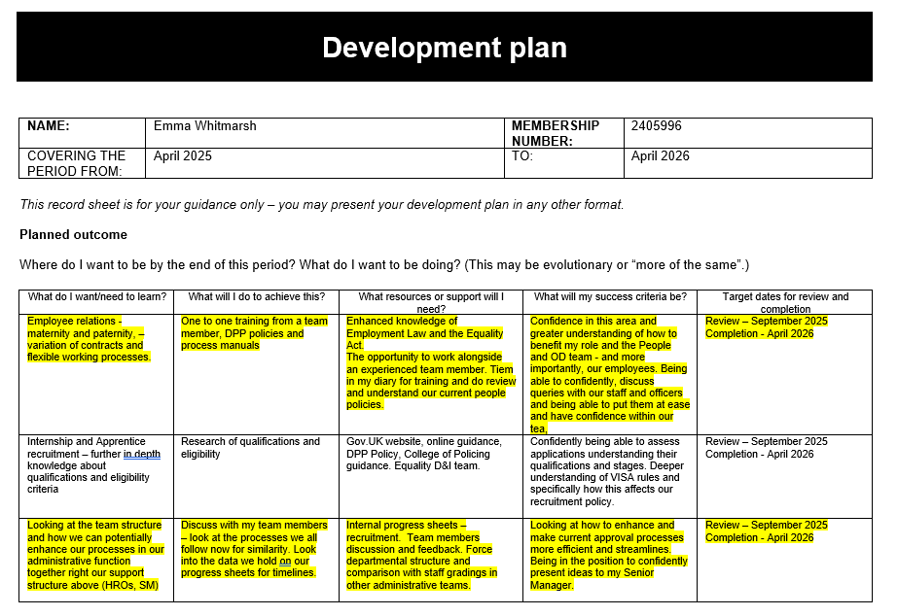

AC 3.2:

From the CIPD Profession Map I have selected 2 core-behaviours. The following tables show the standards for the associate level for each behaviour:

Table 5A: 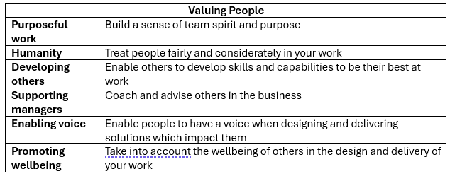
Table 5B:
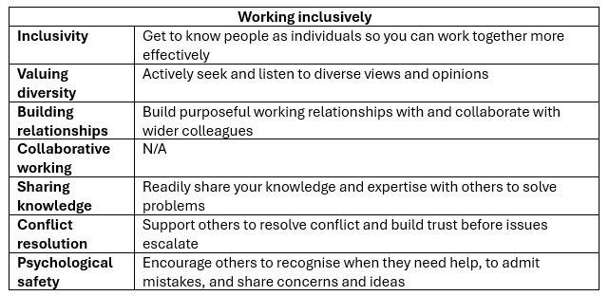
In our team new staff have joined, and as the most experienced team-member I am asked to mentor and provide training on all aspects of our processes, from advertising of vacancies, supporting applicants, closing applications, shortlisting, interviews, to pre-employment checks and onboarding. It is a complicated process and differs across vacancies and candidates.
I always seek opinions from staff about how they find learning, adapting further training to suit their needs, addressing any concerns.
It is vital to be patient, inclusive and demonstrate an understanding of diversity. I believe that the compassion we show others will foster positive relationships with internal and external stakeholders and is vital to both nurture and uphold a positive reputation for the Force.
Table 1 shows feedback I have been given by a team member:
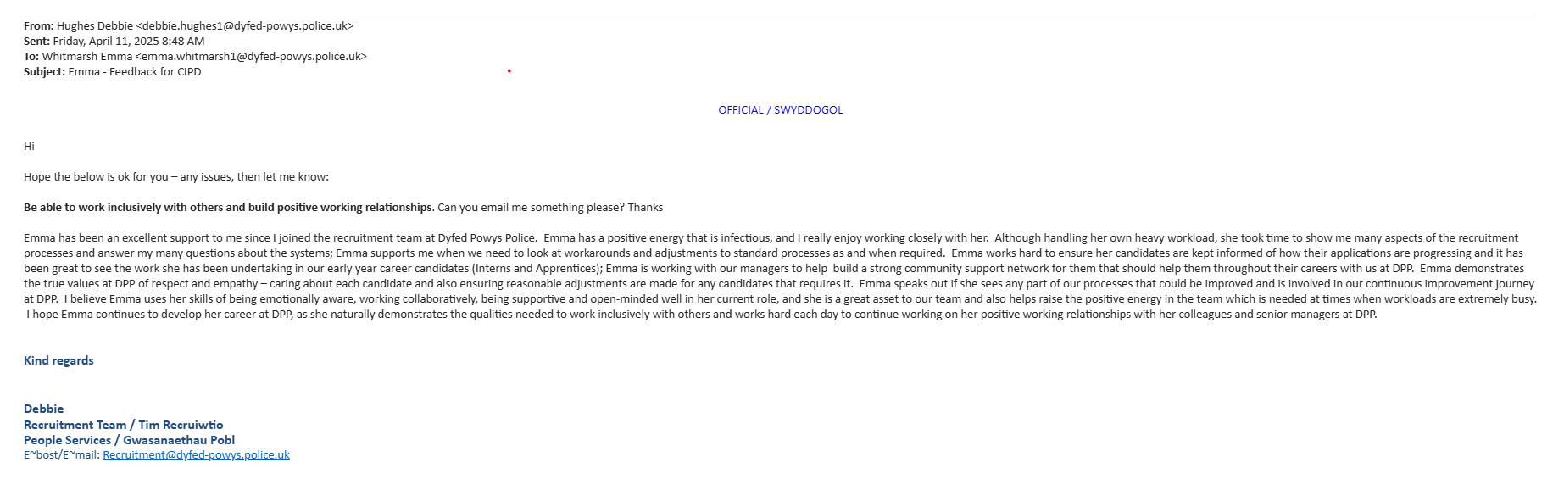
In my role I have become very involved with recruitment for Forensic roles and have worked hard to build positive relationships with my colleagues in these departments:
Table 2 feedback from the Senior Manager of Forensics, CID:
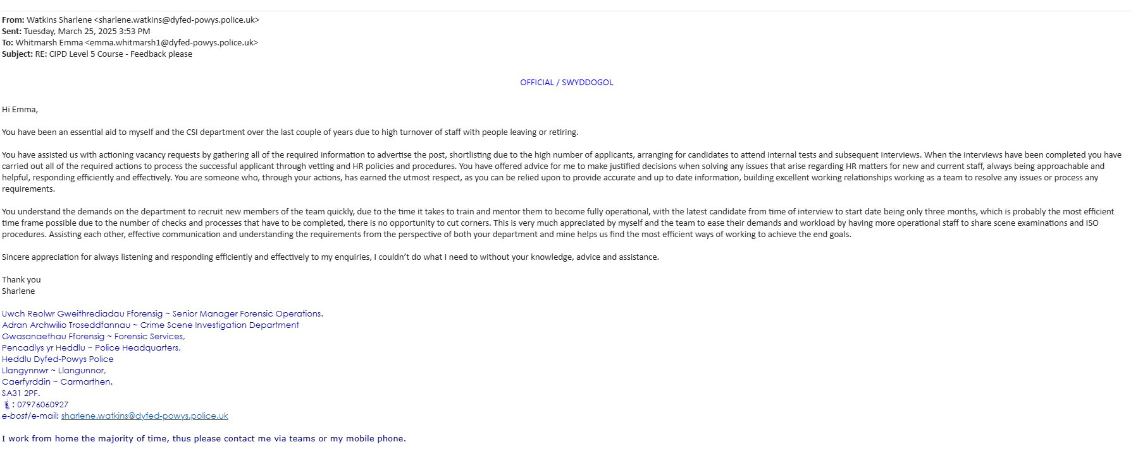

Table 3 feedback from the Senior Manager - Digital Forensics:
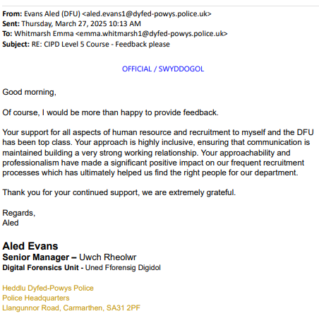

Table 4 - a self-evaluation exercise – what I believe to be my strengths and weaknesses and noting those in both categories, and the reason why I believe them to be both a strength and a weakness.
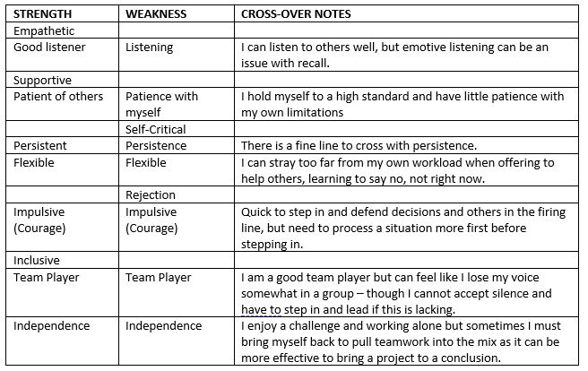
Conflict resolution is an area that I am not confident in, one to study and seek advice with – I find conflict difficult and emotive situations challenging – this is behaviour learnt through years of a difficult relationship and childhood trauma. It is an area I am working on, and since I have started to work in the People side of our team, I am confident that this will help me to improve my skills.
One aspect my colleagues will agree with me on is my occasional lacking confidence - which is both a strength and a weakness. I will admit if a mistake is made, take ownership and strive to correct it, but this creates doubt in my mind. Although my lack of self-confidence stems from wanting to always achieve perfection, and from a positive place, it holds me back from what I want to achieve and slows me down with learning. I am aware that I need to set goals, and for this I could utilise the Gibbs’ Reflective Cycle model. This will allow me to journal any progress, to create an action plan and identify areas to improve (Adeani et al., 2020).

AC 3.3:

Table 8 – this is my personal development plan for the next 12 months – these contain a mix of informal and formal development activities I would like to look at.
The formal activity is the first on my plan (Employee relations processes) as I have been moved into the HR People side of our team (as well as maintaining my recruitment responsibilities for interns, Apprentices and DEO candidates). This development is vital for my learning, and I am very keen to learn quickly, but am aware I need to be trained and have experience in dealing with a variety of these queries and being able to advise our staff and officers confidently.
The second item is both formal and informal but is not something that will be included on my DAP review. In order to feel confident about our recruitment application closing process, I would like to know more about eligibility criteria and qualifications.
The third item is informal as I feel there is the need for a review, and we as support staff feel that it would be beneficial to streamline our processes where possible and spot any quick-wins.
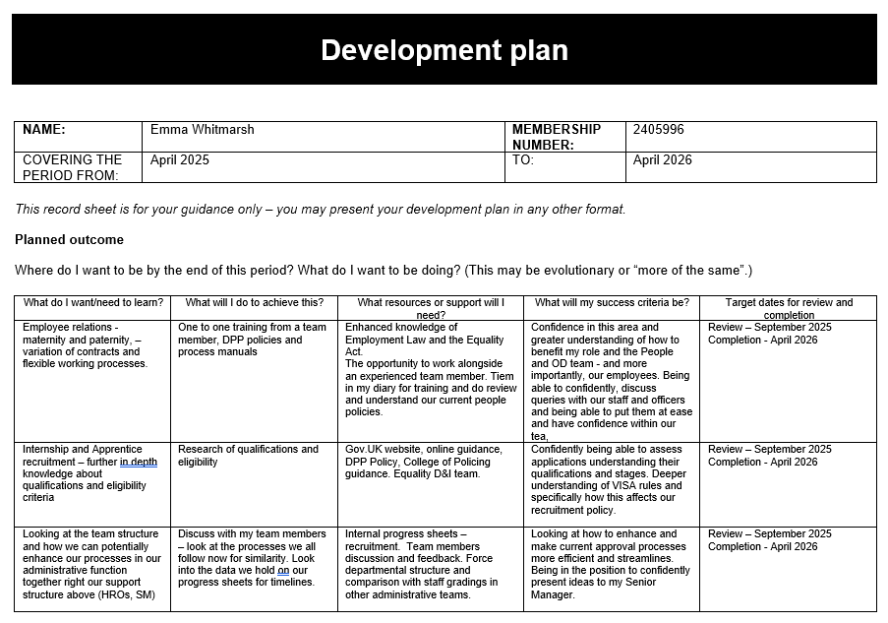

AC 3.4:

Table 9 shows my development record and development activities I have undertaken.

The first – training and mentoring new members of the team has been brilliant in increasing my awareness of the need for inclusivity and recognising diversity, as well as adapting training plan - methods and speed to suit the person I am training or mentoring.

The second and third entries on the record - improve my knowledge of recruitment processes for our Police Constables bulk recruitment, as well as our internal promotion boards for Inspectors. Both helped me with my confidence levels in speaking to people that I don't usually communicate with face-to-face and speak to groups of candidates about the Force and our processes, and what to expect from the day, and the recruitment process as a whole.

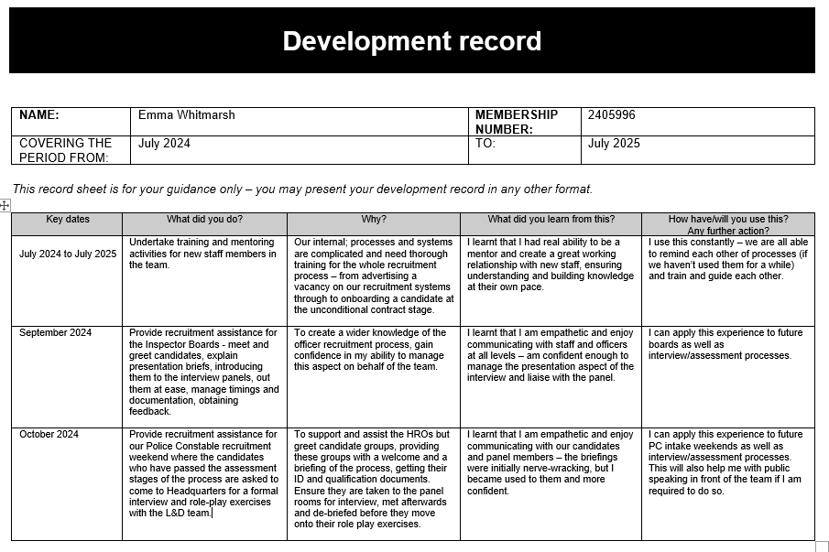

Bibliography

Adeani, I.S., Febriani, R.B. and Syafryadin, S. (2020) in Using Gibbs’ reflective Cycle in Making Reflections of Literary Analysis.  Indonesian EFL Journal, pp. 6–6. | 2.3
Andrews, A. (2024) How HR leadership can drive growth and productivity, Home. Available at: https://www.peoplemanagement.co.uk/article/1887107/hr-leadership-drive-growth-productivity (Accessed: 14 March 2025). | 1.3
CIPD HR-inform (2023) Police. Available at: https://www.hr-inform.co.uk/police (Accessed: 01 March 2025). | 1.1
Code of Ethics | College of Policing (2024) College of Policing. Available at: https://www.college.police.uk/ethics/code-of-ethics (Accessed: 14 March 2025). | 1.4
College of Policing (2024) Code of ethics. Available at: https://www.college.police.uk/ethics/code-of-ethics (Accessed: 02 March 2025). | 1.2
Department for Business, E.& I.S. (2015) Whistleblowing: Guidance and code of practice for employers, GOV.UK. Available at: https://www.gov.uk/government/publications/whistleblowing-guidance-and-code-of-practice-for-employers (Accessed: 16 March 2025). | 1.4
Ethical practice and the role of people professionals: Factsheets (2022) CIPD. Available at: https://www.cipd.org/uk/knowledge/factsheets/ethics-role-hr-factsheet/ (Accessed: 14 March 2025). | 1.4
Ethics - introduction to ethics: Duty-based ethics (no date) BBC. Available at: https://www.bbc.co.uk/ethics/introduction/duty_1.shtml (Accessed: 04 April 2025). | 1.2
Five actions you can take to foster inclusion (2023) CIPD. Available at: https://www.cipd.org/uk/knowledge/guides/five-actions-fostering-inclusion/ (Accessed: 04 April 2025). | 2.2
Gibson, E. (2022) Importance of making employees feel valued, Reworking. Available at: https://reworking.com/importance-of-making-employees-feel-valued/ (Accessed: February 1, 2023). | 2.1
Internal DPP document, DAP, 2025. | 1.2
Lewis, S., Passmore, J. and Cantore, S. (2016) Appreciative inquiry for change management: Using AI to facilitate organizational development. 2nd edn. London, England: Kogan Page. | 2.3
Moore, C. (2024) 119+ appreciative inquiry interview questions and examples, PositivePsychology.com. Available at: https://positivepsychology.com/appreciative-inquiry-questions/ (Accessed: 04 April 2025). | 2.3
Newcombe, T. (2024) HR needs to be the function that that ‘champions employee voice’, HR Magazine. Available at: https://www.hrmagazine.co.uk/content/news/hr-needs-to-be-the-function-that-champions-employee-voice-in-the-organisation-says-bae-systems-hrd/ (Accessed: 14 March 2025). | 1.3
NPCC (2025) HR and recruitment, professional standards, and Welfare. Available at: https://www.npcc.police.uk/careers/police-staff-week-of-celebration-and-recognition/hr-recruitment-and-welfare (Accessed: 01 March 2025). | 1.1
Oliveira, A. de (2025) Self-determination theory and work motivation, Self-Determination Theory and Work Motivation. Available at: https://blog.proactioninternational.com/en/how-self-determination-theory-enhance-employee-motivation (Accessed: 04 April 2025). | 2.1
Parsons, G. (2025) Maslow’s hierarchy of needs, explained [inc. pyramid diagram], BiteSize Learning. Available at: https://www.bitesizelearning.co.uk/resources/maslows-hierarchy-of-needs-theory (Accessed: 01 April 2025). | 2.1
People profession 2030 future trends (2023) CIPD. Available at: https://www.cipd.org/uk/knowledge/reports/people-profession-2030-future-trends/ (Accessed: 04 April 2025). | 3.1
Ryan, RM, & Deci, EL 2017, Self-Determination Theory: Basic Psychological Needs in Motivation, Development, and Wellness, Guilford Publications, New York. Available from: ProQuest Ebook Central. [9 April 2025]. | 2.1
The profession map (2022) CIPD. Available at: https://www.cipd.org/uk/the-people-profession/the-profession-map/ (Accessed: 01 March 2025). | 1.1

