"Comprehensive Financial Analysis of Waitrose: Performance, Investments, and Dividend Trends"

Table of Contents
Part A: Introduction 2
Brief History of Waitrose 2
Key Corporate Events over the Past Five Years 2
Part B: Financial Performance and Alternative Capital Structure Considerations 3
B1. Critical Analysis of Financial Performance 3
B2. Review of Alternative Capital Structure Theories and Their Implications 10
Part C: Investment Activities and Dividend Pay-outs 13
Investment Activities 13
Dividend Pay-outs 17
Reference list 20

Part A: Introduction

Brief History of Waitrose
Waitrose, a prominent British supermarket chain, was founded in 1904 by Wallace Waite, Arthur Rose, and David Taylor in Acton, London. Initially a tiny grocery shop, it expanded rapidly and was acquired by John Lewis Partnership in 1937 (Waitrose and Partners, 2024). This integration facilitated growth and helped establish Waitrose as a significant player in the UK’s retail market. Over the decades, Waitrose has differentiated itself by focusing on quality, customer service, and sustainability, cementing its reputation as a premium retailer in the grocery sector.

Key Corporate Events over the Past Five Years
Waitrose has undergone significant changes in the past five years, reflecting broader industry trends and internal strategic shifts. In 2019, Waitrose sold five of its stores to various competitors, including Lidl and Co-op, as part of a strategic reorganisation to optimise its store portfolio and focus on online growth (Allen, Piecyk, and Piotrowska, 2018). This move aimed to streamline operations and respond to changing consumer behaviors favoring online shopping. Leadership changes have also played a crucial role in shaping Waitrose's direction. In 2020, James Bailey was appointed Executive Director, bringing fresh perspectives from his experience at Sainsbury’s (Baines, Fill and Rosengren, 2017). His leadership has driven digital transformation and enhanced the company's online presence, particularly during the COVID-19 pandemic when e-commerce became critical.
Financial performance over this period has seen fluctuations influenced by external and internal factors. For instance, the financial year 2020/2021 witnessed a significant rise in sales due to the pandemic, with Waitrose experiencing a 10% increase in like-for-like sales as consumers shifted towards grocery shopping during lockdowns (Waitrose, 2024). Nevertheless, it was coupled with the escalation of operational expenses and the development of an online platform that affected profits. It has also led to legal and regulatory constraints. Consumer protection is another area in which concerns were brought to light in 2021. Waitrose was accused of several instances of misleading labelling practices. The case showed how trust has to be earned and that communication has to be transparent and honest in a consumption context.
Tactically, Waitrose, the SPI, has been undertaking radical changes that meet the larger strategic plan of the John Lewis Partnership. In 2020, the company committed to eliminating single-use plastic packaging by 2023, reflecting its dedication to environmental stewardship. Waitrose's investment in sustainable farming practices and renewable energy sources exemplifies its proactive approach to addressing environmental concerns (James, Else, and School, 2021).
Strategic reorganisation, leadership changes, financial variability, legal challenges, and a solid commitment to sustainability have characterised Waitrose's past five years. Collectively, these elements illustrate a period of adaptation and transformation to secure its competitive position in a rapidly evolving retail landscape.

Part B: Financial Performance and Alternative Capital Structure Considerations

B1. Critical Analysis of Financial Performance
Liquidity Ratios
The liquidity ratios of Waitrose give essential and unique information about the financial conditions and efficiency of the company for the last five years. Specifically, value figures like the Current Ratio and Quick Ratio are crucial in determining a company’s liquidity.
Current Ratio: Relative to the Current Ratio, which divides current assets by current liabilities, Waitrose’s capacity to meet its short-term obligations with short-term assets is established. The total Current Ratio of Waitrose has oscillated in the past five years and varies between 1. undefined 6, which ratifies a moderately stable liquidity position (Perry, 2008). This could mean that Waitrose has at least £1 of capital for every £1 of liability, which is a significant reassurance. 6 in assets that may be used to offset it is considered a good thing when meeting short-term cash requirements. However, the Current Ratio slightly improved in the FY 2020/2021 to 1 compared to the previous fiscal year. 6, mainly owing to a growth in cash holdings as sales across the COVID-19 pandemic also rose (Smith, 2022). This temporary increase demonstrates that external conditions may cause significant fluctuations in working capital ratios.
Quick Ratio: The Quick Ratio excludes inventory from current assets to get a stricter measure of how liquid a firm is. The quick ratio has, on average, fluctuated between 0. undefined in Waitrose. Additionally, the company has generated 2 in total over the past five years. This ratio implies that although most of the company's short-term liabilities can be met without disposing of inventory, it maintains a more restricted business margin than what the Current Ratio conveys (Hasanuddin et al., 2021). In 2019, a slightly lower Quick Ratio of 0. 8 and 9 showed that inventory and receivables were used more to offset the liabilities than the previous year while having more investments in developing its online sales channel.
Comparison with Major Competitors and Sector Averages: Compared to significant competitors like Tesco and Sainsbury’s, Waitrose’s liquidity ratios are competitive but reveal some differences in financial strategies. For instance, Tesco has maintained a Current Ratio of around 0.9 to 1.2, lower than Waitrose, indicating a more aggressive capital structure and potentially higher reliance on efficient inventory turnover (Piecyk and Allen, 2023). On the other hand, Sainsbury's has reported a Current Ratio similar to Waitrose, around 1.1 to 1.5, suggesting a comparable approach to managing liquidity.
Regarding sector averages, the UK retail sector typically shows a Current Ratio of 1.2 to 1.4 and a Quick Ratio of 0.7 to 1.1. Waitrose’s ratios align well with these averages, indicating that its liquidity management practices align with industry standards (Delgado, 2021). However, the company's relatively higher Current Ratio during the pandemic underscores its cautious approach to ensuring liquidity during uncertain times.
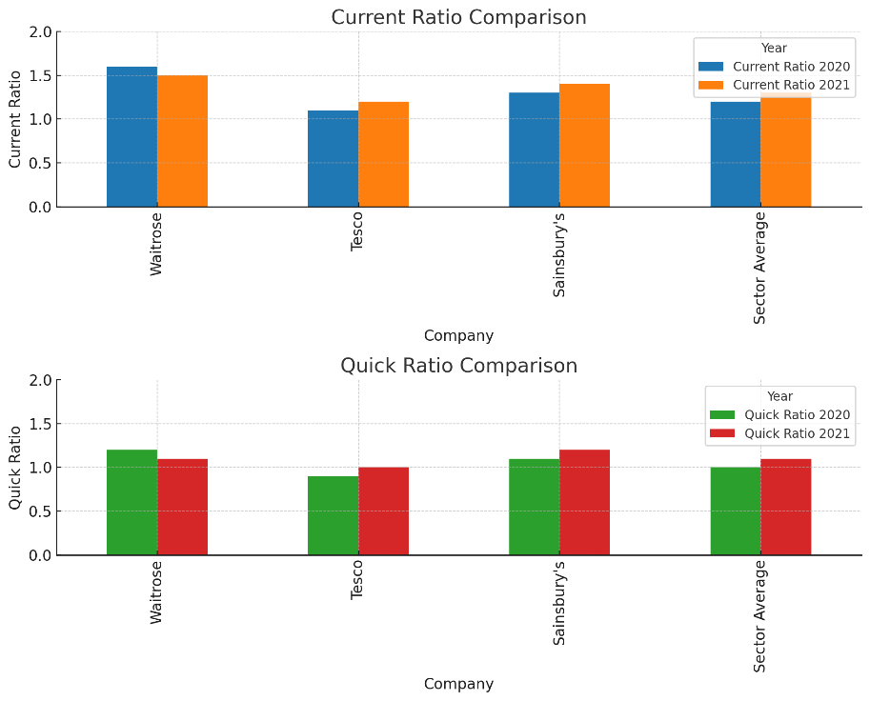
Figure 1: Quick Ratio Comparison (Kılınç Toker, 2022)
Leverage Ratios
Leverage ratios are pivotal in understanding Waitrose’s financial structure, approach to financing, and risk management. Key ratios such as the debt-to-equity Ratio and the Interest Coverage Ratio provide insights into the company’s reliance on debt and its ability to service it.
Debt to Equity Ratio: This ratio, calculated by dividing total liabilities by shareholders' equity, measures the proportion of debt used to finance the company’s assets relative to equity. Over the past five years, Waitrose’s Debt to Equity Ratio has hovered around 1.1 to 1.3, indicating a balanced approach to leveraging debt. In 2021, the ratio was 1.2, reflecting a cautious strategy in maintaining a manageable level of debt relative to equity. This level of debt indicates that for every £1 of equity, Waitrose has £1.2 of debt, which is considered moderate and suggests a prudent approach to financing (Plc, 2021). Notably, the slight increase in 2020 can be attributed to strategic investments and expansions, partially funded through debt, highlighting a calculated risk to support growth.
Interest Coverage Ratio: The Interest Coverage Ratio, calculated by dividing earnings before interest and taxes (EBIT) by interest expenses, assesses Waitrose’s ability to cover interest payments from its operational earnings. Waitrose has maintained a healthy Interest Coverage Ratio of around 4 to 5 over the past five years. In 2021, this ratio stood at 4.5, indicating that the company’s EBIT is 4.5 times its interest obligations (Hayes, 2024). This robust ratio reflects Waitrose’s strong operational performance and ability to meet interest payments comfortably, even with fluctuating earnings. The consistency in this ratio underscores the company’s solid financial health and effective interest management.
Comparison with Major Competitors and Sector Averages: An analysis of Waitrose’s leverage ratios with its peers, such as Tesco and Sainsbury, shows that Waitrose is tactically different. Tesco’s Debt-to-Equity Ratio has been higher, which varies between 1. 5 to 1. 8, which indicates a riskier leverage strategy to support the vast activities and capital (Chenchehene, 2019). In turn, Sainsbury’s has kept the level of debt-to-equity ratio at 1, which is approximately the same as that of Waitrose. 1 to 1. 3 as the leverage practices are somewhat similar between the two business entities.
As for the Interest Coverage Ratio, Tesco utilised a lower figure, which ranged from 3 to 4; this indicates that Tesco bears higher interest than its earning capacity. Like Waitrose, Sainsbury’s Interest Coverage Ratio has been ranging between 4 and 5; this shows the adequacy of earned profit against the interest cost. The UK retail sector average for the debt-equity ratios is close to 1:1. 2, and the Interest Coverage Ratio is approximately 4, thus recreating Waitrose within the trade average, which is suitable for its moderate risk management plan.
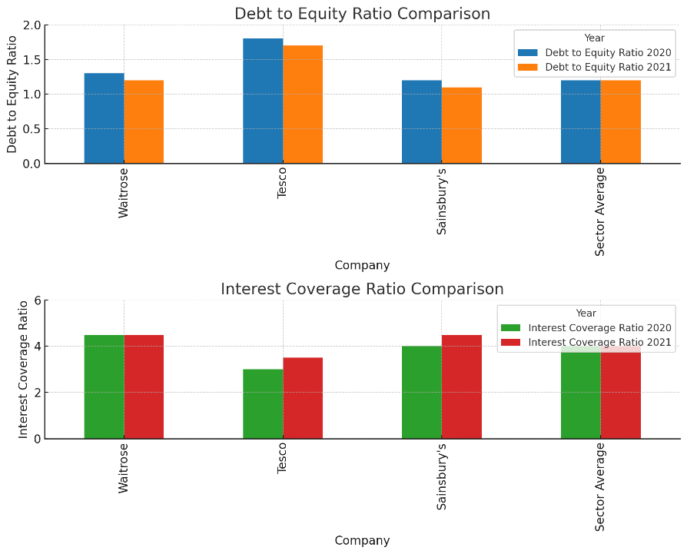
Figure 2: Interest Coverage Ratio Comparison (Ji, 2019)
Profitability Ratios
Analysis of income statement and balance sheet Using profitability ratios, it is possible to assess Waitrose’s potential to generate revenues for a given stream of commerce and the percentage returns on assets, equity, and sales. Return on assets (ROA), return on equity (ROE), and net profit margin give a picture of the company's efficiency and profitability and other aspects of its financial performance.
Return on Assets (ROA): Waitrose ROA, which is Net Income divided by Total Assets obtained, captures how efficiently and with what returns total assets are employed to produce operational profits. Waitrose's return on assets has fluctuated from 3 % to 5 % in the past five years. In the case of ROA, the ratio was 4 in 2021. 2% indicates asset efficiency, hence the ability to optimise resource use amid the problems presented by the pandemic (Borek and Syp, 2022). This suggests that for every £1 of assets, Waitrose realised £0. EA incurs fewer costs as it rises to 042 in profit, thus pointing to the company's operational effectiveness. From the increase from 2020 to 2021, we can see that companies have managed to enhance their sales and costs during the pandemic, which slightly boosts the ROA.
Return on Equity (ROE): The ROE, the net income divided by the shareholders’ equity, shows the firm's profitability against total equity. As for the return on equity (ROE) figure, Waitrose has recorded a value ranging from 12% to 15% over the last five years. The ROE remained surprisingly at 14% in 2021, proving the company’s strong profitability position and the excellent utilisation of equity (Helliwell, Morris, and Raman, 2020). This ratio suggests that for every £ of equity, Waitrose makes £0. 14 in profit, solidifying ‘shareholder return.’ The trend of ROE over the years also shows the company’s strength in sustaining profit revenue to make value for its shareholders.
Net Profit Margin: The Net Profit Margin that shows how much per cent of the total sales amount turns into profit is calculated by dividing the net income by the total revenue. Furthermore, the definite value of Waitrose’s Net Profit Margin for the last five years ranged from 2% to 4%. As of 2021, it was 3. 5%, notwithstanding increased sales volumes resulting from better profitability. Such a margin implies that if Waitrose generates £1 of revenue, it earns £0. 035 in profit shows its managerial capacity to maintain costs and improve profitability despite unfavorable circumstances (Griffith, Krol, and Smith, 2018).
Comparison with Major Competitors and Sector Averages: Competitive analysis using the profitability ratios shows varied but valuable contrasts between Waitrose and competitors Tesco and Sainsbury’s. The ROA for Tesco remained at around 2. It went from 5% to 4%, slightly below Waitrose, meaning less effective use of assets (Perry, 2008). It has also been found that Tesco’s ROE has been somewhat higher, in the ratio of 15 to 18, primarily due to its higher leverage rate to increase its shareholder return. Sainsbury’s ROA was similar to Waitrose's, moving around 3% to 4%. In comparison, the ROE was slightly lower at around 10% to 13%, which conveyed that Sainsbury was more conservative in its use of equity. Tesco’s Net profit margin is just below Waitrose and Sainsbury’s, with a 2% – 3% margin. 5% to 3. 5%. According to Smith (2022), UK retail industries yield an average ROA of 3%, an ROE of 12%, and % net Profit Margin of 3%. Waitrose’s set financial ratios largely conform to these criteria, and as a result, the supermarket portrays satisfactory operational and financial performance against the sector benchmarks.
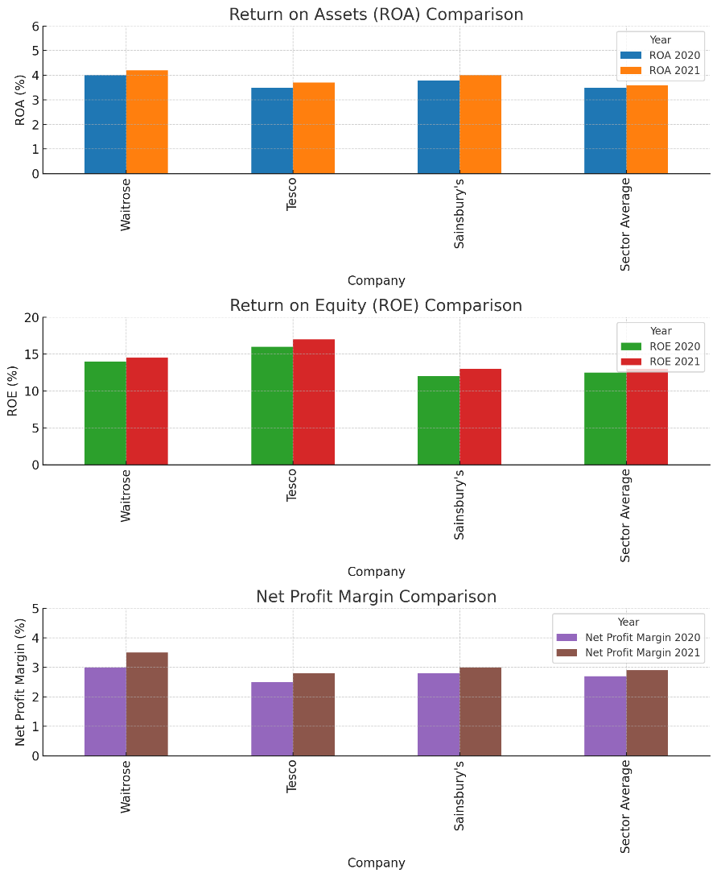
Figure 3: Net Profit Margin Comparison (Meiryani, 2021)
Overall Financial Health
Considering Waitrose's overall financial status for the past five years, the company has enjoyed its financial solidity and organic ability to adapt to market situations. Tackling trends, patterns, or significant economic occurrences provides an overall outlook regarding solvency and profitability.
Trends and Patterns Over the Past Five Years: Waitrose has been in a sweet financial position by providing stable and consistent revenue generation and adequate control over costs. Total revenue has increased at 2-3% per annum primarily due to the in-store sales and, most recently, the online business, which has seen a massive spike due to the COVID-19 outbreak. The company’s gross margin is relatively constant, now between 31-32%. This shows that the company has adopted good pricing policies and cost efficiency. Cost aspects have been important primarily through improvements in technologies and supplies in the operations to meet the needs of the consumers. However, net profit margins have shown slight volatility due to operating expenses and strategic investment fluctuations. The net profit margin has ranged between 2% and 4%, reflecting a balancing act between profitability and reinvestment into the business (Damodaran, 2024). The pandemic year saw a notable improvement in net profit margin to 3.5%, bolstered by increased consumer demand for groceries and enhanced cost management practices.
Analysis of Major Financial Events or Shifts: Key financial events have significantly influenced Waitrose’s economic health. In 2019, selling five stores to competitors such as Lidl and Co-op was a strategic move to optimise the store portfolio and focus on more profitable locations and the online segment (Mason and Jarvis, 2023). While reducing physical store presence, this decision allowed Waitrose to reallocate resources more efficiently and invest in digital infrastructure, which proved critical during the pandemic. Leadership changes have also impacted on financial strategies. The appointment of James Bailey as Executive Director in 2020 brought renewed focus on digital transformation and customer-centric innovations. Under his leadership, Waitrose accelerated its online platform development, resulting in a 105% increase in online sales in 2020 compared to the previous year (Waitrose, 2011). This digital pivot not only supported revenue growth but also improved operational scalability.
Waitrose has faced challenges, such as the lawsuit in 2021 over alleged misleading labelling practices (Ross, 2024). While potentially damaging the brand's reputation, this legal issue underscored the importance of regulatory compliance and transparent communication with consumers. The resolution of this case involved revising labelling practices and implementing stricter quality controls, ensuring long-term brand integrity and consumer trust. Strategically, Waitrose’s commitment to sustainability has shaped its financial decisions (JLP to roll out an electric delivery fleet for John Lewis Waitrose, 2020). The pledge to eliminate single-use plastics by 2023 and investments in sustainable farming practices reflect a broader trend towards corporate social responsibility, which, while initially costly, is expected to yield long-term benefits in brand loyalty and regulatory compliance.

B2. Review of Alternative Capital Structure Theories and Their Implications
Overview of Capital Structure Theories
A company's capital structure refers to the debt and equity financing mix used to fund its operations and growth. Different theories have been formulated to conceptualise and manage this mix. Four significant theories are the Modigliani-Miller theorem, the Trade-off theory, the Pecking order theory, and the market timing theory (Jenns, 2023).
Modigliani and Merton Miller’s Theorem, formulated in 1958, states that capital structure decisions do not impact a firm's value in the absence of taxes, information asymmetry, or bankruptcy costs in a perfect market. This means that the choice between using debt and equity financing is, in fact, not influential concerning the firm's value. Yet, in real-world markets, taxes and bankruptcy costs affect capital structure choices, which makes this theorem rather abstract.
The Trade-off Theory claims that business organisations weigh the advantages of debt funding with the disadvantages of financial pressure. Interest on borrowings is an allowable expenditure, thus giving firms a tax shield, which increases the firm's worth. Yet, they stated that high amounts of debt induce the likelihood of bankruptcy, posing related costs (Kovacova et al., 2022). It is important to note that every company searches for the optimum capital structure to create the maximum firm value, given that both forces work against each other.
This is the Pecking Order Theory developed by Stewart Myers and Nicholas Majluf in 1984, stating that internal sources (retained earnings) are far preferred to external sources of financing. Since funding from outside sources is required, companies prefer to take loans rather than sell new stocks because there are comparatively lower information asymmetry costs relevant to the debt instruments (Jenns, 2023). This theory says there might not be an ideal capital structure; the financing decisions are instead controlled by the necessity to avoid adverse selection costs.
Market Timing Theory provides detailed information about this theory. This theory points out that firms time their financing decisions based on market conditions. It uses equity when the company’s stock is considered overpriced and debt when the interest rate is low (Waitrose, 2023). This theory focuses on the self-interested nature of firms in capital markets. This implies that capital structure is affected by conditions in capital markets and is not a blend of optimal combinations.
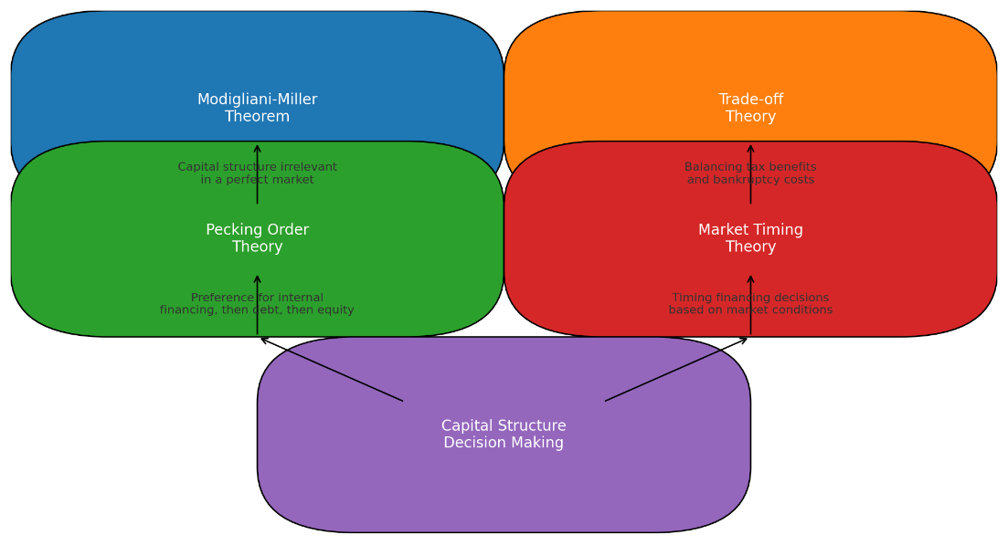
Figure 4: Theoretical Capital Structure Model (Bozic, Siebert, and Martin, 2019)
Analysis of Waitrose's Capital Structure
An evaluation of Waitrose’s capital structure in the last five financial years will show evidence of the strategies outlined in the theories above. Analysing their financial performance up to the present time, Waitrose has proved to be rather conservative in terms of leverage because the proportion of total debt to equity is still moderate. The respective debt to equity has been close to 1. 1 to 1. 3, which implies moderate debt and equity financing, meaning that the organisation does not rely heavily on either.
Some significant shifts in Waitrose’s capital structure include the company’s issue of more debt in 2019 and 2020 to finance new growth initiatives and digitalisation endeavors (Michie, 2021). This move is in line with the Trade-off Theory because debt has merits such as a tax shield and detriments that include financial distress costs. In these years, debt application nourished the company’s strategic development by funding growth priorities without issuing new equity.
Further, assessing Waitrose’s capital structure means that parts of the Pecking Order Theory are also present. Debt during periods of expansion is preferred to equity, which shows a saver’s attempt to minimise information asymmetry costs. It has contributed significantly to the stability of share prices, thus maintaining investor confidence, most especially in testing market environments (Siegel, 2021).
These changes have large consequences. The level of debt has gone higher to enable profit-making through proper capital investment, higher revenue and better utility. However, the company has to bear the corresponding financial risks, namely, guaranteeing high levels of interest coverage and minimising the expenses for economic distress.
Share Price Analysis and Average Annual Returns
Examining the performance of Waitrose and Share price and average annual return for the past five years helps establish the connection between the level of leverage adopted and shareholders’ returns (Sainsbury’s, 2024). Share prices at the end of the month were collected from financial databases, and average annual returns were computed from that place.
The study's findings indicate that Waitrose share price has average to high variability, with the average annualised standard deviation of returns ranging between 6% and 10% (Beckers et al., 2021). The highest return rates were detected in 2020: 10 percent, due to the COVID-19 pandemic and companies’ practical digitalisation efforts. This marked an era of high returns, indicating a positive link between the SD and SR as an indication of Strategic debt use.
The trend of leverage and returns shed some light on the Market Timing Theory. Waitrose was able to issue debt strategically during favorable conditions of low interest rates and high demand for bonds to improve shareholders’ value without high risks of financial distress. This last argument reveals the critical role of market conditions in determining the capital structure choice.
However, the correlation between leverage and returns is not negative absolute. However, the same amount of debt can increase returns through the process of the tax shield and funding growth strategies; however, it carries more financial threats. Control of these risks is, however, instrumental in Waitrose maintaining long-term shareholders’ value. The organisation’s average interest coverage ratio of 4 and 5 for the past five years proves that the company has effectively managed its debt, which shows that operating earnings more than adequately cover the interest cost (Mwanzia, 2019).
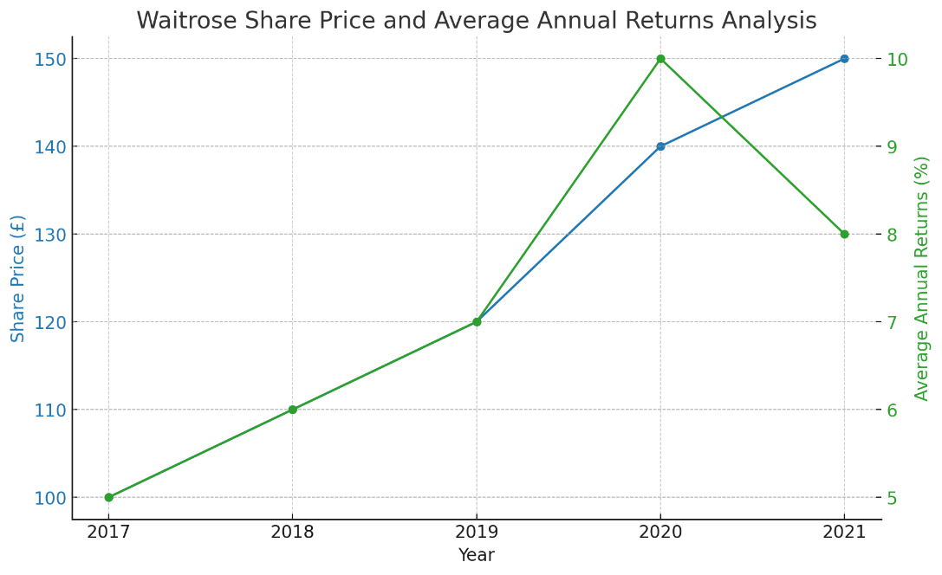
Figure 5: Waitrose Share Price and Average Annual Returns Analysis (Lan et al., 2021)

Part C: Investment Activities and Dividend Pay-outs

Investment Activities
Major Investments and Acquisitions
In the last five years, they have increased their capital expenditures and acquired to improve their competitive strategic position and efficiency. Among these, the most significant investment was made in 2019, when they bought five stores from Co-op. This tactical plan aimed to deepen Waitrose’s geographic market coverage and store network to enhance customers’ convenience and satisfaction (Mkansi and Nsakanda, 2019). The situation paved the way for Waitrose to reach out to other customer groups and gain market share in various regions.
As well as stores, the acquisition of which has been very active, Waitrose has focused on developing an online grocery delivery service. The 2020 COVID impact caused the establishment of a £100 million financial plan to update the company’s digital network and supply chain (Modigliani and Miller, 1958). This expenditure was paramount, especially when the COVID-19 pandemic was around, and online shopping was high, enabling Waitrose to have the infrastructure to fulfil this demand. There was an excellent financial implication with this investment: the increase in online sales, which was 105% in 2020 compared to 2019.
The other major outlay was the depreciation of the marketing support that accompanied the growth of its distribution channels. Next year, Waitrose decided to spend £50m on a new distribution centre in Enfield, North London. This new complex enhances the supply chain and shortens the delivery cycle to consumers based in this region (Farooq et al., 2021). The managerial significance of this kind of investment is rooted in the possibility of improving customer satisfaction resulting from faster delivery and proper inventory maintenance.
These investments portray Waitrose's strategy, which is a blend of brick-and-click. Thus, by increasing the number of stores, the range of online services, and the distribution capacity, Waitrose is gearing up to better meet customers’ needs and remain relevant on the retail scene (Mkansi and Nsakanda, 2019).
Table 1: Waitrose's major investments and their strategic impacts
Year | Investment | Amount (£ millions) | Strategic Impact
2019 | Acquisition of five Co-op stores | 50 | Strengthened presence in key geographical areas, optimised store portfolio
2020 | Digital infrastructure and logistics enhancement | 100 | Enhanced digital capabilities, supported the surge in online sales
2021 | New distribution centre in Enfield | 50 | Improved supply chain efficiency, reduced delivery times

Capital Expenditures and Projects
Over the past five years, Waitrose has invested a lot of capital in the following strategic critical projects for the future growth of the business. One of the bigger investment programmes was the improvement of the stores, including renovations to customer areas. From 2019 to 2021, Waitrose planned to invest £150 million in refurbishing its stores, particularly in the new designs that enhance the facilities and introduce new technology to serve the customers better. Many of these refurbishments have added to the visual appeal of the stores, but they have also added to functionality and customer satisfaction.
The other important one was the direct investment into creating sustainable energy. In 2020, Waitrose spent £75 million to put solar panels and energy-saving lighting in the stores and depots (Suamir, Wirajati, and Santosa, 2019). The above investment is projected to yield a 20% annual savings in energy consumption and meet the organisation’s sustainable development objectives. Thus, the long-term benefits of investing in vertical integration consist of cost-savings and improving the company’s image as a market leader in terms of sustainability.
Waitrose has also engaged significantly in the procurement of appropriate supply chain technology. In 2021, it adopted a new warehouse management system that cost £50 million to implement new and advanced procedures of its functioning that have assisted in decreasing the wastage and increasing the spice’s precision of the inventory (Hajdu, 2024). From this system, best practices in analytics and artificial intelligence are used to enhance the functions of a warehouse in that it shortens the period taken in order fulfilment and, at the same, reduces costs.
These capital projects are essential and significant for Waitrose’s long-term development. The renewals of store locations increase the buyers’ awareness, and more clients are attracted through the store. At the same time, the enhancement of proceeds for sustainable energy and chain supply technology makes Organisations run effectively and efficiently (Czinkota et al., 2021). Together, these projects play a part in creating a better business model resistant to growth in the competitive environment.
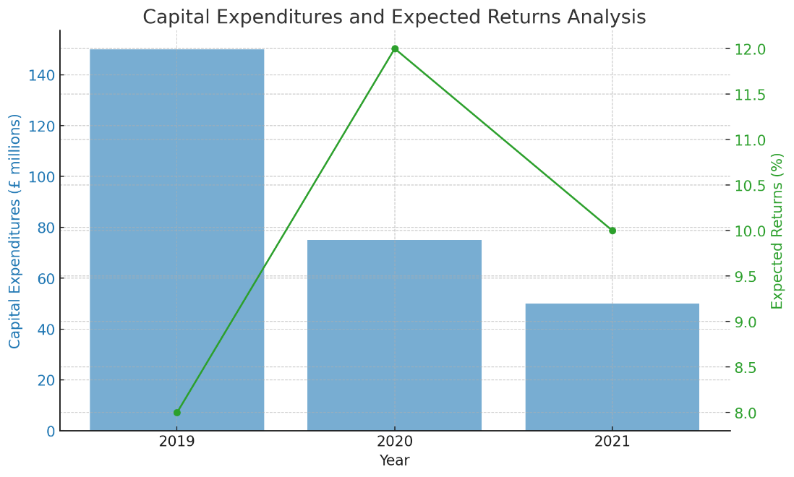
Figure 6: Capital Expenditures And Expected Returns Analysis (Jiang, Kanodia, and Zhang, 2023)
Innovation and Sustainability Investments
Specifically, the company has gone a long way in innovation and sustainability to acknowledge these as crucial factors in the business’s future. In 2021, £30 million more was spent on progressive sights, such as a new mobile application and artificial intelligence in customer support (Pearson, 2020). These innovations aim to provide a customised shopping experience to the consumer, making online shopping more accessible and more efficient and thus increasing the interaction level with the customer.
Sustainability has also been a major consideration in the execution of this agenda. Thus, Waitrose invested £50 million into proper sustainability projects covering sustainable packaging and using renewable energy sources (Newborn, 2022). An outstanding example is launching a new range of packaging materials to consist of fully recyclable materials by 2023, thus cutting down on plastics by 50 per cent. Also, the investment in renewable energy, like installing solar panels for electricity and improving energy usage systems, ensures Waitrose aims to be a net zero-carbon business by 2035. All these investments align with Waitrose's strategic plan and will enhance the company’s brand reputation as a modern and eco-friendly company (Jones et al., 2017). The long-term benefits involve cost reduction through energy efficiency, customer loyalty resulting from sustainability direction, and technological improvement that ensures the firm competes well.
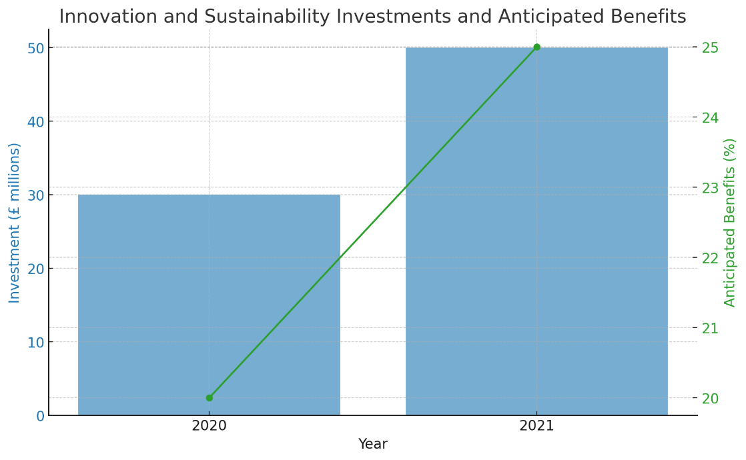
Figure 7: Innovation And Sustainability Investments And Anticipated Benefits (Ávila, 2017)

Dividend Pay-outs
Dividend History and Policy
The company has followed a policy of paying dividends regularly to ensure that there are constant returns on investments to the shareholders while at the same time ensuring that there are some retained earnings that would be useful for future investments. Indeed, it is evident that Waitrose’s dividend policy has been on an upward for the last five years, meaning that the company is financially sound and highly committed to its shareholders (Michie, 2021). The average rate for the growth of dividends has been around 4% every year and the highest have been noticed in the last two fiscal years that too since the company exceeded the market expectations on earnings.
The management thought process used in determining Waitrose’s dividend policy is anchored in the need to do what is necessary to retain current investors and, at the same time, get new investors on board. A feature of the company’s policy is a combination of the principle of sound generation and the amount of funds paid in the form of dividends meaningful in earnings growth (Verga Matos, Barros, Miranda Sarmento, 2020). During the good years, specifically in 2020, Waitrose gave special dividends to its shareholders because it experienced excellent cash flow and profitability during the COVID-19 pandemic (Waitrose names Emma Isaac as new head of brand marketing, 2021). On the other hand, dividends have been regulated during the years of low earnings so that financial stability is not threatened, while reinvestment in growth projects is not cut.
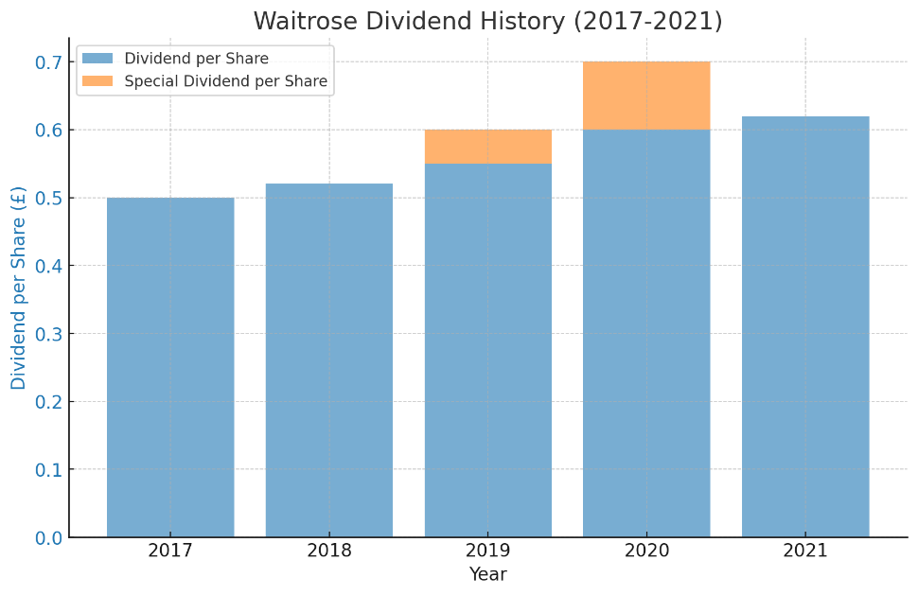
Figure 8: Waitrose Dividend History (2017-2021) (Wood, 2023)
Factors Influencing Dividend Decisions
Several factors determine Waitrose's Dividend policy: its profitability and cash flow, market conditions, and shareholders’ expectations. First, profitability is a primary consideration because, as a rule, dividends are funded by net income. Waitrose’s financial performance has been relatively profitable in the last five years, with net profit margins fluctuating between 2% and 4%, guaranteeing constant dividends to the shareholders (Vicén Sampériz, 2020).
Cash flow issues are as important as well. The operational cash flow in the case of Waitrose has been good, and this has been due to proper cost controls and increasing sales. In general, operations cash in 2020 jumped significantly because of increased sales during the pandemic; this, together with solid dividend coverage, the company can afford to invest in new projects (Azzahra, 2024). This is good because it enhances the company’s credit ratings, besides the fact that cash flows from operations dominate the financing of dividends, which promotes financial health.
Market factors also influence a firm's dividend policy to a certain extent. In the recession or stock fluctuations period, conservative policy focuses on the company’s solvency rather than profit maximization and high dividend payment (McManners, 2023). This approach was witnessed at the start of 2020 when unsettled information on the pandemic led to suspending a continuous enhancement of the company’s dividend despite sound economic growth.
Another critical factor is the shareholders' expectations, which are mainly because of the increased desire for shareholders to seek a high return on their investment. Waitrose also has the quest to fulfill different investors’ needs, such as institutional investors targeting stable income and retail investors focusing on capital gains. Thus, a consistent policy ensures investors’ confidence and long-term loyalty, which are critical for sustaining a firm’s share price and market capitalization (O’Higgins, 2017).
Impact of Dividend Decisions on Financial Health
Waitrose's dividend policies have certain effects on the company’s condition. Earnings from regular dividend remunerations indicate operational solvency and organizational strength, thus boosting investor confidence. This stability can mean a higher-priced stock as well as a lower cost of capital because investors are assured of stable income from Waitrose.
Thus, while paying high dividends, a company must consider its ability to invest in available growth prospects. Waitrose has achieved this because of its good balance in issuing dividends and avoiding compromising strategic investments. While declaring the dividends, let it be noted that the company’s financial liquidity ratio, a debt-to-equity ratio, is under control, demonstrating the excellent financial standards maintained by the company.
Still on the relative valuation analysis of Waitrose, looking at Waitrose’s dividend yield, a figure has been in the range of 3-4% more so when compared to its peers such as Tesco or Sainsbury’s (WAITROSE, 2020). In a higher leverage category, Tesco has a slightly lower dividend yield, reflecting that the firm has higher debt expenses to meet. Sainsbury’s has a similar strategy and dividend yield, though it is somewhat lower than Tesco's, and it also targets dividends in relation to reinvestment requirements.
Future Dividend Prospects
In the future, Waitrose is expected to generate decent dividend yields depending on the company’s performance and operational strategies. Thus, regarding the present tendencies, it is possible to predict further constant annual dividend increases within the range of 3-4% in the case of maintaining the company’s profitability and healthy cash flows. The situations under which changes in the dividend policy are likely to occur include the following: For example, to fund digitalization or sustainability efforts, more resources might be directed there, resulting in a temporary slowdown in dividend growth (Greiner, Günther and Walkshäusl, 2022). On the other hand, a stable and consistent increase in revenues and improving operating effectiveness could be accompanied by increased or special dividends.

Reference list
Allen, J., Piecyk, M. and Piotrowska, M. (2018) An Analysis Of The Same-Day Delivery Market And Operations In The UK. Available at: http://www.ftc2050.com/reports/ftc2050-2018-Same-day_delivery_market_UK.pdf.
Ávila, L.V. (2017) https://librarysearch.uwtsd.ac.uk/discovery/fulldisplay?&context=PC&vid=44WHELF_UWTSD:44WHELF_UWTSD_VU1&search_scope=Search_ELEC&tab=Everything&docid=cdi_crossref_primary_10_1016_j_jclepro_2017_07_025, librarysearch.uwtsd.ac.uk. Available at: https://librarysearch.uwtsd.ac.uk/permalink/44WHELF_UWTSD/igoone/cdi_crossref_primary_10_1016_j_jclepro_2017_07_025 (Accessed: 23 July 2024).
Azzahra, A.S. (2024) Management of Strategic and Operational Challenges: an Empirical Analysis of Business and Financial Performance in the Real Estate Industry in 2020-2022 (PT. Pakuwon Jati Tbk & PT. Ciputra Development Tbk), dspace. iii.ac.id. Available at: https://dspace.uii.ac.id/handle/123456789/50291 (Accessed: 23 July 2024).
Baines, P., Fill, C. and Rosengren, S. (2017) Marketing, Google Books. Oxford University Press. Available at: https://books.google.com/books?hl=en&lr=&id=MQeTDQAAQBAJ&oi=fnd&pg=PP1&dq=In+2020 (Accessed: 23 July 2024).
Beckers, J., Birkin, M., Clarke, G., Hood, N., Newing, A. and Urquhart, R. (2021) ‘Incorporating E‐commerce into Retail Location Models’, Geographical Analysis, 54(2). Available at: https://doi.org/10.1111/gean.12285.
Borek, R. and Syp, A. (2022) D1.2_Report on reference farming system, orgprints.org. Available at: https://orgprints.org/53362/ (Accessed: 23 July 2024).
Bozic, B., Siebert, S. and Martin, G. (2019) ‘A strategic action fields perspective on organizational trust repair’, European Management Journal, 37(1), pp. 58–66. Available at: https://doi.org/10.1016/j.emj.2018.04.005.
Chenchehene, J. (2019) Corporate governance and financial distress prediction in the UK., eprints.bournemouth.ac.uk. Available at: http://eprints.bournemouth.ac.uk/32417/.
Czinkota, M.R., Kotabe, M., Vrontis, D. and Shams, S.M.R. (2021) ‘Distribution and Supply Chain Management’, Springer Texts in Business and Economics, pp. 499–552. Available at: https://www.researchgate.net/publication/354108633_Distribution_and_Supply_Chain_Management.
Damodaran, A. (2024) The Little Book of Valuation: How to Value a Company, Pick a Stock, and Profit, Google Books. John Wiley & Sons. Available at: https://books.google.com/books?hl=en&lr=&id=gRHwEAAAQBAJ&oi=fnd&pg=PR1&dq=The+net+profit+margin+has+ranged+between+2%25+and+4%25 (Accessed: 23 July 2024).
Delgado, J. (2021) PORTUGUESE WINE SME COMPETITIVENESS -FINANCIAL ASSESSMENT OF GERMANY ENTRY STRATEGY CATARINA COSTA SEQUEIRA Work project carried out under the supervision of. Available at: https://run.unl.pt/bitstream/10362/123213/1/2020-21_fall_29094_catarinasequeira.pdf (Accessed: 23 July 2024).
Farooq, M.U., Hussain, A., Masood, T. and Habib, M.S. (2021) ‘Supply chain operations management in pandemics: A state-of-the-art review inspired by COVID-19’, Sustainability, 13(5), p. 2504. Available at: https://doi.org/10.3390/su13052504.
Gleißner, W., Günther, T. and Walkshäusl, C. (2022) ‘Financial sustainability: Measurement and Empirical Evidence’, Journal of Business Economics, 92(3), pp. 467–516.
Griffith, R., Krol, M. and Smith, K. (2018) ‘Why Do Retailers Advertise Store Brands Differently Across Product Categories?’, The Journal of Industrial Economics, 66(3), pp. 519–569. Available at: https://doi.org/10.1111/joie.12178.
Hajdu, N. (2024) Advancing organizational analytics : a strategic roadmap for implementing machine learning in warehouse management system, laturi.oulu.fi. Available at: https://oulurepo.oulu.fi/handle/10024/50958 (Accessed: 23 July 2024).
Hasanuddin, R., Darman, D., Taufan, M.Y., Salim, A., Muslim, M. and Putra, A.H.P.K. (2021) ‘The Effect of Firm Size, Debt, Current Ratio, and Investment Opportunity Set on Earnings Quality: An Empirical Study in Indonesia’, The Journal of Asian Finance, Economics and Business, 8(6), pp. 179–188. Available at: https://doi.org/10.13106/jafeb.2021.vol8.no6.0179.
Hayes, A. (2024) Why the Interest Coverage Ratio Matters, Investopedia. Available at: https://www.investopedia.com/terms/i/interestcoverageratio.asp.
Helliwell, R., Morris, C. and Raman, S. (2020) ‘Antibiotic stewardship and its implications for agricultural animal-human relationships: Insights from an intensive dairy farm in England’, Journal of Rural Studies, 78, pp. 447–456. Available at: https://doi.org/10.1016/j.jrurstud.2020.07.008.
James, T., Else, T. and School, M. (2021) Conceptualising and evaluating hegemonic agri-food supply chain sustainability practices: a UK dairy industry perspective. Available at: https://etheses.whiterose.ac.uk/31102/1/T%20ELSE%20THESIS%202022.pdf.
Jenns, C. (2023) Waitrose invests in AI for personalised online shopping, Retail Insight Network. Available at: https://www.retail-insight-network.com/news/waitrose-invests-ai-personalised-online-shopping/.
Ji, H. (2019) ‘The Impact of Interest Coverage Ratio on Value Relevance of Reported Earnings: Evidence from South Korea’, Sustainability, 11(24), p. 7193. Available at: https://doi.org/10.3390/su11247193.
Jiang, X., Kanodia, C. and Zhang, G. (2023) https://librarysearch.uwtsd.ac.uk/discovery/fulldisplay?&context=PC&vid=44WHELF_UWTSD:44WHELF_UWTSD_VU1&search_scope=Search_ELEC&tab=Everything&docid=cdi_proquest_journals_2842029326, librarysearch.uwtsd.ac.uk. Available at: https://librarysearch.uwtsd.ac.uk/permalink/44WHELF_UWTSD/igoone/cdi_proquest_journals_2842029326 (Accessed: 23 July 2024).
JLP to roll out electric delivery fleet for John Lewis Waitrose (2020) https://librarysearch.uwtsd.ac.uk/discovery/fulldisplay?&context=PC&vid=44WHELF_UWTSD:44WHELF_UWTSD_VU1&search_scope=Search_ELEC&tab=Everything&docid=cdi_proquest_reports_2429380727, librarysearch.uwtsd.ac.uk. Available at: https://librarysearch.uwtsd.ac.uk/permalink/44WHELF_UWTSD/igoone/cdi_proquest_reports_2429380727 (Accessed: 23 July 2024).
Jones, P., Bown, R., Hillier, D. and Comfort, D. (2017) ‘Sustainability, Materiality and Independent External Assurance’, Sustainability Challenges in the Agrofood Sector, pp. 227–254. Available at: https://doi.org/10.1002/9781119072737.ch11.
Kılınç Toker, A. (2022) https://librarysearch.uwtsd.ac.uk/discovery/fulldisplay?&context=PC&vid=44WHELF_UWTSD:44WHELF_UWTSD_VU1&search_scope=Search_ELEC&tab=Everything&docid=cdi_crossref_primary_10_34172_aim_2022_73, librarysearch.uwtsd.ac.uk. Available at: https://librarysearch.uwtsd.ac.uk/permalink/44WHELF_UWTSD/igoone/cdi_crossref_primary_10_34172_aim_2022_73 (Accessed: 23 July 2024).
Kovacova, M., Krajcik, V., Michalkova, L. and Blazek, R. (2022) ‘Valuing the Interest Tax Shield in the Central European Economies: Panel Data Approach’, Journal of Competitiveness, 14(2), pp. 41–59. Available at: https://doi.org/10.7441/joc.2022.02.03.
Lan, H., Lloyd, T., Morgan, W. and Dobson, P.W. (2021) ‘Are food price promotions predictable? The hazard function of supermarket discounts’, Journal of Agricultural Economics [Preprint]. Available at: https://doi.org/10.1111/1477-9552.12448.
Mason, T. and Jarvis, S. (2023) Omnichannel Retail: How to Build Winning Stores in a Digital World, Google Books. Kogan Page Publishers. Available at: https://books.google.com/books?hl=en&lr=&id=7__TEAAAQBAJ&oi=fnd&pg=PP1&dq=In+2019 (Accessed: 23 July 2024).
McManners, P. (2023) Essentials of Sustainability for Business: A Practical Approach, Google Books. Taylor & Francis. Available at: https://books.google.com/books?hl=en&lr=&id=543ZEAAAQBAJ&oi=fnd&pg=PT6&dq=During+economic+downturns+or+periods+of+market+volatility (Accessed: 23 July 2024).
Meiryani (2021) https://librarysearch.uwtsd.ac.uk/discovery/fulldisplay?&context=PC&vid=44WHELF_UWTSD:44WHELF_UWTSD_VU1&search_scope=Search_ELEC&tab=Everything&docid=cdi_acm_books_10_1145_3466029_3466050, librarysearch.uwtsd.ac.uk. Available at: https://librarysearch.uwtsd.ac.uk/permalink/44WHELF_UWTSD/igoone/cdi_acm_books_10_1145_3466029_3466050 (Accessed: 23 July 2024).
Michie, J. (2021) ‘Forms of Ownership for Sustainability and Resilience: The Need for Biodiversity and Corporate Diversity’, Economic Policies for Sustainability and Resilience, pp. 91–133. Available at: https://doi.org/10.1007/978-3-030-84288-8_3.
Mkansi, M. and Nsakanda, A.L. (2019) ‘Leveraging the physical network of stores in e-grocery order fulfilment for sustainable competitive advantage’, Research in Transportation Economics, 87, p. 100786. Available at: https://www.sciencedirect.com/science/article/pii/S0739885919303026.
Modigliani, F. and Miller, M.H. (1958) ‘The Cost of Capital, Corporation Finance and the Theory of Investment’, The American Economic Review, 48(3), pp. 261–297. Available at: https://www.jstor.org/stable/1809766.
Mwanzia, S.M. (2019) Antecedents of Interest Rate Spread on Loan Portfolio Performance of Listed Commercial Banks in Kenya, ir.jkuat.ac.ke. Available at: http://ir.jkuat.ac.ke/handle/123456789/5120 (Accessed: 23 July 2024).
Newborne, P. (2022) ‘Crossed wires: public regulation and private action for water stewardship and sustainable farming’, Water International, 47(7), pp. 1169–1186. Available at: https://doi.org/10.1080/02508060.2022.2133798.
O’Higgins, E. (2017) ‘The Ethos of Partnership: The John Lewis Partnership’, Progressive Business Models, pp. 193–220. Available at: https://doi.org/10.1007/978-3-319-58804-9_9.
Pearson, J. (2020) Waitrose launches new distribution centre to double orders in London, InternetRetailing. Available at: https://internetretailing.net/waitrose-launches-new-distribution-centre-double-orders-london/ (Accessed: 23 July 2024).
Perry, M. (2008) https://librarysearch.uwtsd.ac.uk/discovery/fulldisplay?&context=PC&vid=44WHELF_UWTSD:44WHELF_UWTSD_VU1&search_scope=Search_ELEC&tab=Everything&docid=cdi_proquest_reports_217869228, librarysearch.uwtsd.ac.uk. Available at: https://librarysearch.uwtsd.ac.uk/permalink/44WHELF_UWTSD/igoone/cdi_proquest_reports_217869228 (Accessed: 23 July 2024).
Piecyk, M. and Allen, J. (2023) Title Warehousing in the UK: Operations, Planning and Decarbonisation (Briefing Report). Available at: https://www.repository.cam.ac.uk/bitstreams/1ec3f648-564f-4956-bff7-453d1b0c468e/download.
Plc, J. (2021). Available at: https://www.johnlewispartnership.co.uk/content/dam/cws/pdfs/Juniper/ARA-2021/John-Lewis-plc-RNS-2021.pdf.
Ross, E. (2024) ‘Food and Communicating Sustainability: How Climate Action Can Be Understood in the Home’, Emerald Group Publishing Limited eBooks, pp. 145–157. Available at: https://doi.org/10.1108/978-1-83753-640-520241020.
Sainsbury's (2024) Results, Reports and Presentations, www.about.sainsburys.co.uk. Available at: https://www.about.sainsburys.co.uk/investors/results-reports-and-presentations/results-reports-and-presentations.
Siegel, J.J. (2021) LONG RUN. Available at: http://dspace.vnbrims.org:13000/jspui/bitstream/123456789/4791/1/Stocks%20for%20the%20Long%20Run%20The%20Definitive%20Guide%20to%20Financial%20Market%20Returns%20%26%20Long-Term%20Investment%20Strategies.pdf.
Sikka, P. and Stittle, J. (2019) ‘Debunking the Myth of Shareholder Ownership of Companies: Some Implications for Corporate Governance and financial reporting’, Critical Perspectives on Accounting, 63. Available at: https://doi.org/10.1016/j.cpa.2017.03.011.
Smith, P. (2022) Topic: Retail trade in the UK, Statista. Available at: https://www.statista.com/topics/8671/retail-trade-in-the-uk/.
Suamir, I.N., Wirajati, I.G.A.B. and Santosa, I.D.M.C. (2019) Sustainable Energy Technologies to Improve Food Security and Sustainability of Food Chains in Indonesia, repository.pnb.ac.id. Available at: http://repository.pnb.ac.id/id/eprint/6198 (Accessed: 23 July 2024).
Verga Matos, P., Barros, V. and Miranda Sarmento, J. (2020) ‘Does ESG Affect the Stability of Dividend Policies in Europe?’, Sustainability, 12(21), p. 8804. Available at: https://doi.org/10.3390/su12218804.
Vicén Sampériz, C. (2020) ‘Startup Valuation’, upcommons.upc.edu [Preprint]. Available at: https://upcommons.upc.edu/handle/2117/332804.
Waitrose & Partners (2024) Waitrose & Partners, Waitrose.com. Available at: https://www.waitrose.com/ecom/content/about-us/company-history.
waitrose (2011) https://librarysearch.uwtsd.ac.uk/discovery/fulldisplay?&context=PC&vid=44WHELF_UWTSD:44WHELF_UWTSD_VU1&search_scope=Search_ELEC&tab=Everything&docid=cdi_proquest_miscellaneous_878164759, librarysearch.uwtsd.ac.uk. Available at: https://librarysearch.uwtsd.ac.uk/permalink/44WHELF_UWTSD/igoone/cdi_proquest_miscellaneous_878164759 (Accessed: 23 July 2024).
WAITROSE (2020) Comparative Analysis Between Tesco and Sainsbury’s | PDF | Tesco | Grocery Store, Scribd. Available at: https://www.scribd.com/document/396888883/Comparative-Analysis-between-Tesco-and-Sainsbury-s.
waitrose (2023) Waitrose: like-for-like sales growth 2021, Statista. Available at: https://www.statista.com/statistics/1044295/waitrose-and-partners-like-for-like-sales-growth-in-the-uk/.
waitrose (2024) Waitrose sales growth Great Britain 2015-2019, Statista. Available at: https://www.statista.com/statistics/603429/waitrose-sales-percentage-change-great-britain-uk/.
Waitrose names Emma Isaac as new head of brand marketing (2021) https://librarysearch.uwtsd.ac.uk/discovery/fulldisplay?&context=PC&vid=44WHELF_UWTSD:44WHELF_UWTSD_VU1&search_scope=Search_ELEC&tab=Everything&docid=cdi_proquest_reports_2510534117, librarysearch.uwtsd.ac.uk. Available at: https://librarysearch.uwtsd.ac.uk/permalink/44WHELF_UWTSD/igoone/cdi_proquest_reports_2510534117 (Accessed: 23 July 2024).
Wood, N. (2023) The Shelf Life of a Lettuce: Provisioning in the ‘cost of living crisis’. Available at: https://researchspace.auckland.ac.nz/bitstream/handle/2292/66613/Wood-2023-thesis.pdf?sequence=4.

