

Postgraduate/Distance Learning
Assignment coversheet & feedback form

THIS SHEET MUST BE THE FIRST PAGE OF THE ASSIGNMENT YOU ARE SUBMITTING (DO NOT SEND AS A SEPARATE FILE)

For completion by the student:
Student Name: Helen Claire Astley

Student University Email: 2126960@student.uwtsd.ac.uk
Module code: HPCA7028  Module title: Sacred Skies | Student ID number: 2126960 |  |  | Educational support needs:  Yes/No
Assignment title: Explore the cultural significance of a sky myth

Assignment due date: 31st March 2022
This assignment is for the 1st 2nd 3rd 4th 5th 6th module of the degree
I confirm that this is my original work and that I have adhered to the University policy on plagiarism.
Signed ……………………………………………………………
Email submission:if you are submitting this form via email, please tick this box R
(as a substitute for your signature) to confirm that you agree to the above declaration.
Assignment Mark
1st Marker’s Provisional mark
2nd Marker’s/Moderator’s provisional mark
External Examiner’s mark (if relevant)
Final Mark

NB. All marks are provisional until confirmed by the Final Examination Board.

ALL COMMENTS ARE ON THE PDF OF YOUR PAPER IN TURNITIN

For completion by Marker 1 :
Comments:

Marker’s signature: |  |  | Date:
For completion by Marker 2/Moderator:

Comments:

Marker’s Signature: |  | Date:
External Examiner’s comments (if relevant)

External Examiner’s Signature: |  | Date:

Explore the cultural significance of a sky myth

Introduction
The religious texts of the Egyptians contained works written on tomb walls, coffins and papyrus which have become known as the Pyramid Texts, the Book of the Dead, the Coffin Texts and the Books of the Netherworld. These books are further subdivided with the Amduat being one of the Books of the Netherworld. The focus of the story in the Amduat is the twelve-hour voyage of the sun during the night, through the caverns of the underworld.
This essay will explore the cultural significance of this sky myth while being aware that culture has a variety of complex definitions with some or all of these definitions being found in the Amduat. John H. Bodley argues self-interested individuals manipulate culture and use it as a tool for their benefit, while sharing the benefits of social organisation and language, thus the reality of existence may not correspond to the visualised cultural world. An earlier proposal by Edward B. Taylor sees culture as ‘that complex whole which includes knowledge, belief, art, morals, law, custom, and any other capabilities and habits acquired by man as a member of society’. Terry Eagleton links the cultivation of the soil and the cultivation of the mind, a constantly changing scenario.
Robert A. Segal claims that myth is a narrative containing participants, with a plot or story but a story with a purpose and a source whether is in the past, present or future. While Giorgio de Santillana and Hertha von Dechend endeavour to show that cosmological calculations can be found underpinning many myths. In Katja Goebs and John Baines view ‘Myths conceptualize, describe, explain and control the world, and they were adapted to an ever-changing reality’.

The Twelve Hours of the Amduat
One of the best-preserved copies of the Amduat is to be found in the burial chamber of KV34, the tomb of the pharaoh Tuthmosis III (c.1479-1424 B.C.E), which shows the twelve hours of the night around the walls . With its brownish background Aidan Dodson and Salima Ikram compare the design to a scroll being unrolled around the walls. The east to west axis of the tomb is implied although not geographically accurate Dodson and Ikram state, while the structure of the tomb imitates the geography of the Amduat and its challenging voyage. The burial chamber is cartouche shaped and has a blue ceiling with stars, the cursive hieroglyphs tell the story in black and red in conjunction with stick figure illustrations in three registers. The sporadic spelling mistakes are seen by Andreas Schweizer as the inability of the copyists to read, as these errors appear in other tombs. Edward F. Wente argues that the papyrus used by the artists was rolled up and had been damaged leaving spaces in the text. Although if the errors are repeated perhaps, they are not errors but a problem of translation as Hornung argues that some of the inscriptions are not only perplexing or condensed but others are to be read in reverse.
Hornung describes the journey through the twelve hours in the netherworld as follows, using the headings and texts that exist with the illustrations.
The first hour sees the ram-headed ba or soul of the sun god enter the beginning of the night in a solar boat, this ram-headed image is repeated throughout the hours. Figure 1 is the figure seen in KV34 and is at the beginning of the journey, Figure 2 is a later and more elaborate version from KV17, the tomb of Seti I (c.1290-1279 B.C.E) and Mehen-serpent and the tow rope can be clearly seen. There are divinities, goddesses of the hours and solar baboons in the top and bottom registers. In front of the boat carrying the ram-headed god, there are two figures of the goddess Ma'at, the goddess of truth and balance, with the feather on her head identifying her. The sun god is shown in his morning form of the scarab beetle in a second boat, as seen in Figure 3 from KV17.

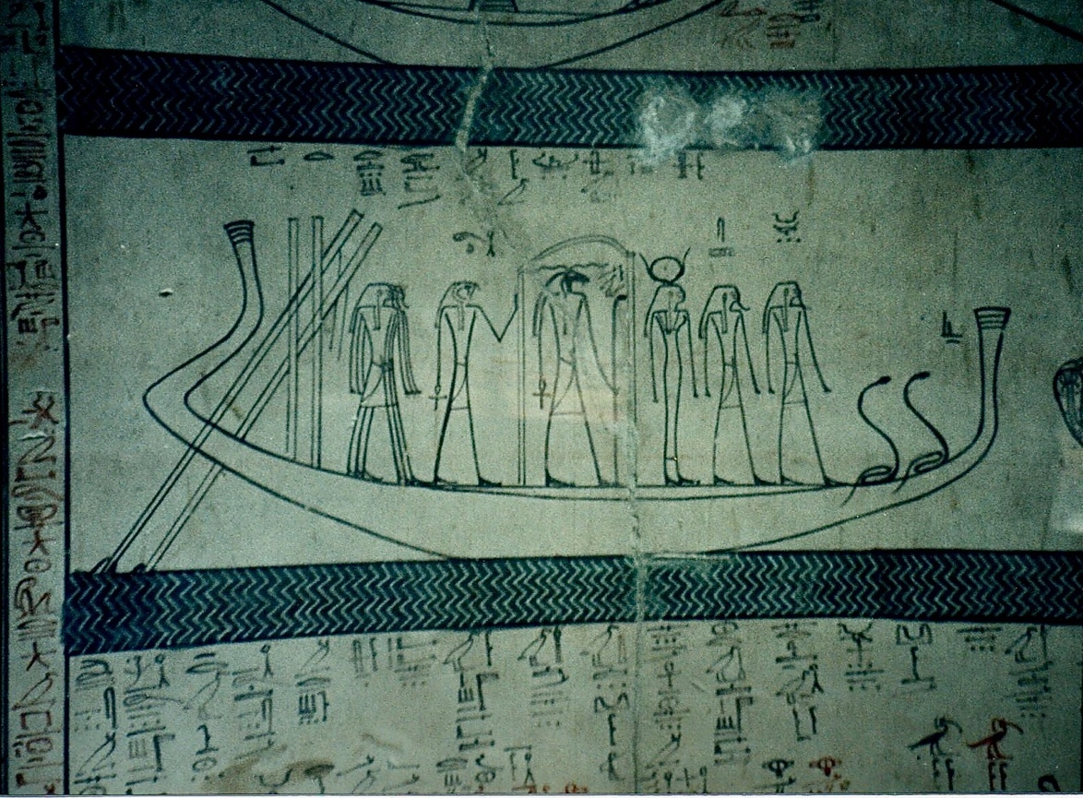
Figure 1 Ram headed sun god KV34-photo Helen Astley

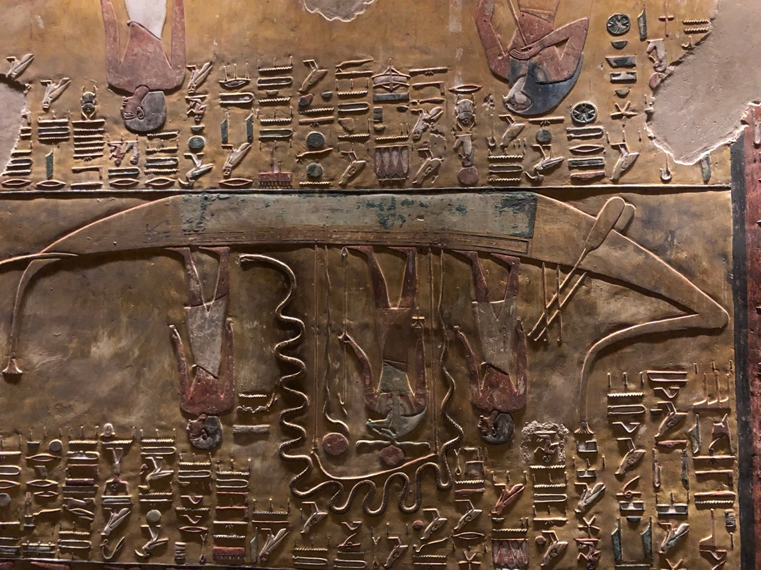
Figure 2 Ram headed sun god with Mehen-serpent KV17-photo Helen Astley

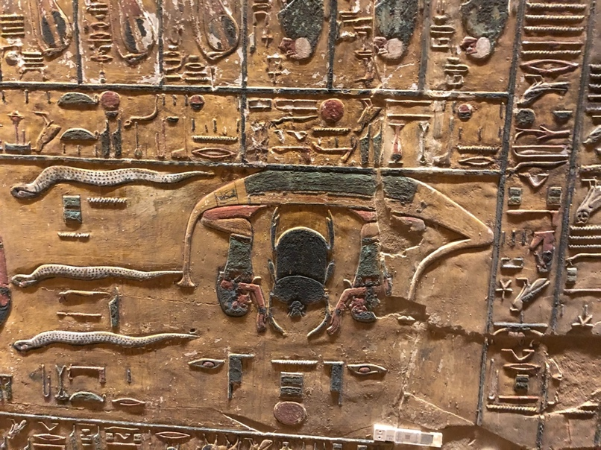
Figure 3 Sun god as a scarab beetle KV17-photo Helen Astley

During the second hour, other boats join the solar boat and they travel over the waters of Wernes, the people are shown with ears of grain as a sign of abundance. The boats travel onto the Waters of Osiris and the creatures the figures who carry knives are there to protect the sun god and defend him from enemies.
This watery landscape ends during the fourth hour and becomes a desert landscape, the solar boat turns into a fiery serpent and requires towing. The way is impeded by doors and is populated by snakes, who have both legs and wings, but the solar Eye is safeguarded and renewed by the gods Horus and Sokar.
The fifth hour requires the addition of more figures pulling the solar boat. The journey is through the cavern of Sokar and this region is identified as the West, the region of the dead. The small hill is where Osiris is buried and the goddesses Isis and Nephthys, as birds, mourn there. The scarab of the sun emerges from the mound as the journey continues with requests that the sun god may travel onwards in peace.
The waters of Nun, the original waters that covered the earth, are reached in the sixth hour. It is here that the ba of the god will join together with the dead sun, depicted as a scarab beetle. This is a most important juncture as the new light dawns and the dead pharaoh is resurrected.
The new light is beset by difficulties in the seventh hour as Apophis, as a serpent, tries to stop the progress of the new light. Isis, Seth and Selket bewitch Apophis while other avenging demons attack him with knives. In the upper part of the scene, Osiris is protected by a Mehen-serpent while a cat-headed being beheads the enemies of Osiris. Representations of the stars as men and women with stars on their heads are in the lower register, the men process towards the enthroned sun god while the women process towards a crocodile who is helping find the body parts of the dead Osiris.
The eighth hour is dominated by beings seated on the hieroglyphic representation for cloth, they sit in a vault in the upper and lower sections that is subdivided into five areas by doors that the sun god has opened. The happy sounds and rejoicing that the ba-souls and the dead make as they respond to the sun god are said in the texts to be unintelligible to humans. The centre register contains the solar boat being towed, shemes (to follow) signs anthropomorphised and the four rams of Tatenen. Hornung lists Tatenen as a god of the primordial earth, in his form of Ptah-Tatenen his embodiment of the earth takes a much more general form.
The theme of provisioning the dead is continued into the ninth hour while the crew members of the solar boat walk in front of it with their rudders in hand, the boat is no longer being towed.
The drowned are depicted in the lower register of the tenth hour, where they are saved by Horus even though they have not been able to be buried correctly. The rescue and healing of the solar Eye and its protection dominate the upper register, while the ba-souls of Sokar and Osiris accompany the guards of the solar boat. The ba-soul of Sokar is depicted as a falcon sitting in a double-headed serpent wearing the crowns of upper and lower Egypt as shown in Figure 4.

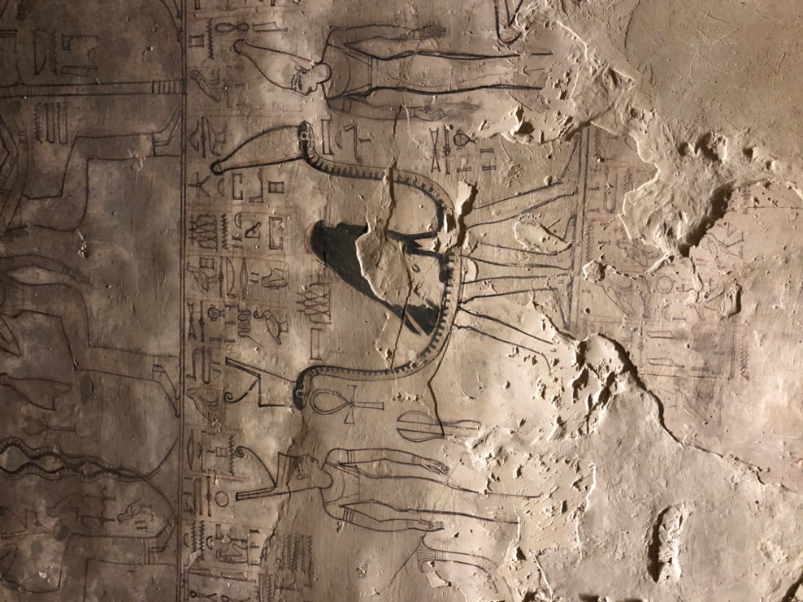
Figure 4 The ba-soul of Sokar KV17-photo Helen Astley
The eleventh hour prepares the scene for the sun’s rebirth. The ‘World-encircler’ snake is carried before the solar boat, the gods and goddesses ensure that any threats to the sunrise are annulled and the crowns of upper and lower Egypt are carried by Isis and Nephthys to Sais’s eastern gate.
The twelfth hour sees the rebirth of the sun. Creation is repeated and the first gods are present to take part in it, this takes place inside the body of the snake that appeared in the eleventh hour. Everyone enters the tail and emerges at the head to be rejuvenated. The solar beetle is lifted into the heavens by the god Shu, the god of air and becomes the rising sun. The netherworld's exit is sealed again and the dead return to sleep. This complex scene curves around the wall in KV34 in burial chamber J, see Figure 5.

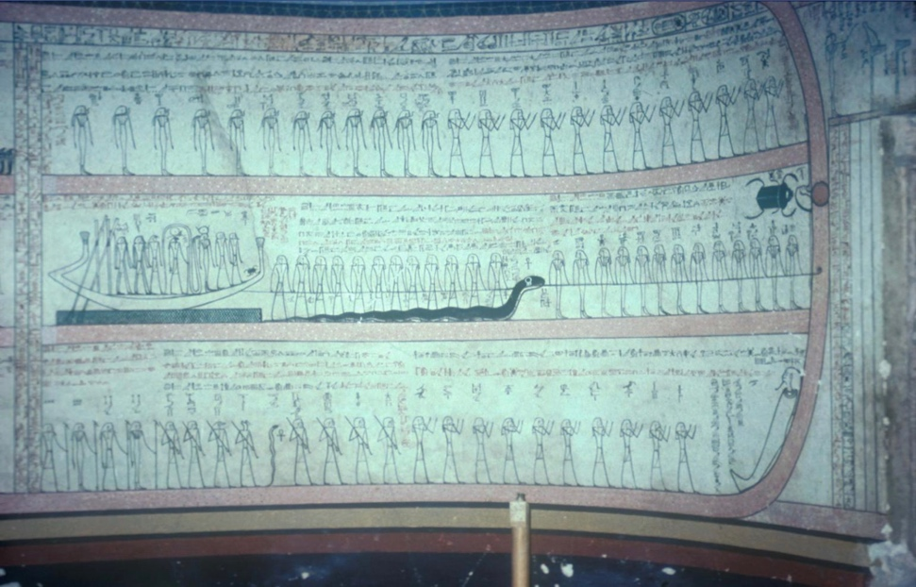
Figure 5 The twelfth hour KV34 - photo Kent R. Weeks thebanmappingproject.com

Sources and Date
The oldest fragments of the Amduat that have been found are from KV38 the tomb of Tuthmosis I (c 1503-1491 B.C.E), Hornung suggests that a possibility of reburial by Queen Hatshepsut (c 1472-1457 B.C.E) could date the fragments to the earlier years of her reign. According to Hornung Hartwig Altenmüller believes there may have been ‘various stages of composition’ which might date the Amduat to as far back as the Old Kingdom (c 2660-2190 B.C.E). Hornung however believes that this is unlikely, due to the complexity of the images, and argues that the book appeared at the beginning of the New Kingdom. This view is disputed by Wente who believes the text to be of Middle Kingdom or First Intermediate Period origin. According to Wente the view of Jan Assman that the text is of purely royal derivation is not necessarily correct.
The tomb of Tuthmosis III and his vizier Useramun TT61 are the earliest complete copies of the Amduat according to Hornung . Most of the following pharaohs used all or large parts of the Amduat in their tombs, apart from those from the Amarna period (c 1352-1332 B.C.E), until Ramesses III. Hornung states that portions of the Amduat also appeared on sarcophagi and gilded shrines, while during the 21st Dynasty the Amduat first appeared on papyrus and high-ranking officials began to use it on their sarcophagi and in their tombs.

The Journey and Regeneration
Stephen Quirke equates the journey of the sun god through the hours of the Amduat with the constant movement of the pharaoh through his kingdom on earth, travelling with his trusted advisors and military entourage. The pharaoh would have travelled through his land using the river Nile where Quirke envisages he might encounter obstructions to his journey, such as sandbanks, crocodiles, snakes and enemies similar to those the sun god finds on his nighttime voyage. Dodson and Ikram explain that after the pharaoh has travelled through the dangers and has joined Osiris, he is reborn with the sun god, this was crucial to the balance and stability of Egypt, the cosmos and therefore the world.
During the sixth hour of the night, the ba of the sun god is reunited with his dead form, represented by Osiris, this provides the impetus for the rebirth of the sun. Quirke notes that the sun while being a ‘source of authority’ does not participate in any of the physical activities required for the journey. Hornung considers the journey through the night as a way of explaining the powers of regeneration after death, organising a pattern of the after-death world, the perception of rejuvenation with the reversibility of time. However, Jan Assmann believes that ‘the concept of temporal reversibility of cyclical renewal, did not belong to the properties of a reversed world but to the order of the cosmos, which could not endure without cyclical time’.
The inner world cosmic journey in Hornung’s the view was not just a view of the underworld, deep in the earth but interlinked with the primordial waters, the darkness and the sky and an attempt to describe the sun’s journey as a whole. Siegfried Morenz considers the journey of the sun united the netherworld and all the dead were recreated as was Osiris, it created a unity in the Osirian realm. In Assman’s view the renewal of the sun god was a rebirth through death, not a reversal of the path from death to birth.

Representations of the Gods
The Egyptian gods are often portrayed with non-human heads, in Hornung’s opinion this is a way of linking the deity with a particular attribute, a way of defining the power, manifestation and nature of a deity. The deity then could be seen as part of the writing of a story, a hieroglyph but an inhabited one, but Hornung writes that the true form of the deity is ‘hidden’ and ‘mysterious’ and is only visible to one who is deceased. Two of the forms that have human heads on an animal body are the sphynx and the ba bird. The personification of objects was also carried out with items being given human heads, this Hornung informs us is to show they are ‘personal, independent powers’, in several of the hours there is the equipment used in judicial circumstances that have human heads. In Morenz’s view most cosmic deities were human in form as they had no cultic tradition this did not influence their form.
The gods would appear to have a limited lifespan, much the same way as mortals, this idea is documented according to Hornung during the New Kingdom, but even from the Old Kingdom, the Egyptians appear to have believed that life and death was a constant circle of renewal. Osiris is the god associated with the afterlife and plays a prominent part in the Amduat, yet Goebs and Baines write that in the Old Kingdom he was seen as a god of the constellation Orion and it was only later, after his death and dismemberment that he became associated with death, the afterlife and the netherworld. Emily Teeter wrote that on from this, the pharaoh was the incarnation of the living Horus, who was the son of Osiris

The Representations of the Amduat
The book of the Amduat opens with a section about knowing, in Assmann’s opinion this is a clear reference to the safety generated by knowing, not just knowing the spell but also the gates, the hours and the gods. In the title of the Amduat the word knowing is repeated nine times:

Knowing the netherworldly bas,
knowing the hidden bas,
knowing the gates,
and the paths that the Great God treads.
Knowing what will be done,
knowing what is in the hours, and their gods,
knowing the course of the hours and their gods.
Knowing the transfiguration for Re,
knowing what he proclaims to them,
knowing the thriving and the annihilated.

Schweizer sees the title and its many repetitions as a writer who was emotionally involved with the script they were writing. Assmann refers to Wente arguing that the people involved in the writing and carrying out of the ceremonies were similar to the secret societies in Greece, whereas Assmann associates the Amduat with the pharaoh and the sun cult.
Wente is of the opinion that although the individuals who had access to the Amduat would be restricted this did not indicate that it was the pharaoh who was the sole officiant, as he was in temple scenes. In Tuthmosis I’s Amduat Wente says he found no mention or image of the pharaoh.
The first hour with its symmetrical groups of gods could according to Schweizer be seen as a way of warding off the evil beings, especially embodied in the serpent Apophis, creating a balance of ma’at to combat chaos. One of the most important jobs of the pharaoh was to balance ma’at.
In the second hour, the region of Wernes is reached, this is described by Schweizer as a place of abundance, with plentiful grain and sweet water, also known as the Field of Reeds. Quirke describes the sun boat travelling through the Field of Reeds, navigating the waterway of Ra and then spending the rest of the time in Wernes. Thomas Schneider suggests that the description and approximate distances found in the Amduat could possibly be reconciled with a mega lake in North Africa about 2000 B.C.E, thus giving a sweet water area at the end of the Abu Ballas Trail.

Conclusion
One of the modern benefits of the Amduat is that it has texts written to clarify the images, unfortunately, although the text can be translated not all of them can be fully understood from a contemporary perspective. It is clear from the number of times the texts have been found in tombs and on later papyri that it was an important set of instructions and although set in the underworld it was clearly associated with the rising of a new dawn. It appears that it was probably created in the New Kingdom for the beginning of a new period in Egyptian history after the Hyksos had been defeated. There was also the move to the Valley of the Kings for the burial of the pharaohs. The texts were still connected to the texts of previous dynasties but looked to the earth and the sun, unlike the Pyramid texts which looked to the stars. This connection to the sun could have been a forerunner to religious changes brought about by Akhenaten (c1352-1335 B.C.E). The pharaoh and the elite of his court would have been privy to the mystical elements of the journey and it was used by high officials, not just the pharaoh. It also has elements of transformation and rejuvenation that appear in later Christian teachings. The Books of the Dead that are in private New Kingdom tombs and the Coffin Texts from the Middle Kingdom had a similar function, to provision and provide freedom to the spirit of the dead. The complex cultural knowledge of these texts supplied the Egyptians with the assurance that the pharaoh would continue to balance ma’at in the land, the Nile would flood and the crops would grow and the sun would rise. The ordinary farmer might not know the words but there is a possibility that they would know that they existed. With the stone temples and statues and other evidence of priestly and royal power, the Egyptian whether he was peasant or pharaoh lived in a religious Egypt that was tied to the Nile, the sun and the sky.

Illustrations
Figure 1 Ram headed sun god KV34-photo Helen Astley
Figure 2 Ram headed sun god with Mehen-serpent KV17-photo Helen Astley
Figure 3 Sun god as a scarab beetle KV17-photo Helen Astley
Figure 4 The ba-soul of Sokar KV17-photo Helen Astley
Figure 5 The twelfth hour KV34 - photo Kent R. Weeks thebanmappingproject.com

Bibliography
Assmann, Jan, Death And Salvation In Ancient Egypt, trans. by David Lorton (Ithica: Cornell University Press, 2014)
Bodley, John H., Cultural Anthropology: Tribes, States, And The Global System, 5th edn. (Lanham: AltaMira Press, 2011)
Dodson, Aidan and Salima Ikram, The Tomb In Ancient Egypt (London: Thames & Hudson Ltd., 2008)
Eagleton, Terry, The Idea Of Culture (Oxford: Blackwell Publishers Ltd, 2000)
Goebs Katja and John Baines, ‘Functions And Uses Of Egyptian Myth’, Association de la Revue de l’histoire des religions, Vol. 235, No. 4 (2018)
Hornung, Eric, Conceptions Of God In Ancient Egypt: The One And The Many, trans. by John Baines (London: Routledge & Kegan Paul, 1983)
Hornung, Eric, The Ancient Egyptian Books Of The Afterlife, trans. by David Lorton (Ithaca: Cornell University Press, 1999)
Morenz, Siegfried, Egyptian Religion, trans. by Ann E. Keep (Ithica: Cornell University Press, 1973)
Quirke, Steven, The Cult Of Ra: Sun-worship In Ancient Egypt (London: Thames & Hudson Ltd., 2001)
Santillana de, Giorgio and Hertha von Dechend, Hamlet's Mill: An Essay Investigating The Origins Of Human Knowledge And Its Transmission Through Myth (Boston: David R. Godine Publisher Inc., 1977)
Schweizer, Andreas The Sungod’s Journey Through The Netherworld: Reading The Ancient Egyptian Amduat, ed. David Lorton (Ithaca: Cornell University Press, 2010)
Segal, Robert A., Myth, A Very Short Introduction, 2nd edn. (London: Oxford University Press. 2015)
Schneider, Thomas, ‘The West Beyond The West: The Mysterious ‘Wernes’ Of The Egyptian Underworld And The Chad Palaeolakes’, Journal of Ancient Egyptian Interconnections, Vol. 2-4 (2010), pp. 1-14
Taylor, Edward B., Primitive Culture: Researches Into The Development Of Mythology, Philosophy, Religion Language, Art, And Custom, Vol. I, 4th edn. (London: John Murray, 1920)
Teeter, Emily, Religion And Ritual In Ancient Egypt (Cambridge: Cambridge University Press, 2011)
Wente, Edward F., ‘Mysticism in Pharaonic Egypt?’, Journal of Near Eastern Studies, Vol. 41, No. 3 (1982), 161- 179

Eric Hornung, The Ancient Egyptian Books Of The Afterlife, trans. by David Lorton (Ithaca: Cornell University Press, 1999), p. 26.
John H. Bodley, Cultural Anthropology: Tribes, States, And The Global System, 5th edn. (Lanham: AltaMira Press, 2011), p.12.
Edward B Taylor, Primitive Culture: Researches Into The Development Of Mythology, Philosophy, Religion Language, Art, And Custom, Vol. I, 4th edn. (London: John Murray, 1920), p. 1.
Terry Eagleton, The Idea Of Culture (Oxford: Blackwell Publishers Ltd, 2000), p. 2.
Robert A Segal, Myth, A Very Short Introduction, 2nd edn. (London: Oxford University Press, 2015), p. 2.
Giorgio de Santillana and Hertha von Dechend, Hamlet's Mill: An Essay Investigating The Origins Of Human Knowledge And Its Transmission Through Myth (Boston: David R. Godine Publisher Inc., 1977).
Katja Goebs and John Baines, ‘Functions And Uses Of Egyptian Myth’, Association de la Revue de l’histoire des religions, Vol. 235, No. 4 (2018), pp. 645-682 (p. 645).
Hornung, The Ancient Egyptian Books Of The Afterlife, p. 28.
Aidan Dodson and Salima Ikram, The Tomb In Ancient Egypt (London: Thames & Hudson Ltd., 2008) p. 224.
Dodson and Ikram, The Tomb In Ancient Egypt.
Andreas Schweizer, The Sungod’s Journey Through The Netherworld: Reading The Ancient Egyptian Amduat, ed. David Lorton (Ithaca: Cornell University Press, 2010), pp. 16-17.
Edward F. Wente, ‘Mysticism In Pharaonic Egypt?’, Journal Of Near Eastern Studies, Vol. 41, No. 3 (1982), 161- 179 (p. 164).
Hornung, The Ancient Egyptian Books Of The Afterlife, p. 32.
Hornung, The Ancient Egyptian Books Of The Afterlife, pp. 34-53.
Erik Hornung, Conceptions Of God In Ancient Egypt: The One And The Many, trans. by John Baines (London: Routledge & Kegan Paul, 1983), p. 80.
Hornung, The Ancient Egyptian Books Of The Afterlife, p. 27.
Hornung, The Ancient Egyptian Books Of The Afterlife, p. 27.
Hornung, The Ancient Egyptian Books Of The Afterlife, p. 28.
Wente, ‘Mysticism In Pharaonic Egypt?’, p. 176.
Wente, ‘Mysticism In Pharaonic Egypt?’, p.176.
Hornung, The Ancient Egyptian Books Of The Afterlife, p. 28.
Hornung, The Ancient Egyptian Books Of The Afterlife, p. 30.
Steven Quirke, The Cult Of Ra: Sun-worship In Ancient Egypt (London: Thames & Hudson Ltd., 2001), pp. 44-45.
Quirke, The Cult Of Ra, p. 45.
Dodson and Ikram, The Tomb In Ancient Egypt, p. 225.
Quirke, The Cult Of Ra, pp. 45-46.
Jan Assmann, Death And Salvation In Ancient Egypt, trans. by David Lorton (Ithica: Cornell University Press, 2014), p. 183.
Hornung, The Ancient Egyptian Books Of The Afterlife, p. 27.
Siegfried Morenz, Egyptian Religion, trans. by Ann E. Keep (Ithica: Cornell University Press, 1973), p. 208.
Assmann, Death And Salvation In Ancient Egypt, p. 184.
Erik Hornung, Conceptions Of God In Ancient Egypt, pp. 121-123.
Hornung, Conceptions Of God, p. 124.
Hornung, Conceptions Of God, p. 123.
Morenz, Egyptian Religion, p. 31.
Hornung, Conceptions Of God, p. 160.
Goebs and Baines, ‘Functions And Uses Of Egyptian Myth’, p. 648.
Emily Teeter, Religion And Ritual In Ancient Egypt (Cambridge: Cambridge University Press, 2011), p. 4.
Assmann, Death And Salvation In Ancient Egypt, p.393.
Assmann, Death And Salvation In Ancient Egypt, p. 393.
Schweizer, The Sungod’s Journey Through The Netherworld, p. 23.
Assmann, Death And Salvation In Ancient Egypt, p. 400.
Wente, ‘Mysticism In Pharaonic Egypt?’, p.176.
Wente, ‘Mysticism In Pharaonic Egypt?’, p.176.
Schweizer, The Sungod’s Journey Through The Netherworld, p. 36.
Schweizer, The Sungod’s Journey Through The Netherworld, p. 50.
Quirke, The Cult Of Ra, p. 48.
Thomas Schneider, ‘The West Beyond The West: The Mysterious ‘Wernes’ Of The Egyptian Underworld And The Chad Palaeolakes’, Journal of Ancient Egyptian Interconnections, Vol. 2-4 (2010), pp. 1-14 (3-4).

