Name: Sukeisha Bailey
Module: Project Management
Module code:LCLM5003
Lecture: Doreen Amundam
Assignment Title: A Project Portfolio
Student ID: 2330686
Submission Deadline:21.11.2025

Part A

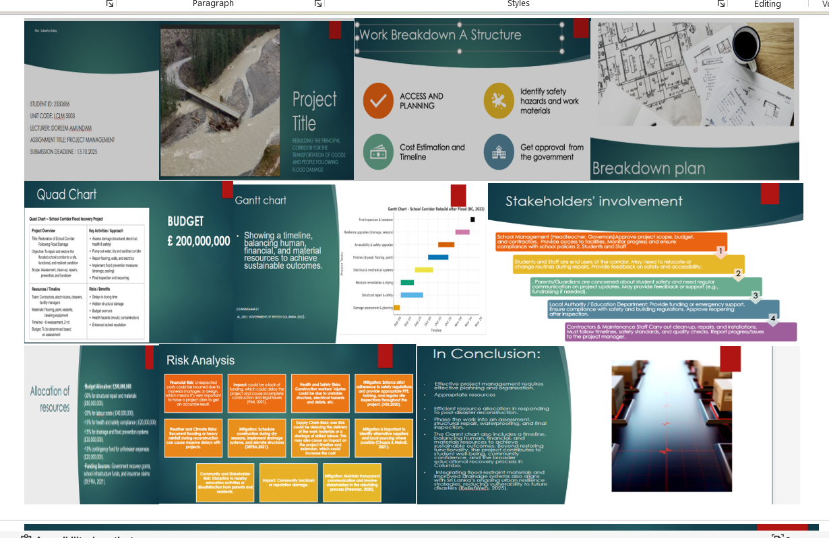

Part B: Reflective Feedback

Description
My poster presentation focuses on the rebuilding of transport infrastructure in British Columbia following the devastating 2022 floods. The poster outlined the project’s main objectives, key stakeholders, expected outcomes, and success measures using a structured quad chart. It also included a work breakdown structure and resource allocation plan to show how the reconstruction could be managed efficiently. During my presentation, I aimed to professionally communicate both the technical and social aspects of the project. According to my evaluation results, I performed solidly across all areas, particularly in content, structure, and professionalism, each rated at a level four. This indicates that I met the learning objectives, but still have room for improvement.
Feelings
Before my presentation, I felt a mix of nervousness and anticipation, as I wanted to convey complex project information to my audience clearly. However, as I began speaking, my confidence grew when I noticed positive reactions to my explanations and visuals. I felt proud to connect project management, able to link project management principles to a real disaster recovery situation. Afterwards, I reflected on how I could have improved the visual layout of the poster and incorporated more academic theory to strengthen my analysis.
Evaluation
Overall, the presentation was well-received. The introduction successfully set the context of the British Columbia floods and highlighted the importance of rebuilding efforts. The quad chart successfully summarises the project’s key dimensions and stakeholder roles. Feedback indicated that my professionalism and presentation delivery were strong, demonstrating that my preparation and rehearsal were worthwhile. However, I realised that while my work breakdown structure and resource allocation were comprehensive, they could have been visually streamlined for clarity. Additionally, I acknowledged that some theoretical connections- such as risk management frameworks and sustainability models- could have been more effectively integrated to support my design and planning decisions.
Analysis
Reflecting on this experience has deepened my understanding of the necessity for balance between visual clarity with analytical depth. According to Kolb (2014), effective learning is achieved through reflection on practical experience, and this process has reaffirmed that principle for me. Although my visuals successfully facilitated supported communication, they were slightly dense, highlighting Mayer’s (2017) point that too much information can reduce understanding. Gibbs’ (1988) model also emphasises that reflection enhances self-awareness and professional growth, which I experienced as I assessed both my strengths and weaknesses. I now recognise that including measurable data—such as costs or environmental impacts—would have made my analysis more evidence-based and aligned with professional standards in project evaluation.
Conclusion

Through this reflection, I learned that my main strengths lie in research, structure, and verbal delivery. However, I need to improve how I apply academic theory and design information visually. The experience taught me the value of ongoing feedback and the importance of integrating both practical and theoretical perspectives in future project work. It also highlighted the significance of adaptability, critical self-assessment, and collaborative learning in professional development. Moving forward, I aim to refine my ability to translate complex theoretical concepts into accessible formats and to leverage visual tools more effectively to enhance communication and stakeholder engagement

Action Plan
Through this reflection, I learned that my main strengths lie in research, structure, and verbal delivery. However, I need to improve how I apply academic theory and design information visually to support diverse learning styles and enhance comprehension.
The experience underscored the value of ongoing feedback and the importance of integrating both practical and theoretical perspectives in future project work. It also highlighted the significance of adaptability, critical self-assessment, and collaborative learning in professional development.
Furthermore, I recognised the need to engage more proactively with academic literature to strengthen the theoretical grounding of my work. Moving forward, I aim to refine my ability to translate complex theoretical concepts into accessible formats and to leverage visual tools more effectively to enhance communication, stakeholder engagement, and overall project impact.

Project Management Plan: Rebuilding the Principal Transportation Corridor (Highway 5), British Columbia

1. Introduction
In 2022, the province of British Columbia (BC) was devastated by catastrophic flooding, triggered by an atmospheric river event. The resultant landslides and bridge collapses caused widespread disruption to the transportation network, critically impacting the main artery connecting the lower mainland, including Vancouver, to the interior and the rest of Canada. This infrastructural failure led to severe economic losses, the isolation of communities, and significantly limited access to essential goods, services, and emergency support (Government of British Columbia, 2022). The events highlighted not only the vulnerability of existing infrastructure but also the urgent need for a resilient, sustainable rebuilding strategy.
The purpose of this Project Management Plan (PMP) is to establish a rigorous, structured, and academically sound framework for the reconstruction of the principal transportation corridor, specifically Highway 5 (The Coquihalla Highway). The plan is designed to ensure the project is delivered efficiently, safely, and sustainably, actively mitigating potential risks and maximising the socio-economic benefits for all affected stakeholders. This PMP outlines the project scope, detailed work breakdown, scheduling, resource allocation, stakeholder management, and a robust risk management strategy, strictly adhering to established project management principles and methodologies, particularly those set forth by the Project Management Institute (PMI, 2021). The commitment to resilience will ensure the long-term viability of this critical national asset, protecting future provincial and federal investments.

2.1 Project Description
The core focus of this project is the comprehensive rebuilding and enhancement of the damaged sections of Highway 5. As a key trade and travel artery, its destruction generated significant logistical and supply chain challenges for businesses across Western Canada, whilst concurrently constraining access for emergency and public facilities (DEFRA, 2021). The selection of a project to restore this vital route is justified by its critical role in economic recovery, enhancing public safety, and securing regional and national connectivity.
2.1 Project Objectives (SMART)
The project objectives are defined using the SMART criteria (Specific, Measurable, Achievable, Relevant, Time-bound):
Rebuild all collapsed sections of Highway 5, incorporating enhanced structural and hydrological designs to ensure a minimum of 1-in-200-year flood resilience. This is a specific and measurable goal related to quality and scope.
Achieve full, unrestricted two-way traffic flow connecting the lower mainland with the interior of Canada within a projected 12-month timeframe from the project's commencement. Integrate sustainable and environmentally friendly construction practices, evidenced by a minimum 20% reduction in carbon footprint compared to traditional construction methods for a similar project.
Implement comprehensive traffic management and public communication protocols to minimise disruption to local communities and businesses, maintaining a zero major complaint rate regarding project site management.
2.2 Project Justification
The investment is strongly justified by the high cost of inaction. Prolonged closure of the corridor would lead to sustained economic haemorrhage, increased reliance on less efficient alternative routes, and a degradation of public confidence. Furthermore, the reconstruction provides a vital opportunity to proactively enhance resilience against future climatic events, directly aligning with provincial and federal disaster mitigation and climate change adaptation strategies (Kerzner, 2022). This forward-looking approach ensures the infrastructure is not merely replaced, but fundamentally improved, delivering long-term value for money.

3. Project Scope
Defining the project scope is essential for controlling what is included and excluded, managing stakeholder expectations, and guiding resource allocation.
Inclusions:
- Reconstruction of damaged roadways, bridges, and drainage systems along Highway 5.
- Implementation of slope stabilisation measures to prevent landslides.
- Installation of resilient infrastructure materials designed to withstand extreme weather.
- Development of traffic management plans to ensure safe passage during construction.
- Quality assurance processes to ensure compliance with Canadian transportation and environmental standards.
Exclusions:
- Reconstruction of private properties and local roads not located on the main corridor.
- Commercial developments or non-essential infrastructure upgrades outside the project area.
- Post-construction improvements unrelated to the core functionality of Highway 5.
Assumptions:
- Funding from provincial and federal sources will be available for the full duration of the project.
- Regulatory approvals and environmental permits can be obtained without significant delays.
- Construction materials and skilled labour will remain accessible throughout the project period.
Constraints:
- Adverse weather conditions may cause delays in construction schedules.
- Potential interruptions in supply chains could affect material availability.
- Access to certain areas may be limited due to environmental hazards or residual flood damage.
Clearly defining the scope helps ensure that project objectives are achievable and aligned with stakeholder expectations (PMI, 2021).

4. Work Breakdown Structure
Table 1: Work Breakdown Structure
WBS Code | Task Description | Subtasks
1 | Project Initiation | Feasibility study, approvals, stakeholder engagement
2 | Design & Surveying | Topographical surveys, geotechnical studies, and engineering designs
3 | Site Preparation | Site clearing, temporary traffic management, and access roads
4 | Construction | Road reconstruction, bridge rebuilding, drainage systems, slope stabilisation
5 | Quality Assurance & Testing | Structural testing, road surface inspection, and environmental compliance audits
6 | Handover & Closeout | Final inspection, commissioning, stakeholder sign-off, documentation
The WBS ensures tasks are clearly defined, measurable, and assigned to appropriate resources. This approach reduces ambiguity, improves accountability, and facilitates progress tracking throughout the project lifecycle (Lock, 2020).

5. Quad Chart
The Quad Chart provides stakeholders with a concise overview of the project objectives, approach, benefits, and risks (Kerzner, 2022).
Component | Description
Objective | Restore Highway 5 connectivity and enhance resilience against future flooding.
Approach | Reconstruct the corridor using reinforced materials, implement slope stabilisation, and maintain effective traffic management.
Benefits | Economic recovery, reliable transportation, improved supply chain efficiency, and long-term infrastructure resilience.
Risks | Extreme weather, budget overruns, supply chain delays, and environmental compliance challenges.
The quad chart is a practical tool for summarising the project in a format that is accessible to all stakeholders, supporting quick decision-making and communication.

6. Gantt Chart
A Gantt chart is used to visualise the project timeline, showing tasks, durations, dependencies, and milestones. The project is scheduled over 12 months:
Table 2: Simplified Gantt Chart
Phase | Duration | Start | End | Dependencies
Damage assessment and planning | 2month | Jan 2025 | feb2025 | -
Project Overview | 2 months | March2025 | Apr2025 | 1
Resources /Timeline Development | 1 month | May 2025 | Apr 2025 | 2
Risk Assessment | 4 months | June2025 | Sept2025 | 3
Key Activities / Project Approach | 2month | Oct 2025 | Nov 2025 | 4.
Handover & Closeout | 1 month | Dec 2025 | Dec 2025 | 5.
7. Stakeholders’ Involvement
Effective stakeholder engagement is a fundamental component in the successful execution and sustainability of infrastructure projects. It not only ensures that the project aligns with public expectations but also fosters transparency, accountability, and trust among all parties involved (Freeman, 2020). In the context of infrastructure development in British Columbia, a diverse range of stakeholders play pivotal roles throughout the project lifecycle.
The Provincial Government of British Columbia serves as a central authority by providing essential funding, strategic oversight, and the necessary regulatory approvals. Its involvement is crucial for aligning the project with provincial policies, legal frameworks, and long-term development goals (Government of British Columbia, 2023).
Local authorities and municipal departments contribute significantly by offering supplementary funding or emergency support when required. They are responsible for ensuring that all construction and operational activities comply with local safety codes, zoning laws, and building regulations.
Furthermore, they play a decisive role in granting approvals for the reopening and continued operation of facilities, thereby safeguarding public welfare (City of Vancouver, 2022). Construction contractors and maintenance personnel are directly responsible for the physical execution of the project.
Their duties encompass site preparation, structural repairs, equipment installation, and ongoing maintenance. These professionals must adhere to strict timelines, comply with occupational health and safety standards, conduct quality assurance checks, and maintain regular communication with project managers to report progress and address emerging issues (Turner, 2021).
Environmental agencies are tasked with monitoring the project’s adherence to environmental regulations and sustainability benchmarks. Their oversight ensures that construction and operational activities minimise ecological disruption, manage waste responsibly, and incorporate green building practices where feasible (Environment and Climate Change Canada, 2023).
Finally, local communities and businesses are key stakeholders whose engagement is vital for the project’s social license to operate. Their input helps identify community needs, mitigate potential disruptions, and foster local economic recovery. By involving these groups in consultation processes, project leaders can enhance social cohesion and ensure that the development delivers tangible benefits to the surrounding population (Reed et al., 2009).

Stakeholder Engagement Strategies in Project Implementation:
Effective stakeholder engagement is a critical component of successful project management, particularly in initiatives with significant public and environmental implications. A multifaceted approach to engagement ensures transparency, fosters trust, and facilitates informed decision-making among all involved parties.
One foundational strategy involves the dissemination of regular progress reports to relevant government agencies. These reports serve to maintain regulatory compliance, provide updates on project milestones, and demonstrate accountability. By keeping authorities informed, project teams can also preemptively address potential concerns and align with policy expectations.
Engagement with local communities is equally vital. Organising public meetings offers a platform for two-way communication, enabling project leaders to share information while also gathering valuable feedback from residents and stakeholders. This participatory approach not only enhances the legitimacy of the project but also helps to identify and mitigate social or environmental concerns early in the process.
Internally, weekly coordination meetings among project teams are essential for maintaining alignment across departments, addressing operational challenges, and ensuring that project objectives remain on track. These meetings foster a culture of collaboration and continuous improvement, which is crucial for adaptive project management.
Furthermore, the submission of environmental monitoring reports to designated authorities underscores a commitment to sustainability and regulatory adherence. These reports provide evidence of environmental stewardship and allow for external oversight, which can enhance public confidence in the project’s integrity.
Collectively, these engagement strategies contribute to a robust governance framework. As Freeman (2020) asserts, meaningful stakeholder engagement not only aligns diverse interests but also supports timely and effective decision-making. By embedding these practices into the project lifecycle, organisations can cultivate enduring relationships with stakeholders and enhance the overall success and sustainability of their initiatives.

8. Allocation of Resources
Managing resources efficiently is crucial for delivering projects on time and within budget (PMI, 2021).
Human Resources:
- Project Manager
- Civil and Structural Engineers
- Environmental Officer
- Construction Crew
- Health and Safety Officers
Material Resources:
- Reinforced concrete, steel beams, asphalt, drainage materials
- Heavy machinery such as excavators, cranes, and pavers
Financial Resources:
- Total estimated budget: £200,000,000
- Contingency fund: 10% of total budget to account for unforeseen costs
Time Allocation:
- Resources will be allocated according to the Gantt chart phases.
- Buffer periods included to account for potential weather delays or supply chain issues.
Monitoring and adjusting resource allocation will help maintain efficiency and prevent bottlenecks during project execution (Lock, 2020).

9. Risk Analysis
Table 3
Risk | Likelihood | Impact | Mitigation Strategy
Weather and Climate Risks | High | High | Recurrent flooding or heavy rainfall during reconstruction can cause significant delays due to flooding.
Financial risk | Medium | High | Contingency funds, regular audits, and cost monitoring
Supply chain delays | High | Medium | Multiple suppliers, pre-order critical materials, logistics planning
Community and stakeholder Risk | Medium | Medium | Environmental impact assessments, continuous monitoring, stakeholder consultation
Community | Low | Medium | Public consultation, transparent communication, and community benefits programs

10. Conclusion
The reconstruction of Highway 5 represents a mission-critical initiative vital for restoring the socio-economic health and stability of British Columbia and Western Canada in the 2022 climate-induced disaster. This Project Management Plan provides a comprehensive and academically rigorous framework to guide the complex, high-pressure execution phase of the project.
The strengths of this are evident in the establishment of clear SMART objectives, a deliverable-oriented work breakdown structure, and an accelerated 12-month schedule that prioritises rapid restoration of services. The integration of the Quad Chart ensures facilitate effective executive communication is facilitated, while the detailed Stakeholder and Resource Management ensures the project is conducted with the necessary political and social licence to operate. Additionally, the systematic Risk Analysis, which identifies and plans for the high-priority threats of extreme weather and supply chain interruption, provides the necessary resilience within the management structure (Kerzner, 2022; PMI, 2021).
Successful completion, achieved within the specified time and budget and adhering to stringent quality and sustainability parameters, will not only restore a vital transportation artery but also establish a new benchmark for climate-resilient infrastructure in Canada. The adherence to established project management principles, methodologies, and continuous performance measurement will be the key to ensuring this project meets its goal of delivering a reliable, durable transportation corridor for the long term.

Reference
Cunningham, J, Smith, R, and Patel (2021). Stakeholder involvement in disaster recovery and infrastructure planning. London: Routledge.
DEFRA, 2021. Guidelines for Flood Resilience Infrastructure. London: Department for Environment, Food & Rural Affairs.
Department for Environment, Food and Rural Affairs (DEFRA). (2021). Flood and Coastal Erosion Risk Management: Policy Statement. London: Department for Environment, Food and Rural Affairs. Available at: https://www.gov.uk/goverment/organisation/department%20-for-environment%20-food--rural-affairs (Accessed 12 October 2025).
Freeman, R. E., 2020. Stakeholder Theory: The State of the Art. Cambridge: Cambridge University Press.
Gibbs, G. (1988) Learning by Doing: A Guide to Teaching and Learning Methods. Oxford: Oxford Polytechnic.
Government of British Columbia, 2022. Flood Recovery Strategy Report. Victoria: Government of British Columbia.
Health and Safety Executive (HSE).(2020) Managing health and safety in construction (L153) Guidance on the Construction (Design and Management Regulation 2015).3rd edn. London: Health and Safety Executive. Available at: https://www.hse.gov.uk/(Accessed 12 October 2025).
Hillson, D. and Simon, P., 2020. Practical Project Risk Management: The ATOM Methodology. 3rd ed. London: Kogan Page.
ISO, 2018. ISO 31000: Risk Management Guidelines. Geneva: International Organization for Standardization.
Kerzner, H., 2022. Project Management: A Systems Approach to Planning, Scheduling, and Controlling. 13th ed. Hoboken, N.J.: Wiley.
Kolb, D.A. (2014). Experiential Learning: Experience as the Source of Learning and Development. 2nd edn. Upper Saddle River, NJ: Pearson Education.
Lock, D., 2020. Project Management. 10th ed. Abingdon: Routledge.
Mayer, R.E. (2017). Multimedia Learning. 3rd edn. Cambridge: Cambridge University Press.
Moon, J.A., 2013. Reflection and Employability: Reflection on Learning for Career Success. London: Routledge.
PMI, 2021. A Guide to the Project Management Body of Knowledge (PMBOK® Guide) – Seventh Edition and The Standard for Project Management. Newtown Square, PA: Project Management Institute.
.

