Marketing plan written for JW Marriott Bucharest Grand Hotel

Student Name:
Elena Luca

Student ID number:
2206171

Marketing Essentials BMIH4005

Lecturer:
Ruth Taylor

Introduction
JW Marriott Bucharest Grand Hotel is situated in Bucharest, the capital of Romania. This is the 2050th Marriott hotel, opened in November 2000, and it is the biggest in Romania with thirteen levels and 80 000 square meters (JW Marriott, 2022).
Ninety per cent of the hotel guests are business but because JW Marriott Bucharest Grand Hotel is situated in the capital of Romania a place full of history, Play World, the new indoor playground aims to attract more leisure guests, to offer them the opportunity to visit the city but to be assured there is always something to do even on the bad weather.
Situation Analysis
For the innovative marketing plan of the JW Marriott Bucharest Grand Hotel, the indoor playground needs to be analysed in the environment in which the hotel operates using a marketing framework, the 5C Analysis: Company, Customers, Competitors, Collaborators and Climate (CFI, 2022).
A SWOT analyse has been used to make a micro-analysis of the company:
Strengths:  - Good positioning,  - Pet friendly,  - Luxury hotel,  - Five-star hotel. | Weaknesses:  - More expensive compared to other hotels in Romania.
Opportunities:  - One of the biggest hotel chains in the World,  - People in Romania are open to new services and experiences. | Threats:  - Other cheaper hotels,  - Rising cost of living.

In Romania tourism is continuously expanding and Bucharest is one of the must-see places. Because is the capital most of the business meetings take place there. JW Marriott Bucharest Grand Hotel is the perfect place for accommodation as it has a strategic location, near the Palace of Parliament, in the city centre and has all the services businesspeople needs (The Telegraph, 2021).
As it is a historical city, the Play World, the new indoor playground of the hotel aims to bring more leisure guests, families with children, adults aged between 25 and 50 years old and children between 0 and 14 years old.
To make an analysis of competitors, Porter`s Five Forces and a Perceptual Positioning Map have been used and can be seen below:
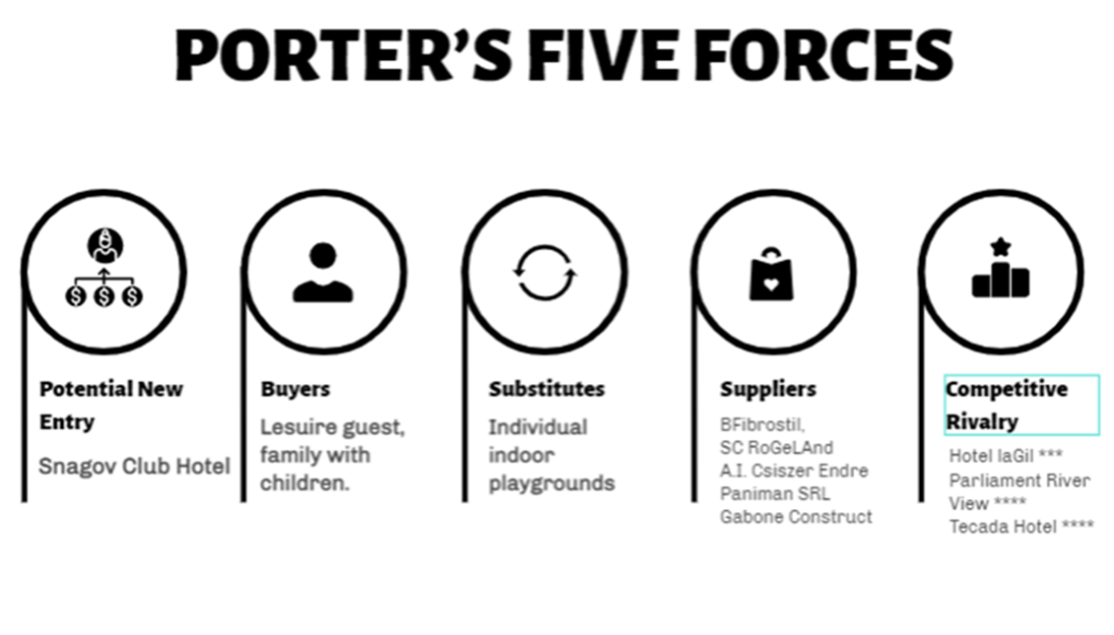
(DirectBooking, 2022 and ClubAfaceri.ro, 2022) (Edit.org, 2022)

High Quality
JW Marriott Bucharest Grand Hotel

Tecada Hotel
Snagov Hotel

Low Price High Price
Parliament River

La Gill Hotel

Low Quality (DirectBooking, 2022)
As collaborators, JW Marriott Bucharest Grand Hotel is part of Luxury`s portfolio of Marriott International. JW Marriott has the most beautiful properties around the world and the most different resorts (JW Marriott, 2022).
The name of the new travel program Marriott is Marriott Bonvoy which allows guests to find global brands and offers them many members benefits (Marriott International, 2019).
As a sustainability program, JW Marriott Bucharest Grand Hotel is part of Serve 360, a program created to help reduce waste and to create a positive and sustainable impact when doing business (Serve360, 2022).
To see the business environment in which the hotel operates has been used Pestel Analysis, a strategic framework which helps businesses to develop new products and helps with financing decisions (CFI, 2022).
P | E | S | T | E | L
-Government policy,  -Political interests are more important than economic interests,  -The government doesn`t allocate enough money for tourism (Romania Natural and Cultural, 2022). | -Due to the rising cost of living the interest rates grew, the same as inflation (Trading Economics, 2022). | -The income for citizens is low compared with Western Europe but in Bucharest are coming many foreign tourists and businesspeople,  - Most employees have high-level education and good qualifications (Romania Natural and Cultural, 2022). | -JW Marriott Bucharest Grand Hotel has installed electric car charging stations, private limousine service, and one of the biggest health Academies from Bucharest (JW Marriott, 2022). | -Romania has four seasons and a climate which facilitates tourism all over the year. | -JW Marriott Bucharest Grand Hotel complies with all the legal regulations (JW Marriott, 2022).

Objectives
A S.M.A.R.T. goal has been used to help guide the new JW Marriott`s Bucharest Grand Hotel indoor playground marketing plan. The indoor playground, Play World will be one of the biggest in the city, with many interactive activities for children and the latest equipment, ready for opening in six months’ time, situated on the ground floor of the hotel, developed to attract more leisure guests and to see an increase in family rooms booked per night, in food and drinks revenue and in general hotel revenue in one year time.

Strategy
JW Marriott Bucharest Grand Hotel is one of the most luxurious hotels in Bucharest and all the services are up to higher standards as it is a five-star hotel. It has 402 Deluxe rooms, three restaurants, three lounges, a health and wellness academy and many conference rooms (The Grand, 2022).
As it is a luxury hotel, all his guests are from the middle to higher class. Because of this, the indoor playground needs to be at high standards of cleanliness, well-equipped and localized at the ground level so it`s safe for all the children.
Because the occupancy is lower at the weekend as all the businesspeople stay at the hotel more from Monday to Friday, the indoor playground will be a success as is the perfect time for leisure guests to visit the capital. The new product can be included in family packages, with discounted rates for more than three children.
Tactics
As JW Marriott Bucharest Grand Hotel plans to open a new indoor playground the company needs to create a marketing plan using the four stages of marketing mix: product, price, place and promotion.
Product- Play World will be the newest indoor playground in the city where children can play under the supervision of highly trained staff.
Place- The indoor playground will be situated on the ground floor of JW Marriott Bucharest Grand Hotel and will have easy and safe access for children and their families. As the customers for Play World are guests staying in the hotel to attract more customers the company needs to promote the new playground more on social media as is the most used channel by people aged between 25 and 45 years old.
Price- In Bucharest are many playgrounds but each one offers different activities hence the prices are slightly different. The price range is between £4.00 and £8.00 (TripAdvisor, 2022).
As a new business for the hotel is good to provide something better than direct competitors. Play World will provide longer hours and better game options. To make the price convenient for the hotel`s guests the price will be £6.00 for a session of 6 hours, a discount price of £4.00 for loyalty members, family packages stay, eat and play where the entrance is free and family packages with discounted rates for more than 3 children (Playtime, 2020).
Once the location and the price have been chosen the next step is promotion. The first step of promotion is to create a big advert on the main page of JW Marriott Bucharest Grand Hotel’s website to alert people about the new product and to create an individual Facebook and Instagram page to attract more people on social media (Ownplayground, 2022).
As seen in the marketing communication mic diagram (please see Appendix 1) the company uses a mix of communication strategies to bring more leisure guests and to increase the occupancy during weekends.

Action
For Play World`s marketing plan Gantt Chart has been used for preparation, market research, marketing channels schedule, and gathering feedback.
Advertising
Tv | 50 views per day |  | March | August
Radio | Promotional code |  | January | January
PPC | £2.00 per click |  | January | November
Social media |  |  | January | January
Personal selling
Staff Training/course |  |  | March | April
Promotional leaflets/Reception desk |  |  | April | June
Promotional banner/Main Entrance |  |  | May | May
Sales promotion
Family packages/online |  |  | May | September
Loyalty guest discounts/Loyalty app |  |  | January | January
Promotional prices for more than 3 children/Reservation department |  |  | May | August
Activity/Channel |  |  | Month | Month
Activity/Channel |  |  | Month | Month
Public relations
M Live/Tv |  |  | May | December
M Live/Online |  |  | May | December
Promotional radio codes/Radio |  |  | November | November
Activity/Channel |  |  | Month | Month
Activity/Channel |  |  | Month | Month
Direct marketing
Promotional emails/online |  |  | May | July

As the opening is scheduled for the 1st of May 2023 staff training was scheduled for March to April so the staff are fully trained before opening. An opening banner at the front entrance was programmed for May the month of opening. Radio advertising, social media advertising and loyalty guest discounts will be available from January 2022 to January 2023 so guests will know in advance about the new project. Family Packages are available from May to September and promotional prices for families with more 3 three children from May to August as families are more likely to travel during school holidays.

Control
For Play World to be profitable innovative equipment will keep the children busy for longer and custom-built facilities will bring more customers. Families will spend more time and money if there is something to do for everyone. A space dedicated to parents to have a break for a coffee while the children are playing will be much appreciated and in this way the revenue for drinks will increase (Playtime, 2020).
With all these benefits of Play World, JW Marriott Bucharest Grand Hotel will gain even more popularity through Bucharest`s hotels and will see an increase in room revenue, food and drinks revenue and the new indoor playground revenue in one year’s time.
Conclusion
Playing has an especially important role in the growing-up process and Play World is there to help make memorable experiences.
The success of the indoor playground depends on the dedication and hard work the company puts in and the demand of the guests.
As has been shown in this marketing analysis, JW Marriott Bucharest Grand Hotel is a successful hotel and an important contribution to the growth of financial indicators is made by the prestige of the company in the world, durability over years and maintained with correctness regarding all the categories of collaborators.

References
CFI (2022) PESTEL Analysis. Available at: https://corporatefinanceinstitute.com/resources/management/pestel-analysis/ (Accessed: 01 December 2022).
CFI (2022) 5C Analysis. Available at: https://corporatefinanceinstitute.com/resources/management/5c-analysis-marketing/ (Accessed: 29 November 2022).
Clubafaceri.ro (2022) Furnizori locuri de joaca. Available at: https://www.clubafaceri.ro/firmehot/locuri-de-joaca/ (Accessed: 30 November 2022). Translated from Romanian.
Directbooking (2022) Hoteluri cu loc de joaca pentru copii Bucuresti, Muntenia Romania 2023. Available at: https://romania.directbooking.ro/hoteluri_cu-loc-de-joaca-pentru-copii_bucuresti.aspx (Accessed: 30 November 2022). Translated from Romanian.
Edit.org (2022) Porter`s Five Forces. Available at: https://edit.org/edit/all/13htay55i (Accessed: 01 December 2022).
JW Marriott (2022) JW Marriott Bucharest Grand Hotel. Available at: https://www.marriott.com/en-us/hotels/buhro-jw-marriott-bucharest-grand-hotel/overview/?scid=cf432f1f-54d2-411a-89ce-225188630324 (Accessed: 29 November 2022).
Marriott International (2019) JW Marriott Announces Collaborations With Leading Brands Including Alo to Offer Full Program of Inspiring Mindfulness Experiences at Gather by JW. Available at: https://news.marriott.com/news/2019/09/12/jw-marriott-announces-collaborations-with-leading-brands-including-alo-to-offer-full-program-of-inspiring-mindfulness-experiences-at-gather-by-jw (Accessed: 30 November 2022).
Ownplayground (2022) How To Start An Indoor Playground Business In 11 Steps. Available at: https://ownplayground.com/how-to-start-an-indoor-playground-business-in-11-steps/ (Accessed: 02 December 2022).
PlayTime (2020) How to create a profitable indoor play area. Available at: https://playtime.com/blog/indoor-play-area-profitability/ (Accessed: 02 December 2022).
Romania Natural and Cultural (2022) Practical Information. Available at: https://romaniatourism.com/practical-information.html (Accessed: 01 December 2022).
Serve360 (2022) Doing good in every direction. Available at: https://serve360.marriott.com/ (Accessed: 30 November 2022).
Trading Economics (2022) Romania Inflation Rate. Available at: https://tradingeconomics.com/romania/inflation-cpi (Accessed: 01 December 2022).
The Grand (2022) JW Marriott Bucharest Grand Hotel. Available at: https://thegrand.ro/jw-marriott (Accessed: 01 December 2022).
The Telegraph (2021) JW Marriott Bucharest Grand Hotel. Available at: https://www.telegraph.co.uk/travel/destinations/europe/romania/bucharest/hotels/jw-marriott-bucharest-grand-hotel/ (Accessed: 29 November 2022).
TripAdvisor (2022) Playgrounds in Bucharest. Available at: https://www.tripadvisor.co.uk/Attractions-g294458-Activities-c57-t45-Bucharest.html (Accessed: 02 December 2022).

Appendices

Appendix 1
The Marketing Communication Mix

Direct Marketing: Promotional Emails.
Advertising: Online Advertising, social media and official website.

Public Relation: M Live, Promotional Radio Codes.
Sales Promotions: Family Packages, Members discount
Personal Selling: Well-trained staff and promotional leaflets on the reception desk.
The Marketing Communication Mix

Appendix 2
Power Point Presentation


