Student: George parker

Student number: 1704367

Course module: Social and ethical marketing

Submission title: Social and ethical marketing in contemporary business

Submission date: 29th of March 2019

Marketing’s evolution and current state in the world

Introduction
Within this assignment there will be an analysis of the effects that social and ethical marketing issues have on businesses, this will be done by looking at various relative academic theories across numerous industries through discussion. Alongside a look at marketing is and are the effects that marketing has in a social as well as an ethical sense within businesses.

What is marketing
Marketing is a large and varied area of business with a wide range of factors that it effects, marketing is the selling of a product and or services to a customer in need to them. Marketing is an incredibly useful tool of business as it allows for the raising of awareness of a topical issue to the general public to create interested and form opinions that can lead to actions and events occurring. Marketing also allows for the building of a brand through advertising to the right and desired market to generate investment and interest this can also be considered as promotion by showing customers what they want to see in the hope of that the chances they may purchase an item or service increase. For this to work large amounts of research must be done and data collected to find out what customers actually want and need so that retailers and other sellers of goods are able to provide what is required by the customer or target market (Review & Silk, 2015), (Strydom, 2004).
Social and ethical marketing is similar to your standard marketing, but instead social and ethical marketing uses material as well as ideas to create positive change. That will have the forward affect of changing the status queue in a purely positive way by addressing the true wants as well as the true needs of customers as well as the creation of a brand that is symbolic of change (Kotler & Lee, 2012), (Andreasen, 2006).

The marketing concept
The marketing concept consists of four key areas that break down the structure into first, customer orientation which looks at understanding what the customer wants and needs form a product and exploits that to generate purchase sales. The next area integrated effort which focuses on making marketing a fundamental part within all areas of business. Following this is profit direction, this focuses around profit being made instead of they amount of sales volume being made. Finally, there is competitor orientation that looks at what is being done by competitive businesses, so you are able distinguish your products from theirs (Bieger, 2015).

Marketing over time
It is of great importance to consider where marketing has come from and how it has changed over the years so that we are able to knowingly consider whoever marketing will go in the future (Fullerton, 1994).
Marketing began to emerge during the 1920’s to the 1240’s during the era of Sales, following from the industrial revolution and during this time there was an abundance of mass-produced. Products that needed to be sold because of the high number of products there was the creation of completion which only focused on selling their products the quickest to whomever was willing to pay. During this time supply was far greater than demand and all areas of sale where pasted about supply and quantity with no consideration for quality at all (Rose & Johnson, n.d.).
Following this in between the 1940’s and 1960’s was the marketing department era, in this time companies brought their marketers into one department so that they were able to communicate on how best to advertise their products so that they would stand out far more against other products. In this time companies began to distinguish themselves and create a positive brand image with their customers.
Between the 1960’s and 1990’s sore the creation of marketing companies whose sole purpose was to find the best ways of advertising to customers, mainly these companies were based around advertising physical products. however, in certain circumstances advertising companies focused around ideas and messages from advertising governments and the messages that they wished to give to their citizens. Also during this time advertisers began to realise the reality that the customer is king, and this created a shift to prove the customer with what they actually wanted and needed instead of persuading them to buy products which they did not, this was done through companies conducting various research such as interviews and focus groups to find what customers required (Schwartz, 1973).
The next shift in marketing was during the 1990’s through to 2010, within this time the primary focused of marketing became relationships between the retailors and their customers. During this time retailors focus on the formation and maintaining of loyalty between both parties, so that customers feel a need to return to an individual store on a routine bases instead of visiting other stores that may be cheaper or easier to reach ("Marketing", 2019).
From 2010 through until the present marketing has changed into social and mobile marketing resulting from an increase in the usability of technological communicative platforms communications between marketers and customers much easier and accurate because of this a customer can directly tell companies what there needs and wants are and through marketing departments and agency’s how they can be for filled ("The Evolution Of Marketing – From Trade to Tech", 2019).

The key principles of marketing
During the 1960’s Jeremy McCarthy identified four essential areas that would go towards creating a profitable business opportunity which has become known as the four p’s the first of which product is, the product in question must fit the task that it is required to do as well as being what the consumers expect to get. Also, a product must either be what is needed or wanted by a consumer so that the purchase of the item in question is felt to be compelling and a must have in relation to other similar items. With a product it is highly important to consider if the introduced product can stand out in any way by either creation an entirely new concept or advancing a current product to make it easier to use or contain more features for the user to take advantage of, from these a products goal could be to create a change in the consumers behaviour and or lifestyle for the better (Armstrong, Adam, Denize & Kotler, n.d.).
The second area for a potentially profitable business venture is place, this is in relation to the ease in which the product should be able to be purchased by the targeted consumer demographic in question. This is dependent on the target market for the product or service in question so for example for the younger generations the product may wish to be placed on online stores where it is easier to access with much less effort being required and for older generations a target product may fit better in a high street. This is where it can be seeing through displays and shop windows which are more ideal for those who are not as comfortable with the use of the internet and prefer to see, touch and feel a product before they decide to purchase it or not. When placing the product, it is important to think of the end goal of where the product is thought to be used and then accommodate this by making the product more convenient and pleasant to use in its end environment (Gbadamosi, 2013).
The third area of consideration for a business venture is the chosen price for the chosen product this should be in line with the characteristics of the chosen target market for the product so to not sell a product that is far too expensive for anyone to by meaning that the product will fail to sell resulting in a failure of the enterprise. However, customers are happy to pay a higher price for a product on occasion that the product in question is of high quality and will last overtime making the cost investment within the product beneficial as it will last longer that similar and cheaper products by other competitive brands. There is not only financial cost that comes with products there can also be physical and emotional costs such as promotion a run to work program will increase body confidence and the amount of exercise that is received within a workplace creating a happier environment to work in a placing participant in a more positive frame of mind as a result of regular exercise (50MINUTES.COM., 2015).
The fourth and final key area to successfully marketing a product is promotion, promotion a product is key as without anyone knowing about the chosen product there is no way for sales to be generated and interested in the product to be created. There are different methods of marketing based on the product of service that is being sold as well as who the product or service is being sold too, social media is a key marketing tool that allows this to take place as through social media a product can prompted and advertised which is key to the organization which is in charge of the product. Promotion can also be done well through activities and events such as sporting events sponsoring energy drinks and racing teams sponsoring car companies, these create a correlation within the mind that when a consumer sees a sporting even which the follow regularly the associate it with a product and in an attempt to emulate the event and surround themselves with the same items they choose to sue the same items such as energy drinks creating repetitive sales for companies. This is only amplified by a team’s success as they become more view, they come more associated with the products that the promote which in the minds of the consumer cause the association with the products promoted and success.
Over time new concepts and theories become relevant and older more established concepts become outdated and no longer accurate, although this is debatable with the four P’s but overtime there has been an alternative view on what is required for the formation of a successful product line this takes the form for the four E’s (Carter, 2019). In relation to the four P’s product has become experience this means that today customers expect everything that they purchase to be flamboyant and luxuries so that they are made to feel special as an individual and this experience is more important that the product this can be done though exclusivity such as car manufacturers creating VIP vehicles for only their more loyal customers. The next transformation is from price to exchange, this is to show that customers have realised that products bought almost always loose value overtime making a costly investment into a product effetely worthless in only a few years’ time so to persuade a sale a customer must feel that the experience that the product will provide either emotionally of physically will be worth its cost and if not look for cheaper alternatives to purchase. Overtime place has changed to everywhere, this means for a business to succeed to isn’t enough to only have a physical shopping location. It must also be online and clearly visible among the infinite online sea of products so that they are always in reach and easily accessible by the consumer. The final change is from promotion to evangelism, traditional marketing will always have its place however now marketing allows the users to create the promotion campaigns for their products to advertise as they see fit to a wider audience this creates forums and conversations regarding products without the creators having to undergo marketing campaigns such as with video games that users record themselves playing and then upload it for others to watch and enticing them to also play the game without the creators of the games involvement ("Just Found – The 4 E’s of Marketing", 2019), (Bowen & Ozuem, n.d.), (Management Association, 2018).

Social marketing mile stones
In todays world social marketing is an everyday part of life as companies realise it provides a unique way for companies to communicate with their customers as well as forming unique ways to promote themselves and their products to the outside world. This has been done extremely well by Wendy’s, a fast food chain in America which has used twitter to voice witty comments on opinions of their food and their competitors’ products (Zipkin, 2019), this removes the usually distant space between a company and their customers allowing for direct comical communication as can be seen bellow.
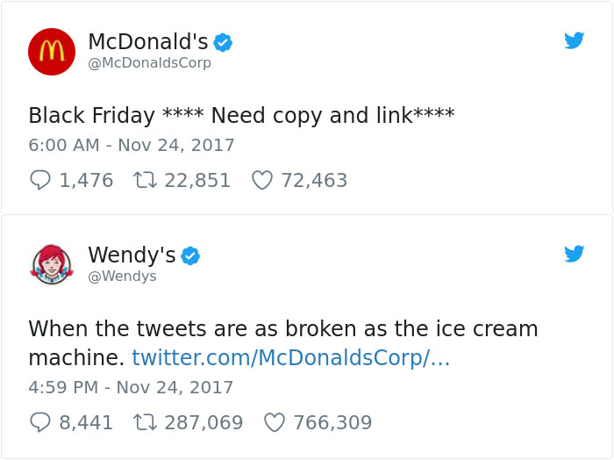
(Wendy’s online presence, 2019.)
From looking at the image the there is a staggering amount of comment, likes and interest created from one tweet from the comical nature of it (Lewis, n.d.).
Another social marketing campaign that almost everyone took part in globally was the ALS ice bucket challenge which became a viral social media challenge in 2014 this challenge translated into over one hundred and fifth teen million being donated to finding a cure for Lou Gehrig’s disease as well as outlining what the disease is to a population that prior to this had little idea of what it was creating an invaluable level of brand awareness that shows the epidemy of what social marketing is all about ("You can make the impossible happen…AGAIN", 2019), (Sample & Woolf, 2019).
A pioneering social marketing campaign was with doves social marketing that Dove finds the beauty in everyone, this started seventeen years ago and still is a Widley recognized campaign because of its inclusivity that all women are beautiful not just the supermodels that advertise similar products. Dove has looked at who is buying their products and made them feel beautiful and promoted them rather that someone who is heavily edited, and photo shopped being the recognised face of their product line ("Real Beauty | Dove Campaigns - Dove", 2019).
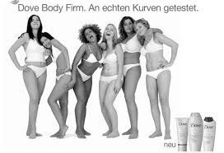
(Dove, body positivity, 2019)
An even more recognized social marketing campaign was created by coke, coke successfully attempted to make a personal connection with their customers by the simplest and most ingenious of means. This created the “share a coke with” campaign, all that coke did for this was remove the large coke logo from the centre of the product and replace it with various names, this had the effect of creating a buying spree in the hunt for a coke bottle with buyer’s name on the bottle. Also, this led to large amounts of social media advertising as customers uploaded images of their bottles with their names on them (Company et al., 2019).
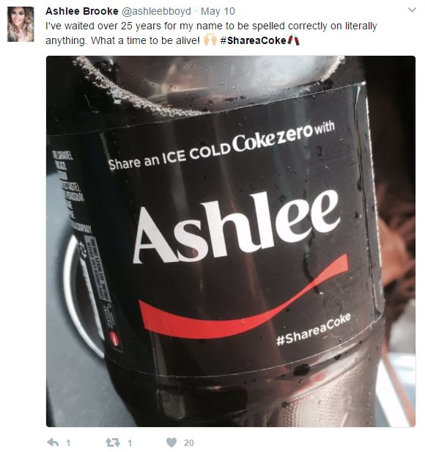

Conclusion
In conclusion social and ethical marketing invites change, this change influences the way that we think and how we see the world for the better by connect us through a common goal or interest. Social and ethical marketing is one of the pest ways to generate interested and or sales in today’s world where everyone has at least one way to access social media and each person is constantly connected to one another. Social and ethical marketing is not a passing trend, there are over three billon people on earth that have access to social media, and this shows no sign of stopping or slowing down, this makes it the most useful tool for business for connectivity and awareness of a brand and boosts sales of well promoted products.

Bibliography
(Schwartz, 1973)
50MINUTES.COM. (2015). The Marketing Mix. Cork: Primento Digital.
Andreasen, A. (2006). Social marketing in the 21st century. Thousand Oaks: Sage.
Armstrong, G., Adam, S., Denize, S., & Kotler, P. Principles of marketing.
Bieger, T. (2015). Marketing concept - the St. Gallen management approach. Bern: Haupt.
Bowen, G., & Ozuem, W. Competitive social media marketing strategies.
Carter, D. (2019). The 4Ps Are Out, the 4Es Are In. Retrieved from https://www.growthcubed.com/2017/04/24/4ps-4es/
Company, O., Main, O., Journey, A., Mission, V., Inclusion, D., & Rights, H. et al. (2019). Is Your Name On a Coke Bottle?. Retrieved from https://www.coca-colacompany.com/stories/is-your-name-on-a-coke-bottle-find-out-here
Dove, body positivity, (2019) retrieved form https://www.dove.com/uk/stories/campaigns.html
Fullerton, R. (1994). Explorations in the history of marketing. Greenwich: JAI Press.
Gbadamosi, A. (2013). Principles of Marketing. Palgrave Macmillan.
Just Found – The 4 E’s of Marketing. (2019). Retrieved from https://onstrategyhq.com/resources/just-found-the-4-es-of-marketing/
Kotler, P., & Lee, N. (2012). Social marketing. Thousand Oaks, Calif.: SAGE.
Lewis, W. Aesthetic clinic marketing in the digital age.
Management Association, I. (2018). Social Media Marketing. Hershey: IGI Global.
Marketing. (2019). Retrieved from https://media3.bournemouth.ac.uk/marketing/02defining/01history.html
Real Beauty | Dove Campaigns - Dove. (2019). Retrieved from https://www.dove.com/uk/stories/campaigns.html
Review, H., & Silk, A. (2015). What Is Marketing?. Boston: Harvard Business Review Press.
Rose, R., & Johnson, C. Experiences.
Sample, I., & Woolf, N. (2019). How the ice bucket challenge led to an ALS research breakthrough. Retrieved from https://www.theguardian.com/science/2016/jul/27/how-the-ice-bucket-challenge-led-to-an-als-research-breakthrough
Strydom, J. (2004). Introduction to marketing. Cape Town, South Africa: Juta.
The Evolution Of Marketing – From Trade to Tech. (2019). Retrieved from https://historycooperative.org/the-evolution-of-marketing-from-trade-to-tech/
Wendy’s online presence, 2019 retrived form https://www.google.com/url?sa=i&source=images&cd=&cad=rja&uact=8&ved=2ahUKEwjcmKrWiKLhAhWBxoUKHTmeBTcQjRx6BAgBEAU&url=https%3A%2F%2Fwww.boredpanda.com%2Ffunny-wendy-tweets-jokes%2F&psig=AOvVaw1KJLmEkvgafku34aifwnkD&ust=1553767351647840
You can make the impossible happen…AGAIN. (2019). Retrieved from http://www.alsa.org/fight-als/ice-bucket-challenge.html
Zipkin, N. (2019). Wendy's Amazing Social Media Team Shares The Secrets to its Success. Retrieved from https://www.entrepreneur.com/article/306259

